Reliability and Adaptability of the SRR Model for Soiling Estimation: Case Studies from Coastal and Desert Climates
Bilal CHEBLI ^{a)}, Bouchra LAARABI ^{b)}, Salma ZAIM and Abdelfettah BARHDADI
Physics of Semiconductors and Solar Energy Research Team (PSES), Energy Research Center, ENS, Mohammed V University in Rabat, Morocco
Corresponding authors: ^{a)} bilal.chebli.811@gmail.com and ^{b)} bouchra_laarabi@um5.ac.ma

Abstract. Quantifying the soiling effect on photovoltaic (PV) modules is essential for improving energy yield predictions and optimizing maintenance strategies. This study applies the Stochastic Rate and Recovery (SRR) model to quantify soiling losses, utilizing a 15-month dataset from the PROPRE.Ma installation in Rabat, Morocco. The SRR model, which operates without dedicated soiling sensors, effectively identified natural cleaning events triggered by rainfall and tracked performance degradation. Validation against measured soiling data revealed the model's tendency to slightly overestimate the soiling ratio (median SR of 0.929 vs. a measured median of 0.88), yet it provided a reasonable approximation, confirming its utility as a practical and accessible assessment tool. Furthermore, a comparative analysis against a decade-long dataset from Alice Springs, Australia, quantified the critical importance of data duration. While the model performed robustly, this analysis demonstrated that longer datasets drastically improve estimation precision, narrowing the 95% confidence interval from a wide range of [0.899–0.986] for a 15-month period to a precise [0.966–0.981] for the long-term benchmark. This finding underscores that while the SRR model is effective, its results are most robust when based on multi-year data. Single-year analyses are not recommended for high-stakes applications, as they can yield biased estimates that do not reflect the long-term soiling state of the site.

Introduction
Photovoltaic (PV) systems are increasingly recognized as a critical component of the global transition towards renewable energy. However, their long-term efficiency and reliability are challenged by various environmental factors, among which soiling is particularly significant. Soiling, which refers to the accumulation of dust, sand, organic matter, and other particulates on the surface of solar modules, can substantially reduce the amount of solar irradiance reaching the PV cells, leading to decreased energy output and economic losses [1–3]. The magnitude of soiling losses varies greatly depending on geographic location, local climate, module tilt, dust composition, etc. In arid and semi-arid regions, where solar installations are often favored due to high irradiance levels, soiling can result in considerable performance degradation if not adequately monitored and managed. Similarly, in coastal environments, soiling patterns are influenced by humidity, rainfall, and salt-laden winds, further complicating the assessment and mitigation of its effects [4–6].
Several approaches have been developed to predict and quantify soiling losses. These include empirical models based on site-specific measurements, artificial neural networks (ANN) that leverage large datasets for predictive analytics, and physical models that simulate the deposition and removal of particles under varying environmental conditions [7–9]. However, many of these methods require the installation of dedicated soiling sensors or rely on complex measurement campaigns, which can be costly and logistically challenging, particularly for small or remote PV systems. In this context, the Stochastic Rate and Recovery (SRR) model presents a valuable alternative. Developed to quantify soiling impacts using only power production and meteorological data, the SRR model offers a low-cost, scalable solution that does not necessitate additional sensing infrastructure [10,11].
The present study applies the SRR model to two PV installations in distinct climatic contexts: a coastal site in Rabat, Morocco, and a desert site in Alice Springs, Australia. The objective is to assess the model’s ability to detect soiling and natural cleaning cycles, evaluate its accuracy against measured data, and analyze the effect of dataset duration on the reliability of soiling estimates. By situating this study within the broader context of soiling research and PV performance optimization, this work contributes to the growing body of literature focused on improving solar energy system efficiency and sustainability. The methodology, results, and implications presented here provide valuable insights for PV operators, maintenance planners, and researchers seeking practical solutions for soiling assessment.

Materials and Methods
The SRR model was implemented to quantify soiling losses at two PV installations: the "PROPRE.Ma" system in Rabat, Morocco and the "12 BP Solar" system in Alice Springs, Australia. Both installations provided an opportunity to test the model's robustness under distinct environmental conditions, thereby ensuring the validity of the results across a wide range of soiling scenarios. The PROPRE.Ma installation is a 2-kW rooftop system using monocrystalline technology, located in a coastal Mediterranean climate where humidity and seasonal rainfall strongly influence soiling dynamics [12], [13]. The 12 BP Solar installation is a 5.1 kW ground-mounted, fixed-tilt PV system, also based on monocrystalline technology. It is located in an arid desert environment characterized by high solar irradiance and frequent wind-blown dust events [14]. For both sites, a 15-month dataset of PV production and meteorological measurements was collected. The data included power output, current, voltage, irradiance, ambient temperature, and relative humidity. Data completeness exceeded 90%, ensuring the reliability of the analysis. The selected period allowed for the observation of seasonal variations and the identification of potential cleaning events.
The SRR model operates through a systematic four-step procedure [15]. First, segmentation of performance metric time series delineates intervals between cleaning events (Fig. 1a). Second, the Theil-Sen estimator, a non-parametric method robust against outliers - calculates soiling slopes within each interval (Fig. 1b) [16]. Monte Carlo simulations generate stochastic soiling profiles accounting for accumulation rate variability and recovery processes (Fig. 1c). Finally, the model calculates confidence intervals (CI) for the Soiling Ratio (SR), providing a probabilistic estimation of soiling losses over the analyzed period (Fig. 1d). The analysis was conducted using Python, leveraging the flexibility of the SRR model's open-source implementation. Data preprocessing and statistical analysis were performed, with particular attention given to handling missing data, time-series formatting, and the detection of outliers. For a more effective application of the SRR model, the authors have prepared a comprehensive application guide, including a detailed overview of encountered issues and their corresponding solutions. This is presented in Annex 1 and can also be accessed via the link provided in the references [17] . The methodology presented in this study focused exclusively on procedures that directly support the results presented in the following sections. Unnecessary background steps or unrelated analyses were deliberately excluded to maintain a clear and focused presentation of the key findings.
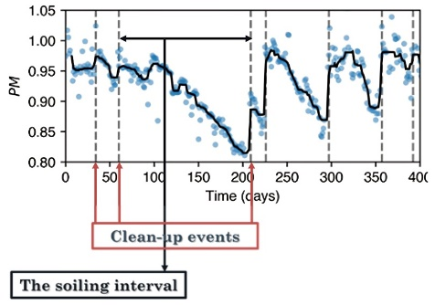 | 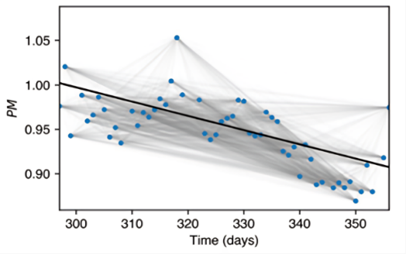
(a) | (b)
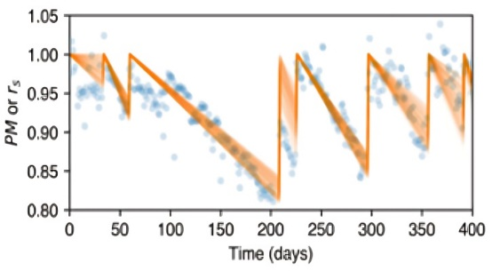 | 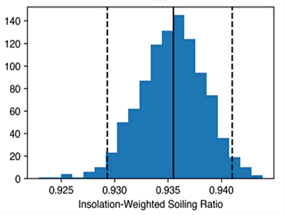
(c) | (d)
FIGURE 1. Steps of the yield-based SRR soiling estimation method. Blue circles are the daily Performance Metric (PM). (a) Time-series segmentation of PM showing cleaning event (vertical dashed lines) detection via 14-day moving median (black line). (b) Soiling rate estimation using Theil-Sen regression (solid line) demonstrating robustness against outliers compared to least-squares (dotted); (c) Stochastic generation of soiling profiles (orange lines) through Monte Carlo simulations of slope uncertainty and recovery events; (d) Final insolation-weighted SR ($r_{s,w}$) distribution with median (solid vertical) and 95% CI (dashed verticals).

Results and Discussion
The application of the SRR model to the "PROPRE.Ma" installation in Rabat revealed soiling patterns characteristic of coastal environments. The system’s performance time-series, shown in Fig. 2, displays regular soiling and natural cleaning cycles, predominantly influenced by seasonal precipitation.
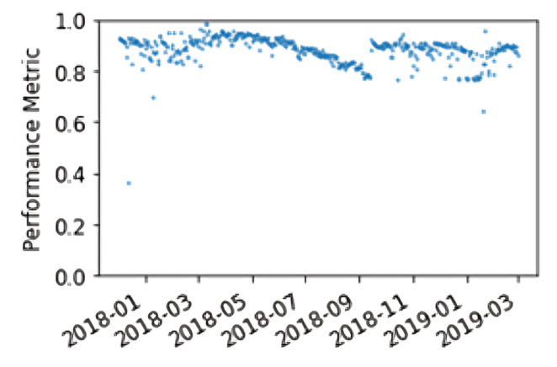 | 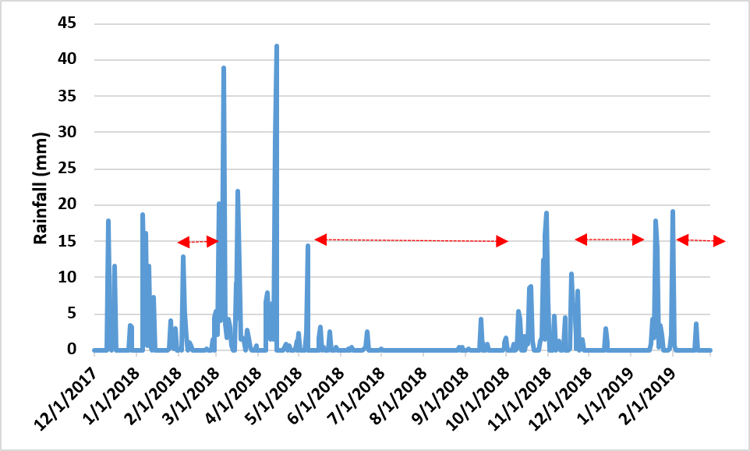
FIGURE 2. Seasonal Performance Metric patterns for PROPRE.Ma installation (Rabat, December 2017-February 2019) | FIGURE 3. Daily rainfall (Rabat, December 2017-February 2019)
A comparison between Fig. 2 and Fig. 3 clearly reveals natural cleaning intervals linked to rainfall events. From January to early March 2018, the system’s performance declined steadily, followed by a sharp recovery in mid-March 2018, coinciding with several heavy rainfall events. Performance then remained relatively stable until May 2018, after which a significant decline was observed throughout the dry summer period. This downward trend lasted until October 2018, when performance improved again in response to multiple rainfall events. A further decline began in December 2018 and persisted until mid-January 2019, when substantial rainfall triggered another recovery. In February 2019, performance decreased once more, reflecting the absence of further precipitation.
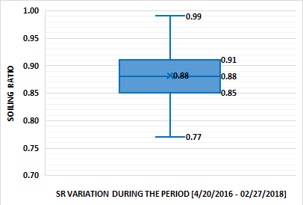 | 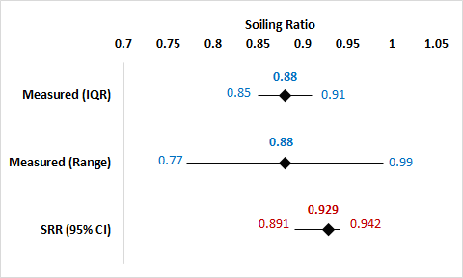
FIGURE 4. SR variation (Rabat, April 20, 2016-February 27, 2018) [18] | FIGURE 5. Overlap Between SRR Model Estimates and Measured SR Distributions from [18]
The SRR model estimated the median SR at this site to be 0.929, with a 95% confidence interval of [0.891–0.942]. To evaluate the reliability of these estimates, they were compared with measured SR data collected at the same site over a different timeframe (April 20, 2016 – February 27, 2018), which nevertheless provides a relevant benchmark for understanding SR variability. The measured distribution (Fig. 4) shows a median SR of 0.88, with 50% of the data falling within [0.85–0.91] and an extended range of [0.77–0.99]. To better visualize the comparison, Fig. 5 illustrates the overlap between SRR model estimates and measured values. The two datasets show only partial agreement: overlap occurs in the narrow interval between 0.891 and 0.91, while most of the measured central tendency lies below the model’s confidence interval. This indicates that the model tends to systematically overestimate SR compared to field observations. A quantitative assessment confirms this deviation: the standardized difference ${(Median}_{model}-{Median}_{measured})/{IQR}_{measured}$​ equals 0.817, meaning that the model median lies about 82% of one interquartile range above the measured median. This suggests a moderate deviation, with the model slightly overestimating soiling losses yet remaining within the expected variability range. Despite the differences in observation periods and the shorter duration of the SRR dataset, the comparison indicates that the model-derived SR values provide a reasonable approximation of the measured data. Nevertheless, it is important to note that longer observation periods generally yield more robust and representative estimations. Shorter datasets may overemphasize infrequent or atypical events, potentially biasing conclusions and affecting maintenance planning and decision-making.
In order to investigate the influence of dataset duration, the SRR model was applied to two different periods at the "12 BP Solar" installation in Alice Springs: a 15-month period from June 2015 to August 2016 (Fig. 6) and a long-term period spanning 2009 to 2018 (Fig. 7). For the 15-month period, the model estimated a median SR of 0.943, with a 95% confidence interval of [0.899–0.986]. In contrast, the extended dataset yielded a median SR of 0.976, with a much narrower confidence interval of [0.966–0.981]. To provide a more quantitative comparison, the standardized difference was calculated by treating the long-term data as the reference. A significant deviation of 2.2 was found. This shows that the SRR median derived from the short observation period (0.943) is significantly lower than that from the long-term reference (0.976), suggesting that short-term data may not fully capture the underlying soiling dynamics, leading to biased estimates. A similar conclusion was drawn by Deceglie et al. [19], who highlighted the potential risk of relying on a single year of data when assessing site-specific performance. This result reinforces the importance of long-term datasets for SRR estimation to reduce uncertainty and avoid misrepresenting soiling impacts in PV performance assessments. Although both estimates were derived from the SRR model, this comparison underscores the importance of a long dataset for generalized soiling quantification. However, a comparison with physical site measurements remains preferable for definitive conclusions.
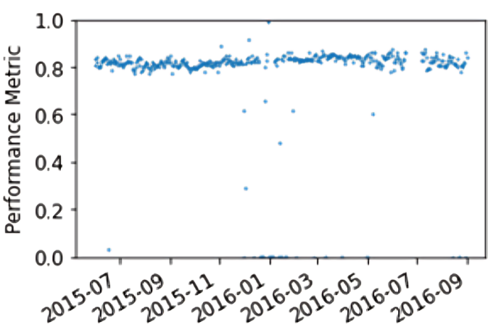 | 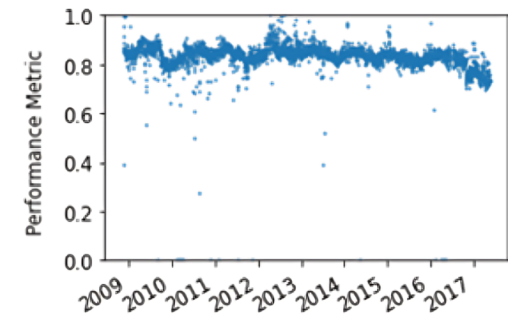
FIGURE 6. PM time series for 12 BP Solar installation (Alice Springs, June 2015-August 2016). | FIGURE 7. Annual PM analysis for Alice Springs (2009-2018).

Despite the inherent limitations of shorter datasets, the SRR model demonstrates significant practical advantages by offering a low-cost solution that relies solely on existing production and meteorological data. This sensor-free methodology is particularly advantageous for small-scale or remote PV installations that cannot justify the investment in dedicated soiling measurement equipment. As supported by N. Pérez et al. [20], the accessibility of computational models like SRR significantly broadens the potential for widespread soiling assessment in the PV sector. Moreover, the application of the Theil-Sen estimator proved highly effective in managing outliers and ensuring reliable slope calculations, a challenge commonly encountered in PV performance time series. This aligns with the conclusions of Zitouni et al. [5], who demonstrated the robustness of non-parametric regression techniques in handling irregular soiling patterns.
Overall, while longer data series yield more robust estimates, the SRR model offers a practical, scalable, and valuable tool for soiling quantification, making it a useful addition to the suite of methodologies available for PV performance optimization.

Conclusion
This study successfully applied the SRR model to two PV installations in distinct climatic environments—Rabat, Morocco (coastal), and Alice Springs, Australia (desert), with the aim of evaluating the model’s reliability and accuracy in detecting soiling patterns. The results confirmed the model's capacity to characterize soiling and natural cleaning cycles using only PV performance and meteorological data, reinforcing its relevance as a sensor-free approach for soiling assessment.
The model’s outputs were benchmarked against available measured soiling data for “PROPRE.MA” installation, showing a reasonable agreement despite differences in observation periods. The analysis also highlighted that dataset duration plays a crucial role in determining the accuracy of the model’s estimations. Longer datasets led to narrower confidence intervals and more representative soiling ratios, while shorter timeframes risked overemphasizing atypical events.
The SRR model demonstrated practical advantages, particularly for small-scale or remote installations, by offering a low-cost, reproducible, and scalable solution. Additionally, the use of the Theil-Sen estimator proved effective in handling outliers and irregularities in performance data, an important factor for robust soiling analysis.
In conclusion, this work reinforces the value of the SRR model as a practical tool for PV operators and researchers aiming to optimize performance and maintenance strategies. Future research should focus on further validation against real-time sensor data and explore applications across a broader range of geographic and climatic conditions to improve model generalizability and support wider adoption.

Acknowledgments
The authors thank Mr. Ayoub DIOUANE, CEO of DISOLAR company, for his considerable contribution and support to this work.

References
1. Micheli L, Muller M. An investigation of the key parameters for predicting PV soiling losses. Progress in Photovoltaics: Research and Applications. 2017;25(4):291–307.
2. Deceglie MG, Micheli L, Muller M. Quantifying Year-to-Year Variations in Solar Panel Soiling from PV Energy-Production Data. IEEE J Photovolt. 2017;
3. Polo J, Martín-Chivelet N, Sanz-Saiz C, Alonso-Montesinos J, López G, Alonso-Abella M, et al. Modeling soiling losses for rooftop PV systems in suburban areas with nearby forest in Madrid. Renew Energy. 2021;178:420–8.
4. Shenouda R, Abd-Elhady MS, Kandil HA. A review of dust accumulation on PV panels in the MENA and the Far East regions. Journal of Engineering and Applied Science. 2022;69(1):1–29.
5. Zitouni H, Azouzoute A, Hajjaj C, El Ydrissi M, Regragui M, Polo J, et al. Experimental investigation and modeling of photovoltaic soiling loss as a function of environmental variables: A case study of semi-arid climate. Solar Energy Materials and Solar Cells. 2021 Mar 1;221.
6. Micheli L, Muller M, Kurtz S. Determining the effects of environment and atmospheric parameters on PV field performance. 2017 IEEE 44th Photovoltaic Specialist Conference, PVSC 2017. 2017;(3):619–25.
7. Cheema A, Shaaban MF, Ismail MH. A novel stochastic dynamic modeling for photovoltaic systems considering dust and cleaning. Appl Energy. 2021 Oct 15;300.
8. Arshad MASS. A minimal neural network model to predict power loss due to soiling in stable environments. In: 2020 International Conference on Electronics, Information, and Communication, ICEIC 2020. Institute of Electrical and Electronics Engineers Inc.; 2020.
9. Laarabi B, Sankarkumar S, Rajasekar N, El Baqqal Y, Barhdadi A. Modeling investigation of soiling effect on solar photovoltaic systems: New findings. Sustainable Energy Technologies and Assessments [Internet]. 2022;52(PB):102126. Available from: https://doi.org/10.1016/j.seta.2022.102126
10. Micheli L, Ruth D, Deceglie MG, Muller M. Time Series Analysis of Photovoltaic Soiling Station Data: Version 1.0, August 2017. Technical Report NREL/TP-5J00-69131 [Internet]. 2017;(August). Available from: www.nrel.gov/publications.
11. GitHub - NREL/pv_soiling [Internet]. [cited 2025 Jun 18]. Available from: https://github.com/NREL/pv_soiling
12. Dahlioui D, Laarabi B, Barhdadi A. Investigation of soiling impact on PV modules performance in semi-arid and hyper-arid climates in Morocco. Energy for Sustainable Development [Internet]. 2019;51:32–9. Available from: https://doi.org/10.1016/j.esd.2019.05.001
13. Laarabi B, Daoudi F ez zahrae, Safsafi F, El Hamouchi J, Barhdadi A. Performances of Various PV Modules Technologies under Climate Conditions of Rabat in Morocco. In: 2017 International Renewable and Sustainable Energy Conference (IRSEC). IEEE Xplore Digital Library; 2017. p. 1–6.
14. DKASC, Alice Springs | DKA Solar Centre [Internet]. [cited 2022 Oct 9]. Available from: https://dkasolarcentre.com.au/locations/alice-springs/technologies
15. Deceglie MG, Micheli L, Muller M. Quantifying Soiling Loss Directly from PV Yield. IEEE J Photovolt. 2018;8(2):547–51.
16. Theil H. A Rank-Invariant Method of Linear and Polynomial Regression Analysis. 1992;3(1950):345–81.
17. pv_soiling/SRR_Instructions.md at master · CHEBLI-Bilal/pv_soiling · GitHub [Internet]. [cited 2025 Jun 19]. Available from: https://github.com/CHEBLI-Bilal/pv_soiling/blob/master/SRR_Instructions.md
18. Dahlioui D, Laarabi B, Barhdadi A. Investigation of soiling impact on PV modules performance in semi-arid and hyper-arid climates in Morocco. Energy for Sustainable Development [Internet]. 2019;51:32–9. Available from: https://doi.org/10.1016/j.esd.2019.05.001
19. Deceglie MG, Micheli L, Muller M. Quantifying Year-to-Year Variations in Solar Panel Soiling from PV Energy-Production Data. 2017 IEEE 44th Photovoltaic Specialist Conference, PVSC 2017. 2017;1–4.
20. Pérez NS, Alonso-Montesinos J, Batlles FJ. Estimation of soiling losses from an experimental photovoltaic plant using artificial intelligence techniques. Applied Sciences (Switzerland). 2021 Feb 2;11(4):1–18.

ANNEX 1– USER GUIDE FOR SRR MODEL APPLICATION
This annex presents a detailed procedure for preparing, executing, and troubleshooting the SRR (Stochastic Rate and Recovery) model for the quantification of soiling losses in photovoltaic (PV) systems based on operational and meteorological data. This guide was prepared based on the instructions provided by the model developers [11], as well as on our own experience in applying the model.

File Preparation
The input required for the SRR model consists of an Excel file in .xlsx format containing a complete and chronologically ordered dataset. Each entry should include timestamps formatted as yyyy/mm/dd hh:mm:ss, active power (P) in kilowatts (kW), plane of array irradiance (POA) and global horizontal irradiance (GHI) in watts per square meter (W/m²), ambient temperature (Ta) and cell temperature (Tc) in degrees Celsius (°C), and wind speed (WS) in meters per second (m/s).
The Excel file name must not contain spaces, and the column headers must exactly match the variable names expected by the Python scripts. Numeric formatting must employ commas as thousand separators and dots as decimal separators. These settings can be manually configured in Microsoft Excel by deactivating system defaults and selecting custom separators.
The dataset must be complete, properly structured, and free of missing timestamps. Irregular or missing intervals may compromise the model’s ability to accurately identify soiling periods and cleaning events.

Software Environment
The SRR model requires Python version 3.7.0 or higher. It is recommended to use Visual Studio Code (VS Code) with the Jupyter extension to facilitate execution and error tracking, although Jupyter Notebook is also compatible.
The numpy, pandas, matplotlib, openpyxl and pvlib libraries must be properly installed before executing the model.
The following Python command was used to install these libraries:

pip install numpy pandas matplotlib openpyxl pvlib

These libraries are essential for data processing, visualization, and photovoltaic system modeling.

Model Preparation and Execution
The SRR model source code is available from the official NREL pv_soiling repository. A new Jupyter Notebook, for example SRR.ipynb, should be created to manage all steps of model execution, including data import, variable initialization, and soiling calculations.
In some cases, the functions from the pvlib.pvsystem library may not be fully compatible with the SRR model. To resolve this, the user must create a separate Python file named pvsystemtest.py containing compatible functions adapted from pvlib version 0.6.3. The adapted code must be saved in the Python library directory, typically located at:
C:\Python\Python310\Lib\site-packages\pvlib

The adapted file must be correctly linked to the execution environment by using the following Python commands:

import sys
sys.path.append('C:\\Python\\Python310\\Lib\\site-packages\\pvlib')
import pvsystemtest as test

This step ensures that the SRR model calls the appropriate version of the pvlib functions.

Common Errors and Troubleshooting
Several errors may occur during execution:
- Errors related to missing Python functions usually result from incomplete library installation or failure to import the adapted pvsystemtest.py file.
- Errors related to file reading are frequently caused by incorrect column headers, incomplete datasets, or improper numerical formatting. Each variable must be precisely labeled, and all numerical entries must conform to the expected separator conventions.
Invalid or extreme values within the dataset must also be carefully addressed. Such entries should either be corrected or flagged using the marker ‘error’ to allow the model to skip them during processing. Missing or irregular timestamps may disrupt time-series segmentation, making it essential to ensure dataset continuity.

Recommendations for Optimal Application
To obtain precise and statistically reliable soiling ratio estimates, it is strongly recommended to apply the SRR model to datasets spanning at least three years. The analysis of the Alice Springs dataset demonstrated that longer time periods significantly reduce confidence intervals and improve the precision of soiling estimations.
The entire process should be conducted in the following sequence: dataset preparation, software environment configuration, library installation, model adaptation (if required), and stepwise execution of the SRR method. Following this methodology ensures accurate and reproducible results when applying the SRR model for soiling quantification in PV systems.

