Comparative Analysis of Heat Transfer Fluids in a Rock-Based Packed-Bed Storage System
Aicha EDDEMANI^{1, a)} Omar Achahour², Hayat El Baamrani¹, Ahmed Aharoune¹, Lahcen Bouirden¹, Ahmed Ihlal²
¹Thermodynamic and Energetics Laboratory, Physics Department, University of Ibn Zohr, Agadir, Morocco.
² Materials and Renewable Energies Laboratory, Physics Department, University of Ibn Zohr, Agadir, Morocco.
^{a)} Corresponding author: eddemani.aicha@gmail.com
Abstract. This study examines the thermal performance of a packed-bed thermal energy storage (TES) system using a non-equilibrium numerical model capable of independently capturing heat transfer in both the fluid and solid phases. The model's accuracy was confirmed through close agreement with experimental data. The analysis focuses on a comparative evaluation of three commonly used heat transfer fluids (HTFs): air, solar salt, and Therminol VP-1 (oil). Simulations were conducted under identical energy input conditions, with operating temperature ranges tailored to the thermal properties of each fluid. Key performance indicators, including temperature distribution, thermal stratification, and storage efficiency, were assessed during both the charging and discharging phases. The findings reveal distinct differences in thermal behavior among the HTFs, highlighting the critical impact of fluid properties such as specific heat capacity, density and thermal conductivity. Solar salt demonstrated the highest efficiency (85%) and excellent thermal stability. Therminol VP-1 exhibited an efficiency of 77% but is constrained by its lower maximum operating temperature and higher cost. Air, while showing the lowest efficiency (67%), offers advantages such as cost-effectiveness and suitability for high-temperature applications.

Introduction
Thermal energy storage (TES) systems are critical enablers of modern renewable energy infrastructure, providing a means to decouple energy supply from demand, enhance grid flexibility, and mitigate the variability inherent in solar and wind power generation. Among the various TES technologies, packed-bed stand out for their economic viability, structural simplicity, modular scalability and high thermal efficiency. These attributes make them particularly well-suited for large-scale applications such as concentrated solar power (CSP) plants and industrial process heat recovery [1].
These systems typically comprise two interacting phases: a solid phase, which acts as the thermal storage medium, and a fluid phase, which functions as the HTF. The solid phase is usually composed of inexpensive, thermally stable materials such as natural rocks [2, 3], alumina [4], or industrial by-products like copper slag [5]. The fluid phase circulates through the packed-bed, delivering thermal energy to the solid medium during the charging process and recovering it during the discharging process, as illustrated in Fig. 1.
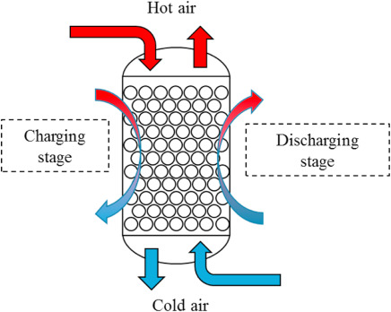

Figure 1. Schematic illustration of the operating principle of a packed-bed in charging and discharging cycle [6].
A variety of HTFs have been utilized in packed-bed TES systems, including air [7], molten salts [8], liquid sodium [9], thermal oils [10], and carbon dioxide CO₂ [11]. A recent comparative study [12] investigated the suitability of various gaseous HTFs, including air, argon, helium, hydrogen, nitrogen, and carbon dioxide, for packed-bed TES systems. The analysis revealed that CO₂ outperformed all other gases, especially in charge/discharge capacity and thermal stratification. Hydrogen, nitrogen, and air displayed moderate efficiency, whereas helium and argon were the least effective. A comparative study investigated [13] packed-bed TES systems using ternary salts and silicone oil as HTFs, with solar salt as the benchmark. The results indicated that silicone oil is a promising HTF due to its favorable thermophysical properties and round-trip efficiencies of up to 90%, although its use may be constrained by higher costs and safety concerns at elevated temperatures. Conversely, ternary salts showed poor performance because viscosity fluctuations within the operating range led to efficiency losses, whereas solar salt achieved strong overall performance and thermocline stability but required higher operating temperatures.
The selection of a suitable HTF is a critical design consideration, as it significantly influences the system’s thermal efficiency, operational safety, and overall economic performance. To ensure optimal performance, several key criteria must be considered when selecting a HTF [14, 15]: these include a low freezing point to prevent solidification under operating conditions, high thermal stability and a high boiling point to enable operation at elevated temperatures, low vapor pressure to reduce containment requirements, high thermal conductivity and specific heat capacity for efficient heat transfer and storage, low dynamic viscosity to minimize pumping power, chemical compatibility with structural and storage materials to avoid corrosion and degradation, cost-effectiveness, widespread availability, and environmental and health safety to ensure sustainable and safe operation.
The literature indicates that the influence of HTFs on the performance of packed-bed systems remains insufficiently explored [16]. Despite the critical role that HTFs play in shaping the thermal behavior of these systems, only a limited number of studies have specifically addressed their impact on system performance, particularly regarding the formation and evolution of the thermocline zone, which directly affects thermal stratification and overall storage efficiency. This study aims to conduct a comparative analysis of three widely used HTFs, namely air, solar salt, and Therminol VP-1 (oil). A non-equilibrium modeling approach is employed to assess the effects of each HTF on thermal behavior and efficiency. Simulations are conducted under identical energy input conditions, with operating temperature ranges tailored to the specific thermal characteristics of each fluid. Particular emphasis is placed on the formation and evolution of the thermocline zone during both charging and discharging periods, as well as on the overall thermal performance of the system.

Methodology and experimental validation
A numerical model has been developed to investigate the thermal behavior within the storage bed, employing a non-equilibrium approach. The computational domain is a 3D axisymmetric cylindrical tank with a height of 1.2 m and a diameter of 0.148 m, representing a vertically oriented packed-bed configuration. The porous medium, composed of solid storage material and HTF, is characterized by a void fraction of 0.4. A mass flow inlet boundary condition was applied at the inlet of the storage tank, where the mass flow rate and temperature of the fluid were specified. At the outlet, a pressure outlet boundary condition was imposed, with the static pressure set to the reference value (0 Pa gauge). This configuration enables the solver to compute the pressure field consistently, while ensuring that the outlet serves as the pressure reference for the entire domain. The governing equations for mass, momentum, and energy conservation in both fluid and solid phases are discretized using the finite volume method and computed using ANSYS-Fluent. Pressure-velocity coupling is handled using the SIMPLE algorithm, while the PISO algorithm and the PRESTO! Scheme are applied to enhance the accuracy of pressure correction and improve the resolution of the pressure field. Second-order upwind schemes are employed for spatial discretization to ensure numerical stability and accuracy. The solution is considered converged when the residuals for mass and momentum fall below 10⁻⁶, and the energy residual drops below 10⁻⁷.
The non-equilibrium model, also known as the two-temperature model, is employed in this study to simulate the thermal behavior of the packed-bed system. In this approach, the solid storage medium (rocks) and the HTF are treated as two distinct phases, each with its own temperature field. The thermal interaction between these phases is captured through an interstitial convective heat transfer term. The system is modeled under fully adiabatic operating conditions, allowing the analysis to focus on the intrinsic thermal behavior of the system, including charge/discharge dynamics and thermocline development, without the confounding effects of external heat losses. The thermal energy balances for the fluid and solid phases are given by Equations (1) and (2), respectively.
$$\frac{∂}{∂t}\left(ερ_{f}E_{f}\right)+∇\left(\vec{u}\left(ρ_{f}E_{f}+P\right)\right)= ∇\left({εk}_{f}∇T_{f}\right)+S_{f}^{h}+h_{fs}A_{fs}\left(T_{s}-T_{f}\right)$$ | (1)
$$\frac{∂}{∂t}\left(\left(1-ε\right)ρ_{s}E_{s}\right) =∇\left({\left(1-ε\right)k}_{s}∇T_{s}\right)+S_{s}^{h}+h_{fs}A_{fs}\left(T_{f}-T_{s}\right)$$ | (2)
The internal energy of the fluid and solid is represented by $E_{f}$​ and $E_{s}$, respectively. The fluid velocity is denoted by the vector $\vec{u}$, and $P$ represents its pressure. The porosity of the packed-bed is indicated by $ε$, while $ρ_{f}$ and $ρ_{s}$ ​are the respective densities. $k_{f}$and $k_{s}$​ denote the thermal conductivities, and $T_{f}$ and $T_{s}$​ correspond to the temperatures for the two phases. The enthalpy source terms are given by $S_{f}^{h}$​ and $S_{s}^{h}$​. The specific surface area between the two phases denoted by $A_{fs}$​, is calculated as follows (Eq. 3):
$$A_{fs}=\frac{6(1-ε)}{d_{s}}$$ | (3)
The calculation of the heat transfer coefficient between air and rock was performed using Equation (4).
$$h_{fs}=\frac{Nu k_{f}}{d_{s}}$$ | (4)
Nusselt number $Nu$, which quantifies the effectiveness of convective heat transfer relative to conduction, is determined using the empirical correlation given in Equation (5).
$$Nu=2+1.1 \left({Re}^{0.6} {Pr}^{0.33}\right)$$ | (5)
Where the Reynolds number $Re$ and the Prandtl number $Pr$ are determined using the following expressions:
$$Re=\frac{ρ_{f}d_{s}\left|\vec{u}\right|}{(1-ε)μ_{f}}$$ | (6)
$$Pr=\frac{c_{p}μ_{f}}{k_{f}}$$ | (7)
The Reynolds number $Re$ is a fundamental dimensionless parameter used to characterize the flow regime in a packed-bed. As reported by Rabi et al. [17], a Reynolds number below 10 generally corresponds to laminar flow within the packed-bed, where Darcy’s law accurately describes the fluid behavior. In contrast, when Re exceeds 300, the flow is considered fully turbulent. In this study, the Reynolds number satisfies the criteria for laminar flow conditions within the packed-bed.
The pressure drop within the packed-bed, representing the reduction in fluid pressure along the flow path due to friction and flow resistance, was evaluated using the Ergun equation [18], which accounts for both viscous and inertial contributions in porous media. The equation is given by:
$$\frac{∆P}{L}=\frac{150μ_{f}{(1-ε)}^{2}}{ε^{3}{d_{s}}^{2}}u+\frac{1.75ρ_{f}(1-ε)}{ε^{3}d_{s}}u^{2}$$ | (8)
where $∆P$ represents the pressure drop along a bed of length $L$, and $μ_{f}$denotes the dynamic viscosity of the fluid.
The total pumping energy $E_{p}$​​ required to pump the heat transfer fluid through the packed-bed is calculated using Eq. (9), which accounts for the fluid properties, bed cross-sectional area $A$, mass flux $G$, and the pressure drop along the bed.
$$E_{p}=\int_{0}^{t}{\frac{AG}{ρ_{f}}∆P dt}$$ | (9)
The efficiency of the packed-bed with various HTFs is evaluated as the fraction of thermal energy recovered during the discharge stage relative to the energy supplied during charging, accounting for the total pumping energy in both charge and discharge phases (Eq. 10).
$$η=\frac{E_{recovred}}{E_{input}+E_{p}^{ch}+E_{p}^{disch}}$$ | (10)
The numerical model is validated against the data obtained from experiments conducted by Meier et al. [19]. The thermal storage bed features a cylindrical geometry with a height of 1.2 m and a diameter of 0.148 m. It is packed with steatite rocks of approximately 0.02 m in diameter, arranged randomly to achieve a porosity of 0.4. Fig. 2 presents a comparison of the simulated and measured temperature profiles during the charging phase. The comparative analysis between the numerical temperature $\left(T_{num,i}\right)$ and the experimental temperature $\left(T_{exp,i}\right)$​ at the $i^{th}$ measurement point is evaluated using the relative error $\left({Er}_{i}={\left|T_{num,i}-T_{exp,i}\right|}/{T_{exp,i}}\right)$. The maximum relative error ${RE}_{max}=9.2\%$ is observed at a bed height of $h=0.3 m$ after 1800 s. This relatively higher deviation occurs during the early stage of the charging process, when steep temperature gradients and rapid front propagation make precise prediction more sensitive to local measurement uncertainties and modeling assumptions. In contrast, the minimum relative error ${RE}_{min}=0.007\%$ is obtained at a bed height of $h=0.7m$ after 10800 s, corresponding to the later stage of charging when the temperature field becomes more uniform and the thermocline front is well stabilized, leading to an almost perfect agreement with experimental data. The overall accuracy of the model is assessed through the mean relative error over all $n$ measurements $\left(MRE=\frac{1}{n}\sum_{i=1}^{n}{E_{r,i}}\right)$ , which yields a value of 2.3% and confirms the robustness and predictive capability of the non-equilibrium modeling approach.
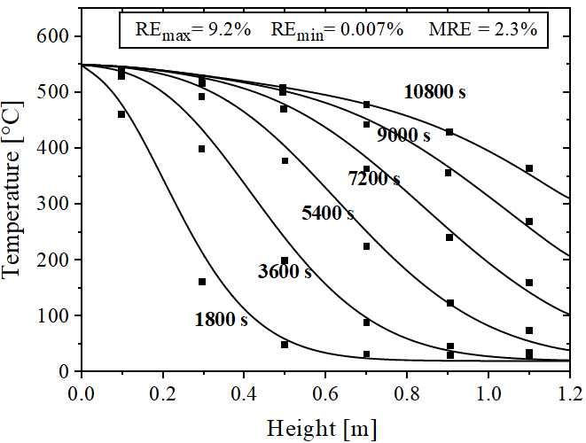
Figure 2. Simulated versus experimental temperature profiles during the charging phase.
Air, solar salt, and Therminol VP-1 exhibit significantly different physical properties, as presented in Table 1. The simulations are conducted using the same energy input for each HTF to ensure a consistent basis for comparison. Additionally, the operating temperature ranges are tailored to the actual thermal limits of each fluid. Both the charging and discharging periods are kept constant across all cases. The mass flow rates were determined based on the imposed energy input and the specific heat capacities of the respective HTFs, as summarized in Table 1. The operating pressure, defined as the pressure drop across the packed-bed, was found to be approximately 63.77 Pa for air, 0.11 Pa for Therminol VP-1, and 0.33 Pa for solar salt, remaining constant throughout the entire charging process. These variations are directly linked to the thermo-physical properties of the working fluids, which determine the balance between viscous and inertial contributions to pressure loss in the porous medium. Owing to its low density, air reaches a relatively high superficial velocity for the imposed mass flux, which amplifies inertial effects and leads to a substantially higher pressure drop. Conversely, the liquid heat transfer fluids, Therminol VP-1 and solar salt, have much higher densities, resulting in significantly lower superficial velocities under comparable conditions. Consequently, their pressure losses are minimal and predominantly governed by viscous effects.
TABLE 1. Thermophysical properties of HTFs and simulation parameters.
Properties of HTFs
Density $ρ_{f}[kg/m^{3}]$, 300°C |  | Air |  | Solar salt | Therminol VP-1
 |  | 0.61 |  | 1901 | 945
Specific heat capacity $c_{p}[J/kg K]$, 300°C |  | 1046 |  | 1549 | 2309
Thermal conductivity $k_{f}[W/mK]$, 300°C |  | 0.05 |  | 0.5 | 0.04
Dynamic viscosity $μ_{f}[Pa s]$, 300°C |  | 2.92 10⁻⁵ |  | 3.07 10⁻³ | 2.36 10⁻⁴
T_{max}-T_{min} [°C] [20] |  | 20-650 |  | 220-600 | 12-400
Simulation parameters
Input power [W] | 2500 |  | 2500 |  |  | 2500
Mass flow [kg/s m²] | 0.215 |  | 0.253 |  |  | 0.184
T_{max}-T_{min} [°C] | 20-650 |  | 220-600 |  |  | 20-400
Charge–Discharge time [h] | 1.333 |  | 1.333 |  |  | 1.333
Operating pressure [Pa] | 63.77 |  | 0.33 |  |  | 0.11
Pumping energy [Wh] | 0.629 |  | 1.04⋅10⁻⁶ |  |  | 5.1⋅10⁻⁷
In terms of cost–performance trade-offs, Therminol VP-1 offers a relatively high specific heat capacity, which enhances energy storage per unit mass, but its high cost (Table 3) and limited maximum operating temperature of 400 °C restrict its suitability for large-scale CSP applications. Solar salt, by contrast, combines low cost, a wide operational range (220-600 °C), higher thermal conductivity (0.5 W/m K), and greater density, enabling superior volumetric energy storage and efficient thermal transfer. Air, although cost-free and easy to handle, avoids issues such as freezing or decomposition; however, its low density and thermal conductivity limit heat transfer efficiency.
Table (2) presents the temperature-dependent thermophysical properties of the three HTFs investigated in this study. For each HTF, the variations in density, specific heat capacity, thermal conductivity, and viscosity with temperature are described using empirical correlations reported in the literature. These correlations were directly incorporated into the numerical model to ensure a realistic representation of heat transfer behavior under the simulated operating conditions.
TABLE 2. Temperature-dependent thermophysical properties of the investigated HTFs.
Fluid | Thermophysical property | Unit | Sources
Solar salt | $$ρ_{f}(T(°C))=2090-0.63⋅T$$  $$c_{p}(T(°C))=1.5404+3.0924⋅{10}^{-5}⋅T$$  $$k_{f}\left(T(°C)\right)=0.3804+3.452⋅{10}^{-4}⋅T$$  $$μ_{f}\left(T(°C)\right)=71,645⋅T^{-1.763}$$ | $$kg/m$$  $$J/g K$$  $$W/m K$$  $$cP$$ | [21, 22]  [23, 22]  [22]  [22]
Air | $$ρ_{f}(T(K)=\frac{p}{R⋅T} , R=287.05 (J/kg K)$$  $$c_{p}(T(K)=1030.5-0.19975⋅T+ 3.9734 {10}^{-4}⋅T^{2}$$  $$k_{f}(T(°C))=0.0241+7.72⋅{10}^{-5}⋅T$$  $$μ_{f}(T\left(K\right))=1.458⋅{10}^{-6}\frac{T^{\frac{3}{2}}}{T+110.4}$$ | $$kg/m$$  $$J/kg K$$  $$W/m K$$  $$Pa s$$ | Standard value  [24]  [25]  [26]
Therminol VP-1 | $$ρ_{f}\left(T(°C)\right)=1083.25-0.90797⋅T+7.8116⋅{10}^{-4}{⋅T}^{2}+2.367⋅{10}^{-6}{⋅T}^{3}$$  $$c_{p}\left(T(°C)\right)=1.498+0.002414⋅T+5.9591⋅{10}^{-6}⋅T^{2}-2.9879⋅{10}^{-8}⋅T^{3}+4.4172⋅{10}^{-11}⋅T^{4}$$  $$k_{f}\left(T(°C)\right)=0.1377-8.1947⋅{10}^{-5}⋅T-1.9225⋅{10}^{-7}⋅T^{2}+2.5034⋅{10}^{-11}{⋅T}^{3}-7.2974⋅{10}^{-15}⋅T^{4}$$  $$μ_{f}\left(T(°C)\right)=171.5 T^{-1.155}$$ | $$kg/m$$  $$J/g K$$  $$W/m K$$  $$cP$$ | [27]  [27]  [27]  [22]

Results and Discussion
To evaluate the performance of various HTFs within the storage bed, numerical simulations were carried out under identical energy input conditions to ensure a fair comparison. The temperature ranges for each HTF were carefully chosen to reflect their specific thermal stability thresholds and operational limits: air was modeled between 650°C and 20°C, solar salt between 600°C and 220°C, and Therminol VP-1 between 400°C and 20°C. This approach enables a realistic assessment of each fluid’s thermal behavior and efficiency within its practical working range.
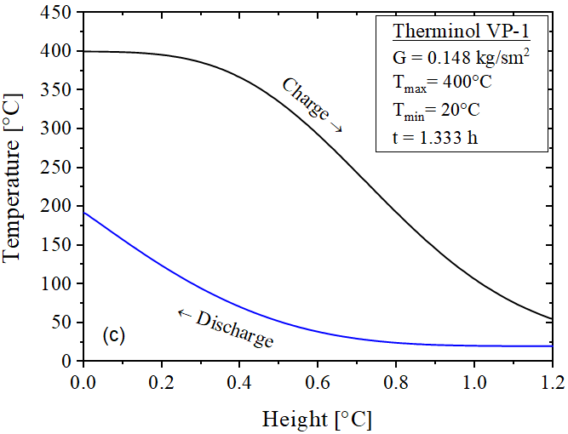
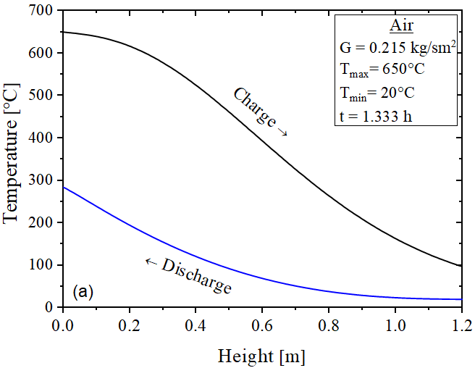
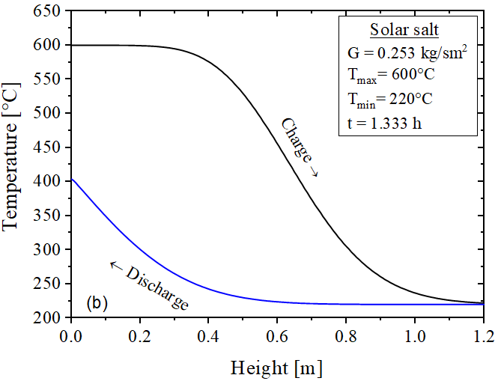
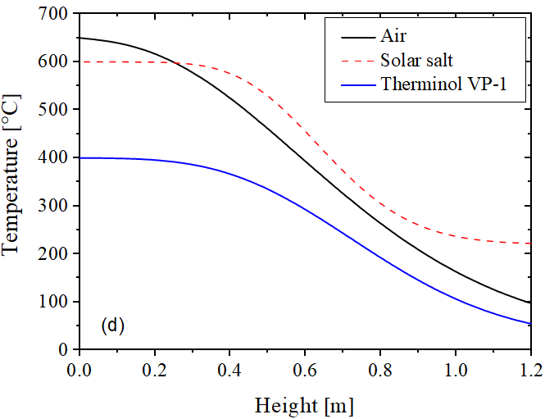
FIGURE 3. Temperature profiles, a) Air charge-discharge cycle, b) solar salt charge-discharge cycle, c) Therminol VP-1 charge discharge cycle, d) axial temperature for different HTFs at the end of charge.
Fig. 3 presents the temperature profiles at the end of a full charge/discharge cycle for each HTF. During the charging phase, each HTF enters the storage tank at its maximum temperature ${(T}_{max})$ to transfer heat to the packed-bed material. Conversely, during the discharging phase, the inlet temperature corresponds to the minimum temperature ${(T}_{min})$. For each HTF, the mass flow rate is determined based on the imposed input energy and the specific temperature range of the fluid. The charging and discharging processes are assumed to have equal durations. For air (Fig. 3a), the maximum temperature $\left(T_{max}=650 °C\right)$, is reached only in the upper section of the reservoir, followed by a gradual decrease along the packed-bed to approximately 300 °C at the bottom. This steep gradient reflects air's lower heat capacity and higher thermal diffusivity, leading to significant thermal stratification and a limited effective thermal storage volume. In contrast, solar salt (Fig. 3 (b)) maintains a more uniform high-temperature region, with the upper portion of the reservoir sustaining $T_{max}=600 °C$ over more than a quarter of its height, before rapidly declining towards the minimum temperature ${(T}_{min}=220 °C)$. At the end of the discharge process, approximately half of the reservoir reaches this minimum temperature, indicating a more complete and efficient heat extraction. Meanwhile, Therminol VP-1 (Fig. 3 (c)) exhibits a concentrated high-temperature zone, with $T_{max}=400 °C$ sustained over less than a quarter of the reservoir height, followed by a sharp decline to temperatures above the expected $T_{min}=20°C$. At the end of discharge, only about a quarter of the reservoir is fully discharged, reflecting a more localized and less uniform heat distribution, consistent with the moderate thermal stability and high heat capacity of this fluid. The overall comparison of thermal behavior for the three HTFs at the end of the charge process, as illustrated in Fig. 3 (d), clearly demonstrates that the packed-bed traversed by molten salt exhibits a more uniform temperature distribution in the upper region, highlighting its superior heat retention and thermal stability compared to air and Therminol VP-1.
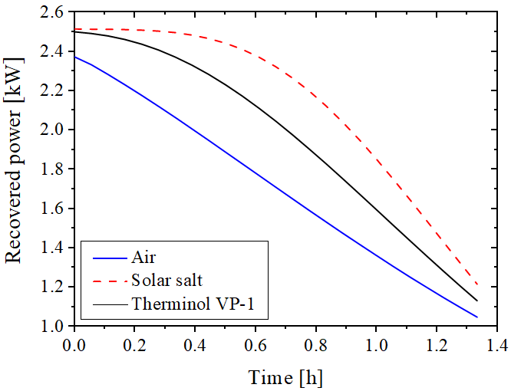
FIGURE 4. Evolution of recovered power over the discharge period.
Fig. 4 illustrates the evolution of recovered power during the discharge process for the evaluated HTFs. It shows that solar salt exhibits the highest recovered power, characterized by a relatively stable output that remains nearly constant for the first 30% of the discharge period. In contrast, Therminol VP-1 demonstrates a slight variation in recovered power at the beginning of the discharge, followed by a gradual decline as the stored heat is released. Meanwhile, air experiences a consistently linear decrease in recovered power throughout the discharge process, reaching the lowest power levels at the end, indicating its limited heat storage capacity and rapid thermal loss.

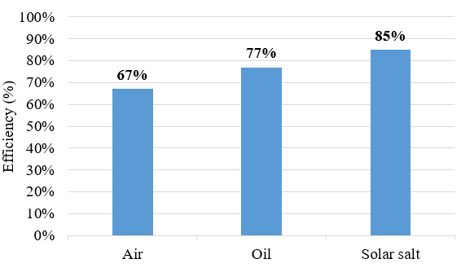
FIGURE 5. Thermal efficiency comparison of air, Therminol VP-1, and solar salt..
Fig. 5 illustrates the efficiency of the packed-bed system for the three HTFs. It reveals that the bed traversed by solar salt achieves the highest efficiency, reaching 85% in the first charge/discharge cycle. In comparison, the efficiency for Therminol VP-1 is slightly lower at 77%. Meanwhile, the bed utilizing air as the HTF exhibits the lowest efficiency at 67%, highlighting the impact of its lower heat capacity and higher thermal diffusivity on overall system performance. Table 3 summarizes the main characteristics of the investigated HTFs, including thermal stability, efficiency, pumping requirements, cost, replacement, environmental safety, and operational issues. The data are compiled from the results of the present study as well as relevant literature sources, providing a comprehensive comparison of HTF performance for packed-bed TES applications.
TABLE 3. Comparative techno-economic and operational characteristics of the investigated HTFs in packed-bed systems.
HTF | Thermal Stability | Efficiency | Pumping Power | Cost  [$/kg] | Maintenance | Environmental  Safety | Operational Issues
Air | Stable at high temperatures  No long-term degradation [28] | Moderate efficiency at high temperature | High pumping power demand | 0 | No replacement required due to inertness and stability | Safe, non-toxic, no environmental hazard | High pumping power requirement
Solar Salt | Risk of solidification under 220 °C Stable up to 600 °C [29] | High efficiency (high specific heat and good conductivity) | Low pumping power demand | 0.5-1.3  [30] | No fluid replacement required under stable operating conditions [31] | No flammable  Not classified as environmentally hazardous [30] | Melting point: 220 °C; freezing prevention required  Low corrosion rates under standard operation [29]
Therminol VP-1 | Stable 12–400 °C Decomposition above 400 °C [32] | High efficiency below 400 °C | Low pumping power demand | 3.9 [30] | Periodic fluid replacement required (Degrades over years) [33] | Toxicity (Very toxic to aquatic life with long lasting effects) [30] | Flash point:110 °C (flammability risk) Copper corrosion [32, 33]

Conclusion
This work presents a numerical evaluation of the thermal performance of a packed-bed TES system using three widely utilized HTFs: air, solar salt, and Therminol VP-1: air, Solar Salt, and Therminol VP-1. The analysis was conducted for both charging and discharging cycles using a non-equilibrium thermal model. The principal findings of the study are summarized as follows:

- Solar salt offers the most favorable thermocline behavior, characterized by a broad and stable high-temperature zone extending over a substantial portion of the bed. This ensures excellent thermal stability and the highest recorded efficiency of 85%, although its practical use requires careful handling due to its high melting point (200 °C).
- Therminol VP-1 demonstrates a moderately stable thermocline, primarily confined near the inlet region during both charging and discharging phases. While it achieves a respectable efficiency of 77%, its application is constrained by a lower maximum operating temperature (400 °C) and higher cost, rendering it less suitable for large-scale TES systems.
- Air displays a steep and narrow thermocline, with rapid temperature decay along the bed and the lowest efficiency at 67%. However, it remains an appealing option for high-temperature applications owing to its low cost, abundance, non-toxicity, and ability to operate at elevated temperatures.
Overall, the selection of HTF is critical for optimizing the performance, efficiency, and economic feasibility of packed-bed TES systems.

References
- A. B. Hernandez, I. Uriz, I. Ortega-Fernández, J. Rodriguez-Aseguinolaza, A. Ortuondo, and A. Faik, “Solid packed bed thermal energy storage for ORC electric generation in Fresnel type CSP plants,” AIP Conf. Proc. 2033, 090013 (2018).
- H. F. Laubscher, T. W. von Backström, and F. Dinter, “Developing a cost effective rock bed thermal energy storage system: Design and modelling,” AIP Conf. Proc. 1850, 080015 (2017).
- H. Geng, Y. Wu, D. Ma, Y. Hao, D. Li, and H. Zhou, “Experimental study on the heat storage characteristics of rock bed heat storage system with different packing structure,” J. Energy Storage 101, 113973 (2024).
- R. Anderson, L. Bates, E. Johnson, and J. F. Morris, “Packed bed thermal energy storage: A simplified experimentally validated model,” J. Energy Storage 4, 14–23 (2015).
- I. Calderón-Vásquez, I. Wolde, V. Segovia, F. G. Battisti, J. M. Cardemil, and R. Escobar, “Modelling the temperature distribution in a horizontal packed-bed thermal energy storage system with copper slag as filler material,” J. Energy Storage 125, 116769 (2025).
- H. Zhou, Z. Lai, and K. Cen, “Experimental study on energy storage performances of packed bed with different solid materials,” Energy 246, 123416 (2022).
- E. Alonso and E. Rojas, “Air solid packed-beds for high temperature thermal storage: Practical recommendations for predicting their thermal behaviour,” Appl. Therm. Eng. 202, 117835 (2022).
- B. Koçak, M. Majó, C. Barreneche, A. I. Fernández, and H. Paksoy, “Performance analysis of a molten salt packed-bed thermal energy storage system using three different waste materials,” Sol. Energy Mater. Sol. Cells 278, 113199 (2024).
- M. V. Bozorg, J. Coventry, and J. F. Torres, “Thermal energy storage in a tightly packed bed with sodium as the heat transfer fluid: A numerical study,” Appl. Energy 352, 121879 (2023).
- I. Ortega-Fernández, A. B. Hernández, Y. Wang, and D. Bielsa, “Performance assessment of an oil-based packed bed thermal energy storage unit in a demonstration concentrated solar power plant,” Energy 217, 119378 (2021).
- T. D. Luz, F. G. Battisti, and A. K. da Silva, “Sensible thermal energy storage in packed beds using supercritical CO₂: A comparative study of tanks with steel-only and reinforced concrete walls,” Renew. Energy 245, 122726 (2025)
- A. M. Rabi’, J. Radulovic, and J. M. Buick, “Comparative study of different gases for packed-bed thermal energy storage systems,” Energies 18, 1307 (2025).
- K. Apostolopoulos-Kalkavouras, S. Trevisan, and R. Guedez, “Comparative modeling of packed-bed thermal energy storage systems using ternary salts, silicone oils and solid waste media,” J. Energy Storage 131, 117650 (2025).
- L. Hellet, “Literature review on heat transfer fluids and thermal energy storage systems in CSP plants,” STERG Report (2013)
- K. Vignarooban, X. Xu, A. Arvay, K. Hsu, and A. M. Kannan, “Heat transfer fluids for concentrating solar power systems – A review,” Appl. Therm. Eng. 146, 383–396 (2015).
- B. Birhanu, R. Mozafari, J. Coventry, G. Rosengarten, and A. Mojiri, “Impact of heat transfer fluid on thermal characteristics of packed bed thermal energy storage,” Appl. Therm. Eng. 278, 127239 (2025).
- A. M. Rabi, J. Radulovic, and J. M. Buick, “Packed bed thermal energy storage system: parametric study,” Thermo. 4, 295–314 (2024).
- S. Ergun, “Fluid flow through packed columns,” Chem. Eng. Prog. 48, 89–94 (1952).
- A. Meier, C. Winkler, and D. Wuillemin, “Experiment for modeling high temperature rock bed storage,” Sol. Energy Mater. 24, 255–264 (1991).
- I. Calderón-Vásquez, E. Cortés, J. García, V. Segovia, A. Caroca, C. Sarmiento, R. Barraza, and J. M. Cardemil, “Review on modeling approaches for packed-bed thermal storage systems,” Renew. Sustain. Energy Rev. 143, 110902 (2021).
- A. Bonk, S. Sau, N. Uranga, M. Hernaiz, and T. Bauer, “Advanced heat transfer fluids for direct molten salt line-focusing CSP plants,” Prog. Energy Combust. Sci. 67, 69–87 (2018).
- A. Giaconia, A. C. Tizzoni, S. Sau, N. Corsaro, E. Mansi, A. Spadoni, and T. Delise, “Assessment and perspectives of heat transfer fluids for CSP applications,” Energies 14, 7486 (2021).
- A. Bonk and T. Bauer, “Solar Salt – Thermal Property Analysis: Report on thermo-physical properties of binary NaNO₃–KNO₃ mixtures (55–65 wt% NaNO₃),” Scientific Report DLR-FB-2022-4, German Aerospace Center (DLR), Institute for Engineering Thermodynamics (2022).
- F. J. McQuillan, J. R. Culham, and M. M. Yovanovich, “Properties of dry air at one atmosphere,” University of Waterloo, Microelectronics Heat Transfer Lab Report UW/MHTL 8406 G-01, Waterloo, Ontario, Canada (1984).
- F. P. Incropera and D. P. DeWitt, Introduction to Heat Transfer, 3rd ed., John Wiley & Sons, New York (1996).
- W. Sutherland, “The viscosity of gases and molecular force,” Philos. Mag. 36, 507–531 (1893).
- L. Ma, Z. Wang, D. Lei, and L. Xu, “Establishment, validation, and application of a comprehensive thermal hydraulic model for a parabolic trough solar field,” Energies 12, 3161 (2019).
- D. Pérez-Gallego, J. Gonzalez-Ayala, A. Medina, and A. Calvo Hernández, “Comprehensive review of dynamical simulation models of packed-bed systems for thermal energy storage applications in renewable power production,” Heliyon 11, e42803 (2025).
- M. Walczak, F. Pineda, Á. G. Fernández, C. Mata-Torres, and R. A. Escobar, “Materials corrosion for thermal energy storage systems in concentrated solar power plants,” Renew. Sustain. Energy Rev. 86, 22–44 (2018).
- A. Giaconia, A. C. Tizzoni, S. Sau, N. Corsaro, E. Mansi, A. Spadoni, and T. Delise, “Assessment and perspectives of heat transfer fluids for CSP applications,” Energies 14, 7486 (2021).
- A. Caraballo, S. Galán-Casado, Á. Caballero, and S. Serena, “Molten salts for sensible thermal energy storage: A review and an energy performance analysis,” Energies 14, 1197 (2021).
- V. Ravindra, A. S. Pegallapati, and R. Maddali, “Suitability of various heat transfer fluids for high temperature solar thermal systems,” Appl. Therm. Eng. 159, 113973 (2019).
- H. Grirate, N. Zari, A. Elmchaouri, S. Molina, and R. Couturier, “Life time analysis of thermal oil used as heat transfer fluid in CSP power plant,” AIP Conf. Proc. 1734, 020005 (2016).

