Energy, Environmental and Economic Assessment of Photovoltaic Potential: A Case Study in Guinea
Papa Lat Tabara SOW^{1,a)}, Cheikh Saliou TOURE^{1,2,b)*}, Mamadou TRAORE^{3,4,c)}, Amadou SIDIBE^{4,d)}, Ousmane BARRY^{2,e)}, Senghane MBODJI^{1,f)}
¹Research Team in Renewable Energies, Materials and Laser of Department of Physics, Alioune Diop University of Bambey, Senegal
²Photovoltaic Energy Department, Faculty of Science and Technology, Labe University, 210-Labe, Guinea
³Research Team Efficiency and Energy Systems (EES), Alioune DIOP University, B.P.:30-Bambey, Bambey, Senegal
⁴Department of physic, Faculty of Natural Sciences, University Julius Nyeree of Kankan, Guinea.

^{b)*} cheikh-saliou.toure@univ-labe.edu.gn
^{c)} mamadoutraore@ujnk.edu.gn
^{e)} ousmane.barry@univ-labe.edu.gn
Abstract. This study assesses the energy, environmental, and economic viability of deploying photovoltaic (PV) systems in Guinea, focusing on the city of Mandiana. In response to the country’s persistent energy deficit and reliance on diesel generators, a 1 MWp PV system was simulated using PVsyst to estimate energy production, emission reduction, and financial performance over a 25-year period. The results indicate an annual energy output of approximately 1.5 GWh, with south-facing installations offering the highest yield (1571 kWh/kWp/year) and a performance ratio of 85%. Environmentally, the system could avoid over 323,000 tons of CO₂, 187.5 tons of SOₓ, and 82.5 tons of NOₓ emissions. Economically, the project shows a benefit-cost ratio (B/C) of 1.995, a profit-cost ratio (P/C) of 1.30, and a return on investment (ROI) of 99.5%. The net present value remains positive under a 5% discount rate, and the payback period is estimated at 11.27 years. These results confirm the feasibility and long-term profitability of PV deployment in Mandiana and support its replication in similar regions. The integration of solar energy can significantly improve electrification in remote areas while advancing Guinea’s climate goals.

Introduction
Energy plays a fundamental role in economic and social development by driving industrialization, innovation, and improvements in living standards. It is derived from various sources, both fossil and renewable. However, fossil fuels such as oil, natural gas, and coal are responsible for significant greenhouse gas emissions, particularly carbon dioxide (CO₂). Emissions resulting from petroleum-based products pose a major environmental threat. CO₂ plays a central role in ozone layer depletion, accounting for nearly 30% of its total absorption in recent years [1].
For decades, academic research has focused on the relationship between energy consumption, economic growth, and environmental sustainability [2], [3]. In response to these challenges, nations have committed to achieving carbon neutrality to limit global warming. The goal is to keep the rise in global average temperature well below 2°C above pre-industrial levels, while striving to limit it to 1.5°C, in line with the Paris Agreement [4]. The causes of global warming are both natural and anthropogenic. However, since the 1950s, the primary driver of temperature increases has been the continued rise in CO₂ emissions from human activities [5]. In 2023, global anthropogenic CO₂ emissions reached approximately 37.4 billion tons [6], leading to an annual atmospheric concentration increase of 2 to 3 ppm. China alone accounted for 11.9 billion tons, significantly impacting global climate change. In this context, the issue of CO₂ emissions convergence has attracted growing research interest. [7] analyze emissions from fossil fuel combustion and cement production in 139 countries from 1960 to 2017. The results show convergence patterns within income groups low-income and high-income countries exhibit internal convergence, while middle-income countries follow trajectories shaped by their development levels, economic structures, and climate policies. The study emphasizes the need for differentiated climate strategies rather than one-size-fits-all approaches. It also highlights the importance of regulatory frameworks, carbon trading mechanisms, and the transfer of clean technologies to developing countries.
Other research explores the interaction between electricity consumption, renewable energy deployment, foreign direct investment (FDI), gross domestic product (GDP), and CO₂ emissions. Fossil fuel dependency is a key driver of carbon footprints. A 1% increase in electricity consumption leads to a 0.45% rise in CO₂ emissions, while a 1% increase in GDP raises emissions by 0.59%, illustrating the close link between development and pollution. Additionally, FDI flows, often directed toward fossil fuel sectors, increase emissions by 0.27%, suggesting a "pollution haven" effect. Conversely, a 1% increase in renewable energy usage could reduce emissions by 0.32% [8]. Given these challenges, decarbonizing the electricity production sector is essential to meet global climate targets. [9] evaluate decarbonization pathways for the top five carbon emitting countries United States, China, Japan, Germany, and India by 2030 and 2050. The electricity sector accounted for 38% of global emissions in 2022, making its transformation a priority to limit warming to 1.5°C or 2°C, in line with the Paris Agreement. Among these countries, China could reduce its emissions by 88.5%, while India could achieve a reduction of up to 90.63% under certain scenarios. Despite its commitment to energy transition, the European Union faces the issue of "carbon leakage," where emissions are outsourced to meet local demand. [10] notes that between 2000 and 2014, the EU's fossil fuel footprint declined, but not fast enough to meet climate goals. Over 50% of imported fossil fuels are indirect imports, often overlooked by existing carbon pricing systems. To address this, the European Commission proposed a Carbon Border Adjustment Mechanism (CBAM), expected to take effect in 2026, initially targeting high-carbon sectors such as cement, iron, steel, aluminum, and electricity.
In response to the climate crisis, circular economy (CE) innovation is emerging as a key solution to mitigate the environmental impacts of fossil fuel consumption. [11] emphasizes that countries embracing CE practices improve green economic indicators and resource efficiency. It is therefore essential for developing countries to prioritize such innovations to support sustainable development [12]. The rise in CO₂ levels has led to global temperature increases ranging from 1°C to 6°C [13]. Without an 80% reduction in CO₂ emissions, this trend will continue, jeopardizing global climate stability. This underscores the urgency of achieving carbon neutrality, as outlined in the Paris Agreement [14].
In Guinea, the national electricity grid suffers from insufficient capacity, resulting in a significant energy deficit and limited access to stable electricity for a large portion of the population. Economic and social development is tightly linked to the availability of reliable and accessible energy. Additionally, the country’s geographic configuration, with many remote and isolated areas, makes grid expansion challenging and further restricts access in these regions. Consequently, many localities rely on diesel generators an expensive, polluting, and unsustainable solution. To address these challenges, the present study proposes the integration of renewable energy, particularly solar photovoltaic (PV) systems, as a viable and necessary alternative. PV solar energy presents numerous advantages for Guinea. It can supply electricity to remote areas without the need for costly grid extensions through standalone systems and solar mini-grids tailored to local needs. Moreover, it reduces reliance on fossil fuels, given the high operational costs and pollution associated with generators. Solar energy abundant and free offers an economic and environmentally friendly solution. Within this context, the following research question arises:
How can the transition to photovoltaic energy effectively contribute to closing Guinea’s energy deficit, improving electrification in remote areas, and supporting sustainable development? To address this question, our study focuses on the energy, environmental, and economic assessment of photovoltaic potential in Guinea.
This study focuses on Mandiana as a case study, selected for its representative socio-economic and climatic characteristics.

Methodology
In this subsection, we assess the impact of the energy produced by PV mini-grids on both the Guinean economy and the environment.

Environmental Impact
The use of fossil fuels is associated with the emission of atmospheric pollutants such as carbon dioxide (CO₂), sulfur oxides (SOₓ), and nitrogen oxides (NOₓ). In contrast, solar photovoltaic (PV) energy generates electricity without producing any pollutants during operation, thereby enabling a significant reduction in emissions per kilowatt-hour (kWh) produced.
This difference in environmental impact can be quantified using an equation that estimates the number of avoided pollutants over the lifetime of a PV installation. Typically, the lifespan of a photovoltaic module is estimated at 25 years.
$$R_{Pollution}=\sum_{i=1}^{n}{E_{i,Tot}\left({EF}_{{CO}_{2}}+{EF}_{{SO}_{x}}+{EF}_{{NO}_{x}}\right) (1)}$$
Where ${EF}_{{CO}_{2}}$, ${EF}_{{SO}_{x}}$and ${EF}_{{NO}_{x}}$represent the emission factors for carbon dioxide, sulfur oxides, and nitrogen oxides, respectively. Their values are as follows: ${EF}_{{CO}_{2}}$= 0.862 kg CO₂/kWh [15], ${EF}_{{SO}_{x}}$= 0.50 g SOₓ/kWh and ${EF}_{{NO}_{x}}$ = 0.22 g NOₓ/kWh.

Total Investment Estimation
Based on the energy production data from the Mandiana site and the estimated surface area required for the installations, an evaluation of the economic feasibility of the project was conducted. This assessment includes an estimation of the total investment, potential revenues, and expected benefits.
A detailed analysis of the project-related costs is presented in Table 1.

TABLE 1. Economic Cost Index of a Photovoltaic Power Generation System
Contents | Unit | Price
Monocrystalline bifacial module | €/W | 0.2035
Supports/integration | €/W | 0.0382
Box inverter integrated machine | €/W | 0.0382
Fixed bracket | €/t | 1119.36
Engineering (design, transport, assembly, and installation) | €/W | 0.0763
Land rent | €/m²/year | 0.1908
Operation and maintenance (O&M) | €/W/year | 0.0051
Inverter replacement | €/W/Every 10 years | 0.0318

The project cost estimation is based on the Regulation on the Preparation of Cost Estimates for Photovoltaic Energy Projects, the Reference Ratio for PV Project Cost Estimation, and other relevant reference documents [16], [17].
The cost estimate includes:
- Initial costs, which encompass equipment and engineering expenses, calculated using Equation (2). These costs include the equipment cost (𝐶_{equi}), the engineering cost (𝐶_{eng}), and the training cost for maintenance operators (𝐶_{ope}).
$C_{init}=C_{equi}+C_{eng} +C_{ope}$ (2)
- Subsequent costs include the replacement cost of equipment, as well as operation and maintenance (O&M) expenses. Equation (3) is used to calculate the operating cost of the project.
$$C_{exp}=\sum_{i=1}^{n}{\left(\frac{C_{i,E_R_Inv}+C_{i, OP_MA}}{{1.035}^{i}}\right)}+\sum_{i=1}^{m}{\left(\frac{C_{i,E,R_Bat}}{{1.035}^{i}}\right)}$$
(3)
Where $C_{i,E_R_Inv}$ and $C_{i,E,R_Bat}$are the unit replacement costs of the inverter and battery, respectively, in year i, and $C_{i, OP_MA}$represents the unit operation and maintenance cost in year i. The discount rate is set at 3.5%.

Total Revenue Estimation
The revenues generated by the photovoltaic project come primarily from two sources:
- The sale of electricity to end-users or the utility grid,
- The monetization of CO₂ emission reductions through carbon credit trading mechanisms.
The total revenue of the project can be estimated using Equation (4) below:

$${R_{t}=R}_{Elec}+R_{{CO}_{2}}=\sum_{i=1}^{n}{\frac{E_{pr}*E_{i,t}}{{1.035}^{i}}}+\sum_{i=1}^{n}{\frac{R_{Pollution}*P_{{i, CO}_{2}}}{{1.035}^{i}}}$$

(4)

Where $E_{pr}$represents the electricity selling price (in €/kWh), $R_{Pollution}$corresponds to the reduction of CO₂ emissions in year i (in tons), and $P_{{i, CO}_{2}}$​​ denotes the average carbon market price for the same year (in €/ton).
In the first year of the study, the average carbon price was €6.4/ton, with an annual increase of 5% thereafter [18].
In Guinea, the average electricity selling price provided by Guinea of Electricity (GOE) is €0.18/kWh. The revenue from electricity sales is calculated by multiplying this average price by the total amount of electricity produced by the photovoltaic system and injected into the grid over the entire project lifetime.

P/C, B/C, ROI, NPV and P_{t}
To assess the economic performance of the solar PV energy, several key financial indicators were employed, including the profit-cost ratio (P/C), benefit-cost ratio (B/C), return on investment (ROI), net present value (NPV), and payback period (Pt). The P/C ratio illustrates the relationship between electricity sales revenue and total project cost, and is computed by dividing the revenue generated from electricity sales by the overall project cost. The B/C ratio provides a broader measure of profitability by incorporating both electricity sales and income related to the reduction of carbon dioxide (CO₂), sulfur oxides (SOₓ), and nitrogen oxides (NOₓ) emissions. It is calculated as the sum of these revenues divided by the project cost. ROI expresses the percentage return on the investment and is obtained by dividing the net income by the project cost. NPV is a widely used metric that represents the present value of projected future cash flows [19]. The payback period is defined as the duration required for cumulative revenue to equal the initial investment. The detailed formulas for these indicators are provided in Eqs. (5)– (10).
$$\frac{P}{C}=\frac{R_{Elec}}{C_{init}+C_{exp}} (5)$$
$$\frac{B}{C}=\frac{R_{t}}{C_{init}+C_{exp}} (6)$$
$$ROI=\left(\frac{R_{t}-(C_{init}+C_{exp})}{C_{init}+C_{exp}}\right)×100 (7)$$
$$NPV={- R}_{t}+\sum_{i=1}^{n}{\frac{ \left(C_{init}+C_{exp}\right)}{{1.035}^{i}}} (8)$$
$$\sum_{i=1}^{P_{t}}{(Revenue-{(C}_{init}+C_{exp}))= 0} (9)$$
$P_{t}=T-1+\frac{{∣R_{t}-{(C}_{init}+C_{exp⁡})∣}_{T-1}}{{R_{t}-{(C}_{init}+C_{exp⁡})}_{T}}$ (10)
Where R_{t} represents the cash inflow. When carbon trading is not considered, R_{t} is denoted as R_{Elec}. When it is considered, R_{t} corresponds to the sum of R_{Elec} and R_{co2}. T refers to the year when the cumulative net cash-flow becomes positive for the first time.

Results and Discussion

Electricity Generation by the city
This section evaluates the contribution of photovoltaic (PV) systems to electricity generation in Mandiana. In this section, we directly consider the optimal PV orientation for Mandiana, as established in the literature and confirmed by standard practice, and integrate it into the electricity production analysis. The main metrics considered are the installed capacity (MW), the annual energy yield (GWh/year), and the performance ratio (PR). Simulation results obtained using PVsyst indicate that south-facing slopes offer the highest energy yields, with a specific annual production of 1571 kWh/kWp/year. These slopes demonstrate a high-performance ratio of 85% and a solar fraction of 100%, meaning that the entire simulated energy demand is fully met by the available solar energy.
East- and west-facing slopes also show significant performance levels, with specific annual productions of 1545 kWh/kWp/year and 1556 kWh/kWp/year, respectively. The associated performance ratios are 74.86% for the east-facing slope and 75.45% for the west-facing slope. These differences are mainly attributed to slightly lower solar irradiation and reduced installation areas compared to south-facing slopes. These findings confirm that slope orientation is a critical factor influencing the energy performance of solar PV energy. In the specific case of the city of Mandiana, the predominance of south-facing slopes represents a strategic advantage for the large-scale deployment of solar energy production, there by strengthening the viability of renewable energy projects in the region.

Environmental benefit analysis
In this section, we assess the potential for pollutant emission reductions resulting from the integration of solar PV energy in the city of Mandiana, Republic of Guinea. The analysis focuses on three main categories of pollutants: carbon dioxide (CO₂), sulfur oxides (SOₓ), and nitrogen oxides (NOₓ). Among these, CO₂ exhibits the most substantial reduction, with an estimated annual decrease of 12,920 tons. This is followed by annual reductions of 7.5 tons of sulfur oxides and 3.3 tons of nitrogen oxides. Over the projected 25-year lifespan of the project, the installation and operation of solar PV energy in Mandiana are expected to result in cumulative reductions of approximately 323,000 tons of CO₂, 187.5 tons of SOₓ, and 82.5 tons of NOₓ. These reductions are particularly significant in the context of Guinea’s climate commitments, as they support the progressive decline in greenhouse gas emissions anticipated after the projected peak by 2030, in alignment with national and international climate mitigation targets [20]. By contributing to the reduction of environmental impacts from the energy sector, solar PV energy plays a vital role in advancing the transition toward carbon neutrality at both local and national levels.

Economic benefit analysis
As part of the evaluation of the project's long-term profitability and viability, a detailed financial analysis was conducted, taking into account all economic and environmental parameters. As previously mentioned, cash flows are defined as the difference between inflows and outflows. Table 2 presents the incoming and outgoing cash flows that influence the financial performance over the investment's lifespan, estimated at 25 years. It also details additional variables that may impact the cash flows throughout the operational period of the proposed photovoltaic solar power plant.
TABLE 2. Cash-Flow for a 1 MWp PV power plant located in Mandiana
Years Initial Cost (€) Tariff (€/kWh) Energy (kWh) Energy Value (€) Expenses (€) Cash-Flow (€) Accumu. CF (€)
0 3361210 - - - - -3361210 -3361210
1 - 0.18 1498890 269800.2 5100 264700.2 -3096509.8
2 - 0.185 1491395.55 275994.68 5239.38 270755.30 -2825754.51
3 - 0.193 1483938.57 282331.38 5382.58 276948.80 -2548805.70
4 - 0.196 1476518.88 288813.57 5529.68 283283.88 -2265521.82
5 - 0.201 1469136.29 295444.58 5680.81 289763.77 -1975758.05
6 - 0.207 1461790.60 302227.84 5836.06 296391.78 -1679366.27
7 - 0.213 1454481.65 309166.84 5995.56 303171.28 -1376195.00
8 - 0.219 1447209.24 316265.16 6159.42 310105.73 -1066089.26
9 - 0.225 1439973.20 323526.45 6327.76 317198.69 -748890.58
10 - 0.231 1432773.33 330954.45 6500.70 324453.75 -424436.82
11 - 0.237 1425609.46 338553.00 6678.36 331874.64 -92562.18
12 - 0.244 1418481.42 346326.01 6860.88 339465.13 246902.95
13 - 0.251 1411389.01 354277.48 7048.39 347229.09 594132.04
14 - 0.259 1404332.06 362411.51 7241.02 355170.49 949302.53
15 - 0.265 1397310.40 370732.30 7438.92 363293.38 1312595.91
16 - 0.273 1390323.85 379244.13 7642.22 371601.91 1684197.82
17 - 0.280 1383372.23 387951.38 7851.09 380100.30 2064298.12
18 - 0.288 1376455.37 396858.55 8065.66 388792.90 2453091.01
19 - 0.300 1369573.10 405970.23 8286.09 397684.14 2850775.15
20 - 0.305 1362725.23 415291.10 8512.55 406778.55 3257553.70
21 - 0.313 1355911.60 424825.98 8745.20 416080.78 3673634.48
22 - 0.322 1349132.05 434579.77 8984.20 425595.57 4099230.05
23 - 0.331 1342386.39 444557.50 9229.74 435327.76 4534557.81
24 - 0.341 1335674.45 454764.32 9481.99 445282.33 4979840.14
25 - 0.350 1328996.08 465205.48 9741.13 455464.35 5435304.49

The total costs for operating the PV power generation project over 15, 20, and 25 years are €3.17 million, €3.98 million, and €4.69 million, respectively, all calculated at their present values using a 5% discount rate. Over a 20-year period, the project achieves a profit-to-cost (P/C) ratio of 1.121, and a benefit-to-cost (B/C) ratio of 1.656, with a return on investment (ROI) of 65.64%. These results indicate that the project is financially viable over a 20-year operational period, though the profit margins remain moderate. When the operational period extends to 25 years, the financial outcomes improve significantly. The P/C ratio increases to 1.30 (Fig.1), and the B/C ratio rises to 1.995 (Fig.1), while the ROI reaches 99.50%, suggesting a much stronger return over the long term. These figures reflect the compounding benefits of continuous energy generation and stable maintenance costs, highlighting the project’s long-term profitability. According to the financial analysis, by the 12th year, the cumulative B/C ratio reaches approximately 1.073, meaning the project begins to generate profit from that year onward. This ratio accounts not only for the revenue from electricity sales but also for the earnings derived from CO₂ emission reductions through carbon trading mechanisms. This environmental contribution significantly enhances the overall profitability of the project. Furthermore, by the 17th year, the cumulative P/C ratio is around 1.006, indicating that the revenue from electricity sales alone slightly exceeds the total project cost from that year onward. Thus, even without considering environmental benefits, the project becomes financially viable in the long run. These findings highlight the importance of carbon credit revenues, which accelerate the payback period and strengthen the project’s economic and environmental sustainability over the long term.
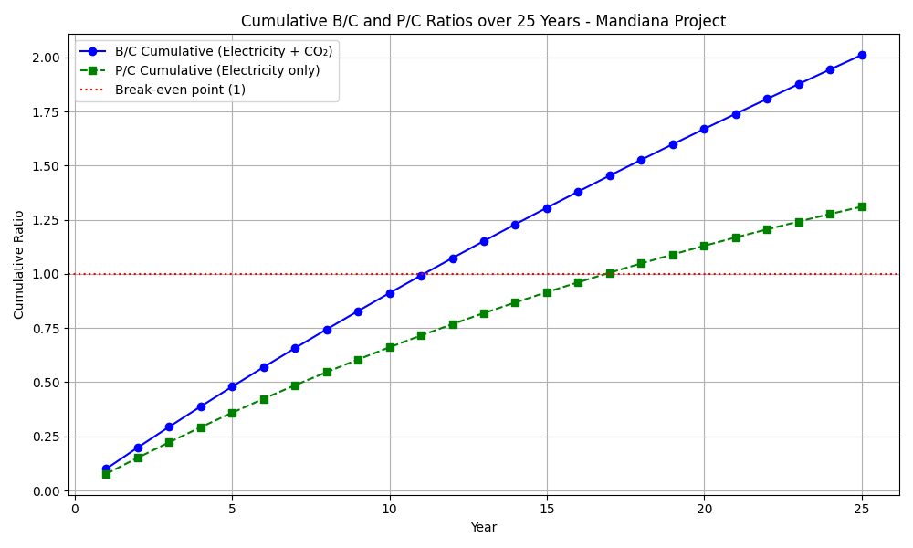

FIGURE 1. Cumulative B/C and P/C Ratios over 25 years-Mandiana Projet

The figure 2 illustrates the variation of the Net Present Value (NPV) as a function of the discount rate, applied to a photovoltaic project with an installed capacity of 1 MWp. The graph shows that the NPV decreases exponentially as the discount rate increases, highlighting the strong sensitivity of the project's profitability to the cost of capital.
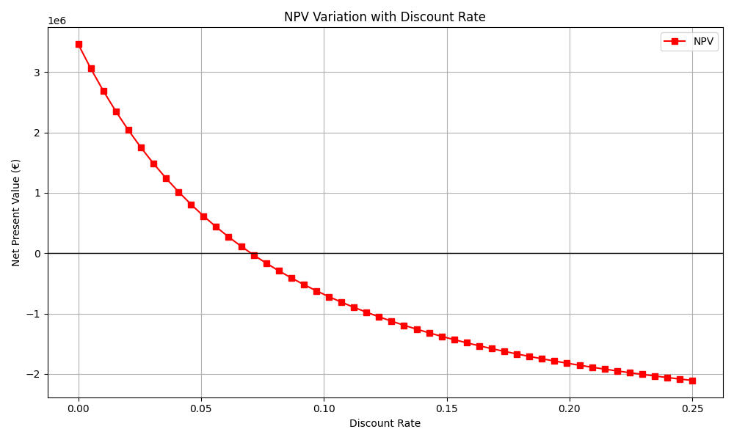
When the discount rate is close to 0%, the NPV exceeds €3.3 million, indicating high profitability in a context where the time value of money is negligible. However, beyond a rate of approximately 7.5%, the NPV becomes negative, reflecting a situation where the project no longer covers its initial investment in present value terms. The intersection points of the curve with the horizontal axis, where NPV = 0, defines the Internal Rate of Return (IRR), estimated here at around 6.9%. This rate represents the profitability threshold of the project: as long as the investor’s cost of capital remains below this value, the project remains economically viable. These results underscore the critical importance of the discount rate in the financial evaluation of solar projects. An investment decision based on the NPV must incorporate a realistic estimate of the cost of capital to avoid overestimating the long-term profitability potential.

FIGURE 2. Net Present Value (NPV) as a function of the discount rate

Figure 3 illustrates the evolution of the accumulated cash-flow over a 25-year period for the proposed photovoltaic (PV) power generation project. The curve initially remains negative, reflecting the dominance of investment and early operational costs during the first years of implementation. However, as the revenues from electricity generation gradually increase, the accumulated cash-flow progressively improves.
A critical milestone observed in the graph is the payback point, which occurs at approximately year 11.27. This indicates the time required for the project to recover its total initial investment through its net positive cash flows. Beyond this point, the project begins to generate cumulative profits, marking the transition from financial recovery to profitability. The steady upward slope after the payback period highlights the strong financial performance and sustainability of the project over the long term. The fact that the accumulated cash-flow reaches over €5.4 million by the 25th year further reinforces the economic viability of the PV installation.
This result aligns with other studies in the literature that emphasize the importance of long-term operation to maximize return on investment in renewable energy projects [21], [22]. Moreover, the relatively short payback period (approximately 11 years) underlines the attractiveness of the system, especially in contexts where stable solar irradiance and favorable feed-in tariffs exist [23].
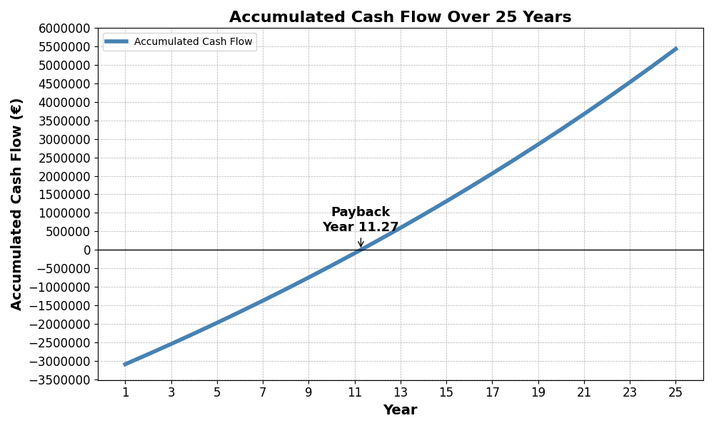

FIGURE 3. Accumulated Cash-Flow Over 25 Years

CONCLUSION

This study evaluated the potential of photovoltaic (PV) electricity generation in Mandiana. The results highlight that the site benefits from high solar irradiance, which allows for significant energy production and demonstrates the viability of PV systems as a sustainable energy solution.
The findings are relevant for both local and national energy strategies. At the local level, PV deployment can reduce dependence on fossil fuels, improve electricity access, and foster socio-economic development. At the national level, this case study illustrates the opportunities for replicating similar projects across other regions of Guinea, thereby contributing to the country’s renewable energy targets and climate commitments.
Future work should expand the analysis by integrating complementary aspects such as storage systems, grid integration challenges, and economic optimization under different financial scenarios. Additionally, assessing the environmental co-benefits and resilience of PV systems under projected climate change conditions would further strengthen the relevance of such studies for long-term planning.

References
- S. H. M. Butchart et al., Global Biodiversity: Indicators of Recent Declines (Science, Washington, 2010), pp. 1164–1168.
- I. Khan, A. Zakari, V. Dagar, and S. Singh, World Energy Trilemma and Transformative Energy Developments as Determinants of Economic Growth amid Environmental Sustainability (Energy Economics, Amsterdam, 2022), pp. 105884.
- L. Wang, M. J. Akhtar, M. N. Khan, N. Asghar, H. ur Rehman, and Y. Xu, Assessing the Environmental Sustainability Gap in G20 Economies: The Roles of Economic Growth, Energy Mix, Foreign Direct Investment, and Population (Heliyon, Amsterdam, 2024), pp. e26535.
- C. Y. Wu, X. Y. Zhang, L. F. Guo, J. T. Zhong, D. Y. Wang, C. H. Miao et al., An Inversion Model Based on GEOS-Chem for Estimating Global and China’s Terrestrial Carbon Fluxes in 2019 (Advances in Climate Change Research, Beijing, 2023), pp. 49–61.
- J. Hansen, D. Johnson, A. Lacis, S. Lebedeff, P. Lee, D. Rind et al., Climate Impact of Increasing Atmospheric Carbon Dioxide (Science, Washington, 1981), pp. 957–966.
- International Energy Agency (IEA), CO₂ Emissions in 2023 (International Energy Agency, Paris, 2024).
- D. Rodríguez-Benavides, R. Andrés-Rosales, J. Álvarez-García, and F. V. Bekun, Convergence of Clubs Between Per Capita Carbon Dioxide Emissions from Fossil Fuels and Cement Production (Energy Policy, Amsterdam, 2024), pp. 114007.
- V. N. Xuan, Determinants of Carbon Dioxide Emissions in Technology Revolution 6.0: New Insights from Brunei (Energy Strategy Reviews, Amsterdam, 2025), pp. 101633.
- S. C. Obiora, O. Bamisile, Y. Hu, D. U. Ozsahin, and H. Adun, Assessing the Decarbonization of Electricity Generation in Major Emitting Countries by 2030 and 2050: Transition to a High Share Renewable Energy Mix (Heliyon, Amsterdam, 2024), pp. e28770.
- T. Heydenreich, Trade and Decoupling of Fossil Fuel Use Embedded in EU Consumption (Journal of Cleaner Production, Amsterdam, 2024), pp. 142702.
- Y. Zhang, Circular Economy Innovations: Balancing Fossil Fuel Impact on Green Economic Development (Heliyon, Amsterdam, 2024), pp. e36708.
- Z. Wang, S. Zeng, and Z. Khan, Impact of Sustainable Energy, Fossil Fuels and Green Finance on Ecosystem: Evidence from China (Heliyon, Amsterdam, 2024), pp. e36712.
- T. Tscharntke, A. M. Klein, A. Kruess, I. Steffan-Dewenter, and C. Thies, Landscape Perspectives on Agricultural Intensification and Biodiversity – Ecosystem Service Management (Ecology Letters, Oxford, 2005), pp. 857–874.
- X. Zhang, J. Zhong, X. Zhang, D. Zhang, C. Miao, D. Wang, and L. Guo, China Can Achieve Carbon Neutrality in Line with the Paris Agreement’s 2 °C Target: Navigating Global Emissions Scenarios, Warming Levels, and Extreme Event Projections (Engineering, Beijing, 2025), pp. 207–214.
- M. Traore, A. Sidibe, S. B. Ogou, A. Ndiaye, and S. Mbodji, Effects of Photovoltaic Power Plants Connected to the Grid from 2016 to 2022 in Senegal on Carbon Dioxide Emissions (Asian Review of Environmental and Earth Sciences, Kuala Lumpur, 2025), pp. 1–5.
- M. Jiang, L. Qi, Z. Yu, D. Wu, P. Si, P. Li, W. Wei, X. Yu, and J. Yan, National Level Assessment of Using Existing Airport Infrastructures for Photovoltaic Deployment (Applied Energy, Oxford, 2021), pp. 298.
- Q. Yang, T. Huang, S. Wang, J. Li, S. Dai, S. Wright, Y. Wang, and H. Peng, A GIS-Based High Spatial Resolution Assessment of Large-Scale PV Generation Potential in China (Applied Energy, Oxford, 2019), pp. 254–269.
- S. Qi, S. Cheng, X. Tan, S. Feng, and Q. Zhou, Predicting China’s Carbon Price Based on a Multi-Scale Integrated Model (Applied Energy, Oxford, 2022), pp. 324.
- A. Huda, I. Kurniawan, K. F. Purba, R. Ichwani, F. Aryansyah, and R. Fionasari, Techno-Economic Assessment of Residential and Farm-Based Photovoltaic Systems (Renewable Energy, Oxford, 2024), pp. 222.
- Republic of Guinea, Updated Nationally Determined Contribution (NDC) (Ministry of Environment and Sustainable Development, Conakry, 2021).
- D. Liu, Y. Lin, C. Wu, and Y. Zhang, Economic Evaluation of Photovoltaic Power Generation in Different Regions of China (Energy Policy, Amsterdam, 2016), pp. 422–431.
- S. You, C. Fung, and P. Lee, Optimal Renewable Energy System Planning for Microgrids with High Solar Penetration (Energy, Amsterdam, 2020), pp. 213.
- H. H. Alhelou et al., Economic and Environmental Performance of Solar PV Systems under Different Financial Schemes: A Case Study (Renewable Energy, Oxford, 2020), pp. 241–252.

