Optimal sizing of autonomous BIPV/PV/ battery for a zero energy mid-rise urban building in the city of Azrou

- Morocco
Sarah FORROUSSO1, Samir Idrissi Kaitouni2, Jamal Brigui1 and Kamal Reklaoui1
¹ Research Team: Materials, Environment and Sustainable Development (MEDD), Faculty of Sciences and Techniques of Tangier, Abdelmalek Essaadi University - BP 416 Tangier, Morocco
² Green Energy Park (IRESEN & UM6P) – Benguerir, Morocco

Abstract. This study investigates the optimal sizing of an autonomous microgrid for mid-rise residential buildings in Azrou, Morocco’s cold climate, targeting net zero energy consumption. The system integrates rooftop photovoltaic (PV), building-integrated photovoltaic (BIPV), and battery storage, optimized using the Particle Swarm Optimization (PSO) algorithm, with hourly resolution in solar irradiance and energy demand. The objective function is to minimize annualized total cost, with BIPV and battery storage capacities as the primary decision variables. Results show that the optimal configuration achieves a levelized cost of electricity (LCOE) of 0.696
$/kWh and reduces CO₂ emissions by about 0.77 t/year. Interestingly, the BIPV system, covering 60% of the facades, contributes to a 15% reduction in energy costs while improving the load coverage factor by 5%. Ultimately, the approach transforms the building from a traditional energy consumer into a decarbonized, self-sufficient energy producer, advancing the transition toward sustainable urban development.

Keywords— Net Zero Energy Building (NZEB), Particle Swarm Optimization (PSO), Hybrid Renewable Energy System, Energy Transition, Building-Integrated Photovoltaics (BIPVs).

INTRODUCTION
The transition to a low-carbon energy system is a fundamental pillar of global decarbonization efforts [1]. This energy transition involves the large-scale integration of renewable energy sources, electrification of end- use sectors, and advanced digitalization to enhance efficiency and sustainability [2]. In this context, microgrids emerge as a key enabler, providing the necessary infrastructure for a flexible, resilient, and reliable operation.
Microgrids incorporating hybrid energy storage systems (HESS) are essential in modern energy systems, enhancing stability, reliability, and efficiency under varying load conditions. They play a critical role in ensuring the seamless integration of distributed energy resources (DERs), such as solar Photovoltaics and wind turbines, by balancing supply and demand through real-time monitoring, demand-side management, energy storage solutions, such as batteries, supercapacitors, pumped hydro storage, and grid interaction, when they operate on on-grid mode [3]. Additionally, they enhance grid reliability and resilience by contributing to a more flexible and stable power system, utilizing automated fault detection, predictive maintenance, reducing power outages and improving energy security [4].
Furthermore, smart grids leverage digitalization through Internet of Things (IoT) technologies, artificial intelligence (AI), and big data analytics to optimize energy distribution and consumption [5]. The deployment of smart meters, dynamic pricing, and demand-response programs empowers consumers to actively participate in energy management, leading to greater system efficiency. Moreover, the smart grid supports the electrification of transportation and industrial sectors [6], [7], [8].
As energy systems continue to decarbonize, energy storage systems become increasingly important in enabling the seamless operation of microgrids, allowing for demand and supply balance. This not only improves energy access in remote areas but also strengthens overall grid stability.
Given the critical role of energy storage in achieving a sustainable and resilient energy system, this study explores the impact of BIPV integration on the Levelized cost of electricity of an off-grid building.

CLIMATE CHARACTERISTICS OF AZROU
Azrou, a city in Morocco’s Middle Atlas region, has a Mediterranean mountain climate characterized by cold winters and mild summers due to its high altitude of around 1,250 meters. Winters (December to February) are often cold with frequent snowfall, while summers (June to August) remain moderate, with daytime temperatures rarely exceeding 30°C and cooler nights. The annual average temperature is around 17.9°C, with

the highest temperatures occurring in July and August, when the average daily temperature is around 22.2°C. The lowest temperatures occur in January and February, when the average daily temperature is around 3.3°C (Figure 1). Besides, Azrou experiences monthly relative humidity levels ranging from 70% in the cold season (December–January) to around 40% during the hot summer months (July–August). This seasonal variation significantly influences thermal comfort and the performance of energy systems in buildings. Most of the rainfall occurs between October and April, contributing to the city's rich cedar forests and fresh air. With its snowy winters, mild summers, and scenic surroundings, Azrou attracts visitors looking for a refreshing mountain escape.
On average, Azrou receives about 1903 kWh/m²/year as Global Horizontal Radiation (GHI) (Figure 2). Overall, the climate characteristics of Azrou require careful consideration in the design of net zero energy buildings, with a focus on efficient heating and cooling strategies and the use of clean and renewable energy sources. The meteorological data used in this study were obtained from the Meteonorm database [9].
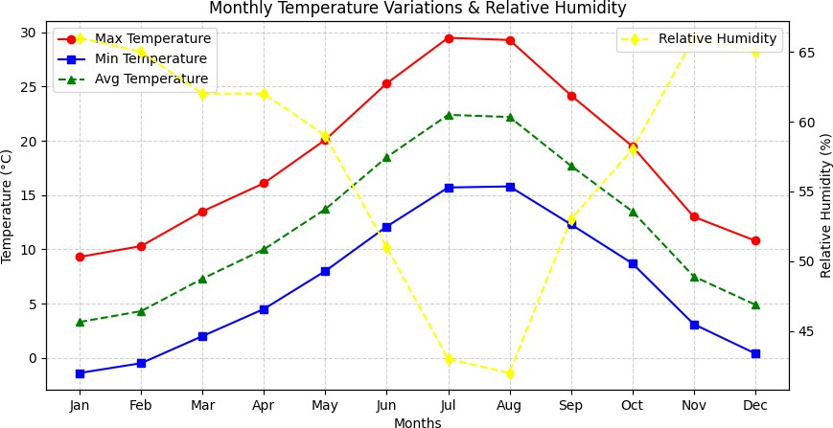

FIGURE 1. Monthly outdoor temperature and relative humidity of Azrou
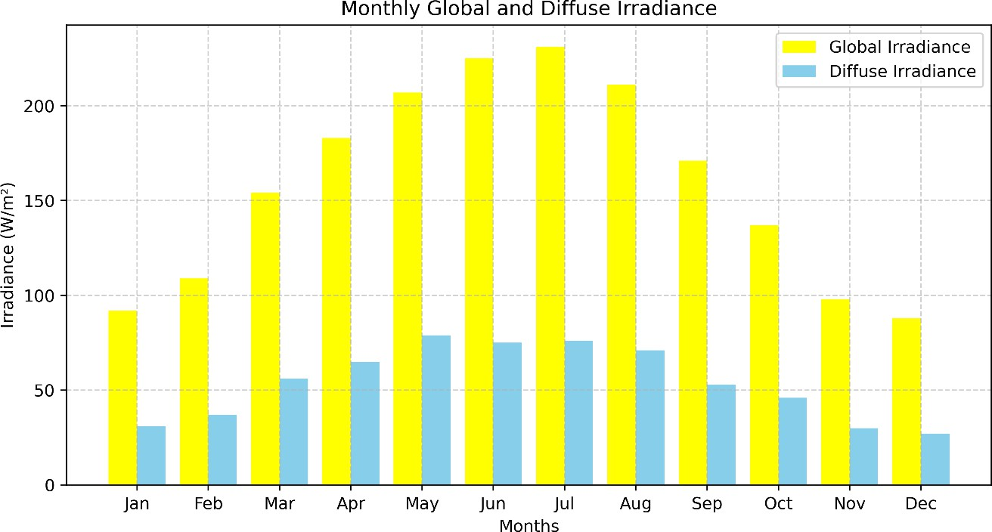

FIGURE 2. Monthly solar radiation of Azrou

METHODOLOGY AND TOOLS

Case study description
This study utilizes a digital parametric workflow through Grasshopper to conduct environmental and energy-based assessments for a solar-powered mid-rise residential building. The building is a detached, four-

story structure measuring 100 meters by 60 meters, with internal characteristics for occupancy, lighting, and equipment schedules outlined in Table 1. Each floor consists of a 3-meter occupied space. To evaluate thermal energy demand during the early phases of urban design, a ‘core and shell’ thermal zoning strategy was applied, following ASHRAE 90.1 guidelines [10] and the thermal zoning method proposed by Reinhart et al.[11]. Each floor is divided into internal and four perimeter zones.
Focusing on solar energy integration within the urban landscape, we propose a digital model to assess the temporal variation of solar potential on buildings, considering both rooftops and facades. The Building- Integrated Photovoltaic (BIPV) system is integrated on the facades, covering a variable width on each story’s East, South and West façades that should be determined through the optimization algorithm. Additionally, the rooftop south-oriented PV system, installed with a 15-degree tilt, covers 50% of the total roof area, maximizing solar energy capture.

TABLE 1. Baseline Parameters for annual building energy demand simulation

Parameters | Descriptions | Values (Mid-rise residential building)
Heating/Cooling setpoints | Ideal Air Load | 20°C/26°C
COP |  | 3 (Heating and Cooling)
Schedules
Zone loads | Lighting | 5W/m²
Occupancy | Occupancy schedule | Ashrae 90.1 for Mid-rise buildings
 | Occupancy density | 0.04 person/m2
 | Equipment | 7W/m²
Material properties
 | Floors | U= 0.55 W/m².K
 | Ground floors: Concrete slab of 20 cm | U= 4.5 W/m².K
 | Windows | U= 2 W/m².K
 | Wall | U= 0.5 W/m².K
 | Window-to-wall ratio (WWR) | 20%
Ventilation |  | 1 ACH

TABLE 2. Cost breakdown per energy system

Component | CAPEX  ($/KW) | OPEX ($/kW/year) | Lifetime (years) | Technical specifications
Rooftop PV | 1600 | 18 | 25 | Efficiency = 21%
BIPV | 2500 | 28 | 25 | Efficiency = 18%
Inverter | 290 | - | 12.5 | Efficiency = 95%
Battery | 350 | 3 | 12.5 | Type= Li-on battery DOD = 80%  Self-discharge efficiency (σ) = 0.001%  ηb, ηc = 95%

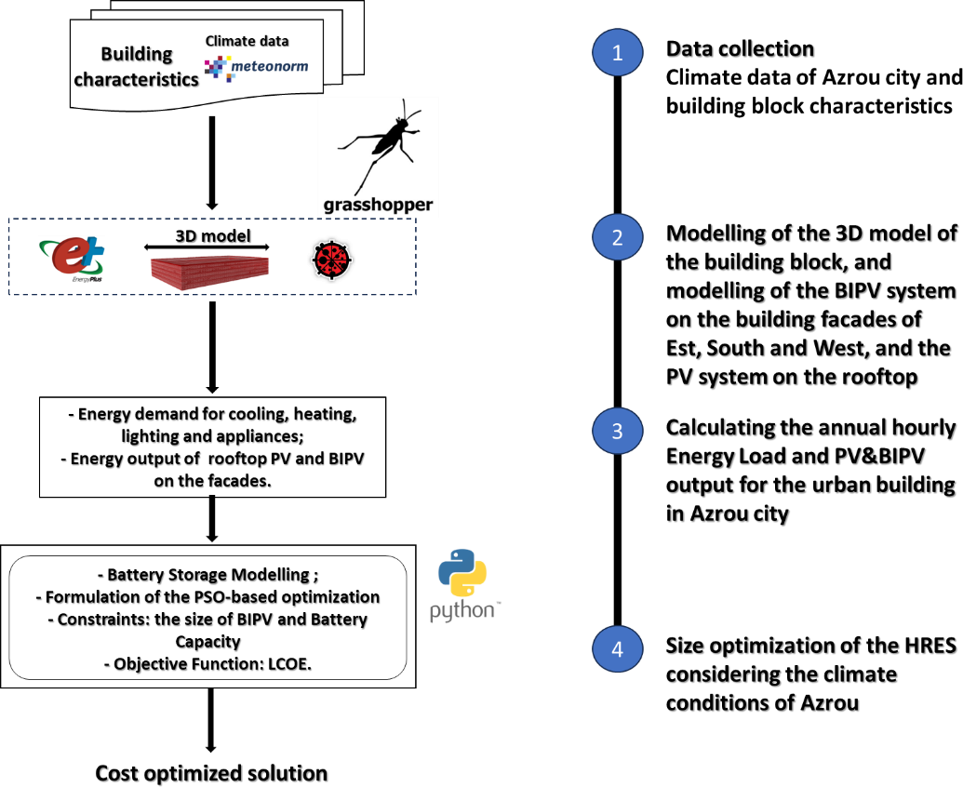

FIGURE 3. Flowchart Methodology in this study

PSO-based workflow
This study employs the Particle Swarm Optimization (PSO) algorithm as an effective computational technique to optimize the design of a self-sufficient PV/BIPV/battery storage system across diverse Moroccan climates. PSO is chosen for its adaptability, enabling cost optimization while balancing battery sizing and BIPV installation [12].
PSO simulates the behavior of a swarm of particles navigating a multidimensional search space, where each particle represents a potential solution. Particles adjust their positions based on individual experiences and collective knowledge, continuously refining their solutions through iterative updates. This approach is particularly effective for exploring complex solution spaces and addressing the intricate optimization challenges of urban energy systems [13], [14], [15].
A key strength of PSO is its ability to optimize both continuous and combinatorial variables, making it well-suited for optimizing BIPV sizing, battery capacity, and energy distribution strategies simultaneously. The optimization parameters used in the PSO method are summarized in Table 3.

TABLE 3. PSO-based optimization controlling parameters.

Parameter | Value
Swarm size | 100
Maximum iteration | 1000
Inertia weight | W = 0.2
Acceleration coefficient | Cognitive weight: C1 = 0.5 Social weight: C2 = 0.5

Energy performance indicators
For each climatic condition, the energy performance metrics – hourly/monthly/yearly thermal energy demand and Net Energy Balance performances - were calculated using EnergyPlus [16] and ladybug [17].
This study adopts an off-grid operational approach for the Net Zero Energy Building (NZEB) to achieve sustainable energy solutions. Specifically, the maximum capacity shortage is set to zero, ensuring that there is

no unmet load throughout the simulated year. To maintain a stable energy supply, lithium-ion batteries are used for energy storage, providing backup power when the combined output from the PV and BIPV systems is insufficient to meet the building's energy demands. The selection of lithium-ion batteries is based on their high efficiency in charge-discharge cycles, long lifespan, and widespread use in off-grid systems.
At any given moment (t), the total solar power generated by the PV and BIPV systems (PPV&BIPV(t)) is determined as the sum of the power generated by the PV system (PPV(t)) and the power generated by the BIPV system (PBIPV(t)), as expressed in Equation (1).
P_{PV&BIPV}(t) = P_{PV}(t) + 𝑥(%) ∗ P_{BIPV}(t) (1)

𝑥(%) is the coverage area between 0 and 70% that should be determined through the PSO algorithm implemented in this research study.
Furthermore, the optimal off-grid Sustainable Energy System (SES) is assessed based on the Total Annualized Cost (TAC), a widely used life-cycle economic index for evaluating renewable energy projects. The optimization process identifies the best system configuration by minimizing the TAC, which accounts for all financial aspects, including installation, replacement, and maintenance costs. The TAC is composed of the annual capital cost (CCap) and the annual maintenance cost (CM), as defined in Equation (2).
TAC = 𝐶_{𝑐𝑎𝑝} + 𝐶_{𝑀} (2)
Additionally, certain components of the PV/BIPV/battery system require multiple replacements throughout the project's lifespan. Typically, batteries and inverters have a lifespan of 10 to 15 years; in this study, their lifetime is assumed to be half of the total project duration (~12.5 years). Lastly, all assumptions, PSO algorithm parameters, and related details are thoroughly outlined in [18].
LCOE is defined in Equation 3 as the average cost per unit of energy, i.e., kWh of useful electricity produced by the solar system. With respect to the investigated case study, the LCOE is calculated by dividing the total annualized cost of the SES (which includes both the initial capital cost and ongoing O&M costs) by the total electric load (ELoad) served to the building’ energy consumption [19]. LCOE is calculated as follows:
LCOE= ^{TAC}  ELoad | (3)

The SESs for Azrou was optimized in Python program, considering as inputs, 25 years for the project lifetime period, 6% and 3% for the discount rate and the inflation rate respectively [20]. Solar PV data, solar BIPV data, system components and their capital prices, replacement cost and operating and maintenance cost, as shown in Table 2.

RESULTS AND DISCUSSION
This study optimizes and simulates an off-grid PV/BIPV system for residential mid-rise buildings in the city of Azrou, analyzing the regional and seasonal distribution of outdoor climate conditions, thermal energy demand, Energy Use Intensity (EUI), solar output, and energy self-sufficiency. The objective to determine the optimal BIPV size and battery capacity that minimizes the Levelized Cost of Energy (LCOE) while assessing regional discrepancies in thermal performance and solar energy production from BIPV and PV systems. The findings contribute to ongoing research on BIPV adoption, supporting efforts to reduce CO₂ emissions and accelerate the transition to carbon neutrality.

The building’s EUI and solar energy output
The building's power consumption primarily comes from air conditioning, equipment, and lighting. This study examines annual heating and cooling loads, revealing significant contributions in energy demand. While lighting and equipment consumption remain consistent, climate heavily influences heating and cooling needs, composing 24% of the total energy demand, highlighting the need for climate-responsive building design to enhance energy efficiency. During optimization, the solar PV and BIPV systems generate 40% more electricity than the building’s annual demand, as illustrated in Figure 4. Given the gradual efficiency decline of solar panels (down to 80% by the end of their lifespan), solar energy is expected to consistently meet the building’s needs throughout the project's duration. Table 4 presents the PV system's energy yield in the city of Azrou, with results aligning with previous studies [18], [19], and [21].

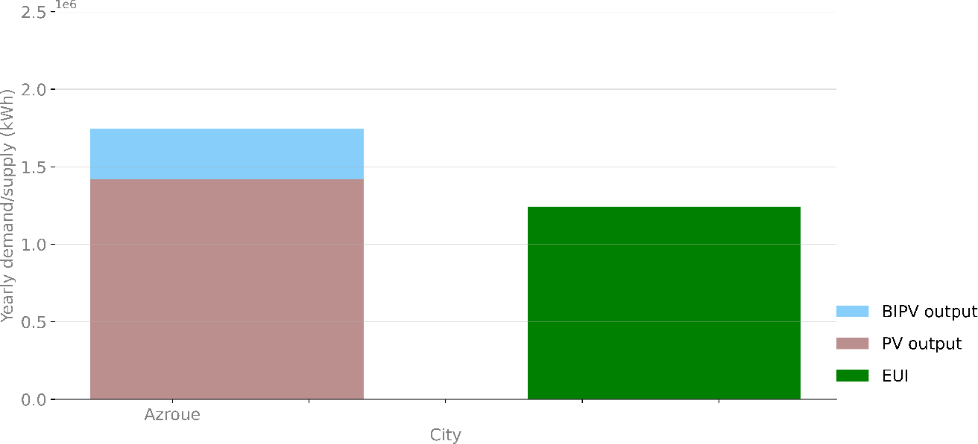

FIGURE 4. Yearly EUI and PV & BIPV energy outputs

Weekly and yearly energy balance evaluation
In this study, the BIPV installation has been investigated in order to determine its contribution to reducing the costs of the installed SES. Figure 5 shows the weekly trends of solar energy generated from rooftop PV systems, the BIPV systems and Energy Use Intensity (EUI), over a typical meteorological year for Azrou. The BIPV output increases the coverage of the electric requirements. In the absence of a BIPV system, the energy produced by the PV systems substantially contributes to meeting 70-100% of the building's weekly average load needs in the city of Azrou, achieving a load cover factor reaching 39.8%. However, this contribution remains subject to seasonal variations, as illustrated in figure 5. On the other hand, the BIPV contributes to enhancing self-sufficiency, increasing it by more than 5.02% annually.

TABLE 4. Optimization results of the off-grid SES

 | PV Energy yield (kWh/kW) | Yearly Load cover factor considering only PV system | Yearly Load cover factor considering both PV & BIPV  system
Simulation results | 4.94 kWh/kW | 39.8% | 41.8%

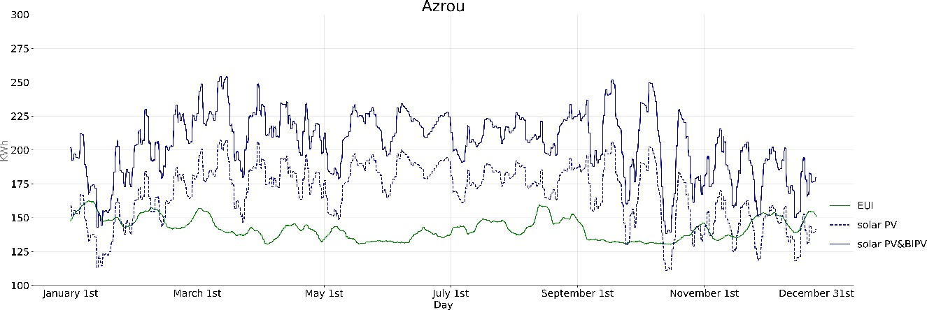
FIGURE 5. Average weekly Load & Supply curves in Azrou

Cost optimization results of the PV/BIPV/BESS
As the building is 100% supplied by solar energy, BESS stores excess energy generated during sunny intervals, providing a reliable power source during periods of low solar output, at night, or during adverse weather conditions. It also contributes to grid independence and load balancing, ensuring a consistent and resilient power supply in autonomous buildings, despite the variability in solar generation.
In this study, the optimal sizing design of the BIPV system and battery storage capacities depends on the results of the objective function that minimizes the Total Annual Cost (TAC).
The cost-optimal configuration is achieved when BIPV covers 60% of the building facades. Also, the findings reveal that the TAC is 870,000 $, with the installed BIPV capacity contributing 7.7%. The findings also show that the value of the LCOE varies around 0.696 $/kWh. Interestingly, the BIPV system helps reduce the cost of energy by 15%. Moreover, the BIPV system reduces battery requirements by 32.5%. Still, the cost of the battery accounts for approximately 79.3% of the total annual cost, as illustrated in Figure 6.
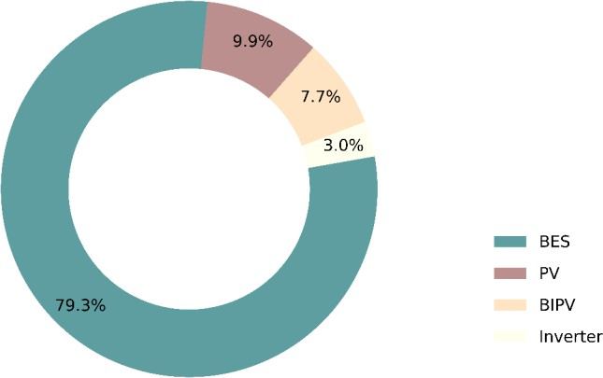

FIGURE 6. Breakdown of total annual cost for optimal off-grid PV-BIPV-Battery System

Environmental Impact Assessment – CO₂ Savings
In addition to the techno-economic optimization, the environmental benefit of the proposed autonomous PV/BIPV/battery system was quantified by estimating the annual CO₂ emissions avoided compared to a conventional grid-supplied building. The amount of avoided CO₂ is calculated based on the total annual electricity demand of the urban building covered by the solar systems (PV + BIPV) and the average carbon intensity of the Moroccan electricity grid [2], [22]. Thus, the deployment of the optimized PV/BIPV system would result in an annual avoidance of approximately 0.77 tons of CO₂ emissions. Besides, over a typical 25- year system lifetime, the cumulative avoided emissions would exceed 19.27 tons of CO₂, contributing directly to local and national decarbonization targets. These results highlight the role of BIPV-enhanced NZEBs not only in reducing operational costs but also in supporting Morocco’s commitments under the Paris Agreement and its Nationally Determined Contributions (NDCs).

CONCLUSION
The Net Zero Energy Residential Building integrates PV, BIPV, and battery storage to meet energy demand at minimal cost. In Azrou’s cold climate, the optimal configuration, covering 60% of facades with BIPV, achieves a TAC of k$870 and an LCOE of 0.696 $/kWh. These outcomes underscore the potential of BIPV technology to significantly bolster clean energy generation for building needs while concurrently reducing energy costs by 8.7-20.72% compared to sole reliance on PV systems and batteries. Moreover, the deployment of the optimized PV/BIPV/Battery system is estimated to avoid around 0.77 tons of CO₂ emissions annually. Overall, these findings highlight the role of BIPV in enabling off-grid, autonomous Net Zero Energy Buildings, especially in regions without reliable grid access.

REFERENCES
- International Energy Agency, ‘Net Zero by 2050 - A Roadmap for the Global Energy Sector’, 2021. Accessed: Nov. 24, 2023. [Online]. Available: https://www.iea.org/events/net-zero-by-2050-a-roadmap-for-the-global-energy- system
- S. Idrissi Kaitouni, Z. Romani, A. Jamil, and M. Ahachad, ‘Zero carbon urban buildings (ZCUBs) in the era of climate change, digital transformation and energy transition: a scoping review from 2000 to 2024’, Jul. 15, 2025, Elsevier Ltd. doi: 10.1016/j.buildenv.2025.113116.
- C. B. Ndeke, M. Adonis, and A. Almaktoof, ‘Energy management strategy for a hybrid micro-grid system using renewable energy’, Discover Energy, vol. 4, no. 1, Feb. 2024, doi: 10.1007/s43937-024-00025-9.
- Q. Hassan, S. Algburi, A. Z. Sameen, H. M. Salman, and M. Jaszczur, ‘A review of hybrid renewable energy systems: Solar and wind-powered solutions: Challenges, opportunities, and policy implications’, Dec. 01, 2023, Elsevier B.V. doi: 10.1016/j.rineng.2023.101621.
- S. Idrissi Kaitouni et al., ‘Implementing a Digital Twin-based fault detection and diagnosis approach for optimal operation and maintenance of urban distributed solar photovoltaics’, Renewable Energy Focus, vol. 48, p. 100530, Mar. 2024, doi: 10.1016/j.ref.2023.100530.
- T. Samad and S. Kiliccote, ‘Smart grid technologies and applications for the industrial sector’, Comput Chem Eng, vol. 47, pp. 76–84, Dec. 2012, doi: 10.1016/j.compchemeng.2012.07.006.
- K. M. Tan, V. K. Ramachandaramurthy, and J. Y. Yong, ‘Integration of electric vehicles in smart grid: A review on vehicle to grid technologies and optimization techniques’, Jan. 01, 2016, Elsevier Ltd. doi: 10.1016/j.rser.2015.09.012.
- IEA, ‘Electrification’. Accessed: Dec. 22, 2024. [Online]. Available: https://www.iea.org/energy-system/electricity/electrification
- Meteotest, ‘Meteonorm software’. Accessed: Mar. 24, 2023. [Online]. Available: https://meteonorm.com/en/
- Ashrae, ‘Ashrae Standard 90.1 - Energy Standard for Buildings except low rise residential buildings’, vol. 8400, 2004, [Online]. Available: www.ashrae.org
- C. F. Reinhart and C. Cerezo Davila, ‘Urban building energy modeling - A review of a nascent field’, Feb. 15, 2016, Elsevier Ltd. doi: 10.1016/j.buildenv.2015.12.001.
- S. Hasan, A. Islam Meem, M. Saiful Islam, S. Sabrina Proma, and S. Kumar Mitra, ‘Comparative techno-economic analyses and optimization of standalone and grid- tied renewable energy systems for South Asia and Sub-Saharan Africa’, Results in Engineering, vol. 21, Mar. 2024, doi: 10.1016/j.rineng.2024.101964.
- J. Kennedy, R. Eberhart, and bls gov, ‘Particle Swarm Optimization’.
- Samy M.M., Barakat S., Sarhan H. H., and Al-Ghamdi S. A., A Hybrid PV-Biomass Generation Based Micro-Grid for the Irrigation System of a Major Land Reclamation Project in Kingdom of Saudi Arabia (KSA) - Case Study of Albaha Area. doi: 10.1109/EEEIC.2018.8494543.
- J. Zhu, Optimization of power system operation.
- ‘EnergyPlus’. Accessed: Jul. 30, 2023. [Online]. Available: https://energyplus.net/
- ‘Ladybug’. Accessed: Jul. 30, 2023. [Online]. Available: https://www.food4rhino.com/en/app/ladybug-tools
- S. Forrousso et al., ‘Optimal sizing of off-grid microgrid building-integrated- photovoltaic system with battery for a net zero energy residential building in

different climates of Morocco’, Results in Engineering, vol. 22, Jun. 2024, doi: 10.1016/j.rineng.2024.102288.
- B. Bacha, H. Ghodbane, H. Dahmani, A. Betka, A. Toumi, and A. Chouder, ‘Optimal sizing of a hybrid microgrid system using solar, wind, diesel, and battery energy storage to alleviate energy poverty in a rural area of Biskra, Algeria’, J Energy Storage, vol. 84, Apr. 2024, doi: 10.1016/j.est.2024.110651.
- ‘Trading Economics. 20 million INDICATORS FROM 196 COUNTRIES’.
Accessed: Mar. 07, 2024. [Online]. Available: https://tradingeconomics.com/
- S. Idrissi Kaitouni, J. Pfafferott, A. Jamil, M. Ahachad, and J. Brigui, ‘A holistic digital workflow methodology to shifting towards net zero energy urban residential buildings in a semi-arid climate’, Solar Energy, vol. 263, p. 111959, Oct. 2023, doi: 10.1016/J.SOLENER.2023.111959.
- S. Idrissi Kaitouni et al., ‘A life cycle carbon dioxide equivalent emissions assessment of zero carbon building in hot semi-arid climate region: Case study’, Results in Engineering, vol. 23, Sep. 2024, doi: 10.1016/j.rineng.2024.102589.

