Integrated Experimental and Theoretical Investigation of LiNi_{0.8}Co_{0.1}Mn_{0.05}Al_{0.05}O₂ Materials Synthesized via a Controlled Co–Precipitation Method
Fadila EL KOUIHEN^{1,} ^{a)}, Mohammed LAMHANI^{1,} ^{b)}, Mohamed CHAKIR^{1,} ^{c)}, ^{1,} ^{d)} Abdessamad FAIK

Author Affiliations
¹ Laboratory of Inorganic Materials for Sustainable Energy Technologies (LIMSET), University Mohammed VI Polytechnic, Benguerir, 43150, Morocco.

Author Emails
^{a)} Corresponding author: Fadila.elkouihen@um6p.ma
^{a)} fadila.elkouihen@um6p.ma
^{b)} mohammed.lamhani@um6p.ma
^{c)} mohamed.chakir@um6p.ma
^{d)} abdessamad.faik@um6p.ma

Abstract. Nickel-rich layered oxides such as ${LiNi}_{0.8}{Co}_{0.15}{Al}_{0.05}O_{2}$ (NCA) are widely studied for their promising properties. In this work, NCMA materials were produced using a controlled co-precipitation approach to attain uniform composition and morphology. Structural investigation techniques, including X-ray diffraction (XRD), scanning electron microscopy (SEM), and Rietveld refinement, were applied to evaluate phase formation, crystallinity, and cation distribution. To complement the experimental results, Density Functional Theory (DFT) calculations were performed using the DFT+U approach to accurately model the localized 3d electrons of the transition metals. These simulations provided atomic-level insights into the optimized crystal structure, magnetic ordering, and electronic behavior of the synthesized materials. The high-precision computational setup ensured reliable predictions of total energy, stability, and electronic properties. Combining experimental and theoretical methods yields a thorough comprehensive of the structure–property relationships in NCMA materials and supports their further development for advanced electrochemical applications.

Abbreviations

NCA | Nickel-Cobalt Aluminate
NCMA | Mn doped NCA
LIBs | Lithium-Ion Batteries
DFT | Density Functional Theory
SEM | Scanning Electron Microscopy
EDS | Energy-Dispersive X-ray Spectroscopy Mapping
XRD | X-Ray Powder Diffraction
PAW | Projector Augmented Wave
GGA | Generalized Gradient Approximation
PBE | Perdew–Burke–Ernzerhof
GGA+U | Generalized Gradient Approximation plus Hubbard correction

INTRODUCTION

Advancing reliable and environmentally sustainable energy-storage systems has become essential, driven by the rising global demand for renewable power and the pressing requirement to address climate change. [1,2]. As global energy systems transition toward intermittent renewable sources such as solar and wind, high-performance batteries are essential for ensuring reliable power supply [3]. Lithium-ion batteries (LIBs) remain the dominant choice due to their high energy density, long cycle life, and proven reliability [4]. However, improving their efficiency, cost-effectiveness, and environmental sustainability continues to be a major challenge, particularly with respect to reducing reliance on critical raw materials [5].
Nickel-rich layered transition metal oxides, especially those based on the ${LiNi}_{1-x-y}{Co}_{x}{Al}_{y}O_{2}$ (NCA) system, have emerged as promising cathode candidates owing to their high theoretical capacity, thermal stability, and tunable structural properties [6,7]. Among these, ${LiNi}_{0.8}{Co}_{0.15}{Al}_{0.05}O_{2}$ is one of the most extensively studied compositions, offering a favorable balance between energy density and structural robustness [8,9]. Partial substitution of cobalt and aluminum enhances electronic conductivity and structural stability, respectively, while lowering cobalt content is a critical advantage given its high cost, limited availability, and supply chain risks [10,11].
With the increasing demand for high-energy cathodes, further reducing cobalt content without sacrificing performance has become a central research focus. In this context, ${LiNi}_{0.8}{Co}_{0.1}{{Mn}_{0.05}Al}_{0.05}O_{2}$ (NCMA) has attracted particular interest. The incorporation of Mn⁴⁺ into the NCA lattice helps suppress cation mixing, improves thermal stability, and enhances structural integrity during cycling. Compared with alternative dopants such as Fe, Mg, or Ti, manganese offers additional benefits: it is low-cost, abundant, and environmentally benign. Moreover, Mn⁴⁺ remains electrochemically inactive within the typical operating voltage range of LIBs, stabilizing the layered framework without inducing undesirable phase transitions. These characteristics make Mn doping a highly effective strategy for optimizing performance while advancing sustainability.
Synthesis conditions exert a major impact on the physical and chemical features of NCA-derived compounds, including particle morphology, stoichiometric homogeneity, crystallite size, and defect concentration [12,13]. Among the available methods, co-precipitation has proven to be one of the most reliable and scalable approaches, enabling precise control over elemental distribution and reaction kinetics [14,15]. This wet-chemical technique promotes uniformity and enhances phase purity in the calcined product, making it well-suited for large-scale production of high-quality cathode materials [16,17].
While experimental techniques provide critical insight into morphology and crystal structure, theoretical modeling offers complementary atomistic-level understanding of intrinsic material properties. Density functional theory (DFT) is particularly powerful for probing electronic structure, defect energetics, thermodynamic stability, and lattice dynamics in transition metal oxides [14]. Integrating DFT with experimental characterization therefore enables a more predictive and comprehensive evaluation of structure–property relationships, guiding the rational design of next-generation cathodes.
In this study, NCMA materials were synthesized via a carefully optimized co-precipitation route to ensure precise compositional control and uniform morphology. Structural properties were investigated through X-ray diffraction coupled with advanced Rietveld refinement, while high-resolution scanning electron microscopy provided detailed morphological analysis. To complement these experimental results, first-principles DFT calculations were performed to model the optimized crystal structure, magnetic ordering, and electronic behavior of Mn-doped NCA. The synergy between experimental characterization and theoretical modeling not only validates the synthesis outcomes but also provides new insights into how Mn incorporation influences both atomic-scale structure and macroscopic properties. By establishing clear correlations between synthesis parameters, structural features, and functional behavior, this work delivers a comprehensive framework for the rational design and optimization of nickel-rich layered cathodes. Such integration of experiment and theory represents a step beyond conventional studies and opens new pathways for the targeted development of high-performance, cobalt-reduced cathode materials.

MATERIALS AND METHODS
A cobalt-reduced material incorporating manganese was synthesized via a co-precipitation route. Metal nitrate salts (Ni, Co, Mn, Al) and LiOH.H₂O were dissolved in distilled water and stirred at 85 °C under controlled pH conditions to promote uniform precipitation of metal hydroxides. The obtained precipitates were filtered, dried at 120 °C, and pre-calcined at 500 °C, followed by high-temperature annealing at 750 °C for 24 h in an oxygen-rich atmosphere to yield the final layered oxide structure. The complete synthesis process is illustrated in Fig. 1.
Phase purity and crystal structure of the NCMA materials were verified by X-ray diffraction (XRD, PANalytical X’Pert PRO) using Cu Kα radiation (λ = 1.5406 Å) at 40 kV and 40 mA over a 2θ range of 10°- 60°. Morphological characteristics and particle distribution were examined by scanning electron microscopy (SEM, JEOL JSM-7610F) equipped with an energy-dispersive X-ray spectroscopy (EDS) detector. Fourier-transform infrared (FTIR) spectra were collected using a Bruker Alpha II spectrometer in the 500 - 3000 cm⁻¹ range to identify functional groups and confirm phase composition. Particle size distribution was further characterized with a Malvern Mastersizer 3000, providing quantitative analysis of mean particle size and overall distribution profile of the NCMA powders.
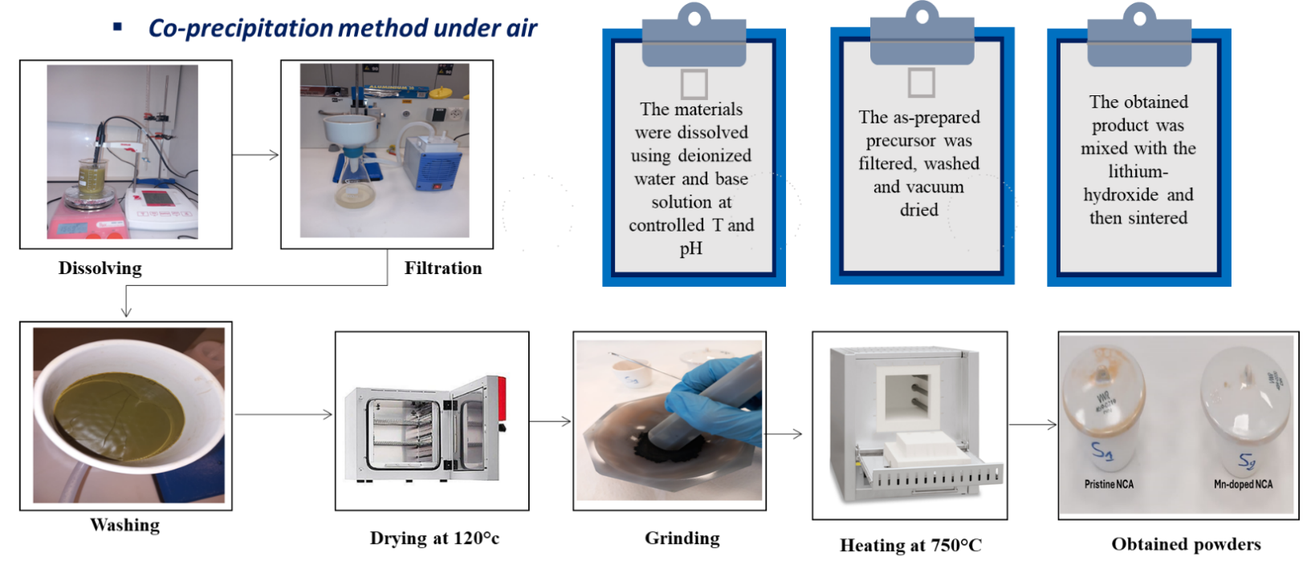
FIGURE 1. Synthesis process of the pristine NCA and Mn-doped NCA materials

DFT Calculations:
All first principles computations were performed through the Quantum ESPRESSO package [18][19], which implements density functional theory (DFT) with plane wave basis sets and pseudopotentials. Ionic cores were described using projector augmented wave (PAW). The exchange–correlation functional was handled using the generalized gradient approximation (GGA) using the Perdew–Burke–Ernzerhof (PBE) parametrization. To improve the description of electron exchange and correlation, the GGA+U method, an extension of GGA that includes a Hubbard model correction for strong on-site Coulomb interactions, was used to better capture the behavior of localized 3d electrons in transition metals. To further account for these interactions, the DFT+U method was employed with effective Hubbard parameters set to 5 eV for Ni, 5.5 eV for Mn, and 5 eV for Co [20][21]. The kinetic energy cutoff for the plane wave basis was established to 80 Ry for wavefunctions and 800 Ry for charge density, ensuring
convergence of total energies and forces. The Brillouin zone was gathered via a Monkhorst–Pack k-point grid of 6×6×1. Atomic positions and cell parameters were relaxed until the forces on all atoms were below 0.001 eV/Å and the total energy change was less than 10⁻⁶ Ry.
To ensure consistency with experimental observations, the lattice constants used in DFT modeling were directly derived from our X-ray diffraction refinement (Rietveld analysis). The refined experimental values are a = 2.8604 Å, c = 14.0433 Å for pure NCA, and for Mn-doped NCA (NCMA), a = 2.8705 Å and c = 14.1362 Å.

RESULTS AND DISCUSSION

Structural Properties
The phase purity and structural characteristics of both pristine NCA (LiNi₀.₈Co₀.₁₅Al₀.₀₅O₂) and Mn-doped NCA (NCMA) were examined by powder X-ray diffraction. Fig. 2a displays the XRD patterns of both samples, while Fig. 2b magnifies the (003) reflection. The patterns were refined using the Rietveld refinement approach with the $R\overline{3}m$ space group, which is typical for layered α-NaFeO₂-type structures. No secondary phases or impurity peaks were observed, indicating successful synthesis of single-phase layered oxides in both cases.
The refinement profiles presented in Fig. 3 show that the computed and observed patterns correlate strongly: Fig. 3a for pristine NCA and Fig. 3b for Mn-doped NCA (NCMA), both yielding low residuals (Rwp < 5%) and acceptable goodness-of-fit values (χ² < 2). Table 1 indicates the obtained cell parameters for both samples. The obtained lattice parameters for pristine NCA were a = 2.8604 Å, c = 14.2229 Å, whereas for Mn-doped NCA, a slight lattice expansion was observed with a = 2.8817 Å and c = 14.2232 Å. This expansion is attributed to the partial substitution of Ni³⁺/Ni²⁺ (ionic radii: 0.56/0.69 Å) by Mn⁴⁺ (0.53 Å), which alters the local lattice environment due to changes in the average transition metal–oxygen bond lengths and electrostatic interactions.
The c/a ratio, often used as an indicator of the degree of cation mixing in layered structures, slightly increased upon Mn doping (from 4.9723 to 4.9357), suggesting a marginal improvement in layer ordering and reduced Li⁺/Ni²⁺ intermixing. Furthermore, peak splitting around 2θ ≈ 38° characteristic of the (006)/ (102) planes was clearly visible in both samples, affirming the presence of a well-ordered layered structure [22]. The difference in the (006)/ (102) peak intensity ratio between pristine NCA and Mn-doped NCA in the XRD patterns is primarily attributed to lattice distortion and changes in structural ordering caused by Mn incorporation. When Mn is doped into the NCA structure, it substitutes for Ni in the transition metal layer, leading to slight distortions due to the difference in ionic radii. This substitution can affect the local electron density and alter the intensity of specific reflections. Additionally, Mn doping may influence crystallinity either by introducing lattice strain and defects or by stabilizing the layered structure and reducing cation mixing. As a result, the change in the (006)/ (102) intensity ratio reflects the effect of Mn on the overall structural integrity and ordering of the material.
To further analyze the microstructural changes induced by Mn doping, crystallite size, lattice strain, and dislocation density were determined using the Williamson–Hall (W–H) method. The average crystallite size was found to be ~89 nm for pristine NCA and slightly increased to ~95 nm for NCMA, indicating enhanced grain growth upon Mn addition. The calculated lattice strain was marginally reduced from 0.0024 in NCA to 0.0020 in NCMA, suggesting lower internal stress levels in the doped structure. Similarly, dislocation density (δ), which is inversely proportional to crystallite size and reflects the concentration of lattice defects, decreased from 1.26 × 10¹⁴ m⁻² to 1.11 × 10¹⁴ m⁻² upon Mn doping. These findings confirm that Mn incorporation not only stabilizes the layered structure but also contributes to reduced lattice imperfection and defect density.
Mn doping appears to have a subtle but beneficial effect on the structural integrity of NCA. The increased lattice volume could enhance Li⁺ diffusion kinetics, while the slight suppression of cation mixing may improve long-term structural stability. No significant peak broadening was observed, indicating minimal strain or crystallite size variation due to Mn incorporation. These structural modifications suggest that Mn acts as a stabilizing dopant without disrupting the overall layered framework.

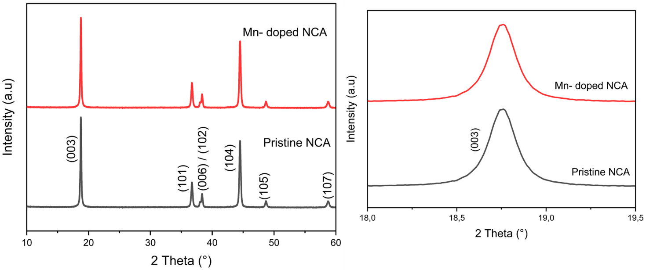
- (b)
FIGURE 2. (a) The XRD patterns of the pristine NCA and Mn–doped NCA, The magnified sections of (b) (003)
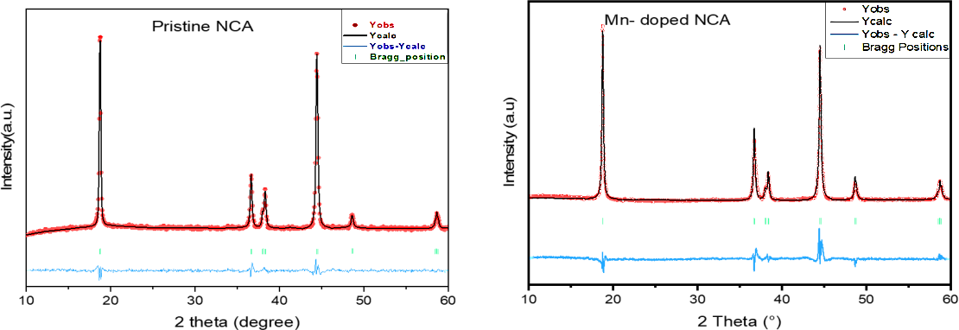
(a) (b)

FIGURE 3. Rietveld refinement patterns of the XRD data for the prepared samples: (a) Pristine NCA, (b) Mn–doped NCA
TABLE 1: Refinement data for the prepared samples from Rietveld refinement method
Sample | a(°A) | c(°A) | c/a
Pristine NCA | 2.8604 | 14.2229 | 4.9723
Mn doped NCA  (NCMA) | 2.8817 | 14.2232 | 4.9357

The FTIR spectra of pristine NCA and Mn-doped NCA (NCMA), shown in Fig. 4, display pronounced differences in vibrational features, highlighting structural modifications induced by Mn incorporation. In particular, the broad absorption bands in the 1250–1600 cm⁻¹ region, typically assigned to metal–oxygen (M–O) stretching and bending vibrations, exhibit reduced intensity and slight peak shifts in the Mn–NCA sample. These variations reflect changes in the local bonding environment, likely arising from partial substitution of Co by Mn, which alters both the atomic mass and bond strength within the M–O framework. This observation is in line with earlier reports describing similar spectral modifications upon Mn doping [27].
Furthermore, absorption bands in the lower wavenumber range (~500–700 cm⁻¹), associated with lattice vibrations characteristic of the layered oxide structure, appear slightly attenuated in the NCMA material. Such damping suggests a potential stabilization of the crystal lattice and a reduction in structural disorder, consistent with findings reported by Lee et al. [28]. Overall, the suppression of IR-active modes in NCMA implies the development of a more rigid and symmetric bonding network, which may underpin improved structural stability.

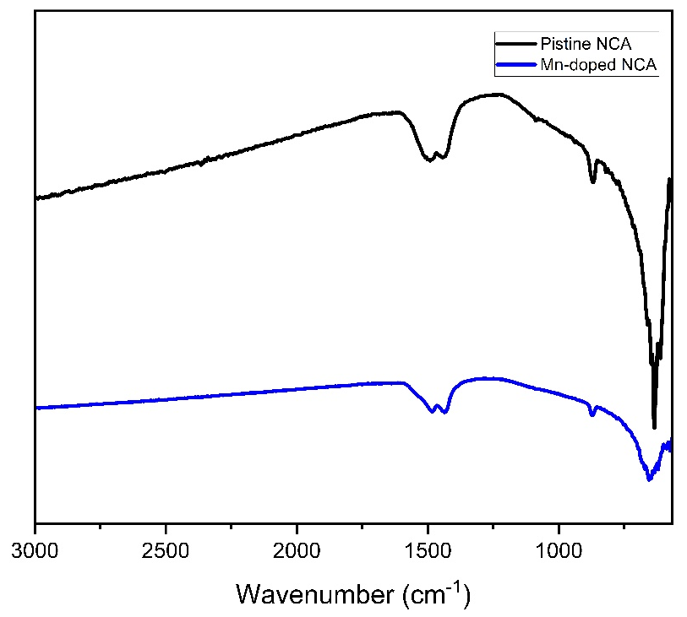
FIGURE 4. FTIR spectra of the pristine NCA and Mn-doped NCA
LiNi0.8Co0.15Al0.05O2 (NCA) crystallizes in the rhombohedral R3̅m space group, adopting a layered α-NaFeO₂-type structure with an O3 stacking sequence. In this configuration, oxygen atoms form a close-packed cubic structure, while lithium and transition metal (TM) ions occupy alternating octahedral interstitial sites. The primitive 12-atom unit cell contains three formula units and consists of repeating Li-O-TM-O planes stacked along the c-axis, as illustrated in Fig. 5a. To examine how Mn doping influences the structural and electronic properties of NCA, we constructed a 3×2×1 supercell, allowing the substitution of one Co atom by Mn, corresponding to the composition LiNi0.8Co0.1Mn0.05Al0.05O2 (NCMA) (Fig. 5b and Fig. 5c). Structural optimization was performed using density functional theory (DFT) with Hubbard U (DFT+U) corrections to account for localized 3d electrons of TM elements. The optimized values of the lattice parameters are a = 2.9119 Å and c = 14.2058 Å for pristine NCA, and a = 2.9151 Å, c = 14.2341 Å for the Mn-doped structure (NCMA). The slight expansion of the lattice upon incorporation of Mn reflects its subtle impact on the crystal structure and arises from the difference in ionic radii between Mn and Co.
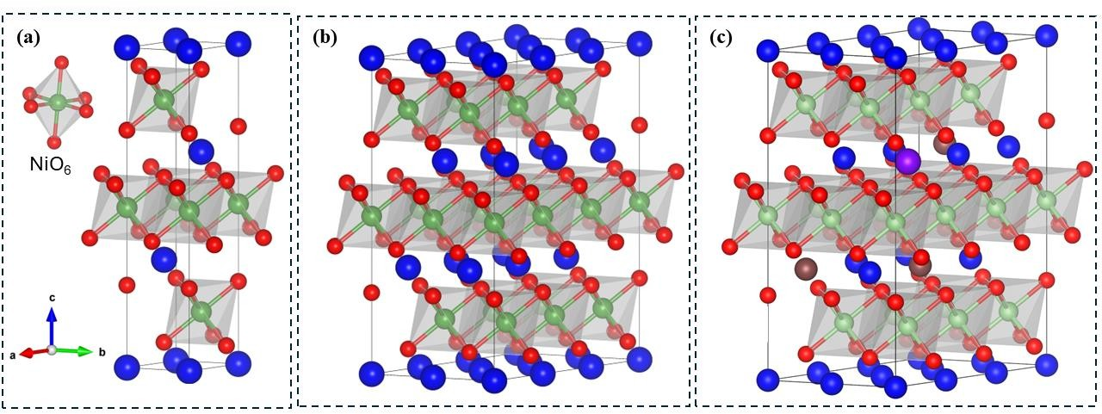
(a) (b) (c)
FIGURE 5. Unit cell representation of the R3̅m phase of LiNiO2 is given in a polyhedral model (a), 3×2×1 supercell of the LiNiO2 material (b), and Optimized 3×2×1 supercell of the NCA material, LiNi0.8Co0.15Al0.05O2 (c). Color code: Lithium atoms are shown in blue, oxygen in red, nickel in green, cobalt and manganese in maroon, and aluminum in violet.

Morphological Properties:
SEM imaging was performed to investigate the surface morphology and particle distribution of both pristine NCA and Mn-doped NCA samples. Fig.6 presents representative micrographs of the two samples (Fig. 6a for the pristine NCA and Fig.6b for the Mn-doped NCA) at a scale of 5 μm. The pristine NCA sample exhibits agglomerated secondary particles consisting of tightly packed primary particles morphology. The average secondary-particle size is close to 5 μm. The particle boundaries are well defined, and the surface is relatively smooth with limited porosity. However, some signs of inter-particle fusion can be observed, potentially due to high- temperature calcination. In contrast, the Mn-doped NCA (NCMA) sample displays a more porous and slightly roughened surface texture, Mn incorporation appears to promote slight particle coarsening and more evident grain boundaries. The morphological differences between pristine and Mn-doped NCA suggest that Mn doping subtly alters the sintering behavior during synthesis.
Notably, the SEM-observed grain features are consistent with the XRD-derived crystallite sizes utilizing the Williamson–Hall (W–H) method. While the SEM reveals secondary particles in the micrometer scale (~5 μm), the crystallite sizes ~89 nm for pristine NCA and ~95 nm for NCMA reflect the nanoscale building blocks that make up these secondary particles. The slight increase in crystallite size upon Mn doping aligns with the observed surface coarsening and more defined grain boundaries in SEM images. This suggests that Mn facilitates grain growth at the nanoscale, which translates to changes in the microstructural features seen in SEM. Thus, the results from XRD and SEM are in good agreement and collectively highlight the influence of Mn doping on both nanostructure and microstructure.
To corroborate the successful introduction and spatial distribution of Mn in the NCA matrix, energy-dispersive X-ray spectroscopy (EDS) elemental mapping was carried out (Fig. 6c). The mapping reveals a well-dispersed distribution of Ni, Co, Al, O, and particularly Mn across the sample, confirming effective doping. The Mn signal is well-dispersed and overlaps with the regions containing Ni and Co, indicating that Mn is integrated within the layered oxide structure rather than forming isolated clusters. This uniform elemental dispersion supports the structural integrity and compositional uniformity of the Mn-doped NCA material.
Additionally, particle size distribution analysis was applied to analyze the influence of Mn doping on particle dimensions (Fig. 7). The volume density versus size plot indicates that both pristine and Mn-doped NCA samples exhibit a unimodal distribution centered around 100-150 μm. However, the Mn-doped NCA shows a slightly narrower distribution and a lower frequency of larger particles (>200 μm), suggesting a drop in particle agglomeration and a narrower and more homogeneous size distribution. This observation is consistent with the SEM results, where Mn doping appears to influence the particle growth dynamics, likely by affecting the surface energy and sintering kinetics during calcination.
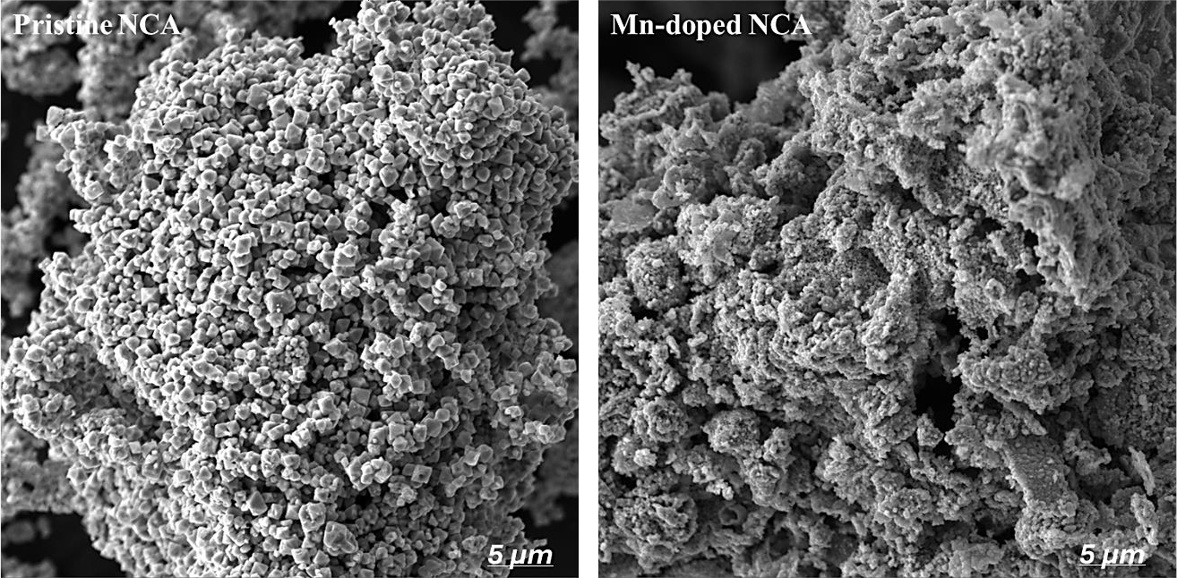
- (b)
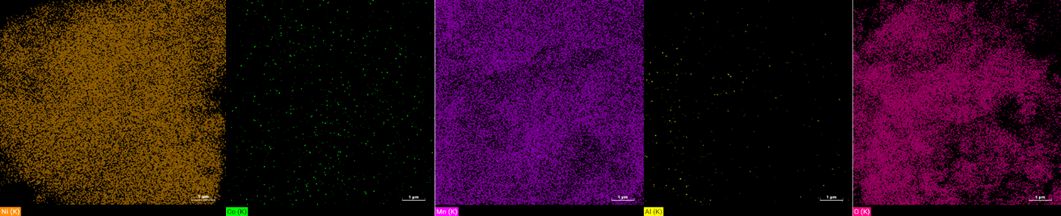
Mn
Co
O
Al
Ni
(c)
FIGURE 6. SEM micrographs of the two prepared materials at a scale of 5 μm; a) Pristine NCA, b) Mn-doped NCA, c) EDS mapping of Mn-doped NCA
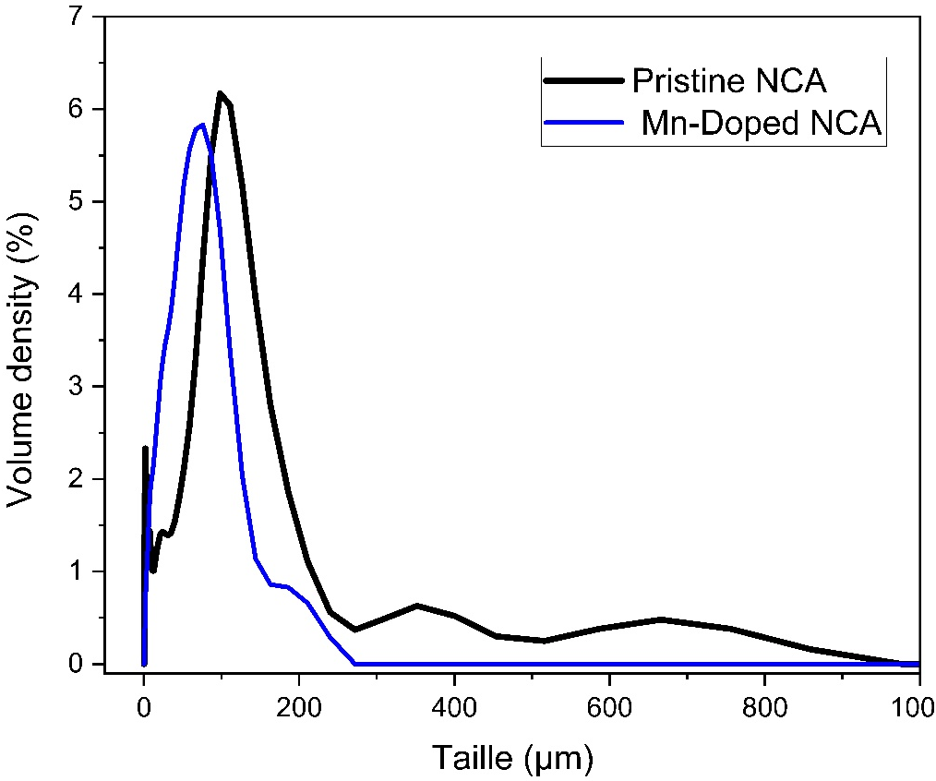
FIGURE 7. Particle size analysis of the two prepared materials; Pristine NCA and Mn-doped NCA

Magnetic and Electronic Properties
The impact of Mn doping on the NCA material's electrical and magnetic structure is discussed in this section.
We approximated the oxidation states of Ni, Mn, and Co from magnetic moments computed by DFT to gain a better understanding of the oxidation states of transition metal (TM) ions in NCA and Mn-doped NCA materials. For NCA, the calculated magnetic moment of Ni ranges from 1.14 to 1.42 μB, corresponding to a low-spin Ni³⁺ state. For NCMA, this value ranges from 1.14 to 1.60 μB. In both materials, the magnetic moment of Co is zero, indicating a low-spin Co³⁺ configuration. Regarding manganese doping in NCA, the calculated magnetic moment of Mn is 2.85 μB, corresponding to a high-spin Mn⁴⁺, while the Ni in this compound has a magnetic moment close to 2 μB (about 1.60 μB), indicating a Ni²⁺ state. These results are consistent with previous theoretical modeling [23][24].
To investigate the electronic characteristics of LiNi0.8Co0.15Al0.05O2 and LiNi0.8Co0.1Mn0.05Al0.05O2, we analyzed their total density of states (TDOS) and partial density of states (PDOS) determined using GGA+U, as shown in Figure 7 and 8. The Fermi level is aligned at 0 eV, and the energy gap between the valence and conduction bands on either side of the Fermi level indicates the band gap. Both NCA and Mn-doped NCA exhibit a semi-metallic character, as revealed by their total density of states (TDOS) and partial density of states (PDOS), with a nearly negligible band gap. These results suggest that Mn doping does not significantly alter the electronic structure near the Fermi level. The calculated electronic properties align well with earlier theoretical studies using the GGA+U approach [25][26].
For the layered NCA material, as illustrated in Fig. 8, the valence band maximum (VBM) is primarily composed of the oxygen 2p orbitals (2p–O) and the nickel 3d orbitals (3d–Ni), with significant hybridization occurring mainly between these orbitals. The contribution of cobalt orbitals to the VBM is negligible. Similarly, the conduction band minimum (CBM) shows comparable orbital contributions to those of the VBM, with additional minor hybridization involving the 3d orbitals of Mn and Co and the 2p orbitals of oxygen. The p orbitals of Al, in addition to the s orbitals of Li, Al, Ni, Co, and O, contribute negligibly to both the VBM and CBM. As depicted in Fig. 9, in Mn-doped layered NCA structures, the overall orbital contributions remain like those of undoped NCA, with the addition of small d- orbital contributions from Mn to the CBM.

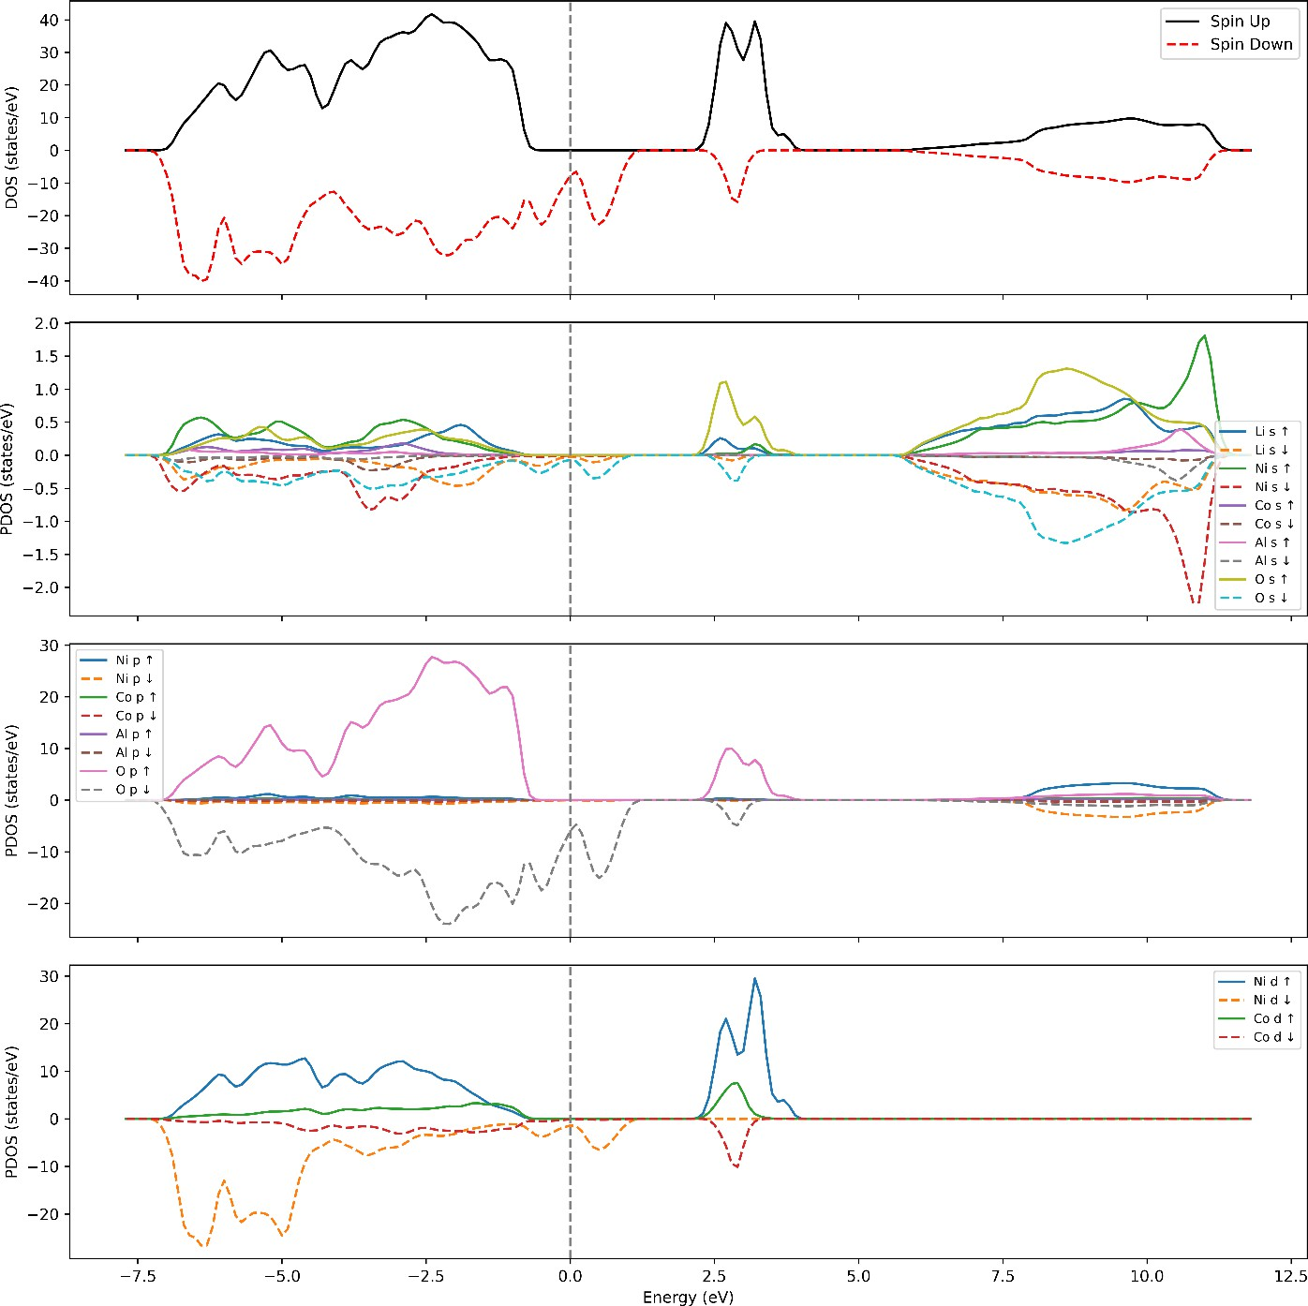
FIGURE 8. Schematic total and projected density of states (PDOS) for NCA.

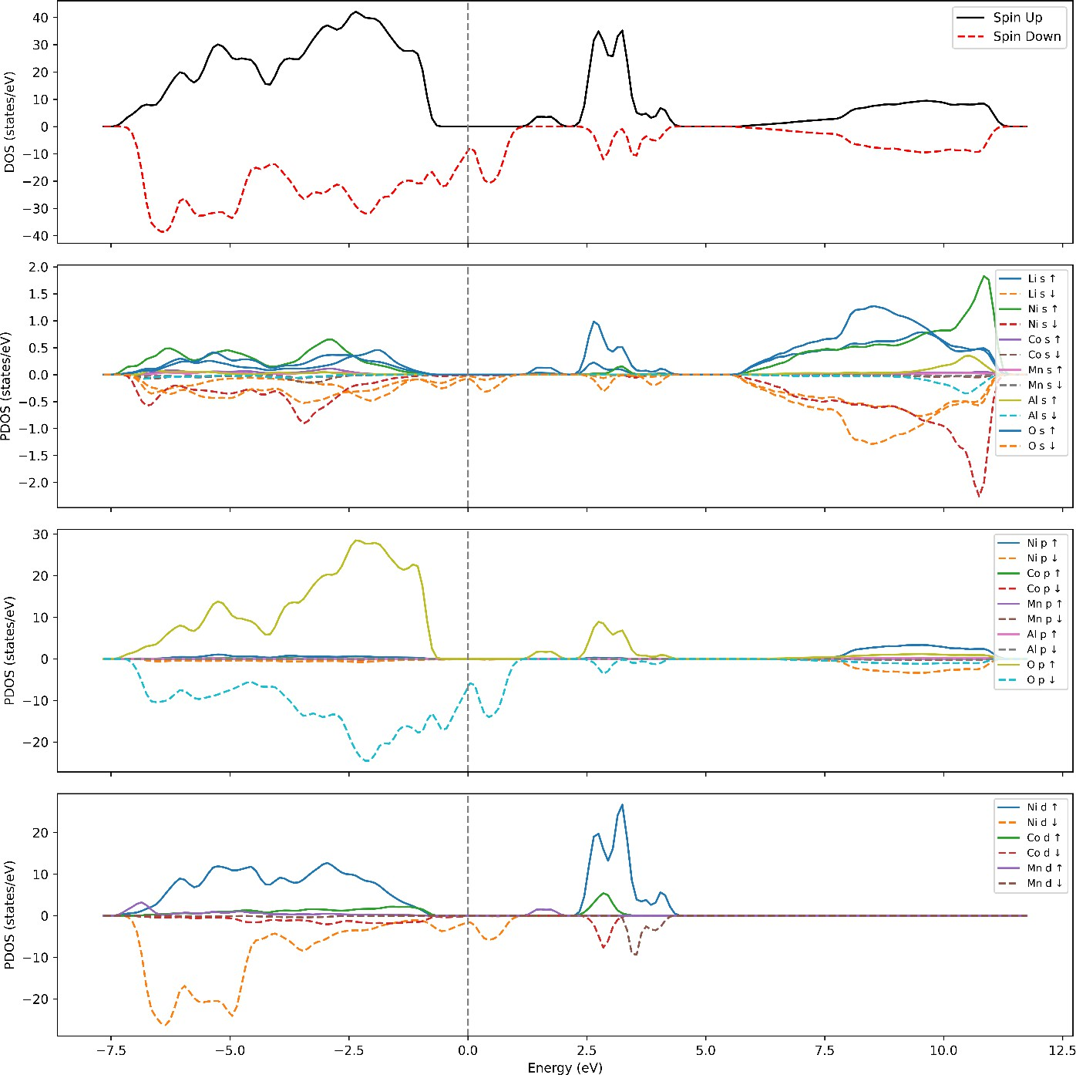
FIGURE 9 Schematic total and projected density of states (PDOS) for Mn doped NCA.

CONCLUSION

In this work, ${LiNi}_{0.8}{Co}_{0.15}{Al}_{0.05}O_{2}$ (NCA) and ${LiNi}_{0.8}{Co}_{0.1}{{Mn}_{0.05}Al}_{0.05}O_{2}$ (NCMA) were synthesized via a controlled co-precipitation method, yielding phase-pure layered structures with uniform morphology. X-ray diffraction combined with Rietveld refinement confirmed the high crystallinity and well-ordered cation distribution within the layered lattice, while scanning electron microscopy provided well-defined particles with a tightly controlled particle size distribution. Such morphological uniformity in NCMA powders suggests favorable processability for electrode fabrication, supporting consistent packing density and reliable performance.
Complementary density functional theory (DFT) calculations revealed atomistic details of the crystal, electronic, and magnetic structures of NCA, further validating the experimental findings. In particular, the theoretical analysis confirmed the stabilizing role of Mn incorporation within the layered framework.
By integrating experimental characterization with first-principles modeling, this study offers a comprehensive understanding of the structure–property relationships in nickel-rich layered oxides. The results not only establish co-precipitation as an effective and scalable synthesis route but also demonstrate that compositional tuning through Mn substitution can reduce cobalt content without compromising electrochemical performance. Overall, the combined evidence highlights NCMA as a promising cathode candidate, capable of balancing high capacity with improved structural and thermal stability.

ACKNOWLEDGMENTS
The authors would like to sincerely thank OCP group for their financial support of the 'Energy, Science & Technology
/ NRG' program, under Specific Agreement Number 175.

REFERENCES
- F. El Kouihen et al., “Valorization of ‘Porcellanite’ as Mining Industry By-Product for Medium Temperature Packed-Bed Thermal Energy Storage System,” Proc. 2021 9th Int. Renew. Sustain. Energy Conf. IRSEC 2021, 2021, doi: 10.1109/IRSEC53969.2021.9741110.
- F. El Kouihen et al., “Investigation of thermal energy storage system based on mining by-products for the recovery of Moroccan mining industrial waste heat,” Appl. Therm. Eng., vol. 230, no. PB, p. 120708, 2023, doi: 10.1016/j.applthermaleng.2023.120708.
- H. Zhang, S. Yang, Y. Huang, and H. Xianhua, “Cathode Material for Lithium-ion Batteries,” 2020, doi: 10.1021/acs.energyfuels.0c01692.
- K. D. R. Ekawati, A. P. Sholikah, C. S. Yudha, H. Widiyandari, and A. Purwanto, “Comparative Study of NCA Cathode Material Synthesis Methods towards Their Structure Characteristics,” Proceeding - 2018 5th Int. Conf. Electr. Veh. Technol. ICEVT 2018, pp. 57–61, 2019, doi: 10.1109/ICEVT.2018.8628433.
- A. Manuscript, “Materials Chemistry A”, doi: 10.1039/x0xx00000x.
- F. El, K. Mohamed, and C. Abdessamad, “The effect of synthesis methods on cation mixing degree in cobalt
- free , nickel ‑ rich NMA materials,” Chem. Pap., no. 0123456789, 2025, doi: 10.1007/s11696-025-03935-7.
- C. S. Yudha, S. U. Muzayanha, H. Widiyandari, F. Iskandar, W. Sutopo, and A. Purwanto, “Synthesis of LiNi0.85Co0.14Al0.01O2 cathode material and its performance in an NCA/graphite full-battery,” Energies, vol. 12, no. 10, 2019, doi: 10.3390/en12101886.
- F. El Kouihen, Z. Kharbouch, and A. Faik, “Review—Advancements in Synthesis Methods for Nickel-Rich NCA Cathode Materials: Optimizing Synthesis Conditions and Their Impact on Electrochemical Performances for Next-Generation Lithium Batteries,” J. Electrochem. Soc., vol. 170, no. 10, p. 100520, 2023, doi: 10.1149/1945-7111/ad01e1.
- D. Y. Wan et al., “Effect of Metal (Mn, Ti) Doping on NCA Cathode Materials for Lithium Ion Batteries,” J. Nanomater., vol. 2018, 2018, doi: 10.1155/2018/8082502.
- C. Al, “An electrolyte to improve the deep charge – discharge performance,” J. Mater. Sci. Mater. Electron., vol. 29, no. 8, pp. 6648–6659, 2018, doi: 10.1007/s10854-018-8650-y.
- L. Wang, Q. Shi, C. Zhan, and G. Liu, “One-Step Solid-State Synthesis of Ni-Rich Cathode Materials for Lithium-Ion Batteries,” 2023.
- A. Purwanto, C. S. Yudha, U. Ubaidillah, H. Widiyandari, T. Ogi, and H. Haerudin, “NCA cathode material: Synthesis methods and performance enhancement efforts,” Mater. Res. Express, vol. 5, no. 12, 2018, doi: 10.1088/2053-1591/aae167.
- Y. Chen, R. Dominko, M. Marczewski, and W. Wieczorek, “Optimizing high-energy lithium-ion batteries : a review of single crystalline and polycrystalline nickel-rich layered cathode materials : performance , synthesis and modification,” 2024.
- A. Urban, D. Seo, and G. Ceder, “Computational understanding of Li-ion batteries This article has been corrected since publication and a corrigendum has also been published,” Nat. Publ. Gr., no. January, 2016, doi: 10.1038/npjcompumats.2016.2.
- S. Jung, H. Gwon, J. Hong, K. Park, and D. Seo, “Understanding the Degradation Mechanisms of Ion Batteries,” pp. 1–7, 2014, doi: 10.1002/aenm.201300787.
- M. Hofmann, F. Nagler, M. Kapuschinski, and U. Guntow, “Li 3 PO 4 Coating to Enable Aqueous Electrode Processing,” pp. 5962–5971, 2020, doi: 10.1002/cssc.202001907.
- A. Purwanto, C. Satria, K. Ikhwan, B. Gustika, H. Widiyandari, and W. Sutopo, “spray pyrolysis method q,”
Adv. Powder Technol., vol. 31, no. 4, pp. 1674–1681, 2020, doi: 10.1016/j.apt.2020.01.035.
- P. Giannozzi et al., “Q UANTUM ESPRESSO : a modular and open-source software project for quantum simulations of materials”.

- C. Matter, “Advanced capabilities for materials modelling with Quantum ESPRESSO Manuscript version : Accepted Manuscript,” pp. 0–68, 2017.
- M. Lamhani, Z. Chchiyai, A. Elomrani, B. Manoun, and A. Hasnaoui, “Enhanced Photocatalytic Water Splitting of SrTiO3 Perovskite through Cobalt Doping: Experimental and Theoretical DFT Understanding,” Inorg. Chem., vol. 62, no. 33, pp. 13405–13418, Aug. 2023, doi: 10.1021/acs.inorgchem.3c01758.
- M. Lamhani, Z. Chchiyai, A. Elomrani, B. Manoun, and A. Hasnaoui, “The effect of Sr substitution on the structural and physical properties of manganite perovskites Ca1−xSrxMnO3−δ (0 ≤ x ≤ 1),” Phys. Chem. Chem. Phys., vol. 24, no. 32, pp. 19414–19431, 2022, doi: 10.1039/D2CP01096H.
- W. Li, E. M. Erickson, and A. Manthiram, “lithium-based automotive batteries,” Nat. Energy, vol. 5, no. Li, 2020, doi: 10.1038/s41560-019-0513-0.
- A. Sannyal, K. Byun, S. A. Mian, and J. Jang, “by Doping Zirconium or Molybdenum: A First-Principles Study,” 2021.
- I. Hsieh, Y. Wu, B. Li, and Y. Qi, “First-Principles Study of the Structures and Redox Mechanisms of Ni- Rich Lithium Nickel Manganese Cobalt Oxides,” pp. 1–23.
- H. Sun and K. Zhao, “Electronic Structure and Comparative Properties of LiNi,” 2017, doi: 10.1021/acs.jpcc.7b00810.
- H. Banerjee, C. P. Grey, and A. J. Morris, “Stability and Redox Mechanisms of Ni-Rich NMC Cathodes: Insights from First-Principles Many-Body Calculations,” 2024, doi: 10.1021/acs.chemmater.4c00928.
- W. Li et al., “New Insight into the Role of Mn Doping on the Bulk Structure Stability and Interfacial Stability of Ni-Rich Layered Oxide,” ChemNanoMat, vol. 6, no. 3, pp. 451–460, 2020, doi: 10.1002/cnma.201900640.
- D. Y. Wan et al., “Effect of Metal ( Mn , Ti ) Doping on NCA Cathode Materials for Lithium Ion Batteries,” vol. 2018, 2018, doi: 10.1155/2018/8082502.

