Fabrication and Characterization of CsPbI3 Perovskite Thin Films via Physical Vapor Deposition

Amina LAOUID ^{1,2,3}, Mientki Mateusz ^{2,3}, Amine Alaoui Belghiti ¹, Krzysztof Wisniewski ^{2,3}, Przemysław Płóciennik^{3,4}, Abdelowahed Hajjaji ¹, Anna Zawadzka ^{2,3}
1 Laboratory of engineer science for energy, National Engineering School of Applied Sciences. Chouaïb Doukkali University, El Jadida, Morocco.
2 Institute of Physics, Faculty of Physics, Astronomy, and Informatics, Nicolaus Copernicus University in Torun, Grudziadzka 5, PL 87-100 Torun, Poland
3 Centre for Modern Interdisciplinary Technologies, Nicolaus Copernicus University in Torun, Wilenska 4, PL 87-100 Torun, Poland Przemysław Płóciennik
4 Institute of Engineering and Technology, Faculty of Physics, Astronomy and Informatics, Nicolaus Copernicus University, Grudziadzka 5, PL 87-100 Torun, Poland.

Abstract:
This study presents a detailed investigation of the optical, structural, and photophysical properties of CsPbI3 thin films prepared by Physical Vapor Deposition (PVD) on silicon and glass substrates. The films were synthesized using CsI and PbI2 powders in a high vacuum environment, and their properties were characterized using transmittance spectroscopy, Tauc plot analysis for bandgap determination, photoluminescence (PL) spectroscopy, and decay time measurements. The results reveal significant characteristics in the optical and photophysical properties of the films, with implications for the application of CsPbI3 in optoelectronic devices including solar cells, light-emitting diodes (LEDs), and photodetectors. The study highlights the importance of substrate selection in optimizing the performance of CsPbI3-based devices.
Keywords— Thin film, CsPbI3, PL, AFM, Transmittance.

Introduction

Perovskite materials, particularly cesium lead iodide (CsPbI₃), have attracted significant attention as potential materials for next-generation optoelectronic devices owing to their outstanding optical and electronic characteristics, including strong photoluminescence, high absorption coefficients, long carrier diffusion lengths, and tunable band gaps [1], [2],[3]. These characteristics make CsPbI₃ an attractive material for a broad range of applications, such as high-efficiency solar cells, light-emitting diodes (LEDs), lasers, photodetectors and other optoelectronic devices. In addition to these intrinsic properties, CsPbI₃ exhibits unique surface- and interface-dependent behaviors, which play a crucial role in identifying the stability and performance of thin-film devices. The morphology, crystallinity, defect density, and substrate interactions strongly influence charge carrier dynamics, optical absorption, emission characteristics, and non-radiative recombination processes, underscoring the importance of careful control over film deposition and surface engineering.

The performance of CsPbI₃ thin films is highly dependent on the deposition technique and the choice of substrate, which can significantly affect the film’s structural, optical, and electronic properties [4]. Conventional solution-based methods often suffer from challenges such as poor reproducibility, solvent-induced defects, and limited control over thickness and uniformity. In contrast, Physical Vapor Deposition (PVD) provides a solvent-free, controllable, and scalable approach to producing high-quality perovskite thin films. PVD allows precise control over film composition, thickness, and uniformity, which is critical for achieving phase-pure films with low defect densities and enhanced optoelectronic performance [5],[6].

Substrate selection is another critical factor that influences the properties of CsPbI₃ thin films. Amorphous substrates, such as glass, can lead to rougher surface morphologies and distinct optical characteristics, whereas crystalline substrates, such as silicon, facilitate smoother films with higher uniformity. These differences can directly impact the bandgap, optical transmittance, photoluminescence behavior, carrier lifetime, and ultimately, the efficiency of devices fabricated using these films. Despite the known importance of substrate effects, systematic studies comparing the influence of different substrates on the structural and photophysical properties of CsPbI₃ thin films remain limited.

In this study, CsPbI₃ thin films were produced on both glass and silicon substrates using PVD, and their optical, structural, and photophysical properties were comprehensively investigated. Characterization techniques, including transmittance spectroscopy, Tauc plot analysis, photoluminescence spectroscopy, time-resolved decay measurements, and atomic force microscopy (AFM), were employed to evaluate the influence of substrate choice on film quality and performance. By correlating substrate-dependent variations in morphology and photophysical properties, this work provides new insights into how substrate-film interactions can be exploited to optimize CsPbI₃ thin films for high-performance optoelectronic applications.

The novelty of this study lies in the combination of a systematic substrate comparison with detailed optical and photophysical analyses, offering valuable guidance for the design of efficient and stable CsPbI₃-based devices. Moreover, understanding the interplay between deposition technique, substrate, and surface/interface effects not only advances fundamental knowledge of perovskite thin films but also paves the way for their integration into next-generation optoelectronic technologies, including solar cells, LEDs, and photodetectors. The results presented herein highlight both the intrinsic potential of CsPbI₃ and the critical role of controlled deposition and substrate engineering in maximizing device performance.

Experimental Methods

Film Deposition

The CsPbI₃ thin films were created on glass and silicone substrates (dimensions of 2 cm × 1 cm) using a vacuum evaporation technique. High-purity CsI (>99.99%) and PbI₂ (>97%) powders were used as precursors. Depositions were carried out under a high vacuum of 5 × 10⁻⁵ Torr using the System-NANO 36™ (Kurt J. Lesker Company) system.

Proper cleaning of the glass substrates is crucial, as their surface quality directly impacts the properties of the deposited thin films. The substrates were sequentially cleaned by ultrasonic treatment in an acetone bath for 15 minutes, followed by rinsing in ethanol, and finally treated with isopropanol using flux synthesis to ensure optimal surface cleanliness. While the silicon samples were cleaned by using the isopropanol flux synthesis.

A schematic representation of the deposition setup is shown in Figure 1. To optimize the deposition conditions, the CsI and PbI₂ powders were positioned in separate tungsten boats, and we controlled manually their temperatures. The goal was to achieve a 1:1 molar ratio, so careful control of the deposition rates was essential. To maintain the desired composition, the boats were shielded until the rates of both materials were stable. Parameters such as material density, Z-factor, and film thickness were carefully adjusted. The final film thickness was influenced by several factors, including evaporation rate, substrate distance, source geometry, and deposition time. The system used a dual-pump setup to achieve primary and secondary vacuum levels, after which the materials were heated to induce evaporation and co-deposition onto the rotating substrates (20 rpm). Film thickness and deposition rates were monitored using piezoelectric sensors, resulting in a uniform final thickness of 100 nm.

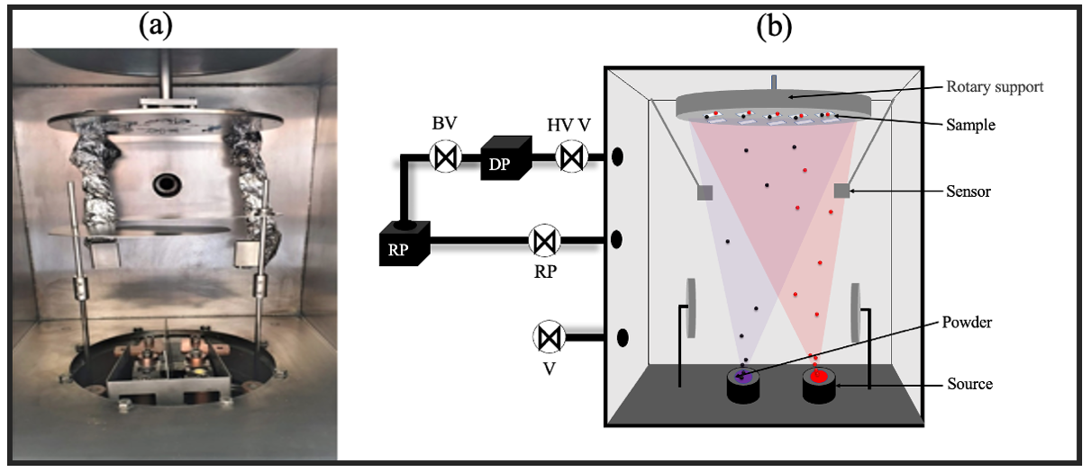

Fig 1: (a) Vacuum chamber and (b) diagram of the process of co-deposition vacuum evaporation, DP; diffusion pump, V1,2,3,4 valves, RP; rotary pump.

Characterization Techniques

The morphological properties of the CsPbI3 thin films were characterized using atomic force microscopy (AFM). A Nanosurf easyScan 2 AFM equipped with a SICON-A cantilever was used to perform contact mode imaging at room temperature [7].
Optical properties were investigated employing a double-beam spectrophotometer (SPECORD 250 PLUS) to measure transmission and absorbance spectra in the 200-1100 nm range at normal incidence [8].
Photoluminescence studies were conducted at room temperature using a FluoroMax-4 apparatus with FluorEssence software. A xenon lamp was employed as the excitation source for both emission and excitation spectra measurements [9].

Results and Discussion

Optical Properties
The transmittance spectra of the CsPbI3 films on a glass substrate are shown in Figure 2. The film exhibits higher transparency in the visible region, around 80 %. The transmittance increases and displays periodic oscillations due to thin-film interference, signifying a smooth and uniform film, highlighting its potential for optoelectronic applications including solar cells and photodetectors.
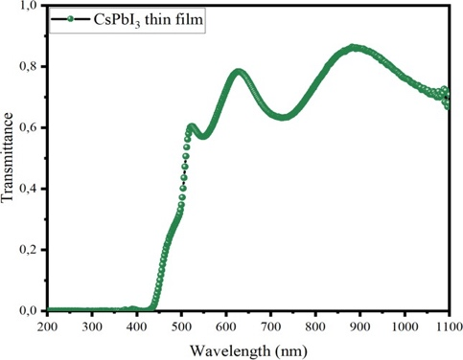

Fig. 2. Transmittance spectra of CsPbI3 thin film.
The optical band gap values (E_{g}) of CsPbI₃ thin films were estimated using the Tauc equation, which is given by [10].
${(αhν)}^{1/n}=k(E-E_{g})$ (1)
$α=A/{0,4343*d}$ (2)
$A=-log⁡(T)$ (3)

In this relation, α denotes the linear absorption coefficient, k is a constant associated with the transition probability, h represents Planck’s constant, ν is the photon frequency, and E_{g} corresponds to the optical band gap. The exponent n depends on the type of electronic transition, taking a value of ½ for an allowed direct transition
The film deposited on glass exhibited a slightly larger bandgap (~1.83 eV, Figure 3) compared to literature-reported values for similar materials [11]. This increased bandgap suggests potential advantages for applications requiring wider bandgap semiconductors, such as tandem solar cells or UV-selective photovoltaics.
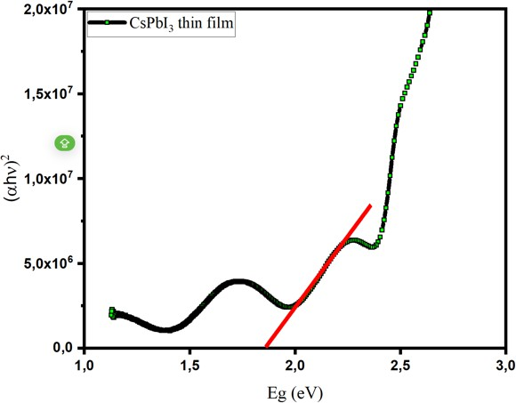

Fig. 3. Tauc plot for CsPbI3 thin film.

Photoluminescence
The photoluminescence (PL) spectrum of CsPbI3 thin films reveals key characteristics regarding their optical properties and phase stability Figure 4. The primary PL peak appears at approximately 702 nm (1.76 eV), which is consistent with the expected bandgap of cubic α- CsPbI3 thin films (1.72–1.8 eV) at room temperature [11]. Compared to literature values, this bandgap aligns well with high-quality CsPbI3 films, though minor shifts may indicate subtle variations in composition or microstructure [12].
A weaker secondary emission is observed in the 760–780 nm range, which can be attributed to trap states, phase segregation, or exciton-phonon interactions. The presence of these long-wavelength emissions suggests that some degree of phase instability may be present, potentially due to partial transformation into the non-perovskite δ-phase, a well-known issue with CsPbI3 at room temperature.
The intensity variations across different spectra suggest a strong dependence on excitation wavelength or power density, typical of lead halide perovskites. Higher excitation energy generally enhances photoluminescence due to increased carrier density and exciton recombination. The gradual reduction in intensity at longer wavelengths likely results from non-radiative recombination or reabsorption effects, commonly observed in perovskite thin films.
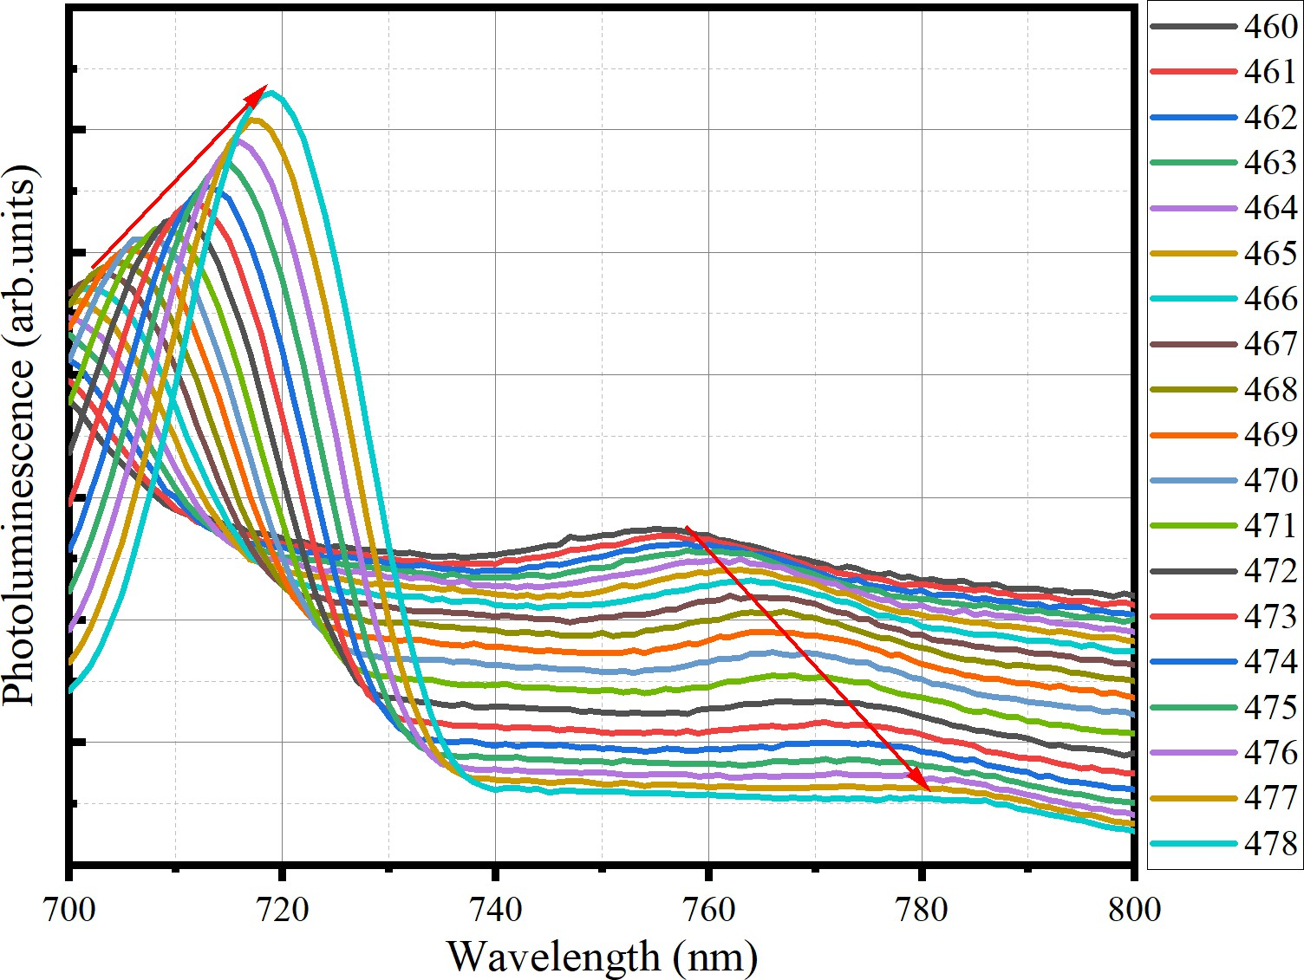
Fig. 3. Emission of CsPbI3 thin film
This analysis confirms that the CsPbI3 thin film exhibits strong optical properties adequate for applications in optoelectronics, including light-emitting diodes (LEDs) and perovskite solar cells. Nevertheless, further improvements in film processing and stabilization techniques could enhance its photoluminescence efficiency and phase stability, making it more suitable for long-term device applications.

3.3 Morphological Properties
The Atomic Force Microscopy (AFM) analysis highlights notable differences in the surface morphology of films deposited on glass and silicon substrates, offering valuable insights into their growth mechanisms and potential applications Figure 4. On the glass substrate, the film exhibits a rougher surface with larger grain-like formations and a peak roughness of approximately 74 nm, suggesting an island growth mode (Volmer-Weber growth). This behavior is likely influenced by the amorphous nature and lower surface energy of the glass. In contrast, the film on the silicon substrate is significantly smoother, with a peak roughness of around 55 nm, indicative of a layer-by-layer growth mode (Frank-van der Merwe growth), facilitated by the crystalline nature of silicon. The current findings emphasize the critical role of substrate properties, such as crystallinity and surface energy, in determining thin film morphology, which can significantly impact their structural, optical, and electronic properties in various applications.
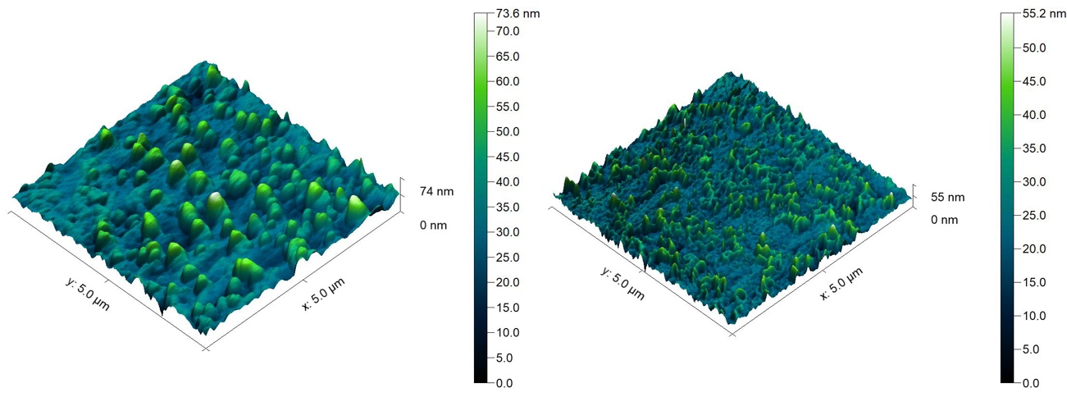
Fig. 4. Figure captions should be centered and placed below the figure.

Conclusion

The study conducts a thorough examination of the optical, structural, and photophysical properties of CsPbI3 thin films deposited via Physical Vapor Deposition on glass and silicon substrates. The findings demonstrate that the choice of substrate significantly influences the film properties, including optical transmittance, bandgap, photoluminescence behavior, and decay dynamics. The glass substrate, with its amorphous nature, promotes rougher surface morphology and distinct optical characteristics, while the silicon substrate, owing to its crystalline structure, facilitates smoother films with enhanced uniformity. These differences underscore the critical role of substrate selection in tailoring the performance of CsPbI₃ thin films for optoelectronic applications such as solar cells, light-emitting diodes (LEDs), and photodetectors. By optimizing substrate-film interactions, this work contributes to advancing the development of efficient and stable CsPbI₃-based devices. Future work will explore device fabrication and performance testing to further assess the feasibility of CsPbI₃ thin films in practical applications, paving the way for next-generation optoelectronic technologies.

References

[1] N.-K. Cho, H.-J. Na, J. Yoo, et Y. S. Kim, « Long-term stability in γ-CsPbI3 perovskite via an ultraviolet-curable polymer network », Commun Mater, vol. 2, nº 1, p. 1‑8, mars 2021, doi: 10.1038/s43246-021-00134-1. Disponible sur: https://www.nature.com/articles/s43246-021-00134-1. [Consulté le: 13 mars 2025]
[2] Z. Qiu et al., « Phase transformation barrier modulation of CsPbI3 films via PbI3− complex for efficient all-inorganic perovskite photovoltaics », Nano Energy, vol. 99, p. 107388, août 2022, doi: 10.1016/j.nanoen.2022.107388. Disponible sur: https://linkinghub.elsevier.com/retrieve/pii/S2211285522004669. [Consulté le: 13 mars 2025]
[3] L.-K. Gao et Y.-L. Tang, « Theoretical Study on the Carrier Mobility and Optical Properties of CsPbI3 by DFT », ACS Omega, vol. 6, nº 17, p. 11545‑11555, mai 2021, doi: 10.1021/acsomega.1c00734. Disponible sur: https://doi.org/10.1021/acsomega.1c00734. [Consulté le: 13 mars 2025]
[4] Q. Zou et al., « Effects of Lead Iodide Crystallization on Photovoltaic Performance of Perovskite Solar Cells by the Vapor-Solid Reaction Method », ACS Omega, vol. 8, nº 13, p. 12430‑12438, mars 2023, doi: 10.1021/acsomega.3c00318. Disponible sur: https://www.ncbi.nlm.nih.gov/pmc/articles/PMC10077426/. [Consulté le: 31 août 2025]
[5] A. Zawadzka et al., « Low-temperature influence on the properties and efficiency of thin-film perovskite solar cells fabricated by the PVco-D technique », Solar Energy Materials and Solar Cells, vol. 274, p. 112993, août 2024, doi: 10.1016/j.solmat.2024.112993. Disponible sur: https://www.sciencedirect.com/science/article/pii/S0927024824003052. [Consulté le: 23 juin 2024]
[6] A. Laouid, A. Zawadzka, A. Alaoui Belghiti, A. Hajjaji, et M. Tlemcani, « Morphology, electrical & optical properties of BaO thin films deposited by PVD », mars 2024, doi: 10.1051/mattech/2023033
[7] A. Laouid et al., « Control of second-and third-order nonlinear optical properties of DCM and Znq2 composites fabricated by the physical vapor co-deposition process », Optical Materials, vol. 157, p. 116045, sept. 2024, doi: 10.1016/j.optmat.2024.116045
[8] P. Plociennik et al., ZnO-based thin-film transparent contacts for applications in perovskite solar cells. 2024. doi: 10.1109/ICTON62926.2024.10647841
[9] A. Laouid, A. Alaoui Belghiti, K. Wisniewski, P. Plociennik, A. Hajjaji, et A. Zawadzka, Investigation of the Physical Properties of Doped ZnS Thin Films Manufactured by PVD. 2024. doi: 10.1109/ICTON62926.2024.10647836
[10] M. Lougdali et al., « Experimental and computational analysis of the Linear and Nonlinear optical properties of Magnesium bis-(8-hydroxyquinoline) thin film », Journal of Alloys and Compounds, vol. 921, p. 165947, nov. 2022, doi: 10.1016/j.jallcom.2022.165947. Disponible sur: https://www.sciencedirect.com/science/article/pii/S0925838822023386. [Consulté le: 3 décembre 2022]
[11] L. Duan, H. Zhang, M. Liu, M. Grätzel, et J. Luo, « Phase-Pure γ-CsPbI3 for Efficient Inorganic Perovskite Solar Cells », ACS Energy Lett., vol. 7, nº 9, p. 2911‑2918, sept. 2022, doi: 10.1021/acsenergylett.2c01219. Disponible sur: https://doi.org/10.1021/acsenergylett.2c01219. [Consulté le: 13 mars 2025]
[12] M. K. Abney, M. Suri, T. Shah, F. L. Deepak, et B. A. Korgel, « Reversible Light-Induced Enhancement of Photoluminescence Lifetime and Intensity in Perovskite-Phase CsPbI3 Nanocrystals », J. Phys. Chem. C, vol. 126, nº 30, p. 12712‑12720, août 2022, doi: 10.1021/acs.jpcc.2c04305. Disponible sur: https://doi.org/10.1021/acs.jpcc.2c04305. [Consulté le: 13 mars 2025]

