Thermodynamic analysis and adaptation of hybrid Flash/ORC power plants WHRS to the conditions of industrial enterprises in Ukraine. PART B
Andriy Redko¹, Yurii Burda^{2, a)}, Oleg Lishchynskyy¹, Kyryl Tsymbal¹,
Timur Lavrinov², Kyrylo Gordiyenko²
¹Sumy National Agrarian University, Department of Architecture and Engineering Surveys, 40021, Sumy, Ukraine
²O.M. Beketov National University of Urban Economy in Kharkiv,
Department of Heat and Gas Supply, Ventilation, 61002 Kharkiv, Ukraine
^{a)} Corresponding author: science.yurii.burda@gmail.com
Abstract. The efficiency and configuration of Organic Rankine Cycle (ORC) installations are strongly influenced by the thermophysical characteristics of the selected working media, making the choice of fluid a decisive design stage. These properties determine the attainable cycle efficiency, yet at elevated heat source conditions the chemical stability threshold of organic compounds becomes a critical restriction. In order to bypass these operational barriers, integrated thermal schemes are being created for hybrid power plants functioning within waste heat recovery systems (WHRS). This study reports on numerical investigations carried out for a combined recovery plant designed to utilize a waste heat stream in the temperature interval of 280–300°C. Several layouts were considered, incorporating a steam turbine together with two expanders operating on organic substances. The assessment was based on comparative analysis of ORC and Flash cycle efficiencies, the resulting electrical power yield, internal turbine effectiveness, and the aerodynamic as well as structural features of the turbine stages. An optimized arrangement was proposed consisting of a steam turbine in combination with a single organic turbine using R600a. Calculations indicate that under conditions of 0.80 efficiency for the steam unit and 0.85 for the organic expander, the complex is capable of producing 349.3 kW of net electricity with an overall efficiency of 20%. In addition, the developed thermal model of the recovery process was integrated with a hydrodynamic model in order to obtain a detailed representation of the turbine flow path behavior.
Keywords: Thermal performance evaluation; Combined Flash/ORC energy units; Waste energy utilization systems; Manufacturing facilities; Energy optimization; Power system modernization; Ukrainian industry; Heat recovery for electricity generation; Technological integration; Renewable-oriented energy complexes.

INTRODUCTION
The study in [1] presents a thermoeconomic evaluation of modular ORC systems for waste heat recovery across a wide range of heat source temperatures and capacities. Research reported in [2] investigates the use of siloxane mixtures in a hybrid solar-biomass ORC power plant, demonstrating that the application of mixtures (0.9 MM/0.1 MDM and 0.8 MM/0.2 MDM) increases the generated electrical power by 2% and 1.4%, respectively, compared to pure MM. Therefore, for the practical implementation of ORC technologies, research continues on hybrid energy systems employing various organic working fluids.
In cement production processes with temperatures ranging from 250 to 450 °C, heat recovery units are employed, including steam Rankine and organic Rankine cycles [4], [5], with potential energy generation of 6–9 MW. Hybrid power plants operating according to the Flash/ORC scheme are also applied in geothermal energy systems [6]. The dual-flash process involves a high-pressure separator and a low-pressure separator; the geothermal fluid separated in the first-stage separator is fed to the second-stage low-pressure separator, where it is further separated into vapor and liquid. Low-pressure steam is supplied to the turbine to enhance electricity production, while the remaining liquid is pumped back into the well [7].
In binary geothermal power plant schemes, the heat removed in the condenser of the steam cycle is utilized in cycles with organic working fluids. This arrangement is particularly effective at geothermal fluid temperatures around 200 °C. The work in [8] addresses the environmental sustainability of geothermal energy production, analyzing the efficiency of energy conversion in a hybrid (steam/ORC) geothermal power plant. Comparative thermodynamic efficiency of different geothermal energy conversion technologies is presented in [9], showing that the energetic efficiency of binary-flash evaporator technology (Otaka pilot plant) reaches 53.9%.
Parameters of geothermal flash-binary power plants employing different cycles (basic ORC, regenerative ORC, and ORC with internal heat exchanger) are studied in [10]. Thermodynamic analyses of hybrid Flash/ORC power plants are provided in [11], [12], [13], [14], [15], offering insights into turbine performance, working fluid selection, and overall system efficiency under various operational conditions.

Research materials and methods
Part A presents the results of the numerical study of the influence of the parameters and properties of the working fluids on the efficiency of the hybrid scheme. The results of 21 calculation options are presented. The generated power and efficiency of the thermal scheme are determined. The optimal working fluids are determined. This part of the work is a continuation of the study [16], [17].
The examined thermal configuration employs water at 25 °C as the cooling medium for the second and third circuits, operating with a heat source temperature of 280 °C, while increasing the circulation rate of the working fluids to achieve a reduction in exhaust gas temperature:
– steam turbine power – 158.2 kW;
– water circuit pump power – 1.4 kW;
– freon turbine power – 169.5 kW (R-245fa) and 38.0 kW (R-245fa);
– freon pump power – 5.9 kW (R-245fa) and 1.2 kW (R-245fa);
– cooling system pump power – 0.2 kW (R-245fa) and 0.04 kW (R-245fa);
– exhaust gas temperature – 131 °C;
– electrical efficiency of the power plant – 20.6%;
– total excess electrical power – 357.0 kW.
The combination of Flash and Organic Rankine Cycle (ORC) technologies offers significant advantages for enhancing energy recovery and overall system efficiency, particularly in low-to-medium temperature waste heat applications. Flash cycles effectively utilize high-temperature heat sources by generating steam for power production, while ORC systems capitalize on lower-grade heat, enabling more complete energy extraction. This dual approach increases net power output, optimizes turbine performance, and extends the operational range of heat recovery systems.
The energy performance of the installation was evaluated under the given conditions. It was found that the electrical efficiency of the power plant is 20.6%, and the total capacity is 357.0 kW.
The proposed thermal arrangement assumes the use of water at 25 °C as the cooling medium for the second and third circuits, with a heat source temperature of 280 °C, while the flow rate of the working fluids is intensified to ensure a lowering of the exhaust gas temperature:
The analyzed thermal power plant demonstrates a steam turbine efficiency of 65%, whereas the efficiency for R-245fa reaches 70%. The net power output of the steam turbine equals 128.5 kW, while the water circuit pump requires 1.4 kW. Within the freon cycle, the turbines generate 142.7 kW and 29.2 kW respectively, with the corresponding freon pumps consuming 6.0 kW and 1.2 kW. The cooling system pumps operate at 0.2 kW and 0.04 kW for the respective freon circuits. Under these conditions, the exhaust gas temperature is reduced to 131 °C, the overall electrical efficiency of the plant reaches 16.89%, and the total surplus electrical power amounts to 291.8 kW. In addition, the working fluids are characterized by specific thermodynamic parameters at the designated control points, which define the operational stability of the cycle.
The obtained performance indicators highlight the potential of hybrid configurations in enhancing waste heat utilization and increasing the overall energy efficiency of thermal power plants. The integration of the organic Rankine cycle with R-245fa demonstrates its capability to effectively recover low-grade heat from the exhaust gases, reducing irreversibility losses and contributing to more sustainable plant operation.
Such a distribution of energy flows indicates a relatively balanced ratio between the generated power and the auxiliary consumption of pumps and cooling systems, which enhances the overall sustainability of the plant.
The calculation results are shown in Table 1.
Table 1. Thermodynamic parameters at cycle points with an efficiency of a steam turbine of 0.80, a freon (R-245fa) turbine of 0.85, and a pump of 0.75
Run | P, kPa | t, °С | x | s, kJ·kg⁻¹ °С | i, kJ·kg⁻¹ | G, kg·s⁻¹
1 | 1,121 | 36.7 | 0 | 0.5258 | -15,772 | 1
2 | 1,133 | 186 | 0.52 | 4.134 | -13,247 | 1
3 | 1,143 | 186 | 0 | 2.291 | -15,142 | 0.45
4 | 1,113 | 187 | 1 | 6.324 | -13,242 | 0.53
5 | 155 | 109.2 | 0.9212 | 6.529 | -13,431 | 0.54
6 | 195 | 109.2 | 0.307 | 3.203 | -14,781 | 0.52
7 | 145 | 36.4 | 0 | 0.5253 | -15,771 | 0.65
8 | 1,223 | 99.7 | 0 | 1.301 | -15,407 | 0.45
9 | 1,328 | 36.2 | 0 | 0.5208 | -15,777 | 0.45
10 | 148 | 36.5 | 0 | 0.5247 | -15,777 | 1
a | 1,255 | 100 | 1 | -3.609 | -4,339 | 5.4
b | 176 | 51.3 | 1 | -3.592 | -4,369 | 5.3
c | 167 | 29.6 | 0 | -4.277 | -4,577 | 5.2
d | 1,256 | 30.2 | 0 | -4.276 | -4,577 | 5.4
e | 1,256 | 99.7 | 0 | -3.978 | -4,476 | 5.9
u | 1,106 | 94.1 | 1 | -3.614 | -4,347 | 1.3
v | 176 | 49.5 | 1 | -3.597 | -4,371 | 1.1
w | 190 | 29.6 | 0 | -4.277 | -4,572 | 1.1
x | 1,106 | 30.1 | 0 | -4.276 | -4,570 | 1.3
y | 1,101 | 94.1 | 0 | -4.002 | -4,492 | 1.1

By employing organic working fluids with advantageous thermodynamic characteristics, ORC systems can function at reduced pressures and temperatures, which mitigates mechanical stress and prolongs the operational life of the equipment. The integration of Flash and ORC cycles provides a complementary solution that optimizes energy extraction, minimizes carbon emissions, and enhances the overall sustainability of industrial operations. In this hybrid configuration, Flash cycles convert high-temperature heat directly into steam for power generation, whereas ORC units capture the remaining lower-temperature heat, thereby ensuring more efficient and complete utilization of available thermal energy.
Considering the actual operational efficiency of the turbines, the energy performance of the combined installation was evaluated under the specified conditions. The analysis revealed that the plant achieves an electrical efficiency of 16.89%, with a total power output of 291.8 kW, demonstrating the effectiveness of the hybrid scheme in converting waste heat into usable electrical energy.
The analyzed thermal configuration employs water at 25 °C as the cooling agent for the second and third loops, while the primary heat source reaches 280 °C. In this arrangement, the circulation rate of the working fluids is deliberately increased, which makes it possible to lower the temperature of the exhaust gases:
– The efficiency of the steam turbine is 65%, for R-600a – 70%;
– The power of the steam turbine is 128.5 kW;
– The power of the water circuit pump is 1.4 kW;
– The power of the freon turbines is 143.5 kW (R-600a) and 31.0 kW (R-600a);
– The power of the freon pumps is 12.7 kW (R-600a) and 2.8 kW (R-600a);
– The power of the cooling system pumps is 0.2 kW (R-600a) and 0.04 kW (R-600a);
– exhaust gas temperature – 131 °C;
– electrical efficiency of the power plant – 16.54%;
– total excess electrical power – 286.0 kW.
The combination boosts overall thermal efficiency, increases net power output, and makes it possible to operate across a broader range of heat source temperatures. Additionally, ORC systems can use environmentally friendly, low-boiling-point working fluids, allowing for safer, lower-pressure operation and reduced wear on components.
Furthermore, the modular nature of ORC systems allows for flexible configuration and scaling, which is particularly advantageous for hybrid setups such as Flash/ORC plants. By carefully selecting working fluids and optimizing cycle parameters, it is possible to tailor the system to specific heat source characteristics, minimizing irreversibility’s and improving overall exergy utilization. These systems also exhibit rapid startup and shutdown capabilities, making them suitable for fluctuating industrial processes and intermittent renewable energy sources.
The adoption of ORC technology contributes not only to energy efficiency but also to environmental sustainability.
The calculation results are shown in Table 2.

Table 2. Thermodynamic parameters at cycle points with an efficiency of steam turbine 0.65, freon (R-245fa) 0.70, pump 0.60
Case | P, kPa | t, °С | x | s, kJ·kg⁻¹ °С | i, kJ·kg⁻¹ | G, kg·s⁻¹
1 | 1,132 | 36.82 | 0 | 0.5292 | -15,770 | 1
2 | 1,134 | 184 | 0.52 | 4.782 | -14,141 | 1
3 | 1,131 | 185 | 0 | 2.188 | -15,231 | 0.41
4 | 1,121 | 182 | 1 | 6.544 | -13,145 | 0.52
5 | 150 | 102.1 | 0.9357 | 6.873 | -13,371 | 0.53
6 | 149 | 109.8 | 0.3177 | 3.266 | -14,753 | 0.68
7 | 141 | 36.96 | 0 | 0.5321 | -15,781 | 0.59
8 | 1,120 | 95.2 | 0 | 1.252 | -15,521 | 0.42
9 | 1,131 | 36.9 | 0 | 0.5217 | -15,773 | 0.43
10 | 142 | 36.7 | 0 | 0.5281 | -15,772 | 1
a | 1,250 | 100 | 0 | -3.609 | -4,337 | 5.52
b | 171 | 57.23 | 1 | -3.575 | -4,362 | 5.51
c | 178 | 29.61 | 0 | -4.277 | -4,576 | 5.52
d | 1,257 | 30.23 | 0 | -4.276 | -4,575 | 5.51
e | 1,253 | 99.74 | 0 | -3.978 | -4,474 | 5.52
u | 1,102 | 94.65 | 1 | -3.612 | -4,341 | 1.21
v | 171 | 55.6 | 1 | -3.58 | -4,364 | 1.22
w | 175 | 29.61 | 0 | -4.277 | -4,576 | 1.23
x | 1,101 | 30.15 | 0 | -4.276 | -4,575 | 1.24
y | 1,101 | 94.13 | 1 | -4.002 | -4,483 | 1.29

The contemporary evolution of energy systems is increasingly shaped by the urgent need to improve efficiency and ensure the rational utilization of available resources. Against the backdrop of global challenges such as climate change, the depletion of fossil fuel reserves, and the transition toward sustainable energy generation models, the investigation of actual operational performance of energy conversion equipment has become critically important. Among the variety of technological solutions, turbine-based power plants occupy a central role, as their operational characteristics largely determine the overall efficiency, stability, and adaptability of the installation under real-world conditions. While theoretical calculations provide a valuable framework for preliminary assessment, only an analysis that incorporates actual turbine efficiencies and real operating parameters can yield reliable conclusions regarding the practical potential of these systems.
The thermodynamic behavior of turbines remains a crucial factor in evaluating the feasibility of power generation units utilizing waste heat recovery, renewable resources, or hybrid energy configurations. Turbines convert thermal energy into mechanical work, which is subsequently transformed into electrical power. Nevertheless, this conversion process is inherently accompanied by irreversibilities and energy losses arising from aerodynamic drag, friction, non-ideal expansion, and mechanical constraints.
An accurate assessment of actual energy performance is essential for several reasons. It enables engineers to detect operational limitations and critical bottlenecks, facilitates the evaluation of alternative design configurations, and provides the foundation for optimization strategies aimed at minimizing fuel consumption and reducing environmental impact. In addition, dependable efficiency data are indispensable for calculating investment payback periods, forecasting operational expenses, and ensuring compliance with international energy regulations and sustainability standards. In contemporary engineering practice, such analyses are no longer supplementary; they increasingly determine the competitiveness, reliability, and overall viability of power generation technologies across industrial and utility sectors.
The calculation results are shown in Table 3.
Table 3. Thermodynamic parameters at cycle points with an efficiency of a steam turbine of 0.65, a freon (R-600a) turbine of 0.70, and a pump of 0.6
Number | P, kPa | t, °С | x | s, kJ·kg⁻¹ °С | i, kJ·kg⁻¹ | G, kg·s⁻¹
1 | 1,124 | 36.46 | 0 | 0.5243 | -15,772 | 1
2 | 1,123 | 191 | 0.52 | 4.111 | -14,141 | 1
3 | 1,122 | 192 | 0 | 2.291 | -14,131 | 0.45
4 | 1,126 | 182 | 1 | 6.544 | -13,234 | 0.51
5 | 141 | 101.4 | 0.9357 | 6.771 | -13,372 | 0.53
6 | 142 | 109.8 | 0.3857 | 3.663 | -14,606 | 0.54
7 | 144 | 36.18 | 0 | 0.521 | -15,775 | 0.52
8 | 1,221 | 109.9 | 0 | 1.422 | -15,465 | 0.41
9 | 1,225 | 36.18 | 0 | 0.5321 | -15,773 | 0.45
10 | 138 | 36.31 | 0 | 0.5233 | -15,773 | 1
a | 2,012 | 100 | 1 | 2.976 | -2,175 | 3.24
b | 410 | 52.31 | 1 | 2.035 | -2,220 | 3.23
c | 402 | 29.11 | 0 | 1.739 | -2,586 | 3.22
d | 2,018 | 31.90 | 0 | 1.833 | -2,585 | 3.28
e | 2,099 | 99.89 | 0 | 2.417 | -2,385 | 3.21
u | 2,011 | 99.81 | 1 | 2.771 | -2,279 | 0.7
v | 422 | 52.17 | 1 | 3.034 | -2,221 | 0.6
w | 451 | 29.89 | 0 | 1.725 | -2,587 | 0.8
x | 2,022 | 32.81 | 0 | 1.833 | -2,481 | 0.5
y | 2,017 | 99.89 | 0 | 2.417 | -2,385 | 0.7

The energy performance of the installation was estimated under the given conditions. It was found that the electrical efficiency of the power plant is 16.54%, and the total capacity is 286.0 kW
In order to reduce the costs of implementing a multi-circuit power plant, the parameters are selected in such a way that there is a possibility of abandoning the third circuit (Fig. 1). The change in condensate flow after the steam turbine ST (point 5) is taken into account.

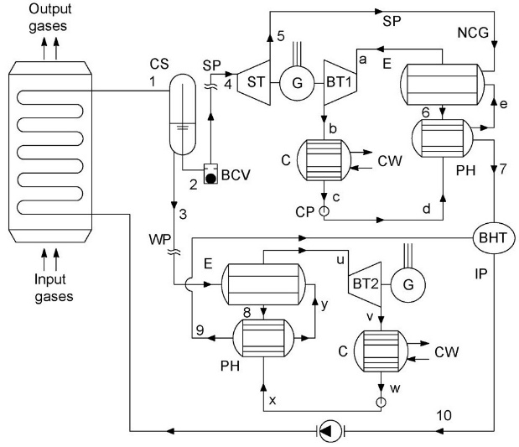

FIGURE 1. Upgraded thermal design

The results of the calculation of the 2-stage scheme showed that the power of the steam turbine is W=128.5 kW, the power of the freon turbine is W=187 kW (R-600a), the total power is W=283 kW, the efficiency is 16.3%. Which is slightly different from the characteristics of the 3stage thermal scheme. Calculation studies of flow parts of turbines.
It is generally known that the expansion rate at the turbine stage should not exceed 1.44 (P1/P2). The initial data for evaluating the geometric and flow characteristics of the steam turbine are the results of the calculation of the thermal scheme (Fig. 1). The distribution of the main characteristics according to stages is given in Table 4.

Table 4. Output data for the flow part of the steam turbine
No | Name | Marking | 1 stage | 2 stage | 3 stage | 4 stage | 5 stage | 6 stage
1 | Pressure at the stage input,  MPa (abs) | Р0 | 1.123 | 0.7937 | 0.561 | 0.3965 | 0.2802 | 0.1981
2 | Temperature at the stage input, °С | Т0 | 191 | 170.1 | 156.23 | 143.35 | 131.2 | 119.91
3 | Pressure at the stage output,  MPa (abs) | Р2 | 0.7937 | 0.561 | 0.397 | 0.280 | 0.198 | 0.138
4 | Rotational frequency, thousand rpm. | n | 25 | 25 | 25 | 25 | 25 | 25
5 | Mass consumption, kg/s | G | 0.51 | 0.53 | 0.59 | 0.51 | 0.54 | 0.71
6 | Degree of partiality | Ω | 0.4 | 0.5 | 0.6 | 0.7 | 0.84 | 1.0

Fig. 2 shows a general view of the flow path of the steam turbine.

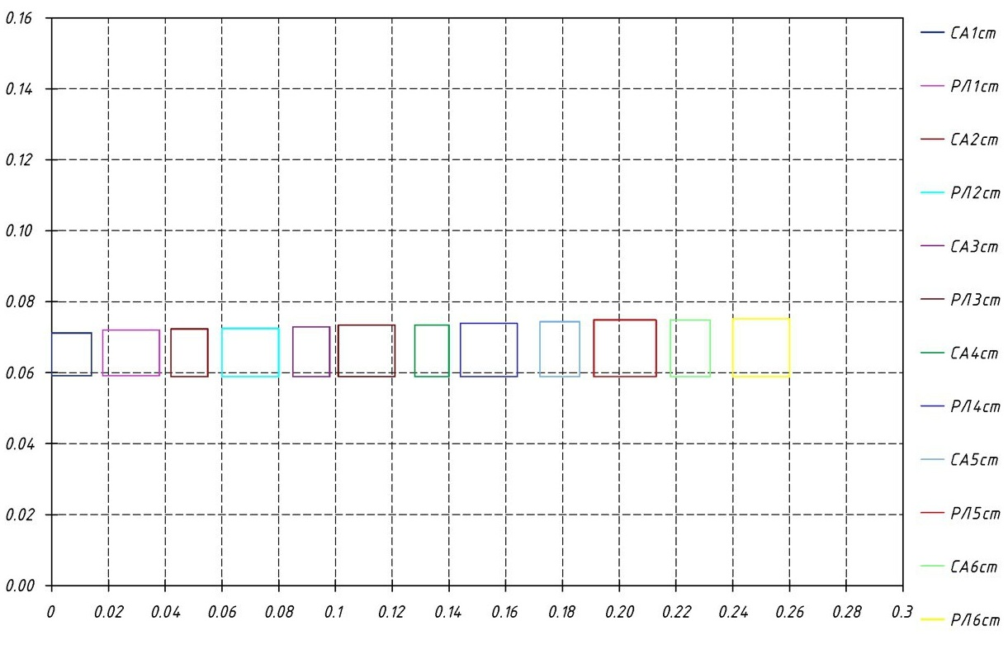

FIGURE 2. General view of the flow path of the steam turbine

Turbine with the R-600a working fluid. The initial data for evaluating the geometrical and flow characteristics of the R-600a turbine are the results of the calculation of the thermal scheme (Fig. 1). The distribution of the main characteristics according to stages is given in Table 5.
Table 5. Output data for the flow path of the R-600a turbine
No | Parameter name | Size
1 | Compound | R-600a
2 | Pressure at the turbine inlet, MPa | 2
3 | Pressure at the turbine outlet, MPa | 0.4
4 | Pressure losses in the inlet nozzle, MPa | 0.0125
5 | Pressure losses in the outlet nozzle, MPa | 0.0117
6 | Pressure at the stage inlet, MPa | 1.9875
7 | Temperature at the stage inlet, °С | 100
8 | Pressure at the stage outlet, MPa | 0.4117
9 | Density (conditional), kg/m3 | 2.484
10 | Mass consumption, kg/s | 3.940

Experimental methodology
The applied research methodology relied on an integrated framework that combined analytical thermodynamic modeling with verification through conditions approximating real industrial operation. As a foundation, the computational approach described in [1] was adopted to evaluate the principal performance indicators of the hybrid Flash/ORC installation. This included establishing complete mass and energy balances, assessing exergy distribution across subsystems, and determining cycle efficiency under different loading regimes. Such a methodology ensures a coherent representation of the plant’s behavior in both stationary and variable modes, while also revealing limiting operational thresholds that govern system reliability and efficiency. In addition, the adopted procedure makes it possible to examine the dynamic interactions between subsystems, providing a more detailed picture of how boundary constraints and transient fluctuations influence the stability of the energy conversion process.

Analysis of research results
This part distills the results of the earlier investigation, directing attention toward the selection of the most advantageous configuration of hybrid Flash/ORC power generation systems tailored to the operational and energy realities of Ukraine’s industrial sector.

CONCLUSION
Thermogasdynamic analysis of turbine flow paths form the foundation for determining both the structural parameters and the actual efficiency of turbine stages. Insights from practical design experience indicate that the geometry of the flow section must be selected according to the degree of expansion and the mass flow rate of the working fluid. The magnitude of this flow critically influences turbine efficiency. At low fluid throughput, blade heights are constrained to levels that are technologically unfeasible and challenging to manufacture within industrial tolerances. Under such conditions, the flow within the inter-blade channels intensifies, increasing secondary losses and consequently reducing the overall effectiveness of the turbine flow path.
Given that the working fluid flow is inherently limited by the amount of recoverable waste heat, partial admission to the steam turbine impeller is often required. This approach allows blade heights to be increased to manufacturable levels, but it reduces the steam turbine’s efficiency to approximately 65%. In contrast, turbines using R600a as the working medium demonstrate higher efficiency, reaching around 74%. The analysis confirms that the actual specific electric power output is 283 kW·kg⁻¹·s⁻¹, with an overall energy conversion efficiency of 16.5%. Additionally, optimizing the turbine flow path reduces the material intensity of the equipment, enhancing both manufacturability and cost-effectiveness of the power plant.

Acknowledgments
The authors would like to express their gratitude to Kharkiv National Automobile and Highway University and the organizing committee of the Modern Automotive Industry, Transport and Road Infrastructure (MAITRI) conference.

Conflict of interests
The authors declare that there is no conflict of interests regarding the publication of this paper.

References
[1] M. Priinger and D. Bruggemann, “Thermoeconomic evaluation of modular ORC for WHR over a broad range of heat source temperatures and capacities,” Energies 10(3), 269 (2017). https://doi.org/10.3390/en10030269
[2] J. Oyekale, et al., “Thermo-economic evaluation of actively selected siloxane mixtures in a hybrid solar-biomass ORC power plant,” Applied Thermal Engineering 165, 114607 (2020). https://doi.org/10.1016/j.applthermaleng.2019.114607
[3] R. DiPippo, Geothermal Power Plants: Principles, Applications, Case Studies and Environmental Impact, 4th ed. (Elsevier, Oxford, 2016).
[4] G. Liao, et al., “Advanced exergy analysis for ORC-based layout to recover waste heat of flue gas,” Applied Energy 266, 114891 (2020). https://doi.org/10.1016/j.apenergy.2020.114891
[5] T. Gibbons, “Waste heat recovery in the cement industry,” World Cement (2013); available at https://www.worldcement.com/
[6] El Haj Assad, et al., “Performance of geothermal power plants (single, dual and binary) to compensate for LHC-CERN power consumption: Comparative study,” Geothermal Energy 5, 17 (2017). https://doi.org/10.1186/s40517-017-0074-z
[7] P. Valdimarsson, Geothermal Power Plant Cycles and Main Components, United Nations University Geothermal Training Programme, Santa Tecla, El Salvador, Jan. 16–22 (year not specified).
[8] T. Nguyen and L. Lin, “Potentials and effects of electricity cogeneration via ORC systems for industrial applications,” Renewable Energy 178, 1109–1122 (2025). https://doi.org/10.1016/j.renene.2021.07.017
[9] X. Xia, C. Yang, T. Sun, L. Chen, B. Peng, and Z. Wang, “Mixture working fluid selection of a novel ORC–VCR system for low-grade waste heat recovery,” Applied Thermal Engineering 185, 116305 (2021). https://doi.org/10.1016/j.applthermaleng.2020.116305
[10] J. Wu, Y. Liang, M. Dong, Y. Zhu, J. Zhou, X. Ling, and J. Lu, “Dynamic analysis and control strategy of solar-driven ORC system with thermal energy storage,” Energy 258, 124722 (2022). https://doi.org/10.1016/j.energy.2022.124722
[11] J. Han, K. Han, Y. Wang, Y. Han, Z. Ye, and J. Lin, “4E (economic, environmental, exergy and emergy) analysis of a combined heat and power system based on organic Rankine cycle,” Renewable and Sustainable Energy Reviews 172, 113042 (2023). https://doi.org/10.1016/j.rser.2023.113042
[12] J. Yazdi, “Investigation of different models of combined parallel flash binary cycles,” International Journal of Engineering Sciences and Research Technology 6(2), 9 (2017). https://doi.org/10.5281/zenodo.290127
[13] R. Liu, C. Liu, L. Tan, W. Yu, X. Ban, and L. Xin, “Pyrolysis mechanisms of low-GWP working fluid R1243zf in superheated steam Rankine cycles,” Energy 258, 124722 (2022). https://doi.org/10.1016/j.energy.2022.124722
[14] H. D. Tessemo, A. I. Hassane, J. Bikai, B. V. Bot, F. Lontsi, P. J. Njock, O. T. Sosso, and R. M. Mouangue, “Techno-economic analysis of viability of two stand-alone desalination systems for rural communities in Cameroon,” Renewable Energy 178, 1109–1122 (2021). https://doi.org/10.1016/j.renene.2021.07.017
[15] J. Ji, Q. Yin, C. Ji, Y. Shi, J. Shi, H. Huang, N. Sun, T. Peng, C. Zhang, and H. Zhao, “Integrating ORC systems for energy recovery in battery-powered electric vehicles: Performance analysis and optimization,” Renewable and Sustainable Energy Reviews 150, 111516 (2021). https://doi.org/10.1016/j.rser.2021.111516
[16] A. Redko, et al., “Rational parameters of a hybrid geothermal power plant based on flash/ORC cycles,” Budownictwo o Zoptymalizowanym Potencjale Energetycznym (BoZPE) 10(1), 127–133 (2021). https://doi.org/10.17512/bozpe.2021.1.13
[17] O. Redko, et al., “Thermodynamic analysis and adaptation of hybrid flash/ORC power plants WHRS to the conditions of industrial enterprises in Ukraine. Part A,” in Modern Automotive Industry, Transport and Road Infrastructure (MAITRI 2025), edited by V. Korohodskyi (AIP Publishing LLC, Melville, New York, 2025), in press.

