Synthesis of Optimal Artificial Neural Control Networks For Controlling Electrical Machines and Electrical and Electronic Apparatuses of a Vehicle's Power Plant
Dmytro Kulagin^{1, a)}, Igor Maslov²
¹Zaporizhzhia Polytechnic National University,
Department of power supply of industrial enterprises,69063, Zaporizhzhia, Ukraine
²Danube Institute of the National University Odessa Maritime Academy
Department of ship power plants and systems,68600, Izmail, Ukraine
^{a)} Corresponding author: kulagindo@gmail.com
Abstract. The article proposes a novel approach for the synthesis of optimal artificial neural networks for controlling electrical machines and electronic devices in vehicle power systems. Unlike traditional training methods, the developed approach combines a modified genetic algorithm with clustering to generate a complete set of optimal neural network structures, providing a broader range of solutions for technical decision-making. The modified algorithm enables the identification of multiple equivalent optima, while clustering ensures accurate localization of solutions near real extrema. The proposed methodology enhances the capabilities of intelligent systems, including expert systems, automated design tools, and control systems, improving their precision and reliability. Further recommendations for refinement include the use of alternative clustering methods and the application of local optimization procedures to enhance stability and solution quality. The results confirm the effectiveness of the approach and demonstrate its potential for developing adaptive neural architectures, which provide increased flexibility and reliability in intelligent control of complex vehicle energy systems.
Keywords: power plant; electrical apparatus; electrical machines; mathematical modelling; electrical systems.

Introduction
In publications [1–3], the application of intelligent systems based on neural networks is investigated, which demonstrate high efficiency in solving a wide range of tasks – from image recognition and classification to approximation of complex functions, forecasting, optimization, and implementation of control functions for electrical machines, electrical and electronic apparatuses, power plants, and means of transport. These systems are characterized by their ability to learn, adapt to changing conditions, and process fuzzy or incomplete information, which makes them particularly valuable in complex technical objects and control systems.
The creation of intelligent systems based on neural networks boils down to the following steps:
– synthesis of the structure of intelligent systems based on neural networks;
– adjustment of the weights of all neurons in intelligent systems based on neural networks (training).
Currently, there are no clear methods for solving the above tasks, only recommendations are given. The proposed algorithms are aimed at solving local tasks, which is why the structure of intelligent systems based on neural networks is unsatisfactory, but more satisfactory during training. In this case, it is necessary to create a network and perform calculations again [4–6]. Even less attention is paid by researchers to the construction of multilayer asymmetric intelligent systems based on neural networks, which are characterized by complexity and multi-variability [7–9].
Methods based on the use of evolutionary algorithms are proposed for forming the structure and adjusting the weight coefficients of a neural network using teacher-guided learning. However, such approaches usually provide only a single option for building the structure of an intelligent system based on neural networks [10–12]. A more promising approach is to use a modified genetic algorithm in combination with cluster analysis of all possible solutions, which allows the formation of a complete set of optimal architectures for intelligent neural systems [13–15]. This approach significantly expands the range of options for selection in decision support systems that use neural network intelligent technologies, in particular in intelligent automated design systems, expert systems, control systems, etc. [16–18]. Neural intelligent systems are based on neurons with a similar biological structure. Each neuron can be viewed as a microprocessor with multiple inputs and one output [19].
Despite all the modifications that have been developed, the disadvantages of the backpropagation algorithm are as follows [20–22]. The learning process can take a long time, and may never end. Excessive weighting of an intellectual system based on neural networks can lead to network “paralysis,” as the predicted weights cannot be changed until learning is complete. The step size must be constantly adjusted, and the network must constantly “retrain.” All these shortcomings make the development of neural network-based intelligent systems for specific tasks very difficult [22–24].
Attempts are being made to apply genetic algorithms to optimize the error function [25–27]. These algorithms are based on the parallel processing of a set of competing solutions and are characterized by advantages such as high convergence speed and resistance to local extrema. Their operation is based on the following key stages: generation of the initial population of variants, selection of the best solutions, crossover and mutation operations, which ensure the evolutionary development of solutions to the optimal result. A large number of modifications of genetic algorithms have been developed, including multi-colonial and controlled search algorithms.
The problem of improving the energy efficiency of the power system can be solved comprehensively, provided that energy savings are achieved through the interconnection of elements, taking into account the necessary operating mode of the entire power system and the rational operating mode of its components. If the latter statement is not taken into account in practice, the economic operating mode of individual power plant units and their optimal energy-efficient management will lead to a situation that will not result in the energy-efficient operation of the entire power system, resulting in increased fuel consumption. Similarly, the operating mode of a diesel engine, based on most economic characteristics, leads to the operation of other elements of the power plant that do not have the greatest energy-saving potential. In transport power systems, the actual process of conversion (transmission) of electrical energy and the corresponding losses are determined by the energy consumption mode and the parameters of the system itself. One of the main reasons for excessive losses of electrical energy in such systems [28–30] is the imperfection of their design, which is determined at the design stage. In modern engineering practice for power supply systems [28–30], the main criterion for decision-making is the annual operating cost, which reflects the price of electrical energy losses, which accounted for a small percentage of the specified criteria. Therefore, in practice, energy conservation factors were not sufficiently taken into account in design decisions, which affected the energy efficiency of the entire existing energy system. The methods used to solve power supply system design problems [1–3, 29] allow finding acceptable characteristics of system elements, but do not guarantee optimization of parameters in terms of energy efficiency and are not universal for marine systems.

Research materials and methods of Synthesis of optimal artificial neural control networks using a modified genetic algorithm
Intelligent energy facility control systems based on neural networks enable successful pattern recognition, classification, function approximation, forecasting, optimization, and control. To create the structure and adjust the network weights within the framework of the “teacher-based” learning strategy, approaches based on the use of evolutionary algorithms are proposed. However, these procedures only allow us to obtain one variant of the structure of an intellectual system based on neural networks. In this context, we will use a modified genetic algorithm in combination with cluster analysis of all possible variants to obtain a complete set of optimal solutions for building an intelligent energy management system that uses neural approaches. This approach will significantly expand the set of alternatives analyzed in decision-making systems based on intelligent systems, such as automated design systems, expert systems, and control systems.
Neural intelligent systems are based on neurons with a similar biological structure. Each neuron can be viewed as a microprocessor with multiple inputs and one output.
Synaptic weight influences the output parameter of the corresponding neuron in the output function of a neuron OUT. [25–27]:

(1)

where – i-th input of the neural network; – number of inputs of the neuron.
The nonlinear converter block generates the final output signal (Fig. 1).
Nonlinear transformers use a sigmoid function as a transformation (compression) function. When neurons are connected to each other, a structure called a neural network is formed. Vertically aligned neurons form layers: input, internal/inner, and output. The number of layers determines the complexity of the network, as well as its functionality. The number of neurons in the hidden layer is determined empirically, but in most cases, the rule is used

(2)

where – the number of neurons in the hidden, input, and output layers, respectively (Fig. 1).
An increase in the number of network inputs and outputs leads to the need to increase the number of neurons in the hidden layer. For intelligent systems based on neural approaches that use multi-stage process modeling, an additional hidden layer is required, but, on the other hand, adding hidden layers can lead to overfitting and incorrect decisions at the network output.
Taking into account the above recommendations, the number of layers and the number of neurons in hidden layers is chosen by the researcher based on his personal experience. A number of algorithms have been developed to perform the training stage of intelligent systems based on neural networks. The most popular is the backpropagation method, which allows weights to be adjusted using a training sample in multilayer complex intelligent systems based on neural networks.

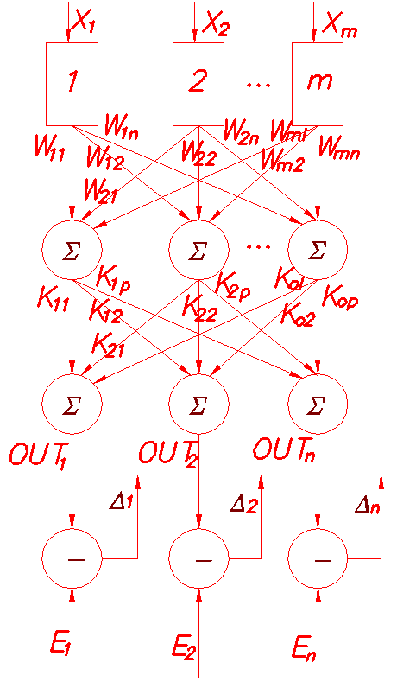

FIGURE 1. Diagram of training intelligent systems based on neural networks using the backpropagation method.

The size of the training set is directly proportional to the number of all weights of the intelligent system based on neural networks and inversely proportional to the proportion of incorrect decisions when the trained network is operating.
The disadvantage of the backpropagation algorithm is that, despite all the modifications that have been developed, the training process takes a very long time and may never end. An excessive increase in the weights of an intelligent system based on neural networks can lead to network paralysis, since the weights of predictions cannot be changed until training is complete.
The step size must be constantly adjusted, and the network must be constantly retrained, as it gradually forgets the previous training sets it was trained on. All these disadvantages make the development of neural network-based intelligent systems for specific tasks very difficult. Let us now consider the research related to the second stage.
The computational task of selecting appropriate weights consists in optimizing the error function R or optimizing the learning quality index (Fig. 1) [26–28]:

(3)

where – the value of the output neuron obtained using the network for the i-th training set; – capacity of multiple training pairs; – the required value of the output neuron for the i-th training set.
Each i–th error will be defined as the difference between the value at the i-th network output and the i-th training indicator:

(4)

The error function (4) is non-smooth and multiply constrained, and the solution to the problem lies in finding its boundary. In this case, the solution involves the implementation of a scale of intelligent systems based on neural networks. Classic solution methods, such as gradient descent, Newton's method, multi-stage dimensionality reduction, and stochastic methods, provide only one solution to the optimization problem.
Attempts are still being made to use genetic algorithms to solve error function optimization problems. Genetic algorithms work on the basis of parallel processing of competing variants and have major advantages such as fast convergence and insensitivity to local extrema.
The main stages of genetic algorithms are variant generation, selection, crossover, and mutation. Numerous modifications of genetic algorithms have been developed, including multi-colonial algorithms and guided search algorithms, which improve the efficiency of searching for optimal solutions and increase their adaptability to specific tasks.
The work uses material coding, in which genes in a chromosome are material numbers rather than bits. Selection consists of determining the fitness of the corresponding chromosome, which is determined by the formula [28–30]:

(5)

where – number of chromosomes or population size; – adaptability of the i-th chromosome.
The most adapted species crossbreed, forming new variants that can be evaluated using (5). Each individual contains information about the connections in the network between neurons and its weight. Thus, it is possible to adjust both the weights and the structure of intelligent systems based on neural networks. The structural diagram of the algorithm for solving the task is shown in Fig. 2.
As the number of chromosomes increases, the size of the gene pool increases in direct proportion to the number of chromosomes set by the user. Many solutions are always generated as a result of selection, mating, and mutations.

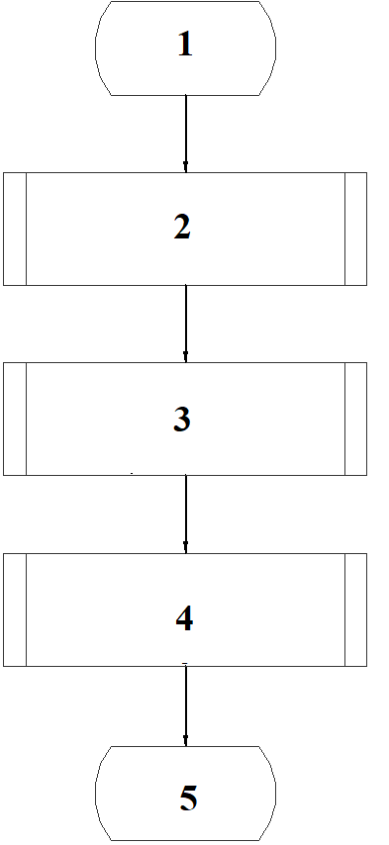

FIGURE 2. Structural diagram of the algorithm.

In Fig. 2: 1 – start; 2 – modified genetic algorithm; 3 – filtering of repeated chromosomes; 4 – finding a set of extrema; 5 – end.
To perform the last step–finding a set of solutions–the hierarchical method of K-means cluster analysis theory was used [30]. A strategy of combining the initial data into clusters was used. Initially, each observation was assigned to a cluster (Fig. 3).

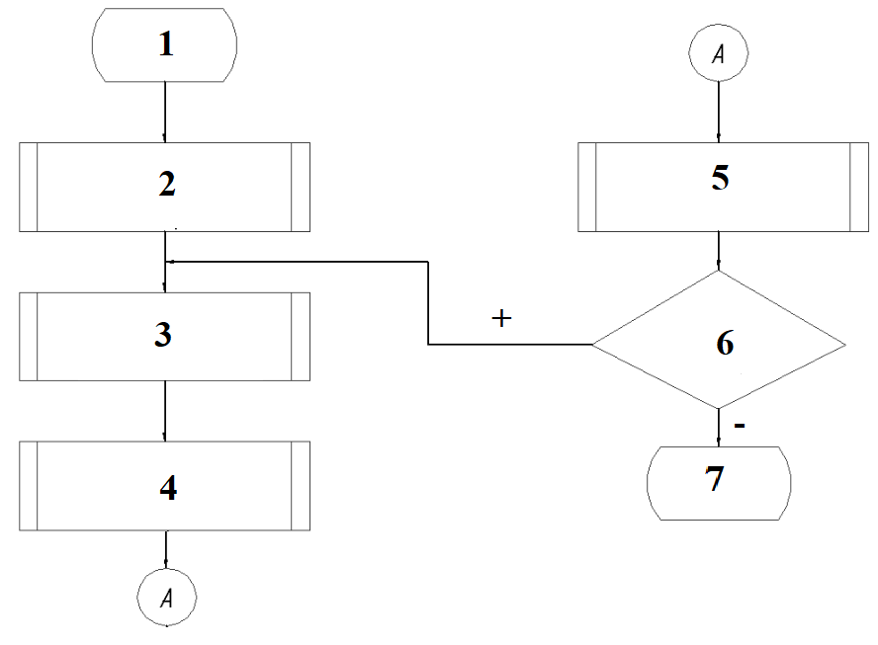

FIGURE 3. Structural diagram of the data clustering algorithm.

In Fig. 3: 1 – start; 2 – creation of element clusters; 3 – calculation of the center of each cluster; 4 – calculation of the distance matrix; 5 – distribution of elements across clusters; 6 – is it possible to reduce the distances to the cluster centers? 7 – end.
Then, the procedure for finding the center of each cluster is performed, and its elements are calculated as the arithmetic mean of the observations contained in this cluster. At the center of each cluster, the sum of the squares of the distances from the center to the elements is calculated [27–29]:

(6)

where – centers of mass of vectors ; – obtained clusters.
Then, the sum of the squares of the deviations of the cluster points from the center is minimized.
The result of checking the distance from each element to the center of its cluster indicates whether the procedure should be repeated or the algorithm should be terminated.
For modeling, Branin test function [24] was used as the error function (6):

(7)

The arguments were varied between [-10; 20] to achieve the minimum of the function .
The complexity of the search lies in the fact that the Branin function has four global extrema (minima located close to each other). When the number of chromosomes is small, the gene pool contains one optimal solution and several close to it.
As the parameter increases, the number of hits in the region of four minima and close minima increases; above the threshold of 1000 chromosomes, studies have shown that a further increase in this parameter increases the number of approximations of the function's extrema to the true value. The results are based on a search accuracy of 0.01. Study of the clustering procedure. The initial value was the set obtained as a result of the multi-colonial genetic algorithm (gene pool). A value of 925 was taken as a sufficient number of chromosomes. The power of the set of variants after filtering identical solutions (Fig. 3) for the Branin function is equal to 87. The results of the algorithm shown are given in Table 1.

TABLE 1. Results of the clustering algorithm.
Number of the cluster found | Coordinates of the cluster center | Meaning of the function  at the cluster center | Corresponding coordinates of the function's extreme value | Meaning of the function  at the extreme point
1 | (8.9; 2.38) | 1.48 | (9.3; 2.4) | 0.42
2 | (3.4; 1.65) | 0.8 | (3.29; 2.17) | 0.42
3 | (-3.08; 12.2) | 0.39 | (-3.1; 12.3) | 0.42
4 | (15.48;13.6) | 0.5 | (15.4; 13.1) | 0.42

Analysis of the clustering results (Table 1) shows that the algorithm successfully identified all four areas of local minima of the Branin function. Further local refinement of the coordinates made it possible to reduce the value of the objective function in three out of four cases. In particular, the first cluster shows the greatest improvement: the function value decreased from 1.48 to 0.42 with a shift of the cluster center coordinates by a distance of about 0.40 from the true minimum, which is approximately a 72% relative improvement. The second and fourth clusters also show a significant decrease in functionality (by 48% and 16%, respectively), although the distance between the cluster center and the extreme in these cases exceeds 0.5. This indicates the presence of elongated or anisotropic minimum regions, where the average value of a set of points is shifted from the true minimum. The third cluster proved to be the most accurate: the distance to the extreme was only 0.10, and the value of the function at the center almost coincided with the value at the minimum (0.39 vs. 0.42). A slight deviation towards a worse value can be explained by the influence of rounding or by the fact that the center has already fallen into the immediate vicinity of the minimum. In summary, the average distance between cluster centers and extrema was 0.39, and the average relative improvement in the function value after local refinement was approximately 49%. All the minimum values of the function found practically coincide (Q≈0.42), which confirms the presence of several equivalent minima and the correctness of the algorithm. Therefore, several conclusions can be drawn. First, the algorithm detected all four basins of attraction of minima, but the accuracy of the cluster centers' locations was uneven. Some areas (clusters 2 and 4) are characterized by a significant shift in the centers, while cluster 3 showed an almost perfect result. Second, the use of local search after clustering is a necessary step that significantly improves the accuracy of finding minima. Third, to improve the quality of cluster centers, it is advisable to increase the population size (over 1000 chromosomes), apply clustering methods that are more resistant to outliers and anisotropy (e.g., k–medoids or DBSCAN), and refine the minimum using more accurate local methods with stricter stopping criteria.
Overall, the study confirmed the effectiveness of the approach: combining a multi-colonial genetic algorithm with clustering and subsequent local search ensures that all equivalent minima of the Branin function are found with acceptable accuracy.

CONCLUSION
The proposed method for synthesizing the optimal structure of an artificial neural network is based on the application of two algorithms. A modified genetic algorithm has been developed which, unlike the classical one, allows finding a multitude of optimal solutions. The proposed method of data clustering allows dividing the areas of optimum locations into areas in which the found cluster centers are as close as possible to the real extrema.
Compared to the backpropagation method, the developed procedure has the advantage that the selection of weights is carried out independently of the form and number of local extrema. This makes it possible, when configuring the weights of neural networks, and as a result, their structure, to find a multitude of optimal options, which gives the researcher more options for implementing complex systems in the process of making technical decisions.
The analysis confirmed that the algorithm correctly identified all four areas of local minima of the Branin function. The values of the function at the extrema are practically identical (Q≈0.42), which indicates the presence of several equivalent minima and the correctness of the search. At the same time, the accuracy of determining the cluster centers was uneven: while the third cluster showed an almost perfect approximation to the minimum, the centers of the first, second, and fourth clusters had more noticeable shifts. Further local refinement of the coordinates significantly improved the results–on average, the function value decreased by almost 49%, proving the effectiveness of combining clustering with local optimization.
To improve the quality of solutions, it is advisable to increase the size of the chromosome population to more than 1000, optimally to 1200–1500, which will allow for a more accurate approximation of the cluster centers. It is also recommended to consider using alternative clustering methods that are more resistant to outliers and anisotropy, such as k–medoids or DBSCAN. The use of weighted centroids taking into account the density of points may also be effective. At the local optimization stage, it is worth using more accurate methods, such as BFGS or Nelder–Mead, with stricter stopping criteria. In addition, for an objective evaluation of the algorithm's performance, it is advisable to implement quantitative clustering quality metrics (silhouette index, Davis–Bouldin coefficient, etc.) and systematically compare the distance from the cluster center to the extreme and the difference in function values.
An additional area for improvement is controlling cluster size and selecting representative solutions from each pool before local search. Thus, the results obtained confirm the effectiveness of the approach used, and the proposed areas for improvement can increase the accuracy and stability of the algorithm when searching for global and local minima of complex functions.
To develop the proposed approach, it is planned to develop algorithms for configuring the structure of an artificial neural network.

Acknowledgments
The authors would like to express their gratitude to Zaporizhzhia Polytechnic National University and the organizing committee of the Modern Automotive Industry, Transport and Road Infrastructure (MAITRI) conference.

Conflict of interests
The authors declare that there is no conflict of interests regarding the publication of this paper.

References
[1] D. O. Kulagin, “The mathematical model of asynchronous traction motor taking into account the saturation of magnetic circuits,” Naukovyi Visnyk Natsionalnoho Hirnychoho Universytetu 2014(6), 103–110 (2014).
[2] K. Narula, Y. Nagai, and S. Pachauri, “The role of decentralized distributed generation in achieving universal rural electrification in South Asia by 2030,” Energy Policy 47, 345–357 (2012). DOI: https://doi.org/10.1016/j.enpol.2012.04.075
[3] D. O. Kulahin, “Rolling electrical complex on the basis of the criterion of minimizing the area under the curve of motion,” Naukovyi Visnyk Natsionalnoho Hirnychoho Universytetu 2016(2), 60–67 (2016).
[4] P. Janik, Photovoltaic Power Generation Assessment Based on Advanced Signal Processing and Optimisation Techniques (Wroclaw University of Science and Technology, Wroclaw, 2014).
[5] D. O. Kulagin, “Mathematical model of asynchronous traction motor taking into account the saturation,” Tech. Electrodyn. 2014(6), 49–55 (2014).
[6] P. Janik, G. Kosobudzki, and M. Schwarz, “Influence of increasing numbers of RE-inverters on the power quality …,” Front. Electr. Electron. Eng. China 12, 46–53 (2017). DOI: https://doi.org/10.1007/s11708-017-0469-3
[7] D. Kulagin and I. Maslov, “Mathematical model of electromagnetic transients of a frequency-controlled propeller’s induction motor,” in 2024 IEEE 5th KhPI Week on Advanced Technology (KhPIWeek 2024) Proceedings (IEEE, 2024). DOI: https://doi.org/10.1109/KhPIWeek61434.2024.10877991
[8] D. Tsuanyo, Y. Azoumah, D. Didier, and P. Neveu, “Modeling and optimization of batteryless hybrid PV/Diesel systems for off-grid applications,” Energy, pp. 152–163 (2015).
[9] V. V. Nitsenko, “Research on effect of differential-phase protection of busbars system with voltage of 110–750 kV,” Naukovyi Visnyk Natsionalnoho Hirnychoho Universytetu 2017(4), 72–79 (2017).
[10] X. Y. Wang and H. X. Zhang, “A hybrid genetic algorithm for neural network optimization,” Int. J. Neural Syst. 21(5), 421–432 (2011). DOI: https://doi.org/10.1142/S0129065711003096
[11] I. Maslov, O. Tymoshchuk, and D. Kulagin, “Determining the causes of major energy losses in a ship’s unified AC power system,” AIP Conf. Proc. 3428, 020021 (2025). DOI: https://doi.org/10.1063/12.0038611
[12] V. Prokopenko, “Analysis of current approaches to modernizing the electric power scheme of diesel generator transport,” in 2023 IEEE 4th KhPI Week on Advanced Technology (KhPIWeek 2023) Proceedings (IEEE, 2023). DOI: https://doi.org/10.1109/KhPIWeek61412.2023.10312881
[13] K. Bratkovska, “Estimation of optimization approaches … energy intensive equipment’s power-time diagrams …,” in 2022 IEEE 8th International Conference on Energy Smart Systems (ESS 2022) Proceedings (IEEE, 2022), pp. 277–281. DOI: 10.1109/ESS57819.2022.9969248.
[14] S. Yekimov, “The importance of environmental education for effective environmental management,” E3S Web Conf. 296, 08002 (2021). https://doi.org/10.1051/e3sconf/202129608002.
[15] D. V. Fedosha, V. V. Nitsenko, and S. Yu. Shevchenko, "Using a phase-differential busbar protection for switchgears of power system facilities," Naukovyi Visnyk Natsionalnoho Hirnychoho Universytetu 2019(4), 63–67 (2019). DOI: 10.29202/nvngu/2019-4/10.
[16] V. Nitsenko, “Improvement implementation methods of relay busbars protection of switchgears,” Tech. Electrodyn. 2017(6), 61–71 (2017). https://doi.org/10.15407/techned2017.06.061.
[17] B. Korobko, “Experimental study of the efficiency of the differential pump of electromagnetic action on the basis of mathematical modeling of the parameters of its operation,” Lect. Notes Civ. Eng. 181, 203–213 (2022). https://doi.org/10.1007/978-3-030-85043-2_20.
[18] F. Hussain, R. Hussain, A. Anpalagan, and A. Benslimane, “A new block-based reinforcement learning approach for distributed resource allocation in clustered IoT networks,” IEEE Trans. Veh. Technol. 69, 2891–2904 (2020). DOI: https://doi.org/10.1109/TVT.2020.2965796.
[19] P. Kordík, GAME – Hybrid Self-Organizing Modeling System based on GMDH (Springer-Verlag, Berlin, Heidelberg, 2009).
[20] D. C. Ciresan, U. Meier, J. Masci, and J. Schmidhuber, “Multi-column deep neural network for traffic sign classification,” Neural Netw. 32, 333–338 (2012).
[21] V. Mnih, K. Kavukcuoglu, D. Silver, A. Graves, I. Antonoglou, D. Wierstra, and M. Riedmiller, “Playing Atari with deep reinforcement learning,” arXiv:1312.5602 (2013).
[22] K. Gregor, A. Mnih and C. Blundell, “Deep autoregressive networks,” arXiv:1310.8499 (2013).
[23] J. B. Tenenbaum, C. Kemp, T. L. Griffiths, and N. D. Goodman, “How to grow a mind: statistics, structure, and abstraction,” Science 331(6022), 1279–1285 (2011).
[24] Y. Bengio, P. Lamblin, D. Popovici, and H. Larochelle, “Greedy layer-wise training of deep networks,” Adv. Neural Inf. Process. Syst. 19, 153–160 (2007).
[25] M. A. Ranzato, C. Poultney, S. Chopra, and Y. LeCun, “Efficient learning of sparse representations with an energy-based model,” Adv. Neural Inf. Process. Syst. 19, 1137–1144 (2007).
[26] S. A. Khan and M. A. Alimi, “A review of genetic algorithms in optimization,” Comput. Intell. Neurosci. 2017, Article ID 2401356 (2017). DOI: https://doi.org/10.1155/2017/2401356
[27] R. C. Singh and R. A. S. N. Rao, “Genetic algorithms for optimization of power systems,” Int. J. Electr. Power Energy Syst. 64, 176–184 (2015). DOI: https://doi.org/10.1016/j.ijepes.2014.06.002
[28] Y. F. S. Loo and L. Y. Choi, “Application of genetic algorithms for the optimization of scheduling in manufacturing systems,” Comput. Ind. Eng. 137, 106026 (2019). DOI: https://doi.org/10.1016/j.cie.2019.106026
[29] X. X. Zhang and H. Y. Li, “Improved genetic algorithm for solving multi-objective optimization problems,” Soft Comput. 24(9), 6825–6837 (2020). DOI: https://doi.org/10.1007/s00542-020-05743-6
[30] R. Alzubi, N. Ramzan, H. Alzoubi, and A. Amira, “A Hybrid Feature Selection Method for Complex Diseases SNPs,” IEEE Access 6, 1292–1301 (2017). DOI: https://doi.org/10.1109/ACCESS.2017.2778268.

