Research on Energy Storage Systems for Electric Vehicles Based on Batteries and Supercapacitors
Oleh Smyrnov^{1, a)}, Anna Borysenko^{1, b)}, Iryna Trunova^{1, c)} and Andriy Nechaus^{1, d)}
¹Kharkiv National Automobile and Highway University,
Department of Automotive Electronics, 61002 Kharkiv, Ukraine
^{a)} Corresponding author: smirnov1oleg@gmail.com
^{b)} anutochka2111@gmail.com
^{c)} trunova.irinaserg@gmail.com
^{d)} a.nechaus@gmail.com
Abstract. This paper presents a conceptual synthesis of hybrid energy storage systems for electric vehicles, combining lithium-ion batteries with supercapacitors to exploit their complementary characteristics of high energy density and high-power density. Particular emphasis is placed on circuit topologies, energy management strategies, integration with photovoltaic charging and vehicle-to-grid operation, as well as practical packaging and layout considerations – topics that are less systematically addressed in previous reviews. This conceptual synthesis makes reference to Thevenin-type equivalent circuits for lithium-ion batteries and simplified representations of supercapacitors, which are widely employed in the literature to characterize transient and steady-state behavior. A rational active hybrid energy storage systems architecture using two bidirectional DC/DC converters is proposed as a reference solution, since it offers superior control flexibility and efficiency compared to passive or semi-active alternatives. To support the conceptual discussion, an illustrative numerical case study is included, demonstrating a significant reduction in peak battery current during regenerative braking together with an observable enhancement in total recovered energy. The paper concludes with design guidelines and highlights key limitations and perspectives for future research, particularly the role of energy management system optimization and experimental validation under real driving conditions.
Keywords: battery; hybrid energy storage system; electric vehicle; capacity; converter; power; supercapacitor.

INTRODUCTION
The development of electric vehicles is a critical component of the global transition toward sustainable and environmentally friendly transportation. Driven by technological advances and policy support, the electric vehicle market is expanding rapidly, playing a decisive role in reducing greenhouse gas emissions, decreasing dependence on fossil fuels, and improving urban air quality. The evolution of electric vehicles signals the gradual decline of the internal combustion engine (ICE) era. Progress and rapid development in the field of sustainable automotive engineering are being achieved through the deployment of electric motors, which replace ICEs primarily to enhance drivetrain efficiency and ensure environmental compatibility. Electric motors are powered exclusively by battery systems or supercapacitors (SC). The major challenge hindering the widespread adoption of electric vehicles is the development of high-power and high-capacity energy storage systems that can extend driving range and prolong battery lifespan. However, the anticipated levels of power and energy density in battery technologies have not yet been fully achieved. Researchers are actively addressing the issue of designing highly efficient and powerful energy storage systems for electric vehicles. At present, this challenge can be mitigated through the integration of supercapacitors. Supercapacitors are regarded as one of the most promising and distinctive energy storage technologies owing to their exceptional charge-discharge characteristics, ability to deliver higher power than conventional batteries, and extended operational lifetime. Moreover, their reliable performance across a wide temperature range further enhances their potential for application in electric vehicle energy storage systems.

LITERATURE REVIEW AND STATEMENT OF THE PROBLEM
Batteries represent a key component of electric mobility and energy storage. A systematic review and analysis of electric vehicle batteries is provided in [1]. The evaluation and prediction of the instability of lithium-ion battery packs in electric vehicles, based on real-world operational data, are reported in [2]. The reliability and efficiency of energy storage systems used in electric vehicles are of critical importance to consumers. An overview of the main challenges associated with lithium-ion batteries in electric vehicles is presented in [3].
A practical solution is the integration of a battery with a supercapacitor, which is essentially an electrochemical device with a similar architecture but characterized by a higher charge-discharge rate and superior cycling stability. In such a configuration, the supercapacitor can supply the additional energy required when the battery alone is insufficient. Beyond considering the battery and supercapacitor as independent units, the electrical design of the hybrid system architecture is of paramount importance. Recent studies on the application of hybrid battery-supercapacitor energy storage systems in electric vehicles are reviewed in [4].
The use of energy-efficient technologies that combine supercapacitors and lithium-ion batteries has recently gained wide adoption in transportation, industry, and power engineering, particularly in the domain of electric vehicles [5, 6]. A comprehensive review presented in [7] highlights the latest advances in the design and implementation of hybrid energy storage systems (HESS) based on batteries and supercapacitors for electric vehicles. The study examines the impact of integrating such hybrid systems on key performance indicators, including extended driving range, improved acceleration, and enhanced overall durability of lithium-ion batteries.
In [8], it was established that two essential components of electric vehicle power management systems are the battery pack and supercapacitors. Long-term energy storage is ensured by the high energy density of batteries, complemented by the high-power density and fast charge/discharge capability of supercapacitors. The integration of these technologies enables effective energy management, balancing energy demands while extending battery lifetime.
In [9], a hybrid energy storage system for electric vehicles, combining batteries and a supercapacitor integrated with solar photovoltaic cells, was proposed and numerically modeled in MATLAB/Simulink.
Furthermore, in [10], a control strategy was developed for an active hybrid battery-supercapacitor energy storage system intended for electric vehicle applications.
In [11], a hybrid energy management method for a battery-supercapacitor energy storage system is presented, along with an approach to integrated charging in electric vehicles. An enhanced energy management strategy for hybrid energy storage systems in electric vehicles is reported in [12].
Furthermore, in [13], an optimized energy management strategy based on an adaptive neuro-fuzzy inference system is proposed for the integration of battery and supercapacitor power in electric vehicles.
The study in [14] introduces a dual energy storage solution for electric vehicles, combining a lithium-ion battery as the primary energy source with a supercapacitor serving as an auxiliary energy buffer.
In [15], recent advances in the integration of lithium-ion batteries and supercapacitors are reviewed, highlighting innovative synthesis strategies and hybrid nanostructures. Finally, [16] provides an analysis of the development trends of supercapacitors and batteries over the past 18 years and outlines prospects for their application in the coming decade.
The analysis of publications indicates that the ideal characteristics of energy storage systems for electric vehicles include high specific energy and power density, rapid response, extended service life, high operational reliability, and low maintenance costs. Lithium-ion batteries are currently emerging as the dominant technology among various battery types due to their relatively low cost, favorable specific characteristics, and high number of charge-discharge cycles. It is expected that next-generation lithium-ion batteries will achieve an energy density of up to 500 Wh/kg. However, their limitations, such as insufficient specific power and susceptibility to degradation, necessitate the development of hybrid battery-supercapacitor energy storage systems.
Although several recent reviews and studies [7-12, 16] address elements of battery–supercapacitor hybrid systems, a focused conceptual synthesis that explicitly combines HESS design, PV and V2G integration and practical packaging/layout considerations for vehicle implementation remains limited. The present work aims to provide such a synthesis and to illustrate its implications via circuit-level solutions and a numerical example.
Reliability, efficiency, and long service life of the energy storage system used in electric vehicles are of critical importance to consumers. At present, lithium-ion batteries equipped with a battery management system (BMS) and a cooling system are predominantly employed to supply power to electric vehicle drives. This choice is justified by the fact that lithium-ion batteries offer high specific energy, high operating voltage, low self-discharge rate, and sufficiently high charge acceptance.
However, such energy storage systems exhibit several challenges, including:
- capacity fade caused by the degradation of lithium-ion batteries, which reduces both the driving range and service life of electric vehicles [17];
- safety concerns, which may lead to elevated temperatures, thermal runaway, fire, and even explosion of lithium-ion batteries [3, 18].
In addition, lithium-ion batteries show significant drawbacks when used as the sole power source in the energy storage system of electric vehicles. For instance, during steep ascents, rapid acceleration, or sudden starts, electric vehicles are unable to effectively meet the demands of high-rate discharge. Furthermore, during energy recuperation, particularly on downhill slopes under regenerative braking conditions – lithium-ion batteries are unable to fully absorb the recovered energy. In such cases, the high charging current accelerates degradation and shortens the service life of the battery. Therefore, the development of energy storage systems for electric vehicles based on rechargeable batteries and supercapacitors represents a highly relevant and promising research direction.

Research Aim and Objectives
The objective of this research is to enhance the environmental sustainability, power capability, efficiency, and service life of electric vehicle energy storage systems through the combined utilization of lithium-ion batteries and supercapacitors.
To achieve this objective, the following research tasks have been carried out:
- substantiation of the research direction, determination of the relevance, and assessment of the prospects for the development of energy storage systems for electric vehicles;
- systematic review and analysis of recent scientific and technical literature on electric vehicles, energy storage systems, lithium-ion batteries, supercapacitors, and control systems;
- analysis of lithium-ion batteries, including the development of equivalent electrical circuits and battery models;
- analysis of supercapacitors, including the development of equivalent electrical circuits and supercapacitor models, as well as identification of the main characteristics of commercially available devices;
- development of circuit solutions for the design of a hybrid battery-supercapacitor energy storage system for electric vehicles, along with investigations of vehicle-to-grid technology integrated with a photovoltaic power station;
- construction of structural and electrical schematics of voltage converters for electric vehicle drives;
- development of rational approaches to the placement of supercapacitors and other components of a hybrid energy storage system within the vehicle;
- formulation of key challenges and prospects for the implementation of hybrid battery-supercapacitor energy storage systems in the field of sustainable automotive engineering.

LITHIUM-ION BATTERY RESEARCH
Lithium-ion batteries offer several advantages over other advanced battery technologies, such as nickel–metal hydride and nickel-cadmium. They exhibit one of the highest specific energy densities among contemporary battery technologies, ranging from 200 Wh/kg to 500 Wh/kg. Furthermore, lithium-ion batteries provide up to three times more charge/discharge cycles compared to these technologies. This implies that lithium-ion batteries can ensure a longer service life with relatively low maintenance requirements compared to other types of batteries.
Another important advantage is their low self-discharge rate, which is typically in the range of 3–5% per month. In contrast, nickel-metal hydride batteries, such as those used in the Toyota Prius, exhibit a self-discharge rate of about 30%. Owing to these advantages, lithium-ion batteries have largely replaced nickel-cadmium and nickel-metal hydride batteries as the dominant technology in the market for portable electronic devices (e.g., smartphones and laptops). They are also widely employed in aerospace applications, where weight is a critical factor. In the automotive industry, electric vehicles such as the Nissan Leaf, Tesla, and others use lithium-ion batteries as their primary energy source. Despite these advantages, lithium-ion batteries still have notable drawbacks, particularly regarding safety. They are prone to overheating and can be damaged by excessive voltage [19]. Elevated temperatures may, in some cases, lead to thermal runaway and combustion. Consequently, in recent years, several safety management strategies have been developed to enhance operational reliability and reduce the failure rate of lithium-ion batteries [20].
A comparison of the key parameters of various types of commercial rechargeable batteries is presented in Table 1.
TABLE 1. Comparative parameters of rechargeable batteries
Battery type | Cell voltage, V | Specific energy, Wh/kg | Specific power, W/kg | Cycle life
Lead acid | 2.2 | 35 | 180 | 1,000
Nickel-cadmium | 1.2 | 50 – 80 | 200 | 2,000
Nickel-metal hydride | 1.2 | 70 – 95 | 250 | 3,000
Lithium-ion | 3.6 | 200 – 500 | 350 | 5,000

The following types of lithium-based batteries are commercially widely used: lithium cobalt oxide (LCO), lithium iron phosphate (LFP), lithium manganese oxide (LMO), lithium nickel manganese cobalt oxide (NMC), lithium nickel cobalt aluminum oxide (NCA), lithium titanium oxide (LTO).
Lithium cobalt oxide batteries have been widely deployed in portable electronic devices owing to their high volumetric energy density. They have also found application in electric vehicles, including the Tesla Roadster and Smart ForTwo. However, their widespread adoption in the automotive sector has been constrained by the high cost associated with the limited availability of cobalt resources [21]. Another cathode material employed in electric vehicles, particularly in electric buses in China, is lithium iron phosphate.
The key advantages of LFP batteries include stable operating voltage, long cycle life, and high thermal stability. Lithium manganese oxide is another commercially utilized cathode material, valued for its good thermal stability and power capability at relatively low cost; however, its energy density remains limited. To enhance energy density, some electric vehicles – such as the Nissan Leaf, BMW i3, and Chevrolet Bolt – incorporate blended battery systems that combine LMO cells with lithium nickel manganese cobalt oxide cells. Nickel-rich lithium NMC batteries offer high specific energy, however, their thermal stability and charge-discharge cycle life necessitate additional safety measures prior to integration into electric vehicles. Lithium NCA batteries are employed in electric vehicles such as those manufactured by Tesla.
One of the most widely used electrical models of a lithium-ion battery is the Thevenin model [22]. The equivalent Thevenin model incorporates a polarization resistance (R_{Th}) in parallel with an equivalent capacitance (C_{Th}), as illustrated in Fig. 1 a. The Thevenin capacitor (C_{Th}) accounts for the transient characteristics observed during the charge-discharge process of the battery. In study [22], a lithium-ion battery model for the Partnership for a New Generation of Vehicles (PNGV) was developed to support the next generation of electric vehicles. The equivalent electrical circuit of the PNGV battery differs from the Thevenin battery model by incorporating an additional capacitor in series with the resistor R₀, as illustrated in Fig. 1 b. This additional capacitor C_{d} helps to explain variations in the open-circuit voltage of an electric vehicle battery under load current conditions.

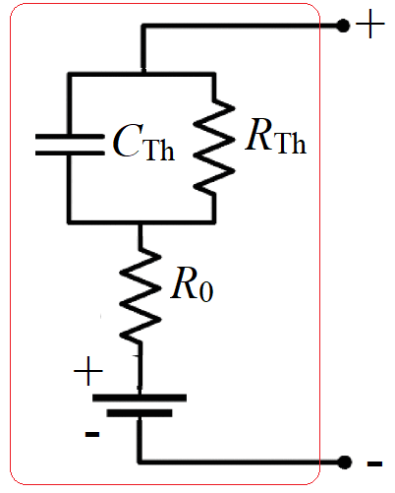 | 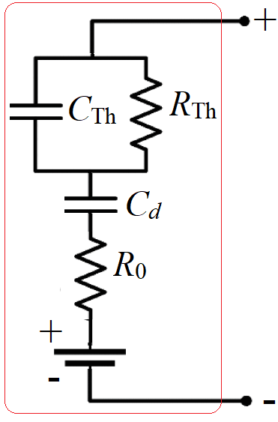 | 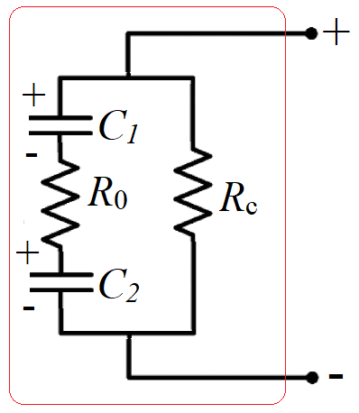
(a) | (b) | (c)
Figure 1. Equivalent electrical circuits of a lithium-ion battery and supercapacitors: (a) Thevenin model; (b) PNGV model; (c) supercapacitor model.

Supercapacitors Research
In the scientific literature, the terms electrochemical double-layer capacitors, ultracapacitors, and supercapacitors are commonly used to describe electrochemical energy storage technologies suitable for rapid energy release
[8, 23–27]. Supercapacitors are characterized by high specific power, fast charge-discharge capability, and an extended cycle life with virtually negligible degradation. When constructing an equivalent electrical circuit of a practical supercapacitor, it is necessary to account for the double-layer capacitance formed at the electrode-electrolyte interface, which is associated with a certain resistance. In addition, supercapacitors exhibit a self-discharge current resulting from their structural characteristics and underlying electrochemical processes. Therefore, a practical supercapacitor can be represented by the equivalent electrical circuit illustrated in Fig. 1 c. Where C₁ is the capacitance of the anode double-layer, C₂ is the capacitance of the cathode double-layer; R₀ is the internal resistance; R_{c} is the self-discharge resistance.
The virtually unlimited service life of supercapacitors represents another significant advantage, as they can operate for between 100,000 and 1,000,000 cycles owing to their charge storage mechanism. Unlike batteries, they physically store charge on the surface of the electrodes without irreversible chemical reactions, thereby achieving a longer operational lifetime. Moreover, the simple charge storage mechanism generates less heat compared to batteries, ensuring safer and more reliable operation. It is also important to highlight the wide operating temperature range of different energy storage devices. Supercapacitors can be used at temperatures as low as −40 °C, which is unattainable for conventional batteries. In addition, supercapacitors exhibit greater reliability and safety than batteries under high-current charge-discharge conditions. A supercapacitor is capable of delivering up to one hundred times more power than batteries of the same volume, although the amount of electrical energy it can store is typically 3 to 30 times lower.
Recently, supercapacitors have been increasingly employed in transportation applications as high-power buffers, either independently or in combination with rechargeable batteries. However, supercapacitors exhibit a relatively low specific energy, typically ranging from 2.5 Wh/kg to 15 Wh/kg. At the same time, they demonstrate an exceptionally high specific power, reaching up to 10,000 W/kg, which enables rapid charge-discharge capabilities. These properties make them well suited for a variety of high-power applications, including regenerative braking and acceleration in electric vehicles. As integral components of HESS in electric vehicles, supercapacitors meet stringent power requirements, thereby alleviating the load on batteries, extending their service life, and enhancing the overall efficiency of electric vehicles. Supercapacitors have also found application in commercial transportation. For instance, the Chinese company «Ningbo CSR New Energy Technology» developed electric buses equipped with CSRCAP supercapacitors, which consume approximately 50 % less energy compared to conventional electric buses [23]. In 2010, PSA introduced a vehicle that employed supercapacitors to enhance initial acceleration and to recover braking mechanical energy into electrical energy, thereby reducing overall energy consumption. This approach significantly improves efficiency compared with conventional vehicles powered by gasoline and diesel engines [23].
Thus, a supercapacitor is an efficient electrical energy storage device with considerable potential for application in electric transportation. However, to enable their effective integration into electric vehicles, supercapacitors must be cost-effective, compact, and possess high energy density, while rational design approaches for hybrid battery-supercapacitor energy storage systems should also be developed.

Circuit design solutions for the development of a hybrid battery-supercapacitor energy storage system for electric vehicles
Hybrid battery-supercapacitor energy storage systems are gaining increasing attention due to their ability to combine the advantages of different energy storage technologies. The choice of circuit topology has a significant impact on both the performance of the energy storage system and the overall efficiency of the electric vehicle. The two energy sources (the battery and the supercapacitors) can be interconnected using different topologies, incorporating one or more DC/DC converters:
- passive topology is the simplest, consisting of a battery and a supercapacitor connected in parallel (Fig. 2 a). Although cost-effective and easy to implement, this configuration lacks active control mechanisms, which may result in voltage imbalance and reduced system efficiency, particularly under dynamic load conditions;
- semi-active topologies employ power electronic converters to enable active control of the energy flow between the battery and the supercapacitor (Fig. 2 b and Fig. 2 c);
- active topology employs dedicated power electronic converters for both the battery and the
supercapacitor (Fig. 2 d).
In our view, the active HESS topology is the most suitable for application in electric vehicles, as it enables optimal energy management, provides a rapid response to dynamic load variations, and ensures improved overall efficiency. The active topology can effectively meet the high-power demands during acceleration and braking, as well as the steady power requirements during constant-speed driving. The active HESS topology can enhance the efficiency, driving range, and overall performance of an electric vehicle by optimizing the utilization of both the battery and the supercapacitor, while simultaneously extending battery lifespan. In this configuration, the supercapacitors and the lithium-ion battery are interconnected via bidirectional DC/DC converters to deliver power to the load.
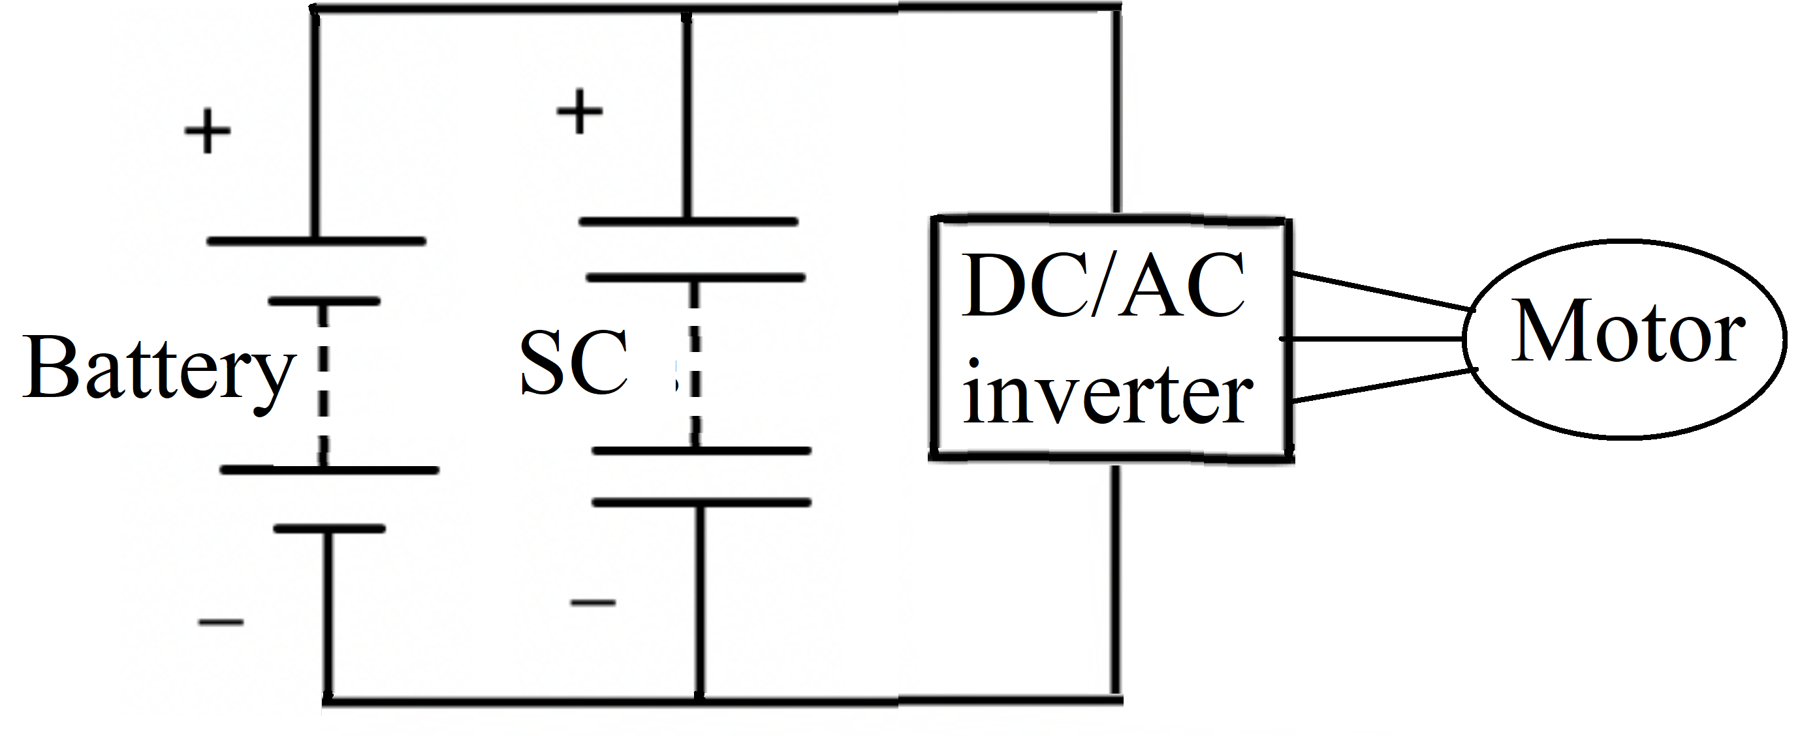 | 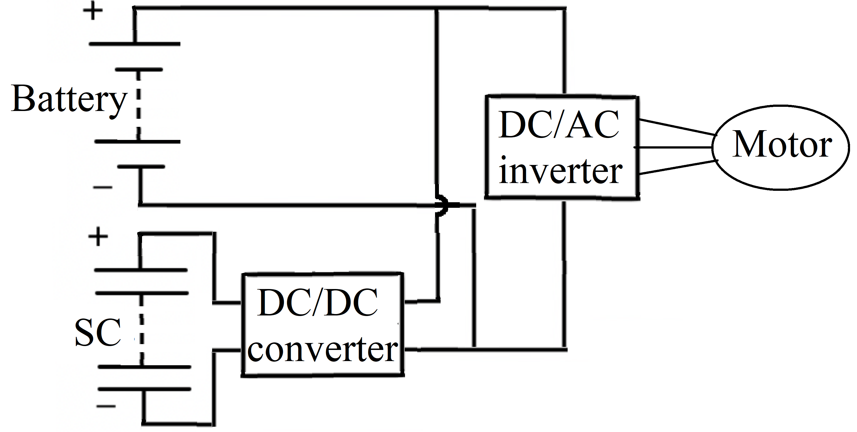
(a) | (b)
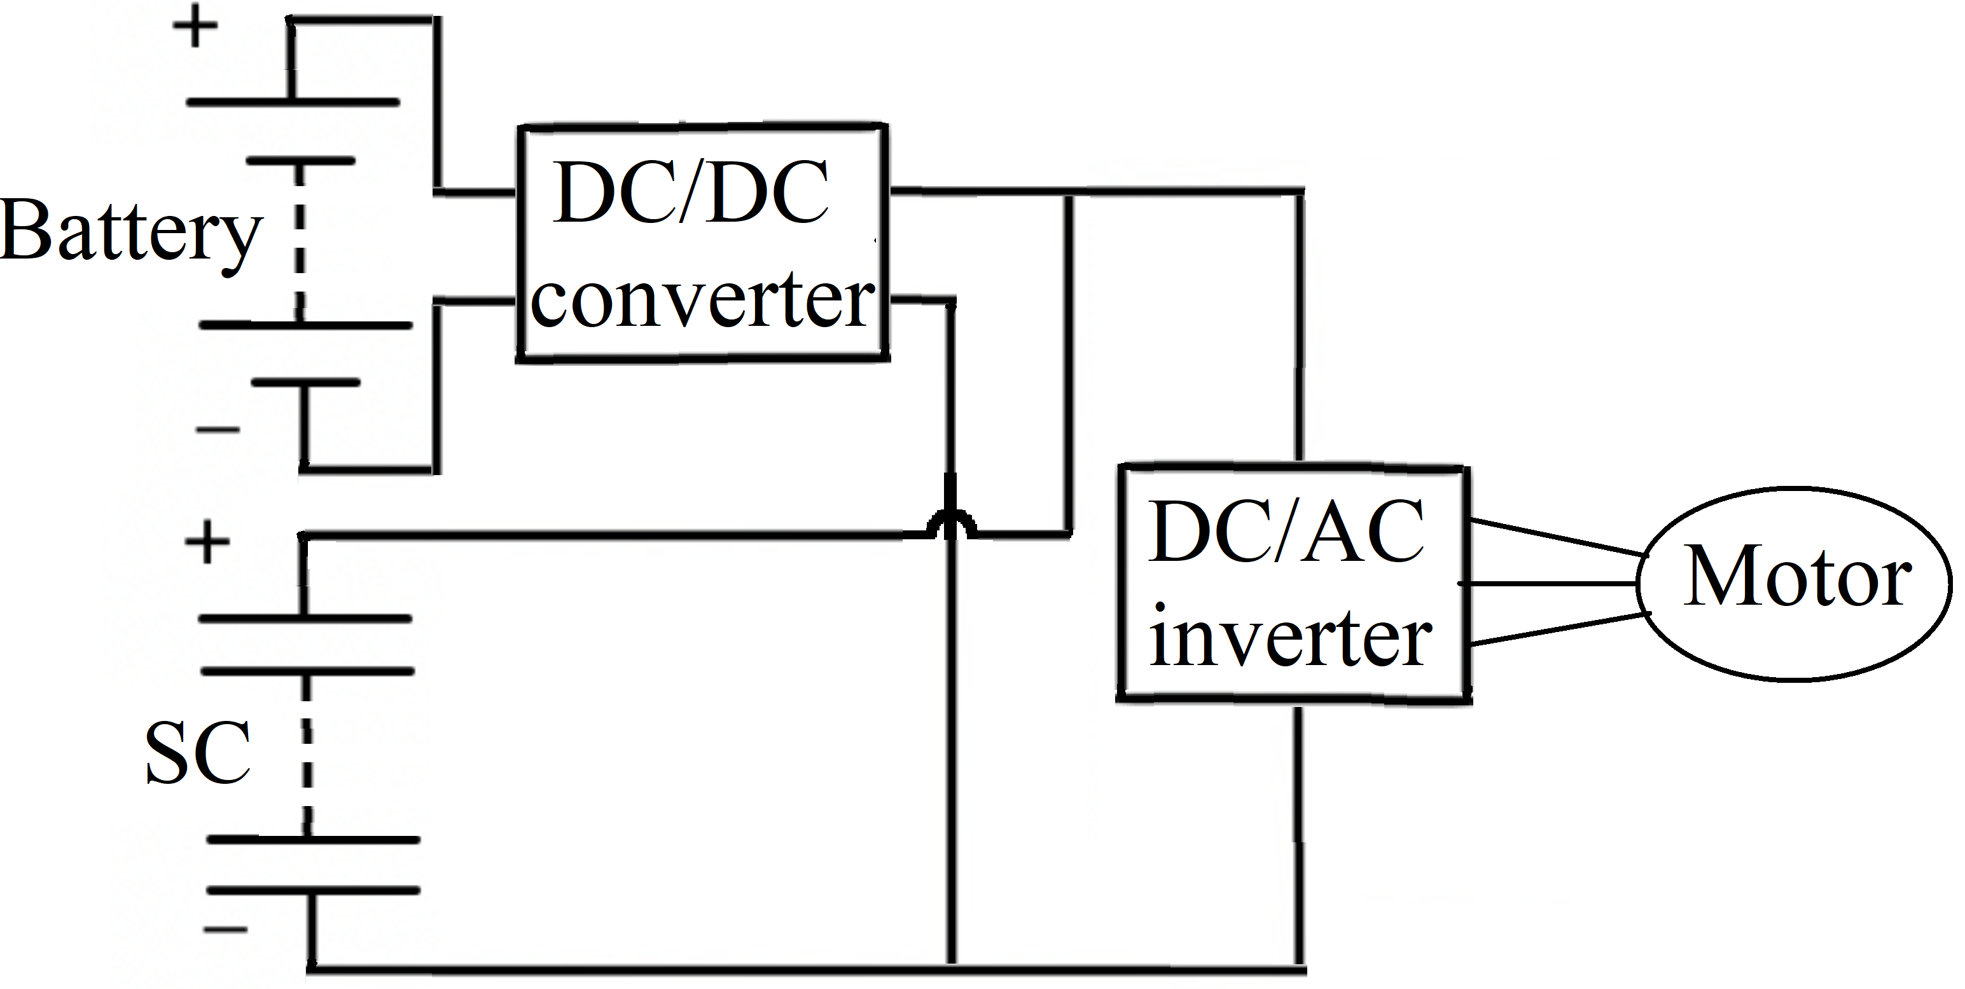 | 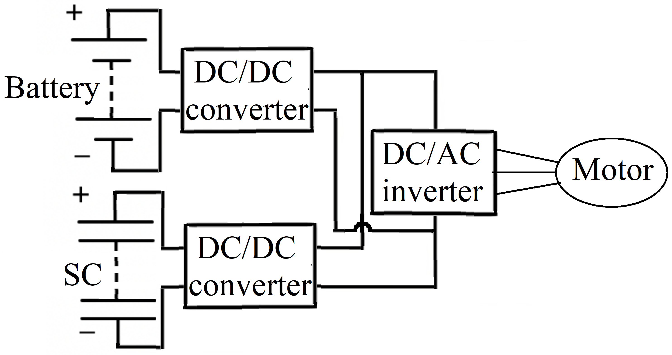
(c) | (d)
Figure 2. Structural configurations of a hybrid energy storage system: (a) passive topology; (b) semi-active topology with supercapacitor control; (c) semi-active topology with battery control; (d) active topology.

To complement the discussion of circuit solutions, a comparative evaluation of passive, semi-active, and active hybrid energy storage system topologies is presented in Table 2. The comparison is based on key performance indicators frequently reported in the literature [28, 29], including energy recovery efficiency, battery current ripple reduction, cost, mass, and packaging flexibility.

TABLE 2. Comparative analysis of hybrid energy storage system topologies for electric vehicles
Topology type | Regenerative and energy efficiency, % | Energy efficiency, % | Battery current ripple reduction, % | Cost | Mass | Packaging flexibility | Applicability in EVs
Passive | ~60 | 85 | ~20 | Low | Low | Limited | Limited
Semi-active | ~75 | 90 | ~35 | Medium | Medium | Moderate | Suitable for small EVs
Active | ~85 | 95 | ~50–60 | High | High | High | Recommended for EVs

The results indicate that passive topologies, while simple and low-cost, provide only limited efficiency and flexibility, making them suitable only for small-scale applications. Semi-active topologies offer moderate improvements but remain constrained in scalability. Active topologies, despite their higher hardware and control complexity, deliver superior performance across efficiency, current ripple reduction, and packaging flexibility, and are therefore considered the most suitable option for modern electric vehicles.
Figure 3 illustrates the circuit diagram of the HESS, which comprises two bidirectional DC/DC converters, each consisting of two IGBT transistors (T1, T2) and a single inductor (L) that stores and releases electrical energy. The operating mode of the DC/DC converter depends on the system’s power demand and the state of charge of both the battery and the supercapacitor.
The energy management system (ЕМS) of the HESS enhances power management by effectively distributing energy between the supercapacitors and the battery. Furthermore, control strategies such as proportional-integral-derivative (PID) regulators are employed to optimize energy consumption, thereby maximizing system efficiency and reliability. In addition, the EMS enables rapid energy discharge from the supercapacitors while providing sustained energy supply from the battery, which improves the overall stability of the system and enhances the dynamic performance of the electric vehicle.
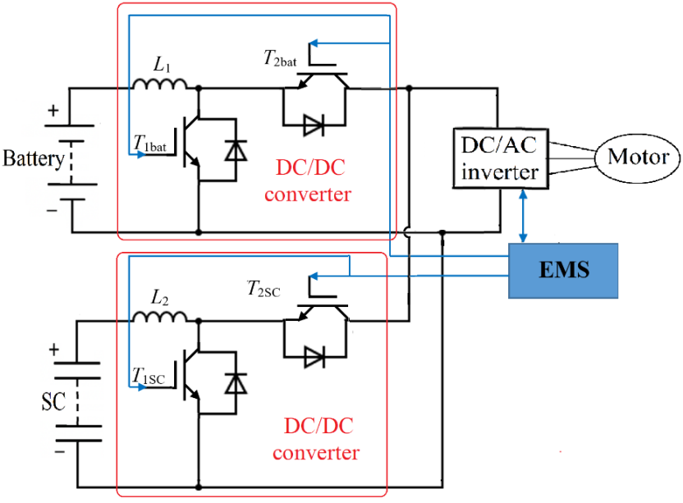
Figure 3. Structural configurations of the hybrid energy storage system.

Through two bidirectional DC/DC converters, the lithium-ion battery and the supercapacitor pack are connected to the DC bus to supply power to the DC/AC inverter, which is integrated into the electric motor control system. The DC/AC inverter converts direct current into alternating current to drive the electric motor, which in turn propels the electric vehicle via the transmission system.
The EMS allows the energy to be managed between the two sources based on the state of charge of each source, the vehicle's driving status, and road conditions such as starting, accelerating, decelerating, climbing, or descending.
To manage the distribution of electrical energy among different sources in order to meet load demands, numerous studies have been conducted on algorithms for developing energy management strategies. These methods are generally classified into two main categories: rule-based methods, optimization-based methods.
Optimization-based approaches can be further divided into two groups: offline global optimization and online local optimization. Representative methods in this category include dynamic programming, neural networks, Pontryagin’s Minimum Principle, genetic algorithms, particle swarm optimization, and model predictive control strategies, among others.
In the active hybrid energy storage system, the lithium-ion battery serves as the primary power source for the electric drive of the vehicle and is employed to supply energy over relatively long operating periods, whereas the supercapacitor is utilized during peak power demand and regenerative braking in order to alleviate the load on the battery.
The peculiarity of the hybrid energy storage system is that it effectively regulates the voltage of the DC circuit, creating a minimal load on the battery, which leads to an increase in its service life, improved dynamics, increased range and overall efficiency of the electric vehicle.
Hybrid battery-supercapacitor energy storage systems for electric vehicles can be effectively utilized when connected to an external power grid via vehicle-to-grid (V2G) technology [30, 31] and integrated with photovoltaic (PV) power plants [32]. PV-based electricity generation systems are emerging as a key solution to environmental challenges while simultaneously meeting the growing global demand for energy. The integration of renewable solar energy with electric vehicles and the power grid offers significant potential for reducing greenhouse gas emissions in both the transportation and energy sectors.
Connecting the hybrid energy storage system of an electric vehicle to the external grid through V2G technology and to a photovoltaic power plant serves not only for charging, but also for enhancing the stability and dynamic response of the PV system. This configuration provides both continuous power supply and rapid grid support.
The study [32] introduces an innovative approach to improving power quality in grid-connected photovoltaic systems by integrating a hybrid energy storage system that combines batteries and supercapacitors with a novel three-phase, ten-switch inverter. The bidirectional converter effectively regulates the exchange of electrical energy between the photovoltaic system, the battery, the supercapacitor, and the external power grid.
In the hybrid energy storage system, the battery provides long-term energy storage for supplying power to the grid. The supercapacitors, in contrast, enable rapid discharge for transient power support during short-term fluctuations in electricity demand, such as variations in solar irradiance or load changes. This hybrid configuration allows the system to respond more rapidly and efficiently to sudden changes in output power.
Each component of the hybrid energy storage system is interfaced with the DC bus through a bidirectional converter, which enables both charging and discharging modes. During charging, the electric vehicle battery absorbs energy either from the external power grid or from the PV system.
Given that supercapacitors exhibit relatively low specific energy, their placement within an electric vehicle represents a critical challenge due to their considerable volume. In [6], a concept was proposed involving the integration of supercapacitors into the vehicle body. The supercapacitors are primarily connected in series to increase the overall operating voltage. Additionally, the series-connected units are arranged in parallel to enhance the nominal energy capacity and power output. The panel geometry of the body-integrated supercapacitors is designed to conform to the contours of the original vehicle structure. They are seamlessly incorporated into the doors, trunk lid, roof, and hood. According to this concept, the supercapacitor modules and other components of the hybrid energy storage system are located on the roof, behind the passenger and driver seats, as well as in the hood and vehicle doors. The bidirectional voltage converter, motor controller, hybrid energy storage management controller, and vehicle control unit are installed in the trunk of the electric vehicle, while the primary energy source – a lithium-ion battery is positioned beneath the two front seats.

CASE STUDY OF A BRAKING–ACCELERATION EVENT

To provide quantitative support for the conceptual analysis, a simplified numerical example is presented. The purpose is to compare the battery current demand and the amount of recovered braking energy in two configurations: a battery-only energy storage system and an active hybrid energy storage system that combines a lithium-ion battery with a supercapacitor. This case study is illustrative and based on representative vehicle and component parameters reported in the literature [33–40].
The case considers a mid-size electric passenger vehicle with a mass of 1500 kg [33]. The initial speed (v₀) is set to 50 km/h (13.89 m/s), and the braking duration (t_{brake}) is assumed to be approximately 3 s, which lies within the range reported in braking-event data [34, 35]. The direct current (DC) bus voltage (V_{bus}) is taken as 350 V, representative of mid-voltage electric vehicles operating in the 300–400 V range [36, 37]. Conversion efficiencies (𝜂_{SC}) are assumed as 98% for the supercapacitor bidirectional DC/DC converter [38] and 90% for the battery-side (η_{bat}) charging path [39]. In line with common energy management strategies, it is further assumed that 80% of the transient braking energy is routed to the supercapacitor and 20% to the battery, reflecting control policies that prioritize the supercapacitor for high-power short-term capture [40].
Step 1. Kinetic energy available:

Step 2. Average braking power:

Step 3. Battery-only case. Without HESS, the battery absorbs the full braking power:

After conversion losses:

Step 4. Active HESS case. Energy directed to SC (before losses):

With converter efficiency:

Energy directed to the battery (before losses):

With efficiency:

Corresponding battery current:

Step 5. Results. The numerical results are summarized in Table 3, providing a side-by-side comparison of the two configurations in terms of peak battery current and recovered braking energy.

TABLE 3. Battery current and recovered energy during braking
Case | Peak battery current, A | Energy to SC, Wh | Energy to battery, Wh | Total recovered, Wh
Battery only | 138 | 0 | 36.2 | 36.2
Active HESS | 28 | 31.5 | 7.2 | 38.7

Discussion and limitations. The results indicate that the active hybrid energy storage system reduces the peak battery current by almost 80 %, significantly alleviating battery current stress during regenerative braking. Furthermore, the total recovered energy is marginally higher compared to the battery-only configuration, primarily due to the high efficiency of the supercapacitor power converter. These findings are consistent with prior studies, which report that hybrid storage systems contribute to both mitigation of battery degradation risks under high-power transients and enhanced utilization of regenerative braking energy [40–42].
This case study is preliminary and based on simplified assumptions. For comprehensive validation, full drive-cycle simulations and experimental tests are required, including detailed modeling of supercapacitor voltage dynamics, converter switching losses, and battery aging effects

Conclusions
A hybrid energy storage system that integrates the advantages of lithium-ion batteries and supercapacitors represents a viable and rational solution to meet the requirements of electric drive power supply systems in electric vehicles. The implementation of such energy storage systems, combining batteries and supercapacitors, is expected to provide the following benefits for the power source, the electric drive, and the electric vehicle as a whole:
- high power capability, which determines the dynamic performance of the electric vehicle;
- high energy capacity, which determines the driving range on a single battery charge;
- extended service life of the lithium-ion battery;
- improved regenerative braking efficiency.
A rational structural configuration of a hybrid battery-supercapacitor energy storage system for electric vehicles is presented, employing two bidirectional DC/DC converters to connect a lithium-ion battery and a supercapacitor module to the DC bus. The traction electric motor is supplied via a three-phase DC/AC inverter. The control system enables energy management between the two sources based on the state of charge of each source, the vehicle’s operational status, and prevailing road conditions. It has been demonstrated that the hybrid battery-supercapacitor energy storage system is also suitable for integration with an external vehicle-to-grid electrical network and a photovoltaic power station. The article examines the layout of the principal components of the electric drive within the vehicle: supercapacitors are embedded into the doors, hood, and roof; batteries are positioned beneath the seats; while voltage converters and control units are installed in the trunk. Finally, the advancement of electric vehicle technologies is strongly dependent on research and development in energy storage systems, manufacturing technologies, and continuous innovations in control systems, paving the way toward a more reliable, sustainable, and efficient future for electric mobility.
Design takeaways:
- active HESS with dedicated bidirectional converters provides the most effective mitigation of peak battery currents during transient events, thereby reducing electrochemical stress and potentially extending battery lifetime;
- in addition to topological and integration aspects, the effectiveness of hybrid battery–supercapacitor systems strongly depends on the design of the Energy Management System (EMS). A simple rule-based EMS, in which the supercapacitor handles high-power short transients and the battery supplies steady power, is practical for real-time implementation. Optimization-based methods, including Dynamic Programming and Model Predictive Control, offer further potential for maximizing regenerative energy utilization and prolonging battery life. The integration of these EMS paradigms remains an important avenue for future research;
- integration with photovoltaic (PV) charging and vehicle-to-grid (V2G) operation is technically feasible and can provide ancillary grid services, but requires coordinated control strategies and careful consideration of converter sizing;
- structural packaging of SC modules into vehicle components (e.g., doors, roof panels) can improve volumetric utilization; however, this introduces significant challenges in terms of mechanical robustness and thermal management;
- converter efficiency and control complexity remain the key trade-offs: active topologies provide superior dynamic performance but at the expense of higher hardware cost and more demanding control requirements.
Limitations and future work:
- the presented numerical case study is illustrative in nature. Comprehensive validation through detailed drive-cycle simulations, Hardware-in-the-Loop testing, and experimental measurements is required;
- battery degradation and ageing mechanisms were not explicitly modeled. Future studies should quantify lifetime benefits of HESS by coupling electrochemical ageing models with system-level energy management;
- mechanical and thermal integration of large-scale SC banks requires dedicated investigation, especially when considering distributed packaging into vehicle structures.

ACKNOWLEDGMENTS
The authors would like to express their gratitude to Kharkiv National Automobile and Highway University and the organizing committee of the Modern Automotive Industry, Transport and Road Infrastructure (MAITRI) conference.

CONFLICT OF INTERESTS
The authors declare that there is no conflict of interests regarding the publication of this paper.

References
[1] F. Liu, M. Shafique and X. Luo, "Unveiling the determinants of battery electric vehicle performance: A systematic review and meta-analysis", Commun. Transp. Res. 4, 100148 (2024). https://doi.org/10.1016/j.commtr.2024.100148
[2] S. Wang, Y. Wang and Y.-Y. Soo, "Evaluation and prediction of lithium-ion battery pack inconsistency in electric vehicles based on actual operating data", Energy 319, 134879 (2025). https://doi.org/10.1016/j.energy.2025.134879
[3] M. Şen, M. Özcan and Y. R. Eker, "A review on the lithium-ion battery problems used in electric vehicles", Next Sustain. 3, 100036 (2024). https://doi.org/10.1016/j.nxsust.2024.100036
[4] L. Kouchachvili, W. Yaïci and E. Entchev, "Hybrid battery/supercapacitor energy storage system for the electric vehicles", J. Power Sources 374, 237–248 (2018). https://doi.org/10.1016/j.jpowsour.2017.11.040
[5] S. M. Benoy, M. Pandey, D. Bhattacharjya and B. K. Saikia, "Recent trends in supercapacitor-battery hybrid energy storage devices based on carbon materials", J. Energy Storage 52, 104938 (2022). https://doi.org/10.1016/j.est.2022.104938
[6] A. Hnatov, S. Arhun, and S. Ponikarovska, "Energy saving technologies for urban bus transport," Int. J. Automot. Mech. Eng. 14(4), 4649–4664 (2017). https://doi.org/10.15282/ijame.14.4.2017.5.0366
[7] C. V. M. Gopi and R. Ramesh, "Review of battery-supercapacitor hybrid energy storage systems for electric vehicles", Eng. 24, 103598 (2024). https://doi.org/10.1016/j.rineng.2024.103598
[8] M. S. Ramkumar, S. Muthukrishnan, J. Giri, T. Sathish and A. Fatehmulla, "Optimizing battery and supercapacitor management in electric vehicles: A hybrid approach for enhanced performance and reduced harmonics," Case Stud. Therm. Eng. 2025, 105815. https://doi.org/10.1016/j.csite.2025.105815
[9] K. Raut, A. Shendge, J. Chaudhari, R. Lamba and N. F. Alshammari, "Modeling and simulation of photovoltaic powered battery-supercapacitor hybrid energy storage system for electric vehicles", J. Energy Storage 82, 110324 (2024). https://doi.org/10.1016/j.est.2023.110324
[10] B. Yang, J. Wang, X. Zhang, J. Wang, H. Shu, S. Li, T. He, C. Lan and T. Yu, "Applications of battery/supercapacitor hybrid energy storage systems for electric vehicles using perturbation observer based robust control", J. Power Sources 448, 227444 (2020). https://doi.org/10.1016/j.jpowsour.2019.227444
[11] O. A. AlKawak, J. R. R. Kumar, S. S. Daniel, and C. V. K. Reddy, "Hybrid method-based energy management of electric vehicles using battery-supercapacitor energy storage," J. Energy Storage 77, 109835 (2024). https://doi.org/10.1016/j.est.2023.109835
[12] M. A. Takrouri, N. R. N. Idris, M. J. A. Aziz, R. Ayop and W. Y. Low, "Refined power follower strategy for enhancing the performance of hybrid energy storage systems in electric vehicles", Eng. 25, 103960 (2025). https://doi.org/10.1016/j.rineng.2025.103960
[13] N. Kumaresan and A. Rammohan, "Adaptive neuro fuzzy inference system based optimized energy management strategy for the power integration of battery and supercapacitor in electric vehicle", J. Energy Storage 126, 117073 (2025). https://doi.org/10.1016/j.est.2025.117073
[14] F. Abdelhedi, I. Jarraya, H. Bawayan, M. Abdelkeder, N. Rizoug and A. Koubaa, "Optimizing Electric Vehicles efficiency with hybrid energy storage: Comparative analysis of rule-based and neural network power management systems", Energy 313, 133979 (2024). https://doi.org/10.1016/j.energy.2024.133979
[15] M. Kazemi, H. Noorizadeh, Y. Jadeja, S. K. Saraswat, R. M. M., A. Shankhyan, S. Supriya, and K. K. Joshi, "Advancing CdSe quantum dots for batteries and supercapacitors: electrochemical frontiers," RSC Adv. 15, 16134–16163 (2025). https://doi.org/10.1039/D5RA02414E
[16] R. K. Azega, A. D. Smith, N. R. Chowdhury, A. Vyas, Q. Li, M. Haque, Q. Xun, X. Zhang, S. Thurakkal, T. Thiringer, P. Enoksson and P. Lundgren, "Supercapacitors and rechargeable batteries, a tale of two technologies: Past, present and beyond", Sustain. Mater. Technol. 41, e01111 (2024). https://doi.org/10.1016/j.susmat.2024.e01111
[17] H. Liu, Z. Deng, Y. Yang, C. Lu, B. Li, C. Liu and D. Cheng, "Capacity evaluation and degradation analysis of lithium-ion battery packs for on-road electric vehicles", J. Energy Storage 65, 107270 (2023). https://doi.org/10.1016/j.est.2023.107270
[18] S. Chavan, B. Venkateswarlu, M. Salman, J. Liu, P. Pawar, S. W. Joo, G. S. Choi and S. C. Kim, "Thermal management strategies for lithium-ion batteries in electric vehicles: Fundamentals, recent advances, thermal models, and cooling techniques", Int. J. Heat Mass Transf. 232, 125918 (2024). https://doi.org/10.1016/j.ijheatmasstransfer.2024.125918
[19] Y. Wang, "Rational design of anode materials for high-performance lithium-ion batteries," in International Conference on Optoelectronic Materials and Devices (ICOMD 2022), edited by Q. Huang (SPIE, Bellingham, WA, 2023), Vol. 12600, p. 126000D. https://doi.org/10.1117/12.2674115
[20] P. V. Chombo and Y. Laoonual, "A review of safety strategies of a Li-ion battery", J. Sources 478, 228649 (2020). https://doi.org/10.1016/j.jpowsour.2020.228649
[21] A. G. Olabi, M. A. Abdelkareem, T. Wilberforce, A. Alkhalidi, T. Salameh, A. G. Abo-Khalil, M. M. Hassan, and E. T. Sayed, "Battery electric vehicles: Progress, power electronic converters, strength (S), weakness (W), opportunity (O), and threats (T)," Int. J. Thermofluids 16, 100212 (2022). https://doi.org/10.1016/j.ijft.2022.100212
[22] E. Hossain, D. Murtaugh, J. Mody, H. M. R. Faruque, M. S. Haque Sunny and N. Mohammad, "A Comprehensive Review on Second-Life Batteries: Current State, Manufacturing Considerations, Applications, Impacts, Barriers & Potential Solutions, Business Strategies, and Policies", IEEE Access 7, 73215–73252 (2019). https://doi.org/10.1109/access.2019.2917859
[23] A. Shuja, H. R. Khan, I. Murtaza, S. Ashraf, Y. Abid, F. Farid, and F. Sajid, "Supercapacitors for energy storage applications: Materials, devices and future directions: A comprehensive review," J. Alloys Compd. 1009, 176924 (2024). https://doi.org/10.1016/j.jallcom.2024.176924
[24] M. Yaseen, M. A. K. Khattak, M. Humayun, M. Usman, S. S. Shah, S. Bibi, B. S. U. Hasnain, S. M. Ahmad, A. Khan, N. Shah, A. A. Tahir and H. Ullah, "A Review of Supercapacitors: Materials Design, Modification, and Applications", Energies 14(22), 7779 (2021). https://doi.org/10.3390/en14227779
[25] Poonam, K. Sharma, A. Arora and S. K. Tripathi, "Review of supercapacitors: Materials and devices", J. Energy Storage 21, 801–825 (2019). https://doi.org/10.1016/j.est.2019.01.010
[26] A. Hnatov, S. Arhun, O. Ulyanets та S. Ponikarovska, "Ultracapacitors Electrobus for Urban Transport", у 2018 IEEE 38th International Conference on Electronics and Nanotechnology (ELNANO), Kiev, 24–26 квітня 2018 (IEEE, 2018). https://doi.org/10.1109/elnano.2018.8477449
[27] A. Hnatov, A. Patlins, S. Arhun, N. Kunicina, H. Hnatova, O. Ulianets та A. Romanovs, "Development of an unified energy-efficient system for urban transport", у 2020 6th IEEE International Energy Conference (ENERGYCon), Gammarth, Tunis, Tunisia, 28 вересня–1 жовтня 2020 (IEEE, 2020). https://doi.org/10.1109/energycon48941.2020.9236606
[28] N. Fesakis, G. Falekas, I. Palaiologou, G. E. Lazaridou, and A. Karlis, “Integration and optimization of multisource electric vehicles: A critical review of hybrid energy systems, topologies, and control algorithms,” Energies 17(17), 4364 (2024). https://doi.org/10.3390/en17174364
[29] I. A. Gadai, et al., “Enhancing electric vehicle performance: A comparative study of full active and passive hybrid energy storage systems via MATLAB Simulink,” Int. Res. J. Eng. Technol. (IRJET) 11(7), (2024), available at https://www.irjet.net/archives/V11/i7/IRJET-V11I7100.pdf
[30] G. M. S. Kumar, X. Guo, S. Zhou, H. Luo, Q. Wu, Y. Liu, Z. Dou, K. Pan, Y. Xu, H. Yang and S. Cao, "State-of-the-art review of smart energy management systems for supporting zero-emission electric vehicles with X2V and V2X interactions", Renew. Sustain. Energy Rev. 208, 115050 (2025). https://doi.org/10.1016/j.rser.2024.115050
[31] O. Smyrnov, A. Borysenko, and I. Trunova, "Development of Vehicle-to-Grid in Ukraine," in Proc. 28th Int. Sci. Conf. Transport Means 2024, pp. 503–506. https://doi.org/10.5755/e01.2351-7034.2024.P503-506
[32] K. B. Tawfiq, H. Zeineldin, A. Al-Durra and E. F. El-Sadaany, "Enhancing photovoltaic grid integration with hybrid energy storage and a novel three-phase ten-switch inverter for superior power quality", Int. J. Electr. Power & Syst. 167, 110580 (2025). https://doi.org/10.1016/j.ijepes.2025.110580
[33] L. Nicoletti, A. Romano, A. König, F. Schockenhoff, and M. Lienkamp, “Parametric modeling of mass and volume effects for battery electric vehicles, with focus on the wheel components,” World Electr. Veh. J. 11(4), 63 (2020). https://doi.org/10.3390/wevj11040063
[34] Analyses of Rear-End Crashes and Near-Crashes in the 100-Car Naturalistic Driving Study to Support Rear-Signaling Countermeasure Development, Report No. DOT HS 810 208, National Highway Traffic Safety Administration, U.S. Department of Transportation, Washington, DC (2007). https://www.nhtsa.gov/sites/nhtsa.gov/files/analyses20of20rear-end20crashes20and20near-crashes20dot20hs2081020846.pdf
[35] A. Kashkanov, A. Semenov, A. Kashkanova, et al., “Estimating the effectiveness of electric vehicles braking when determining the circumstances of a traffic accident,” Sci. Rep. 13, 19916 (2023). https://doi.org/10.1038/s41598-023-47123-7
[36] ZVEI, Voltage Classes for Electric Mobility (ZVEI, Frankfurt, 2021), available at https://www.zvei.org/fileadmin/user_upload/Presse_und_Medien/Publikationen/2014/april/Voltage_Classes_for_Electric_Mobility/Voltage_Classes_for_Electric_Mobility.pdf
[37] Wolfspeed. (2024). EV Charging Power Topologies Design Guidebook (Application Note PRD-08367). https://assets.wolfspeed.com/uploads/2024/01/Wolfspeed_PRD-08367_EV_Charging_Power_Topologies_Design_Guidebook_Application_Note.pdf
[38] J. Wang, B. Wang, L. Zhang, J. Wang, N. I. Shchurov, and B. V. Malozyomov, “Review of bidirectional DC–DC converter topologies for hybrid energy storage system of new energy vehicles,” Green Energy Intell. Transp. 1(2), 100010 (2022). https://doi.org/10.1016/j.geits.2022.100010
[39] Battery University, “BU-808: How to Prolong Lithium-based Batteries,” available at https://batteryuniversity.com/article/bu-808-how-to-prolong-lithium-based-batteries (accessed 2023)
[40] A. Ranjan and S. Bodkhe, “Energy management strategy for hybrid energy storage systems in electric vehicle – A review,” Int. J. Electr. Electron. Eng. Telecommun. 11(2), 88–101 (2022). https://doi.org/10.18178/ijeetc.11.2.88-101
[41] D. Lemian and F. Bode, “Battery-supercapacitor energy storage systems for electrical vehicles: A review,” Energies 15, 5683 (2022). https://doi.org/10.3390/en15155683
[42] A. Urooj and A. Nasir, “Review of hybrid energy storage systems for hybrid electric vehicles,” World Electr. Veh. J. 15(8), 342 (2024). https://doi.org/10.3390/wevj15080342

