Some Ways to Increase the Level of Public Transport Attractiveness Using the Example of Cherkasy City
Ihor Shlonchak^{1, a)}, Liudmyla Tarandushka^{1, b)}, Ivan Tarandushka^{1, c)},
Yan Tarandushka^{1, d)}, Oleh Zakharchuk^{2, e)} and Emiliia Shlonchak^{1, f)}
¹Cherkasy State Technological University,
Department of Vehicles and Technology for Their Operation, 18000 Cherkasy, Ukraine
²Lutsk National Technical University,
Department of Automobile and Transport Technology, 43018 Lutsk, Ukraine
^{a)} Corresponding author: Igor_Shlionchak@ukr.net
^{b)} Tarandushkal@ukr.net
^{с)} i.tarandushka@chdtu.edu.ua
^{d)} yan453620@gmail.com
^{e)} zaharchukov205@gmail.com
^{f)} emily_shlnchk@ukr.net
Abstract. The article examines ways to increase the attractiveness of public transport in order to increase the level of urban mobility. The main features of transport mobility are identified, which distinguish it from freedom of movement. A classification of factors and their characteristics that affect the city's public transport system is carried out. A survey of city residents was conducted, based on the results of which the main requirements for public transport were formed. The existing public transport system in the city of Cherkassy, Ukraine, was analyzed. Based on the analysis, ways of its improvement were identified. It was shown that the most appropriate vector of improvement in the current conditions is the renewal of the public transport fleet and the replacement of route buses with electric buses A08611 "Malva Electro". A typical urban public transport route and passenger flows along this route have been studied. The number and cost of electric buses necessary to meet the needs of residents in passenger transportation, as well as the interval of public transport on a given route, have been determined. The implementation of the recommendations provided will contribute to increasing population mobility and improving the environmental situation in the city.

Keywords: public transport, attractiveness level, sustainable transport, urban transport system, electric bus.

Introduction
The modern city is a dynamic structure within which economic, political, social, cultural and transport components actively function and develop. At the same time, the share of the urban population in the total population continues to grow [1]. According to the UN Economic and Social Council, the share of the urban population in Singapore is 100%, in Japan - 92.5%, in France - 86.9%, in the USA - 82.9%, in Ukraine - 69.2%. The expansion of urban areas, the formation of megacities and urban agglomerations lead to the need to meet the needs of urban residents in movement associated with the performance of various socio-cultural functions. Mobility is one of the main criteria for the effectiveness of modern society. Mobility of the urban population is ensured by transport mobility.
Transport mobility is generally understood as the intensity of spatial movements of people, expressed in such indicators as the average number of trips or the number of passengers per kilometer per inhabitant over a certain period of time. In general, the expansion of freedom of movement contributes to the growth of population mobility. However, Ilchuk notes that there are significant differences between these concepts (Table 1) [2].

TABLE 1. Differences between the concepts of "freedom of movement" and "population mobility"
Freedom of movement | Population mobility
Determined by the ability to move | Determined only in quantitative terms and characterized by already completed movements
Covers both the movement of people and the movement of material resources | Applies only to the movement of people

Transport mobility is the process of safe, comfortable, fast, accessible and economically justified movement of a person or group of people using one or more modes of transport [3]. At the same time, this process is conventionally divided into two stages: the preparatory ("passive" phase) and the final stage ("active" phase). The "passive" component of transport mobility determines the conditions for the provision of transport services. The "active" component of transport mobility is the actual implementation of transport services (transportation), that is, the direct movement of the population. The International Agenda for Sustainable Urban Development, developed by the United Nations until 2050, predicts that in 30 years the distance that the average urban resident travels daily using urban public transport will increase at least threefold compared to current indicators [4].
At the same time, the rapid increase in the number of private cars is becoming an urgent problem. In large cities, there are an average of 2.6 cars per family [5]. This leads to a sharp actualization of environmental problems. Understanding all the problems associated with ensuring urban transport mobility requires a shift in priorities towards public transport. The problem of public transport requires a systemic solution. It is necessary to take into account the factor that there is a trend towards urbanization all over the world. That is, people find work in cities, but at the same time prefer to live in an ecologically clean rural environment [6, 7, 8].
Global energy and environmental issues are driving urban residents to adopt sustainable transport. The term “Sustainable Transport” has come into use as a logical extension of the concept of “Sustainable Development” and is used to describe modes of transport and transport planning systems that respond to broader sustainable development issues. There are many definitions of sustainable transport and the related terms sustainable transport and sustainable mobility [7, 9].
A response scale was also used to analyze the responses. In the study of passenger satisfaction with the quality of transport services, it was proposed to evaluate quality parameters by their importance and degree of implementation according to a ten-point scale, where 0 is not at all important, 10 is very important [10, 11].
The article offers an interesting solution to improve the attractiveness of urban passenger flows. Managing high volumes of passengers in urban rail transit systems requires the development of effective flow control strategies, which are vital for smooth operations. When large crowds gather outside stations, deploying customized buses can help ease congestion and improve passenger distribution. To create efficient plans for both passenger flow regulation and bus coordination, we introduce an optimization approach. The first stage of the model focuses on minimizing the number of passengers waiting inside and outside stations by accounting for variables such as arrival rates and train schedules. The second stage constructs a tailored bus deployment strategy using a time–space–state network framework [12].
The purpose of this work is to study key aspects of the organization of the urban transport system and find ways to improve it using the example of the city of Cherkassy through the renewal of the public transport fleet.

Identifying factors affecting the state of the public TRANSPORT network AND PROBLEm FORMULATION
The concept of "Sustainable transport" is usually associated with a fairly wide range of desired changes that are planned to be introduced into the organization of social life, including from the point of view of environmental and climatic factors. The sustainability of transport systems is assessed according to several main directions [9], namely:
− using of certain means of transport that meet modern requirements for road, sea or air transport;
− energy source that would meet the requirements of environmental friendliness, safety and would be economically profitable and feasible;
− state of the infrastructure that would accommodate and service transport units (roads, railways, airlines, as well as waterways, canals and terminals).
At the same time, it should be noted that a high level of mobility combined with the advantages of a modern transport system using low-carbon vehicles is only part of the overall benefits that arise in the social, environmental and economic spheres of life. Sustainable transport is designed to ensure not only the mobility of urban residents (access to work, to various goods and services, to communication and education), but also to guarantee the simultaneous minimization of the negative impact on the environment (ecology), the availability and profitability of certain vehicles and energy sources, which allow managing traffic congestion, preventing a critical increase in the number of traffic jams or a worsening of the emergency situation in the city (social sphere).
In the process of studying ways to improve the level of public transport service and, accordingly, increase the level of urban mobility, factors that affect the public transport system of the city of Cherkassy were identified. These factors are divided into 3 subgroups (Table 2).
The quality of transport services includes the comfort of public transport. There are methods of transport policy that affect this factor: expanding the fleet of ground transport with access to the Wi-Fi network; expanding the fleet of legal passenger taxis and minibuses. Regularity of traffic is the most important qualitative indicator of passenger transport. Irregular traffic affects waiting times at bus stops, so passengers stop using short-distance transport services. With irregular traffic, transport is distributed and used unevenly on the route, some types of transport are heavily overloaded, while others travel with little occupancy. The regularity of transport can be increased: by organizing a dispatching department that controls the movement of transport along all routes; by introducing the time of passage of intermediate checkpoints into the traffic schedule of each vehicle (this especially applies to intercity routes); by introducing regular traffic control using automated dispatching control systems that provide constant receipt of operational information about the movement of vehicles along the route; by encouraging drivers who adhere to the regularity of road traffic. The average trip duration can be reduced by implementing adaptive management, which will increase the capacity of the city's existing transport network. Strengthening control over traffic violations can be carried out by introducing a vehicle technical control system and an intelligent road transport management system.

TABLE 2. Classification of factors affecting the city's public transport system
Factor | Characteristic
Quality | Vehicle comfort
Quality | Vehicle movement frequency
Quality | Trip duration
Quality | Reliability
Quality | Availability of traffic information
Quality | Availability of free seats in the vehicle
Accessibility | Convenient location of stops
Accessibility | Availability of discounts
Accessibility | Financial burden
Security | Obeying traffic rules

The main reasons for violating traffic rules by public transport drivers:
− inconsistency of the actual mode of movement of vehicles with the schedule due to natural conditions, road congestion, violation of the established traffic schedule by the driver, etc.
− insufficient number of vehicles operating on the route due to untimely or incomplete release of them onto the line, transport downtime for technical reasons.
All of the above reasons lead to the fact that the movement of vehicles along the route is carried out at intervals that do not correspond to the traffic schedule. That is, the movement becomes irregular. Therefore, one of the ways to increase the level of urban mobility is to improve the public transport system by determining the qualitative and quantitative composition of the public passenger transport fleet.
The author [13] of the article notes that the formation and analysis of alternative strategies for managing the technical maintenance of road transport rolling stock makes it possible to obtain a set of controlled actions depending on the real state of the technical maintenance system. Thus, by choosing the appropriate strategies based on the optimality criterion, it is possible to manage the production processes of technical maintenance in the relevant projects depending on the actual mileage of the rolling stock, the need to ensure the technological process of transportation and ensure maximum loading of the technical maintenance area. This also increases the attractiveness of the motor transport enterprise in the conditions of urban passenger transportation.
The authors of the article [14] note that the use of blockchain technology has great prospects for effective use in the digital sphere of any human activity, including supply chain management. The paper highlights the main advantages and disadvantages of the aforementioned technology in order to establish greater efficiency in its application in the field of supply chain management. Based on the above, it should be concluded that the blockchain digital technology is a promising system in the Ukrainian vector of European integration, in particular in the context of passenger transportation.
To improve the efficiency of urban passenger transportation, the authors of the article also propose using passenger surveys. Despite its importance, public transportation faces numerous obstacles that compromise its overall effectiveness, influencing aspects such as passenger volume, infrastructure quality, financial performance, and operational efficiency. This study aimed to identify and analyze the key barriers affecting daily rail transit usage, particularly in densely populated regions marked by heavy reliance on private vehicles, poor pedestrian infrastructure, and weak integration with other transport systems. To achieve this, researchers designed a self-administered questionnaire and carried out a survey targeting commuters at multiple public transit locations [15].
The authors of the article [16] propose to improve the use of public transport using the example of the city of Agder in Norway. Public transportation plays a key role in reducing environmental impact while meeting everyday mobility demands. Recent studies have explored various determinants influencing public transport usage, highlighting factors such as age, vehicle ownership, commuting distance, and parking availability as significant contributors to individual mode choice. However, much of this research has concentrated on travel patterns in large metropolitan areas, where high population density and well-developed transit systems prevail. This study expands the scope by examining how eleven distinct variables affect public transport usage among employees residing and working in interconnected small towns and cities across Northern Europe. The analysis is based on data from the 2019 regional travel survey conducted in Agder, Norway, using ordered logistic regression techniques.

Theoretical AND EXPERIMENTAL DATA AND RESuLTS
The determination of the number of rolling stocks for fleet renewal was carried out using the example of PJSC "Cherkassyavtotrans". This enterprise serves 4 routes in the city of Cherkassy (Ukraine): №№ 8, 21, 27, 26 (Table 4). The balance of this enterprise is registered with 40 PAZ-32053 buses. This enterprise was chosen because it has the oldest autopark in the city. It is proposed to replace the autopark of this enterprise with a modern one based on A08611 electric buses.

TABLE 4. Characteristics of routes of PJSC "Cherkassyavtotrans"
Route name | First and last departures from final stops
№8 "Center - OJSC "Khimvolokno" | 6.13 – 23.20 5.36 – 22.49
№21 "River Station - Patsaeva Street" | 5.50 – 21.20 5.50 – 20.45
№26 "Bus Station – Regional Hospital" | 5.50 – 20.00 6.21 – 20.30
№27 "Railway Station – Petrovsky Street" | 6.21 – 20.55 5.30 – 20.58

For example, the results of further research and corresponding calculations will be presented for typical route № 21 (Fig. 1, Table 5).

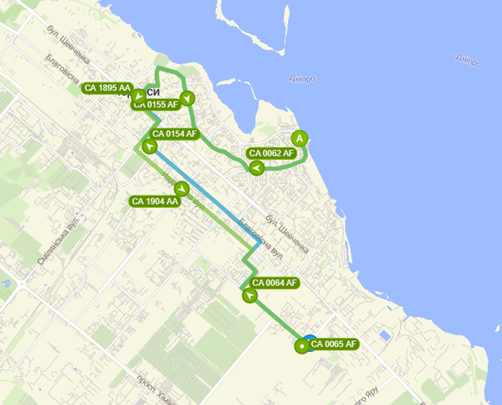

Figure 1. Transport route No. 21 in the city of Cherkassy (Ukraine)
TABLE 5. Passenger traffic and stage load on route No. 21 (7:00 – 8:00)
Forward direction |  |  |  |  |  | Return direction |  |  |  |  |  | Total
Stop No. | Entered, pass. | Exited, pass. | Stage load | Passenger traffic, passengers |  | Stop No. | Entered, pass. | Exited, pass. | Stage load | Passenger traffic, passengers |  | Passenger traffic
1 | 6 | 0 | 0 | 0 |  | 1 | 8 | 0 | 0 | 0 |  | 0
2 | 7 | 0 | 6 | 1.74 |  | 2 | 5 | 0 | 8 | 3.36 |  | 5.1
3 | 8 | 1 | 13 | 4.42 |  | 3 | 6 | 1 | 13 | 4.68 |  | 9.1
4 | 4 | 2 | 20 | 7.6 |  | 4 | 5 | 3 | 18 | 7.38 |  | 14.98
5 | 2 | 1 | 22 | 7.48 |  | 5 | 7 | 4 | 20 | 7.8 |  | 15.28
6 | 5 | 2 | 23 | 8.28 |  | 6 | 8 | 4 | 23 | 10.12 |  | 18.4
7 | 5 | 4 | 26 | 7.8 |  | 7 | 9 | 5 | 27 | 12.15 |  | 19.95
8 | 6 | 5 | 27 | 8.64 |  | 8 | 4 | 7 | 31 | 12.09 |  | 20.73
9 | 7 | 5 | 28 | 9.52 |  | 9 | 6 | 4 | 28 | 10.64 |  | 20.16
10 | 4 | 6 | 30 | 10.2 |  | 10 | 8 | 8 | 30 | 12.3 |  | 22.5
11 | 6 | 3 | 28 | 10.64 |  | 11 | 6 | 3 | 30 | 11.7 |  | 22.34
12 | 8 | 6 | 31 | 11.16 |  | 12 | 6 | 2 | 33 | 12.21 |  | 23.37
13 | 5 | 3 | 33 | 10.23 |  | 13 | 5 | 6 | 37 | 13.32 |  | 23.55
14 | 5 | 4 | 35 | 13.3 |  | 14 | 12 | 10 | 36 | 16.2 |  | 29.5
15 | 6 | 6 | 36 | 12.6 |  | 15 | 14 | 14 | 38 | 15.2 |  | 27.8
16 | 12 | 8 | 36 | 12.96 |  | 16 | 10 | 12 | 38 | 15.96 |  | 28.92
17 | 10 | 12 | 40 | 12.8 |  | 17 | 8 | 9 | 36 | 14.04 |  | 26.84
18 | 14 | 8 | 38 | 13.3 |  | 18 | 8 | 7 | 35 | 13.3 |  | 26.6
19 | 8 | 5 | 44 | 15.84 |  | 19 | 5 | 6 | 36 | 12.6 |  | 28.44
20 | 6 | 14 | 47 | 17.39 |  | 20 | 6 | 5 | 35 | 14.35 |  | 31.74
21 | 5 | 7 | 39 | 14.82 |  | 21 | 8 | 7 | 36 | 15.48 |  | 30.3
22 | 5 | 4 | 37 | 11.84 |  | 22 | 9 | 6 | 37 | 16.65 |  | 28.49
23 | 5 | 12 | 38 | 13.3 |  | 23 | 7 | 8 | 40 | 17.6 |  | 30.9
24 | 6 | 4 | 31 | 10.54 |  | 24 | 6 | 5 | 39 | 15.99 |  | 26.53
25 | 8 | 8 | 33 | 11.88 |  | 25 | 5 | 6 | 40 | 14.4 |  | 26.28
26 | 6 | 12 | 33 | 12.87 |  | 26 | 2 | 9 | 39 | 14.43 |  | 27.3
27 | 6 | 8 | 27 | 9.18 |  | 27 | 5 | 8 | 32 | 13.12 |  | 22.3
28 | 9 | 4 | 25 | 8.75 |  | 28 | 3 | 9 | 29 | 11.31 |  | 20.06
29 | 5 | 12 | 30 | 11.7 |  | 29 | 1 | 9 | 23 | 8.51 |  | 20.21
30 | 4 | 8 | 23 | 8.51 |  | 30 | 2 | 6 | 15 | 6.15 |  | 14.66
31 | 6 | 7 | 19 | 6.46 |  | 31 | 2 | 6 | 11 | 3.96 |  | 10.42
32 | 4 | 6 | 18 | 5.76 |  | 32 | 0 | 7 | 7 | 2.73 |  | 8.49
33 | 3 | 4 | 16 | 5.76 |  |  |  |  |  |  |  | 5.76
34 | 1 | 8 | 15 | 5.55 |  |  |  |  |  |  |  | 5.55
35 | 0 | 8 | 8 | 2.8 |  |  |  |  |  |  |  | 2.8
Total | 207 | 207 | 955 | 335.62 |  |  | 196 | 196 | 900 | 359.73 |  | 335.62

Fig. 1 shows that 7 vehicles operate on route № 21. The travel interval is 6 min, the total length of the route is 12.19 km. A detailed presentation of the distribution of passenger traffic on route № 21, is presented in Fig. 2.
The largest number of passengers was observed on the stages from the stop on Gogolya Street to the stop at Hospital. On other stages, the passenger flow is relatively uniform. The peak load of the routes is observed at their middle distances, with a subsequent decrease towards the initial and final stops.
As a result of mathematical processing of the results of experimental research, indicators of uneven passenger flow on route № 21 were determined. Summary indicators of route unevenness are given in Table 6.

DETERMINING THE NUMBERS OF VEHICLES FOR THE EFFECTIVE OPERATION OF A PASSANGER ROUTE
The organization of route transport requires careful analysis and a balanced approach to the selection and planning of the number and range of rolling stock. The main goal is to ensure the optimal number of vehicles, taking into account their passenger capacity, which will minimize the carrier's costs while maintaining a high level of passenger service. Fleet planning should take into account not only current needs, but also development prospects, forming a balanced and efficient transport system. A key factor in the selection of rolling stock is determining its optimal capacity, since this indicator directly affects operational characteristics, such as route duration, economic costs and overall transportation efficiency. Strategic planning should take into account fluctuations in passenger traffic, especially during peak hours, when there is a significant increase in the number of passengers. The use of vehicles of different capacities depending on the time of day contributes to the optimization of transportation and flexible response to changes in demand. Fig. 3 presents the relationship between the capacity of rolling stock, the frequency of flights and the volume of passenger traffic on the main sections of the route [17]. This information serves as the basis for a well-founded choice of vehicles that ensure efficient passenger transportation and increase the overall productivity of the route network.

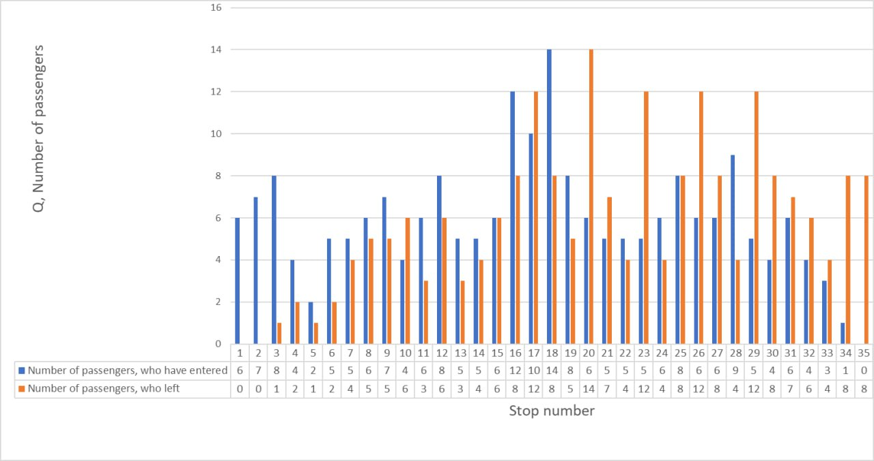
Figure 2. Passenger traffic distribution on route No. 21 in the forward direction

TABLE 6. Indicators of uneven passenger flows on route No. 21
Indicator | Route №21
Indicator | Forward direction | Return direction
Average passenger traffic on the route | 27.53 | 29.10
Passenger traffic unevenness coefficient | 1.71 | 1.37
Hourly coefficient of unevenness on the route | 3.95 | 3.83
Unevenness coefficient by direction | 1.1

Fig. 3 presents that if the passenger flow capacity is 498 passengers per hour and the vehicle movement interval is 6 min., then the optimal vehicle capacity is 50 passengers. This ensures efficient use of vehicles, minimizing underloading or overcrowding of the bus. Thus, the optimal route vehicle among the considered ones is the electric bus A08611 "Malva Electro" with a passenger capacity of 53 passengers.
A nomogram was developed for effective management of transport resources. This graphical method allows carriers to determine the required number of vehicles on a route and optimal travel intervals, based on data on hourly passenger traffic. To build such a nomogram, it is necessary to establish maximum and minimum passenger traffic values for each route during the day. The results of the analysis of peak hours and periods of reduced activity were taken into account. Using the nomogram allows carriers to quickly adjust travel intervals in accordance with changes in passenger traffic, which contributes to the rational use of vehicles, reducing costs and increasing passenger satisfaction.

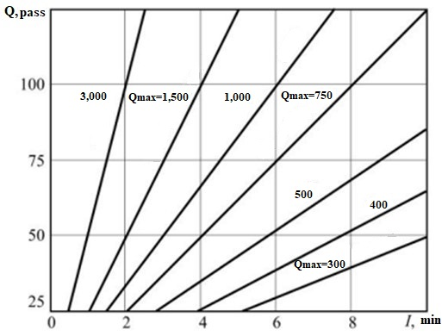
Figure 3. Graphical representation of the dependence of passenger capacity of public transport vehicles on the interval of movement and passenger flow

The bus turnaround time on a route is the time required to complete a full cycle of movement, which includes departure from the starting point, time at the stop for boarding and disembarking passengers, and return. This parameter is key, as it determines the schedule and affects the number of vehicles required to ensure a given movement interval. It was determined that the turnaround time of a route vehicle on route №21 in the city of Cherkassy (about 1.3 hours).

CONCLUSION
As a result of researching the factors of transport mobility, public transport, passenger requirements for public transport, transport problems of large cities, it was determined that the integration of the usual model of transport provision of the city requires the joining of forces of the state and the private sector, the development of a methodology for cooperation between all participants in transport processes. Public transport serves to ensure not only the mobility of city residents, but also to guarantee at the same time the minimum negative impact on the environment (ecology). Increasing the attractiveness of urban passenger transport is possible by ensuring the comfort of public transport; reducing the intervals of movement of urban passenger transport, by strengthening control over violations of traffic rules, as well as creating a single control center.
The main problem of public transport in the city of Cherkassy, Ukraine, was identified as moral and physical aging of transport. In the process of comparative analysis, the optimal vehicles for the city to update the public transport were determined. Using the example of route № 21, the optimal number of electric buses A08611 "Malva Electro" that will serve the route at different times of the day was determined. The total number of buses that need to be purchased for the effective functioning of the specified route was 10 pcs. This number of buses is due to the presence of such a number of buses on the route. The cost of electric buses was €3,000,000. In this case, the use of a nomogram proved to be effective. This method contributes to making informed decisions regarding the commissioning of the required number of buses at different times of the day, ensuring a balance between passenger demand and the economic efficiency of transportation. The implementation of the proposed recommendations will increase the attractiveness of urban passenger transport, reduce the share of private transport in the city, relieve the route network, reduce the duration of public transport, and improve the environmental situation in the city.

Acknowledgments
We extend our heartfelt appreciation to the administration of Cherkasy State Technological University for their comprehensive support throughout the course of our scientific research. We are also deeply grateful to the faculty of the Department of Automobiles and Vehicle Operation at Cherkasy State Technological University for their invaluable assistance in the research conducting.
We sincerely thank the administration of the city of Cherkassy for facilitating these scientific researches and helping to conduct experiments.
We thank our colleagues from the Department of Automobiles and Transport Management of Vinnytsia National Technical University for their support in conducting the experimental and theoretical research presented in this article.

Conflict of interests
The authors declare that there is no conflict of interests regarding the publication of this paper.

References
[1] A. R. Haikov, O. P. Yevsieieva, O. V. Baranov, and V. Yu. Baranov, “Intelligent transport systems in Ukraine,” Bull. Natl. Tech. Univ. “KhPI”, Automob. Tractor Constr. 9(1052), 106–112 (2014).
[2] N. I. Ilchuk, City Transport (Lutsk National Technical University, Lutsk, 2010), p. 96.
[3] V. S. Postnikov, “Current problems and prospects for the development of the urban transport system,” Econ. Anal. 28(2), 64–70 (2018).
[4] O. V. Stepanchuk and I. M. Stepanchuk, “Road transport and environmental problems of cities,” Environ. Ecol. Life Saf. 6, 88–92 (2014).
[5] M. Bando, H. Hasebe, A. Nakayama, A. Shibata, and Y. Sugiyama, “Dynamical model of traffic congestion and numerical simulation,” Phys. Rev. E 51(2), 1035–1042 (2015); https://doi.org/10.1103/PhysRevE.51.1035.
[6] Ye. Yu. Fornalchyk, I. A. Mohyla, V. E. Trushevskyi, and V. V. Hilevych, Traffic Management at Controlled Intersections in Cities: Monograph (Lviv Polytechnic Publishing House, Lviv, 2018), p. 236.
[7] V. S. Vinychenko, Microprocessor Automation Tools in Transport (Kharkiv National Academy of Urban Economy, Kharkiv, 2020), p. 215.
[8] A. R. Haikov, O. P. Yevsieieva, O. V. Baranov, and V. Yu. Baranov, “Intelligent transport systems in Ukraine,” Bull. Natl. Tech. Univ. “KhPI”, Automob. Tractor Constr. 9(1052), 106–112 (2014).
[9] Yu. S. Lihum, Information Systems in Transport (Ukrainian Transport University, Kyiv, 2015), p. 196.
[10] The development of Ukraine’s transport infrastructure requires new approaches, Online article, https://www.epravda.com.ua/columns/2022/01/28/681863/ (accessed Jan. 8, 2025).
[11] L. A. Tarandushka, I. A. Shlionchak, and I. P. Tarandushka, “Assessment of passenger service quality in public urban transport in Cherkasy,” Collection of Scientific Papers 2021, pp. 260–268.
[12] Q. Zhao, J. Tang, C. Li, Q. Dong, T. Feng, and X. Yang, “Optimization of passenger flow control and customized bus bridging in urban rail transit network,” Comput. Oper. Res. 178, 106997 (2025).
[13] M. Smieszek, N. Kostian, V. Mateichyk, J. Mosciszewski, and L. Tarandushka, “Estimation of the public transport operating performance: Example of a selected city bus route,” Commun. Sci. Lett. Univ. Zilina 25(1), B7–B21 (2023); https://doi.org/10.26552/com.C.2023.002.
[14] I. A. Shlionchak, A. P. Soltus, and M. P. Rud, “Analysis of the possibility of applying blockchain technology in supply chain management,” Central Ukrainian Scientific Bulletin. Technical Sciences. 7(38), Part II, 231–236 (2023).
[15] M. Ahmad, I. Anwer, M. I. Yousuf, and M. A. Javid, “Investigating the key factors affecting public transport ridership in developing countries through structural equation modeling,” Sustainability 16(11), 4426 (2024); https://doi.org/10.3390/su16114426.
[16] S. Rasca and N. Saeed, “Exploring the factors influencing the use of public transport by commuters living in networks of small cities and towns,” Travel Behav. Soc. 28, 249–263 (2022).
[17] M. F. Dmytrychenko et al., Fundamentals of the Theory of Transport Processes and Systems (Publishing House “Slovo”, Kyiv, 2009), p. 336.

