Influence of Chemical Composition of Minerals on the Adhesion of Their Surfaces to Bitumen
Serhii Yefremov^{1, a)}
¹Kharkiv National Automobile and Highway University,
Department of Technologies of Road-Building Materials, 61002 Kharkiv, Ukraine
^{a)} Corresponding author: svefr@ukrl.net
Abstract. The article examines the influence of the chemical formula of minerals on the quality of adhesion of their surface to bitumen. Since all rocks are composed of minerals without exception, the intensity of adhesion of mineral surfaces to bitumen directly affects the intensity of adhesion of rock surfaces to bitumen, and this is important because they are the main components of asphalt concrete. It has been shown that increasing the content of alkaline earth metal oxides (MgO, CaO) in the chemical formula of minerals improves the quality of adhesion of the surface of these minerals to bitumen, which can increase the durability of asphalt concrete in road pavements. The advantage of selecting rocks with such minerals is a significant improvement in their adhesion properties to bitumen. This selection of rocks for the production of asphalt concrete mixtures will improve the quality of asphalt concrete, as a traditional road surface, on which the durability of these roads depends.
Keywords: bitumen, adhesion, minerals, granitic rocks, asphalt concrete

Introduction
The main components of asphalt concrete mixtures are mineral materials and bitumen; therefore, the quality of the asphalt concrete pavement depends on their interaction. This topical issue is very important when predicting the guaranteed service life of asphalt concrete pavements in road construction. For such a prediction of the durability of asphalt concrete road surfaces, it is necessary to know the intensity of adhesion of bitumen to the surface of mineral materials. In turn, this adhesion index depends on the chemical compounds that are part of the rocks in the form of rock-forming minerals. Previous studies in this direction [1] have proven that the adhesion of bitumen to rocks containing carbonate minerals is significantly better than the adhesion of the same bitumen to rocks containing silicate minerals. The crystalline rock deposits of Ukraine have a significant range of mineral diversity that make up these rocks, which in turn are components of asphalt concrete mixtures. Therefore, the ability to choose a large number of options for the mineral compositions of these rocks provides unlimited possibilities for the highest quality use of mineral materials, which include various minerals, and an optimally high-quality mineral composition makes it possible to obtain high-quality asphalt concrete road pavement. Therefore, research to determine the best adhesion of rock-forming minerals to bitumen in terms of their impact on the durability of asphalt concrete is becoming more and more urgent every year. Determining the intensity of adhesion of bitumen to the surface of various minerals that make up rocks makes it possible to find out which minerals of these rocks interact best with bitumen, and which, in turn, can reduce financial costs for the production of asphalt concrete mixtures and the construction of road surfaces from them by increasing their durability and at the same time not losing the regulatory quality of this coating, in which these mineral components can be used.
The chemical formulas, and accordingly the chemical compounds that make up the minerals, as well as the mineral composition of rocks as components of asphalt concrete mixtures, may be different in different territorial regions of Ukraine, but the main task of the producers of these mixtures is that the mineral composition of rocks ensures the best possible adhesion to bitumen, and accordingly, good coating of the stone material with bitumen, and after its arrangement in the asphalt concrete road surface in which they are used, they do not reduce the service life between repairs. First of all, based on the well-known literature information from the studies of Kolbanovska A.S., Lysikhina A.I., Rudenska I.M., that rocks containing carbonate minerals have good adhesion to bitumen, it was taken into account that such rocks can provide greater durability of asphalt concrete pavements in which they will be used than in asphalt concretes with rocks containing silicate minerals, which affects the durability of asphalt concrete. All of these minerals are components of most rocks, and they are present throughout the entire massif of the Ukrainian Crystalline Shield, the Carpathians, and Crimea.
The rock-forming minerals used in the tests provide and condition a wide range of rocks that differ in origin. And in turn, the adhesion of bitumen to minerals depends on the chemical composition, the structure of the crystal lattice, and many of their physical properties. Depending on these properties, the structure and composition of asphalt concrete is formed, which includes selected mineral components and on which the durability of road surfaces depends.
Therefore, the problem of scientific research is the lack of information about the quantitative intensity of adhesion of various minerals to bitumen. Based on this, the goal and objective of the research is to identify quantitative indicators of adhesion of bitumen to mineral surfaces.
To solve this research problem, a device and software for measuring the area of a bitumen stain were used, which were created at the Department of Road Construction Materials Technology of the Kharkiv National Automobile and Highway University [2, 3]. With the help of these scientific developments, the adhesion and area of bitumen stains remaining on the mineral surface after the regulatory test according to DSTU 9169:2021 [4] were measured (calculated) due to the stable adhesion to this surface, which were compared with the stains that were applied to the mineral surfaces before the test. This definition is mainly based on counting pixels of the same color that belong to bitumen [1].

Analysis of the chemical composition of rock-forming minerals and their interaction with bitumen
Granite road-building materials are most often used in the construction of highways. Their prevalence and popularity among road builders are based on their fairly high strength and, as a result, low abrasion, which guarantees the durability of the asphalt concrete pavement. But the main indicator when choosing the initial mineral components of asphalt concrete mixtures is their adhesion to bitumen, and this indicator depends on the chemical composition of these rocks. In turn, the chemical composition of rocks depends on their mineral composition, and each mineral has its own individual chemical formula by which it is identified.
To analyze the chemical composition of granite rock, the studies of Levinson-Lessing F. Yu. and literature data [5-15] were used, which indicate the average percentages of the mineral composition, presented in Table 1, and the chemical compositions of rock-forming minerals, presented in Table 2.

TABLE 1. Mineral composition of granite rocks
Name of Minerals | Content, %
Quartz | 25÷35
Feldspars (Orthoclase, Microcline, Albite, Anorthite, Augite, Labrador, Hornblende) | 60÷65
Micas (Biotite, Muscovite) | 5÷10

The mineral composition of granite rocks (Table 1) varies in a fairly wide range, which allows you to select rocks that have the best adhesion to bitumen without reducing the standard strength indicators. However, it should be noted that the most common composition of granitic rocks includes minerals such as quartz, orthoclase, augite, hornblende, labrador, biotite, and muscovite. But a more significant indicator is the chemical composition of the rock-forming minerals of granitic rocks, which is presented in Table 2.
Based on the well-known provisions that the adhesion of bitumen to a mineral surface is enhanced as a result of chemisorption processes on the surface of mineral materials containing oxides of alkaline earth metals (MgO, CaO) and heavy metals and the data in Table 2, it was assumed that the adhesion of bitumen to the surface of dark feldspar minerals (augite, hornblende, labrador) will be better than to the surface of light feldspar minerals (orthoclase, anorthite), and the worst with the surface of quartz. It was assumed that the oxides of alkaline earth metals of the second group (MgO and CaO) would have the greatest positive effect on increasing adhesion to bitumen. Such chemical compounds have dark feldspar minerals such as augite, hornblende, and labrador. This assumption was based on previously obtained results of bitumen adhesion to alkaline (limestone, marble) and acidic (quartz, granite) mineral surfaces [16, 17].
TABLE 2. Chemical composition of rock-forming minerals of granitic rocks
Name of Minerals | Content of Chemical Compounds, %
Name of Minerals | SiO₂ | Na₂O | K₂O | MgO | CaO | Al₂O₃ | Fe₂O₃ | FeO
Quartz | 100 | - | - | - | - | - | - | -
Orthoclase | 64.7 | - | 16.9 | - | - | 18.4 | - | -
Microcline | 64.7 | - | 16.9 | - | - | 18.4 | - | -
Albite | 68.4 | 11.7 | - | - | - | 19.4 | - | -
Anorthite | 43.2 | - | - | - | 20.1 | 36.7 | - | -
Augite | 21÷26 | - | - | 30÷60 | - | 4÷9 | 10÷40 | -
Labrador | 55.5 | 4.0 | 0.4 | 0.2 | 10.9 | 26.8 | 1.6 | -
Hornblende | 42÷48 | 1.5 | - | 11÷14 | 10÷13 | 6÷13 | 3÷9 | 9.5÷11.5
Biotite | 33÷45 | - | 4.5÷8.5 | 0.3÷28 | - | 9.5÷31.5 | 0.3÷20.5 | 2.8÷27.5
Muscovite | 45.2 | - | 11.8 | - | - | 38.8 | - | -
Materials and methods
To determine the influence of the chemical composition of minerals on the adhesion of their surfaces to bitumen, plates of minerals of quartz, muscovite, orthoclase, anorthite, labrador, hornblende, and augite were prepared in accordance with regulatory requirements [4]. When selecting test objects, the types of mineral surfaces were previously determined using a five percent aqueous solution of hydrochloric acid. The reaction in the form of boiling of a 5% aqueous solution of hydrochloric acid on the surface of the mineral with the formation of foam with a large number of bubbles indicated that these surfaces were alkaline, and the absence of boiling is characteristic of acidic surfaces.
Thirty-five samples of the surfaces of the selected minerals were accepted for testing, the appearance of the presentation part of which is shown in Figure 1. Five samples were prepared for each mineral accepted for testing to ensure reliable reliability of the results obtained. The test results for each mineral object were taken as the arithmetic mean of five values.
Before applying the standard bitumen stain to the surfaces to be tested, they were photographed in order to have information about those parts of the area of mineral surfaces that were subsequently hidden under these bitumen stains, which are shown in Figure 1 under the index “a”. After applying a standard bitumen stain, measuring 70 × 25 mm [4], to each plate before testing, they were photographed and these photographs are presented in Figure 1 under the index “b”. After conducting regulatory tests, the samples were photographed and these photographs are presented in Figure 1 under the index “c”.
The tests used bitumen of the brand BND 35/50 with the depth of needle penetration at a temperature 25 °С 43 × 0.1 mm and softening point 57.3 °С, which meets the requirements DSTU 4044:2019 [18]. Testing of samples of mineral surfaces with bitumen stains applied to them was carried out in accordance with regulatory requirements [4] in distilled water.
The tests were conducted according to the established regulatory procedure [4], which regulated the unchanged test conditions. Immersion of the samples into distilled water, the temperature of which was 85 °C, occurred instantly in the amount of seven samples. The incubation in the thermostat took place for 30 minutes. To record the results of the change in the area of bitumen stains on the samples, at the end of the regulatory period, the samples were cooled, removed and dried. Dry samples after testing were photographed from a certain specified distance, as before testing, which allowed for accurate counting using the photometric method.
All images of all test objects were subjected to photometric processing. After applying a standard bitumen stain to each sample and conducting tests in accordance with the requirements of the standard [4], the percentage of adhesion of bitumen to mineral surfaces and the area of the bitumen stain remaining after the test were determined using specially designed equipment and specialized software [2, 3]. All stages and actions for determining the percentage of adhesion of bitumen to mineral surfaces and the area of the bitumen stain remaining after the test were previously presented in previous publications [1-3].
For a sufficiently objective assessment of the results, the number of samples of each mineral accepted for testing was five plates (orthoclase, anorthite, labrador, hornblende, augite, quartz, and muscovite).
After the tests, the obtained image files of the surfaces "before the test" and "after the test" were used to calculate the percentages and area indicators of adhesion of bitumen to the mineral surface. The mineral plates were not reused after testing.
І | 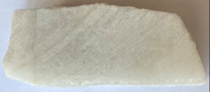 | 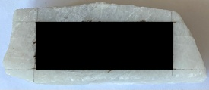 | 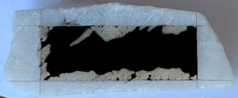
ІІ | 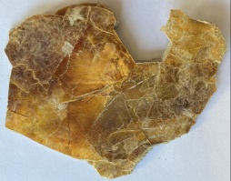 | 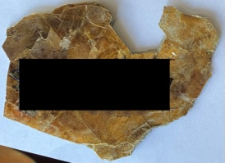 | 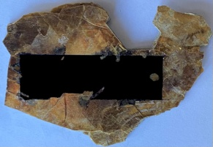
ІІІ | 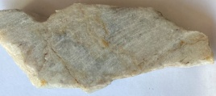 | 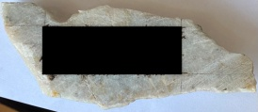 | 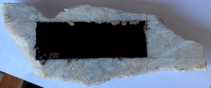
ІV | 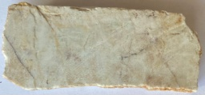 | 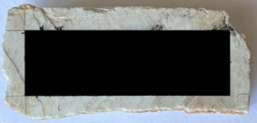 | 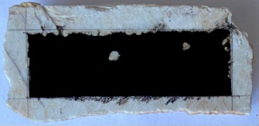
V | 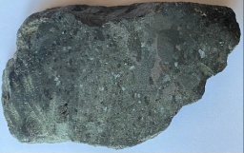 | 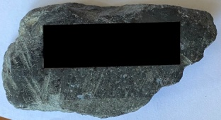 | 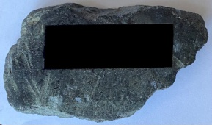
VІ | 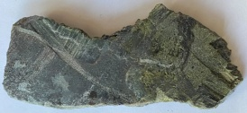 | 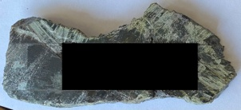 | 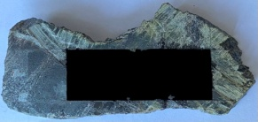
VІІ | 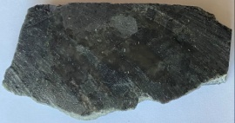 | 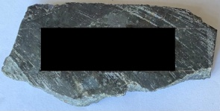 | 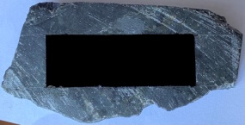
 | (a) | (b) | (c)
FIGURE 1. Mineral plates before and after testing: І – quartz; ІІ – muscovite; ІІІ – orthoclase;
ІV – anorthite; V – labrador; VІ – hornblende; VІІ – augite; (а) – area of mineral surfaces before applying bitumen stain;
(b) – before the test; (c) – after the test.
Results and discussion
The obtained results of calculations of the areas of bitumen stains remaining after regulatory tests and regulatory indicators of bitumen adhesion to various mineral surfaces are presented in the form of arithmetic mean values of five samples of the corresponding mineral that were tested. These averaged test results are presented in Table 3.

TABLE 3. Areas of bitumen stains after testing and adhesion indices of bitumen to mineral surfaces
Sample No. | Naming Mineral Surfaces | Area of Bitumen Stain Before Testing, mm² | Area of Bitumen Stain After Test, mm² | Adhesion Index, %
I | Quartz | 1,750 | 1,197.09 | 68.4
II | Muscovite | 1,750 | 1,497.70 | 85.6
III | Orthoclase | 1,750 | 1,506.35 | 86.1
IV | Anorthite | 1,750 | 1,548.90 | 88.5
V | Labrador | 1,750 | 1,635.48 | 93.5
VІ | Hornblende | 1,750 | 1,663.62 | 95.1
VІІ | Augite | 1,750 | 1,727.33 | 98.7
The obtained test results confirm the hypothetical assumptions about the better interaction of dark feldspar minerals with bitumen in comparison with light feldspar minerals and quartz, which is explained by chemisorption processes on the surface of mineral materials containing oxides of alkaline earth metals of the second group (MgO, CaO) and this corresponds to the well-known ideas. This feature is probably due to the rather high content of these compounds (MgO, CaO) in dark feldspar minerals, and in addition, they have a much lower content of silicon oxide (SiO₂). And in this case, there is a dependence according to which an increase in the oxides of alkaline earth metals of the second group (MgO, CaO) and a decrease in the content of silicon oxide (SiO₂) leads to an intensification of the bonds of bitumen with the surfaces of dark feldspar minerals. Thus, the highest content of magnesium oxide (MgO) and the lowest content of silicon oxide (SiO₂) in augite provided it with the highest adhesion rates compared to other samples. Even compared to other samples of dark feldspar minerals, the adhesion of its surface to bitumen is 3.6% greater than that of hornblende and 5.2% greater than that of labrador, which have less magnesium oxide (MgO) and more silica (SiO₂).
Comparison of the results of bitumen adhesion to the surfaces of dark and light feldspar minerals allows us to state that adhesion to the surface of dark feldspars is on average 8.5 % greater than to the surface of light feldspars, and to the surface of muscovite by 10.2 %. It is logical that the adhesion of bitumen to the quartz surface turned out to be the lowest, since the content of silicon oxide (SiO₂) in quartz is the highest, therefore this adhesion was on average 27.4 % less than to the surface of dark feldspars and 18.9 % less than to the surface of light feldspars. Even such a comparison explains the results of previously published tests [1] where the highest adhesion index was for the granite surface with the highest content of dark feldspars. And this increase in the intensity of adhesion to bitumen is also explained by the presence of oxides of alkaline earth metals of the second group, and areas of granite mineral surfaces with a high quartz content have the lowest adhesion indicators, since this is influenced by the presence of silicon oxide (SiO₂).
CONCLUSION
Analyzing the test results, it can be assumed that the adhesion indicators of bitumen with all mineral surfaces accepted for testing allow us to state that the surfaces of dark feldspar minerals interact with bitumen by 8.5% better than the surfaces of other non-carbonate minerals, since the adhesion mechanism directly depends on the number of oxides of alkaline earth metals of the second group (MgO, CaO). Therefore, when choosing stone materials as components of asphalt concrete mixtures, it is necessary to strive to obtain granite rocks of the darkest possible color.
Based on the results obtained, it can be argued that such tests allow to improve the qualitative selection of mineral components of asphalt concrete mixtures by increasing the intensity of interaction of bitumen with rocks containing dark feldspars, and to increase the durability of asphalt concrete road surfaces.

Acknowledgments
The authors would like to express their gratitude to Kharkiv National Automobile and Highway University and the organizing committee of the Modern Automotive Industry, Transport and Road Infrastructure (MAITRI) conference.

Conflict of interests

The authors declare that there is no conflict of interests regarding the publication of this paper.

References
[1] S. Yefremov, B.-E. Azize, A. Yefremova, and A. Kravtsov, “Method for determining the mineral composition of rocks as components of asphalt concrete,” AIP Conf. Proc. 2490, 050005 (2023); https://doi.org/10.1063/5.0123100.
[2] V. O. Zolotarev, S. V. Yefremov, O. M. Ageyeva, Y. I. Pyrig, and K. V. Permyakov, “The use of a computer to determine the adhesion of bitumen to the glass surface,” Autodrozhnik Ukr. Sci. Prod. J. 3, 30–33 (2005).
[3] S. V. Yefremov, “Determination of adhesion of bitumen with stone materials in asphalt concrete by photometric method,” Bull. KhNADU 30, 190–193 (2005).
[4] DSTU 9169:2021. Bitumen and Bituminous Binders. Determination of Adhesion to Mineral Material (Ukraine, 2021).
[5] E. K. Lazarenko, Mineralogy Course (State Publishing House of Technical Literature of Ukraine, Kyiv, 1951), p. 688.
[6] W. Terry R. West, Geology Applied to Engineering (Waveland Press, Long Grove, IL, 2010), p. 560.
[7] P. Lanari and E. Duesterhoeft, “Modeling metamorphic rocks using equilibrium thermodynamics and internally consistent databases: Past achievements, problems and perspectives,” J. Petrol. 60(1), 19–52 (2019); https://doi.org/10.1093/petrology/egy058.
[8] C. J. Wall and J. S. Scoates, “The Stillwater Complex: Integrating zircon geochronological and geochemical constraints on the age, emplacement history and crystallization of a large, open-system layered intrusion,” J. Petrol. 59(1), 134–158 (2018); https://doi.org/10.1093/petrology/egx094.
[9] G. Yogodzinski, S. T. Brown, P. B. Kelemen, and J. D. Vervoort, “The role of subducted basalt in the source of island arc magmas: Evidence from seafloor lavas of the western Aleutians,” J. Petrol. 56(3), 554–578 (2015); https://doi.org/10.1093/petrology/egv007.
[10] H. St. C. O’Neill, “The smoothness and shapes of chondrite-normalized rare earth element patterns in basalts,” J. Petrol. 57(8), 1653–1675 (2016); https://doi.org/10.1093/petrology/egw034.
[11] L. G. Berry, B. Mason, and R. V. Dietrich, Mineralogy, 2nd ed. (W. H. Freeman & Co., New York, 1983).
[12] P. A. Sossi, S. Eggins, and R. W. Nesbitt, “Petrogenesis and geochemistry of Archean komatiites,” J. Petrol. 57(1), 37–77 (2016); https://doi.org/10.1093/petrology/egw039.
[13] C. Klein and C. S. Hurlbut Jr., Manual of Mineralogy, 20th ed. (John Wiley & Sons, New York, 1985).
[14] J.-W. Park, I. H. Campbell, J. Kim, and J.-W. Moon, “The role of late sulfide saturation in the formation of a Cu- and Au-rich magma: Insights from the platinum group element geochemistry of Niuatahi–Motutahi lavas, Tonga rear arc,” J. Petrol. 56(1), 103–128 (2015); https://doi.org/10.1093/petrology/egu074.
[15] M. E. Wieser et al., “Atomic weights of the elements 2011 (IUPAC Technical Report),” Pure Appl. Chem. 85, 1047–1078 (2013); https://doi.org/10.1351/PAC-REP-10-12-23.
[16] V. O. Zolotarev, S. V. Yefremov, and F. P. Goncharenko, “Durability of asphalt concrete at static creep test,” in Proc. Fifth Int. RILEM Symposium MTBM, Lyon, France, 255–261 (1997).
[17] V. O. Zolotarev and S. V. Yefremov, “Dependence of water resistance of asphalt concrete on temperature and test time,” Bull. KhGADTU 12–13, 145–147 (2000).
[18] DSTU 4044:2019. Viscous Petroleum Road Bitumens. Specifications (Ukraine, 2019).

