Lightweight Plywood-Based Roof Panels with Curved Ribs
Andrii Bidakov¹, Dmytro Kochkarev², Oksana Pustovoitova^{3, a)}
¹O.M. Beketov National University of Urban Economy,
Department of Building Constructions, 61002 Kharkiv, Ukraine
²National University of Water and Environmental Engineering, Ukraine,
Department of Urban Construction and Economy, 33000 Rivne, Ukraine
³Kharkiv National Automobile and Highway University,
Department of Computer Graphics, 61002 Kharkiv, Ukraine.
^{a)} Corresponding a\Author: oksana_pustov@ukr.net
Abstract. The work presents a new type of designed and tested wood-based lightweight PRX-panels for roofs spanning appr. 20 m. The PRX-panels’ shells and ribs are made of plywood of different thickness, with ribs curved and coupled to create a X-shaped cross-section. For easy assembly, the X-shaped ribs are inserted and glued in the small saw cuts in the plywood skins. The lightweight plywood 20-m roof PRX-panels are produced from automated CNC-cut plywood. PRX-panels’ strength and stiffness, especially for spans over 7 m, makes them more effective in comparison to CLT-panels. The presented results of PRX-panels’ experimental testing and their comparative analysis are supported with proposed solutions for PRX-panel joints.
Keywords: panels, lightweight roof structure, X-shaped ribs, curved plywood, novel light-timber panels

INTRODUCTION
Lightweight wooden structures are an effective solution, reducing the building structures’ material consumption and their cost through the use of modern technological equipment. The publication presents the results of tests and analytical calculations of lightweight glued plywood panels with X-shaped plywood ribs and shell, or PRX-panels. This type of panels is patented and is distinguished by its high manufacturability achieved through CNC-processing of plywood sheets to obtain the components of PRX-panels. The PRX-panel design ensures high strength and rigidity parameters, which allow it to cover large spans. PRX-panel static tests, carried out in the Laboratory of Building Structures at the Kharkiv National University of Civil Engineering and Architecture, Ukraine, confirmed the expected strength parameters and the nature of failure. The publication presents the designed features of the panel and its production and the results of numerical analysis and experimental studies. At the moment, the PRX-panel production has begun to install flat roofs in private houses, townhouses, carports and public buildings of a complex development in the Kyiv Region.

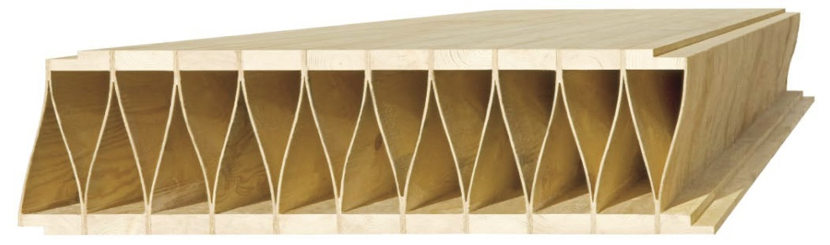
FIGURE 1. General view of the Kielsteg panel [14-15]
Initially, the idea emerged for beams with X-shaped ribs, and then it evolved into the idea of panels with X-shaped ribs. The performance of ribs with different curvature radii was investigated as part of the dissertation work [10] in 2011−2014. The design of beams with X-shaped ribs was patented in 2014 [1], and the design of the PRX-panel with curved plywood ribs was patented in 2023 [2]. A close analogue to the proposed panels is provided by the Austrian Kielsteg panels, patented during the same period, in 2013 [4], which are based on a keel-shaped beam, also with curved ribs but of a slightly different nature, see Fig. 1. Research into the Kielsteg panels’ strength and performance is presented in the works of Prof. S. Aicher, University of Stuttgart [3, 8, 18].
Kielsteg panels are recommended for up to 30 m spans. With the 800 mm cross-sectional height, the panel shells are made of 43 to 85 mm thick glued laminated or solid timber with 4 to 12 mm thick ribs made of OSB [19] or plywood, according to the technical report [7] and the manufacturer's technical catalogues [14−15, 17]. Kielsteg panels have been installed in dozens of buildings, which is a confirmation of the effectiveness and objective advantages of lightweight innovative solutions for building structures.
In personal communication, Kielsteg panel designers gave a preliminary positive assessment to PRX-panels, recognizing that the performance of curved ribs is more effective than the straight ribs.

constructingX-SHAPEDRIBS forPRX-PANELS
A lightweight PRX-panel consists of double plywood shell and X-form plywood ribs arranged along the span of the PRX-panel and glued into the pre-cut grooves in the shells, as shown on Fig. 2, also see PRX-panel cross-section in Fig. 3.

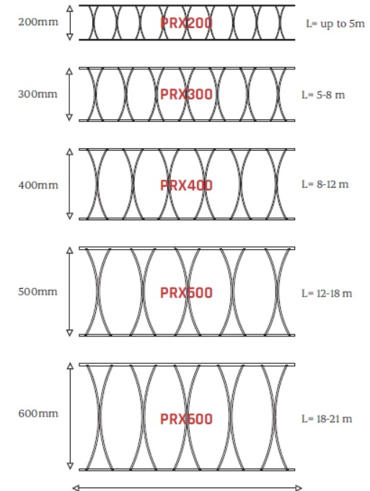 | 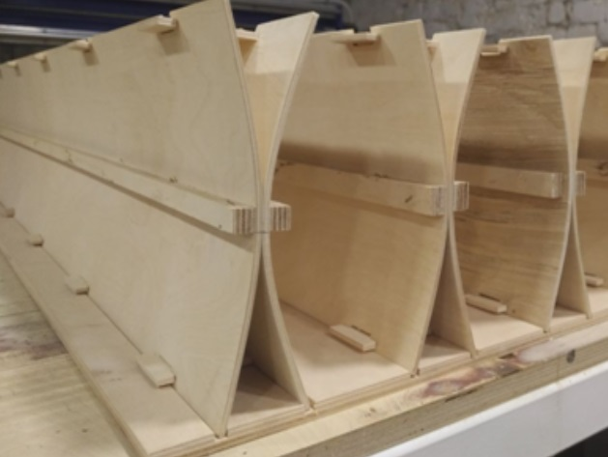
(a) | (b)
FIGURE 2. PRX-panels: (a) PRX-panel size range; (b) curved X-shaped ribs manufactured before gluing into the shells

The pairs of PRX-panel plywood ribs are connected to each other in the middle of their section height with 12mm thick plywood spacer strips and are bent using pre-milled plywood plates. Spacer plates are installed into the recesses of the plywood rib edges with the 300 mm interval to facilitate gluing of X-shaped ribs to the panel skins. The curved cross-sectional shape of such paired ribs is reflected in the PRX-panel name. There are several cross-section sizes, ranging from PRX200 to PRX600 with the100 mm increment. The PRX-panel skins thickness ranges from 8 to 15 mm with the plywood ribs thickness ranging from 4 to 8 mm. The ribs curvature radius is different for each PRX-panel type and, accordingly, the number of ribs is different, depending on the PRX-panel cross-section height. All PRX-panels are 1,200 mm wide, since the plywood sheet width is 1,250 mm.

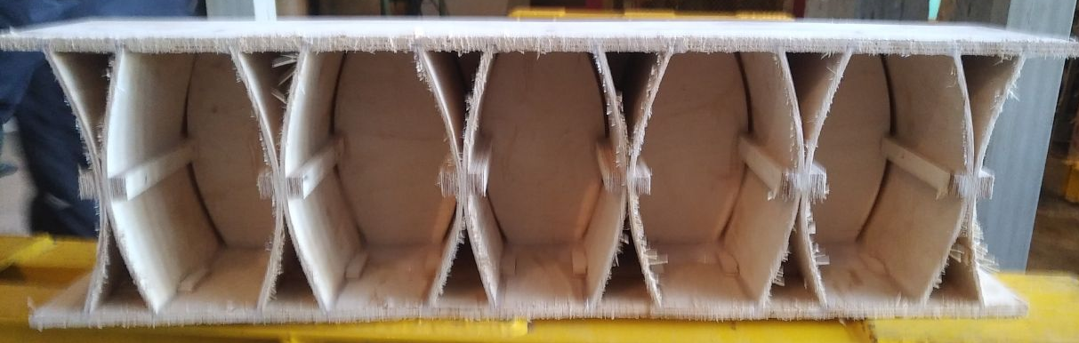
FIGURE 3. PRX200 panel in cross-section

PRX-panel plywood sheets meet the production standards EN 636-2 [6] and EN 13986 [16]. PRX-panels are manufactured by assembling panel fragments about 2500 mm long, which are then spliced by overlapping the X-shaped ribs of one fragment with another and gluing them between the shells of another panel and plywood overlays, Fig. 4. Also, the lower panel shells are joined with one-sided plywood overlays on the inside of the PRX-panel. The top panel shells are joined by installing a plywood insert over the edges of the two panel pieces. The panels are joined lengthwise to each other by screwing together plywood strips glued to the lower panel shells and a pressure pad, also made of plywood. The panels at the ends have 12 to 30mm thick plywood ribs, which are glued between the plywood panel shells. The end rib has milled-in grooves shaped to match the curvature of the longitudinal X-shaped edges of the panel to glue both together. Such a solution for the panel end ribs is a crucial and effective, which is confirmed in the work on beams with fixed ends [16]. Fiber orientation in the plywood outer veneers is longitudinal.
The veneer fibers direction in the outer layers of plywood skins and ribs matches the longitudinal direction of the panel. The minimal panel width is equal to the part of the cross-section with one X-type rib, which can be calculated as the H-type profile beam. The operational elements length ranges from 5 m to 20 m. PRX-panel parts production is fully CNC-automated and then the shells with the pre-fabricated ribs are assembled without significant pressure. A two-component epoxy adhesive is used to bond the ribs and the shells together. Also, EN301 [20] sanctions the use of others adhesives. Panels over 10 m long consist of prefab parts up to 2.5 m long.
After the ribs are glued in, there is no need to plane the PRX-panels. Additional plywood planks are glued to the lower skins for easy lateral joining of the PRX-panels to rigid roof structures. The planks are pressed against a plywood strip with an inclined groove to tighten the panels at the joint. It is secured to the mounting structure with screws or staples, see Fig.4, left.
The PRX-panel upper shells are narrower in width than the lower ones and are overlaid as shown in Fig. 4, right. The narrower upper shells enable to join the lower skins. The plank, joining the upper shells, can also be fastened with screws or staples.

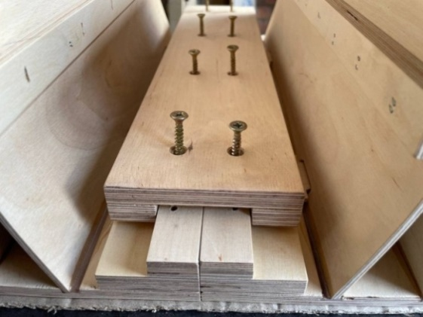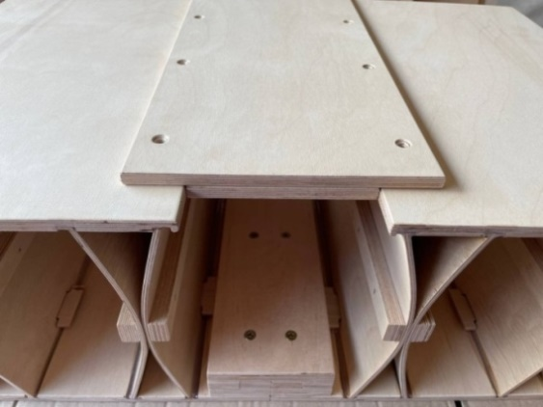
FIGURE 4. View of PRX-panels lateral joint

The plywood ribs curvature is ensured by spacing their top and bottom parts with special plywood strips, installed with the increment of 200 to 400 mm into the milled grooves along the plywood ribs. Before the ribs are spaced, they are first connected in the middle with staples along the entire length of the rib. To prevent plywood from splitting, gasket strips are installed under the staples. Spacer strips do not prevent the ribs from being glued into the grooves in plywood the shells.
All PRX-panels are 1,200 mm wide due to the available format of the plywood sheets, and the corresponding thicknesses of the ribs and shells are variable depending on the section height (Table 1). X-shaped ribs and shells are joined with one-component adhesives without pressing. End ribs are also secured with adhesives in the final phase of manufacturing.
Table 1. Cross-sectional geometry of PRX panels
PRX-panels height, mm | Lower shell thickness, mm | Upper shell thickness, mm | Ribs thickness, mm | Rib curvature radius, mm | Ribs height/width ratio(h_{w}/b_{w}) | Max. PRX-panel span
300 | 10 | 10 | 6 | 300 | 23.33 | 5-8
400 | 12 | 12 | 6 | 400 | 31.33 | 8-12
500 | 15 | 15 | 8 | 500 | 29.38 | 12-15
600 | 15 | 15 | 8 | 600 | 35.63 | 15-18
800 | 20 | 20 | 10 | 800 | 38 | 18-22

EXPERIMENTAL TESTING
To analyze efficiency of the designed lightweight PRX-panels, the carrying capacity and rigidity full-scale element tests were performed in the Laboratory of Building Constructions at O.M. Beketov National University of Urban Economy in Kharkiv, Ukraine. Four-point bending test was conducted according to the standard DSTU EN408 [12], but the ratio height of the cross-section span was smaller than the recommended ratio of 1/18. The length of the PRX200 panel was l=3m (span l_{s}=2.8) and the height was h=200 mm. The h/ls ratio of the tested panels was 0.2/2.8=1/11 due to the focus on the curved ribs behavior and their shear capacity as the PRX-panel weak point and it is used in testing beams with X-shaped ribs [10]. Fig. 5a shows the general view of a PRX-panel 3000 mm long (span of 2.8 mm) and 750 mm wide, with 208 mm section height. The loading scheme is a 4-point bend with the application of concentrated forces in the thirds of the PRX-panel through the pads that transmit the load across the entire width of the panel. To record vertical movements at the load application points, gauges D-2 and D-4 were installed, with gauge D-3 installed in the middle of the span. To determine the angle of rotation of the PRX-panel end edges, linear displacement indicators were installed in the middle of its width and at the upper point according to the section height. The PRX-panel was loaded with a uniform increase in load in the time interval of 300 +/- 120 s until failure (Fig. 5b), according to the requirements of the DSTU EN408 standard [12].

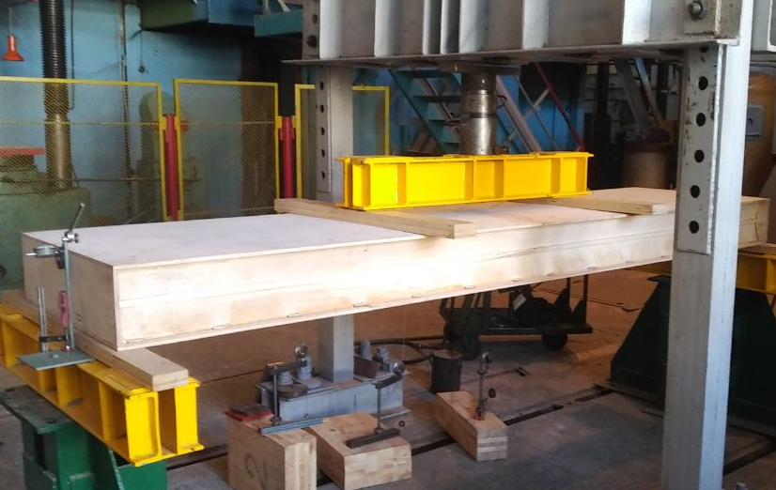 | 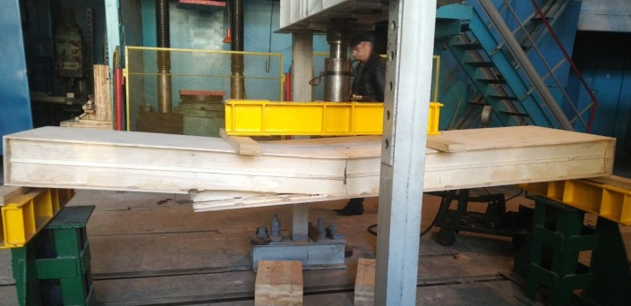
(a) | (b)
FIGURE 5. Test set-up to determine PRX200 bending capacity: (a) PRX-panel before testing;
(b)PRX-panel failure

The laboratory test focused on the PRX-panel bearing bending capacity. The PRX-panel design with X-shaped curved ribs has a cross-sectional height in the middle of the ribs (or the point of their contact) connected with a plywood longitudinal strip and staples, which prevents the ribs from sliding under loading, as was discovered during the study of the beams [10]. The Mid-part connection reduces the effective length of the curved ribs and increases the stability of this part of the rib as the cylindrical element. The elastic work of the ribs until the failure reveals several stages of deformation, in particular, multidirectional bending of some of its sections.
Installing different types of insulation between the ribs inside a PRX-panel can increase its load-bearing capacity by limiting or preventing deformations of the PRX-panel ribs along their initial curvature and achieving a failure pattern in the opposite direction.

MECHANICAL BEHAVIOUR ANALYSIS
To analyze the PRX-panel bending and shear strength, as well as its deformability, taking into account the compliance of curved X-shaped ribs, the closest methodology for calculating thin-ribbed composite beams is provided by EN1995-1-1 [5]. Considering that the plywood PRX-panel shell thickness does not considerably exceed the plywood ribs thickness, the calculation method involves the application of correlation coefficients for the wall stiffness for different types of panels, taking into account their curvature ratio and the shells/ribs thickness ratio. PRX-panels strength and flexibility are especially important in the areas contacting with supports, concentrated loads and in openings perpendicular to the plane of the PRX-panel or to the rib direction, Fig.6.
The tensile and compressive stresses distribution in curved X-shaped ribs has a complex trajectory, which was analyzed by PRX-panel modeling in the Ansys software package. The F60/10 E90/10 plywood type featured the following elastic properties: E_{x}=5,500 N/mm², E_{y}=370 N/mm², E_{z}=1,000 N/mm², G_{xy}=700 N/mm², G_{xz}=700 N/mm², G_{yz}=200 N/mm², ν_{xy}=0.042, ν_{xz}=0.015, ν_{yz}=0.35. Fig. 7 shows solid models of PRX-panels with the section heights of 200 mm, 300 mm, 400 mm and 500 mm. All the PRX-panel types are calculated with plywood cross-ribs on supports, Fig.6, a) and with the PRX-panel height /length ratio h/l=1/25.

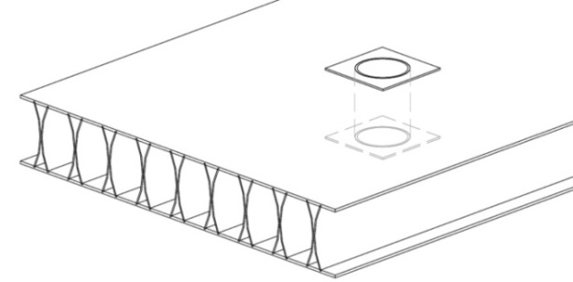 | 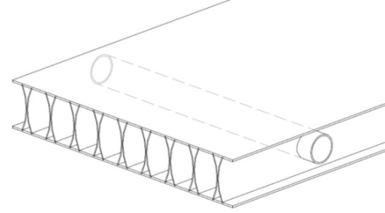
(a) | (b)
FIGURE 6. Schematic illustration of possible openings in PRX-panels: (a) openings perpendicular to the plane of the PRX-panel; (b) openings perpendicular to the rib direction in the plane of the PRX-panel

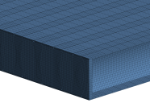 |  | 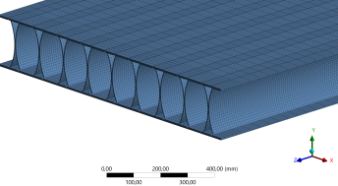
(a)
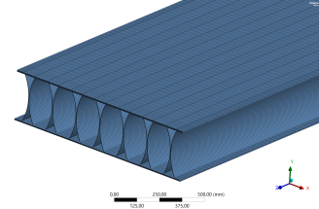 | 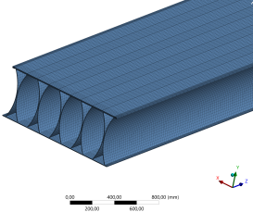 | 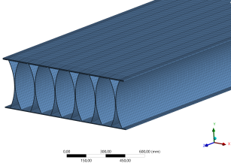 | 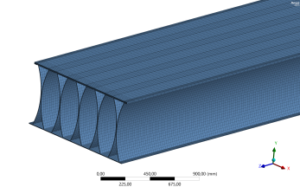
(b) | (c) | (d) | (e)
FIGURE 7. Solid models of PRX-panels by calculation: (a) Panel type PRX200 with cross rib on support; (b) PRX300;
(c) PRX400; (d) PRX500; (e) PRX600.
Fig. 8 shows a diagram of the shear stresses distribution in a panel with the section heights of 200, 300, 400, 500 and 600 mm in different planes.
Fig. 9 shows a diagram of the normal stress distribution in a panel with the section heights of 200, 300, 400 and 500 mm.
Comparison of the PRX-panel mid-span deformability (curve D-3) and deformability at the points of load application (curves D-2 and D-4) with the mid-span deformations during numerical analysis with the ANSYS software package (line "Ansys") is shown in Fig. 10. Linear approximation shows the reliability of the obtained experimental data for the mid-span deflection by FEM calculation.
Analysis of the angular deformation intensity relative to the mid-span deformation intensity and the deformation at the load application points shows a close coincidence, which is confirmed by the nature of the curved ribs performance with a certain redistribution of stresses and a variable shape of the ribs along the length of the panel with a corresponding damping component to the support zones from the mid–span zone.

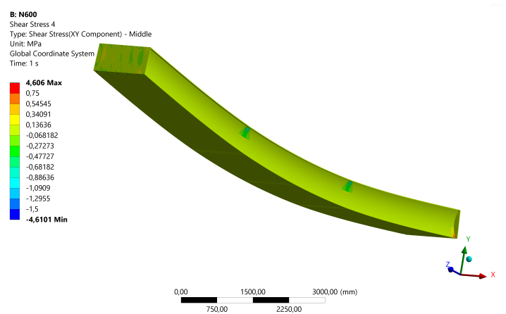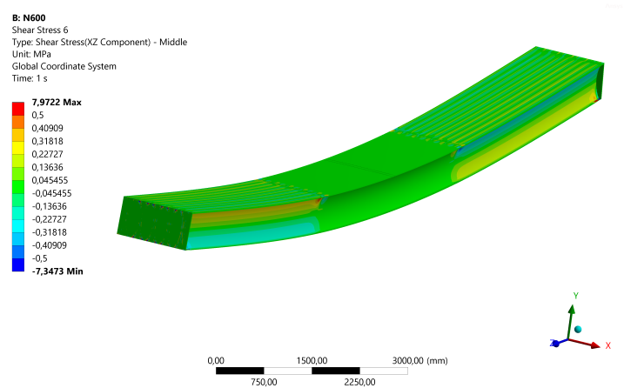
FIGURE 8.: Shear stresses distribution in PRX panels

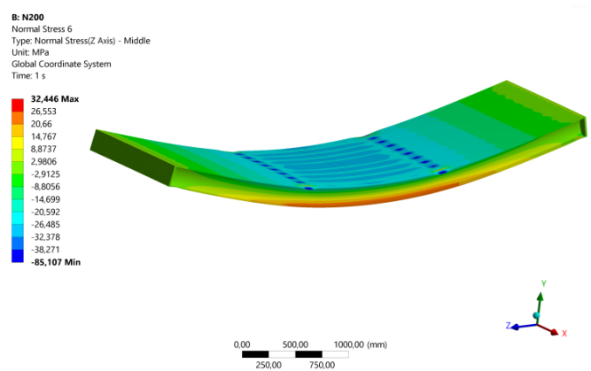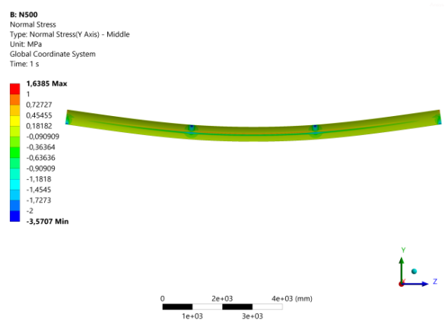
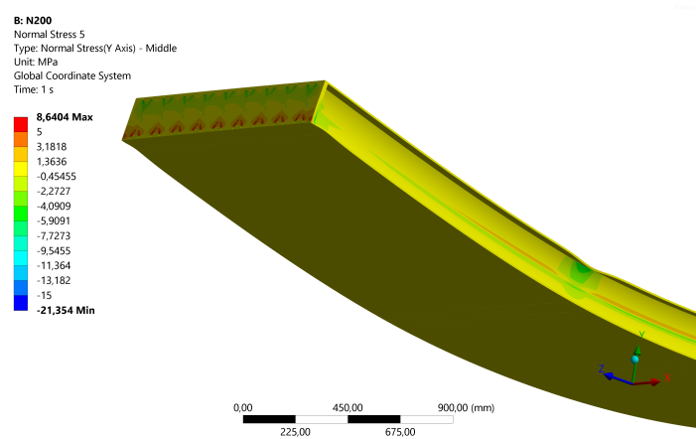
FIGURE 9. Normal stresses distribution in PRX-panels

The operating conditions of PRX-panels in accordance with fire safety standards require the design of solutions for PRX-panels with glued laminated timber shells50 to 90 mm thick, depending on the fire resistance class and, accordingly, the time for the structures to last before failure (REI45 or REI60), see DBN V.1.1-7:2016 [13]. Thus, the PRX-panel will have cross-sections close to the Kielsteg panels and the performance of the beams with X-shaped ribs will be more similar to PRX-panels with glued timber shells, since the tested beams had a thick-shelled cross-section.

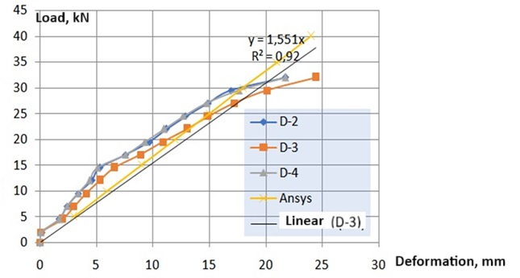
FIGURE 10. Deformations of the tested PRX-panel and deformations according to the FEM calculation

To facilitate PRX-panels application, simplified engineering calculation methods are used on an approximation as a set of beams with X-shaped curved ribs, which in turn is equated to a beam with thin ribs, see Fig. 11. The method used to calculate the strength of the beam’s upper and lower flanges is typical for this type of structures, and the X-shaped ribs require special attention and consideration of their strength reduced by shear f_{v,0,d} when calculating the shear force F_{v,w},E_{d}, which, as a rule, for simply supported beams reaches its maximum in the support zone.

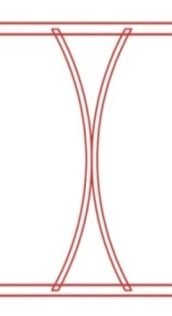 | 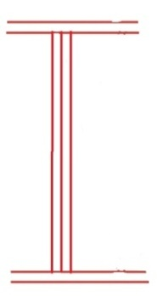
(a) | (b)
FIGURE 11. Simplification of the beams with X-shaped curved ribs as thin-ribbed I-beam: (a) X-shaped curved ribs; (b) thin-ribbed I-beam

Eurocode-5 [5] specifies that the calculation of the transverse force should be performed depending on the ratio of the rib height h_{w} to its thickness b_{w} (Equations 1 and 2). The height of compressed and tensioned flanges is marked respectively as h_{f,t} and h_{f,c}.

for (1)

When h_{f,t} and h_{f,c} are the same, a modified equation can be used instead of equation (8a)

(1a)

for (2)

Simplified design methods for Kielsteg panels, similar to PRX-panels, proposed the following design alghorithms published in [3, 7, 8], where V_{w,k}, R_{w,k} are the characteristic values of the effective shear force and the shear force capacity per rib panel and the effective rib cross-section are marked as A_{w,eff}:

(3)

(4)

The effective in-plane shear strength of plywood ribs is the characteristic in-plane shear strength of the rib material f_{v,0,k} and the factor ξ, which takes into account compression and shear buckling effects. The coefficient ξ is semi-empirical parameter based on the testing results and it depends on the ribs height/ thickness ratio h_{w}/b_{w}.

(5)

(6)

According to ETA-18/1014 “Kielsteg Vorgefertigtetragende Tafeln aus Holz und Holzwerkstoffen” [7], the effective strength by shear in plywood ribs f_{v,w,eff,k} must be calculated depending on a different h_{w}/b_{w} ratio, in comparison to EN1995-1-1 [5]:

for (7)

for (8)

Due to the equal widths of the compression and tension flanges makes a possible the idealized substitution on I-cross-section. Shear force capacity design of the curved rib plywood plates subjected to nonlinear bending and buckling due to interacting compression and shear stresses on the supports represents the cylindrical shell issue.
A slightly different strength calculation algorithm is proposed for calculating the shear strength of PRX-panels curved ribs. The tangential stresses must be lower than the shear strength of the plywood:

(9)

where Q is shear force; S_{f} – static moment of the flange relative to the neutral axis of the considered beam; J – moment of inertia of a beam; t_{w} –plywood ribs thickness; φ_{х} – the plywood ribs stability coefficient, calculated as follows:

(10)
The ultimate shear stress for a plywood wall is taken as equal to τ_{u} = 7.5МPа.
The critical shear stress (equation 10) is applied in the calculation practice of curved plywood cylindrical shells of aircraft wings and bodies:

(11)

where Е_{w} is modulus of plywood elasticity; R – plywood rib curvature radius; k₁ – coefficient depending on the way the PRX-panel sides are fixing: for supported PRX-panel edges k₁=5; for sealed edges k₁=7.5. In calculating the deflection magnitude, there is a need to consider the value of the coefficient k_{J}, which reflects the plywood ribs slip, reducing its rigidity, as well as the effect of shear stresses on the deflection.
Comparisons of the reduction coefficients values according to the above methods are given for PRX-panels on the basis of their cross-sectional geometry (Table 1), and the height h_{w}/ width b_{w} rib ratio see Fig. 12. For PRX-panels with a cross-sectional height of 600 mm and above, a decrease in shear strength is observed.

FIGURE 12. Reduction coefficients for PRX-panel types

These curves show the reduction in the ribs shear strength with respect to their height/thickness ratio, which is increased by increasing the thickness of the webs. Analysis of the ribs shear strength values and the acting stresses at the points of the ribs attachment to the shells indicates the acceptability of the adhesive joint discontinuity or of technological errors and lack of adhesive joint solidity. This also makes it possible to make transverse holes in the PRX-panel without reinforcing its ribs.

CONCLUSION
The PRX-panel is an innovative solution for floors and roofs of buildings, which ensures significant rigidity parameters provided by the work of the X-shaped plywood ribs. The PRX-panels’ lightness and high strength together with their automated manufacturing, make them a competitive solution for CLT-panels, especially with spans of 7 m and more. The proposed engineering calculation method for such beams with X-shaped plywood ribs in PRX-panels is based on the method proposed in EC-5 for thin-ribbed beams with box-section and I-section, but with the account of the curved ribs work through the application of the additional coefficient φх for calculating the shear strength of the ribs in the support zones. The difference in reduction parameters according to different methods makes up 9 to12%, with the higher coefficient for PRX-panels. The PRX-panel static tests showed its deformability, the failure areas and the nature of the failure itself.
To provide accurate assessment of the rib curvature effect on the PRX-panel rigidity value and the nature of force redistribution in its shells, a finite element analysis of volumetric models was performed. The analysis of the proposed calculation method with the Eurocode-5 method by approximation of the X-shaped beam as the I-beam showed minor differences. A comparative analysis of experimental testing of the PRX-panel and the results of numerical calculation shows a maximum difference in deflections of 2.4 to 3.1 mm at the load limit close to half the bearing capacity, which is characterized by a change in the deformations intensity. In this case, the experimental values of deflection in the middle of the span are smaller than according to the calculation results.
Further studies of the PRX-panels require an assessment of the strength of the panel joints along its length and between the PRX-panels. The shear bearing capacity of plywood ribs in support zones exceeds the maximum values of forces arising at maximum spans recommended for specific panel sections. This allows fora percentage of non-glued ribs or for simplifying the technology of joining ribs with shells, resulting in adhesive seam heterogeneity or tearing.
The results of the conducted research ensure confidence in the practical application of the proposed PRX-panels in construction. There is a need for further research into the entire typology of PRX-panels and into their connecting elements.

Acknowledgments
The authors would like to express their gratitude to the Kharkiv National Automobile and Highway University and the organizing committee of the Modern Automotive Industry, Transport and Road Infrastructure (MAITRI) conference.

Conflict of interests
The authors declare that there is no conflict of interests regarding the publication of this paper.

References
[1] V. V. Fursov and A. M. Bidakov, “Plywood beam with X-shaped web,” Ukrainian Patent No. 104243 (2014); available at https://sis.nipo.gov.ua/media/INVENTIONS/2012/a201213757/published_description.pdf.
[2] A. M. Bidakov, “Plywood panel,” Ukrainian Utility Model Patent No. 150812 (2022).
[3] S. Aicher, C. Stritzke, and W. Klöck, “Keel-web element – Novel wood-based lightweight element for wide spans,” in Proc. World Conference on Timber Engineering (Quebec, Canada, 2014); available at https://www.researchgate.net/publication/265178293.
[4] Kielsteg GmbH, Trägerartiges / aus Einzelteilen zusammengesetztes Bauelement sowie Verfahren zur Herstellung des Bauelements, Austrian Patent No. AT 501521 (2013); available at https://www.kielsteg.com/.
[5] European Committee for Standardization (CEN), EN 1995-1-1: Eurocode 5: Design of Timber Structures – Part 1-1: General – Common Rules and Rules for Buildings (CEN, Brussels, 2004); available at https://www.phd.eng.br/wp-content/uploads/2015/12/en.1995.1.1.2004.pdf.
[6] CEN, EN 636: Plywood – Specifications (CEN, Brussels, 2012); available at https://www.scribd.com/document/747874749/BS-EN-636-2012-Plywood-Specifications.
[7] European Technical Assessment (ETA), ETA-18/1014 Kielsteg: Pre-fabricated wood-based load-bearing stressed skin panels (European Organisation for Technical Approvals, Brussels, 2019); available at https://www.researchgate.net/publication/396413038_LIGHTWEIGHT_PLYWOOD_PANELS_WITH_CURVED_X-SHAPED_LONGITUDINAL_RIBS_OF_RIGIDITY.
[8] S. Aicher and C. Stritzke, “Novel lightweight timber composite element – Web design in shear and compression,” in Materials and Joints in Timber Structures, ed. by S. Aicher, H.-W. Reinhardt, and H. Garrecht (Springer, Cham, 2013), pp. 135–148; https://doi.org/10.1007/978-94-007-7811-5_13.
[9] CEN/TC 250/SC 5, prEN 1995-1-1: Eurocode 5: Design of Timber Structures – Common Rules and Rules for Buildings – Part 1-1: General (CEN, Brussels, 2023); available at https://www.phd.eng.br/wp-content/uploads/2015/12/en.1995.1.1.2004.pdf.
[10] A. M. Bidakov, Enhancing Strength and Stability of Plywood Beams by Arranging an X-Shaped Plywood Web, Ph.D. thesis (Kharkiv, 2014); available at https://library.knuba.edu.ua/books/zbirniki/02/2017/201765.pdf.
[11] CEN/TC 250/SC 5, EN 12369-2: Wood-Based Panels – Characteristic Values for Structural Design – Part 2: Plywood (CEN, Brussels, 2011); available at https://standards.iteh.ai/catalog/standards/cen/cb05b7d6-5d7d-446c-8587-7c35af7226c9/en-12369-2-2025.
[12] State Committee of Ukraine for Technical Regulation and Consumer Policy, DSTU EN 408:2007 Structural Timber and Glued Laminated Timber – Determination of Some Physical and Mechanical Properties (Kyiv, 2007); available at https://online.budstandart.com/ua/catalog/doc-page?id_doc=66659.
[13] Ministry of Regional Development, Construction and Housing of Ukraine, DBN B.1.1-7:2016 Fire Safety of Construction Projects – General Requirements (Kyiv, 2016); available at https://sci.ldubgd.edu.ua/handle/123456789/13680.
[14] Kielsteg, “Kielsteg official website,” accessed Sept. 14, 2025; available at https://www.kielsteg.com/.
[15] KulmerBau, “Kielsteg 68,” accessed Sept. 14, 2025; available at https://www.massivholzsystem.at/wp-content/uploads/2020/05/ETA-18_1014_de.pdf.
[16] CEN, EN 13986: Wood-Based Panels for Use in Construction – Characteristics, Evaluation of Conformity and Marking (CEN, Brussels, 2005); available at https://standards.iteh.ai/catalog/standards/cen/f79d9239-0fea-4ee4-b9eb-9722b87c87ab/en-13986-2004.
[17] DIBt, German Technical Approval Z-9.1-831 for “Keel-Web Element”, issued Apr. 30, 2013, Kielsteg GmbH, Graz, Austria; available at https://www.dibt.de/en/service/approval-download/detail/z-91-831.
[18] C. Stritzke and S. Aicher, “Traglastverhalten von innovativen geklebenen Holzleichtbau-Elementen,” in Holzbau Forschung + Praxis, ed. by U. Kuhlmann and F. Brühl (University of Stuttgart, 2012), pp. 115–124.
[19] CEN, EN 300: Oriented Strand Boards (OSB) – Definitions, Classification and Specifications (CEN, Brussels, 2006); available at https://www.en-standard.eu/bs-en-300-2006-oriented-strand-boards-osb.
[20] European Committee for Standardization (CEN), EN 301: Adhesives, Phenolic and Aminoplastic, for Load-Bearing Timber Structures – Classification and Performance Requirements (CEN, Brussels, 2013); available at https://standards.iteh.ai/catalog/standards/cen/9ee4376f-b905-4d15-924b-bc63bb5168c0/en-301-2013.

