Analysis of the Load-Bearing Capacity and Bearing Capacity of a Temporary Bridge to Carry Heavy Loads
Serhii Buhaievskyi¹, Yaroslav Smahlo^{1, а)},
Tetiana Tarasenko¹, Zinaida Kornilova¹
¹Kharkiv National Automobile and Highway University, 61002 Kharkiv, Ukraine, Department of bridges, structures and building mechanics
^{a)} Corresponding author: smahlo91yaroslav@gmail.com
Abstract. The work presents a systematic analysis of temporary bridge structures for the restoration of the transport infrastructure in Ukraine destroyed during the Russian military aggression. Modern designs of permanent and temporary bridges built in different countries of the world have been considered, taking into account the possibility of using polymer composite materials. The transverse distribution coefficients have been determined by the lever method for the main beam No. 2, as the most loaded. The calculation was performed for modern and old temporary loads N-30 (general load), NG-30, NG-60 (tracked loads), NK-80, NK-100 (wheeled loads), A15 (automobile load, tandem + distributed), as well as non-standard loads, like ChMZAP-5523, ChMZAP-5208, ChMZAP-5212, ChMZAP-5530, ChMZAP-5247G (manufactured at Chelyabinsk Machine-Building Plant for Automotive Trailers) and the trailers by the Trailer by Minmontazhspetsbud. Determining the values of the bending moment and shear force for the main girder of the temporary bridge was performed for all the listed temporary loads and for beam spans of 15, 18, 24, 32, and 44 m in length. Recommendations are provided for improving the design of temporary bridges using polymer composite materials for the conditions of Ukraine. A transition from the use of a wooden roadway slab to a polymer one is proposed. Polymer roadway slabs developed abroad have a high load-bearing capacity, reliable connection with steel beams, and will ensure increased bridge durability.
Keywords: temporary bridge, temporary loads, load-bearing capacity, bearing capacity, heavy loads, non-standard loads, abnormal loads, polymer composite materials, polymer roadway slabs.
INTRODUCTION
The military aggression of the Russian Federation against Ukraine has led to significant destruction of the Ukrainian transport infrastructure. There was a need to rebuild a large number of bridges in a short time. Technically and organizationally, it is impossible to fulfill this task in modern conditions. There is a need for wider use of temporary bridges with various designs constructed of various materials to ensure the passage of heavy loads on Ukrainian roads which transport civilian and military cargo. The most technical, organizational and technological solution is the improvement of temporary collapsible bridges for these tasks.
The scope of applying temporary collapsible bridges is very significant [1-5]:
- for the construction of new or reconstruction of existing bridges, there is a need to pass vehicles across a water obstacle;
- to ensure communication when laying mineral deposits with limited resources, namely quarries of non-metallic materials, open cuts, wells, etc.;
- as additional facilities: working bridges, crane overpasses, piers, overpasses for transporting concrete mix, etc.;
- in emergency cases when permanent bridges are destroyed due to various accidents, natural disasters and during hostilities.
For the main load-bearing structures, additional (auxiliary) elements, assembly joints and supporting parts of temporary bridges, steel and partly reinforced concrete are most often used [1-5].
Designs of steel and reinforced concrete structures for temporary prefabricated bridges were developed during the Soviet Union period [1-5] in inventory and unified forms (Table 1).
One of the modern examples of prefabricated bridges is the Unibridge system of the Matiere company (France) [6]. This innovative concept of an industrial steel bridge, scalable and quickly assembled, is designed, developed and patented for the construction of overpasses, military, automobile, railway or temporary bridges. The span structure consists of steel box girders connected by steel pins. Three types of decking are used for driving on the bridge: metal, of prefabricated or monolithic reinforced concrete and wooden. The bridge elements are easily transported, quickly assembled and have a high load-bearing capacity, capable of withstanding loads of up to 300 tons. The bridge is protected from corrosion by painting and galvanization. Pedestrian sidewalks can be added to one or both sides of the bridge without affecting the load-bearing capacity. Matiere will transfer 36 bridges from 23 to 46 m in length to Ukraine to restore the destroyed transport infrastructure of Ukraine from the war with the Russian Federation [2].

TABLE 1. Characteristics of temporary collapsible bridges
Project developer, year of development | Type of main beams / length of main assembly marks | Roadway design
1. Special multi-purpose bridge metal structures
Project 6-F7310 Central Research and Design Institute of Building Structures, 1982 | - rolled I-beams №100B1/ 6, 9 and 12 m;  - welded I-beams 1.8 m high / 9 and 12 m | 1) wooden;  2)prefabricated reinforced concrete slabs;  3) inventory orthotropic steel slabs
2. Inventory beam structures (KIB-82) made of rolled I-beams
TU 14-2-24-72 project 5856 Special design bureau of Central Bridge Construc-tion Body, 1982 | rolled I-beams №100B1/ 6, 9 and 12 m | 1) wooden;  2) prefabricated reinforced concrete slabs;  3) inventory orthotropic steel slabs
3. Steel girder structures with orthotropic PC slab for road bridges in Western Siberia
Project 378 MC at Leningrad State Design Institute for Design of Transport Structures, 1981 | welded I-beams with heights of 2.48, 3.16 and 3.6 m / end – 5.55 m, main – 10.5 m, increased – 21 m | 1) reinforced concrete covering;  2) prefabricated reinforced concrete slabs laid on mortar.

Temporary bridges using composite materials are becoming increasingly common in the world. As of 2011, more than 360 bridges with main load-bearing elements made of polymer composite materials (PCM) were in operation in the world [7]. Among them, about 53 bridges with solid composite span structures, the rest are hybrid in terms of structural material.
A feature of hybrid structures is that different materials are used for load-bearing elements. In hybrid structures, polymer composite materials are used mainly in the manufacture of main beams of span structures, roadway slabs or reinforcing bars [7-12].
The first bridge using reinforced plastics was built in 1978, USA, Virginia [8]. In 1982, the Miyur Bridge with a solid composite span structure was built in China [13]. The single-span beam bridge has two lanes of traffic with a maximum vehicle weight of 30 tons. The span structure is 21 m long, 9.8 m wide and 7.0 m wide and consists of six fiberglass box-section beams.
In 1990, the Aberfeldy Golf Course Bridge was built in the UK with a length of 112.8 m and a width of 2.1 m, all the load-bearing elements of which are made of PCM. The length of the central span is 63 m. It was designed for a pedestrian load with an intensity of 5.6 kN/m. The intensity of the permanent design load was 2.0 kN/m, of which the load directly from the weight of the span structure was 1.0 kN/m [14, 15].
In 1997, in Kolding, Denmark, a cable-stayed pedestrian bridge made of fiberglass was built over a double-track electrified railway. The total length of the bridge is 40 m, the width of the passage is 3 m. The weight of the bridge is 10 tons less than a similar steel structure. Its service life is at least 100 years [16, 17].
In 2001, in Lleida, Spain, a single-span girder pedestrian bridge with a one-piece composite span structure made of fiberglass in the form of an arch with a tightening length of 38 m, with a height of 6.2 m and a width of 6 m was built over a road and railway [18].
Bridges constructed using PCM are operated in a wide variety of conditions and withstand temperature extremes, hurricane winds, intense ultraviolet radiation without additional protection from the elements and are successfully operated at present [19-21].
The accumulated world experience in the construction and operation of bridges using PCM allows foreign bridge construction companies to offer their use in Ukraine as permanent and temporary bridges. There are two main directions (methods) of designing bridge structures using PCM: replacement and adaptation. The first method consists in replacing traditional building materials with composite ones without modernization of the structure. The second method uses modernization of the structure to take into account the properties of PCM. Let us give examples of highway bridges designed using the second method.
In 2000, in the USA, California, on a section of highway No. 86, the Kings Stormwater Channel Bridge was put into operation [21, 22]. The bridge with a frame-cantilever structure with a total length of 20.1 m consists of two spans rigidly connected to the intermediate support beam. The span with a width of 13 m has six main beams of circular cross-section with a pitch of 2.3 m and a roadway slab, which is included in the joint work with the beams using flexible reinforcing bar stops [20]. The beams with a diameter of 381 mm are made of carbon fiber pipes with a wall thickness of 10 mm and are filled with lightweight concrete. The fiberglass roadway slab consists of panels with a thickness of 181 mm with a honeycomb cross-section. The disadvantages of the structure are its low maintainability and high weight, which increases operating costs and the cost of installation work.
In 2008, the first road bridge in Europe with a hybrid girder structure was built, the Friedberg Bridge [23]. The girder structure of a single-span girder bridge with a length of 27 m and a width of 5 m consists of two steel beams of I-section, on top of which a fiberglass slab of the carriageway is laid. The inclusion of a fiberglass slab in the joint work with the beams due to the adhesive connection made it possible to increase the vertical stiffness of the structure by 20% and provide its necessary transverse stiffness to perceive transverse loads. The girder structure is designed for one lane of vehicle load weighing 30 tons with two service passages of 0.75 m each [23]. The main disadvantage of this design, like of the previous one, is low maintainability, due to the non-separable adhesive connections of individual slab blocks to each other and to the main beams.
The issue of a reliable connection between a steel beam and a composite roadway was solved by Strongwell Virginia Tech [23].
The West Mill Bridge over the River Cole (near Shrivenham in Oxfordshire) was officially opened on 29 October 2002 [24, 25]. It was the first public bridge in Western Europe to be built using modern composite materials. Fibreline structural profiles made of plastic composites were used for the supporting beams and the roadway slab. The plastic composite profiles have the same load-bearing capacity as similar road bridges made of steel and reinforced concrete. The bridge has a span of 10 m and a width of 6.8 m. The total weight of the structure is 37 t. It has a load-bearing capacity for vehicles up to 46 t with an axle load of 13.5 t. The bridge deck weighs 100 kg/m². The span structure has four load-bearing beams, which in turn consist of four profiles reinforced with glass fiber and carbon fibers glued together and have a cross-sectional size of 520 mm × 480 mm. The roadway slab is glued from 34 ASSET bridge deck profiles, installed and glued to the main beams. The profiles can be installed on both reinforced concrete and steel beams.
Composite materials have a long service life, which is significantly longer than that of reinforced concrete, and since the roadway slab is resistant to water and salt, a waterproof membrane is not required. Only the surface of the wear-resistant canvas and the joints of the structure require periodic maintenance [13, 23].
Analysis of temporary bridge structures using different materials shows that all of them, along with their advantages, are not without disadvantages. The search for constructive solutions is always carried out taking into account the characteristics of specific materials. Abroad, this search is increasingly directed at promising hybrid structures designed using the adaptation method. These structures have great potential and can be used for temporary pedestrian and road bridges in our country. Effective implementation of this potential is possible only when creating structures adapted to the properties of the material. To ensure sufficient load-bearing capacity of temporary bridges and the passage of heavy loads in the conditions of military aggression of the Russian Federation against Ukraine, it is most rational to use metal main beams and a wooden carriageway, which will lighten the own weight of the span structure of the temporary bridge.
RESEARCH OBJECTIVES AND TASKS
The aim of the work is to analyze the load-bearing capacity and bearing capacity of temporary bridges with metal main girders and a wooden carriageway for span lengths from 9 m to 44 m. The objectives of the work include:
- determination of the equivalent load on a metal beam from various types of automobile and non-standard loads;
- determination of the values for bending moments and transverse force for a metal beam from various types of automobile and non-standard loads;
- provide recommendations for improving the design of temporary bridges for the conditions of Ukraine.
DIFFERENT TYPES OF VEHICLE LOADS FOR BRIDGE DESIGN
The main temporary moving loads used in the calculation of bridges of different years of construction [27] are shown in Fig. 1. Diagrams of trailers and tractors [26] used for transporting heavy and oversized cargo are shown in Fig. 2.

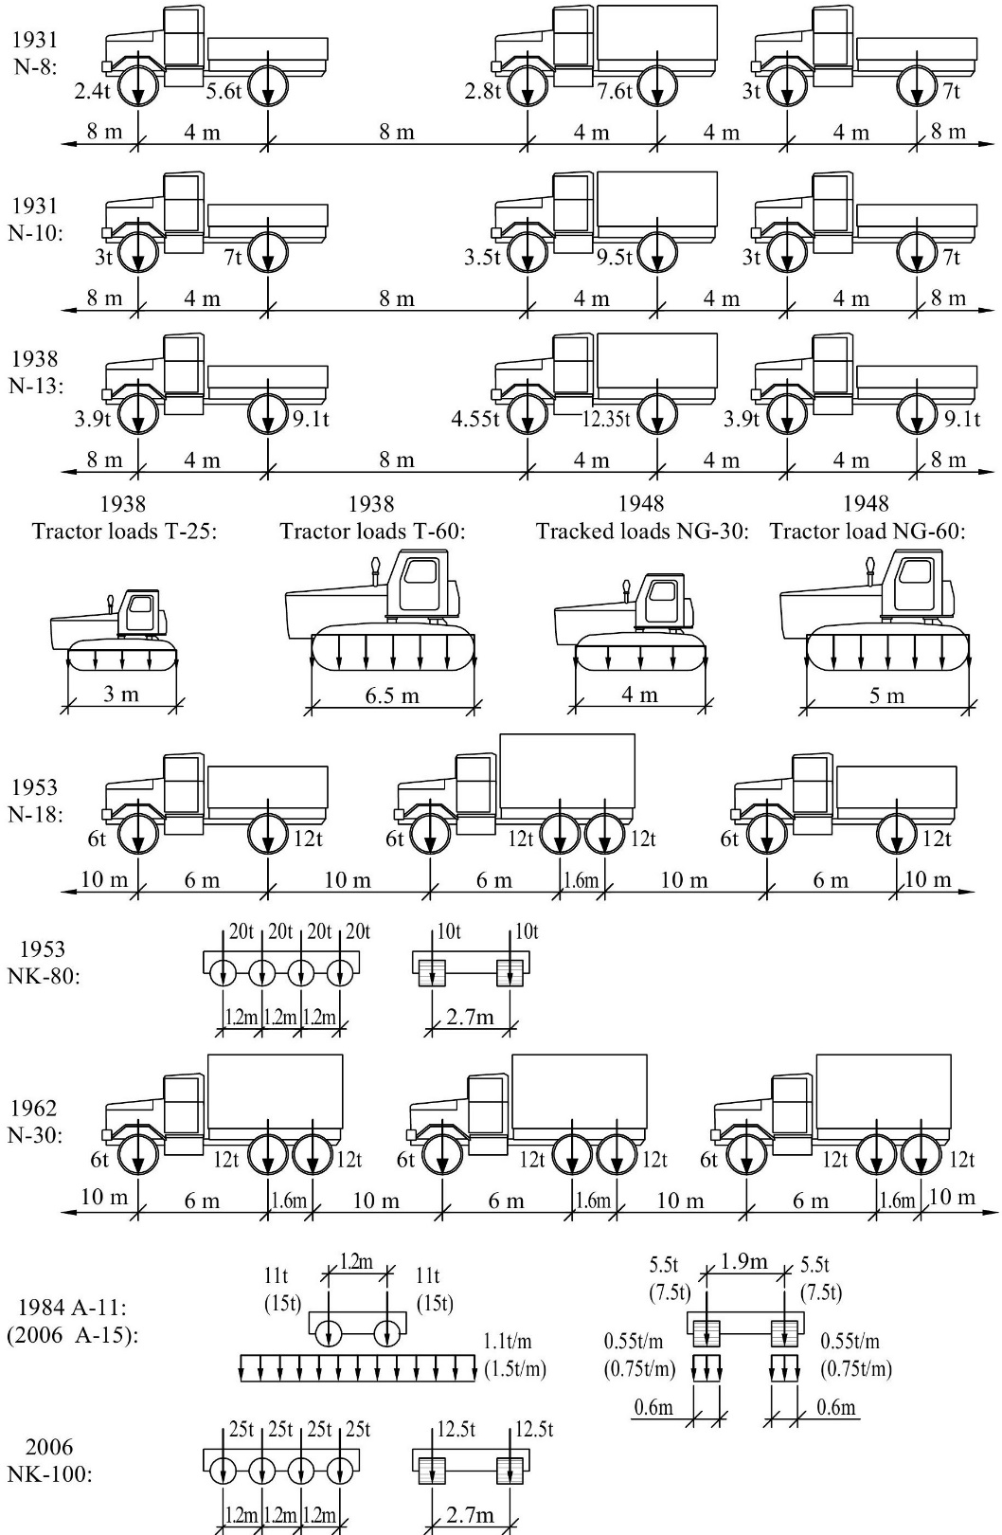

FIGURE 1. Standard loads for bridge calculations
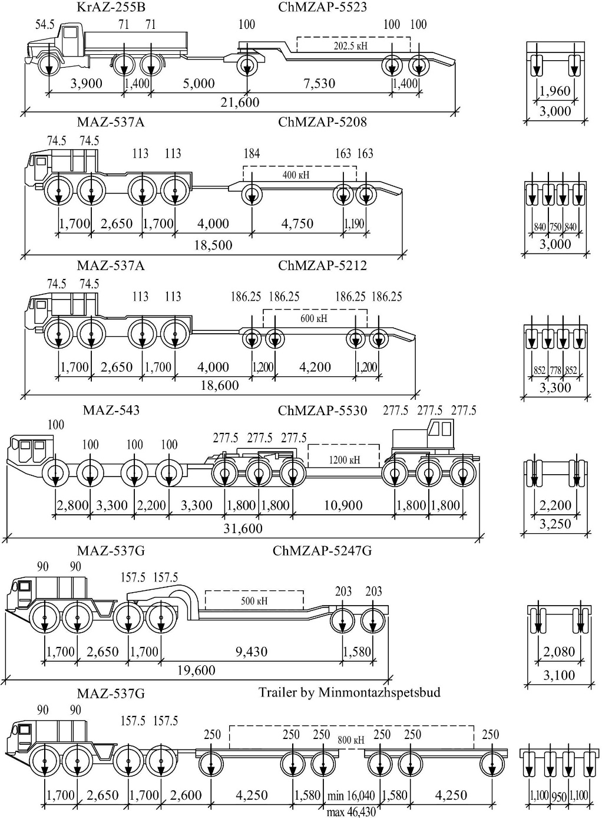

FIGURE 2. Abnormal load schemes

For convenience in calculating the main beams of a span structure, equivalent loads are often used. (q_{eq}). Equivalent load is a uniformly distributed load the force of which is equal to the force from concentrated loads. The value is determined by the formula:

(1)

where Р_{і} stands for the force on the axle of the vehicle load;
z_{і} – marks ordinates under forces on the line of influence of the force;
ω – area of the influence line of the force.
If the equivalent load is determined for the track load, then formula (1) has the form:

(2)

where q stands for the intensity of tracked load;
ω₁ – area with the line of influence under tracked load.
When loading the lines of force influence with wheel or tracked loads, the sum ∑Р_{і} × z_{і} і q × ω₁ should be maximum. An example of loading the bending moment lines and determining the equivalent load is presented in Fig. 3.
For the load NK-80 (wheeled load):

For the load NG-60 (tracked load)

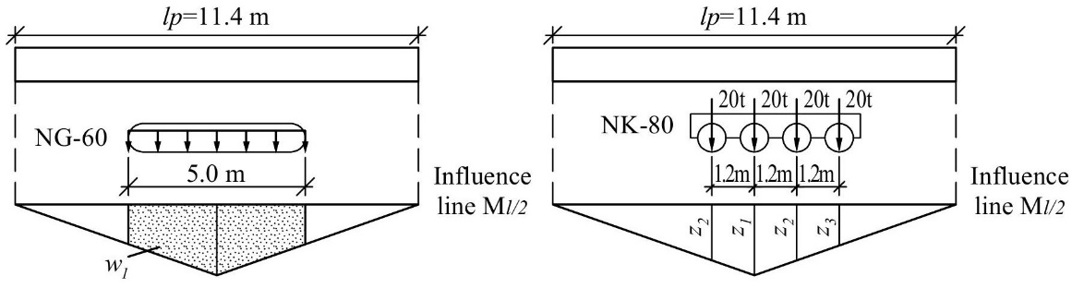

FIGURE 3. Loading the influence line М_{l/2}

The calculation of equivalent loads for various vehicle loads is given in Table 2.

TABLE 2. Equivalent load for a triangular influence line with the vertex in the middle from standard temporary vertical loads, kN/m
Design load | Run length, m
Design load | 9 | 12 | 15 | 18 | 24 | 30 | 32 | 40 | 44
N-8 | 18.2 | 15.5 | 13.4 | 12.3 | 10.8 | 10.1 | 9.8 | 9.2 | 9.0
N-10 | 22.7 | 19.4 | 16.7 | 15.4 | 13.5 | 12.6 | 12.3 | 11.5 | 11.3
N-13 | 29.6 | 25.2 | 21.7 | 20.0 | 17.6 | 16.4 | 16.0 | 14.9 | 14.6
N-18 | 43.9 | 34.7 | 30.2 | 26.6 | 21.3 | 18.4 | 17.6 | 16.8 | 16.4
N-30 | 43.9 | 34.7 | 30.2 | 26.6 | 21.3 | 18.4 | 17.6 | 17.6 | 17.6
A11 | 53.7 | 44.1 | 37.5 | 33.8 | 28.3 | 24.9 | 24.1 | 21.5 | 20.5
NG-30 | 51.8 | 41.7 | 34.7 | 29.6 | 22.9 | 18.7 | 17.6 | 14.2 | 13.7
NG-60 | 93.6 | 79.2 | 66.7 | 57.4 | 44.8 | 36.7 | 34.6 | 28.1 | 26.1
NK-80 | 130.4 | 106.7 | 89.6 | 77.0 | 60.0 | 49.1 | 46.2 | 37.6 | 34.8
NK-100 | 163.0 | 133.4 | 112.0 | 96.3 | 75.0 | 61.4 | 57.8 | 47.0 | 43.5
A15 | 73.2 | 60.1 | 51.1 | 46.1 | 38.6 | 34.0 | 29.8 | 29.3 | 27.9

TABLE 3. Equivalent load for a triangular influence line with a vertex at the end from standard temporary vertical loads, kN/m
Design load | Run length. m
Design load | 9 | 12 | 15 | 18 | 24 | 30 | 32 | 40 | 44
N-8 | 21.2 | 18.5 | 16.0 | 14.2 | 12.6 | 11.3 | 11.0 | 10.2 | 10.0
N-10 | 26.5 | 23.1 | 20.1 | 17.8 | 15.7 | 14.1 | 13.7 | 12.7 | 12.4
N-13 | 34.5 | 30.0 | 26.0 | 23.2 | 20.4 | 18.4 | 17.8 | 16.5 | 16.1
N-18 | 50.7 | 41.0 | 34.2 | 29.6 | 25.5 | 22.7 | 21.8 | 19.8 | 19.3
N-30 | 50.7 | 41.0 | 34.2 | 29.6 | 27.5 | 25.4 | 24.6 | 22.9 | 22.4
A11 | 55.6 | 45.2 | 38.6 | 34.2 | 28.1 | 25.1 | 24.2 | 21.6 | 20.6
NG-30 | 51.8 | 41.7 | 34.7 | 29.6 | 22.9 | 18.7 | 17.6 | 14.2 | 13.1
NG-60 | 96.3 | 72.9 | 66.7 | 57.4 | 44.8 | 36.7 | 34.6 | 28.1 | 25.8
NK-80 | 142.2 | 113.3 | 93.8 | 80.0 | 61.7 | 50.1 | 47.1 | 38.2 | 35.2
NK-100 | 177.8 | 141.6 | 117.3 | 100.0 | 77.1 | 62.6 | 58.9 | 47.8 | 44.0
A15 | 75.8 | 61.6 | 52.6 | 46.6 | 39.0 | 34.2 | 33.0 | 29.4 | 28.1

TABLE 4. Equivalent load for a triangular influence line with a vertex in the middle from non-standard loads, kN/m
Design load | Run length, m
Design load | 9 | 12 | 15 | 18 | 24 | 30 | 32 | 40 | 44
ChMZAP-5523 | 37.5 | 29.4 | 24.2 | 22.3 | 18.8 | 17.0 | 16.8 | 15.5 | 14.8
ChMZAP-5208 | 62.1 | 55.3 | 49.0 | 43.8 | 38.9 | 35.4 | 34.5 | 31.0 | 29.2
ChMZAP-5212 | 74.5 | 70.8 | 69.1 | 66.2 | 59.1 | 52.8 | 50.9 | 43.7 | 40.7
ChMZAP-5530 | 135.7 | 113.5 | 97.9 | 87.1 | 71.5 | 65.3 | 64.3 | 61.6 | 59.5
ChMZAP-5247G | 74.4 | 58.8 | 48.4 | 41.2 | 35.4 | 32.7 | 32.1 | 29.6 | 28.2
Trailer by  Minmontazhspetsbud | 94.7 | 84.5 | 75.9 | 70.4 | 62.3 | 56.1 | 54.2 | 49.1 | 46.5

TABLE 5. Equivalent load for a triangular influence line with a vertex at the end from non-standard loads, kN/m
Design load | Run length, m
Design load | 9 | 12 | 15 | 18 | 24 | 30 | 32 | 40 | 44
ChMZAP-5523 | 41.2 | 35.7 | 31.5 | 29.9 | 26.9 | 23.9 | 22.9 | 19.6 | 18.3
ChMZAP-5208 | 81.6 | 70.9 | 65.5 | 61.5 | 53.0 | 45.7 | 43.6 | 36.8 | 34.1
ChMZAP-5212 | 104.9 | 92.2 | 84.6 | 78.8 | 67.6 | 58.2 | 55.5 | 46.7 | 43.3
ChMZAP-5530 | 148.0 | 179.4 | 98.9 | 92.2 | 87.5 | 81.5 | 79.3 | 70.4 | 66.3
ChMZAP-5247G | 82.3 | 65.4 | 60.1 | 57.1 | 50.9 | 44.6 | 42.7 | 36.3 | 33.7
Trailer by  Minmontazhspetsbud | 123.1 | 111.2 | 101.7 | 93.7 | 78.6 | 66.9 | 63.7 | 53.2 | 49.1
RESEARCH RESULTS
1. Design of the span structure of a temporary bridge. The decking on the crossbars is made of boards with a thickness of 40 to 100 mm. On temporary bridges it can be single-layer. In this case, the crossbars made of rectangular timber are placed at a distance of 0.5 m from each other, ensuring a gap of 30-50 mm between them for ventilation (Fig. 4).

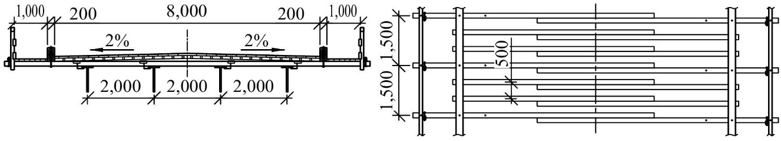

FIGURE 4. Construction of a wooden roadway on crossbars

2. Determination of the load-bearing capacity of the temporary bridge. Determination of the load-bearing capacity and bearing capacity of the bridge metal beam span structure is carried out in order to establish the actual values of the bending moment and transverse force from various automobile loads and compare them with the values obtained for the automobile load A15 and NK-100.
The strength of the main beam was checked using normal, tangential and induced stresses from the action of the largest loads aA15 and NK-100 for a span of 15 m. A metal beam of I-section with a height of 100 cm made of steel grade 15ChSNC was taken for the calculation. The beam flanges had a cross-section of 21×320 mm and were weakened by two rows of holes with a diameter of 25 mm. The vertical wall of the beam with a thickness of 15.5 mm in the cross-section along the joint has 6 holes with a diameter of 25 mm.
The determination of the bending moment values and transverse force from various automobile loads was performed according to the current standards for bridge design using reliability factors, operating conditions and dynamic [26].
The determination of the transverse distribution factor was performed using the lever method for the main beam No. 2, as the most loaded. Modern and old temporary loads N-30 (general load), NG-30, NG-60 (tracked loads), NK-80, NK-100 (wheeled loads), A15 (automobile load, tandem + distributed), as well as non-standard loads, like ChMZAP-5523, ChMZAP-5208, ChMZAP-5212, ChMZAP-5530, ChMZAP-5247G (manufactured at Chelyabinsk Machine-Building Plant for Automotive Trailers) and the trailers by the Trailer by Minmontazhspetsbud (Fig. 5).
The bending moment (M) and shear force (Q) values were determined for all listed temporary loads and for beam spans of 15, 18, 24, 32, and 44 m in length (Table 6-9).

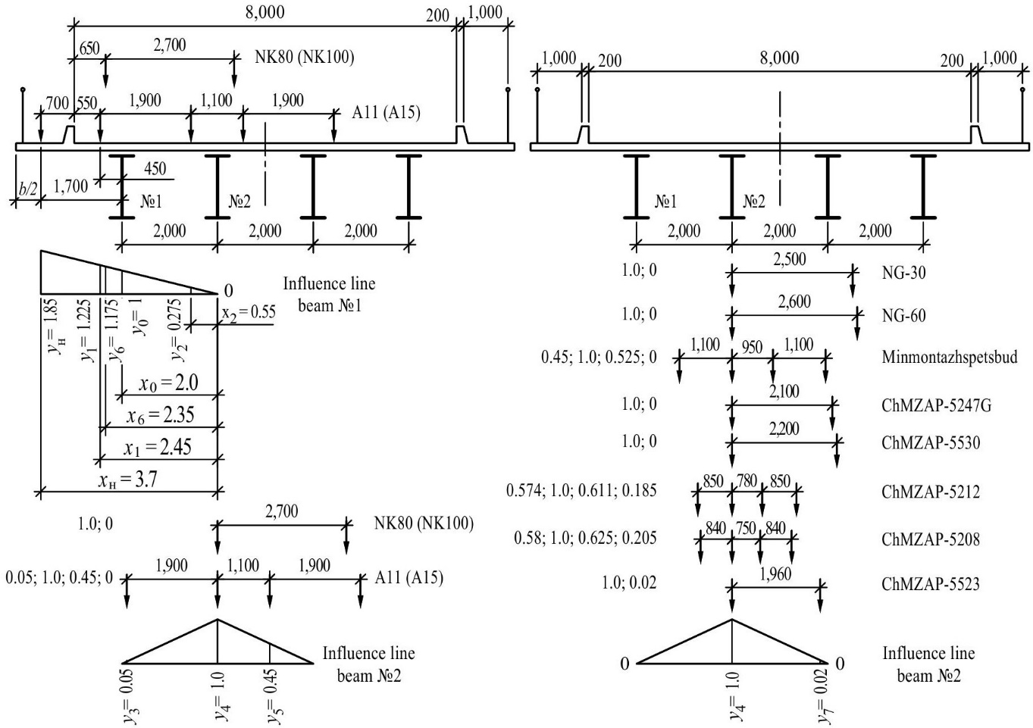

FIGURE 5. Schemes and influence lines for determining the transverse distribution coefficient (TDC) for various loads

TABLE 6. Results of determining M from temporary loads for a span of 15 m
Load | $$γ_{f}$$ | $$(1+μ)$$ | Ordinates on the influence line, control and intermediate №2 beam calculations | Interim calculations | $$L_{p}, м$$ | $$ω, м^{2}$$ | $$q,$$  $$кН/м$$ | $M$, кНм
N-30 | 1.3 | 1.3 | 0.05, 1.0, 0.45 | 0.75 | 14.6 | 26.65 | 30.2 | 1,020
NG-30 | 1.0 | 1.0 | 1.0 | 0.5 | 14.6 | 26.65 | 34.7 | 462
NG -60 | 1.0 | 1.0 | 1.0 | 0.5 | 14.6 | 26.65 | 66.7 | 888
NK -80 | 1.0 | 1.0 | 1.0 | 0.5 | 14.6 | 26.65 | 89.6 | 1,194
NK-100 | 1.0 | 1.0 | 1.0 | 0.5 | 14.6 | 26.65 | 112.0 | 1,492
А15 | 1.5 | 1.3 | 0.05, 1.0, 0.45 | 0.75 | 14.6 | 26.65 | 36.4 | 1,807
А15 | 1.5 | 1.0 | 0.05, 1.0, 0.45 | 0.66 | 14.6 | 26.65 | 14.7 | 1,807
ChMZAP-5523 | 1.0 | 1.0 | 1.0, 0.02 | 0.51 | 14.6 | 26.65 | 24.2 | 329
ChMZAP -5208 | 1.0 | 1.0 | 0.58, 1.0, 0.205 | 0.45 | 14.6 | 26.65 | 49.0 | 588
ChMZAP -5212 | 1.0 | 1.0 | 0.574, 1.0, 0.185 | 0.44 | 14.6 | 26.65 | 69.1 | 810
ChMZAP -5530 | 1.0 | 1.0 | 1.0 | 0.5 | 14.6 | 26.65 | 97.9 | 1,305
ChMZAP -5247G | 1.0 | 1.0 | 1.0 | 0.5 | 14.6 | 26.65 | 48.4 | 645
Trailer by  Minmontazhspetsbud | 1.0 | 1.0 | 0.45, 1.0, 0.525 | 0.49 | 14.6 | 26.65 | 75.9 | 991

TABLE 7. Results of determining Q from temporary loads for a span of 15 m
Load | $$γ_{f}$$ | $$(1+μ)$$ | Ordinates on the influence line, control and intermediate №2 beam calculations | Interim calculations | $$L_{p}, м$$ | $$ω, м^{2}$$ | $$q, кН/м$$ | $Q$, кН
N-30 | 1.3 | 1.3 | 0.05, 1.0, 0.45 | 0.75 | 14.6 | 7.3 | 34.2 | 187
NG-30 | 1.0 | 1.0 | 1.0 | 0.5 | 14.6 | 7.3 | 34.7 | 127
NG-60 | 1.0 | 1.0 | 1.0 | 0.5 | 14.6 | 7.3 | 66.7 | 243
NK-80 | 1.0 | 1.0 | 1.0 | 0.5 | 14.6 | 7.3 | 93.8 | 342
NK-100 | 1.0 | 1.0 | 1.0 | 0.5 | 14.6 | 7.3 | 117.3 | 428
A15 | 1.5 | 1.3 | 0.05, 1.0, 0.45 | 0.75 | 14.6 | 7.3 | 37.9 | 279
A15 | 1.5 | 1.0 | 0.05, 1.0, 0.45 | 0.66 | 14.6 | 7.3 | 14.7 | 279
ChMZAP-5523 | 1.0 | 1.0 | 1.0, 0.02 | 0.51 | 14.6 | 7.3 | 31.5 | 117
ChMZAP-5208 | 1.0 | 1.0 | 0.58, 1.0, 0.205 | 0.45 | 14.6 | 7.3 | 65.5 | 215
ChMZAP-5212 | 1.0 | 1.0 | 0.574, 1.0, 0.185 | 0.44 | 14.6 | 7.3 | 84.6 | 272
ChMZAP-5530 | 1.0 | 1.0 | 1.0 | 0.5 | 14.6 | 7.3 | 98.9 | 360
ChMZAP-5247G | 1.0 | 1.0 | 1.0 | 0.5 | 14.6 | 7.3 | 60.1 | 219
Trailer by  Minmontazhspetsbud | 1.0 | 1.0 | 0.45, 1.0, 0.525 | 0.49 | 14.6 | 7.3 | 101.7 | 363

TABLE 8. Results of determination of M from temporary loads for spans of 18, 24, 32 and 44 m
Load | 18 м |  |  | 24 м |  |  | 32 м |  |  | 44 м
Load | $$ω, м^{2}$$ | $$q,$$  $$кН/м$$ | $M$, кНм | $$ω, м^{2}$$ | $$q,$$  $$кН/м$$ | $M$, кНм | $$ω, м^{2}$$ | $$q,$$  $$кН/м$$ | $M$, кНм | $$ω, м^{2}$$ | $$q,$$  $$кН/м$$ | $M$, кНм
N-30 | 38.72 | 26.6 | 1,305 | 69.62 | 21.3 | 1,880 | 123.25 | 17.6 | 2,749 | 235.45 | 17.6 | 5,252
NG-30 | 38.72 | 29.6 | 573 | 69.62 | 22.9 | 797 | 123.25 | 17.6 | 1,085 | 235.45 | 13.7 | 1,613
NG-60 | 38.72 | 57.4 | 1,111 | 69.62 | 44.8 | 1,559 | 123.25 | 34.6 | 2,132 | 235.45 | 26.1 | 3,073
NK-80 | 38.72 | 77.0 | 1,491 | 69.62 | 60.0 | 2,089 | 123.25 | 46.2 | 2,847 | 235.45 | 34.8 | 4,097
NK-100 | 38.72 | 96.3 | 1,864 | 69.62 | 75.0 | 2,611 | 123.25 | 57.8 | 3,562 | 235.45 | 43.5 | 5,121
A15 | 38.72 | 31.4 | 2,341 | 69.62 | 23.9 | 3,446 | 123.25 | 18.1 | 5,056 | 235.45 | 13.2 | 7,972
A15 | 38.72 | 14.7 | 2,341 | 69.62 | 14.7 | 3,446 | 123.25 | 14.7 | 5,056 | 235.45 | 14.7 | 7,972
ChMZAP-5523 | 38.72 | 22.3 | 432 | 69.62 | 18.8 | 654 | 123.25 | 16.8 | 1,035 | 235.45 | 14.8 | 1,742
ChMZAP-5208 | 38.72 | 43.8 | 848 | 69.62 | 38.9 | 1,354 | 123.25 | 34.5 | 2,126 | 235.45 | 29.2 | 3,438
ChMZAP-5212 | 38.72 | 66.2 | 1,282 | 69.62 | 59.1 | 2,057 | 123.25 | 50.9 | 3,137 | 235.45 | 40.7 | 4,791
ChMZAP-5530 | 38.72 | 87.1 | 1,686 | 69.62 | 71.5 | 2,489 | 123.25 | 64.3 | 3,962 | 235.45 | 59.5 | 7,005
ChMZAP-5247G | 38.72 | 41.2 | 798 | 69.62 | 35.4 | 1,232 | 123.25 | 32.1 | 1,978 | 235.45 | 28.2 | 3,320
Trailer by  Minmontazh-spetsbud | 38.72 | 70.4 | 1,363 | 69.62 | 62.3 | 2,169 | 123.25 | 54.2 | 3,340 | 235.45 | 46.5 | 5,474

TABLE 9. Results of determining Q from temporary loads for spans of 18, 24, 32 and 44 m
Load | 18 м |  |  | 24 м |  |  | 32 м |  |  | 44 м
Load | $$ω, м^{2}$$ | $$q,$$  $$кН/м$$ | $Q$, кН | $$ω, м^{2}$$ | $$q,$$  $$кН/м$$ | $Q$, кН | $$ω, м^{2}$$ | $$q,$$  $$кН/м$$ | $Q$, кН | $$ω, м^{2}$$ | $$q,$$  $$кН/м$$ | $Q$, кН
N-30 | 8.8 | 29.6 | 330 | 11.8 | 27.5 | 411 | 15.7 | 24.6 | 490 | 21.7 | 22.4 | 616
NG-30 | 8.8 | 29.6 | 130 | 11.8 | 22.9 | 135 | 15.7 | 17.6 | 138 | 21.7 | 13.1 | 142
NG-60 | 8.8 | 57.4 | 253 | 11.8 | 44.8 | 264 | 15.7 | 34.6 | 272 | 21.7 | 25.8 | 280
NK-80 | 8.8 | 80.0 | 352 | 11.8 | 61.7 | 364 | 15.7 | 47.1 | 370 | 21.7 | 35.2 | 382
NK-100 | 8.8 | 100.0 | 440 | 11.8 | 77.1 | 455 | 15.7 | 58.9 | 462 | 21.7 | 44.0 | 477
A15 | 8.8 | 31.9 | 577 | 11.8 | 24.3 | 642 | 15.7 | 18.3 | 717 | 21.7 | 13.4 | 836
A15 | 8.8 | 14.7 | 577 | 11.8 | 14.7 | 642 | 15.7 | 14.7 | 717 | 21.7 | 14.7 | 836
ChMZAP-5523 | 8.8 | 29.9 | 132 | 11.8 | 26.9 | 159 | 15.7 | 22.9 | 180 | 21.7 | 18.3 | 199
ChMZAP-5208 | 8.8 | 61.5 | 271 | 11.8 | 53.0 | 313 | 15.7 | 43.6 | 342 | 21.7 | 34.1 | 370
ChMZAP-5212 | 8.8 | 78.8 | 347 | 11.8 | 67.6 | 399 | 15.7 | 55.5 | 436 | 21.7 | 43.3 | 470
ChMZAP-5530 | 8.8 | 92.2 | 406 | 11.8 | 87.5 | 516 | 15.7 | 79.3 | 623 | 21.7 | 66.3 | 719
ChMZAP-5247G | 8.8 | 57.1 | 251 | 11.8 | 50.9 | 300 | 15.7 | 42.7 | 335 | 21.7 | 33.7 | 366
Trailer by  Minmontazhspetsbud | 8.8 | 93.7 | 412 | 11.8 | 78.6 | 463 | 15.7 | 63.7 | 500 | 21.7 | 49.1 | 533
CONCLUSION
1. Analysis of Table 6 shows that the maximum value of the bending moment Mbending=1,807 kNm occurs in metal beam No. 2 with a span length of 15 m from the temporary load A15 (tandem + distributed load), the following values from the load NK-100 – Mbending=1,492 kNm and ChMZAP-5530 – Mbending=1,305 kNm, and the maximum transverse force from the load NK-100 – Q=428 kN, the following values from the load of trailers by the Minmontazhspetsbud – Q=363 kN and ChMZAP-5530 – Q=360 kN.
2. Analysis of Table 8 shows that the maximum value of the bending moment for span lengths of 18, 24, 32 and 44 m occurs in metal beam No. 2 from the temporary load A15 (tandem + distributed load). The value of the bending moment from the load NK-100 for spans of 18 and 24 m is in second place, and for a span of 32 m - in third place, and further, with an increase in the span size, the values of the bending moments from the normative temporary loads are less than from the non-normative ones.
3. The maximum value of the transverse force for span lengths of 18, 24, 32 and 44 m also occurs in the metal beam No. 2 from the temporary load A15 (tandem + distributed load). The value of the transverse force from the load NK-100 for spans of 18 m is in second place, and further, with an increase in the span size, the maximum values of the transverse force are inferior to the non-normative loads.
4. Analysis of the structures of temporary bridges using polymer composite materials showed the prospect of improving them by switching for the conditions of Ukraine from a wooden slab of the roadway to a polymer one. The developed polymer roadway slabs have a high load-bearing capacity, reliable connection with steel beams, and will increase the durability of the bridge.

Acknowledgments
The authors would like to express their gratitude to Kharkiv National Automobile and Highway University and the organizing committee of the Modern Automotive Industry, Transport and Road Infrastructure (MAITRI) conference.

Conflict of interests
The authors declare that there is no conflict of interests regarding the publication of this paper.

REFERENCES
[1] Recommendations on Structural Solutions for the Reconstruction of Damaged Bridges and Culverts (DP DerzhdorNDI, Kyiv, 2022), 167 pp.
[2] State Agency for Restoration and Development of Infrastructure of Ukraine, https://restoration.gov.ua (accessed September 1, 2025).
[3] Project “Pavlo Avdokushyn. Infrastructure Reviewer,” https://avdokushyn.info (accessed September 1, 2025).
[4] BridgeUkraine, https://www.bridgeukraine.org (accessed September 1, 2025).
[5] S. O. Buhaievskyi, T. O. Nenastina, K. V. Berezhna, S. M. Krasnov, and V. O. Buhaievskyi, Restoration of Bridges and Pipes after Damage. Bridge Accidents: Textbook (NOVABOOK, Kremenchuk, 2024), 252 pp.
[6] Matiere (France), https://www.matiere-tp.com/entreprise (accessed September 1, 2025).
[7] P. B. Potyrala, Use of Fibre-Reinforced Polymers in Bridge Construction. State of the Art in Hybrid and All-Composite Structures (2011), 93 pp.; http://upcommons.upc.edu/pfc/handle/2099.1/12353.
[8] J. S. O’Connor and J. M. Hooks, U.S.A.’s Experience Using Fiber Reinforced Polymer (FRP) Composite Bridge Decks to Extend Bridge Service Life (January 2005); https://www.pwri.go.jp/eng/ujnr/tc/g/pdf/19/7-4oconnor.pdf.
[9] B. J. Taylor, Fiber-Reinforced Polymer Honeycomb Bridge Deck Heating Evaluation (Master’s thesis, Univ. of Toledo, 2009); http://rave.ohiolink.edu/etdc/view?acc_num=toledo1260205596 (accessed September 1, 2025).
[10] T. Keller, Use of Fibre Reinforced Polymers in Bridge Construction (2003); https://doi.org/10.2749/sed007.
[11] B. Wan, Using Fiber-Reinforced Polymer (FRP) Composites in Bridge Construction and Monitoring Their Performance: An Overview (2014); https://doi.org/10.1533/9780857097019.1.3.
[12] X. Wei, J. Russell, S. Živanović, and J. T. Mottram, “Measured dynamic properties for FRP footbridges and their critical comparison against structures made of conventional construction materials,” Compos. Struct. 223, 110956 (2019); https://doi.org/10.1016/j.compstruct.2019.110956.
[13] R. A. Shenoi, S. S. Moy, and L. Hollaway, Advanced Polymer Composites for Structural Applications in Construction: Proceedings of the First International Conference, Southampton University, UK, April 15–17, 2002 (Thomas Telford, London, 2002); https://doi.org/10.1680/apcfsaic.31227.
[14] P. Dufton (Ed.), Lightweight Thermoset Composites. Materials in Use, Their Processing and Applications (Rapra Technology Ltd., Shrewsbury, 2000), 212 pp.
[15] M. Bonn, “Span-tastic news as plastic bridge is open,” Daily Record (2018); https://www.dailyrecord.co.uk/news/local-news/span-tastic-news-plastic-bridge-13225299.
[16] M. Zoghi (Ed.), The International Handbook of FRP Composites in Civil Engineering, 1st ed. (CRC Press, Boca Raton, 2013); https://doi.org/10.1201/b15806.
[17] L. Własak, K. Balke, J. Michalski, Ł. Gołębiowski, P. Poneta, and P. Swiezewski, “Optimization of the Composite Footbridge Prototype Structure Based on FEM Analysis” (2012); https://www.researchgate.net/publication/322676783_Optimization_of_the_composite_footbridge_prototype_structure_based_on_FEM_analysis (accessed September 1, 2025).
[18] T. Keller, “Overview of Fibre-Reinforced Polymers in Bridge Construction,” Struct. Eng. Int. 12, 66–70 (2002); https://doi.org/10.2749/101686602777965595.
[19] T. Siwowski, M. Rajchel, and D. Kaleta, “Development, testing and construction of the hybrid FRP composite–concrete road bridge,” IABSE Symp. Rep. 109 (39), 1816–1823 (2017); https://doi.org/10.2749/vancouver.2017.1824.
[20] T. Siwowski, M. Rajchel, D. Kaleta, and L. Własak, “The First Polish Road Bridge Made of FRP Composites,” Struct. Eng. Int. 27, 308–314 (2017); https://doi.org/10.2749/101686617X14881932436339.
[21] M. Rajchel and T. Siwowski, “Hybrid Bridge Structures Made of FRP Composite and Concrete,” Civil & Environ. Eng. Rep. 26, 161–169 (2017); https://doi.org/10.1515/ceer-2017-0043.
[22] L. Zhao, R. Burgueno, H. La Rovere, F. Seible, and V. Karbhari, Preliminary Evaluation of the Hybrid Tube Bridge System, Technical Report No. TR-2000/4-59AO032 (California Department of Transportation, Sacramento, USA, 2000).
[23] J. Knippers and M. Gabler, “The FRP Road Bridge in Friedberg, Germany – New Approaches to a Holistic and Aesthetic Design,” in Proc. Fourth Int. Conf. FRP Compos. in Civ. Eng. (CICE2008), Zurich, Switzerland, 2008.
[24] J. Qureshi, “A Review of Fibre Reinforced Polymer Bridges,” Fibers 11, 40 (2023); https://doi.org/10.3390/fib11050040.
[25] L. Canning, “Performance and 8-year load test on West Mill FRP bridge,” in Proc. 6th Int. Conf. FRP Compos. in Civ. Eng. (CICE 2012), Rome, Italy, June 13–15, 2012; https://www.researchgate.net/publication/287271682_Performance_and_8-year_load_test_on_West_Mill_FRP_bridge.
[26] N. E. Strakhova, V. O. Holubiev, P. M. Kovalov, and V. V. Todirika, in A. I. Lantukh-Lyashchenko (Ed.), Bridge Operation and Reconstruction (Transportna Akademiya Ukrainy, Kyiv, 2000), 408 pp.
[27] I. Yermakova and M. Nechyporenko, “Prospective design loads for bridges on automobile roads,” Dorogi i Mosti (Roads & Bridges) 29, 251–272 (2024); https://doi.org/10.36100/dorogimosti2024.29.251 [in Ukrainian].

