Compliance with European Certification Regulations for the Strength and Safety of Retrofitted City Buses during their Electrification
Kostiantyn Holenko^{1, a)}, Oleksandr Dykha¹, Orest Horbai², Volodymyr Dytyniuk¹, Maksym Dykha¹, Oleh Babak¹
¹Khmelnytskyi National University,
Department of Tribology, Automobiles and Materials Science, 29016 Khmelnytskyi, Ukraine
²Lviv Polytechnic National University,
Department of Equipment Design and Operation, 79013 Lviv, Ukraine
^{a)} Corresponding author: holenkoke@khmnu.edu.ua
Abstract. The rapid transition of the European Union towards zero-emission urban transport requires effective solutions for electrifying the existing diesel bus fleet while ensuring compliance with UNECE Regulation No. 100. This study proposes an analytical algorithm and validates it through finite element analysis (FEA) for evaluating the stress–strain behavior of bus bodies after the installation of roof-mounted traction batteries. Using a 480 kg AMPHERR LFP-400-052 battery mounted on a Mercedes-Benz Citaro (O530) body model, transient structural simulations in ANSYS under regulatory acceleration pulses (12g longitudinal, 10g transverse) were performed. The results revealed maximum von Mises stresses of 398.7 MPa (10g mode) and 441.9 MPa (12g mode), exceeding both the yield strength (σ_{y} = 253.8 MPa) and ultimate tensile strength (σ_{u} = 428.5 MPa) of S235 steel in localized roof zones. Residual stresses at 120 ms reached 292.7 MPa (10g) and 255.9 MPa (12g). Maximum deformations were 42.5 mm in 10g mode and 10.7 mm in 12g, remaining within acceptable operational limits for window bonding. Reaction and moment analysis of inter-window racks demonstrated asymmetrical loading, with up to 17% higher reactions on the driver’s side in transverse mode and stress wave propagation towards the rear overhang in longitudinal mode. These findings confirm that roof reinforcement is essential for safe battery integration but highlight that the inter-window racks remain below critical stress thresholds. The proposed algorithm, suitable for Python or MATLAB implementation, provides a practical framework for preliminary evaluation of structural compliance, reducing the need for full-scale certification testing.
Keywords: structural rigidity; von Mises stress; structural reinforcement; residual stresses; deformation analysis; battery mounting; reaction forces; load distribution.

INTRODUCTION
According to analytical reports by Rabobank (a Dutch cooperative bank), there were about 215 thousand city buses operating in the EU in 2023. The share of BEBs (Battery Electric Buses) among new registrations was 36% (up from 20% in 2021) according to data by T&E (Transport & Environment – a Brussels-based non-governmental organization advocating for clean transport policies in Europe). In 2024, 49% of new city buses in the EU were zero-emission, of which 46% were electric, 3% were hydrogen fuel cell powered. According to the EU's strategic decarbonization goals defined by a number of regulatory requirements (Regulation (EU) 2019/1242 (changes 2023/24), Euro 7 Emission Standards, AFIR (2023/1804) regarding charging for BEBs in cities, etc.) approved in 2023/2024, from 2030 all new city buses must be zero-emission (electric or hydrogen). The question arises as to what to do with the existing diesel fleet of city buses, given that the cost of the body, for example, in 12-meter models is 45-55% on average. Converting to electric traction with the installation of batteries is the only possible solution, and at the same time, an era of great opportunities for small bus manufacturers in Europe. There are several problems: the inadmissibility of making changes to the bus body as this will automatically require full re-certification according to the UNECE (United Nations Economic Commission for Europe), and automatic activation of a number of tests related to electric vehicles, such as ECE Regulations No. 100 (Uniform provisions concerning the approval of vehicles with regard to specific requirements for the electric power train) [1], which is the subject of this study. The main idea lies in developing an analytical algorithm as a basis of an applicable software- or browser-based tool development for assessing key stress-strain indicators (stresses, reactions, moments, etc.) in the inter-window racks and roof truss, as well as conducting a verification FEA analysis to identify relevant trends and areas for optimization.
LITERATURE REVIEW AND PROBLEM STATEMENT
Since UNECE No. 100 [1] determines the integrity and safety of battery packs within the body, it is advisable to refer to relevant scientific publications. Thus, Pepó et al., 2025 [2] describe standardized battery tests, including mechanical (vibration, shock, compression) tests according to No. 100 (in particular Annex 9). A description of the BYD Dolphin battery pack testing at No. 100 is provided, including the results of vibration, shock and other tests. The authors of [3] analyze the crash test requirements between UNECE No. 100 and other international standards. In particular, No. 100 sets a minimum of 100k N of crashing force for the mechanical integrity test; it also considers force compensation according to battery weight. In addition to the batteries themselves, it is advisable to analyze publications about the strength of the bodies. Thus, Holenko et al. [4] propose a methodology for simulating frontal crashes in city buses based on UNECE No. 29, revealing that due to the absence of deformation zones and lower structural stiffness compared to other bus types, city buses experience faster and more severe frontal deformations, necessitating revised testing conditions and attachment schemes. Authors of [5] enhance the structural safety and stiffness of a bus body frame by optimizing the sectional shapes of critical tube beams using mesh morphing, multi-objective algorithms, and six-sigma robust design, resulting in a 5.9% weight reduction and prediction accuracy within 0.3%. Jongpradist et al. [6] analyze the crash behavior of a lightweight monocoque composite microbus structure under frontal impact, demonstrating that targeted reinforcements can significantly reduce intrusion and injury risk while maintaining structural lightness, thereby enhancing occupant safety during severe collisions. The study [7] aims to enhance the safety and efficiency of electric buses by optimizing the chassis frame through the substitution of steel with aluminum alloys, using ANSYS-based structural analysis to ensure reduced weight without compromising strength or crash safety. All these publications consider the safety of the bus body as a whole, or separately the safety of the batteries, but the analysis of structures (for the installation of batteries) in the body has been almost unexplored, especially for compliance with No. 100, which is the key goal of this study.
It is advisable to familiarize oneself with publications on the bus body structures and factors affecting their static and dynamic strength. Thus, [8] presents FEA and experimental validation of a passenger bus body structure, leading to the proposal and implementation of optimization measures, such as closed-loop configurations, mechanically stable and special-shaped beams, and symmetrically distributed rod structures. The study [9] proposes and validates a procedure for assessing bus body durability on rural roads, showing that poor road conditions accelerate frame cracking by 3.8–13.1 times compared to regulatory conditions. Yang et al. [10] present a lightweight design optimization of a commercial electric bus body frame using TOPSIS, surrogate modelling, and evolutionary optimization, achieving a 51.59 kg (4.99%) weight reduction while simultaneously enhancing stiffness, strength, and crashworthiness performance. Bijwe et al. [11] describe a FE-methodology for evaluating the stress-strain behavior of a full bus body under regulatory requirements, providing a standardized framework for assessing structural integrity and safety in the bus industry. [12] presents initial steady-state test results for Letenda Inc.’s fully electric bus, aimed at validating multi-body dynamic and finite element models for lightweight design optimization, durability assessment. The paper [13] focuses on a multi-objective optimization of a commercial electric bus body frame using MOMVO (multi-objective multi-verse optimization) algorithm, achieving simultaneous reductions of 4.8% in mass, 10.5% in stress, and 15.2% in side impact intrusion while ensuring strength, crashworthiness, and lightweight performance. Authors of [14] evaluate and optimize the hydrogen fuel cell city bus body frame using finite element analysis, reducing maximum stresses by up to 20.13% and body weight by 106 kg, thereby improving structural performance and meeting strength design requirements under typical operating conditions. Wang et al. [15] present a two-level ATC-based (analytical target cascading) optimization of a multi-material electric bus body, achieving a 49 kg weight reduction and a 17.5% increase in torsional stiffness while ensuring structural strength through validated finite element analysis. The study [16] demonstrates that replacing ancillary frame elements of a medium-sized passenger bus with fiberglass preserves structural safety, improves dynamic characteristics by up to 20%, reduces frame mass by 11%, and lowers the center of gravity, enhancing stability, comfort, and fuel efficiency.
The absolute majority of the publications reviewed are devoted to the evaluation of buses in their existing configurations under certain conditions (static loads or dynamics and crash-tests), however, the core-idea of transformation from diesel to hydro- or electric traction with the appropriate placement of power units on the roof in existing buses is still poorly researched, although it is predicted to develop in view of the prospects for the implementation of EURO 7 and other environmental directives, and therefore the tasks set in this work (analytical algorithmization and FEA-validation) will become relevant.

Analytical approach to UNECE No. 100 boundary conditions
UNECE No. 100 defines the requirements for absorption of accelerations (pulses): for example, category M3 (urban low-floor models) must absorb accelerations of $10g$ in the transverse and $12g$ in the longitudinal directions (Fig. 1 a), reaching them during 0–50 ms (point B in Fig. 1 b), hold up to 80 ms (point G), fall to 0 N to 120 ms (point H) and staying between the max and min curves (Fig. 1 b).

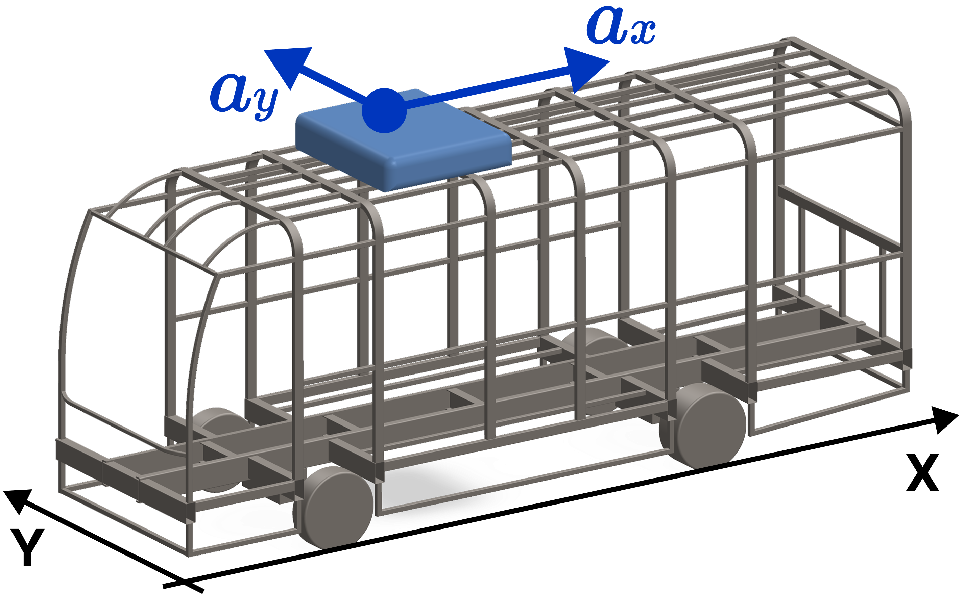 |  | 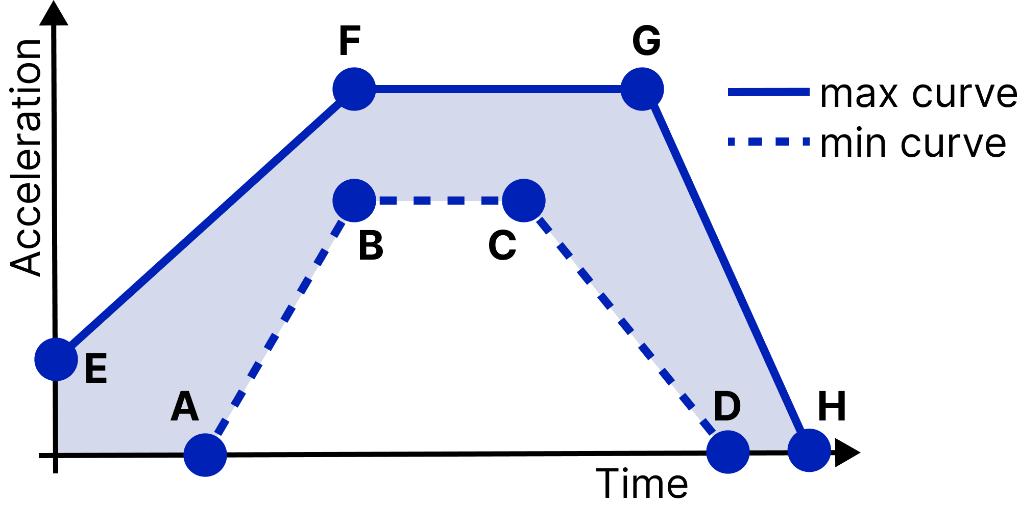
(a) |  | (b)
FIGURE 1. UNECE No. 100 generic description of test pulses: (a) bus model accelerations; (b) regulatory measures.

In reality, the acceleration values in full-scale tests are different from the normative ones and depend on many parameters. The proposed equation (1) is based on such assumptions as: battery is considered as a rigid body attached to the roof through elements with damping and stiffness; the bus body is a deformable medium with a certain modal behavior; the acceleration calculation is based on the mechanical model "mass-spring-damper", to which an external disturbance (emergency braking, impact) is applied. It’s possible to present the effective acceleration a_{x eff} using the example of the equation for the longitudinal (X axis) based on damping, stiffness, spatial momentum damping (damping in the body), and torque around the battery center of gravity (CoG):

, (1)

where: a_{x,0} – peak acceleration at the point of impact (12g or 10g), m/s²; k_{dx} – spatial damping coefficient, 1/m; L_{x} – distance from the point of impact to the battery (along the X axis), m; c_{x} – damping coefficient in X direction, kg/s; m – battery mass, kg; x′ – battery movement velocity along the X axis, m/s; k_{x} – battery mounting stiffness (X axis), kg/s²; x – linear battery displacement (X axis), m; θ″ – angular acceleration around the Z axis, rad/s²; y – distance from CoG to the calculation point along the Y axis (transverse axis), m; ω – angular velocity (if the battery rotates upon impact or the mount is loose), rad/s. In most cases, the value of ω²x can be neglected.
Equation (1) begins with a damped impulse, attenuated by the mounts’ damping and elasticity, and includes rotational effects, which can be significant if the battery rotates or has substantial length or width. For example, for a model with the following indicators (a_{x,0} = 117.7 m/s² (12g); k_{dx} = 5·10⁻² 1/m; L_{x} = 3 m; c_{x} = 2000 kg/s; m = 400 kg; x′ = 0.6 m/s; x = 15·10⁻³ m; k_{x} = 2·10⁵ kg/s²; θ″ = 45 rad/s²; y = 0.4 m; ω = 3 rad/s) the value of a_{x eff} = 11.1g, which is 7.5% less, than the normative longitudinal (12g). However, under alternative boundary conditions, the calculated acceleration may exceed the regulatory threshold.
Further development of the model to become a full-fledged 6-DOF (degrees of freedom) MDOF (Multi Degrees of Freedom Systems) system validated under UNECE No. 100 Rev. 3, Annex 9C and subsequently, the basis for optimization of the mounts consists of the following stages:
1. Consider the battery pack as a rigid body (6-DOF) on $n$ mounts (spring + damper in each: k_{i} (N/m) and c_{i} (N⋅s/m)) connecting it to the “base” of the body, the generalized state vector will be:
, (2)

where: q – generalized state vector, where: x, y, z – longitudinal, transverse, vertical displacement of CoG accordingly, m; φ, θ, ψ – rotation angle around axes X (roll), Y (pitch) and Z (yaw), rad; q′ – velocity, m/s or rad/s; q″ – acceleration, m/s² or rad/s².
The inertia-mass matrix consists only of diagonal elements:

(3)

where: m – battery pack mass (i.e., m at position (1,1) is multiplied by x″ that corresponds to the force of inertia along the X axis (longitudinal), kg; I_{x}, I_{y}, I_{z} – moments of inertia, kg⋅m².
Kinematic representation: for the i-th fastener with radius vector r_{i}, m (from the battery unit CoG to the attachment point), the relative deflection δ_{i} (scalar, m) and its derivative δ_{i}′ (m/s) in the direction of the local axis is:

, (4)

where: B_{i} = [I₃,-[r_{i}]×] – influence matrix relating the generalized coordinates q of the rigid body to the displacement of the attachment point i; [r_{i}]× – a skew-symmetric matrix (vector product operator); n_{i} – unit direction of the spring damper (vector); I₃ – a unit matrix (3×3), which corresponds to the direct transfer of translational coordinates (X, Y, X axes) to the displacement of the point; u_{b,i} – microdisplacement or vibration of the base at the attachment point (body influence), m; u_{b,i}′ – appropriate derivative, m/s.
Forces and moments from the attachment i:

, , (5)

where: f_{i}(t) – the scalar force in the action direction of fastener i (depends on elongation δ_{i} and velocity δ_{i}′), N; w_{i}(t) – force vector in 3D, N; n_{i} – unidirectional vector (dimensionless).
Vector of generalized forces Q_{i} ∈ R⁶ (3 forces + 3 moments) in [x y z φ θ ψ] coordinates:

. (6)

Summing over all i = 1..n, it’s possible to obtain the global stiffness/damping matrices:

, . (7)

Explanation: for each attachment it’s suggested to form a n_{i}n_{i}^{T} (3×3) projector onto the direction of action of the element, raise this local contribution to the generalized coordinate space through B_{i}^{T}B_{i} and multiply by the scalar stiffness k_{i} or damping c_{i}. The sum over all i gives the global K and C ∈ R^{6×6}.
Thus, it’s possible to formulate the motion equation (basic excitation from the body):

, (8)

where: a_{b}(t) = [a_{x} a_{y} a_{z}]^{T}– acceleration impulse from the body, m/s²; -MΓa_{b}(t) – D'Alembert inertial force (N) from the "implied" acceleration of the base, where Γ = diag(I₃,0_{3×3}) matrix. In equation (1), the “spatial damping”
e^(-k_{dx}L_{x}) can be replaced by a physically justified transfer function body mounting point through u_{b,i}(t) and a_{b}(t). What this gives in practice: the ability to obtain a coupled translational-rotational model.
2. Input impulse according to UNECE No. 100 Annex 9C (M3/N3): Instead of an abstract a_{x,0}·e^(-k_{dx}L_{x}), a real test pulse for category M3/N3 can be presented by linear sections of reaching 12g (longitudinal) and 10g (transverse), with timings (Fig. 1 b). Formally, it is possible to specify a piecewise linear function a_{x}(t), a_{y}(t) as an interpolator by nodes (E–F–G–H in Fig. 1 b), which fully complies with Annex 9C. This allows to model exactly the profile that the certification attack follows. The specified exponent e^(-k_{dx}L_{x}) is convenient for a first approximation, but it is better to determine the frequency transfer function, which is based on EMA (Experimental Modal Identification) on the bus frame, or FEM of the body (Craig–Bampton modal reduction), and then convolve in time.
3. Nonlinearities and contact. Realistic mounts are:
- bilinears and stoppers k_{i}(x) = k_{i1} while |x| < x* and k_{i2} ≫ k_{i1} while |x| ≥ x* (similarly for c_{i});
- dry friction and slip in supports:

, (9)

where: Q_{f} – friction force vector, N; μ – the coefficient of dry friction (dimensionless); N – normal pressing force (battery weight or the pre-clamping), N; sgn(δ′) – the sign of the function (+1 or −1), which specifies the direction of the friction force opposite to the sliding velocity; n_{i} – unit vector of the sliding direction (indicates in which direction the friction force acts).
- backlash: dead zone: |x| < x₀ ⇒ k_{i} = 0
The motion equations then become a nonlinear model, where F_{base}(t) – vector of generalized external forces and moments from base excitation (No. 100) that describes the effect of external excitation from the body on the battery:

. (10)

4. Stochastics and reliability UQ/RBDO (Uncertainty Quantification / Reliability-based design optimization). The parameters of the m, I_{j}, k_{i}, c_{i}, r_{i}, μ vary, so it’s advisable to enter the input uncertainty vector ξ (Gaussian or Lognormal):

. (11)

Next point is the polynomial chaos (gPC) or Latin Hypercube for estimating quantiles (95th percentile); reliability:
P{max a_{x eff} ≤ 12g, max a_{y eff} ≤ 10g}≥ 1 – β, where β is failure probability.
5. Checking No. 100 criteria and moving to bolt (or bracket) forces: it’s recommended to check not only at the g-levels, but also the forces in the mounts:

, , (12)

where: σ_{bolt}(t) – normal stress in a bolt, Pa; F_{i}(t) – force in the i-th fastener, N; A_{bolt} – effective cross-section area of the bolt, m²; τ_{bracket}(t) – tangential (shear) stress in bracket, Pa; T_{i}(t) – moment of force transmitted by the i-th fastener, Nm; W_{t} – section modulus of the bracket section, m³. This allows to immediately translate the dynamics into the mounting size and thickness of the brackets.
In summary, the practical algorithm based on Python or Matlab looks like this:
- Pulse: specify a_{x}(t), a_{y}(t) as piecewise linear functions (12g/10g, nodes 0–50–80–120 ms in Fig. 1 b);
- Battery parameters: m, I_{x}, I_{y}, I_{z} – from CAD; r_{i}, n_{i} – from 3D diagram; k_{i}, c_{i} – from passports or identification (step-sine or EMA);
- Numerical integration: Newmark-β or Hilber–Hughes–Taylor (for linear) or Runge–Kutta and events (stoppers and backlashes);
- Post-process: a_{x eff}(t), peaks, time to peak, energy indicators; forces in fasteners, FOS (Factor of Safety);
- UQ/RBDO: LHS (Latin Hypercube Sampling) 200–1000 runs; validation on shock-pulse bench;
- No. 100 reporting: confirmation that peak g-levels are within Annex 9C criteria; no hazardous effects (fire, explosion, electrolyte leakage, insulation).
Taking into account the conclusions obtained at the FE-analysis stage regarding the rationality of the batteries distribution over the roof structure (multi-block approach: 480 kg → 2×240 kg or 3×160 kg), it’s advisable to expand the analytical methodology presented above, starting from equation (8) but applying it to the total ("tot" index in the equations below) multi-mass assembly. Let there be 𝑁 battery modules; for each 𝑗=1,…, 𝑁 there is its own vector of generalized coordinates 𝑞_{𝑗} ∈ R⁶:
, (13)

where total q and M are defined as:

, , (14)

where: M_{j} correspondents to the j-th element according to (3).
The total stiffness consists of the local contributions of the fasteners of each module and intermodular connections (if the modules are connected to each other or through a common frame):

, (15)

where: K^{(j)​} ∈ R^{6N×6N} – local contribution of the module 𝑗 obtained by raising K presented in (7); K_{conn}^{(j,k)} ∈ R^{6N×6N} – stiffness of the connections (“conn” index in the equations below) between modules 𝑗 and 𝑘:

, (16)

where: E_{j} – projection matrix (a block matrix that places a 6×6 block in the position of the corresponding submatrix of size 6𝑁). The damping matrices C_{tot} are formed similarly; k_{pq}^{(jk)} – stiffness of the intermodule connection between points p ∈ j і q ∈ k, N/m. The sum ∑p,q is carried out over all pairs of connection points between modules j and k.
This approach (13–16) somewhat complicates analytical modelling, so as a simplification alternative, one can base it on the initial single-mass scheme (8), applying it to each body section separately, i.e. analyze the bus discretely (section by section). A possible disadvantage of this approach is the lack of clear values of the interconnection reactions between the sections, however, if it’s assumed that the total strength of all tubes (profiles) connecting the sections into one structure is above the yield strength σ_{y}, then this approach can be a simplified alternative to integration (13).
UNECE No. 100 ANSYS BOUNDARY CONDITIONS
In conditions of tough market competition, the proposed analytical models based on math-modelling and subsequent implementation in Python or MatLab are an effective solution for templating typical tasks – assessing the strength of the bus bodies when converting them to electric traction with the batteries installation on the roof. The next stage is a FEA-calculation (Ansys Transient Structural is used in the particular analysis) with an estimate of the reactions in the inter-window racks (tags B-Q correspond to the Fixed Support constraints in Fig. 2) and max stress σ_{max} with the condition of preserving the yield strength (σ_{y} =253.8 MPa for the S235 steel according to the Ansys Granta EduPack data): σ_{max} < σ_{y}. Globally, the results should show whether the bus body (Mercedes-Benz Citaro (O530) as prototype 3D model) tolerates the additional mass of the battery on the roof: 480 kg (AMPHERR LFP-400-052 battery, which is certified according to European standards (ECE R100, R10.6, UN38.3), has integrated BMS, cooling, scalability) provokes the Remote Force (tag A in Fig. 2) of 56505.6 N (tag A in Fig. 2) applied to battery CoG (at 145 mm height from the roof ) along the longitudinal axis (12g mode). In the 10g mode, the Remote Force of 47088 N acts in the transverse axis. In both 10g and 12g modes, the force application corresponds to the time-steps on the graph (Fig. 1 b): grows during 0 – 50 ms, holds up to 80 ms, falls to 0 N to 120 ms. Additionally, the Standard Earth Gravity (9806.6 mm/s²) is applied to the model.

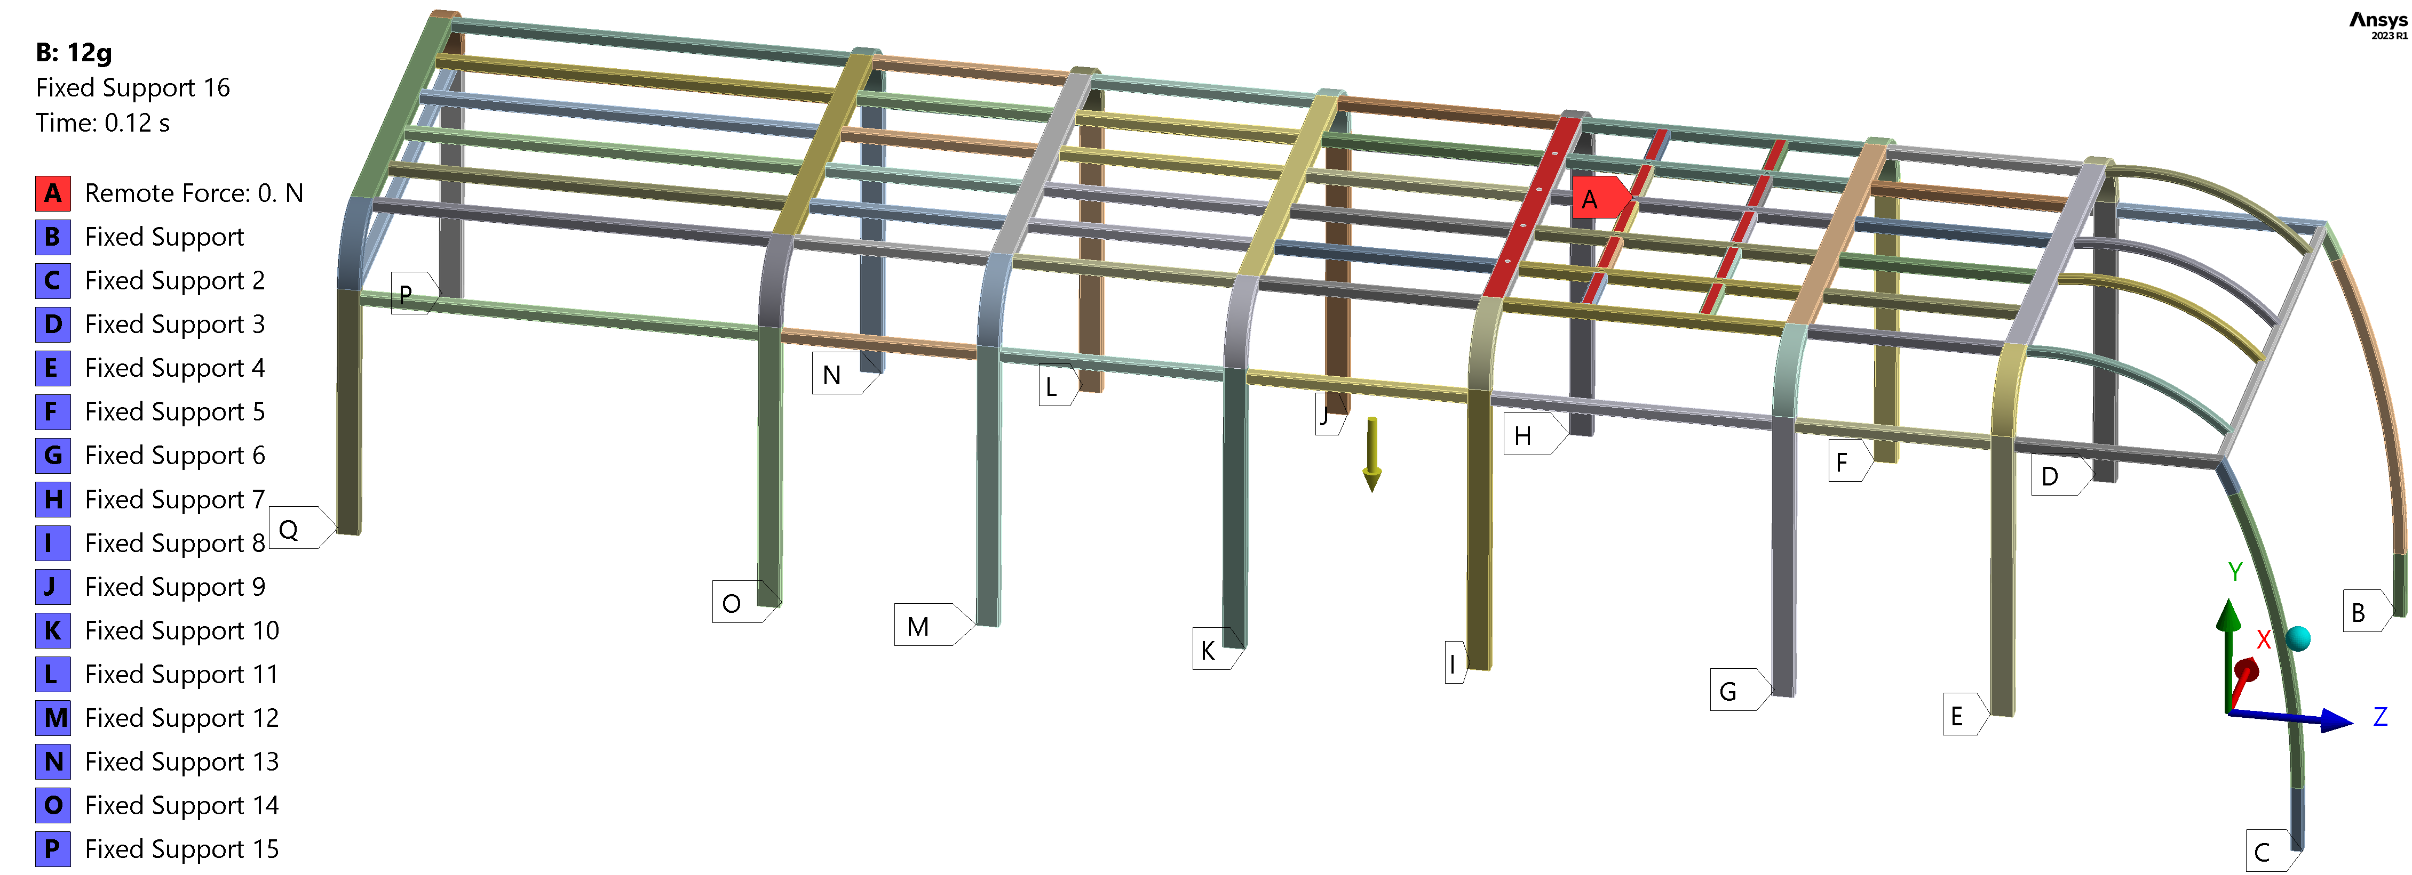
FIGURE 2. Ansys Transient Structural boundary conditions (12g mode).

The Ansys tetrahedral mesh consists of 698773 nodes connecting 295897 elements with a maximum size of 30.0 mm. Characteristics of steel S235: Young’s Modulus = 209.9 GPa; Tangent Modulus = 1.18 GPa; Poisson’s
Ratio = 0.3; Tensile Ultimate Strength σ_{u} = 428.5 MPa.
RESULTS OBTAINED AND THEIR DISCUSSION
In 10g mode, the maximum von Mises stress σ_{max} = 398.7 MPa at 62 ms (tag max in Fig. 3 a, b) and in the 12g mode σ_{max} = 441.9 MPa at 56 ms (tag max in Fig. 3 c), which repeats again at 78 ms (graph in Fig. 3 b) – it’s greater than the Tensile Ultimate Strength (although the spot is local with the minimal area). The critical value is the residual local stresses σ_{res} at 120 ms (when the Remote Force = 0 N): 292.7 MPa in 10g mode and 255.9 MPa in 12g, which is actually lower despite the fact that the max overall stress σ_{max} is mm higher in 12g mode, although both values exceed the yield strength. In this case, for a comprehensive assessment of strength, it is advisable to also analyze the Safety Factor (SF = σ_{max /} σ_{y}), which is planned in future publications as continuations of this research. The rate of stress growth in 10g mode is higher than in 12g, as evidenced by the larger slope of the graph (Fig. 3 b) at the first stage of Remote Force growth (0 – 50 ms), which indicates a higher compliance of the truss in the transverse direction (explained by the lower section modulus of the inter-window racks in the transverse axis). The σ_{max} value of the inter-window racks (Fig. 4) is lower than the stress directly on the roof (Fig. 3 a, c): 370.4 MPa in 10g mode and 357.9 MPa in 12g, which is even lower despite the more severe 12g mode boundary conditions. Residual stresses σ_{res} vary more than threefold: 259.7 MPa (10g) vs 77.3 MPa (12g).
Summing up the results of the σ_{max} stresses, unfortunately, it can be stated that the recorded values exceed not only the ultimate strengths but also the yield point of S235 steel – this can be seen from the graph (part between 50 and 80 ms in Fig. 3 b). At the same time, the fact of fixing σ_{max} in the roof cascade (Fig. 3 a, c), and not in the lower part of the inter-window racks where they are welded to the window sill (σ_{max} doesn’t exceed σ_{y}), is a positive result: to install battery blocks, structural reinforcement of the roof will be required anyway, so there is an opportunity to simultaneously strengthen problem areas – weld angles to the racks at the points of connection with the roof (both max tags are at the top of the racks in Fig. 4).

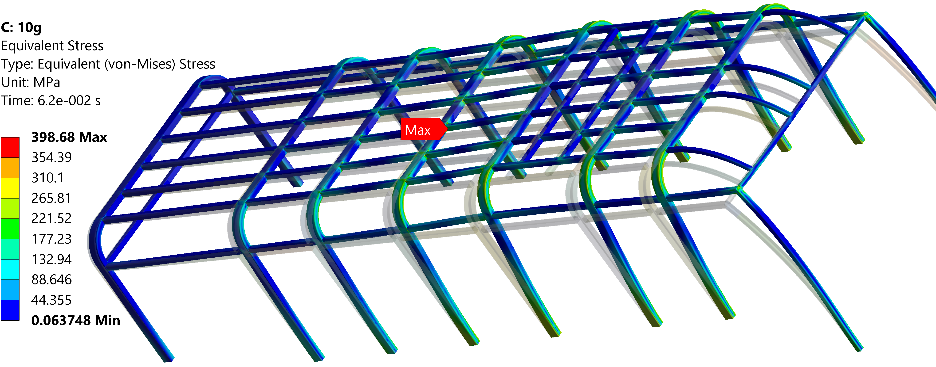
(a) | (b)
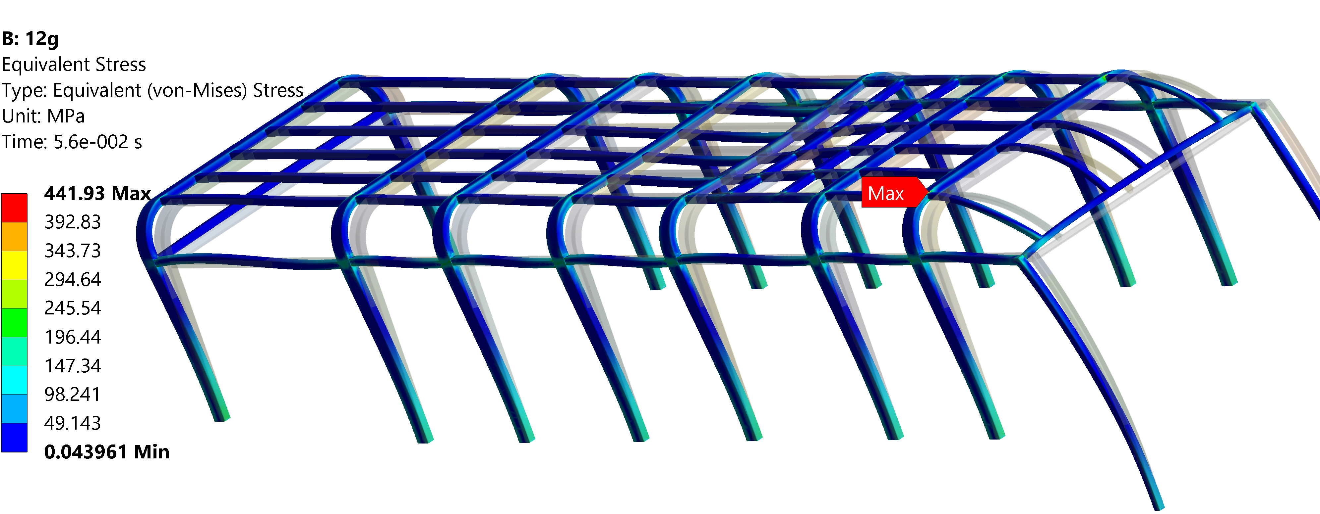 | 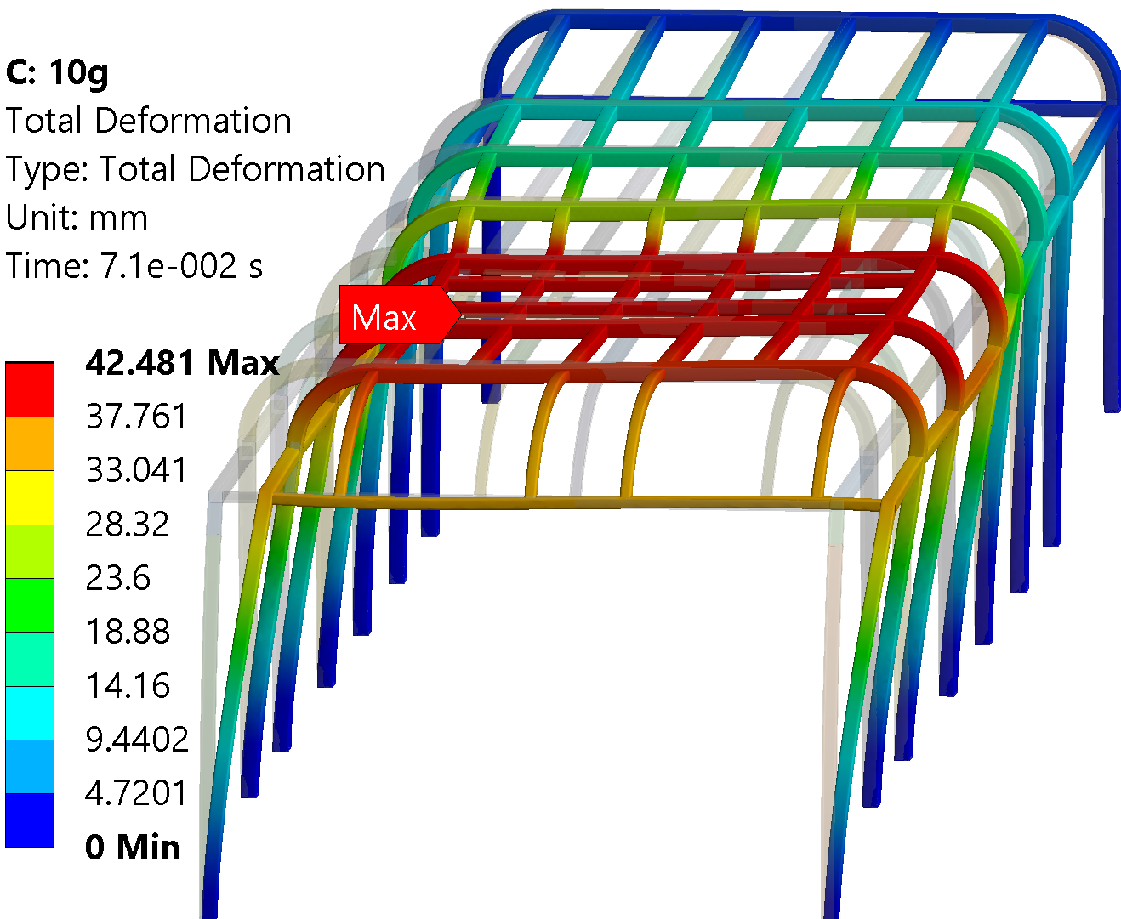
(c) | (d)
FIGURE 3. Stress-strain state of the model: (a, c) von Mises stress map in 10g and 12g mode accordingly; (b) von Mises stress graphs; (d) deformation in 10g mode

Max deformations δ_{max} (in Ansys, the “Deformation” instrument corresponds to the displacement in mm) are: 42.5 mm in the 10g mode (Fig. 3 d) on the left side of the bus (towards the driver) and just 10.7 mm – in 12g along the longitudinal axis. Empirically, it is believed that values up to 50 mm are acceptable for normal operation of glued windows, which in real conditions add rigidity to the body and reduce δ_{max}. Fig. 3 d shows the unevenness of roof deformations: the higher the mass (inertia from the batteries), the higher the deformations in this area. This leads to side effects that may be the subject of future, deeper research: the impulse is not distributed instantly throughout the entire structure of the body frame, but propagates in the form of stress-strain waves with a finite velocity c=√(E / ρ) – ratio of the square root of Young's modulus to the density. In fact, as energy is absorbed, the deformations can even reach the rear overhang of the bus in a wave, which will be further confirmed in the analysis of reactions.

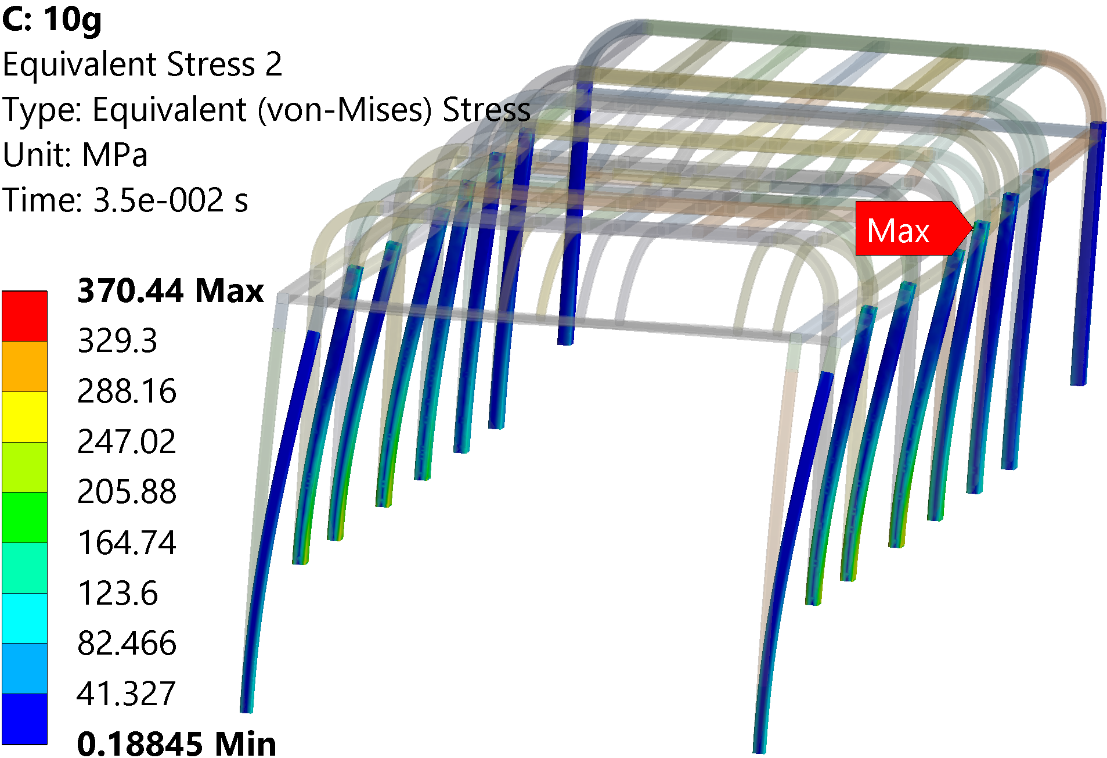 | 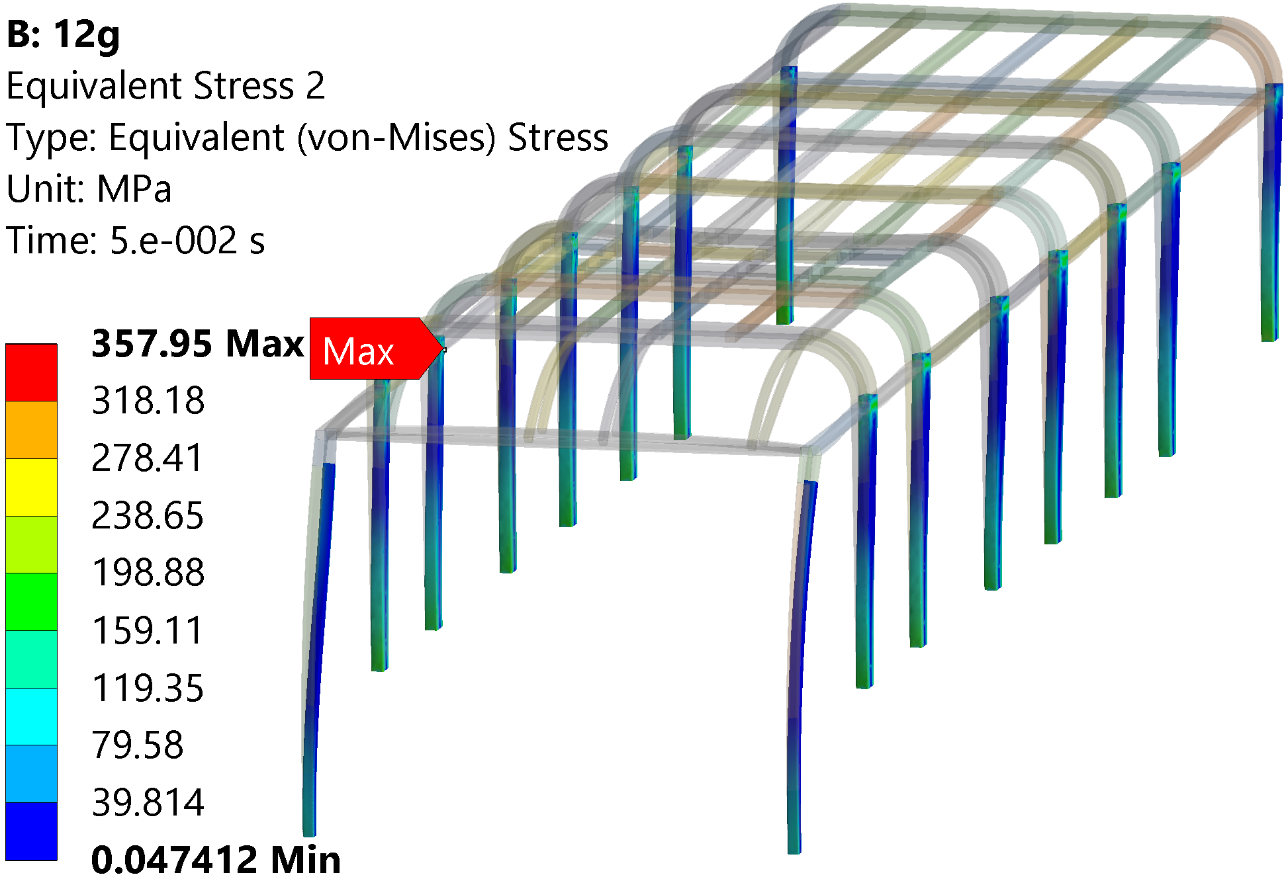
(a) | (b)
FIGURE 4. Stress-strain state of the inter-window racks in the mode: (a) 10g; (b) 12g

In the most simplified form, the bus can be represented as a two-mass model: the roof (with air conditioners, batteries and other equipment) and the base (chassis, engine and load-bearing structure of the body) are interconnected by inter-window racks. That is why it is so important to control the reactions (Fig. 5 a) and moments (Fig. 5 b) in the lower ends of the racks (according to the Fixed Supports in Fig. 2) to ensure the SF and the body's uniform strength, which determines the selection rationality of pipe profiles and their materials.

(a) | (b)
FIGURE 5. Inter-window racks: (a) total reactions; (b) moments
The resulting graphs (Fig. 5) demonstrate a number of trends and observations:
- despite the longitudinal application of Remote Force (Fig. 2) in the 12g mode and the symmetry of the body sidewalls, a difference was recorded between the reactions of the left (labels B, D, F, H, J, L, P) and the right bus side (labels C, E, G, I, K, M, O, Q), which is 2-3% more loaded (Fig. 5 a). The right sidewall has lower stiffness due to the door openings.
- In the transverse mode 10g, the left sidewall (driver's side), to which the Remote Force is directed, demonstrates 17% higher reactions than the right one. Higher bending moments occur here, as confirmed in Fig. 5 b, and higher deformations (Fig. 3 d) accordingly.
- The wave theory of inertia (impact) transfer is reflected in the 12g mode results – the highest values of reactions (over 4500 N) and moments (over 3500 N·m in Fig. 5 b) precisely in the last P, Q racks (rear overhang), although the battery is located closer to the front part (H and I racks), where the reactions are just 4203 and 4220 N accordingly. The front B and C pillars, on the contrary, are the least loaded (by more than 20%) – the inertia of the battery’s mass goes from them to the rear overhang of the bus.
- The front racks B, C have the lowest values of reactions in the 10g mode (slightly above 1000 N), but the ones following them (D, E) received 5 times higher values in a stridor-like manner. This emphasizes the need for careful verification of the results for each structural element, even if they are adjacent. Besides, considering the minimum reactions of the front racks (B and C), the windshield will be safe under conditions of oblique-diagonal alternating loads (driving over bumps, etc.).
The results of the stress-strain analysis show that, despite the initially assumed safety margin of the sidewalls (determined by side rollover safety in accordance with UNECE Regulation No. 66), the structural strength of the sidewalls and roof require detailed verification when installing roof-mounted batteries. Such audit must be conducted individually for each specific bus model or modification and be accompanied by local strength optimization. A potentially more favorable design solution may involve distributing the battery mass across multiple smaller units (e.g., replacing a single 480-kg block with two-three lighter blocks), which constitutes a promising direction for further investigation. Within this context, the development of a proposed practical algorithm based on Python or Matlab, appears particularly relevant for analyzing the structural effects of multi-mass battery configurations. In addition, a significant avenue for future research lies in the creation of a dedicated software tool (or browser-based) with a user-oriented interface for the preliminary estimation of load reactions and stresses in the inter-window racks. By enabling the input of essential parameters (battery mass, CoG coordinates, and attachment locations, etc.) such a tool would provide valuable preliminary insights prior to undertaking resource-intensive FEA. Considering the influence of climatic conditions and temperature gradients on the operation of fasteners and the stiffness of joints is also a relevant direction for expanding research: both analytical (in the form of input parameters. i.e, temperature) and FEA (using Ansys Coupled Field Transient). This approach could thus offer substantial practical benefits for design bureaus engaged in the structural adaptation of bus frames for electrification.

CONCLUSIONS
- Analytical modelling demonstrates that the regulatory accelerations of 12g and 10g prescribed by UNECE No. 100 represent generalized empirical benchmarks rather than absolute values. In practice, the effective impulses should be recalculated for each specific bus configuration. For example, the present study yielded 11.1g instead of the nominal 12g; however, under alternative boundary conditions, the calculated acceleration may exceed the regulatory threshold.
- Finite element simulations of a Mercedes-Benz Citaro (O530) with a roof-mounted 480 kg AMPHERR LFP-400-052 battery revealed critical stress concentrations under both longitudinal (12g) and transverse (10g) certification loads. Peak von Mises stresses reached 398.7 MPa (10g) and 441.9 MPa (12g), surpassing the yield strength of S235 steel (σ_{y} = 253.8 MPa) and, in the longitudinal case, even the ultimate tensile strength (σ_{u} = 428.5 MPa). Residual stresses at 120 ms were 292.7 MPa (10g) and 255.9 MPa (12g), still above σ_{y} but notably lower than the transient peaks, indicating localized overstressing in the roof joints.
- Maximum displacements were 42.5 mm under 10g and 10.7 mm under 12g, both within the empirical 50 mm tolerance considered acceptable for bonded glazing, which further contributes to body rigidity.
- Reaction analysis of the inter-window racks revealed structural asymmetry: under 10g transverse loading, the driver’s side absorbed 17% higher forces, while under 12g longitudinal excitation, inertia waves shifted the maximum loads to the rear overhang, where reactions exceeded 4500 N and moments surpassed 3500 N·m. The roof cascade was identified as the critical weak zone, whereas inter-window posts remained below critical limits, suggesting that local roof reinforcement rather than a full frame redesign would suffice.
- The proposed algorithm, designed for Python/Matlab implementation and validated through ANSYS FEA, proved to be an effective tool for preliminary verification of UNECE No. 100 compliance, significantly reducing the reliance on costly full-scale crash tests.
- For practical integration of roof-mounted batteries, localized roof strengthening is recommended, as stresses may locally exceed both yield and ultimate limits. Furthermore, partitioning the battery mass into multiple smaller modules instead of a single 400-480 kg unit could mitigate peak stresses and enable more favorable load distribution across the body frame. The algorithm provides a valuable design-stage methodology for optimizing reinforcement strategies prior to certification.

ACKNOWLEDGMENTS
The authors would like to express their gratitude to Kharkiv National Automobile and Highway University and the organizing committee of the Modern Automotive Industry, Transport and Road Infrastructure (MAITRI) conference.

Conflict of interests
The authors declare that there is no conflict of interests regarding the publication of this paper.

References
[1] UN ECE Regulation No. 100, Uniform provisions concerning the approval of vehicles with regard to specific requirements for the electric power train (United Nations Economic Commission for Europe, Geneva, 2024); available at https://unece.org/transport/documents/2022/03/standards/regulation-no-100-rev3.
[2] M. Pepó, S. Fullér, T. Cseke, and Z. Weltsch, “Advances in standardised battery testing for enhanced safety and innovation in electric vehicles: A comprehensive review,” Batteries 11(4), 157 (2025). https://doi.org/10.3390/batteries11040157
[3] B. Kotak, Y. Kotak, K. Brade, T. Kubjatko, and H.-G. Schweiger, “Battery crush test procedures in standards and regulation: Need for augmentation and harmonisation,” Batteries 7(3), 63 (2021). https://doi.org/10.3390/batteries7030063
[4] K. Holenko, O. Dykha, E. Koda, I. Kernytskyy, Y. Royko, O. Horbay, O. Berezovetska, V. Rys, R. Humenuyk, S. Berezovetskyi, M. Żółtowski, A. Markiewicz, and T. Wierzbicki, “Validation of frontal crashworthiness simulation for low-entry type bus body according to UNECE R29 requirements,” Applied Sciences 14(13), 5595 (2024). https://doi.org/10.3390/app14135595
[5] D. Fan, X. Yang, Y. Song, and S. Zhang, “Robust optimization of an electric bus body frame based on the mesh morphing technology,” SAE Technical Paper 2023-01-0033 (2023). https://doi.org/10.4271/2023-01-0033
[6] P. Jongpradist, N. Saingam, P. Tangthamsathit, P. Chanpaibool, J. Sirichantra, and S. Aimmanee, “Crashworthiness analysis and design of a sandwich composite electric bus structure under full frontal impact,” Heliyon 8, e11999 (2022). https://doi.org/10.1016/j.heliyon.2022.e11999
[7] S. Nandhakumar, S. Seenivasan, A. Mohammed Saalih, and M. Saifudheen, “Weight optimization and structural analysis of an electric bus chassis frame,” Materials Today: Proceedings 37, 1824–1831 (2021). https://doi.org/10.1016/j.matpr.2020.07.404
[8] C. Lu and F. Zeng, “Analysis and optimization of bus body structure,” Journal of Physics: Conference Series 3021, 012048 (2025). https://doi.org/10.1088/1742-6596/3021/1/012048
[9] D. Ruban, L. Krainyk, H. Ruban, S. Khimka, O. Sukach, V. Khotunov, V. Shevchuk, I. Dufanets, and O. Artyukh, “Identifying the influence of micro profile of rural roads on the durability of bus body when carrying passengers,” Eastern-European Journal of Enterprise Technologies 2(134), 18–28 (2025). https://doi.org/10.15587/1729-4061.2025.325773
[10] X. Yang, D. Tian, J. Liu, Y. Cui et al., “Lightweight optimization of an electric bus body frame based on the C2oDE algorithm,” SAE Technical Paper 2025-01-8654 (2025). https://doi.org/10.4271/2025-01-8654
[11] V. Bijwe, R. Mahajan, R. Vaidya, K. Patel et al., “Simulation methodology development for vibration test of bus body structure Code AIS-153:2018,” SAE Technical Paper 2024-26-0249 (2024). https://doi.org/10.4271/2024-26-0249
[12] P. Kehoe, N. Jafroudi, R. Oubahou, and E. Toma, “Experimental testing for the validation of a multi-body dynamics model for a novel electric bus,” in Advances in Dynamics of Vehicles on Roads and Tracks III, edited by W. Huang and M. Ahmadian (Springer, Cham, 2024), pp. 703–711. https://doi.org/10.1007/978-3-031-66968-2_65
[13] X. Yang, D. Tian, Y. Cui, Q. Lin et al., “Multi-objective optimization of the electric bus body frame based on the PSO-BP-MOMVO approach,” SAE Technical Paper 2025-01-8652 (2025). https://doi.org/10.4271/2025-01-8652
[14] R. Yang, W. Zhang, S. Li, M. Xu, W. Huang, and Z. Qin, “Finite element analysis and optimization of hydrogen fuel cell city bus body frame structure,” Applied Sciences 13(19), 10964 (2023). https://doi.org/10.3390/app131910964
[15] P. Wang, Y. Bai, C. Fu et al., “Lightweight design of an electric bus body structure with analytical target cascading,” Frontiers of Mechanical Engineering 18, 2 (2023). https://doi.org/10.1007/s11465-022-0718-y
[16] T. Pravilonis, E. Sokolovskij, A. Kilikevičius, J. Matijošius, and K. Kilikevičienė, “The usage of alternative materials to optimize bus frame structure,” Symmetry 12(6), 1010 (2020). https://doi.org/10.3390/sym12061010

