Slowing the Wear of Rails in Curved Sections of the Track by Improving the Lubrication Capacity of Rail Lubricator Oils
Serhii Voronin¹, Volodymyr Stefanov¹, Oleksii Suranov^{1, a)},
Dmytro Onopreychuk¹, Serhii Semenchenko², Oleksandr Kebko¹
¹Ukrainian State University of Railway Transport, Feuerbach square 7, 61050, Kharkiv, Ukraine
²Department of Armored Vehicles of the National Academy of the National Guard of Ukraine, Square of the Defenders of Ukraine 3, 61001, Kharkov, Ukraine
^{a)} Corresponding author: lhornet.hneu@gmail.com
Abstract. The direction of reducing the wear of rails in curved sections of railway tracks by adding an anti-wear additive to the lubricants of rail greasers, created on the basis of previous research in the field of nanotechnology and tribology, is considered. The applied additive is purified carbon black, which contains carbon fullerenes and nanotubes. Carbon black was obtained by the method of electric arc evaporation of chemically pure carbon in a helium environment. The results of comparative laboratory studies of tribological characteristics of lubricants for rail lubricators on a four-ball friction machine are given. The nomenclature of the researched materials was chosen based on the analysis of structures and experience of operation of rail greasers of Ukrainian railways. Lubricants selected for the study: "Agrinol Relsol GS", "Agrinol Relsol M", "MARIOL NT", oil I-30A with the addition of carbon black. The tests conducted showed that among the studied commercial lubricants, the best anti-wear properties are possessed by “Agrinol Relsol GS” and “MARIOL NT”.
Keywords: curved track section, wear, lubricant, carbon black, carbon nanoparticles.

Introduction
Railway infrastructure requires economical use of resources that are consumed due to the wear and tear of certain responsible elements, for example, rails in the area of greatest load on the wheels of the rolling stock. That is why slowing down the wear of rails in curved sections of the track in railway transport by means of their lubrication is an urgent scientific and practical task, especially in the conditions of high-speed transport [1].
To solve this problem in Ukraine and other countries of the world, systems for lubricating rails and ridges of wheels of rolling stock have been developed, which include ridge lubricators, mobile and stationary rail lubricators [2]. But rail greasers are the least unified and standardized among them. This is due to the fact that today there are no single scientifically based requirements for the constructive implementation of such systems, lubricants for them, as well as the method and technique of applying lubricants to the working surface of the rail, especially in curved sections of the track.
Taking into account the current state of technical and economic provision of mobile rail lubricators, the main tasks for improving their efficiency are: reducing the consumption of lubricants; increasing the accuracy of applying lubricant to the working area; use of lubricants with high anti-wear properties; introduction of rail lubrication process automation systems [7-9]. At the same time, the task of ensuring the specified lubricity of lubricants while minimizing their costs is the least studied.

ANALYSIS OF RECENT RESEARCH AND PUBLICATIONS
In the mobile rail lubricators used by the Ukrainian Railways, the use of rail lubricant that has passed the procedure of admission to use (STP-Н 04-009 [3]), RS-6 "B" and RS-6 "VU" is provided. Rail lubricant RS-6 "B" is produced by serially diluting two components of the graphite composition and a polymer film thickener in A-76 gasoline (GOST 2084-77). RS-6 "VU" is obtained by mixing RS-6 "B" with an anti-wear additive additionally diluted in the same gasoline. The railway was supplied with a graphite-containing mixture for the preparation of such lubricants. Given the fact that there are problems with the supply of A-76 gasoline and other components, this rail lubricant is practically not used, that is, there is a need to find alternatives. Instead, in rail greasers, in particular, at Lviv Railways in the Lviv Zahid locomotive depot, a mixture of spent diesel oils of the M-14B2, M-14G2, M-14G2CS, M-14D2 brands with the addition of 10% of graphite powder is used [4]. Despite the high antifriction properties of used diesel oil, the resulting lubricating mixture is ineffective. This is due to the rapid flow of the mixture from the rail due to low viscosity and weak adhesive properties. In addition, crushed graphite (graphite powder) in the oil quickly settles, which complicates the process of applying a homogeneous lubricating mixture to the rails without additional constant mixing [13-15].
One of the possible solutions to the problem of using rail lubricating fluids is the search and use of anti-wear additives that, at low concentrations, would have a high lubricating capacity and contribute to the expansion of the range of normal friction and wear to the limits of operating loads. These requirements are met by substances that, in small concentrations, change the structure of the surface layer of the metal - they are concentrators and carriers of molecules of surface-active substances to the friction surface, and penetrate into a softer surface, strengthening its surface layers. Such substances include carbon micro- and nanoparticles [1, 5].
The effective anti-wear effect of carbon nanoparticles is confirmed by works [5, 6], according to which the lateral wear of rails under the conditions of their lubrication is inversely proportional to the square of the thickness of the limiting lubricating film, i.e.

(1)

where I is the intensity of wear;
h is the thickness of the boundary lubricating film.

If we take into account that the carbon nanoparticles present in the lubricant increase the surface activity, we can predict a decrease in the intensity of wear. A full-fledged scientific justification of this process is ahead, therefore, at the initial stage, it is advisable to conduct exploratory experimental studies aimed at establishing the effectiveness of the use of carbon nanoparticles in lubricants for rail greasers, which are currently used in sufficiently large quantities on the railways of Ukraine [11-12].
SETTING THE GOAL AND OBJECTIVES OF THE RESEARCH
The purpose of the study is to confirm the possibility of reducing the lateral wear of rails by adding carbon black, which contains carbon nanoparticles, to lubricants for rail greasers as an anti-wear additive.
To achieve the set goal, the following tasks are solved in the work:
– the nomenclature of the studied lubricants is substantiated;
– research methodology and basic equipment are selected and described;
– a study of the tribological characteristics of commercial lubricants depending on the external load in the control tribosystem was conducted;
– a study of the tribological characteristics of the same lubricants when carbon black is added to them was carried out.
THE MAIN PART OF THE RESEARCH
On the railways, mobile comb lubricators are widely used, which use lubricants that have passed the STP-N 04-009 [3]) "Agrinol Relsol GS" and "Agrinol Relsol M" approval procedure. In addition, manufacturers of the SPP 12-5 locomotive wheel comb lubrication system recommend MARIOL NT lubricant. In connection with the current situation, it is advisable to consider the possibility of using in rail lubricators the lubricants that are used in comb lubricators.
The main physicochemical properties of lubricants intended for lubrication of the "wheel-rail" friction pair are listed in Table 1.

TABLE 1 Physico-chemical properties of lubricants for the "wheel-rail" friction pair
Parameter | Agrinol Relsol GS | Agrinol Relsol M | MARIOL NT
Penetration at 25°C with stirring (60 double strokes), m×10⁻⁴ | 445-495 | 400-445 | 445
The viscosity is effective at a temperature of minus 30°С and an average rate of deformation of 10 s⁻¹, Pa•s, no more than | 100-200 | 800 | 185
Dripping temperature, °С, not lower than | - | 70 | 189
Tribological characteristics on a four-ball friction machine at 20±5°С, H, no less:
- welding load, N, not less than | 1,260 | 1,260 | 2,452
- critical load, N, not less than | 560 | 560 | 982
- burr index | - | - | 492
- wear index at 196 N, mm, not more than | - | - | 0.45
- wear index at 392 N, mm, not more than | - | - | 0.6

The main indicators of the quality of lubricants that work in the "wheel-rail" pair are tribological characteristics. Such characteristics are given by certain manufacturers in the quality passport for the lubricant and are determined on a four-ball friction machine according to the GOST 9490 method.
For the comparative analysis of tribological characteristics according to the wear indicator, semi-liquid lubricants "Agrinol Relsol GS" and "Agrinol Relsol M" manufactured by the company "Agrinol", "MARIOL NT", a mixture of used motor oils (М-14В₂, М-14G₂, М-14G₂CS) were taken , M-14D₂) with the addition of 10% graphite, as well as industrial oil subgroup A of the I-30 brand according to GOST 20799-88 as a control sample that does not contain functional additives and a mixture of I-30A oil with the addition of 0.2% carbon black [10] obtained by the method of electric arc evaporation of chemically pure carbon in a helium environment.
Testing of oil and grease samples was carried out on the four-ball friction machine shown in Fig. 1 according to the GOST 9490-75 method.
The main friction unit of the four-ball machine is a pyramid of three fixed and one moving steel balls (Fig. 2). The upper ball is fixed in the spindle of the machine and rotates relative to the three lower ones, which are fixed stationary in the bowl of the machine with the test lubricant, under a specified load at a spindle rotation frequency of 1470±50 min⁻¹. Turning the balls during the test is not allowed. In the tests, balls with a diameter of 12.7±0.01 mm with accuracy class 16 in accordance with GOST 3722 and made of steel SHX15 according to GOST 801 were used.

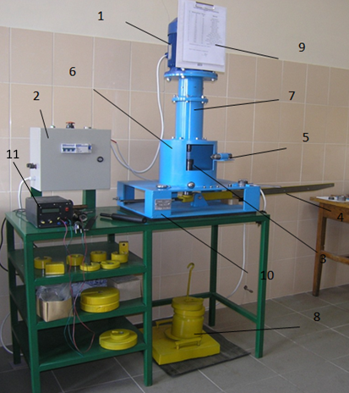
FIGURE 1. Four-ball friction machine: 1 – electric motor; 2 – control panel of the ChKM; 3 – bowl with balls and test lubricant; 4 – lever; 5 – friction torque limiter; 6, 7 – protective cover (support) of the friction unit and shaft; 8 – a set of weights; 9 – table of loading series 1 and 2; 10 – bed; 11 - friction torque measuring device;

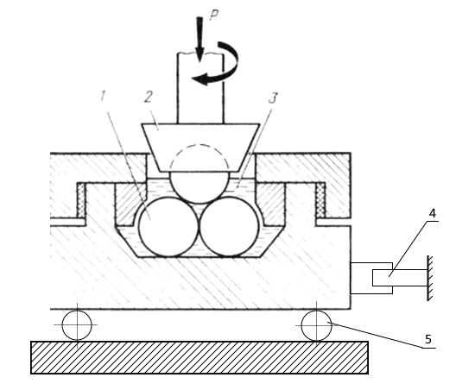
FIGURE 2. The friction working unit of the four-ball friction machine: 1 — fixed balls (three); 2 — a rotating spindle with a fourth ball; 3 — studied oil; 4 - torque sensor; 5 - axial thrust bearing;

The test consisted of determining the diameter of the wear spot of each lubricant under loads of 196 N and 392 N. The choice of the two specified loads is based on the need not only to compare the anti-wear properties, but also to compare the changes in these properties when the load increases. To obtain a more accurate result, each test was performed twice. Each new determination was made on a new lubricant sample with four new balls that were completely covered by the lubricant in the cup.
Before starting each test of lubricant samples for tribological characteristics, all parts with which the lubricant is in contact during the test (bowl with parts for fastening the lower balls, fasteners in the spindle of the upper ball and the balls themselves) were washed with C3-80/120 nefras, in order to remove lubricant, and subsequent air drying.
The duration of machine operation from the moment of switching on to the moment of turning off the engine when determining the wear rate at loads of 196 N and 392 N was 60.0±0.5 min. Time was measured using a mechanical stopwatch.
The diameters of the ball wear spots after each test were measured on a biological microscope with a magnification of 20 times using a scale on an eyepiece with a graduation price of 0.01 mm.
RESULTS AND DISCUSSION
The results of tests of tribological characteristics of selected samples of lubricants are shown in Table 2 and Figure 3.

TABLE 2 Wear index of the investigated lubricants
Load, Н | № Test Number | Relsol GS | Relsol GS Relsol GS With The Addition Of Carbon Black (0.2%) | Relsol M | Relsol M With The Addition Of Carbon Black (0.2%) | MARIOL NT | A Mixture Of Spent Motor Oils With The Addition Of 10% Graphite | Industrial Oil I-30 A | I-30A With The Addition Of Carbon Black (0.2%)
 |  |  |  |  |  |  |  | According to the work [5]
Load, Н | № Test Number | Diameter Of Wear Spot, D, mm
196 | 1 | 0.418 | 0.34 | 0.479 | 0.4 | 0.44 | 0.72 | 0.75 | 0.53
196 | 2 | 0.422 | 0.36 | 0.481 | 0.44 | 0.44 | 0.74 | 0.731 | 0.54
196 | average value | 0.42 | 0.35 | 0.48 | 0.42 | 0.44 | 0.73 | 0.74 | 0.535
392 | 1 | 0.599 | 0.57 | 0.98 | 0.86 | 0.5 | 1.042 | 1.33 | 0.76
392 | 2 | 0.62 | 0.53 | 0.98 | 0.84 | 0.52 | 1.048 | 1.331 | 0.77
392 | average value | 0.61 | 0.55 | 0.98 | 0.85 | 0.51 | 1.045 | 1.33 | 0.765

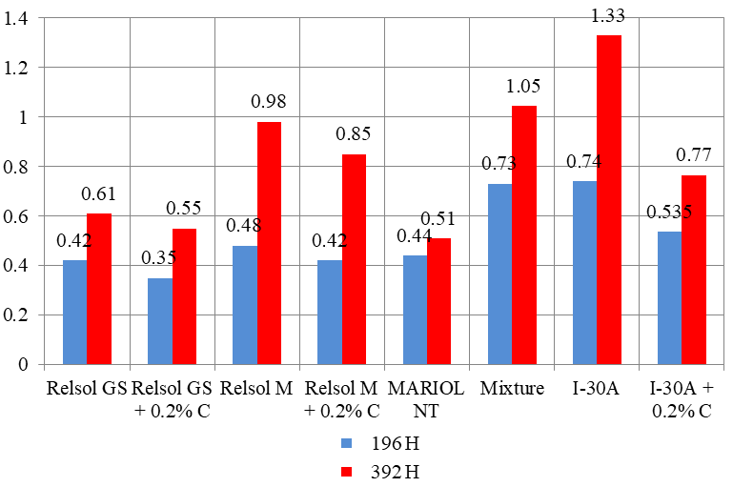

FIGURE 3. The value of the diameters of wear spots for lubricants at loads of 196 N and 392 N

From the obtained histogram, it can be seen that at a load of 196 N, semi-liquid lubricants "Agrinol Relsol GS", "Agrinol Relsol M" and "MARIOL NT" have almost the same wear rate of 0.42-0.48 mm. The situation is the same for the mixture of motor oils with graphite and industrial oil I-30A, where the wear indicator is 0.73-0.74 mm, and the mixture of I-30A and carbon fullerene carbon black is 0.53-0.54. At a load of 392 N, semi-liquid lubricant "MARIOL NT" proved to be better, and mixtures of motor oils with graphite and industrial oil I-30A were worse.
When carbon black is added to lubricants, a decrease in the average wear spot is observed in each case. For "Agrinol Relsol GS" grease, this reduction is 16% at a load of 196 N and 10% at a load of 392 N. For "Agrinol Relsol M" lubricant - 12.5% and 13%, respectively; for I-30A oil – 28% and 42%. The greatest reduction of the wear spot is observed on industrial oil, which is explained by the absence of pre-introduced additives. Such a result indicates the possibility of using the mixture "I-30A + 0.2% С" as a lubricant for rail lubricators.
CONCLUSIONS
1. The conducted tests established that, among the investigated commercial lubricants, the best anti-wear properties are "Agrinol Relsol GS" and "MARIOL NT". According to the obtained data, it can be considered appropriate to use the indicated materials in rail greasers of various types, since the wear of rails in curves will be minimal, if compared with other investigated materials.
2. The use of a mixture of spent motor oils and graphite powder, as well as pure I-20A oil, is not advisable, since their anti-wear properties are much worse. In case of production necessity, it is possible to use a mixture of I-30A oil and carbon black, since the tribological characteristics of this mixture are significantly improved and approach the characteristics of commercial lubricant "Agrinol Relsol GS".
3. The most effective materials among those studied, from the point of view of the minimum wear of rails in curved sections of the track, are the mixture "Agrinol Relsol GS and 0.2% carbon black", as well as the commercial lubricant "MARIOL NT". This conclusion is preliminary, since the final confirmation of the effectiveness of any lubricant requires bench modeling of the contact of the wheel with the rail and, if necessary, operational tests.

Acknowledgments
The authors would like to express their gratitude to Kharkiv National Automobile and Highway University and the organizing committee of the Modern Automotive Industry, Transport and Road Infrastructure (MAITRI) conference.

Conflict of interests
The authors declare that there is no conflict of interests regarding the publication of this paper.
REFERENCES
[1] M. Kurhan, D. Kurhan, R. Novik, S. Baydak, and N. Hmelevska, "Improvement of the railway track efficiency by minimizing the rail wear in curves," IOP Conf. Ser.: Mater. Sci. Eng. 985, 012001 (2020); https://doi.org/10.1088/1757-899X/985/1/012001
[2] V. Kosarchuk, M. Chausov, V. Tverdomed, A. Pilipenko, and O. Aharkov, "Lubricant composition for increasing wear resistance of heavy-loaded friction pairs," Transp. Syst. Technol. 39, 30–40 (2022); https://doi.org/10.32703/2617-9040-2022-39-4
[3] STP-Н 04-009:2017, Lubricants and oils for traction rolling stock, machines and mechanisms of PJSC "Ukrzaliznytsia". The procedure for admission to use, https://zakon.rada.gov.ua/rada/show/v0244650-08
[4] V. Kosarchuk, V. Tverdomed, and O. Bambura, "Calculation schemes for determining contact stresses in railway rails," Appl. Sci. 15, 2970 (2025); https://doi.org/10.3390/app15062970
[5] S. V. Voronin, A. V. Suranov, and A. A. Suranov, "The effect of carbon nano-additives on the tribological properties of industrial oils," J. Frict. Wear 38, 359–363 (2017); https://doi.org/10.3103/S1068366617050130
[6] Al-Quraan, T. M., Mikosianchyk, O., Tokaruk, V., Mnatsakanov, R., Kharchenko, O., & Kharchenko, S. (2024). Determination of the criteria for the transition of the tribosystem to disastrous wear. Jurnal Tribologi, 41, 93-112. https://jurnaltribologi.mytribos.org/v41/JT-41-93-112.pdf
[7] D. Potapov, Y. Tuley, S. Kulik, V. Manuilenko, and L. Safoshkina, "Effects of train driving modes and the rail foundation structure on the rail side wear in small-radius curves," IOP Conf. Ser.: Mater. Sci. Eng. 708, 012022 (2019); https://doi.org/10.1088/1757-899X/708/1/012022.
[8] E. Milovanova and M. Egorova, "The development of a method to reduce wear in the wheel-rail system," IOP Conf. Ser.: Mater. Sci. Eng. 760, 012044 (2020); https://doi.org/10.1088/1757-899X/760/1/012044.
[9] A. Shvets, O. Bolotov, L. Saparova, and A. Shvets, "Wear wheels and rails at the uneven loading of gondola cars," Railway Transp. Certif. Bull., 4–17 (2019); https://www.researchgate.net/publication/339140964_Wear_Wheels_and_Rails_at_the_Uneven_Loading_of_Gondola_Cars
[10] A. Khimko, O. Mikosianchyk, R. Mnatsakanov, S. Bespalov, and V. Tokaruk, “Analysis of damage to aircraft parts made of titanium alloys and increase of their wear resistance by gas-thermal coatings,” Probl. Frict. Wear 107(2) (2025); https://doi.org/10.18372/0370-2197.2(107).20057
[11] B. S. Asadov, "Determination of technological parameters of the aerosol type rail lubricators," Coll. Sci. Works Ukr. State Univ. Railway Transp. 184, 108–114 (2019); https://doi.org/10.18664/1994-7852.184.2019.176431
[12] O. Mikosianchyk, R. Mnatsakanov, V. Tokaruk, and O. Kharchenko, “Phenomenological probabilistic model of friction pair wear taking into account thermal mechanical stability of boundary layers,” in Chemmotological Aspects of Sustainable Development of Transport, Sustainable Aviation, edited by S. Boichenko, A. Yakovlieva, O. Zaporozhets, T. H. Karakoc, and I. Shkilniuk (Springer, Cham, 2022); https://doi.org/10.1007/978-3-031-06577-4_3
[13] M. Waqas, R. Zahid, M. U. Bhutta, Z. A. Khan, and A. Saeed, "A review of friction performance of lubricants with nano additives," Materials 14, 6310 (2021); https://doi.org/10.3390/ma14216310
[14] A. Singh, P. Chauhan, and T. Mamatha, "A review on tribological performance of lubricants with nanoparticles additives," Mater. Today Proc. 25, 586–591 (2020); https://doi.org/10.1016/j.matpr.2019.07.245
[15] V. A. Vojtov, A. G. Kravtsov, and B. M. Tsymbal, “Evaluation of tribotechnical characteristics for tribosystems in the presence of fullerenes in the lubricant,” J. Frict. Wear 41, 521–525 (2020); https://doi.org/10.3103/S1068366620060197

