Development of the Ecological, Energy and Economic Efficiency Index of Firefighting and Emergency-Rescue Vehicles Exploitation Process and Selection of a Rational Way to Take into Account the Phenomenon of Inflation when Determining its Monetary Components
Oleksandr Kondratenko^{1, a)}, Volodymyr Koloskov², Hanna Koloskova³,
Olha Lytvynenko⁴, Viacheslav Krasnov¹, Dmytro Bogdan⁵
¹National University of Civil Protection of Ukraine of SES of Ukraine, Department of Fire and Technogenic Safety of Objects and Technologies of Scientific and Educational Institute of Fire and Technogenic Safety, 18032, Cherkasy, Ukraine
²National University of Civil Protection of Ukraine of SES of Ukraine, Department of State Supervision in the Field of Fire and Technogenic Safety of Scientific and Educational Institute of Fire and Technogenic Safety, 18032, Cherkasy, Ukraine
³National Aerospace University «Kharkiv Aviation Institute» of MES of Ukraine, Department of Structures and Designing of Rocket Technique of the Faculty of Rocket and Space Engineering, 61070, Kharkiv, Ukraine
⁴National University of Civil Protection of Ukraine of SES of Ukraine, Department of Language Training of Scientific and Educational Institute of Civil Protection, 18032, Cherkasy, Ukraine, 18032, Cherkasy, Ukraine
⁵Kharkiv National Automobile and Highway University, of MES of Ukraine, Department of Machine Elements and Theory of Mechanisms and Machines of Automobile Engineering Faculty, 61002, Kharkiv, Ukraine
^{a)} Corresponding author: kondratenkoom2016@gmail.com
Abstract. The research deals with the selection of rational units of monetary equivalents expression of the fuel values and ecological damage costs in the structure of Prof. Igor Parsadanov’s complex fuel and ecological criterion as environmental safety level indicators of the exploitation process for emergency and rescue vehicles with reciprocating internal combustion engine. The main results of the study have been obtained and substantiated through comparative calculations. To account for inflation, the use of the Consumer Price Index (CPI) was proposed, and the time-dependent dynamics of the US dollar CPI were approximated by a third-degree polynomial using the least squares method. Differences in the resulting monetary cost values can be interpreted as part of the methodological component of the systematic error associated with the application of this criterion. A new vector-based approach for conducting a comprehensive, criteria-driven assessment of indicators reflecting the environmental sustainability level of the given process has been proposed, using the decarbonization index DCI as its foundation. It contains the RICE thermal pollution criterion K in its structure, and enables obtaining the Index of Ecological, Energy and Economic Efficiency 4EI as a mixed product of three vectors. One of them defines the cost equivalents while accounting for inflation. Specifically, it incorporates the product of the discount rates i2 and i4 as a function of CPI. This approach makes it possible, firstly, to account for current decarbonization trends, including the role of thermal energy and greenhouse gas emissions, and secondly, to perform assessments across all stages of the life cycle except the initial «Design and Production» stage.
Keywords: Environment Protection Technologies, Power Plants, Reciprocating Internal Combustion Engines, Firefighting and Emergency-Rescue Vehicles, Criteria-Based Assessment, Motor Fuel Consumption, Monetary Equivalents, Inflation, Costumer Price Index, Discount Rates.

INTRODUCTION
Ecological safety (ES) is an essential component of national security at both global and local scales. Its significance is primarily associated with the economic dimensions embedded within the complex, criteria-based assessment process. The core element of the final stage of the ecological safety management system (ESMS) constitutes a fundamental component of civil defense [1]. Accordingly, most management decisions within the sphere of civil defense are predicated upon the established methodological framework [2, 3] and basic principles of public administration [4]. The considerations described above determine relevance of the study. Also, the results of the study can be applied as the part of methodology to predict the prime cost of emergency and rescue vehicles with RICE exploitation process and lifetime duration of new units of emergency and rescue vehicles with reciprocating internal combustion engine (RICE) as for building structures of reinforced concretes in study [5], in particular when increasing the ES level of such technical facilities by transferring them to the consumption of alternative renewable motor fuels [6, 7].
Purpose of the study. Development of a calculation-based rationale for the selection of appropriate units to express the monetary components of the complex fuel-ecological criterion, employed for the assessment of environmental safety indicators in the operational processes of power plants (PP) equipped with reciprocating internal combustion engines (RICE). Object of the study. Monetary components of ES indicators of PP with RICE exploitation process. Subject of the study. Units for expressing the object of the study and methods for calculating the inflation in its quantitative indicators. Tasks of the study: 1. Comprehensive review and analysis of specialized scientific, technical, normative, patent, and reference literature relevant to the study. 2. Analysis of mathematical apparatus of complex fuel-ecological criterion. 3. Analysis of the official exchange rate dynamics of the Ukrainian Hryvnia against the US Dollar during 1998–2016. 4. Examination of the mathematical methodology underlying the Consumer Price Index (CPI). 5. Conducting a calculation-based comparative study of various unit types for expressing monetary components across different historical periods. 6. Analysis, presentation, and interpretation of the results of the calculation-based comparative study. Methods of the study. Analysis of specialized scientific and technical, normative, patent, and reference literature; refinement of the mathematical framework of the complex fuel-ecological criterion; examination of the mathematical methodology of the Consumer Price Index (CPI); and application of the least squares method. Scientific novelty of results of the study. For the first time, a calculation-driven rationale has been developed for selecting appropriate units to express the monetary components of the complex fuel-ecological criterion, applied to the assessment of environmental safety indicators in the operation of power plants (PP) with reciprocating internal combustion engines (RICE), while accounting for inflation. Practical value of results of the study. The application of the selected units of expression, in combination with an indicator of inflation, enables criteria-based assessments of objects across different models, varying technical conditions, diverse operational regions, and different historical periods.
ANALYSIS OF PUBLICATIONS
Among modern approaches to the comprehensive assessment of the operational efficiency of power plants (PP) with reciprocating internal combustion engines (RICE), including FERV units, several widely recognized methods simultaneously incorporate thermodynamic, economic, and environmental components and enable forecasting across the entire life cycle of such equipment, as described in the work [8]. These approaches provide a structured framework for evaluating multi-criteria performance, facilitating informed decision-making regarding design, operation, and maintenance strategies while accounting for both technical and ecological factors. These assessment methods typically integrate energy, exergy, and sustainability considerations, alongside exergoeconomic and ecological-economic analyses [9]. This approach also allows for the inclusion of alternative motor fuel consumption in the analysis, as illustrated in [10], the implementation of dual-fuel operation [11] and the rationale for its application [12], through the addition of hydrogen and ethanol to the fuel mixture [13], and for the broader transport subsector in a specific country, such as maritime transport in Ireland [14], biomass as a raw material for its production [15], biomethanol [16], biodiesel [17], mixtures of biodiesel and other non-traditional combustible liquids [18], by adding special additives to traditional fuels [19]. This approach enables the generalization of assessment results, for example, in relation to the life-cycle costs of fuel cells and hydrogen systems [20], as well as strategies for implementing hybrid drives in vehicles [21], the determination of alternative motor fuel types for the entire national market, as exemplified by England. [22], the payback period and profitability of biofuel utilization from the perspective of balancing environmental damage and associated costs [23]. The efficiency assessment of converting large watercraft RICE from fossil fuels to hydrogen is presented in [24], and for the aircraft in [25]. Some of the more advanced assessment methodologies incorporate additional technical and operational parameters, including propeller (or vehicle tire) characteristics as well as maintenance and repair costs. This approach, illustrated by the case study of Sydney’s city bus fleet, enables a more holistic evaluation of operational efficiency and total lifecycle expenditures under real-world operating conditions. [26]. Sometimes, the complex assessment also simultaneously takes into account the parameters of traditional motor fuel and the logistical features of using PP with RICE, as in [27]. In addition, this integrated approach makes it possible to more accurately quantify greenhouse gas emissions, thereby enhancing the reliability of environmental impact assessments and supporting evidence-based decision-making for sustainable transport management [28]. Furthermore, these evaluation methods are widely employed to conduct comparative analyses of conventional mechanical and electrical energy sources – specifically internal combustion engines – against alternative technologies, including fuel cells, as demonstrated in the study [29]. They are also applied to the evaluation of specific operational subsystems, such as the takeoff and landing regimes of aviation reciprocating internal combustion engines (RICE), allowing for a more detailed analysis of performance under distinct flight conditions [30], the «electric» range of operation of RICE in a hybrid vehicle [31]. In such studies, artificial neural networks are already being actively employed, as described in the literature, to model complex nonlinear dependencies, improve predictive accuracy, and support the optimization of operational parameters [32].
METHODOLOGY
Analysis of mathematical apparatus of complex fuel-ecological criterion
A comprehensive criterion-based assessment of the qualitative and quantitative indicators that characterize the environmental safety (ES) level of the operational processes of power plants (PP) equipped with reciprocating internal combustion engines (RICE) – specifically firefighting and emergency-rescue vehicles (FERV) and other specialized equipment operated by the institutions and departments of the State Emergency Service (SES) of Ukraine – should be performed during their active duty cycles to ensure accurate monitoring and effective management of their environmental impact. This study proposes the application of Prof. Parsadanov’s (NTU «KPI») mathematical apparatus – the complex fuel and ecological criterion K_{fe} (see formula (1)) – which was developed on the basis of the Temporary Standard Methodology for Determining the Economic Efficiency of Environmental Protection Measures and Assessing the Economic Damage Caused to the National Economy by Environmental Pollution (Bystrov A.S., Varankiv V.V., Vilensky M.A., et al., 1984). The theoretical foundations and practical use of this criterion have been further detailed in the literature [33] and improved in the research works [34, 35]. The main advantage of the K_{fe} criterion over alternative criterial mathematical apparatuses lies in the inclusion of physical parameters that possess direct monetary equivalents, namely: Z_{f} (in ₴/(kW∙h)) – monetary costs for consumed motor fuel, Z_{e} (in ₴/(kW∙h)) – the compensation for ecological damage to the environment and human health, and Z_{fe} (in ₴/(kW∙h)) – the sum of these two components (see formula (4)), representing the total fuel and ecological costs [1, 33, 35].

, ‰; (1)
; (2)
; (3)
, ₴/(kW∙h); (4)
, kW; (5)
, ₴/( kW∙h); (6)
, ₴/( kW∙h); (7)
, ₴/kg; (8)
; (9)
, kg/h; (10)

where the index i indicates the values for a separate representative mode of RICE operation or landfill in its exploitation model; Н_{и} = 42,7 MJ/kg [33] – lower fuel combustion heat; N_{e} – effective power, kW; G_{fuel} – mass hourly fuel consumption, kg/h; G_{k} – k-th pollutant mass hourly emission in EG flow, kg/h; A_{k} – index of relative aggressiveness of k-th pollutant in flow of EG (dimensionless quantity) (А_{NOx} = 41,1; А_{PM} = 200; А_{CnHm} = 3,16;
А_{СO} = 1,0 [4]); h = 4 [8] – number of pollutants in EG flow; σ – relative dangerous index of pollution of different territories (dimensionless quantity) (for car diesel RICE σ = 1,0, for tractor diesel RICE σ = 0,25 [33]); f – coefficient that takes into account the character of dispersion of EG in atmosphere (dimensionless quantity) (for Ukraine f = 1,0 [33]); δ = P_{f} – dimension index that converts of the score assessment into monetary $/kg; WF – weight factor; η_{e} – effective efficiency coefficient; β – coefficient of relative exploitational ecological monetary costs (dimensionless quantity); Z_{e} and Z_{f} – monetary costs on compensation of ecological damage and on motor fuel, $/(kW∙h); g_{e} – specific effective fuel consumption (mass hourly) , kg/(kW∙h); M_{T} and n_{cs} – crankshaft torque and speed, N∙m and rpm; P_{f} – price of weight unit of motor fuel, $/kg (fuel density ρ_{fuel} = 0.850 kg/m³); U_{e} – monetary compensation of ecological damage, $/kg; g_{pr} – specific reduced emission of pollutants with flow of EG (dimensionless quantity).
However, in order to perform a comparative calculation study of RICE in FERV – across different and identical brands, various models with different production years, theoretically and experimentally investigated at different times, or for the same RICE in varying technical conditions, operational environments, or countries – it is necessary to standardize the units of expression of all relevant values Z_{f}, Z_{е} and Z_{fe} problem. In the K_{fe} criterion original mathematical apparatus at the time of its developing (2003), this units were Ukrainian Hrivnas (UAH) per kilo watt per hour – ₴/(kW∙h) [33], in the research work [1] it has been proposed to standardize all monetary values by converting them to United States dollars (USD) – a globally recognized reserve currency that is freely convertible and whose historical record fully encompasses the operational period of the RICE under our study as is, i.e. $/(kW∙h). However, under conditions of extreme volatility in the exchange rate between the Ukrainian Hryvnia (UAH) and the US Dollar (USD) [36], there is a degree of uncertainty in determining the precise magnitudes of the monetary cost values Z_{f}, Z_{е} and Z_{fe} for various historical periods.
Thus, when the Ukrainian Hryvnia was introduced into circulation in 1996, its official exchange rate against the US Dollar was less than 2 ₴/$, at the time of creation of the original criterion mathematical apparatus (2003) – about 5 ₴/$, at the time of obtaining experimental data in study [1] (2013) – about 8 ₴/$, at the time of creation of mathematical models described in [37,38] (2014) – about 12 ₴/$, at the time of publication of the study [1] (2018) it was about 28.5 ₴/$, at the time of publication of the study [35] (2019) it was about 23.5 ₴/$ and now (2025) it is about 52.5 ₴/$. This historical evolution of exchange rates is illustrated in Fig. 1: for the US Dollar (Fig. 1a), the Euro (Fig. 1b), and the Russian Ruble (Fig. 1c) [2].
he initial dataset for this study was derived from the analysis of bench motor tests reported in studies [37, 38] for the 2Ch10.5/12 autotractor diesel engine. These datasets include the distributions of the K_{fe} criterion and its fuel and ecological components (see Fig. 2), as well as the monetary components of the K_{fe} criterion (see Fig. 3) across the full range of operational modes. These initial data were also employed in the complex, criteria-based assessment of the environmental safety (ES) level of the operational processes of power plants (PP) equipped with RICE, as reported in previous studies [35, 39]. For the post-operational stage of the RICE life cycle, fundamentally different assessment approaches should be applied [40].
RESULTS AND DISCUSSION
In this study we have calculated the following variants of the P_{f} – price of weight unit of diesel fuel expression: A) 1.81 ₴/kg (numerical value at the time of publication of the work [33] – 2003); B) 0.34 $/kg (numerical value at the time of publication of the work [33]); C) 23.08 ₴/kg (numerical value at the time of publication of the work [1] – 2018); D) 0.871 $/kg (numerical value at the time of publication of the work [1]); E) 29.40 ₴/kg (numerical value at the time of publication of the work [35] – 2019); G) 1.153 $/kg (the numerical value corresponding to the time of publication of the monograph [35]).

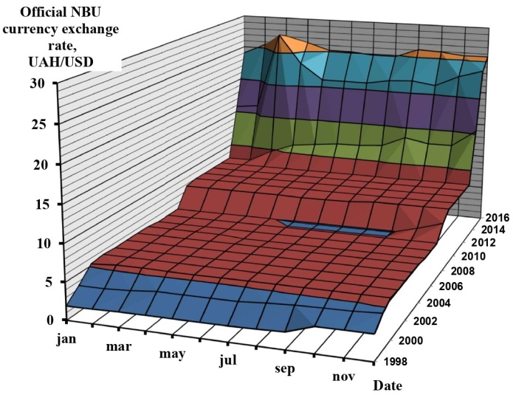 | 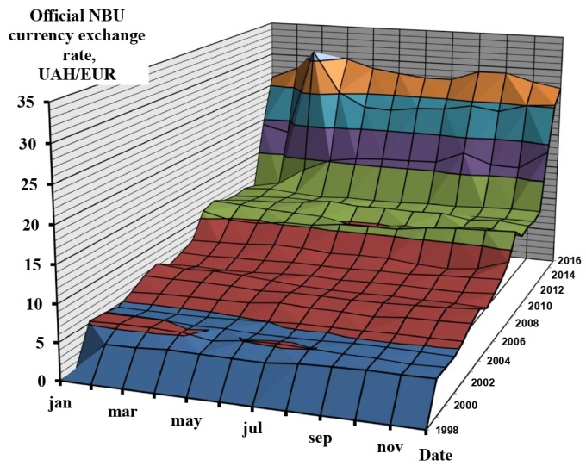
(a) | (b)
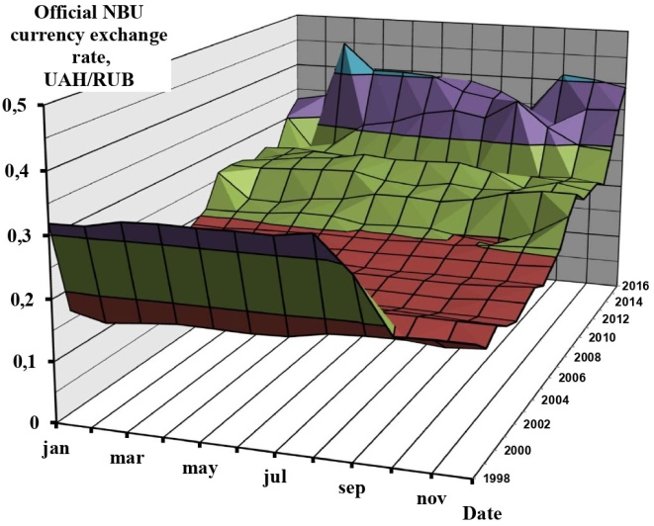
(c)
FIGURE 1. The official average monthly exchange rate for the National Bank of Ukraine from 1998 to 2016 for the Hryvnia to the US Dollar (a), Euro (b) and Russian Ruble (c) [1,36]

It is taken into account that liquid motor fuel is distributed in the filling stations networks in volume units, i.e. in ₴/dm³, and the density of diesel motor fuel ρ_{fuel} is 840–850 kg/m³. The results of a comparative calculation study to justify this choice are summarized in Table 1 and illustrated in Fig. 2 and Fig. 3. Namely, Fig. 2 shows the distributions of magnitudes of K_{fe} (in ‰) (Fig. 2,d) criterion and its fuel and ecological components – g_{e} (in kg/(kW∙h)) (Fig. 2,a), g_{pr} (dimensionless quantity) (Fig. 2,b) and U_{e} (in $/kg) (Fig. 2,c) – over its 2Ch10.5/12 diesel engine operational regimes field. Fig. 3 presents the distributions of magnitudes monetary components of K_{fe} criterion over its 2Ch10.5/12 diesel engine operational regimes field, namely Z_{e} (in $/(kW∙h)), Z_{f} ($/(kW∙h)), Z_{fe} ($/(kW∙h)) – in the full range of change (Fig. 3,a,c,e) and in engine operating regimes other than idle and low effective power regimes (Fig. 3,b,d,f) and β (Fig. 3,g). The study was performed on the example of D21A1 autotractor diesel engine (2Ch10.5/12 according to ISO 3046-1:2002), the technical characteristics of which are given in the source [35] and have also been mathematically modelled with the Online free system for modeling the working processes of reciprocating internal combustion engines using digital twins Blitz-PRO [41], and the 13-regime standardized steady testing cycle ESC (according to UNECE Regulation No. 49 [42]) as its exploitation model. The results of the study are summarized in Table 1 and illustrated in Fig. 4. Fig. 4,a shows the distribution of the magnitudes of monetary costs for compensation of ecological damage to the environment and human health Z_{e} for all variants of the study (see Table 1) by regimes of the selected exploitation model. Fig. 4,b also shows such distribution for the magnitudes of the complex fuel-ecological criterion K_{fe}.
As shown in Fig. 4a, the highest monetary costs correspond to the minimal idle regime, i.e., the operational regime in which the engine’s effective power is close to zero – №№ 1, 7 and 13 (marked as «min idle» in Table 1), and the lowest – at regimes of maximum torque (№ 6, marked as «M_{max}» in Table 1) and nominal effective power (№ 8, marked as «N_{enom}» in Table 1). It also demonstrates that the values of the same physical quantity – specifically, the monetary cost Z_{e} – can differ significantly depending on the unit of monetary expression and the historical period considered. For the same units over different periods, the differences are several-fold, while for different units, the discrepancies can span orders of magnitude, even for identical operational regimes of the unchanged assessed object. Fig. 4,c illustrates the distribution of magnitudes of monetary costs Z_{f}, Z_{e} and Z_{fe} in chosen units of expression – $/(kW∙h) – for all variants of the study (see Table 1) on the regimes of selected exploitation model. Fig. 4,d illustrates such distribution of magnitudes of relative exploitational ecological monetary costs coefficient β.

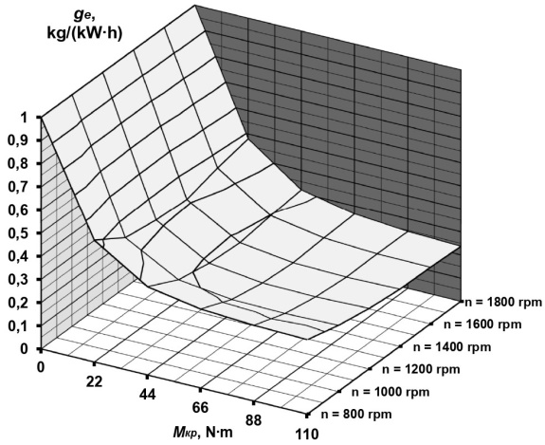 | 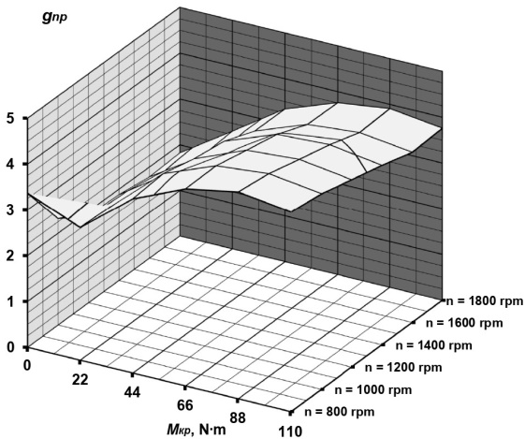
(a) | (b)
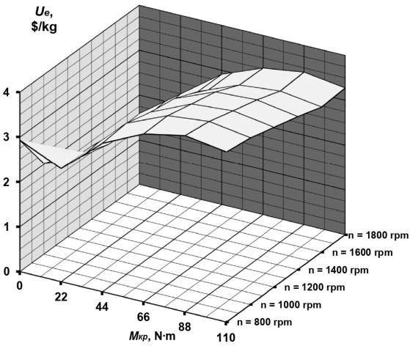 | 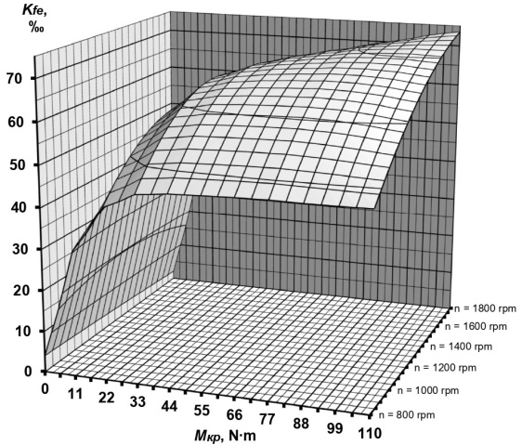
(c) | (d)
FIGURE 2. Distributions of magnitudes of K_{fe} criterion and its fuel and ecological components over its 2Ch10.5/12 diesel engine operational regimes field

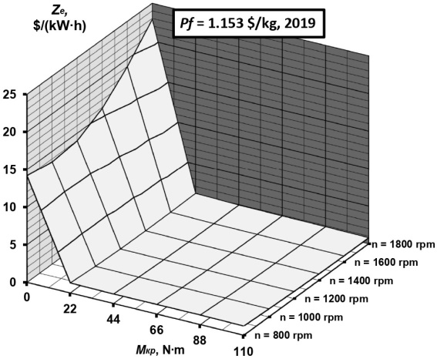 | 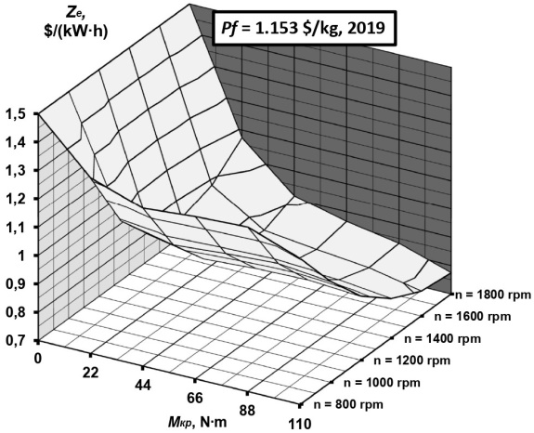
(a) | (b)
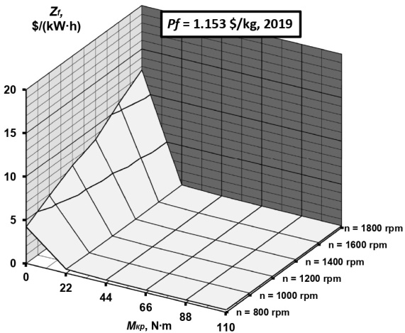 | 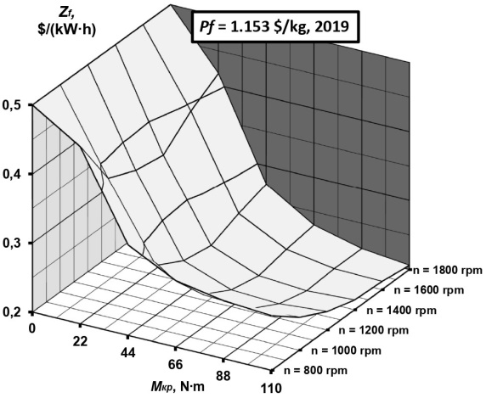
(c) | (d)
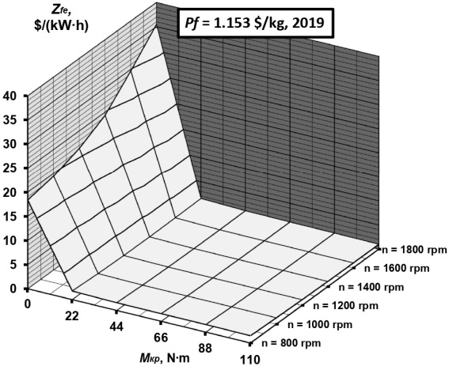 | 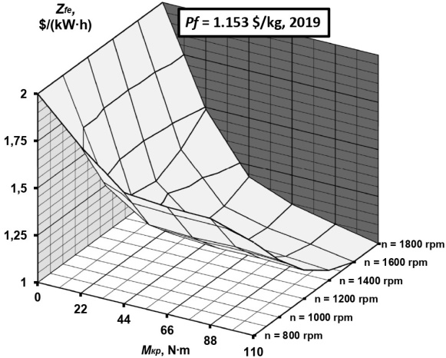
(e) | (f)
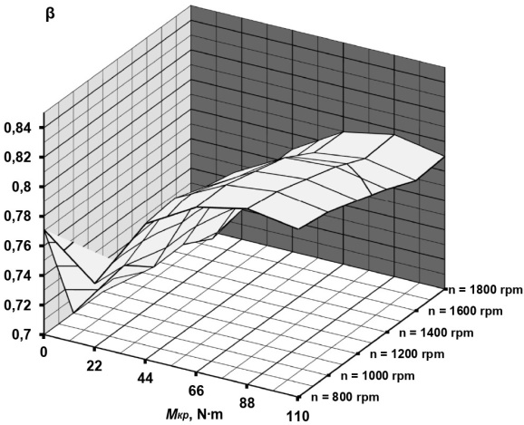
(g)
FIGURE 3. Distributions of magnitudes monetary components of K_{fe} criterion over its 2Ch10.5/12 diesel engine operational regimes field

TABLE 1. Results of the study
Monetary  costs | Year | Units of expression
Monetary  costs | Year | UAH/(kW∙h) |  |  | USD/(kW∙h)
Z_{e} | 2003 | 2.081 | 2.729 | 2.553 | 0.391 | 0.513 | 0.480
Z_{e} | 2018 | 27.050 | 35.472 | 33.185 | 0.567 | 0.744 | 0.696
Z_{e} | 2019 | 35.706 | 46.823 | 43.804 | 0.748 | 0.982 | 0.919
Z_{f} | 2003 | 0.574 | 0.685 | 0.899 | 0.108 | 0.129 | 0.169
Z_{f} | 2018 | 7.463 | 8.903 | 11.681 | 0.156 | 0.187 | 0.245
Z_{f} | 2019 | 9.851 | 11.752 | 15.419 | 0.206 | 0.247 | 0.323
RICE operational regime |  | N_{enom} | M_{max} | min idle | N_{enom} | M_{max} | min idle

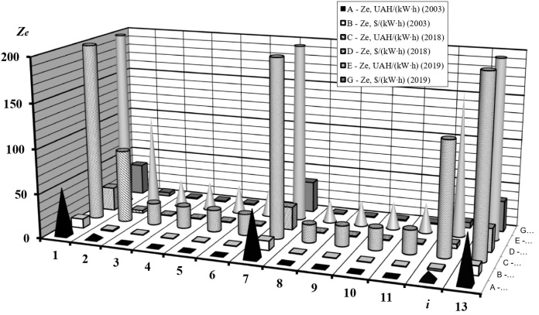 | 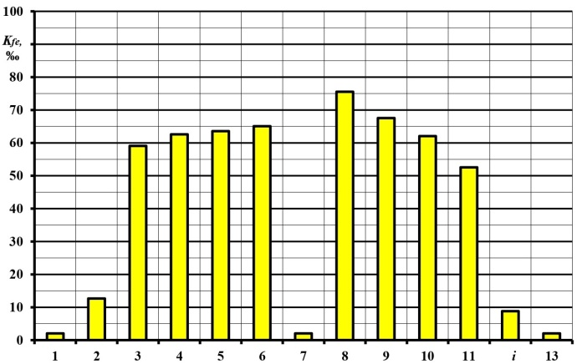
(a) | (b)
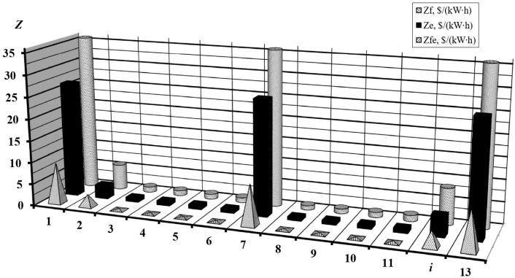 | 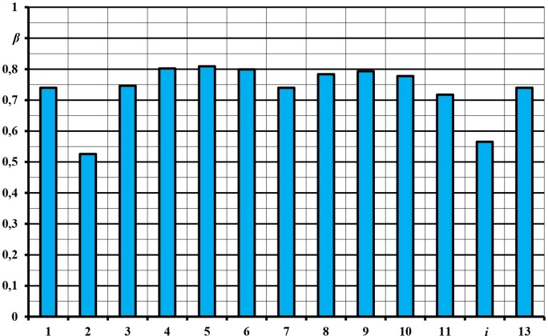
(c) | (d)
FIGURE 4. Results of comparative calculated study

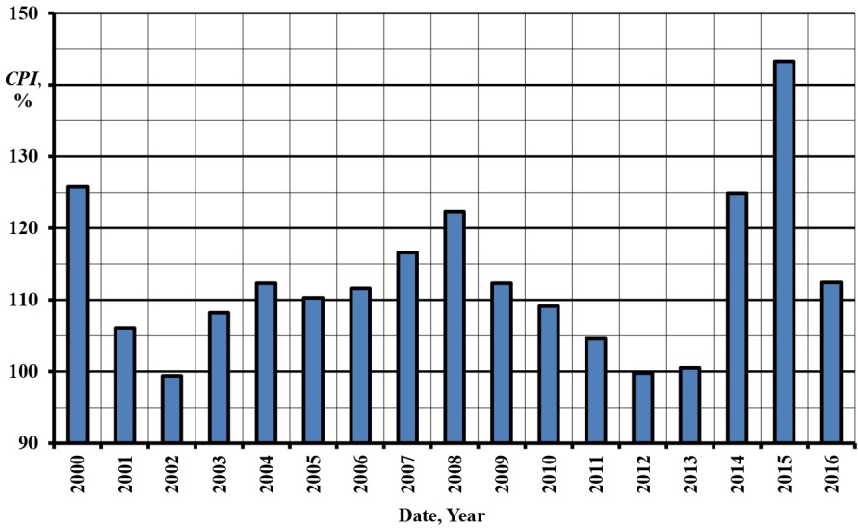
FIGURE 5. Average annual magnitudes of the CPI index in Ukraine from 2000 to 2016 [36]

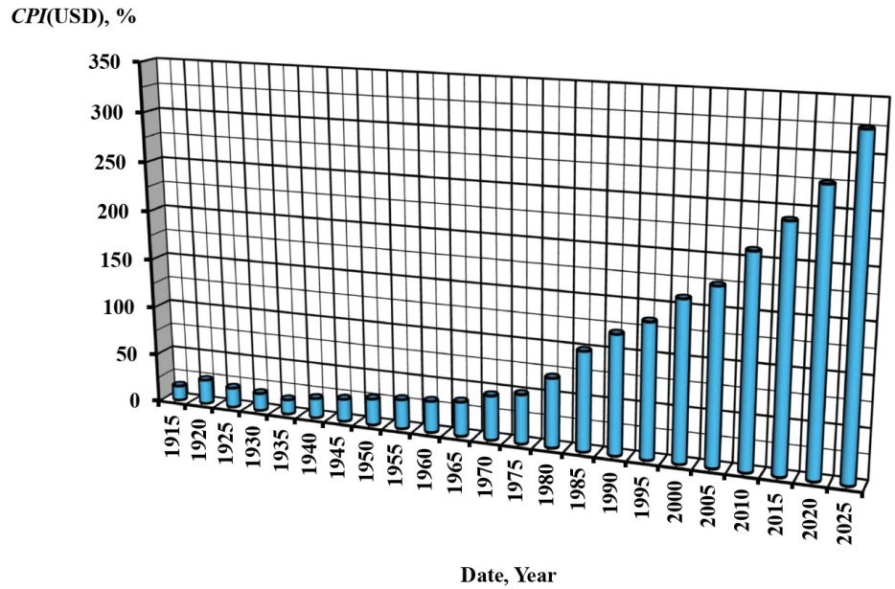
(a)
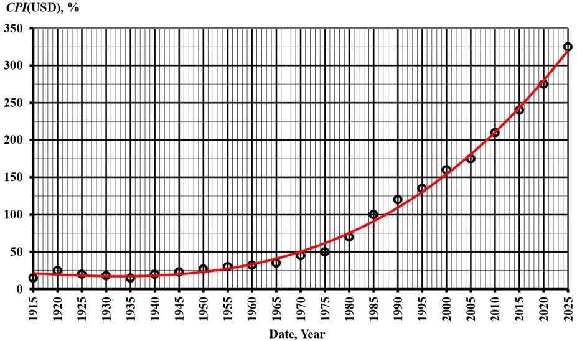
(b)
FIGURE 6. Average annual magnitudes of the CPI index in USA from 1913 to 2025 (a) and approximation polynom for describing and prediction of its changes (b) [43]

In Fig. 4,b magnitude of ration between the magnitudes of costs Z_{f} and Z_{e} can be seen (also expressed by magnitudes of coefficient β), i.e. between the magnitudes of fuel and ecological components of criterion K_{fe}, which is not constant for different regimes of exploitational model. This phenomenon is attributable to both the qualitative distribution and the quantitative magnitudes of the environmental safety (ES) factors considered within the mathematical framework of the criterion K_{fe}. It can also be observed that the ecological component of the criterion attains its maximum weight in the regime № 5 (β = 0.810) and minimal – in the regime № 2 (β = 0.540). To account for the effects of inflation on the selected units of monetary equivalents of the K_{fe} criterion, the study proposes to use the mathematical apparatus of the customer price index CPI (dimensionless quantity), which was 175 for the USD in 2003, and now it is 254 [1,11,18]. It is described by formulas (11) and (12).
In Fig. 4,c such distribution is given for the magnitudes of Z_{e}, Z_{f}, Z_{fe} for Variant G by the regimes of the selected exploitation model and in Fig. 4,d – for the magnitudes of β. Fig. 5 illustrates the average annual magnitudes of the CPI index in Ukraine from 2000 to 2016 [32]. Figure 6,a presents the average annual Consumer Price Index (CPI) in the USA from 1913 to 2025, while Figure 6,b shows the polynomial approximation used to describe and predict its temporal changes [34]. Fig. 6,b illustrates the average annual CPI in the USA from 1913 to 2025 (a) and an approximation polynom to describe and predict its changes (b) [34].

, (11)

. (12)

where index j = e, f or fe marks the type of monetary costs; Z_{j} – monetary costs, $/(kW∙h); index i marks the type of product; index 0 marks the magnitude for basic period (i.e. CPI = 100 for USD it is 1982–1984); t – current date; P – price of produced goods, $; Q – total amount of produced goods.
The change in the CPI magnitude for the UAH is illustrated in Fig. 5 according to the source [36], and for the USD – in Fig. 6, obtained from the study [43]. It is suggested to describe the dynamics of change in the CPI for USD over time (see Fig. 6) in the approximation using the least squares method by formula (13) that is a polynomial of the third degree (R² = 0.994).

. (13)

An alternative approach, particularly valuable for forecasting monetary costs associated with mitigating inflation, is to employ the mathematical framework of Net Present Value (NPV), which represents the series of discounted future cash flows expressed in present-day terms (see formula (14)). It includes the Discount Rate (i), which is the interest rate applied to convert future cash flows into a single present value. Within this rate, i₂ represents the estimated inflation rate over the selected period, reflecting the cost associated with the risk of fund depreciation, while i₄ corresponds to the baseline discount rate at the national financial level, i.e., the implied Equity Risk Premium (ERP) for the current period. [44].

(14)

This study demonstrates the application of the CPI index to the specified problem; future research will examine the relationship between the CPI index and NPV and explore its use in addressing the problem more comprehensively.
It should be emphasized that environmental pollution from thermal energy emissions constitutes a significant component of overall energy pollution, primarily originating from power plants equipped with RICE. The quantitative and qualitative aspects of this type of pollution were analyzed in a previous study by the authors [45], which forms part of a systematic investigation into the ecological safety of transport as an element of Ukraine’s national security during armed conflict, and as a foundation for a «green» transition in the context of post-war reconstruction [46].
Moreover, given the increasing relevance of decarbonizing power plants equipped with RICE, the results obtained in this study by the corresponding author, Prof. Oleksandr Kondratenko, and his adjunct, Viacheslav Krasnov, suggest the use of the RICE thermal pollution criterion K (a dimensionless quantity), as proposed and described in their study [47]. It incorporates bot the value of the effective engine efficiency coefficient η_{е} = 0.35...0.45 (for a diesel engine) and its theoretically maximum possible value η_{max} = E_{Q} / Q_{X} = 0.75...0.85 (for a diesel engine), which represents the ratio of the exergy supplied to the working fluid in the engine cylinder during the working process E_{Q} (in J), the total thermal energy supplied to the working fluid in the engine cylinder during the working process Q_{X} (in J), and the carbon content of the motor fuel С_{СО2} = 0.85 (for a diesel motor fuel of petroleum origin), i.e. determined by formula (15).

(15)

where k₁ is a dimensionless coefficient accounting for the composition of the motor fuel; k₂ is a dimensionless coefficient accounting for the degree of fuel perfection in the diesel engine’s working process.
At the same time, according to the authors’ analysis, the prospects for further research in this area lie in refining this approach by expanding the factors considered in such a criterion and in characterizing the so-called «carbon footprint» of RICE. This footprint originates not only from exhaust gases but also from crankcase emissions, vapor losses from on-board fuel storage tanks due to both large- and small-reservoir breathing phenomena, and the production of greenhouse gases during engine operation.
Therefore, the RICE decarbonization index or DeCarb–Index DCI (dimensionless quantity) has been suggested by a corresponding author of this article, Prof. Oleksandr Kondratenko, determined by formula (16).

(16)

where B_{D}, B_{EG}, B_{UV} and B_{GH} are weighting factors of the components of such criteria (dimensionless quantities), respectively: thermal pollution criterion of RICE, emission of EG carbonaceous fractions, emission of other carbonaceous gases (crankcase and motor fuel vapors) and sulfur oxides and emission of EG and other greenhouse gases; K_{D}, K_{EG}, K_{UV} and K_{GH} – criteria (dimensionless quantities) of thermal pollution of RICE (see formula (15)), emission of carbonaceous fractions of EG, emission of other carbonaceous gases and emission of EG greenhouse gases, respectively; A(CO) = 1.0, A(CO₂) = 0.02, A(PM) = 200.0, A(C_{n}H_{m}) = 3.2, A(RB) = A(fuel) = 38.4, A(CG) = 25.5, A(SO_{x}) = 22.0, A(H₂O) = 0.002 and A(NO_{x}) = 41.1 [34] are weighting factors (dimensionless quantities) of emission of carbon monoxide, carbon dioxide, particulate matters, unburned hydrocarbons, motor fuel vapors, crankcase gases, sulfur oxides, dihydrogen monoxide vapors, nitrogen oxides, respectively; A_{GH}(CO₂), A_{GH}(C_{n}H_{m}), A_{GH}(RB) = A_{GH}(fuel), A_{GH}(CG), A_{GH}(H₂O) and A_{GH}(NO_{x}) [34] – weighting factors (dimensionless quantities) of emission of carbon dioxide, unburned hydrocarbons, motor fuel vapors, crankcase gases, dihydrogen monoxide vapors, nitrogen oxides as greenhouse gases, respectively; G(CO) = f(n_{cs}, M_{T}), G(CO₂) = f(n_{cs}, M_{T}), G(PM) = f(N, G_{fuel}, G_{air}, C(C_{n}H_{m})) = f(n_{cs}, M_{T}), G(C_{n}H_{m}) = f(n_{cs}, M_{T}), G(RB) = f(n_{cs}, M_{T}), G(CG) = f(n_{cs}, M_{T}), G(CO₂) = f(n_{cs}, M_{T}), G(SO_{x}) = f(n_{cs}, M_{T}), G(H₂O) = f(n_{cs}, M_{T}) and G(NO_{x}) = f(n_{cs}, M_{T}) are hourly mass emissions of carbon monoxide, carbon dioxide, solid particles, unburned hydrocarbons, engine fuel vapors, crankcase gases, sulfur oxides, dihydrogen monoxide vapors, nitrogen oxides, respectively, kg/h; n_{cs} – RICE crankshaft rotation speed, rpm; M_{T} – RICE crankshaft torque, N·m; N – indicator of EG opacity, %; C(C_{n}H_{m}) – concentration of unburned hydrocarbons in EG, ppm; G_{fuel} – mass hourly motor fuel consumption, kg/h; G_{air} – mass hourly air consumption, kg/h.
The distributions of mass hourly emissions values of carbonaceous substances and EG greenhouse gases from RICE taking into account G(CO), G(CO₂), G(PM), G(C_{n}H_{m}), G(RB), G(CG), G(CO₂), G(SO_{x}), G(H₂O) and G(NO_{x}) in the field of operating regimes of RICE, i.e. in the coordinates (n_{cs}, M_{T}), have been defined based on the results of bench motor tests and the application of conversion formulas [34], as well as mathematical modeling, for example in a free open access software package Blitz-PRO [41].
In the suggested approach, the only values which remain undetermined are weighting factors B_{D}, B_{EG}, B_{UV} and B_{GH} of the components of thermal pollution criterion of RICE K_{D}, criterion of emission of EG carbonaceous fractions K_{EG}, criterion of emission of other carbonaceous gases K_{UV}, and criterion of emission of EG greenhouse gases K_{GH}.
Therefore, this study proposes a formula (17) to establish the physical significance and interpretation of the weighting factor B_{D} of the criterion of thermal pollution criterion of RICE K_{D} offered to use the values of weighting factors (dimensionless quantities) of thermal energy emissions from RICE A(Q) = 28.8 (dimensionless quantity) [34].

(17)

This study also suggests a formula (18) for the moment of time t to determine the physical significance and interpretation of weighting factor B_{EG} of the emission criterion of EG carbonaceous fractions of RICE K_{EG} using the value of the coefficient β_{EG} (dimensionless quantity) according to formula (3). It is determined by the values of monetary equivalents Z_{f} and Z_{e} as components of a complex fuel-ecological criterion K_{fe}, described by the formulas (6) and (7), with the consideration of the value of Z_{e} of emissions and weighting factors only of legally regulated carbonaceous pollutants in the composition of EG and carbon dioxide (i.e. without considering emissions and the weighting factor of nitrogen oxides), namely: CO, CO₂, PM, C_{n}H_{m}.

(18)

This study proposes a formula (19) for the moment of time t to determine the physical content and meaning of weighting factor B_{UV} of the o emission criterion of EG carbonaceous fractions of RICE K_{UV} offered using the value of the coefficient β_{UV} (dimensionless quantity) according to formula (3) considering the value of Z_{e} of emissions and weighting factors of other carbonaceous gases (crankcase and motor fuel vapors) and sulfur oxides SO_{x}.

(19)

Finally, this study suggests a formula (20) for the moment of time t to determine the physical significance and interpretation of the weighting factor B_{GH} of the emission criterion of EG greenhouse gases K_{GH} using the value of the coefficient β_{GH} (dimensionless quantity) according to formula (3) considering the value of Z_{e} of emissions and weighting factors of greenhouse gases, namely: CO₂, C_{n}H_{m}, H₂O, NO_{x}, RB, CG.

(20)

To determine discount rate values, it has been proposed to use the tabular method of market risk premiums, specifically Damodaran’s tables, the current values of which are available online [48].
Finally, the corresponding author of this article has proposed a novel approach for a comprehensive, criteria-based assessment of the technogenic and ecological safety of accident-free operation of a power plant with a RICE, namely the Energy and Ecological Efficiency Index (3EI, a dimensionless quantity). This index is vectorial in nature and incorporates a criterion that reflects the legally mandated requirements for the ecological safety level of the process – specifically, emissions of regulated pollutants and motor fuel consumption. This criterion is represented by the complex Fuel-Ecological Criterion (K_{fe}), corresponding to the real part of the complex number or the first component of the matrix. The criterion characterizes the latest requirements for the ES level of the specified process (thermal energy emission, greenhouse gases, and the presence of the so-called «carbon footprint») – this is the DeCarb–Index DCI (the imaginary part of the complex number, corresponding to the second component of the matrix), i.e. formula (21) takes place

(21)

where j = (–1)^{1/2} = e^{iπ/2} is an imaginary unit.
In this case, the index 3EI is a radius vector on the phase plane in coordinates (K_{fe}, DCI), and its absolute value (modulus) is determined by formula (22), and the angle of inclination to the abscissa axis (K_{fe}) ψ (see formula (23).

(22)

, degrees. (23)

Simultaneously, it has been proposed to characterize the factors influencing ecological safety that arise at other stages of the life cycle of such technical objects – beyond «accident-free operation» and «design and production» –such as environmental pollution from solid waste (worn or damaged components) and spills of technical fluids (motor fuel, engine oil, etc.), using the Utilization and Disposal Index (UDI, a dimensionless quantity). Additionally, factors of ecological safety arising from information and energy impacts on the environment – such as noise, vibration, and electromagnetic or informational pollution – are characterized using the Information and Energy Index (IEI, a dimensionless quantity). These two indices also form a vector – the Energy and Utilization Efficiency Index 2EUI (a dimensionless quantity), which is described by a complex number or a column matrix (see formula (24)) and has parameters determined by formulas (25) and (26).

. (24)

(25)

. degrees. (26)

In light of the foregoing considerations, the authors suggest that the approach to determining the monetary equivalents of the complex Fuel–Ecological Criterion (K_{fe}) should also be revised. Thus, the total fuel and ecological costs Z_{fe} (in $/(kW∙h)) (see formula (4)) are not represented as a scalar quantity, but as a vector sum of two components: monetary costs for consumed motor fuel Z_{f} (in $/(kW∙h), a real part of a complex number) (see formula (6)), compensation for ecological damage to the environment and human Z_{e} (in $/(kW∙h), an imaginary part of a complex number) (see formula (7)), that is, expressed by a radius vector on the phase plane (Z_{f}, Z_{e}) and described by formulas (27)–(29).

. (27)

. (28)

, degrees. (29)

Taking into account the effects of inflation in this context, it is possible to scale the components of the radius vector Z_{fe} to a scalar value – the inflation indicator (for example, the CPI index or the product of discount rates i₂ · i₄ as a function of CPI), that is, the formulas hold (30)–(32), which formulas (11) and (13) reflect. Then the coefficient β (see formula (3)) takes on a slightly different meaning, namely according to the formula (33).

, $/(kW∙h). (30)

, $/(kW∙h). (31)

, degrees. (32)

. (33)

Thus, a comprehensive assessment of the technogenic and ecological safety throughout the entire life cycle of a power plant with RICE – including operation and disposal (Post–Production stage) – can, according to the proposed approach, be represented by the vector of the Ecological, Energy, and Economic Efficiency Index 4EI. This is the combined product of three vectors: index vector 3EI, index vector 2EUI and vector z_{fe}, thus, it is a scalar dimensional quantity (expressed in $/(kW∙h)) and is determined by the formula (34): scalar product of the vector z_{fe} on the vector product of vectors 3EI and 2EUI.

, $/(kW∙h). (34)

This approach represents a significant alternative to the Index of Particulate Matter Filter Efficiency in environmental protection technologies for diesel generators using biofuels, as developed in study [34] and presented in the conference proceedings [49] in 2021 by the corresponding author of this article, Prof. Oleksandr Kondratenko. Nevertheless, it draws upon the experience gained from comparative analyses, computational studies, and practical applications of the aforementioned criterion. It should also be noted that a complex, criteria-based assessment has been successfully applied by the authors in research on the development of an ecological safety framework for the operational model of a firefighting and emergency-rescue vehicle with a reciprocating internal combustion engine consuming a mixture of biodiesel and petroleum fuel [50].
The proposed new approach to a complex criteria-based assessment of the ES level the application of PP with RICE, in particular FERV divisions of the SES of Ukraine, at the stages of the life cycle «Accident-free Exploitation» and «Utilization» (however, without taking into account the stage «Designing and Manufacturing») has the following sub-stage, in a certain sense «physical content».
1. The principle of combining pairwise scalar dimensionless indicators, similar in terms of the characteristics of the life cycle stage, but different in terms of the ES factors taken into account, as well as two scalar dimensional heterogeneous quantities with monetary equivalents, by transforming them into a single two-component vector:
– the complex Fuel–Ecological Criterion K_{fe} and the DeCarb–Index DCI into the dimensionless vector of the Energy and Ecological Efficiency Index 3EI,
– the Utilization and Disposal Index UDI and the Information and Energy Index IEI into the dimensionless vector of the Energy and Utilization Efficiency Index 2EUI,
– the monetary costs for consumed motor fuel Z_{f} and the compensation for ecological damage to the environment and human Z_{e} into the dimensional vector of the total fuel and ecological costs Z_{fe},
this allows us to operate with these quantities taking into account all aspects of their fundamental differences and similarities.
2. The principle of obtaining the resulting dimensionless scalar indicator, which characterizes the ES level of the use of PP with RICE at the stages of the life cycle «Accident-free Exploitation» and «Utilization» – the Index of Ecological, Energy and Economic Efficiency 4EI as the mixed product of three vectors: the index vector 3EI, the index vector 2EUI and the vector z_{fe}, allows using the advantages of the vector approach, taking into account the manifestations of the phenomenon of inflation and, nevertheless, obtaining a dimensionless scalar value that best corresponds to the general idea of a complex criteria-based assessment.
CONCLUSIONS
Thus, in this study, the selection of monetary equivalents for the complex Fuel–Ecological Criterion was substantiated through comparative calculations. The observed differences in monetary values can be interpreted as part of the methodological component of the resulting systematic error when applying this criterion. The subject of the study is fully aligned with the key provisions of the Presidential Decree № 722/2019 of 30.09.2019 «About the Sustainable Development Goals of Ukraine for the period up to 2030» [51], «Regulation on the Organization of Environmental Support of the SES of Ukraine», approved by Order № 618 of 20.09.2013 [52], Specialty passport 21.06.01 «Ecological Safety», approved by the resolution of the Presidium of the Higher Attestation Commission of Ukraine № 33-07/7 dated 04.07.2001 [53], Resolution of the Cabinet of Ministers of Ukraine № 476 dated 04/30/2024 «On approval of the list of priority thematic areas of scientific research and scientific and technical developments for the period until December 31 of the year following the termination or abolition of martial law in Ukraine» [54] and Law of Ukraine № 3769-IX of 04.06.2024 «On Amendments to Certain Laws of Ukraine Regarding the Mandatory Use of Liquid Biofuels (Biocomponents) in the Transport Sector» [55]. At the same time, the research topic also corresponds to the content of the Topics of Scientific Research and Scientific and Technical (Experimental) Developments for 2025-2029, approved by Order of the MIA of Ukraine № 326 dated 21.05.2024, namely: item 25 «Modeling and Forecasting of the State of the Environment, Technologies for Overcoming Negative Impacts on It» [56]. In accordance with the Priority Areas of Scientific Activity of the NUCP of Ukraine of SES of Ukraine [57], the research topic corresponds to area 2 «Problems of increasing the efficiency of ensuring fire safety of objects, processes, etc.», item 2.5 «Methods for determining the characteristics of fire equipment, automation, signaling, other products and fire protection systems». The text of the Civil Defense Service Oath (Civil Defense Code of Ukraine in the current version of September 12, 2025, Article 108) [58] states: I swear to courageously and resolutely protect the lives and health of citizens, the property of Ukraine, and its natural environment from emergencies.
A novel criterion has been proposed for a comprehensive assessment of the level of decarbonization of internal combustion engines, their thermal environmental pollution, and associated greenhouse gas emissions, taking into account the RICE Thermal Pollution Criterion K – termed the DeCarb–Index DCI. The placement of the value equivalents for the components of this proposed criterion has been established, and two mechanisms for incorporating the effects of inflation into the calculations have been identified: the Consumer Price Index CPI and the Discount Rate i.
A novel approach has been proposed for a comprehensive, criteria-based assessment of the ES associated with the operation of power plants with RICE, in particular, FERV units of the State Emergency Service of Ukraine, at the «Accident-Free Operation» and «Utilization» stages of their life cycle (however, without the stage «Designing and Manufacturing»). It involves, at the first stage, combining pairwise scalar dimensionless indicators, similar in terms of the features of the life cycle stage, but heterogeneous in terms of the ES factors taken into account, as well as two scalar dimensional heterogeneous quantities with monetary equivalents, taking into account inflation, namely, contains the product of discount rates i₂ and i₄ as a function of CPI, by converting at the second stage into a single two-component vector, which is further transformed into the resulting dimensionless scalar indicator that characterizes the ES level of the use of PP with RICE at the specified stages of the life cycle. This approach enables the analysis of these quantities by accounting for all their fundamental differences and similarities at the first stage, while leveraging the advantages of a vector-based method. It also incorporates the effects of inflation, ultimately yielding a dimensionless scalar quantity that best represents the overall concept of a complex, criteria-based assessment at the second stage. This methodology allows, firstly, the integration of contemporary decarbonization trends, including thermal energy and greenhouse gas emissions, and secondly, the evaluation of all life-cycle stages beyond the first – «Design and Production».

ACKNOWLEDGMENTS
The research has been performed within the R&D work «Development of a methodology for complex assessment of the impact of exploitation and application of special equipment on the environment in conditions of military aggression» (State Reg. № 0124U000374). The materials from the VCU library system have been used, including electronic versions of journals and other materials, databases, interlibrary subscription as part of participation in Non-Resident Academic Associates program co-sponsored by the College of Humanities and Sciences at Virginia Commonwealth University and the Davis Center for Eurasian Studies at Harvard University in 202–2025 academic year. In the study there have also been used the results of the author’s completion of the course on the educational online platform «Progresylni!» «Big Course «About AI in Education» (26.05-09.06.2025, 1.5 ECTS credits, certificate VKShIO-1773), the course on the educational online platform «Zrozumilo!» «Training of Energy Auditors of Buildings and Designers (TEAD)» (23.06-23.07.2025, 3.76 ECTS credits, certificate, certificate № 1649/25) and full-time participation in the training program «Academy of Mentoring» of the Public Organization «Progresylni!» (14-18.08.2025, 1.0 ECTS credits, certificate № 012/AM dated 17.08.2025).

Conflict of interests
The authors declare that there is no conflict of interests regarding the publication of this paper.
AI APPLICATION DECLARATION
The authors declare that there is no AI application regarding the publication of this paper.

REFERENCES
[1] S. O. Vambol, V. V. Vambol, O. M. Kondratenko, and I .V. Mishchenko, Criteria based assessment of ecological safety level of exploitation process of power plants: Monograph, (Styl-Izdat, Kharkiv, 2018). Available at: http://repositsc.nuczu.edu.ua/bitstream/123456789/8457/1/Monograph_320_V2.pdf.
[2] M. I. Vasiliev, I. O. Movchan, and O. M. Koval, "Diminishing of ecological risk via optimization of fire-extinguishing system projects in timber-yards," in Naukovyi Visnyk Natsionalnoho Hirnychoho Universytetu, 5, pp. 106–113, (2014). Available at: https://www.nvngu.in.ua/index.php/en/archive/on-the-issues/985-2014/contents-no-5-2014/environmental-safety-labour-protection/2797-diminishing-of-ecological-risk-via-optimization-of-fire-extinguishing-system-projects-in-timber-yards.
[3] V. V. Tiutiunyk, H. V. Ivanets, I. A. Tolkunov, and E. I. Stetsyuk, "System approach for readiness assessment units of civil defense to actions at emergency situations," in Naukovyi Visnyk Natsionalnoho Hirnychoho Universytetu, 1, pp. 99–105, (2018), Available at: http://www.nvngu.in.ua/index.php/en/archive/on-the-issues/1546-2018/contents-1-2018/environmental-safety-labour-protection/4281-system-approach-for-readiness-assessment-units-of-civil-defense-to-actions-at-emergency-situations.
[4] V. O. Shvedun, "Experience of EU countries in ensuring public administration of advertising activity," in Actual Problems of Economics, 168(6), art. no. A084, pp. 84–90, (2015). Available at: http://nbuv.gov.ua/UJRN/ape_2015_6_12.
[5] Y. Otrosh, A. Kovalov, O. Semkiv, I. Rudeshko, and V. Diven, "Methodology remaining lifetime determination of the building structures", in MATEC Web of Conferences, 230(02023), (2018). https://doi.org/10.1051/matecconf/201823002023.
[6] A. M. Levterov and A. A. Levterov, "Thermodynamic properties of fatty acid esters in some biodiesel fuels," in Functional Materials, 25(2), pp. 308–312, (2018), https://doi.org/10.15407/fm25.02.308.
[7] O. Kondratenko, I. Mishchenko, G. Chernobay, and Yu. Derkach, "Criteria-based assessment of the level of ecological safety of exploitation of electric generating power plant that consumes biofuels," in Proc. 2018 IEEE 3rd Int. Conf. Intelligent Energy and Power Systems (IEPS–2018), Kharkiv, Ukraine, Sep. 10–14, pp. 185–189, (2018), https://doi.org/10.1109/IEPS.2018.8559570.
[8] P. Korba, O. Balli, H. Caliskan, S. Al-Rabeei, and U. Kale, "Thermodynamics, environmental damage cost, exergoeconomic, life cycle, and exergoenvironmental analyses of a JP-8 fueled turbodiesel aviation engine at take-off phase," in Case Studies in Thermal Engineering, 43, 102806, (2023), https://doi.org/10.1016/j.csite.2023.102806.
[9] H. Y. Akdeniz, O. Balli, and H. Caliskan, "Energy, exergy, economic, environmental, energy based economic, exergoeconomic and enviroeconomic (7E) analyses of a jet fueled turbofan type of aircraft engine," in Fuel, 322, 124165, (2022), https://doi.org/10.1016/j.fuel.2022.124165.
[10] O. Balli, N. Caliskan, and H. Caliskan, "Aviation, energy, exergy, sustainability, exergoenvironmental and thermoeconomic analyses of a turbojet engine fueled with jet fuel and biofuel used on a pilot trainer aircraft", in Energy, 263(D), 126022, (2023), https://doi.org/10.1016/j.energy.2022.126022.
[11] K. Q. Bui, L. P. Perera, J. Emblemsvåg, "Life-cycle cost analysis of an innovative marine dual-fuel engine under uncertainties," in Journal of Cleaner Production, 380(2), 134847, (2022), https://doi.org/10.1016/j.jclepro.2022.134847.
[12] L. M. Abadie and N. Goicoechea, "Powering newly constructed vessels to comply with ECA regulations under fuel market prices uncertainty: Diesel or dual fuel engine?," in Transportation Research, Part D: Transport and Environment, 67, pp. 433–448, (2019), https://doi.org/10.1016/j.trd.2018.12.012.
[13] S. M. M. E. Ayad, C. R. P. Belchior, and J. R. Sodré, "Exergoeconomic analysis of a lean burn engine operating with ethanol and hydrogen addition, " in International Journal of Hydrogen Energy, 61, pp. 387–394, (2024), https://doi.org/10.1016/j.ijhydene.2024.02.279.
[14] K. Gore, P. Rigot-Müller, and J. Coughlan, "Cost assessment of alternative fuels for maritime transportation in Ireland", in Transportation Research, Part D: Transport and Environment, 110, 103416, (2022), https://doi.org/10.1016/j.trd.2022.103416.
[15] M. F. Rojas-Michaga, S. Michailos, E. Cardozo, K. J. Hughes, D. Ingham, and M. Pourkashanian, "A techno-economic and life cycle assessment of a new power and biomass to liquids (PBtL) configuration with negative emissions for producing sustainable aviation fuel (SAF)," in Energy Conversion and Management: X, 25, 100841, (2025), https://doi.org/10.1016/j.ecmx.2024.100841.
[16] Sh. Wang, Ch. Li, Y. Hu, H. Wang, G. Xu, G. Zhao, and Sh. Wang, "Assessing the prospect of bio-methanol fuel in China from a life cycle perspective," in Fuel, 358(B), 130255, (2024), https://doi.org/10.1016/j.fuel.2023.130255.
[17] Y. Wang, R. Sedghi, H. Shahbeik, H. Hosseinzadeh-Bandbafha, J. Pan, M. Tabatabaei, and M. Aghbashlo, "A comprehensive review of exergy analysis in biodiesel-powered engines for sustainable power generation," in Sustainable Energy Technologies and Assessments, 68, 103869, (2024), https://doi.org/10.1016/j.seta.2024.103869.
[18] M. Mbarawa, "Performance, emission and economic assessment of clove stem oil–diesel blended fuels as alternative fuels for diesel engines," in Renewable Energy, 33(5), pp. 871–882, (2008) https://doi.org/10.1016/j.renene.2007.06.009.
[19] N. Upadhyay, K. Kumar, R. K. Das, and S. K. Ghosh, "A thermodynamic approach to energy, exergy, exergoeconomic, enviroeconomic, and sustainability assessments involving an VCR diesel engine employing third-generation biodiesel with TiO2 NPs and n-heptane," in Energy Conversion and Management, 321, 119064, (2024), https://doi.org/10.1016/j.enconman.2024.119064.
[20] Y. Ishimoto, Ch. Wulf, A. Schonhoff, and W. Kuckshinrichs, "Life cycle costing approaches of fuel cell and hydrogen systems: A literature review," in International Journal of Hydrogen Energy, 54, pp. 361–374, (2024), https://doi.org/10.1016/j.ijhydene.2023.04.035.
[21] S. Sarvaiya, S. Ganesh, and B. Xu, "Comparative analysis of hybrid vehicle energy management strategies with optimization of fuel economy and battery life," in Energy, 228, 120604, (2021), https://doi.org/10.1016/j.energy.2021.120604.
[22] C. Domarchi and E. Cherchi, "Role of car segment and fuel type in the choice of alternative fuel vehicles: A cross-nested logit model for the English market," in Applied Energy, 357, 122451, (2024), https://doi.org/10.1016/j.apenergy.2023.122451.
[23] Ch. Lu "When will biofuels be economically feasible for commercial flights? Considering the difference between environmental benefits and fuel purchase costs," in Journal of Cleaner Production, 181, pp. 365–373, (2018), https://doi.org/10.1016/j.jclepro.2018.01.227.
[24] B. Jesus, I. A. Inês Ferreira, A. Carreira, S. O. Erikstad, and R. Godina, "Economic framework for green shipping corridors: Evaluating cost-effective transition from fossil fuels towards hydrogen," in International Journal of Hydrogen Energy, 83, pp. 1429–1447, (2024), https://doi.org/10.1016/j.ijhydene.2024.08.147.
[25] P. Korba, O. Balli, H. Caliskan, S. Al-Rabeei, and U. Kale, "Energy, exergy, economic, environmental, and sustainability assessments of the CFM56-3 series turbofan engine used in the aviation sector," in Energy, 269, 126765, (2023), https://doi.org/10.1016/j.energy.2023.126765.
[26] C. Balbontin, D. A. Hensher, L. Ho, and E. Wei, "Identifying the relationship between tyre performance, fuel consumption and maintenance costs in operating urban bus services: A case study in Sydney, Australia using telematics and fitted sensors," in International Journal of Sustainable Transportation, 17(4), pp. 348–368, (2023), https://doi.org/10.1080/15568318.2022.2039977.
[27] F. Chireshe, A. M. Petersen, A. Ravinath, L. Mnyakeni, G. Ellis, H. Viljoen, E. Vienings, C. Wessels, W. H. L. Stafford, T. Bole-Rentel, J. Reeler, and J. F. Görgens, "Cost-effective sustainable aviation fuel: Insights from a techno-economic and logistics analysis," in Renewable and Sustainable Energy Reviews, 210, 115157, (2025), https://doi.org/10.1016/j.rser.2024.115157.
[28] J. E. H. Branco, F. V. da Rocha, T. G. Péra, F. P. de Bastiani, D. B. Bartholomeu, E. L. Costa, I. G. Junior, "Assessing greenhouse gas emissions and costs of Brazilian light-duty vehicles," in Renewable and Sustainable Energy Reviews, 206, 114845, (2024), https://doi.org/10.1016/j.rser.2024.114845.
[29] L. Kistner, F. L. Schubert, Ch. Minke, A. Bensmann, and R. Hanke-Rauschenbach, "Techno-economic and Environmental Comparison of Internal Combustion Engines and Solid Oxide Fuel Cells for Ship Applications," in Journal of Power Sources, 508, 230328, (2021), https://doi.org/10.1016/j.jpowsour.2021.230328.
[30] O. Balli, U. Kale, D. Rohács, T. Karakoc, "Environmental damage cost and exergoenvironmental evaluations of piston prop aviation engines for the landing and take-off flight phases," in Energy, 261(B), 125356, (2022), https://doi.org/10.1016/j.energy.2022.125356.
[31] X. Liu, F. Zhao, and Z. Liu, "Energy-saving cost-effectiveness analysis of improving engine thermal efficiency and extending all-electric range methods for plug-in hybrid electric vehicles," in Energy Conversion and Management, 267, 115898, (2022), https://doi.org/10.1016/j.enconman.2022.115898.
[32] A. Kumar, I. Mohan, and D. B. Lata, "Modelling to predict performance and emission parameters of hydrogen, additive and nano-particles blended fuel in a dual-fuel diesel engine through artificial neural network," in International Journal of Hydrogen Energy, 80, pp. 599–611, (2024), https://doi.org/10.1016/j.ijhydene.2024.07.150.
[33] I. V. Parsadanov, Improving the quality and competitiveness of diesel engines based on complex fuel and ecological criteria: Monograph (NTU «KhPI», Kharkiv, 2003). Available at: https://web.kpi.kharkov.ua/diesel/nauka/pidruchniki/.
[34] O. M. Kondratenko, Naukovo-metodolohichni osnovy zakhystu atmosfernoho povitria vid tekhnohennoho vplyvu enerhoustanovok z porshnevymy dvyhunamy vnutrishnoho zghoriannia: dys. d-ra tekhn. nauk: spets 21.06.01 – ekolohichna bezpeka (Scientific and methodological basis of protection of atmospheric air from technogenic impact of power plants with reciprocating internal combustion engines: dissertation for Doctor of Technical Sciences: speciality 21.06.01 – Ecological Safety) (National University for Civil Protection of Ukraine, State Emergency Service of Ukraine, Kharkiv, 2021). Available at: http://repositsc.nuczu.edu.ua/handle/123456789/25902.
[35] O. M. Kondratenko, Metrological aspects of complex criteria-based assessment of ecological safety level of exploitation of reciprocating engines of power plants: Monograph (Style-Izdat, Kharkiv, 2019), 532 p. Available at: http://repositsc.nuczu.edu.ua/handle/123456789/10293.
[36] Official site of National Bank of Ukraine, Available at: https://bank.gov.ua/control/en/curmetal/detail/currency?period=daily.
[37] O. M. Kondratenko, S. O. Vambol, O. P. Strokov, and A. M. Avramenko, "Mathematical model of the efficiency of diesel particulate matter filter," in Naukovyi Visnyk Natsionalnoho Hirnychoho Universytetu, 6, pp. 55–61, (2015), Available at: https://nvngu.in.ua/index.php/en/component/jdownloads/finish/57-06/8434-2015-06-kondratenko.
[38] S. Vambol, V. Vambol, O. Kondratenko, Y. Suchikova, and O. Hurenko, "Assessment of improvement of ecological safety of power plants by arranging the system of pollutant neutralization," in Eastern-European Journal of Enterprise Technologies, 3(10-87), 63–73 (2017). Available at: https://doi.org/10.15587/1729-4061.2017.102314.
[39] O. M. Kondratenko, "Taking into account the emissions of CO₂ as a toxic pollutant and as a greenhouse gas in fuel and ecological complex criteria-based assessment of diesel-generator operation process," in Technogenic and Ecological Safety, 6(2/2019), pp. 12–23 (2019). Available at: http://repositsc.nuczu.edu.ua/handle/123456789/9630?locale=en.
[40] S. Vambol, V. Vambol, V. Sobyna, V. Koloskov, and L. Poberezhna, "Investigation of the energy efficiency of waste utilization technology, with considering the use of low-temperature separation of the resulting gas mixtures," in Energetika, 64(4), pp. 186–195, (2018), https://doi.org/10.6001/energetika.v64i4.3893.
[41] Online free system for modeling the working processes of reciprocating internal combustion engines using digital twins Blitz-PRO, WWW document, Available at: http://blitzpro.zeddmalam.com/application/index/signin.
[42] Uniform provision concerning the approval of compression ignition (C.I.) and natural gas (NG) engines as well as positive-ignition (P.I.) engines fuelled with liquefied petroleum gas (LPG) and vehicles equipped with C.I. and NG engines and P.I. engines fuelled with LPG, with regard to the emissions of pollutants by the engine: regulation United Nations Economic and Social Council Economics Commission for Europe Inland Transport Committee Working Party on the Construction of Vehicles of 26 January 2013 year Regulation No. 49, Revision 6 (UNECE, Geneva, 2013). Available at: https://unece.org/sites/default/files/2021-07/R049r4e.pdf.
[43] E. Daşdemir, A New Proposal for Consumer Price Index (CPI) Calculation and Income Distribution Measurement by Income Groups in Journal of Economy, Culture and Society, 0(65), pp. 395–414, (2022). Available at: https://doi.org/10.26650/JECS2021-984480.
[44] V.G. Rogov Assessment of the effectiveness of economic stimulation of the development of shipbuilding enterprises. Business-Inform № 11, pp. 205–211, (2020). Available at: https://doi.org/10.32983/2222-4459-2020-11-205-211.
[45] O. Kondratenko, V. Koloskov, H. Koloskova, O. Lytvynenko, Determination of quantitative and qualitative aspects of environmental pollution by thermal energy from power plants with reciprocating internal combustion engines. Technogenic and ecological safety, 17(1/2025), pp. 18–31, (2025). Available at: https://doi.org/10.52363/2522-1892.2025.1.2.
[46] O. Kondratenko, O. Lytvynenko, Exploring the digital landscape: interdisciplinary perspectives. Monograph. Сhapter 5 «Artificial intelligence and innovative educational approaches in digital society». Subsection 5.6. Ecological safety of transport as a component of national security of Ukraine during armed aggression and as a prerequisite for a «green» transition during post-war reconstruction, Materials of 6th International scientific conference «Digital economy and digital society», Section 6 «Learning for the green and digital transition», Academy of Silesia, Katowice, Poland, April 09–10, 2024, pp. 853–869, (The University of Technology in Katowice Press, Katowice, 2024). Available at: http://www.wydawnictwo.wst.pl/uploads/files/f22f3113112eb3a985d36ee5fcdb6747.pdf, DOI: https://doi.org/10.54264/M036.
[47] A.P. Marchenko, I.V. Parsadanov Сriteria for assessing the effectiveness of transport power plants decarbonisation in accordance with implementation of the sustainable development concept, Internal Combustion Engines, № 1, pp. 3–11 (2024). Available at: https://doi.org/10.20998/0419-8719.2024.1.01.
[48] Risk Premiums for Other Markets. Damodaran online, WWW document, Available at: http://pages.stern.nyu.edu/~adamodar/.
[49] O. Kondratenko, V. Andronov, V. Koloskov, O. Strokov, Development and Use of the Index of Particulate Matter Filter Efficiency in Environmental Protection Technology for Diesel-Generator with Consumption of Biofuels. 2021 IEEE KhPI Week on Advanced Technology: Conference Proceedings (13–17 September 2021, NTU «KhPI», Kharkiv). Pp. 239–244. Available at: https://doi.org/10.1109/KhPIWeek53812.2021.9570034.
[50] O. Kondratenko, V. Koloskov, H. Koloskova, O. Lytvynenko, Development of ecological safety structure of exploitation model of firefighting and emergency-rescue vehicle with reciprocating ICE that consumes mixture of biodiesel and petroleum fuel. Proceedings of International Scientific and Practical Conference Until the Day of Workers of Automobile Transport and Road Workers “Modern Automotive Industry, Transport and Road Infrastructure ‘2024 (MAITRI 2024)”, 22–23 October 2024, (Kharkiv National Automobile and Highway University, Kharkiv, 2025). AIP Conference Proceedings, 34289(1). 020010 (2025). Available at: https://doi.org/10.1063/12.0038600.
[51] About the Sustainable Development Goals of Ukraine for the period up to 2030: Presidential Decree No. 722/2019 of 30.09.2019, Available at: https://zakon.rada.gov.ua/laws/show/722/2019#Text.
[52] On approval of the Regulations on the organization of environmental support of the State Emergency Service of Ukraine: Order of SES of Ukraine No. 618 of 20.09.2013, Available at: https://zakon.rada.gov.ua/rada/show/v0618388-13#Text.
[53] Specialty passport 21.06.01 «Ecological Safety», approved by the resolution of the Presidium of the Higher Attestation Commission of Ukraine № 33-07/7 dated 04.07.2001, Available at: https://zakon.rada.gov.ua/rada/show/va7_7330-01#Text.
[54] Resolution of the Cabinet of Ministers of Ukraine № 476 dated 04/30/2024 «On approval of the list of priority thematic areas of scientific research and scientific and technical developments for the period until December 31 of the year following the termination or abolition of martial law in Ukraine», Available at: https://zakon.rada.gov.ua/laws/show/476-2024-%D0%BF#Text.
[55] Law of Ukraine No. 3769-IX of 04.06.2024 «On Amendments to Certain Laws of Ukraine Regarding the Mandatory Use of Liquid Biofuels (Biocomponents) in the Transport Sector», Available at: https://zakon.rada.gov.ua/laws/show/3769-20#Text.
[56] Topics of Scientific Research and Scientific and Technical (Experimental) Developments for 2025-2029, approved by Order of the MIA of Ukraine № 326 dated 21.05.2024. Available at: https://mvs.gov.ua/normativno-pravovi-akti/nakaz-mvs-vid-21052024-326-pro-zatverdzennia-tematiki-naukovix-doslidzen-i-naukovo-texnicnix-eksperimentalnix-rozrobok-na-2025-2029-roki.
[57] Priority Areas of Scientific Activity of the NUCP of Ukraine of SES of Ukraine. Available at: https://nuczu.edu.ua/ukr/nauka/priorytetni-napriamky-naukovoi-diialnosti.
[58] Civil Defense Code of Ukraine in the current version of 12.09.2025. Available at: https://zakon.rada.gov.ua/laws/show/5403-17#Text.

