Improvement of Mobile Rail Lubricator Parameters for Use with Lubricants of Different Consistencies
Serhii Voronin¹, Volodymyr Stefanov¹, Dmytro Onopreichuk¹,
Vitalii Hamora^{1, a)}, Serhii Stefanov¹, Ivan Tsebriuk²
¹Ukrainian State University of Railway Transport,
Department of Mechanical Engineering and Technical Service of Machines, 61050, Kharkiv, Ukraine
²National Academy of the National Guard of Ukraine,
Department of Armored Vehicles National, 61001, Kharkiv, Ukraine
^{a)} Corresponding author: vitaligamora5912@gmail.com
Abstract. Modern rail and wheel flange lubrication systems should ensure effective and uniform coverage of all friction zones with a lubricant. The developed system uses compressed air to create an aerosol mixture of air and lubricant via a nozzle. Optimizing parameters such as air pressure, nozzle diameter, and air flow enables adaptation of the system for various types of lubricants and allows precise control over their consumption. Studies have demonstrated that the proposed system can operate with liquids of varying viscosities, confirming its versatility. To ensure accurate application of the lubricant, we designed a nozzle bracket that takes into account the dynamic loads encountered during the movement of the locomotive. Modeling in the APM FEM software assessed the bracket’s strength under different load conditions. Results showed that the designed structure withstands significant deformation and stress, ensuring reliable operation even in challenging conditions. This enhancement will allow the proposed system to function stably and reliably, a crucial factor for extending the service life of railway equipment.
Keywords: railway infrastructure, wheel–rail contact, friction and wear, aerosol lubrication, lubricant, nozzle, spraying precision, control of lubricant consumption.

INTRODUCTION
Effective lubrication of rails and wheel flanges is a key factor in ensuring the reliable and uninterrupted operation of railway transport [1]. Rail lubricating devices reduce friction between wheels and rails, which not only extends the equipment's service life but also reduces noise and vibration [2, 3], lowers maintenance costs, and enhances traffic safety. Today, there are numerous designs for such devices, employing various technical solutions to lubricate and minimize friction. However, these solutions have certain limitations, such as restrictions on placement, precision, and uniformity of lubricant application, maintenance convenience, and strict requirements regarding the physicochemical properties of the lubricant.

ANALYSIS OF RECENT RESEARCH AND PUBLICATIONS
According to research, improving the efficiency of lubricants has a significant impact on the wear process of elements. An improved lubricating film reduces friction and wear, which leads to increased durability of components and a reduction in maintenance intervals [4].
Research on the influence of lubricants on the lubrication process shows that the correct choice of lubricant is critical to ensuring lubrication efficiency. In particular, the viscosity of the lubricant plays a key role, as it determines the ability to form a stable lubricating film on friction surfaces, preventing wear. High viscosity and adhesive properties allow the lubricant to remain on the surface, preventing displacement under the influence of friction and gravity. This is especially important on curved sections of the track, where these forces increase significantly [5].
It is also important to consider the roughness of the wheel–rail contact elements. Not only the effect of lubrication at different surface roughness levels should be taken into account, but also how different types of lubricants influence the wear process [6]. For example, lubricants with inorganic nanoadditives improve tribological properties and thus reduce both the coefficient of friction and wear [7]. A positive effect of adding carbon nanomaterials on tribological properties has also been demonstrated in several studies [8, 9].
Different types of lubricants used in aerosol application require individual adjustment of feed modes, since accurate dosing into the working zone is critically important. Uncontrolled application may cause the lubricant to spread onto the rolling surface of the rail, which in turn decreases the adhesion coefficient of the wheelset [10].
The proposed system for rail lubrication in curved sections of track using modern lubricants applied on Ukrainian railways provides a similar effect. This helps maintain the optimal rail condition even in areas of high load, reducing wear and extending the service life of track elements.
A design solution is proposed that ensures effective lubrication in critical areas, contributing to increased efficiency and reliability of the railway track.
It is worth noting that modern wheel and rail lubrication technologies involve the use of various approaches and systems, among which the following can be distinguished:

- SKF EasyRail. This system uses SP9-2 and SP9-2-S7 metering valve nozzles to precisely apply grease to the wheel flange, ensuring even distribution on the rail surface. The system automates lubrication, thereby improving rail efficiency by reducing wear and maintenance costs. The main benefits include reduced wheel and rail wear, particularly on curves, minimized manual maintenance, accurate lubrication, and decreased friction, which results in lower noise levels. Optimized lubricant use also reduces environmental impact, while integration with monitoring systems enables real-time performance control. However, the system has some disadvantages: high initial installation costs, the need for periodic maintenance, and potential efficiency issues caused by incorrect settings [11, 12].
- Sécheron system. This technology employs a two-pipe configuration that supplies grease and air separately, ensuring efficient spraying on the wheel flange. Its advantages include effective lubrication, reduced friction, extended wheel and rail service life, and adaptability to different operating conditions. On the downside, installation and maintenance are relatively complex, material costs are higher, and regular servicing is required [13].
- SPP 12-5 by Yugtechnotrans LLC. This system is designed to lubricate the wheel flanges of locomotives. Its key advantages include reduced wear, increased safety due to improved traction, fuel savings, and automation that minimizes the need for manual lubrication. Nevertheless, significant disadvantages are associated with high initial costs, the requirement for regular maintenance, and the risk of environmental pollution [14].
- TrainSys-AL. This system provides lubrication of the rail running surface without using compressed air, maintaining a stable amount of sprayed material. Its advantages include uniform and precise lubrication, process automation, reduced wear, fuel savings, and ease of operation. However, the system also has limitations: high initial investment, regular maintenance requirements, and possible difficulties with integration into existing infrastructure [15].
- Dropsa. The system applies pneumatic spray valves controlled by an on-board computer. Its main advantages are high efficiency, automation, reduced maintenance costs, and monitoring capability. Disadvantages include high installation costs, the need for regular servicing, and potential challenges in personnel training [16].

SETTING THE GOAL AND OBJECTIVES OF THE RESEARCH
The aim of this study is to develop and improve a rail and wheel flange lubrication system based on the aerosol application of lubricants. The research focuses on optimizing the nozzle design and compressed air parameters to achieve uniform and efficient spraying of lubricants with various viscosities.
Research objectives:
- to develop an experimental setup for the application of lubricants using the aerosol method;
- to determine the optimal air pressure parameters and nozzle diameter for different types of lubricants;
- to study the impact of air pressure and nozzle diameter on lubricant consumption;
- to design a bracket for mounting a prototype nozzle on the VL-80 electric locomotive wheelset;
- to conduct stability modeling of the bracket under dynamic loads using the Finite Element Method (APM FEM).
THE MAIN PART OF THE RESEARCH
A system for lubricating the rail and wheel flange has been developed, which uses the principle of aerosol lubrication. The aerosol is formed in a nozzle, and the lubricant is supplied using compressed air. The key parameters of this process are the shape and dimensions of the elements of the working chamber of the nozzle, the air pressure (P), which determines the lubricant flow rate (Q), and the volume of air passing through the nozzle.

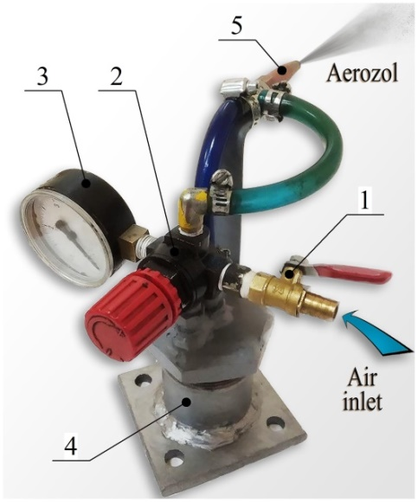 | Before operating the laboratory setup, the following settings must be made:  - Ensure that ball valve 1 is closed. If it is open, close it.  - Unscrew and remove the lid from the lubricant tank 4.  - Fill the tank with lubricant to the required level.  - Close the lubricant tank lid.  - Supply compressed air to the system’s inlet.  - Set the required air pressure using reduction valve 2, monitoring its readings on pressure gauge 3.
FIGURE 1. Components of the laboratory device for studying the lubricant spray process: 1 - ball valve; 2 - pressure-reducing valve; 3 - pressure gauge; 4 - lubricant tank; 5 - nozzle

Let's examine the operation principle of the nozzle in more detail, based on the hydraulic schematic.

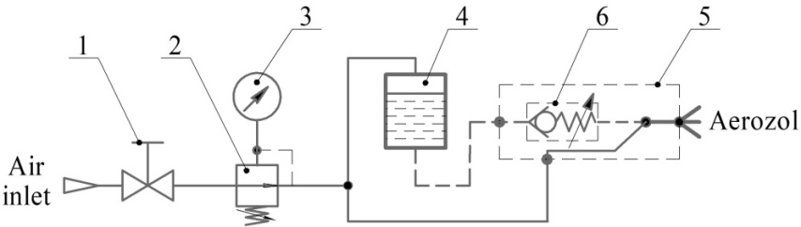

FIGURE 2. Hydraulic schematic of the research setup for analyzing the lubricant spray process

Compressed air is supplied to the system from the compressor receiver. The ball valve (1) regulates the pressure in the system, enabling the completion of the operation or the addition of lubricant to the tank. The reduction valve (2) stabilizes the air pressure in the experimental setup, while the manometer (3) monitors the pressure in the system. The air flow is distributed into two channels: one leads to the nozzle (5), and the other leads to the lubricant tank (4). Under the influence of air pressure, the lubricant is expelled from the tank, regardless of its viscosity. The intake is from the lower part of the tank to ensure continuous supply. The lubricant, through the check valve (6), which also prevents spontaneous leakage, is directed to the nozzle, where an aerosol of lubricant and air is formed (Fig. 3).
Figure 3 shows the nozzle design, which consists of the following main components: the nozzle (1), where the aerosol is formed; the tube (2), used to deliver the lubricant to the nozzle; the locknut (3), responsible for shaping the aerosol spray and securing the nozzle; and the T-connector (4), which ensures the mixing of air with the lubricating liquid.
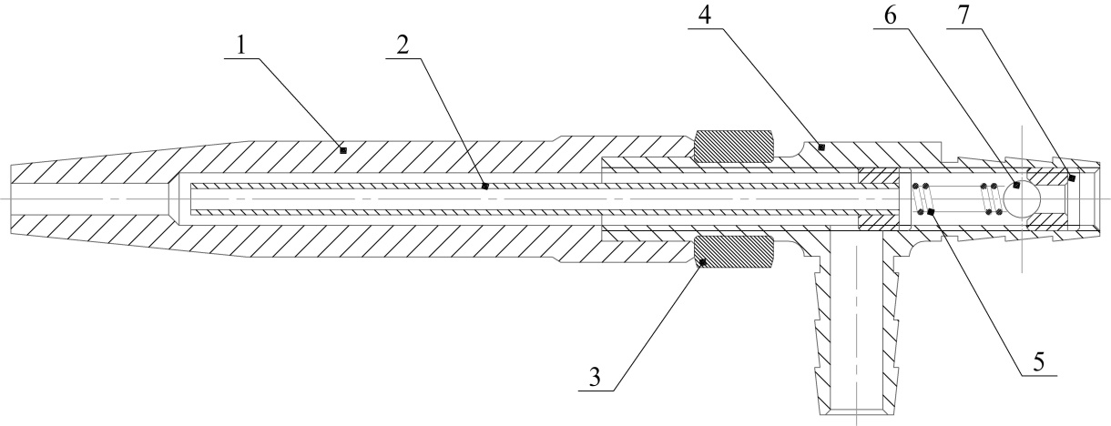
FIGURE 3. Nozzle structure: 1 - nozzle; 2 - tube; 3 - locknut; 4 - T-connector; 5 - spring; 6 - check valve ball; 7 - valve seat

Main parameters of the developed setup:
- device weight - 1.5 kg.
- nozzle outlet diameter of the spray nozzle - 1-3 mm;
- air pressure adjustment range for the sprayer - 0-0.5 MPa;
- minimum air pressure for system operation - 0.05 MPa;
- air flow rate - 1.5 • 10⁻³ m³/ s;

For the experiments, the device was mounted on a manipulator that ensured uniform movement. The lubricant was applied to Whatman paper, which made it possible to visualize the operation of the nozzle at different compressed air supply modes.
Studies have shown that the installation effectively sprays both thick liquids (for example, Relsol-M, Relsol-GS and Mariol-NT) and liquid (RS-6 «B»), depending on the air pressure setting and nozzle diameter.
When conducting studies with RS-6 «B» type lubricant, it was found that with a nozzle with a diameter of 1 mm and an air pressure of 0.05 MPa, the aerosol spray occurs unevenly and with pulsation. With increasing pressure, the spray becomes uniform, the pulsation disappears, and the size of the aerosol torch increases. The use of a nozzle with a diameter of 3 mm at the same pressure (0.05 MPa) provides a more uniform spray, but wavy protrusions appear at the edges of the spray cone, indicating a slight pulsation. With increasing pressure, the uniformity of the spray improves. Table 1 shows the results of a series of experimental studies of the consumption of the lubricant RS-6 «B» at different air pressures and nozzle diameters.

TABLE 1 Material consumption depending on pressure force, lubricant RS-6 «B»
Nozzle diameter, mm | Air pressure, MPa | Lubricant consumption, kg/h
Nozzle diameter, mm | Air pressure, MPa | Q₁ | Q₂ | Q₃ | Q_{mean}
1 | 0.05 | 1.083 | 1.087 | 1.082 | 1.084
 | 0.1 | 2.159 | 2.163 | 2.164 | 2.162
 | 0.2 | 4.321 | 4.324 | 4.319 | 4.321
2 | 0.05 | 2.161 | 2.156 | 2.154 | 2.157
 | 0.1 | 3.942 | 3.946 | 3.945 | 3944
 | 0.2 | 6.324 | 6.319 | 6.321 | 6.321
3 | 0.05 | 2.884 | 2.883 | 2.886 | 2.884
 | 0.1 | 5.760 | 5.762 | 5.764 | 5.762
 | 0.2 | 7.924 | 7.919 | 7.923 | 7.922

where: Q₁, Q_{2,} Q₃ – results of individual measurements, kg/h;
Q_{mean} – average value, kg/h.

During experimental studies, it was found that the use of a nozzle with a diameter of 1-2 mm with Relsol-M, Relsol-GS and Mariol-NT lubricants does not ensure the required quality of lubricant application. The small diameter of the nozzle limits the spray volume, leading to pulsation and instability of the aerosol jet. This, in turn, leads to uneven surface coverage, which does not meet the requirements for effective lubrication.
During experiments with Relsol-M, when using a nozzle with a diameter of 3 mm and an air pressure below 0.15 MPa, the aerosol spray was uneven with a pulsating effect, which was also observed in studies with other lubricants. With increasing air pressure, the lubricant spray became uniform, and the spray cone widened. In the case of Relsol-GS under the same conditions (nozzle 3 mm, air pressure 0.15 MPa and more), the spray was uniform, without pulsations, and the line width remained stable. Increasing the pressure led to an increase in the thickness of the applied layer. Similar results were observed for Mariol-NT. Increasing the pressure also increased the layer thickness, but did not affect the line width. Table 2 shows the results of a series of experimental studies of the consumption of lubricant consumption for Relsol-M, Relsol-GS and Mariol-NT at different air pressure supply but with a fixed nozzle diameter of 3 mm.

TABLE 2 Material consumption depending on the pressure force, Relsol-M, Relsol-GS and Mariol-NT lubricants
Lubricant | Air pressure, MPa | Lubricant consumption, kg/h
Lubricant | Air pressure, MPa | Q₁ | Q₂ | Q₃ | Q_{mean}
Relsol – M | 0.15 | 0.156 | 0.154 | 0.153 | 0.154
 | 0.2 | 0.182 | 0.180 | 0.179 | 0.180
 | 0.3 | 0.547 | 0.547 | 0.548 | 0.547
 | 0.4 | 0.730 | 0.727 | 0.729 | 0.728
Relsol – GS | 0.15 | 0.068 | 0.069 | 0.065 | 0.067
 | 0.2 | 0.246 | 0.247 | 0.249 | 0.247
 | 0.3 | 0.363 | 0.361 | 0.360 | 0.361
 | 0.4 | 0.487 | 0.489 | 0.488 | 0.488
Mariol – NТ | 0.15 | 0.072 | 0.074 | 0.072 | 0.072
 | 0.2 | 0.247 | 0.248 | 0.247 | 0.247
 | 0.3 | 0.482 | 0.488 | 0.486 | 0.485
 | 0.4 | 0.723 | 0.722 | 0.725 | 0.723

The experiments revealed significant differences in the spray characteristics between different types of lubricants. The specialized software was employed to analyze the dependence of lubricant consumption on the main parameters of the experiment, such as pressure and nozzle diameter.
Based on the results of experimental studies, a multifactorial regression model was developed that takes into account the influence of several variables, in particular pressure and nozzle diameter, and describes the use of RS-6 «B» lubricant by nozzle.

(1)

where: a, b, c, d, f, g, j - empirical regression coefficients;
Q - lubricant flow rate, kg/h;
P - air pressure, MPa;
D - nozzle diameter, mm.

The following equation represents a third-degree polynomial regression model. It reflects the dependencies for lubricants such as Relsol-M, Relsol-GS and Mariol-NT.

(2)

After constructing the dependencies, the next step was to calculate the coefficients for each type of lubricant based on experimental data. These coefficients are critically important for refining the regression models, as they determine the specifics of the dependence of the lubricant flow rate on variable parameters, such as pressure and nozzle diameter.
The values of the coefficients of the regression equation for RS-6 «B», Relsol-M, Relsol-GS and Mariol-NT lubricants for use with nozzle are given in table 3.

TABLE 3 Coefficients obtained from the regression analysis
Lubricant | Empirical coefficients of the model
RS-6 «B» | a = - 21.6 | b = 49.828 | c = 0.624 | d = 9.078
 | f = - 0.0875 | g = - 188.739 | j = 167.078
Relsol – M | a = 0.063 | b = - 2.193 | c = 21 | d = - 28
Relsol – GS | a = 0.017 | b = - 0.943 | c = 13.167 | d = - 19.76
Mariol – NT | a = 0.062 | b = - 2.195 | c = 20.56 | d = - 27.4

The results of the regression analysis demonstrate the dependence of the lubricant flow rate on the air pressure. The graph for RS-6 «B» is shown in Fig. 4, while the graphs for Relsol-M, Relsol-GS and Mariol-NT are shown in Fig. 5.

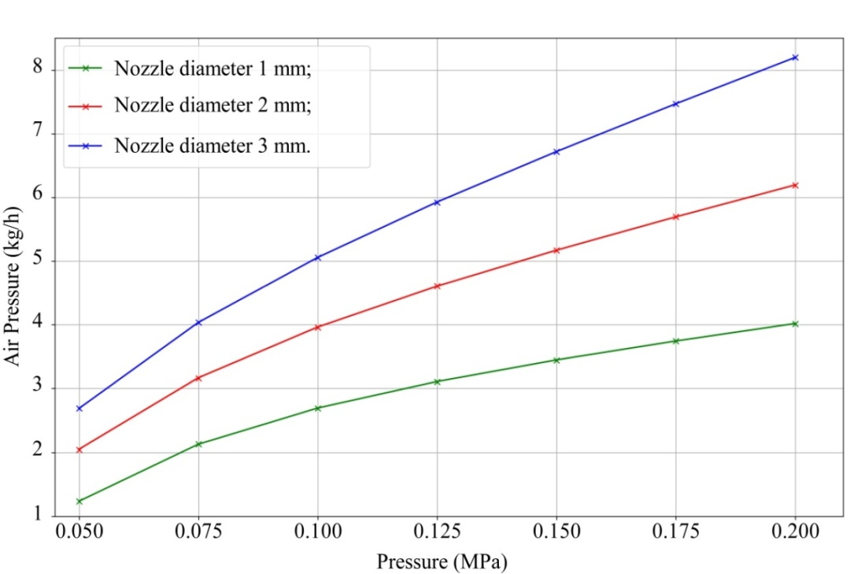
FIGURE 4. Graph of the dependence of the lubricant flow rate of RS-6 «B» on the air pressure and the nozzle diameter

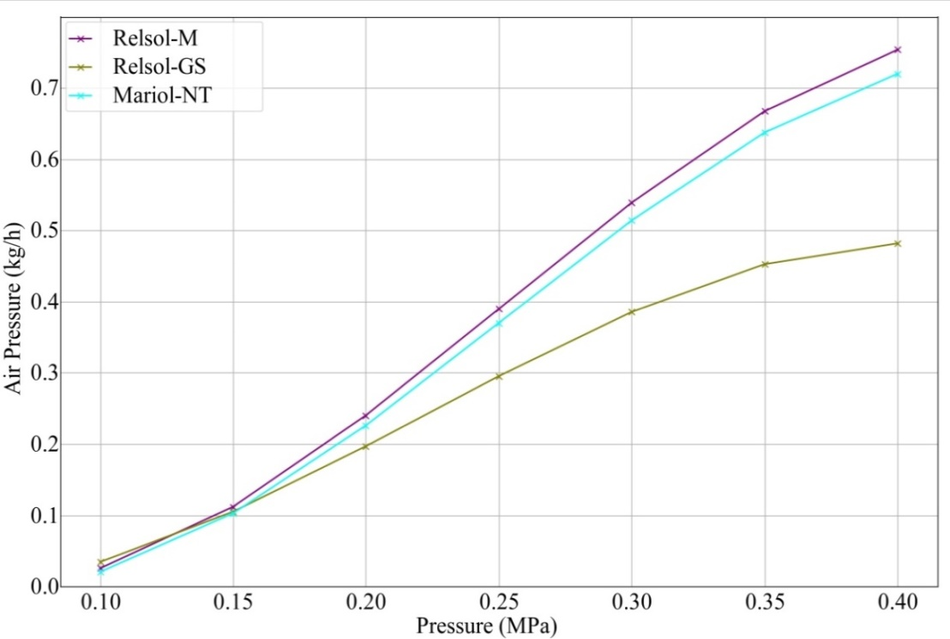
FIGURE 5. Graph of the dependence of the lubricant flow rate of Relsol-M, Relsol-GS and Mariol-NT on the air pressure
The obtained data demonstrate that the characteristics of the flow curves of the lubricant are determined by its viscosity. The flow rate of the liquid lubricant RS-6 «B» increases significantly with increasing pressure, which is explained by its lower viscosity. In contrast, for thicker lubricants, such as Relsol-M, Relsol-GS and Mariol-NT, the flow increases more slowly with increasing pressure. These features emphasize the importance of considering the type of lubricant when setting the nozzle parameters. For liquid lubricants, it may be advisable to use low pressure for uniform spraying to avoid excessive flow. For thick lubricants, on the contrary, increased pressure or a change in the nozzle diameter may be required to ensure flow stability and avoid pulsations.
Based on the experiments conducted with the laboratory setup, a prototype of a new nozzle design was developed and proposed, which retains the key characteristics of experimental model, shown in Fig. 6 (a). All aspects identified during the tests were taken into account and the nozzle design was optimized to improve its reliability and efficiency. The new design provides for a more accurate supply of lubricating fluid, ease of installation and maintenance. The nozzle body has 4 holes for fixing it on the bracket (Fig. 7). The mounting design allows you to adjust the nozzle position both in the vertical and horizontal planes, which ensures accurate application of lubricant to the working area of the «wheel-rail».
Fig. 6 (b) shows the main elements of the nozzle prototype. This nozzle is equipped with a nozzle (1), through which lubricating fluid is supplied, a lock nut (2) is used to securely fasten the nozzle, the basis of the entire structure is the housing (4), inside which is located a spring, the stiffness of which was previously set (5) and a check valve ball (6), it interacts with the valve seat (7) to prevent spontaneous leakage of lubricant, the plug (8) is used to seal the technological opening of the channel, and the fittings (9) are used to connect to pipelines A - for lubricant, B - for air.

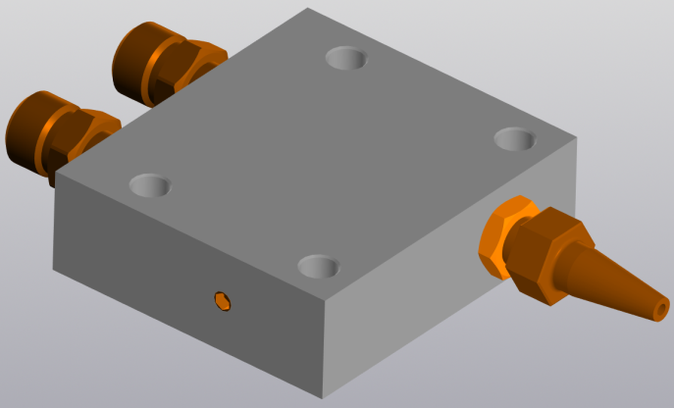 | 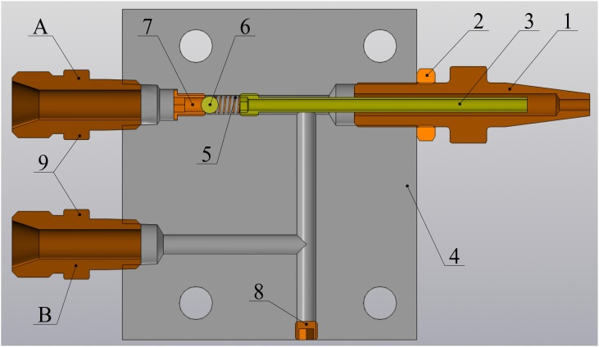
(a) | (b)
FIGURE 6. Structure of the nozzle prototype, (a) general view, (b) cross-sectional view: 1 - nozzle; 2 - locknut; 3 - tube; 4 - body; 5 - spring; 6 - check valve ball; 7 - valve seat; 8 - plug; 9 - fitting (2 pcs.)

To fix the nozzle on the locomotive, a special bracket is required, which requires separate development. For its manufacture, it was decided to use the VL-80 electric locomotive as a basis for further design. The main limitations of the bracket dimensions are its dimensions and design, which should not interfere with the operation of the bogie elements, such as brake shoes or springs.
The spray nozzle cannot be attached to the bogie frame, due to the fact that in the VL-80 electric locomotive the wheelset is sprung, the bogie will not copy the movement of the machine relative to the rolling surface of the rails, thus the lubrication of the rails will occur incorrectly, and lubricant may get on the rolling surface, which is unacceptable. The axle box bearing assembly is protected from external factors by a cover fixed on 8 bolts, to which the bracket can be attached.
The design solution must include an adjustable nozzle mount, which will allow for precise adjustment of its position regardless of changes in the diameter of the wheelset. This approach will ensure optimal rail lubrication and increase the efficiency of the system, taking into account the individual parameters of each electric locomotive. A bracket was developed for attaching the nozzle to the wheelset, which is shown in Fig. 7 (a).

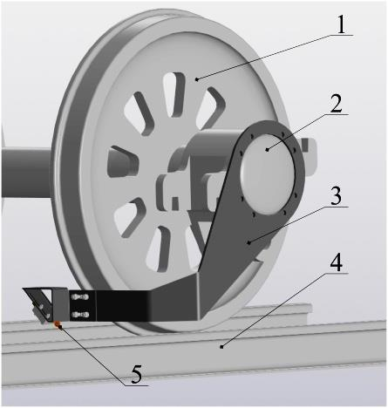 | 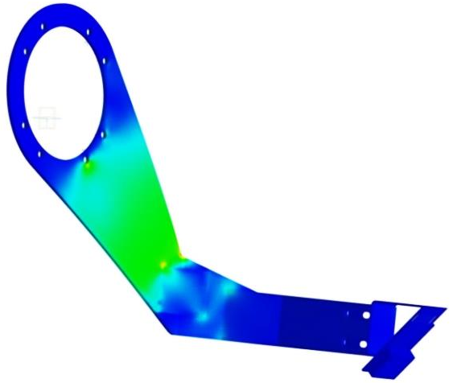 | 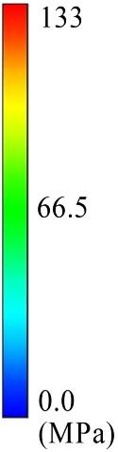
(а) | (b)
FIGURE 7. Bracket for securing the nozzle in the rail lubrication zone, (a) general view of the mounted rail lubrication system on the leading wagon: 1 - wheelset; 2 - axle box bearing unit; 3 - bracket; 4 - rail; 5 - nozzle, (b) equivalent stress according to Mises

Static calculations of the bracket were performed in the APM FEM program. A finite element model was created, which allowed to estimate the distribution of stresses, displacements and stability of the bracket, as well as to identify possible optimization methods to increase its reliability. The calculations showed that the maximum equivalent stress according to the Mises criterion is 132.99 MPa, Fig. 7 (b), which is within the permissible values for the St3sp steel (yield strength – 220 MPa). This indicates that the structure is able to withstand the applied loads without the risk of exceeding the yield limit.

DISCUSSION OF RESULTS
Experimental studies have shown that the proposed nozzle prototype is universal and allows working with lubricants of different viscosities. Lubricant consumption (Q) depends on the air pressure (P) and nozzle diameter (D). It was found that thick lubricants (Relsol-M, Relsol-GS and Mariol-NT) require higher air pressure to ensure a stable torch, compared to liquid (RS-6 «B»).
Regression models have been built that allow predicting lubricant consumption at different operating modes, and the obtained empirical coefficients are useful for creating system operating maps and dosing algorithms.
Finite element analysis of the bracket showed that the maximum stresses remain within the limits permissible for St3sp steel.

Conclusions
The developed lubrication system for the rail and wheel flange, which is based on the principle of aerosol lubricant application, demonstrates high efficiency when using different types of lubricants.
The study of lubricant consumption using an experimental setup allowed determination of the dependence of lubricant consumption on the pressure and diameter of the nozzle. During the experiment, the minimum operating pressure and the optimal nozzle diameter were established for correct operation of the nozzle. The used polynomial regression model of the third degree and the empirical multifactor regression model demonstrated their effectiveness in predicting lubricant consumption when varying these parameters. In particular, the obtained models allow us to accurately predict lubricant consumption as a function of air pressure and nozzle diameter, which provides the possibility of optimizing the lubrication process.
The design of the nozzle mounting bracket also demonstrated high reliability under significant dynamic loads, which is confirmed by the results of modeling using APM FEM. Maximum stresses and deformations are within the permissible values for the material, which ensures the reliability of the system during operation.
Thus, the proposed system can effectively perform its function under conditions of high dynamic loads and provide optimal lubrication of the rail pair, increasing the service life of the wheels and rails.

Acknowledgments
The authors would like to express their gratitude to Kharkiv National Automobile and Highway University and the organizing committee of the Modern Automotive Industry, Transport and Road Infrastructure (MAITRI) conference.

Conflict of interests
The authors declare that there is no conflict of interests regarding the publication of this paper.
REFERENCES
[1] V. Kossov, A. Lunin, A. Spirov, Y. Panin, N. Ivashkovska, and A. Nikolajevs, “The technology of rail lubrication by the hauling locomotive in train formation,” Proc. Comput. Sci. 149, 331–335 (2019); https://doi.org/10.1016/j.procs.2019.01.144
[2] G. Csortos, F. Augusztinovicz, and P. Bocz, “Optimal operation of a rail lubrication device with respect to noise reduction and wheel/rail friction coefficient,” Acta Tech. Jaurinensis 14(2), 138–154 (2021); https://doi.org/10.14513/actatechjaur.00592
[3] A. S. Ayvaz and M. Alalou, “Lubrication models in railway curves,” Int. J. Innov. Eng. Res. Technol. 8(4), 154–160 (2021); https://repo.ijiert.org/index.php/ijiert/article/view/2445
[4] S. Voronin, D. Onopreychuk, V. Stefanov, Y. Bashkatov, and V. Panchenko, “Reduction of construction duration by improving the anti-wear properties of power fluids in hydraulic drives of earth-moving machines,” Int. J. Eng. Technol. 7(4.3), 105–109 (2018); https://doi.org/10.14419/ijet.v7i4.3.19717
[5] S. Voronin, I. Hrunyk, B. Asadov, D. Onopreychuk, and V. Stefanov, “Study of the process of lubricant application on the friction surface using aerosol lubricators,” Int. J. Eng. Technol. 7(4.3), 20–24 (2018); https://doi.org/10.14419/ijet.v7i4.3.19546
[6] A. Khalladi and K. Elleuch, “Effect of surface topography with different groove angles on tribological behavior of the wheel/rail contact using alternative machine,” Friction 4, 238–248 (2016); https://doi.org/10.1007/s40544-016-0121-y
[7] J. Wang, W. Zhuang, W. Liang et al., “Inorganic nanomaterial lubricant additives for base fluids, to improve tribological performance: Recent developments,” Friction 10, 645–676 (2022); https://doi.org/10.1007/s40544-021-0511-7
[8] M. M. Rahman, M. Islam, R. Roy, H. Younis, M. AlNahyan, and H. Younes, “Carbon nanomaterial-based lubricants: Review of recent developments,” Lubricants 10(11), 281 (2022); https://doi.org/10.3390/lubricants10110281
[9] V. Kosarchuk, M. Chausov, A. Pylypenko, V. Tverdomed, P. Maruschak, and A. Menou, “Nanopowders of different chemical composition added to industrial lubricants and their impact on wear resistance of steel friction pairs,” Lubricants 10(10), 244 (2022); https://doi.org/10.3390/lubricants10100244
[10] B. White, Z. S. Lee, and R. Lewis, “Towards a standard approach for the twin disc testing of top-of-rail friction management products,” Lubricants 10(6), 124 (2022); https://doi.org/10.3390/lubricants10060124
[11] SKF, “SKF lubrication systems optimize tram operations,” p. 4; https://cdn.skfmediahub.skf.com/api/public/0901d19680c5a59f/pdf_preview_medium/0901d19680c5a59f_pdf_preview_medium.pdf
[12] SKF, “SP9-2-S7 – Vogel/SKF spray nozzle for fluid grease – 0.05 cm³/actuation”; https://www.central-lubrication.com/SKF-Spray-nozzle-for-fluid-grease005-cml-Acutation
[13] Sécheron, “Wheel flange lubricators”; https://www.secheron.com/products-solutions/ess/wheel-flange-lubricators/
[14] Sistema zmashuvannia hrebniv kolis lokomotyviv SPP 12-5. Posibnyk z ekspluatatsii; https://drive.google.com/file/d/1kFuso5VU2zRGebu1hUxZBsROSkLpeDYd/view
[15] Igralub, “Train Sys-AL® druckluftlose Sprühanlage”; https://igralub.com/wp-content/uploads/2022/11/201-Systeme.pdf
[16] Dropsa, “Dropsa spray valve for wheel flange lubrication”; https://www.dropsa.com/flex/cm/pages/ServeAttachment.php/L/EN/D/D.cf397917c25bdfcabdc4/P/BLOB%3AID%3D991/E/pdf?mode=download

