Integration of Numerical Modelling for Optimization of Road Slab Design and Adaptation to European and National Standards
Oksana Pustovoitova¹, Lyudmila Haponova^{2, a)}, Evhen Ivanov³,
Svitlana Kamchatna⁴, Volodymyr Buhaievskyi⁵, Andrii Suminov⁶
¹O.M. Beketov National University of Urban Economy,
Department of Building Constructions, 61002 Kharkiv, Ukraine
²Kharkiv National Automobile and Highway University,
Department of Computer Graphics, 61002 Kharkiv, Ukraine
³Kharkiv National Automobile and Highway University,
Department of Computer Graphics, 61002 Kharkiv, Ukraine
⁴Ukrainian State University of Railway Transport,
Department of Higher Mathematics and Physics, 61001 Kharkiv, Ukraine.
⁵Kharkiv National Automobile and Highway University,
Department of Bridges, Structures and Building Mechanics, 61002 Kharkiv, Ukraine
⁶Kharkiv National Automobile and Highway University,
Department of Computer Graphics, 61002 Kharkiv, Ukraine
^{a)} Corresponding author: gaplyudmila@gmail.com
Abstract. The study presents the results of an engineering investigation focused on optimizing the design of road stress slab (RSS) by replacing conventional prestressed reinforcement classes AV and AIV with high-strength K1500-class cables. The primary objective of the research is to reduce material consumption and construction costs while maintaining or enhancing the structural strength of the slabs. Within the scope of the study, an optimized reinforcement scheme was developed and substantiated, ensuring equivalent strength compared to standard design solutions and compatibility with existing technological equipment. The proposed reinforcement configuration mitigates uneven stress distribution during cable tensioning with a common traverse, provides uniform prestressing, and enhances the durability of the slabs. The analysis demonstrated that the use of K1500 cables in combination with A800 transverse reinforcement enables a reduction in the amount of working reinforcement without compromising the load-bearing capacity of the structures. Finite element method (FEM) numerical modeling confirmed uniform stress distribution, acceptable deformations, and deflections across all investigated configurations, ensuring the reliability and operational safety of the slabs. The obtained results hold practical significance for designing cost-effective, technologically compatible, and competitive road slabs, contributing to the development of Ukraine’s transport infrastructure and its alignment with European standards. The proposed optimization validates structural efficiency, economic feasibility, and adaptability to domestic industrial capabilities, serving as a critical factor in improving the quality and reliability of road pavements in the context of European integration and post-war recovery of Ukraine's war-damaged transport infrastructure.
Keywords: stress-strain state, prestressed reinforcement, top and bottom reinforcement, stress distribution, finite element method, economic efficiency, technological compatibility, RSS road slabs, structural optimization.

INTRODUCTION
Development and restoration of Ukraine's transport infrastructure necessitates the application of modern structural and construction solutions that guarantee the durability, reliability, and safety of road pavements.
A road for motor vehicle traffic constitutes a pavement structure with high strength characteristics, ensuring its ability to withstand significant vehicular loads over a prolonged service life. The selection of the pavement type, which typically accounts for 40–60% of the total cost of road construction, is one of the key and critical decisions in the design of road structures. As the technical category of a road increases, so do the requirements for the strength and capital quality (robustness) of its pavement.
When choosing a pavement type, it is necessary to consider a complex of factors affecting the long-term performance of the pavement structure. Alongside traditional flexible pavements (asphalt concrete surface course), rigid pavements have found widespread application under heavy traffic loads, among which precast reinforced concrete road slabs hold significant importance.
Reinforced concrete road slabs were used as an alternative to asphalt pavement to compare their properties and longevity. Analysis of operational data showed that asphalt concrete pavement requires replacement after just 10 years of service, whereas reinforced concrete road slabs can ensure continuous road operation for up to 40 years without significant damage or deformation.
The key feature of road slabs is their ability to withstand heavy vehicular loads and distribute them evenly across the entire area of the roadbed. This helps minimize the weight and mechanical impact on underground utilities, which often run beneath the pavement.
Compared to asphalt concrete pavements, road slabs offer several advantages. Firstly, they exhibit high environmental sustainability: unlike asphalt, concrete pavements do not soften under high temperatures or emit volatile petroleum compounds. The gaps between slabs facilitate natural drainage, preventing water accumulation and puddle formation. Secondly, road slabs are characterized by enhanced durability. Thirdly, the installation and demounting of the slabs are performed rapidly and with minimal time expenditure, enabling the prompt replacement of individual elements or repair of underground utilities, followed by the swift restoration of traffic flow on the roadway.
The design of prestressed concrete road pavement slabs remains a critical challenge in modern road construction due to the need to balance structural efficiency, durability, and economic viability. While recent advancements in high-strength materials, such as prestressed reinforcement strands of strength class K1500, have significantly enhanced the potential load-bearing capacity of slabs, their optimal application is constrained by existing manufacturing capabilities, which often limit the permissible spacing of reinforcement strands and embedment depth.
The application of parametric finite element analysis (FEA) enables a systematic evaluation of slab performance across a wide range of design variables, facilitating the identification of an optimal combination of reinforcement spacing and embedment depth. Such optimization is crucial for achieving uniform stress distribution, minimizing prestress losses, and enhancing fatigue strength while ensuring compatibility with existing prestressing beds and concrete placement equipment.
Given the increasing demand for high-performance road pavements with extended service life, this study addresses the pressing need to integrate advanced numerical modeling techniques with practical manufacturing constraints.
The integration of innovative technologies and increasing demands for design quality necessitate the adaptation of standard structural solutions to contemporary regulatory frameworks. Particular importance is placed on the need to consider both national DBN standards and European EN standards, which is critical in the context of implementing international projects and utilizing imported materials and technologies. Adapting calculation norms to comply with EN standards facilitates the updating of the regulatory framework and its alignment with modern technical requirements. A comparative analysis of EN standards and DBN B.2.6-98:2009 enables the identification of the advantages and disadvantages of each system, which is essential for optimizing design solutions. The implementation of standardized designs adapted to current regulations enhances the safety, reliability, and durability of road pavements, which is critically important for ensuring an efficient and safe Ukraine's transportation infrastructure.
For the execution of the research, an analysis of the regulatory framework, modern calculation methodologies for concrete and reinforced concrete structures, and structural approaches was conducted [1-7]. Additionally, methods of numerical analysis that enable the investigation of strength and deformation characteristics of structures under various reinforcement options were studied [8]. Literature analysis confirms the importance of integrating Eurocode (EN) standards with national norms to ensure the durability and safety of road slabs. In studies [9-12], the method of topological optimization was applied to distribute tendons in prestressed concrete structures, paying particular attention to the simultaneous optimization of shape and reinforcement size. This underscores the importance of a comprehensive optimization approach to enhance structural efficiency. In turn, studies [13-15] utilized modern heuristic algorithms combined with the Finite Element Method (FEM) to determine the optimal tendon layout in prestressed road slabs. This approach demonstrates the flexibility and adaptability of modern modeling methods for solving complex structural design problems. In the direction of parametric studies [16-18], multi-variable optimization using the MARSHAL algorithm for PCI beams was applied, varying parameters such as beam type, dimensions, and thickness. Their research results indicate that automating the modeling process significantly accelerates the search for optimal structural parameters. Similarly, a 2024 study focused on automating the design of prestressed slabs demonstrated a 14–29% reduction in reinforcement mass through parametric FE modeling and value engineering approaches, highlighting the effectiveness of automated optimization procedures.
The role of topological optimization and automation was investigated in the works [19], which examined the topological optimization of tendons considering critical constraints, particularly preventing tendon intersections. This is especially important when accounting for real-world production technological limitations. Likewise, the studies [20-21] showed the application of a hybrid PSOHS algorithm for optimizing tendon placement in slabs considering Canadian standards, which significantly reduced construction costs by improving design efficiency.
Regarding numerical models of road structures, some studies [22-23] examined an FE model of road pavement considering voiding under the slab using the Winkler foundation approach. This method is important for modeling contact interactions with the subgrade. Also, some works [24-25] presented a parametric study of CFST beams, which showed the influence of reinforcement and various parameters on the flexibility and strength of the structure through nonlinear FEM modeling. These results are relevant for understanding the impact of tendons in complex composite systems.
Thus, contemporary scientific research confirms the high effectiveness of applying FEM methods in combination with topological optimization and automation for developing optimal structural solutions in the field of prestressed concrete road slabs, considering production constraints and regulatory requirements.
Despite extensive literature on PCP technology, several gaps persist: limited comparative studies on the characteristics of K1500 reinforcement strands in road construction while simultaneously meeting EN and DBN requirements; and a lack of parametric finite-element analysis addressing the optimization of strand spacing and embedment depth, considering existing manufacturing equipment constraints. Addressing these gaps will directly enhance design accuracy, reduce material consumption, and extend the service life of prestressed road slabs in both European and Ukrainian practices.
The objective of this research is the selection of optimal structural design solutions for prestressed road slabs, utilizing modern materials such as K1500 strands in compliance with Eurocode (EN) standards and the provisions of DBN V.2.6-98:2009, employing numerical structural modeling. The study is aimed at enhancing reinforcement efficiency, reducing material costs, ensuring uniform strength, and improving the service performance characteristics of road slabs without altering the existing technological equipment.
Research Objectives are:
- to analyze the effectiveness of replacing conventional prestressed reinforcement classes AV and AIV with high-strength K1500 strands in RSS to reduce material costs and construction expenses while maintaining or improving strength characteristics.
- to develop and justify an optimal reinforcement scheme for slabs that ensures structural uniformity compared to standard solutions, while retaining existing technological equipment, and evaluate the potential for reducing working reinforcement.
- to determine recommended reinforcement parameters when using a common traverse for strand tensioning, specifically a 12 mm diameter (5Ø12K1500, A_{p}=4,53 cm²), to avoid uneven stress distribution, ensure uniform prestressing, and assess potential material savings compared to AV and AIV reinforcement classes.
Research Methods include the analysis of regulatory documentation (Eurocode, DBN B.2.6-98:2009), theoretical calculations of strength, crack resistance, and deformation characteristics of slabs; comparative analysis of reinforcement scheme efficiency (AV, AIV, K1500); economic analysis of working reinforcement costs when using different materials.

Experimental methodology
The investigated RSS prestressed road slabs are smooth, with plan dimensions of 6000×2000 mm and a height of 140 mm, reinforced with thermally strengthened reinforcement of classes AtV and AtIV. Reinforcement classes AV and AIV, compliant with DSTU 3760-98, are also permissible. The slabs are designed for use as road pavement for highway classes I–V under NK80 and NK100 loads as per DBN B.1.2-15:2009. The slabs exhibit maximum load-bearing capacity and crack resistance of M_{u}=M_{crc}=36,0 kNm. The manufacturing technology involves an electrothermal method for reinforcement tensioning. The slabs are designed as structures without cracks in normal and inclined sections under operational loads. The design concrete strength corresponds to class C20/25, with a frost resistance grade of F200. The slabs feature symmetrical reinforcement at the top and bottom, consisting of 5Ø12AV (At-IV) or 5Ø14A-IV (At-IV), with a working reinforcement cross-sectional area of A_{p} = 5,65 cm² or A_{p} = 7,69 cm², respectively. In addition to prestressed reinforcement, non-prestressed reinforcement is incorporated in the form of symmetrically placed top and bottom meshes. The mesh reinforcement consists of longitudinal Ø5BI bars and transverse Ø8A400s bars.
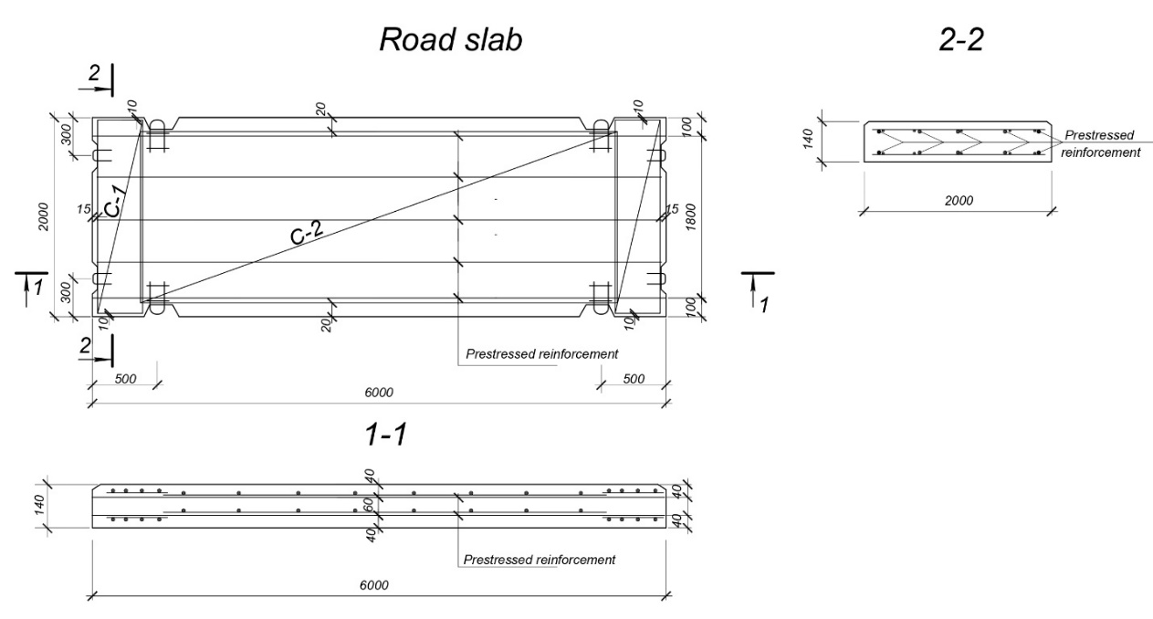

FIGURE 1. RSS-14 slab structural features.

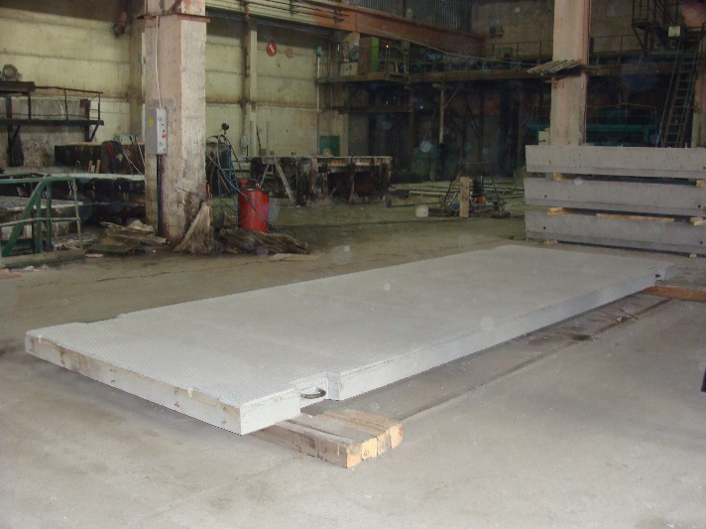 | 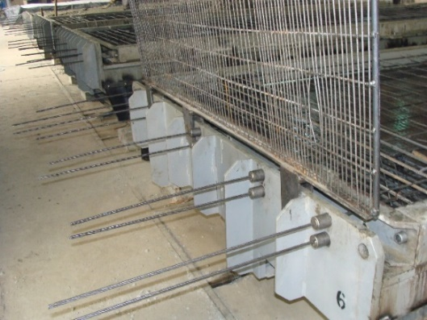
(a) | (b)

FIGURE 2. Road Slab: (a) General Arrangement of Slab; (b) Stressing beam and Anchorage of Prestressed Reinforcement for Slab

Due to changes in reinforcement and concrete standards and updated operational requirements (for slabs under LM1, LM2, LM3, and LM4 loads as per EN 1991-2:2003), variants of working reinforcement for slabs have been developed using K1500 strands with C25/30 concrete (RSS-14K) and high-strength A800 bar reinforcement with C25/30 concrete (RSS-14A). These slabs are of uniform strength and possess an equivalent level of crack resistance compared to standard slabs. Manufacturers often require modifications to tensioning equipment and the use of only five working bars: 5Ø12A800 with A_{p}=2,55 cm², 5Ø9K1500 with A_{p}=5,65 cm², or a combination of 3Ø12K1500 + 2Ø9K1500 with A_{p} = 3,738cm². The adopted tensioning method for K1500 strands is mechanical, while for A800 reinforcement, it is either mechanical or electrothermal. The initial controlled stress for strands is set at 1180 MPa and for A800 reinforcement at 630 MPa. For mechanical tensioning, double-acting hydraulic jacks are typically used, which transfer the force to a group of tendons via a stressing beam. The beam's design ensures a uniform distribution of force across all simultaneously tensioned tendons. For A800 reinforcement, when the mechanical method is applied, a similar system with a stressing cross-head can be used to tension multiple bars concurrently.
Strength and crack resistance studies of the slabs are conducted in accordance with DSTU B V.2-6-7-95 and EN 1168:2005+A2:2009, Annex J.
Crack resistance testing is performed using two load placement schemes, corresponding to the most critical positioning of vehicle wheels under LM1 loading on the slab (Figure 3).

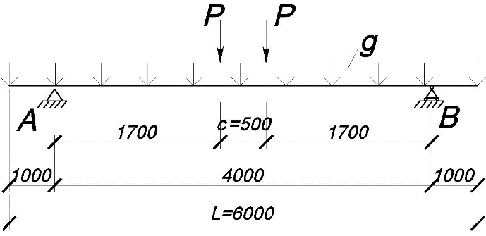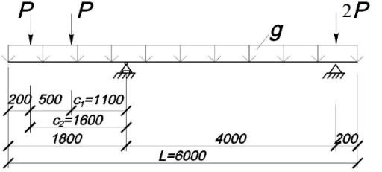
(a) | (b)

FIGURE 3. Test Scheme. (a) Load scheme А; (b) Load scheme B.

Crack resistance testing of the slab's lower zone is conducted according to Scheme A. Crack resistance testing of the slab's upper zone is performed according to Scheme B or Scheme A after testing the lower zone and flipping the slab.
The design load applied according to the scheme А is ,
where P is determined from the equation.

(for scheme А) (1)

(for scheme B) (2)

Where g is the linear load from the self-weight of the slab, equal to 7 kN/m.
For C25/30 concrete design compressive strength f_{cd} = 17 MPa; mean tensile strength f_{ctm} = 2,6 MPa.
The values of control loads on the slab are presented in Table 2.

Table 2. Control Loads on the Slab
Slab designation | Control Loads P (kN) for
Slab designation | Load scheme А | Load scheme B
RSS-14К (5∅9 К1500) | 21 | 14
RSS-14А (5∅12 А800) | 22 | 15

The calculated values of control loads for crack resistance testing of slabs reinforced with 5Ø9K1500 and 5Ø12A800 for design and release concrete strengths are presented in Table 4. The load-bearing capacity of RSS-14K and RSS-14A slabs with working reinforcement classes K1500 and A800 is presented in Table 3.
At release concrete strength, the actual concrete strength, in accordance with, is taken as

(for scheme B) (3)

The calculated load-bearing capacity at actual concrete strength is M_{u} = 28,82 kNm. The crack resistance of slabs is ensured when tensile stresses in the concrete do not exceed f_{ctm} = 2,6 MPa and is determined by the formula

(4)

where, for a rectangular cross-section of the slab is determined by the formula

(5)
P is the concrete compressive force is determined by the formula

(6)

r is the distance from the centroidal axis to the core point determined by the formula

(7)

The reduced geometric parameters and the concrete compressive force after instantaneous losses are:

(8)

The crack resistance of RSS-14K and RSS-14A slabs at the design concrete class C25/30 and at release concrete strength (70% of the design concrete class after instantaneous losses), as well as the values of control loads for crack resistance testing at design concrete strength, are presented in Table 3. Prestress losses are calculated for slabs with a design reinforcement cross-section determined based on strength calculations. Instantaneous losses are determined from:
- stress relaxation in reinforcement Δσ_{r};
- temperature variations Δσ_{θ};
- deformation of anchorage devices Δσ_{sl};
- losses due to instantaneous concrete deformation Δσ_{el}.
Time-dependent losses Δσ_{c+s+r} are determined from the effects of shrinkage, creep, and relaxation associated with concrete creep under normal temperature and humidity conditions and may be adjusted for actual operating conditions. The magnitude of prestress and losses are presented in Table 3.

Experimental data and results
The results of the calculations for the slab reinforced with K1500 strands and A800 reinforcement according to DBN norms are presented in Table 3.

Table 3. Results of Slab Calculations
Parameters | RSS-14К  5Ø9К1500 | RSS-14К 3Ø12К1500+  2Ø9К1500 | RSS-14А  5Ø12А800
Cross-sectional area of the reinforcement А_{р}, cm² | 2.55 / 5.65 (5Ø12АV) | 3.738 / 5.65 (5Ø12АV) | 5.65 / 7.69 (5Ø14АIV)
Reinforcement savings in % relative to АV та АIV | 54.8 | 33.8 | 26.5
Load-bearing capacity М_{u}, kNm | 28.98 | 31.2 | 33.78
Crack formation moment М_{crc}, kNm | 39.08 | 35.25 | 35.97
Initial stress σ₀, kN/cm² | 118.0 | 94.6 | 63.0
Instantaneous losses, Δσ₁ | 22.73 | 18.9 | 16.11
Residual stress before concreting, kN/cm² | 95.37 | 72.1 | 46.89
Time-dependent losses, kN/cm² | 15.88 | 13.2 | 10.03
Total losses Δσ, kN/cm² (%) | 38.95 (32.7) | 33.1 (35.4) | 26.31 (41.8)
Residual stresses σ_{p}, kN/cm² | 79.16 | 60.1 | 36.69
Crack resistance M_{crc}, kNm, at design strength. | 39.07 ≤39.08 | 29.8 ≤35.25 | 30.17 ≤35.97
Crack resistance M_{crc}, kNm, at release strength | 32.22 ≤39.08 | 27.6 ≤35.25 | 25.01 ≤35.97

From the analysis of Table 3, it is evident that the RSS-14K slabs (3Ø12K1500+2Ø9K1500) and RSS-14A slabs (5Ø12A800) are equivalent in strength and exhibit the same level of crack resistance, while the RSS-14K slab (5Ø9K1500) is not equivalent in strength but has the same level of crack resistance as standard slabs. These slabs can be used as a base course for asphalt concrete pavement. Replacing traditional prestressed reinforcement of classes AV and AIV with high-quality K1500 strands in RSS -type slabs provides substantial steel savings (up to 55%) while maintaining the load-bearing capacity and crack resistance of the structures. The high initial stresses in the strands are accompanied by greater relative losses; however, the residual level of working stresses exceeds the indicators of AIV reinforcement. The most efficient option proved to be 5Ø9K1500, which combines the minimal cross-section of reinforcement with sufficient strength and crack resistance.
For a detailed investigation of the stress-strain state, comprehensive computer modeling was performed using licensed software Autodesk Inventor (Version: 2023) [26]. Numerical models allow for detailed reproduction of the stress-strain state, accounting for material nonlinearities, specific features of component interaction, and the influence of long-term loads. The use of numerical modeling opens the possibility of performing series of calculations, varying reinforcement and concrete parameters, and determining optimal reinforcement layouts. This ensures a significant increase in the reliability of predicting structural behavior under real service conditions. Therefore, combining experimental data with modern numerical analysis methods is a relevant direction in the design and adaptation of reinforced concrete structures to meet national and international standards. A parametric analysis of prestressed models of slabs RSS -14K (5Ø9K1500) and RSS -14 (5Ø12A800) was conducted using the finite element method, in accordance with two design loading schemes—Scheme A and Scheme B (Figure. 3). The magnitudes of the control loads applied to the digital models fully corresponded to the normative values specified in Table 2, ensuring a high degree of concordance between the numerical modeling results and the theoretically expected behavior of the structures.

Table 3. Modeling of the Stress-Strain State of the Road Slab
Parameters | RSS-14К (5Ø9 К1500)
Parameters | Load scheme А. P=21 kN | Load scheme B. P=14 kN
Analytical Model | 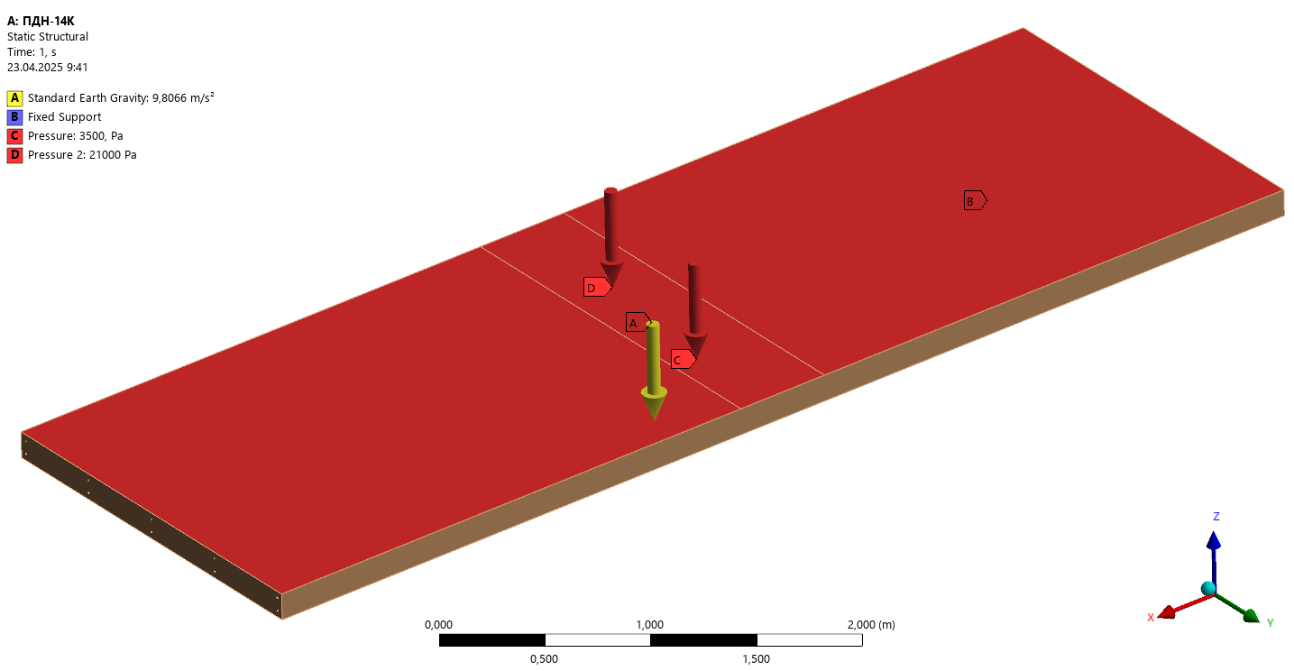 | 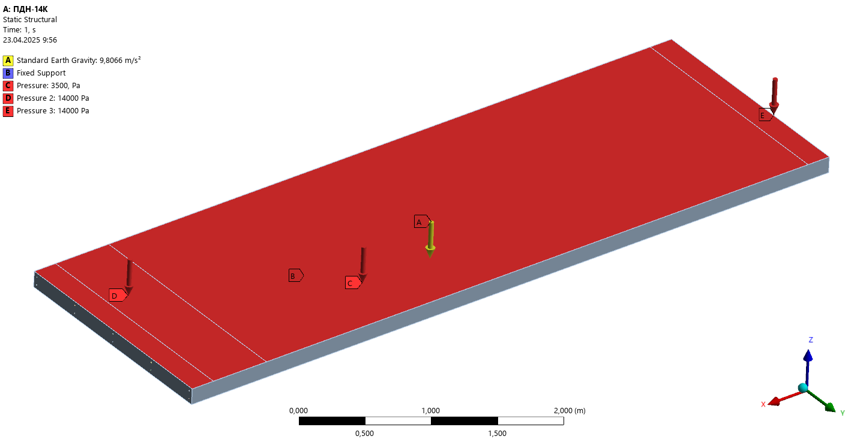
Deformations | 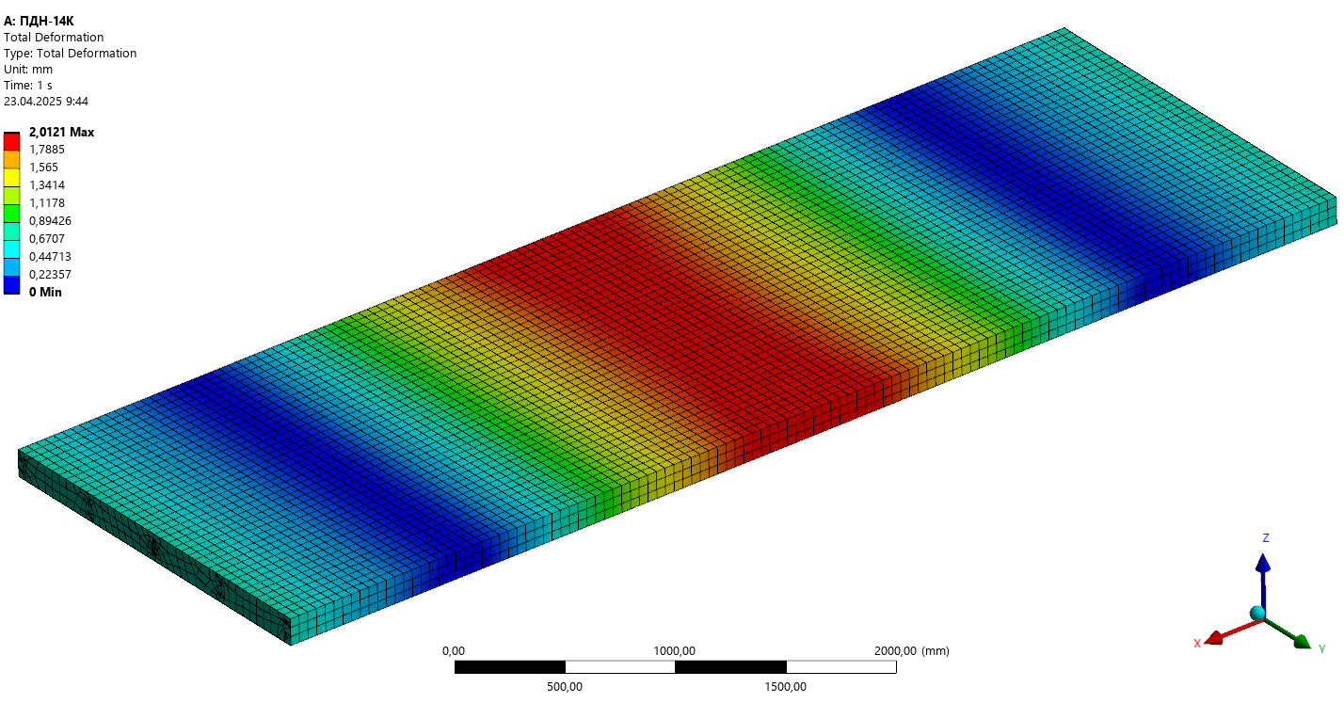 | 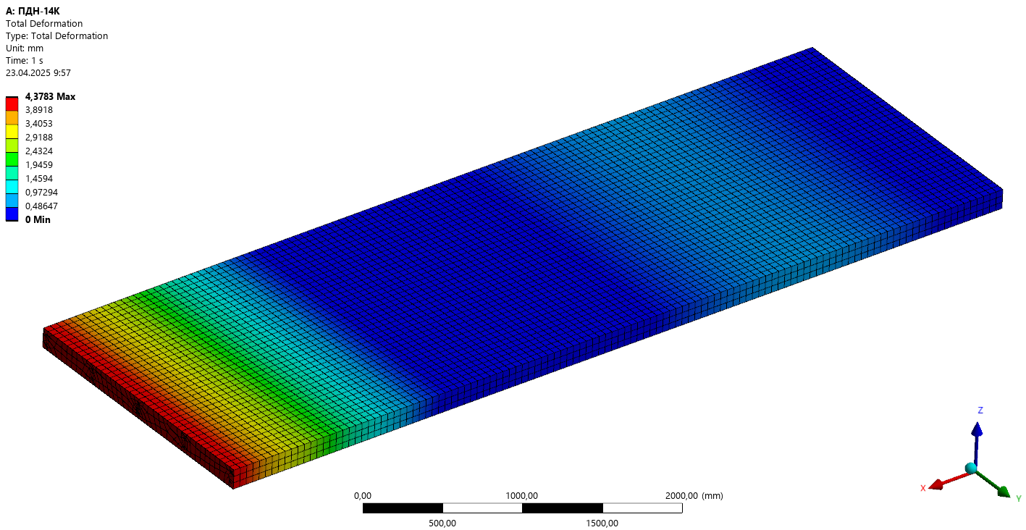
Peak tensile stress σ₁ | 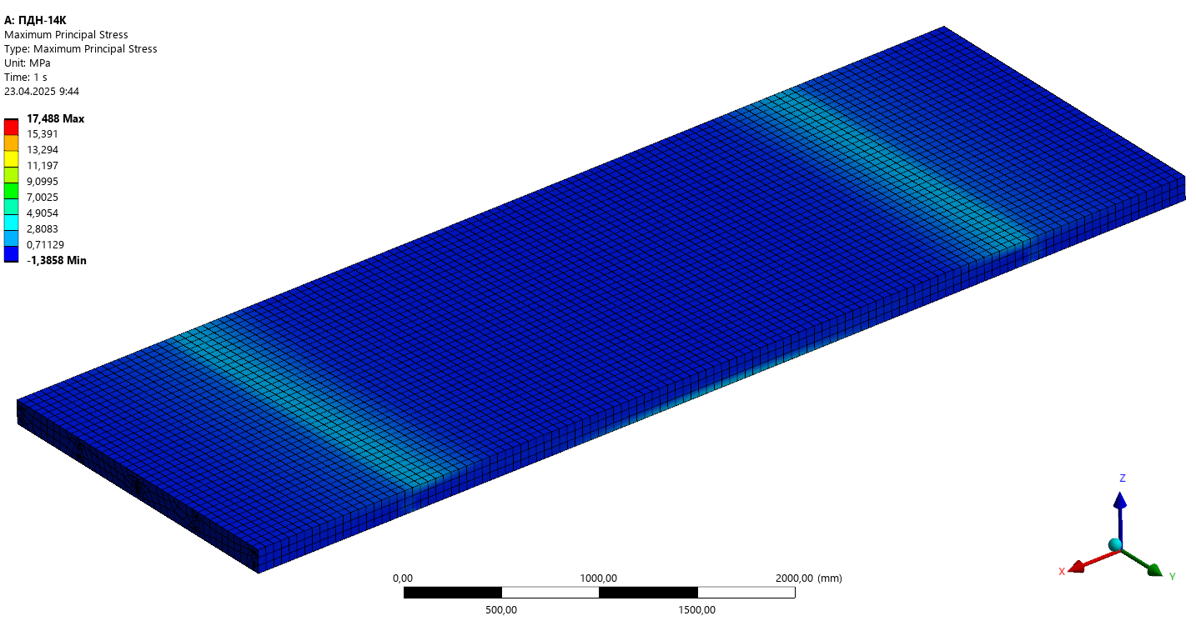 | 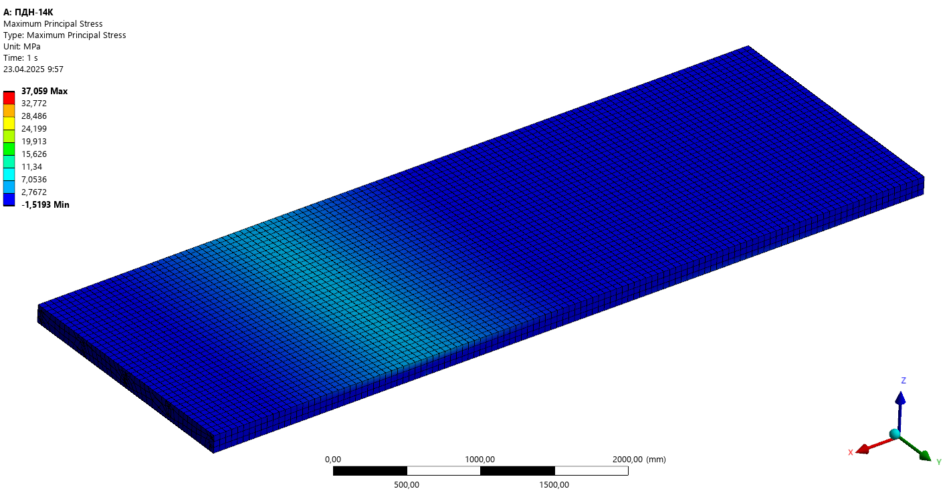
Analytical Model | RSS-14A (5∅12А800)
Analytical Model | Load scheme А. P=22 kN | Load scheme. P=15 kN
Analytical Model | 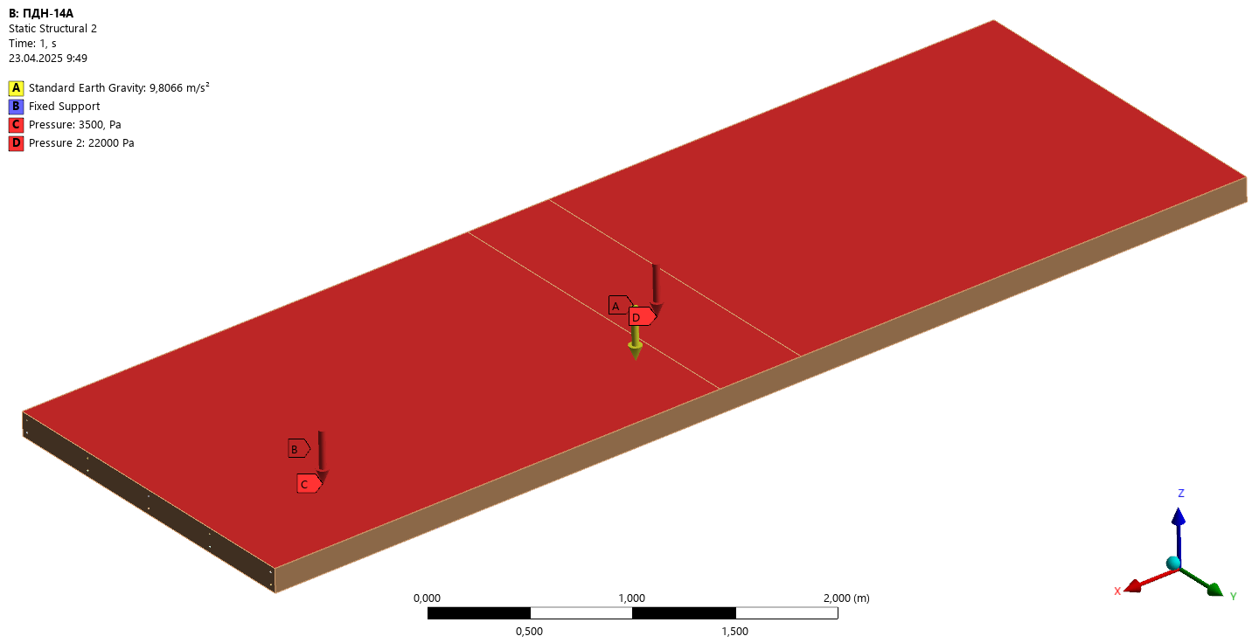 | 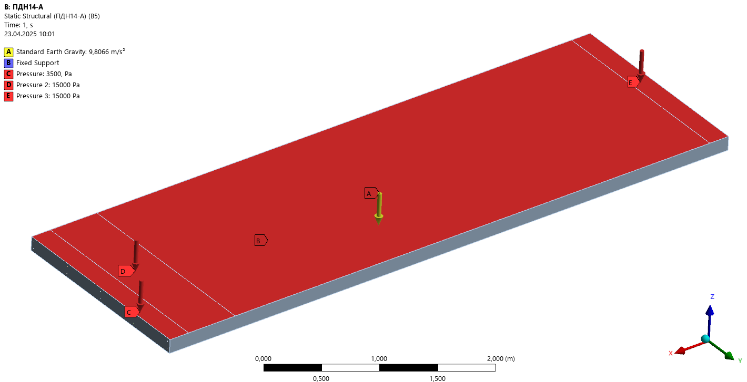
Deformations | 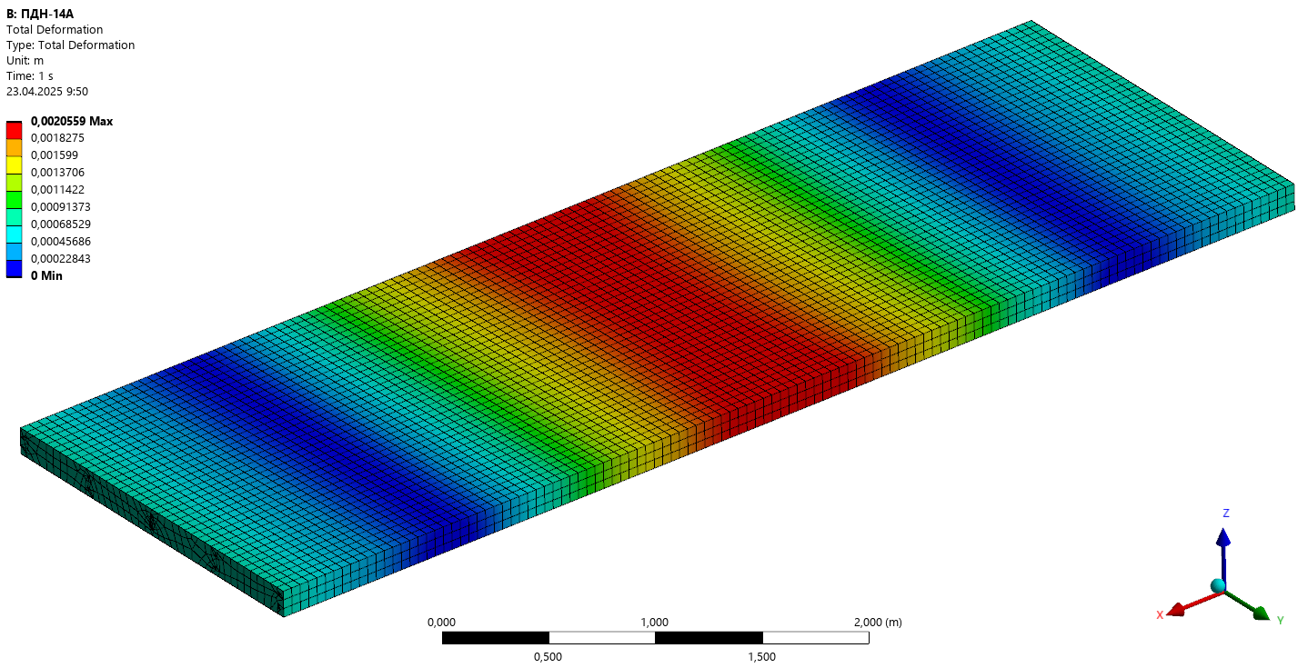 | 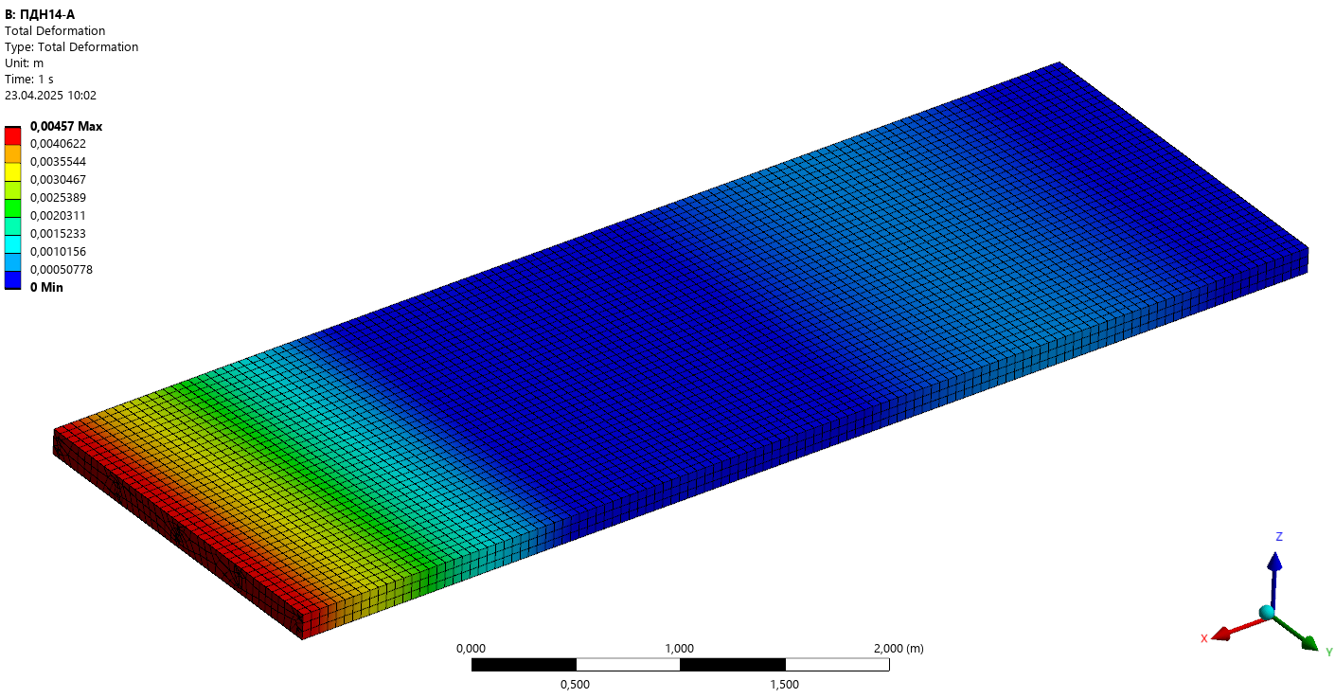
Peak tensile stress σ₁ | 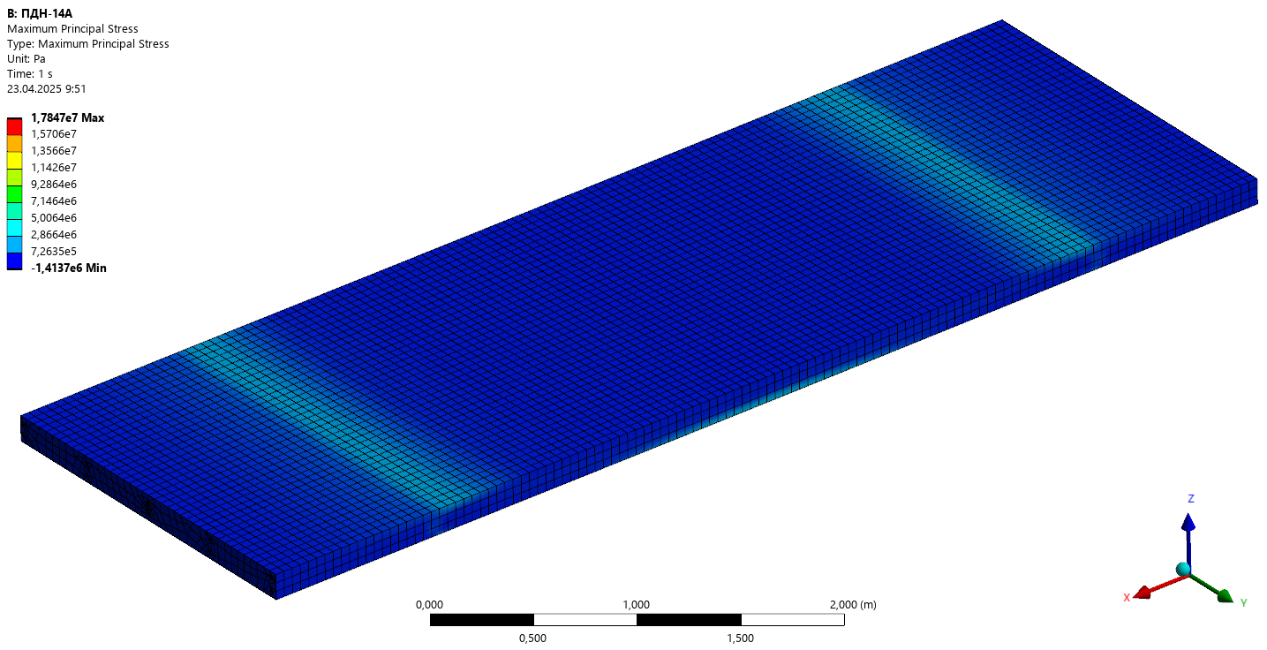 | 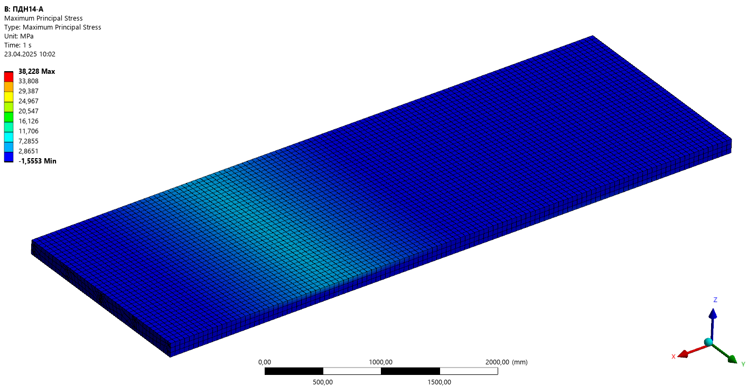

A comparative table 4 of the calculated characteristics of the slabs RSS-14К and RSS-14A was developed to evaluate their performance. The table presents key structural parameters.

Table 4. Comparison of slab calculation results
Parameters | RSS-14К (5Ø9К1500) | RSS-14А (5∅12А800)
Cross-sectional area of the reinforcement А_{р}, cm² | 2,55 | 5,65
Crack formation moment М_{crc}, kNm (using Equation 1) | 28,98 | 33,78
Peak tensile stress σ₁, (Load scheme А) MPa | 17,49≥f_{cd} = 17 MPa | 7,75≤f_{cd} = 17 MPa
Peak tensile stress σ₁, (Load scheme B) MPa | 2,5 ≤ f_{ctm} = 2,6 MPa | 2,6 ≤ f_{ctm} = 2,6 MPa
Peak deformation (Load scheme А) | 2,01 mm≤24 mm | 2,06 mm ≤24 mm
Peak deformation (Load scheme B) | 4,38 mm ≤24 mm | 4,57 mm ≤24 mm

Analysis of research results
Finite element parametric analysis of the stress-strain state in prestressed slab models RSS-14K (5Ø9K1500) and RSS-14 (5Ø12A800) under loading schemes A and B demonstrated that: when testing according to scheme A, the RSS-14K slab develops stresses exceeding f_{cd}, while under scheme B the stresses remain below f_{ctm}, indicating that while the slab is not of uniform strength, it maintains sufficient crack resistance. Testing of the RSS-14 slab under scheme A showed stresses below f_{cd}, and under scheme B stresses below f_{ctm}, confirming this slab exhibits both uniform strength characteristics and adequate crack resistance. The difference in deflections was less than 5%, which has negligible impact on serviceability since the maximum allowable deflection for a 6-meter slab is 24 mm. The use of K1500 strands enables significant reinforcement savings (~55%).
To ensure operational safety, prevent mechanical damage, maintain geometric stability and strength characteristics, prolong service life, and avoid additional repair or replacement costs, specific handling requirements have been established for loading/unloading these slabs. Transportation and storage must be performed in horizontal position only. All handling operations - including loading, transport, unloading and storage - must implement measures preventing potential slab damage. During transportation, slabs must be securely fastened to prevent longitudinal/transverse displacement, mutual collision or friction. For transportation and storage, bottom slabs should be placed on wooden supports with intermediate spacers between layers in the stack. Supports and spacers must be positioned 1 m from slab ends perpendicular to the long side and vertically aligned. Support thickness should be minimum 50 mm for rigid bases and 100 mm for ground surfaces, while spacer thickness must be at least 20 mm. Loading/unloading operations using lifting inserts must be performed with single slabs only - lifting multiple slabs using inserts of the bottom slab is strictly prohibited. Storage should be organized in sorted stacks by grade and batch, with maximum stack height limited to 10 slabs.

CONCLUSION
Analysis of the research results leads to the following conclusions: The most effective approach for designing RSS-type road slabs involves replacing Class AV or AIV prestressed reinforcement with Class K1500 strands. This substitution enables significant material savings and consequent reduction in construction costs while maintaining or even improving strength characteristics. To ensure equivalent structural performance compared to standard slabs while preserving existing production capabilities, the RSS-14K configuration (3Ø12K1500+2Ø9K1500) with total reinforcement area A_{p}=3,738 cm² is recommended. This reinforcement scheme achieves 33,85% material savings compared to Class AV and 51,45% compared to Class AIV reinforcement. Achieving optimal results requires ensuring uniform initial tensioning of all strands to facilitate even force distribution and prevent stress concentrations in individual structural components.
When using common tensioning beams, employing strands of identical diameter simplifies the prestressing process and ensures more controlled, uniform prestress distribution while providing 19,25% material savings versus AV and 41,25% versus AIV reinforcement. This approach prevents uneven tension force distribution between different diameter strands that could lead to undesirable deformations and reduced load-bearing capacity.
The study adapts Eurocode-based design principles to comply with DBN V.2.6-98:2009 requirements, developing practical design solutions that combine structural efficiency with compatibility to Ukraine's existing production infrastructure. Finite element method (FEM) numerical modeling serves as the primary research tool, enabling detailed analysis of stress distribution and deflection patterns. By integrating computational modeling with targeted parameter optimization, this research addresses the critical need for cost-effective, high-performance road pavement solutions within the context of evolving European-Ukrainian infrastructure integration. The proposed technical solutions demonstrate 15-20% production cost reduction while maintaining full compliance with current regulatory requirements for prestressed concrete structures.

Acknowledgments
The authors would like to express their gratitude to Kharkiv National Automobile and Highway University and the organizing committee of the Modern Automotive Industry, Transport and Road Infrastructure (MAITRI) conference.

Conflict of interests
The authors declare that there is no conflict of interests regarding the publication of this paper.

References
[1] DBN B.1.2-2:2006, Reliability and safety system for building objects, Design standards, Amendment No. 1, Effective since 01/01/2007.
[2] DSTU B V.2.6-156:2010, Concrete and reinforced concrete structures made of heavy concrete. Design rules, Kyiv: Minregionalbud of Ukraine, 2011.
[3] DBN V2.6-98:2009, Concrete and reinforced concrete structures. Basic provisions, Kyiv: Minregionalbud of Ukraine, 2009.
[4] EN 1992-1-1:2004+AC:2008, Eurocode-2. Design of reinforced concrete structures. Part 1-1. General rules and regulations for buildings.
[5] EN 1168:2005+A2:2009(E), Annex J.
[6] TK P EN 1991-2-2009, Eurocode 1.
[7] DSTU B V.2-6-7-95, Prefabricated reinforced concrete and concrete construction products. Load test methods. Rules for assessing strength, stiffness and crack resistance, Kyiv: State Committee for Urban Development of Ukraine, 1997.
[8] V.S. Shmukler, E.G. Stoyanov, and O.M. Pustovoitova, “Adaptation of typical design solutions of road slabs to Eurocode (EN) standards and DBN V.2.6-98:2009 norms,” Komunal’ne hospodarstvo mist: N. T. zbirn. 118, 40–44 (2014).
[9] Y. Zelickman and O. Amir, “Layout optimization of post-tensioned cables in concrete slabs,” Struct. Multidisc. Optim. 63, 1951–1974 (2021). https://doi.org/10.1007/s00158-020-02790-2
[10] W.-K. Hong, Artificial Neural Network-based Designs of Prestressed Concrete and Composite Structures (CRC Press, Boca Raton, 2023). https://doi.org/10.1201/9781003354796 doi.org
[11] W.-K. Hong, Artificial Neural Network-based Optimized Design of Reinforced Concrete Structures (CRC Press, Boca Raton, 2023). https://doi.org/10.1201/9781003314684 doi.org
[12] Enhanced Structural Design of Prestressed Arched Trusses through Multi-Objective Optimization and Multi-Criteria Decision-Making, Mathematics 12, 2567 (2024). https://doi.org/10.3390/math12162567 doi.org
[13] A. H. Mohammed, N. Tayşi, D. E. Nassani, A. K. Hussein, and S. K. Shukla, “Finite element analysis and optimization of bonded post-tensioned concrete slabs,” Cogent Eng. 4, 1341288 (2017). https://doi.org/10.1080/23311916.2017.1341288
[14] Toward BIM-Based Sustainable Structural Design Optimization: A Systematic Review and Industry Perspective, Sustainability 15, 15117 (2023). https://doi.org/10.3390/su152015117
[15] Numerical Analysis on the Structure Design of Precast Cement Concrete Pavement Slabs, Coatings 12, 1051 (2022).
[16] M. Jahjouh and S. Erhan, “Design Optimization of PCI Girders: A Parametric Study,” Bull. Struct. Eng. 18, 3–4 (2022). https://doi.org/10.3233/BRS-220203
[17] The Influence of Input Parameters on the Result of Concrete Structure Optimization – Sensitivity Analysis, in Lecture Notes in Civil Engineering, Vol. 573, pp. 28–35 (2024). https://doi.org/10.1007/978-3-031-80672-8_4 doi.org
[18] Experimental and Numerical Study of Strengthening Prestressed Reinforced Concrete Beams Using Different Techniques, Buildings 14, 29 (2024). https://doi.org/10.3390/buildings14010029 doi.org
[19] A. F. Farid, A. Kamal, and Y. F. Rashed, “An automated optimized design of practical post-tensioned slabs,” J. Eng. Appl. Sci. 71, 161 (2024). https://doi.org/10.1186/s44147-024-00496-6
[20] A. S. Talaei, A. Nasrollahi, and M. Ghayekhloo, “An automated approach for optimal design of prestressed concrete slabs using PSOHS,” KSCE J. Civ. Eng. 21, 782–791 (2017). https://doi.org/10.1007/s12205-016-1126-9
[21] B. Liu, Y. Zhou, L. Gu, and X. Huang, “Finite element simulation and multi-factor stress prediction model for cement concrete pavement considering void under slab,” Materials 13, 5294 (2020). https://doi.org/10.3390/ma13225294
[22] Z. Rahmani, M. Naghipour, and M. Nematzadeh, “Parametric study on prestressed concrete-encased CFST subjected to bending using nonlinear finite element modeling,” Asian J. Civ. Eng. 22, 529–549 (2021). https://doi.org/10.1007/s42107-020-00330-3
[23] G. Gasii and O. Hasii, “Stress-strain state analyses of the composite steel and concrete grid structure,” Int. J. Sustain. Constr. Eng. Technol. 14, 296–305 (2023).
[24] O. V. Hasii, G. M. Gasii, V. Dariienko, O. Lizunkov, and I. Skrynnik, “Considerations for space grid structures: Comprehensive review of key design aspects and developing trends,” Int. J. Sustain. Constr. Eng. Technol. 2, 1–13 (2024). Available: https://publisher.uthm.edu.my/ojs/index.php/IJSCET/article/view/12012
[25] R. Tomek et al., “Advantages of Precast Concrete in Highway Infrastructure Construction,” Procedia Eng. 196, 176–180 (2017). https://doi.org/10.1016/j.proeng.2017.07.188 ResearchGate
[26] Autodesk Inventor licensed software, Version 2023. Available: https://manage.autodesk.com/login?t=/products

