Optimization of Horizontal Highway Alignment within a Constrained Corridor Using the Flexible Bracelet Method
Igor Musiienko^{1, a)}, Liudmyla Kazachenko¹
¹Kharkiv National Automobile and Highway University,
Department of Road Design, Geodesy and Land Management, 61002 Kharkiv, Ukraine
^{a)} Corresponding author: rp@khadi.kharkov.ua
Abstract. The article is devoted to addressing the problem of creating a high-quality highway alignment in plan using computer technologies. The study examines modern achievements of science and practice in this field. Theoretical and practical aspects of applying optimization methods to design solutions in highway engineering are analyzed. Special attention is given to the state of the art and capabilities of contemporary software systems for highway design. It is concluded that a high level of road alignment optimization is achieved in certain software products, such as Trimble Quantm. However, the closed nature of information about the applied optimization algorithms prevents the use of this knowledge in the academic domain. In this regard, the development of a computer-based systems approach to highway design is proposed, in particular through the method of tracing with a “flexible bracelet.” The article presents the achievements and practical implementation of this method using a dedicated computer program. The scientific novelty of the study lies in the introduction of a function that enables the optimal fitting of the physical model of the “flexible bracelet” within predefined boundaries. For this purpose, a toolkit was developed to establish limiting boundaries beyond which the physical model should not extend. This function, termed initial optimization, was implemented through an algorithm described in the article. The results of the proposed function are presented, demonstrating the generation of the shortest possible highway alignment in plan under specified geometric and corridor constraints. For practical application, the study further suggests generating reporting documentation and implementing the method by smoothing the midpoints of the bracelet segments using the previously developed method of maximum radii, thereby ensuring both technical feasibility and applicability in production.
Keywords: highway design, horizontal highway alignment; optimization; flexible bracelet method; computer-based systems approach.

INTRODUCTION
The science of road design in the 20th century underwent significant development, encompassing three key stages: technical, systems engineering, and anthropocentric.
In the second half of the 20th century, computer technologies began to be actively introduced into all spheres of human activity, which had a considerable impact on road design as well. The foundations of computational processes are based on loop operators and conditional operators, which ensure the repeated execution of calculations and allow the selection of optimal solutions.
Extensive use of computer-based calculations makes it possible to improve the quality of design solutions. Consequently, modern scientific research in the field of road design is largely focused on the development and improvement of optimization algorithms, which determines their high relevance today.

LITERATURE ANALYSIS
When computer technologies were first introduced to the field of road design, the initial task was to delegate complex mathematical calculations to computer programs and use graphic editor tools to assist in drawing plans and longitudinal and cross-sectional profiles, as well as other components of road design. These plans were then printed using plotters and plotter printers. This was a significant breakthrough, enabling us to save time and enhance the quality of our design solutions by expanding the range of alternative routes. But what was revolutionary 50 years ago cannot be considered revolutionary today. However, the ideology behind most modern road CAD systems has remained largely unaltered. Let's use systems such as TCP-MDT, AutoCAD Civil 3D and TopoGRAPH as examples. When designing a road, tangential tracing is incorporated into the plan, which greatly simplifies manual calculations and drafting [1]. The longitudinal profile is designed manually by connecting straight lines and circular curves of different radii [2].
A positive example of the use of modern computer technology is the Greek program Anadelta Tessera [3]. It uses complex algorithms to visualize design solutions. Although designing the route in plan and longitudinal profile is standard practice, the design can be evaluated by simulating driving on the designed highway.
Bentley's road design CAD system offers powerful visualization capabilities. When designing road elements in plan or longitudinal profile, any changes are immediately reflected in a separate 3D view window. This can improve the quality of design solutions [4].
Computer technologies such as CAD (computer-aided design) [2], [3], [5], CAM (computer-aided manufacturing) [2], [3], [4], and CAE (computer-aided engineering) [1], [6], [7] are present in virtually all areas of road building. However, the development and implementation of complex optimization algorithms in the field of computer-aided design of motorways cannot be described as widespread.
The following approaches to optimization can be identified:
– genetic algorithms (GA): these are widely used for multi-objective optimization problems in road design; GAs can efficiently explore the design space to find optimal solutions that balance cost, safety, and environmental factors [8];
– path planner method (PPM): this method utilizes the rapidly-exploring random tree (RRT) algorithm to generate an optimal horizontal alignment; it efficiently searches in high-dimensional spaces and ensures compliance with geometric guidelines [9];
– calculus of variations: this approach aims to find the curve that minimizes an integral function, often used to determine optimal curvatures in road design [8];
– dynamic programming and network optimization: these methods are also employed to solve complex optimization problems in road alignment by considering various constraints and objectives [8];
– BIM-based optimization: building information modeling (BIM) is used for dual-objective optimization, focusing on driving safety and construction cost efficiency; this method allows for a comprehensive approach to road design, considering both economic and safety aspects [10];
– AI and heuristics: artificial intelligence (AI) and heuristic algorithms are extensively used for optimizing horizontal highway alignment; these methods help in finding near-optimal solutions for road design, considering factors like cost and safety [9];
– diffusion model-based optimization: a novel approach for rural road environments uses image generation technology to optimize road alignments, focusing on improving the visual and functional aspects of rural roads [11].
– multiobjective optimization: this method considers both economy and safety in highway horizontal alignment design. It aims to find a balance between cost-effectiveness and safety standards [12].
– parameter-based optimization: focuses on parameters affecting the cost and lifespan of horizontal road alignment, aiming to reduce construction costs while enhancing safety and considering environmental impacts [8];
– mathematical search models: these models are used to find global or near-global optimal solutions for highway alignment, based on total cost considerations [9].
The following key considerations can be identified:
– cost and lifespan: optimizing road alignment involves minimizing construction costs while maximizing the lifespan of the road; factors such as material usage, labor costs, and maintenance expenses are considered [8];
– safety indicators: ensuring vehicle stability, preventing rollover, and maintaining appropriate curvature to manage centrifugal forces are crucial safety considerations [13];
– environmental constraints: the alignment should minimize environmental impact by avoiding sensitive areas and reducing the footprint of the road [8];
– geometric design: the alignment must comply with geometric design standards, including appropriate curvature, cross slope, and super elevation to ensure smooth transitions between straight and curved sections [9].
The following software for road axis alignment optimization can be identified:
– Softree Optimal: a patented add-on to RoadEng, it uses AI to quickly determine feasible corridor options for road alignment optimization [14] (Fig. 1);
– Trimble Quantm: a route optimization software for determining and costing optimal 3D corridors and alignments, widely used in transportation planning [15] (Fig. 2);
– LiDAR and Earthwork Optimization: Software that uses LiDAR data for horizontal and vertical alignment optimization, helping to better locate roads based on terrain analysis [16].
All of the above software tools use algorithms that are classified closed applied knowledge.

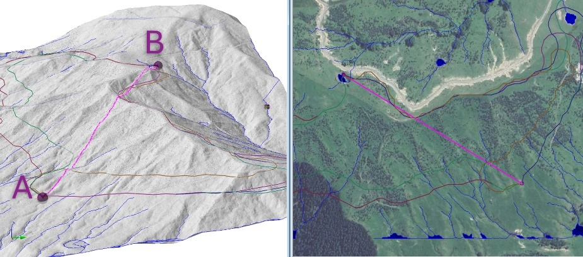

FIGURE 1. The example of variant design of motorways using optimization algorithms in Softree Optimal [14]

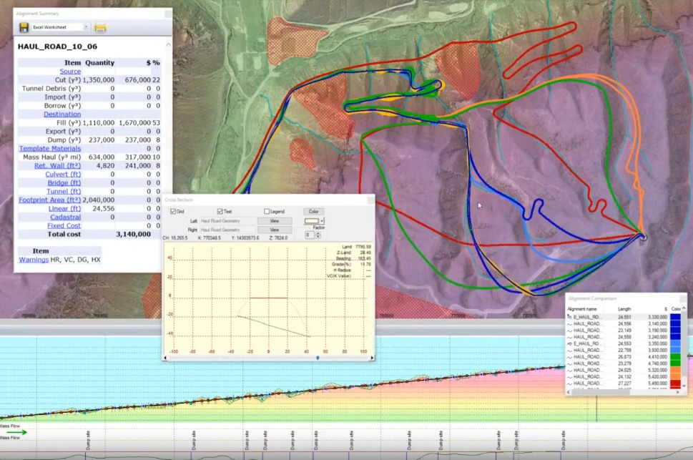

FIGURE 2. The example of variant design of motorways using optimization algorithms in Trimble Quantm [15]

In the field of computer technologies (and especially algorithms), we can observe a dual nature of knowledge:
– open scientific knowledge: generated in academia (universities, research centers); published in scientific articles, available for reproduction and verification; based on the principles of scientific communication and academic integrity;
– closed applied knowledge (corporate, industrial): created within companies for commercial use; protected as trade secrets, know-how, or sometimes patents; may have high scientific value but is inaccessible for academic analysis.
Terminology used to describe this phenomenon:
– tacit knowledge – knowledge that is not codified or published, but exists within organizations;
– proprietary knowledge – knowledge protected by intellectual property rights, patents, or secrecy;
– open science vs. proprietary R&D – the opposition between open academic science and corporate research;
– knowledge divide or knowledge gap – the gap between what is known to academia and what is held by industry;
– industrial secrecy / trade secrets in algorithms – narrower terms applied to hidden algorithms;
– black-box algorithms – a modern expression used when the internal workings of algorithms are hidden from external scrutiny.
The author proposed a computer system approach to highway design [17]. This approach was later named 'computer system highway design'. An alternative name for this design is 'single-variant design'. The idea behind this approach is that there is one and only one road option that best meets the complex combination of initial criteria. Creating complex optimization algorithms is only one part of implementing this approach [18]. In developing this approach, methods for tracing roads with maximum radii [19] and a flexible bracelet method were created [20]. Implementing the flexible bracelet method is a pressing issue.

ACHIEVEMENTS IN THE IMPLEMENTATION OF THE FLEXIBLE BRACELET METHOD
The practical implementation of the flexible bracelet method should solve two problems in road design.
1) moving away from the principle of tangential routing towards implementing the flexible ruler principle;
2) solving routing optimization problems.
Although the second issue has already been discussed, the implementation of the flexible line principle requires further consideration.
Currently, two key principles underpin highway routing: the polygonal routing principle (Fig. 3, a) and the flexible ruler principle (Fig. 3, b).

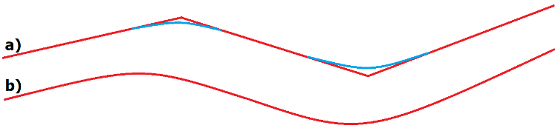

FIGURE 3. The two key principles underpin highway routing: (a) the polygonal routing principle; (b) the flexible ruler principle

From a mathematical point of view, the first principle is widespread and easy to implement, but long straight sections and circular curves with minimum radii, combined with transition curves and bends, negatively impact traffic safety (Fig. 4, b). In practice, the second principle is implemented, particularly on higher-category roads
(Fig. 4, a; Fig. 5). However, implementing the second principle using traditional approaches involving straight lines and circular curves is difficult.

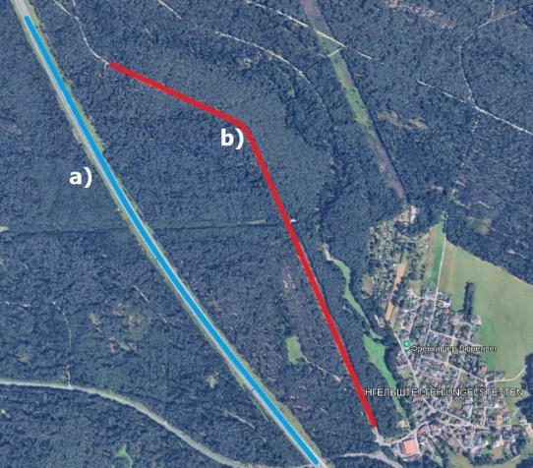

FIGURE 4. The example of the two principles underpins highway routing in Germany: (a) the flexible ruler principle; (b) the polygonal routing principle

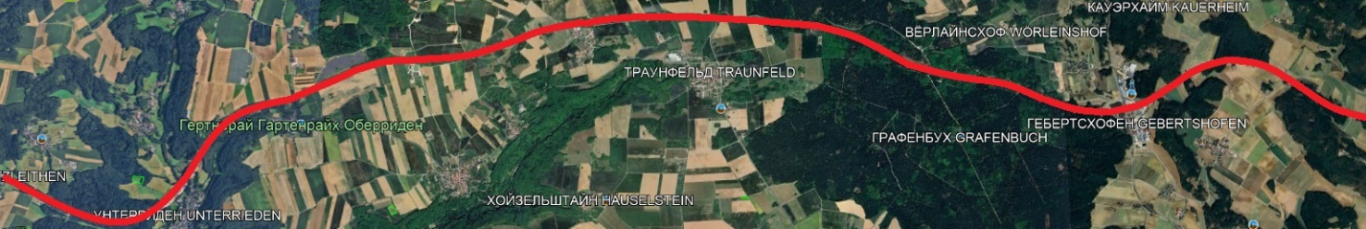

FIGURE 5. The example of the flexible ruler principle highway routing in Germany

The flexible bracelet method was designed based on the principle of a flexible ruler. Here, it is organic.
By the time the research described in this article had begun, the following tasks had already been accomplished:
1) the concept of road alignment design using the flexible bracelet method was developed;
2) the computer program was created, which implements a set of functions:
– the ability to create a flexible bracelet of any size within the graphical field;
– each element of the chain represents a rectangle, and the user can create any number of segments of arbitrary size;
– hinge connections between the segments ensure the flexibility of the structure;
– the function for constructing a curve with the flexible bracelet is provided: by simultaneously pressing a segment with the left mouse button and the Ctrl key, the segment is highlighted in yellow and rotates until it touches the next one; all subsequent segments rotate accordingly;
– the possibility of forming a curve with admissible curvature;
– the ability to upload a background for performing road alignment;
– the function for obtaining the coordinates of the segment midpoint in the internal coordinate system (which differs from both geodetic and rectangular zone systems) (Fig. 6).

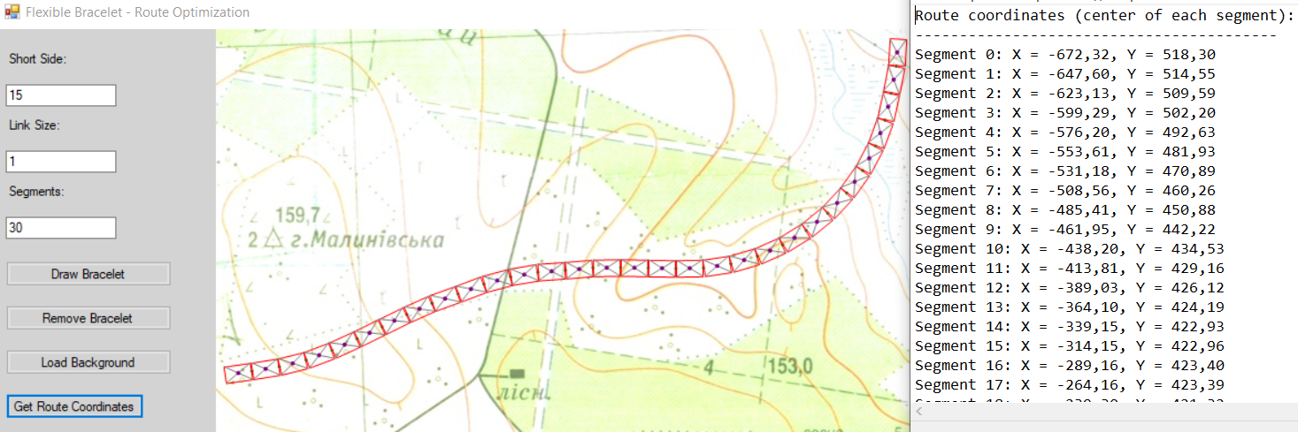

FIGURE 6. An example of highway alignment tracing using the flexible bracelet method with the input of segment midpoint coordinates

PROBLEM STATEMENT
At the next stage, it is necessary to develop the following functionality:
– formation of boundaries within which the road alignment must be located;
– implementation of a mode in which the flexible bracelet structure can stretch sideways while preserving the initial and final directional angles;
– prevention of the structure from extending beyond the defined boundaries;
– when the bracelet touches the boundaries, a sliding effect should occur, but without intersection;
– as a result, the function should generate a road alignment that is the shortest possible, while still meeting the geometric constraints in plan.
Compliance with these constraints is ensured by the segment dimensions of the flexible bracelet and the hinge connections between them. The implementation of this function represents the beginning of the optimization process. Thus, a main alignment is formed, which can serve as a basis for subsequent optimization steps.

THE SCIENTIFIC NOVELTY OF THE RESEARCH
Implementing the above idea is the scientific novelty of this study. It was implemented in C# in the WinForms environment. Two buttons were added to create the first and second boundaries of the restrictive corridor using polylines, as well as a 'Route Optimization' button. A physical model of a flexible bracelet being 'stretched' to the sides was created. This was achieved by uniformly reducing the angle of deviation of the flexible bracelet segments from the initial and final direction angles. At each step, the absence of intersection with the corridor boundaries was verified. The flowchart for this process is shown below (Fig. 7).
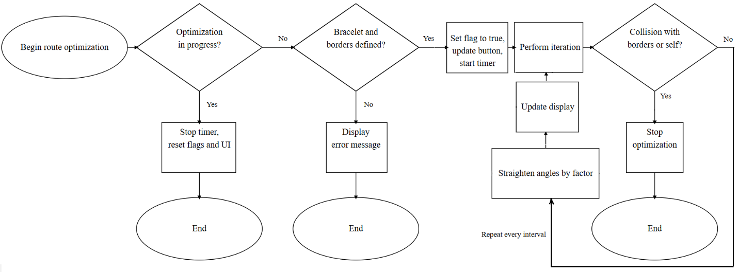

FIGURE 7. Flowchart of route optimization process

Figure 8 shows the example of the implementation of this algorithm. The flexible bracelet consists of 50 segments, the geometry of which determines the required radius of the circular curve in the plan. The terrain and situation have formed the required corridor along which the motorway can be planned. The user creates the initial version of the motorway route (Fig. 8a) and clicks the 'Route Optimization' button. Optimization takes time; pressing the 'Route Optimization' button again stops the process. Figures 8b and 8c show intermediate route options, and Figure 8d shows the final result. This is the shortest route that complies with all the geometric constraints in the plan.

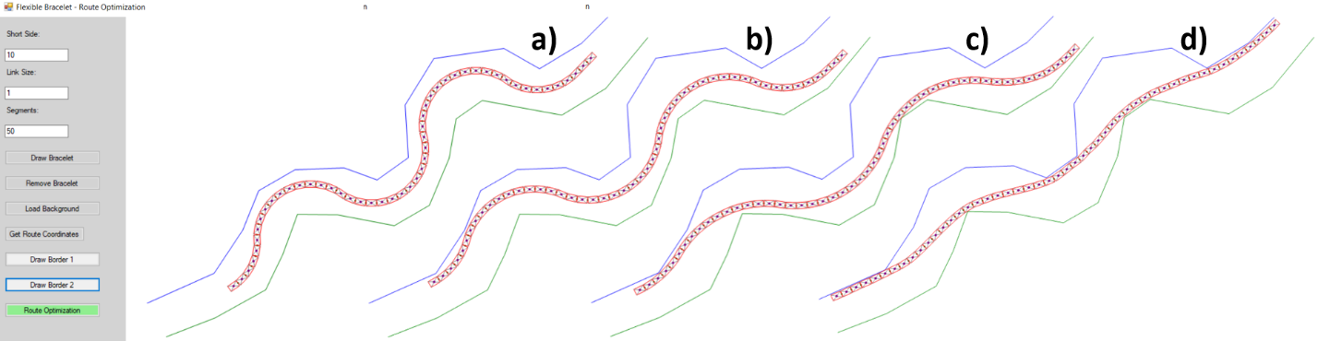
FIGURE 8. Stages of route optimization process

With the coordinates of the segment centers (intersection points), we can inscribe circular curves using the maximum radius method (Fig. 9) [19].
The next stage of optimization involves the use of the longitudinal profile with the calculation of:
– earthwork volumes,
– maximum longitudinal slope,
– and other engineering constraints.

CONCLUSION
Research on road alignment using the "flexible bracelet" method, initiated in 2012, is still ongoing. This article focuses on the problem of optimizing the design line of a highway.
This problem is highly complex, as it combines the necessity of satisfying mutually conflicting criteria. For instance, the criterion of minimizing capital costs conflicts with the criterion of minimizing operating costs. Likewise, road safety criteria may contradict the criterion of minimizing capital expenditures.
There is, however, one criterion that integrates the others most effectively – the criterion of minimizing route length.
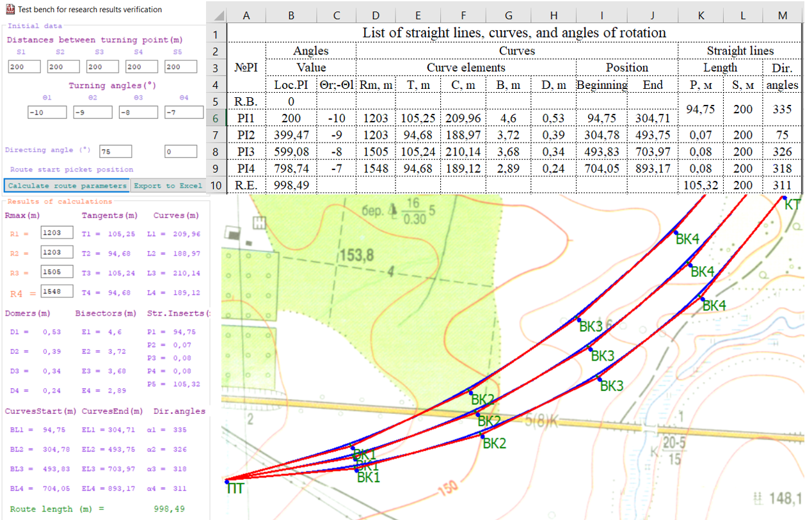

FIGURE 9. Stages of route optimization process

Its fulfillment ensures compliance with the criterion of minimizing operating costs, reducing emissions of harmful substances, and, to some extent, improving road safety. The only criterion that is not satisfied under this condition is the minimization of capital costs.
When designing high-category roads, the criterion of minimizing route length can be considered universal. In the present work, the idea of simulating a physical model of stretching a flexible bracelet under constraints defined by polyline boundaries forming corridors on both sides of the alignment was partially implemented.
These constraint corridors are represented by broken lines. To construct them, the developed program provides three control buttons. The first button allows the user to draw a blue polyline – corridor № 1. The second button sets a green broken line – corridor № 2. These two lines serve as boundaries for the flexible bracelet. When the third button, “Route Optimization,” is pressed, the program simulates the physical phenomenon of stretching the bracelet. The deformation is limited by the geometry of the bracelet segments and by the boundaries of corridors № 1 and № 2.
As a result, a unique and unambiguous road alignment is obtained, implementing the principle of computer-aided system design of highways. This principle states that there exists only one solution that meets the specified criteria, with route length minimization taken as the primary criterion.
At the same time, an important challenge remains unresolved – the transition from the horizontal plan to the longitudinal profile in the alignment process. At this stage, additional geometric constraints appear, including radii of convex and concave curves, maximum longitudinal gradients, as well as criteria of earthwork balance and earthwork volumes. It should also be emphasized that the proposed approach can be applied to optimizing the design line of the longitudinal profile.

Acknowledgments
The authors would like to express their gratitude to Kharkiv National Automobile and Highway University and the organizing committee of the Modern Automotive Industry, Transport and Road Infrastructure (MAITRI) conference.

Conflict of interests
The authors declare that there is no conflict of interests regarding the publication of this paper.

References
[1] E. Lopes, R. Menezes, T. Silva, H. Pitanga, A. Santos, and A. Ferraz, “Comparative study of software for road geometric design,” in Acta Scientiarum. Technology, 41, 2019, 36959.
[2] A. Rifai, E. Purviyanto, and J. Prasetijo, “The implementation of AutoCAD® Civil 3D for highway geometric redesign: a case of Indonesian toll road,” in IOP Conference Series: Earth and Environmental Science, 1347, 012060, 2024.
[3] Anadelta Software. Official Website. URL: https://www.anadelta.com/en/ (Last accessed: 28.08.2025).
[4] Bentley Systems. Official Website. URL: https://www.bentley.com/software/road-and-site-design/ (Last accessed: 28.02.2025).
[5] V. Stadnikov, N. Likhva, N. Miroshnichenko, V. Kostiuk, and Y. Dorozhko, “Exploring geoinformation technology potential for automating the development and maintenance of digital topographic maps,” in African Journal of Applied Research, 11(1), 2025, 146–156.
[6] Y. Dorozhko, N. Arsenieva, H. Sarkisian, and O. Synovets, “Determining the most dangerous loading application point for asphalt-concrete layers on a rigid base,” in Eastern-European Journal of Enterprise Technologies, 3(7), 99, 2019, 36–43.
[7] I. Musiienko and L. Kazachenko, “Creation and filling of the database of asphaltic concrete layers for the pavement design programme UKRRDO 24,” in AIP Conference Proceedings, 3428(1), 020030, 2025.
[8] S. Hossein and K. Rahimov, “Optimization of horizontal road alignment based on parameters affecting its cost and lifespan using genetic algorithm,” in International Journal of Transportation Engineering (IJTE), 11(3), 2024, 1547–1570.
[9] M.B. Sushma and A. Maji, “Optimization of horizontal highway alignment using a path planner method,” in Urban Transport XXIII, WIT Transactions on The Built Environment, 176, 2017, 81–92.
[10] C. Han, T. Han, T. Ma, Z. Tong, S. Wang, and T. Hei, “End-to-end BIM-based optimization for dual-objective road alignment design with driving safety and construction cost efficiency,” in Automation in Construction, 151, 2023, 104884.
[11] B. Yu, Z. Zhu, Y. Chen, J. Wang, K. Gao, and X. Qian, “A diffusion model-based intelligent optimization method of rural road environments,” in International Journal of Transportation Science and Technology, 2025.
[12] K. You, Q. Yu, W. Huang, and Y. Hu, “Safety-based optimization model for highway horizontal alignment design,” in Mathematical Problems in Engineering, 2022, Article ID 6214910, 15 p.
[13] X. Wu, S. Fu, and L. Guo, “Study on highway alignment optimization considering rollover stability based on two-dimensional point collision dynamics,” in Applied Sciences, 13, 509, 2023.
[14] Softree. Official Website. URL: https://www.softree.com/products/optimization (Last accessed: 04.09.2025).
[15] Petroglyph Projects. Official Website. URL: https://www.petroglyphprojects.com/software-solutions/quantm/ (Last accessed: 04.09.2025).
[16] Softree Support. Official Website. URL: https://support.softree.com/knowledge-base/videos/previous-webinars/video-horizontal-optimization-using-lidar-earthwork-optimization-software-better-locate-roads (Last accessed: 04.09.2025).
[17] I. Musiienko, “The computer systems approach in highways designing as a part of computer aided designing,” in Transbaltica 2013. Proceedings of the 8th International Scientific Conference, Vilnius: Vilnius Gediminas Technical University, 2013, 140–142.
[18] K. Makanae, “Optimization of Highway Geometric Design Process for Computer-based Design,” in Computing in civil and building engineering ©ASCE, 2014, 1376–1383.
[19] I. Musiienko, “Tracing of Highways Using the Maximum Radius Method,” in Transport Means 2024. Proceedings of 28th International Scientific Conference, (Kaunas, Lithuania, 02-04 October 2024), 2024, 641-646.
[20] I.V. Musiienko, “The Implementation of Highways Tracing Physical Model – “flexible Bracelet,” in Transbaltica 2015, Procedia Engineering, 9th International Scientific Conference, Vilnius, 2016, edited by Vilius Bartulis, Irina Yatskiv (Jackiva), Nijolė Batarlienė (Vilnius Gediminas Technical University, Vilnius, 2016), 2016, 134, 366-371.

