Modeling of Bridge Foundations in PLAXIS 3D Software
Vladyslav Fitarov^{1, a)}, Oleksii Ovcharenko^{1, b)}
¹Kharkiv National Automobile and Highway University,
Department of bridges, structures and construction mechanics named after V.O. Rosiiskyi, 61002 Kharkiv, Ukraine
^{a)} Corresponding author: fitarov24@gmail.com
^{b)} ol.ovcharenko1@gmail.com
Abstract. This paper examines the application of PLAXIS 3D software for the analysis and modeling of bridge foundations, motivated by the need to restore transport infrastructure in Ukraine, where hundreds of bridges have been damaged or destroyed by war. Bridge design and foundation selection constitute a complex, multi-criteria process that must reconcile structural demands with geotechnical uncertainty, serviceability limits, and construction constraints. Within this context, PLAXIS 3D provides a comprehensive environment for geotechnical simulation – including staged construction, groundwater flow, interface elements, dynamic loading, etc. – together with a rich library of constitutive models suitable for both preliminary assessment and serviceability-level prediction. Particular attention is paid to combined piled-raft foundations, which leverage interaction between raft and piles to control settlements, redistribute stresses, and achieve cost-effective performance in complex and variable ground conditions. A representative bridge case on the A45 motorway (Gießen-Aschaffenburg, Germany) illustrates a design-oriented workflow that proceeds from preliminary sizing through calibration against expected load-deformation response to verification. The numerical model employs a hybrid discretization in which piles are represented as three-dimensional solids and the raft as a plate element with soil interfaces, enabling detailed resolution of pile-soil-raft contact behavior, load transfer, and raft bending actions. Computed responses indicate service-level settlements on the order of one centimeter and a balanced distribution of vertical load between raft and piles, consistent with the intended combined piled-raft mechanism. The findings demonstrate that PLAXIS 3D can deliver reliable predictions of settlements, stress redistribution, and structural actions in bridge foundations, thereby supporting selection and optimization of combined piled-raft solutions for cost-effective, serviceability-controlled bridge design in large-scale reconstruction contexts.
Keywords: piled-raft foundation; settlement; raft; pile; bridge; finite element method; PLAXIS 3D.

INTRODUCTION
According to the State Agency for Infrastructure Restoration and Development, since the beginning of the full-scale war in Ukraine in 2022, 346 bridges have been destroyed, nearly half of them on roads of national importance [1]. Moreover, inspections carried out by a commission evaluating the condition of bridge structures revealed that every fourth bridge out of the majority of those surveyed across the country was in critical condition [2]. Consequently, there is an urgent necessity to restore old bridges and construct new ones.
In new bridge projects, foundations are among the most important and costly elements. When designing foundations, geotechnical engineers widely use finite element software due to its ability to model complex soil-structure interaction and to provide a detailed understanding of foundation behavior under various loading conditions [3]. One such software package is PLAXIS 3D, which offers advanced capabilities for modeling soil-structure interaction, enabling engineers to analyze and simulate foundations, slopes, tunnels, and other geotechnical structures.

Literature Review and Problem Statement
Bridge foundations govern overall stability and the transfer of loads into the ground. Its solutions encompass a broad spectrum; typical choices range from spread footings and rafts (with or without soil improvement) to pile groups and other deep systems, with combined piled-raft foundations considered when project-specific serviceability and subsurface conditions indicate potential advantages [4, 5, 6]. In a design-oriented perspective, Poulos and Ameratunga [4] outline practical selection pathways for bridge foundations, emphasizing stiffness compatibility and settlement control. Recent experimental-numerical studies quantify how raft rigidity and pile layout govern participation and settlements [4, 5]. Consistent with this, laboratory and finite element analysis work on soft and intermediate soils demonstrates that rational modification of pile number/length and raft thickness can reduce settlements [6, 7].
Finite element analysis has become the standard for evaluating soil-structure interaction in bridge foundations, supporting comparative assessment of foundation schemes, calibration against physical modeling, and development of parametric envelopes [3, 4]. In this context, PLAXIS 3D is widely adopted software because it enables staged construction, hydraulic coupling (pore-water pressures, seepage, consolidation), dynamic loading etc. within a single framework, which is essential for consistent treatment of service and extreme actions [8]. Applications range from numerical comparisons of piled-raft versus alternative systems to reviews of static and dynamic response characteristics relevant to bridge foundations [3, 9].
State-of-practice modeling in PLAXIS 3D typically represents piles as three-dimensional solids (or embedded line elements where appropriate) and the raft as a plate/shell; interface elements capture contact and potential slip, and layered stratigraphy is assembled from site investigations. These choices are reflected in recent parametric and project-scale applications that resolve settlement profiles and raft actions under service loads [7, 10]. For constitutive behavior, Mohr-Coulomb remains suitable for preliminary screening, whereas Hardening Soil (HS/HSsmall) is preferred for serviceability predictions because it reproduces stress-dependent stiffness and small-strain effects; comparative studies motivate this progression from Mohr-Coulomb to HS/HSsmall in practice [11]. Experimental-numerical investigations in soft soils report good agreement between measured and computed settlements and bending actions when HS/HSsmall is used with calibrated stiffness ranges, while configurations and connection details (e.g., connected versus disconnected piled-rafts) are shown to influence stress redistribution and settlement patterns [6, 10]. Complementary works extend the modeling toolkit with approximate formulations for raft/piled-raft screening and with response envelopes under combined vertical-moment-horizontal actions and under dynamic loading, which are pertinent to bridge design checks [12, 13, 14].
Against this backdrop, the present work concentrates on how PLAXIS 3D can be deployed on a representative bridge project to deliver stable and defensible predictions of settlements and stress resultants, and to quantify piled-raft load sharing, within a verification-aware workflow consistent with contemporary practice [4, 6].

Aim and Research Tasks
The aim of the work is to assess the capabilities and effectiveness of PLAXIS 3D for modeling foundations of bridge structures, with emphasis on combined piled-raft foundations.
The tasks of the study include (i) review the literature on the capabilities and experience of foundation modeling in PLAXIS 3D; (ii) build a calibrated 3D finite element model of foundation and site stratigraphy; (iii) compute settlements and internal actions under service loading; (iv) quantify load sharing between raft and piles via a pile-raft coefficient; (v) draw conclusions regarding the effectiveness of applying PLAXIS 3D software package in modeling foundations of bridge structures.

RESEARCH MATERIALS AND METHODS
Bridge foundations play a crucial role in structural stability and in distributing loads from the superstructure into the soil. The choice of foundation type depends on load characteristics, subsurface conditions, construction constraints, and budget. Commonly adopted bridge foundation types are raft, pile, piled-raft and others [4].
The analysis of a bridge foundation structure typically involves the following stages: creation of a finite element model of the foundation and preliminary assessment of its type and geometry; model calibration – an iterative reconciliation of loads and ground-foundation parameters with potential refinement of foundation type and geometry – followed by verification; final analysis of the modeled foundation and a report on the analysis results [4].
PLAXIS 3D is a software package that utilizes the finite element method to simulate geotechnical problems such as soil and rock deformation, load and stress distribution, pore-water pressure, seepage, consolidation, and more. This software also supports various types of loads and boundary conditions, such as gravity, applied forces, displacements, temperature effects, and seismic waves. PLAXIS offers a wide range of soil and structural models, enabling the simulation of various geotechnical tasks, including foundations, excavations, retaining walls, soil improvement, tunnels, embankments, slopes, seismic analysis, and others [9].
PLAXIS 3D includes more than 10 soil models [9], among which the most commonly used are the Mohr-Coulomb and Hardening Soil models [11]:
- Mohr-Coulomb Model – a linear elastic perfectly plastic model that includes five basic input parameters: E and ν for soil elasticity, φ and c for soil plasticity, and ψ as the dilatancy angle. The Mohr-Coulomb model is considered as “first-order” approximation of soil or rock behavior. It is recommended for preliminary analysis. For each layer, either a constant average stiffness or a stiffness increasing linearly with depth is estimated. Thanks to the constant stiffness assumption, computations are generally fast and provide an initial estimate of deformations;
- Hardening Soil (HS) Model – an advanced model for simulating soil behavior. As with the Mohr-Coulomb model, stress states are defined by the friction angle φ, cohesion c, and dilatancy angle ψ. However, soil stiffness is described much more accurately using three different stiffness parameters: E₅₀ (stiffness in triaxial loading), E_{ur} (stiffness in triaxial unloading), and E_{oed} (stiffness in oedometer loading). Unlike the Mohr-Coulomb model, the Hardening Soil model also accounts for stiffness dependency on stress levels, meaning all stiffnesses increase with confining pressure. In addition to the parameters mentioned above, initial soil conditions such as preconsolidation play a significant role in many deformation problems;
- Hardening Soil model with small-strain stiffness (HSsmall);
- Jointed Rock model (for fractured rock formations);
- Soft Soil model (for weak soils);
- Sekiguchi-Ohta model (for viscous soils);
and others.
As part of this study on the effectiveness of modeling bridge foundations in PLAXIS 3D, a bridge project on the A45 motorway between Gießen and Aschaffenburg, Germany (Fig. 1) – designed by Ingenieursozietät Professor Dr.-Ing. Katzenbach GmbH in 2022 – was examined. In this project, a piled-raft foundation was designed to support the bridge piers. A piled-raft foundation is a system in which the loads from the structure are distributed between the piles and the raft. This type of foundation has proven to be a cost-effective alternative to traditional pile foundations, offering significant construction budget savings.

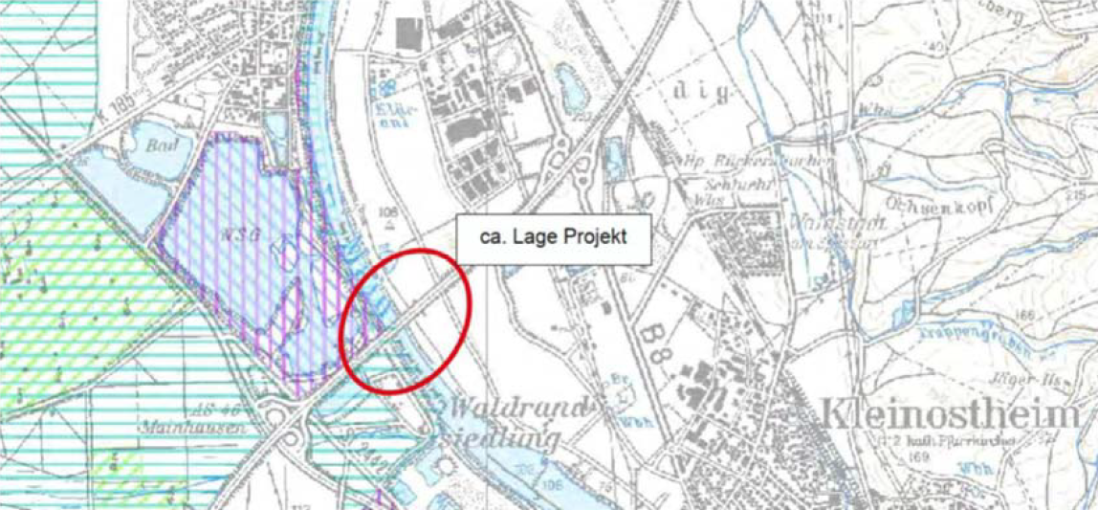
FIGURE 1. Project location.

During the simulation of the geotechnical problem, the geotechnical conditions of the construction area were defined. These conditions are characterized by the following soil types (Fig. 2):
- B2 – Silt/clay (Quaternary floodplain loams);
- B3 – Gravel and sands (Quaternary deposits);
- B4 – Clays and sands (Tertiary deposits);
- B5 – Clays with wood and coal fragments (Tertiary deposits).
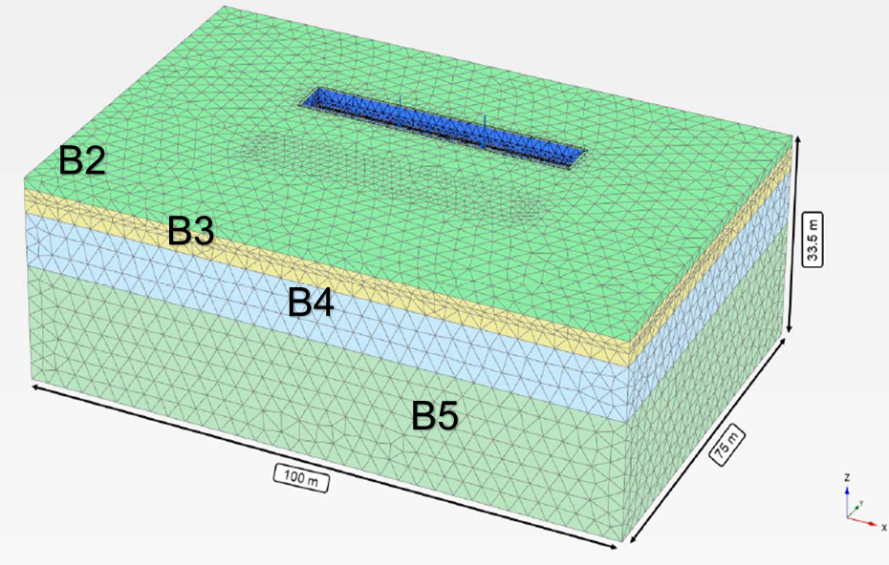
FIGURE 2. Soil layer model of the project site in PLAXIS 3D (Hardening Soil).

According to the design input data, the groundwater level was assumed to be directly beneath the raft.
The modeled piled-raft foundation (Fig. 3) has the following parameters:
- Raft: length – 46 m, width – 6.25 m, thickness – 1.30 m;
- Piles: diameter – 1.20 m, length – 9.90 m, spacing – 5.20-7.40 m (two rows);
- Load supported by the foundation: 59.9 MN.

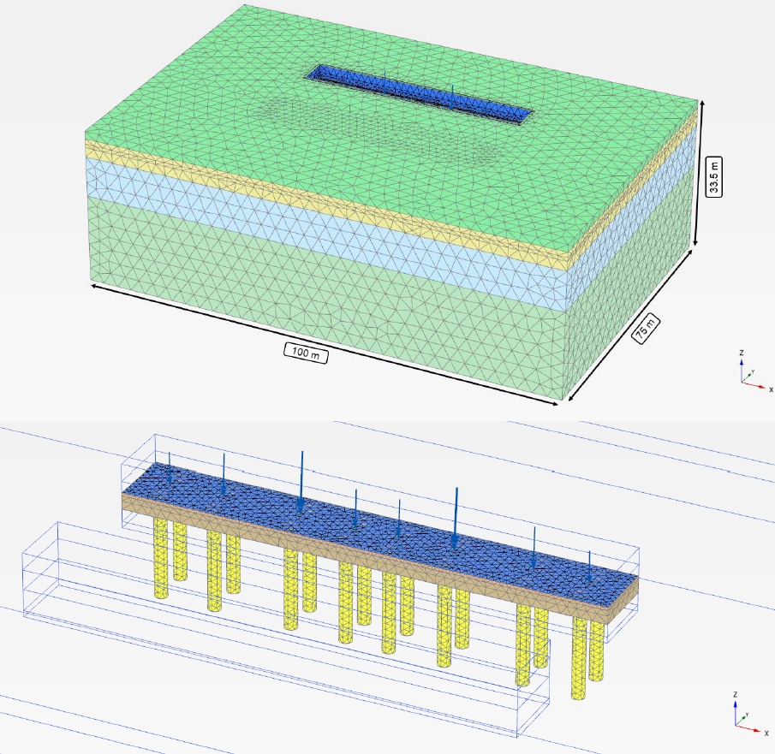
FIGURE 3. Piled-raft foundation model in PLAXIS 3D.
In this model, the piles were defined as a solid body, while the raft was modeled as a plate, separated from the soil by retaining walls along the entire perimeter.
The main criterion for evaluating the interaction of piled-raft foundation elements is the pile-raft coefficient ${\text{α}}_{\text{pr}}$, which is defined as the ratio of the load carried by the pile component $\sum{{\text{P}}_{\text{p}}}$to the total load from the structure ${\text{P}}_{\text{tot}}$:

${\text{P}}_{\text{tot}}\text{ = }{\text{P}}_{\text{r}}\text{ + }\sum{{\text{P}}_{\text{p}}}$ (

where ${\text{P}}_{\text{tot}}$ – total load from the structure; ${\text{P}}_{\text{r}}$ – load carried by the raft; $\sum{{\text{P}}_{\text{p}}}$ – total load carried by the pile component.

The coefficient ${\text{α}}_{\text{pr}}$ is calculated using the formula:

$${\text{α}}_{\text{pr}}\text{ = }\frac{\sum{{\text{P}}_{\text{p}}}}{{\text{P}}_{\text{tot}}} \text{ (2)}$$

where ${\text{α}}_{\text{pr}}$ – pile-raft coefficient.

If this coefficient is 0, the piled-raft system functions as a raft foundation; if it is 1, it functions as a pile foundation. For the piled-raft system to operate as a combined pile-raft foundation, the following identity must be satisfied [15]:

$\text{0 < }{\text{α}}_{\text{pr}}\text{ < 1}$ (3)

RESEARCH results
Computed settlements of the piled-raft range from approximately 0.9 to 1.3 cm, satisfying the performance requirements specified in the design brief (Fig. 4 and Fig. 5).

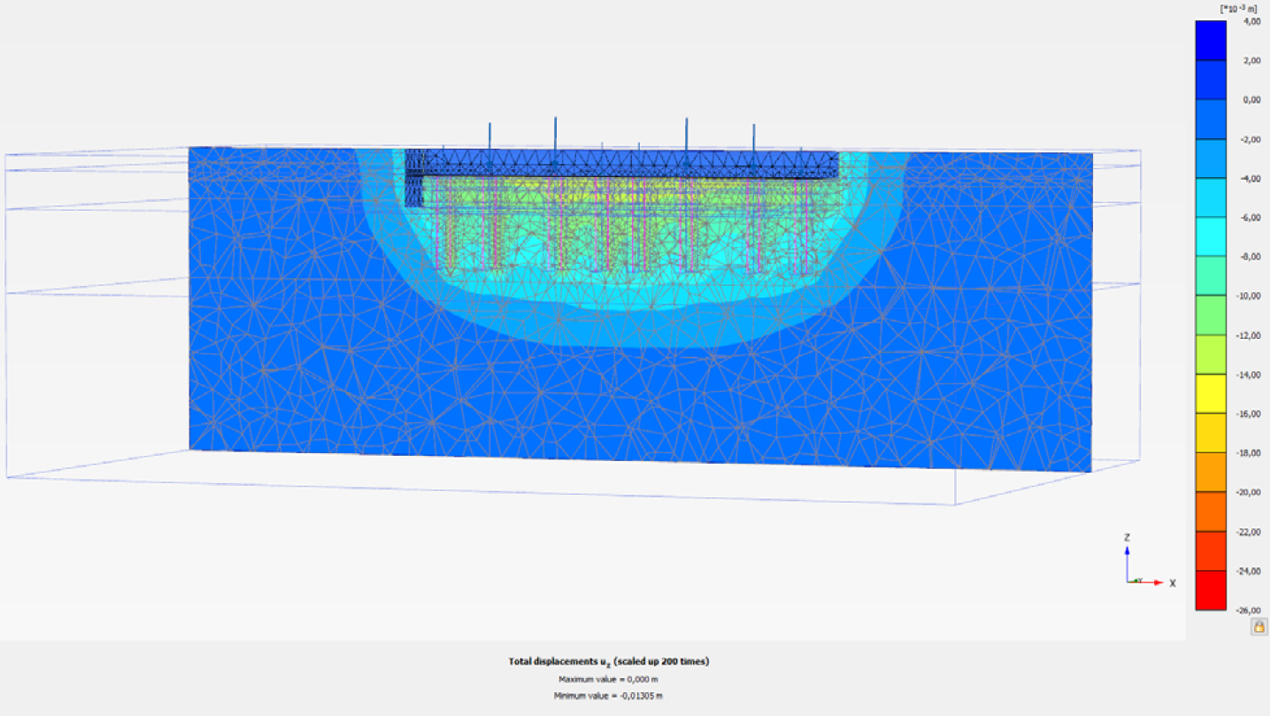
FIGURE 4. Settlement isosurfaces of the piled-raft foundation in cross-section.

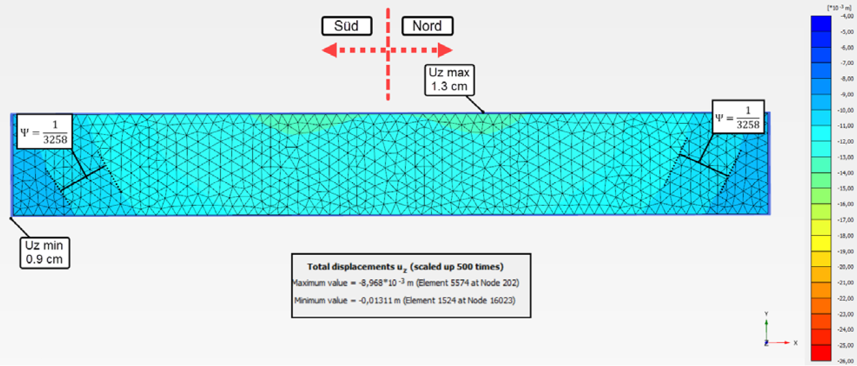
FIGURE 5. Isosurfaces of soil stresses along the Z-axis in cross-section.

Isosurfaces of normal stresses in the raft indicate compatible stress redistribution and moderate raft bending actions (Fig. 6).

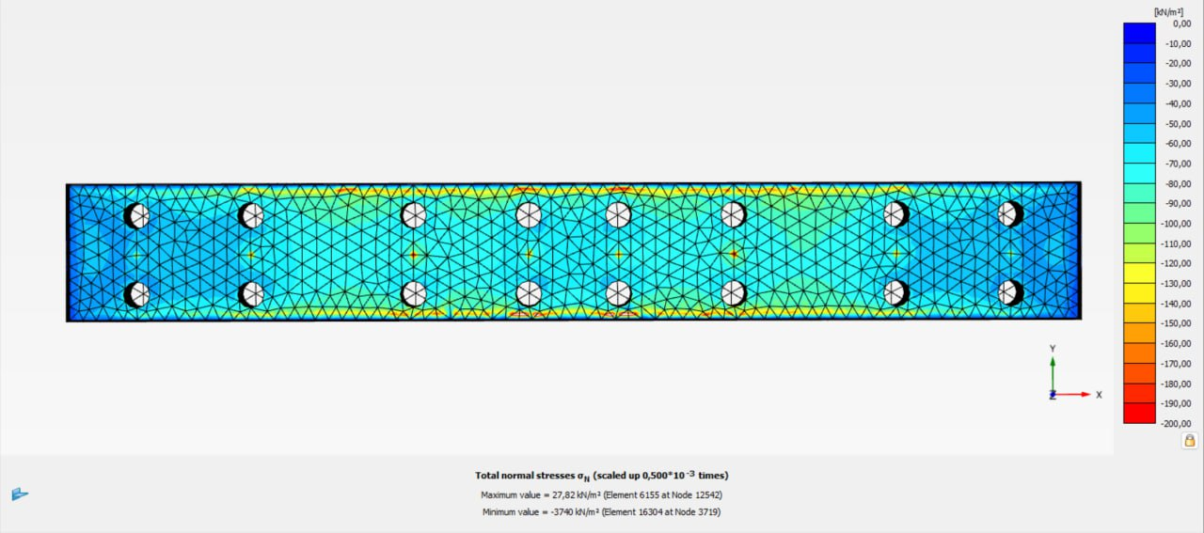
FIGURE 6. Isosurfaces of normal stresses in the raft in plan view.

To verify the plausibility of the computed settlements and stress resultants, the PLAXIS 3D outputs were benchmarked against well-instrumented case studies in which PLAXIS 3D reproduced monitored settlements with small variance [16], and peer-reviewed experimental-numerical validations for piled-raft and related systems [6, 10, 17]. Published comparisons generally report close agreement and, under cautious modeling choices – for example, reducing interface stiffness – a slight safety-side bias with numerically predicted settlements marginally exceeding field values [16, 17].
The total load ${\text{P}}_{\text{tot}}$ on the foundation modeled in PLAXIS 3D is 59.9 MN, of which 40.6 MN is carried by the pile component $\sum{{\text{P}}_{\text{p}}}$ and 19.3 MN by the raft ${\text{P}}_{\text{r}}$. According to (2), the piled-raft coefficient is obtained:

$${\text{α}}_{\text{pr}}\text{ = }\frac{\text{40.6 МN}}{\text{59.9 МN}}\text{ = 0.68} \text{ (4)}$$

Considering that the piles carry 68% of the total load, the modeled foundation is classified as a piled-raft foundation.

RESULTS DISCUSSION
The settlement magnitudes and load-sharing ratio are consistent with recent 3D finite element analysis and experimental findings on piled-raft systems in both stiff and soft soils [6, 7, 10, 18]. Literature highlights the decisive influence of raft stiffness, pile spacing/length, and layered stratigraphy on settlements and on the raft/pile participation ratio [5, 12, 13, 19]. PLAXIS 3D’s staged construction, groundwater coupling, interface elements, and HS/HSsmall models enable design-oriented calibration aligned with these trends [9]. In reconstruction programs – such as those in Ukraine – piled-raft foundations offer a cost-effective pathway to satisfy serviceability limits while optimizing the number and size of piles [7]. Dynamic and seismic scenarios warrant continued attention, as frequency content and cyclic degradation can modify load sharing and stiffness demands [14, 19]. Future work should expand parametric envelopes (pile number/spacing/length, raft thickness and stiffness; groundwater variations) and include validation against field monitoring on regional soils.

CONCLUSION
The conducted study has shown that PLAXIS 3D is a powerful and effective software package for modeling foundations of structures that require special attention, such as bridges. PLAXIS 3D offers a comprehensive library of soil models, structural elements, and load types, enabling the simulation of three-dimensional geotechnical problems of any complexity. The software also provides a wide range of tools for convenient and informative analysis of displacements, stresses, and other modeling results, such as isosurfaces, tables, diagrams, etc.
It is also worth noting that, given the economic advantages of the modeled piled-raft foundation and the importance of post-war reconstruction of Ukraine’s civil infrastructure, research into this geotechnical system in bridge structures and the development of scientific foundations for its modeling is a highly relevant and promising direction in soil mechanics and foundation engineering within Ukrainian practice.
The goal of future studies is to substantiate rational parameters for piled-raft foundations in bridge structures using PLAXIS 3D software package.

Acknowledgments
The authors would like to express their gratitude to Kharkiv National Automobile and Highway University and the organizing committee of the Modern Automotive Industry, Transport and Road Infrastructure (MAITRI) conference for the opportunity to participate.

Conflict of interests
The authors declare that there is no conflict of interests regarding the publication of this paper.

References
[1] State Agency for Infrastructure Restoration and Development of Ukraine, “Experts of the Restoration Agency will join the Commission for inspection of the technical condition of bridges in Ukraine,” Agency for Restoration – Blog, 29 Jun. 2023. [Online]. Available: https://restoration.gov.ua/blog/fahivczi-agentstva-vidnovlennya-uvijdut-do-skladu-komisiyi-z-perevirky-tehnichnogo-stanu-mostiv-v-ukrayini/ (accessed Aug. 27, 2025).
[2] Ministry for Development of Communities and Territories of Ukraine, “The commission for bridge inspection has completed its work and presented the final findings on the condition of engineering structures in Ukraine,” News, Aug. 21, 2023. [Online]. Available: https://mtu.gov.ua/news/34627.html (accessed Aug. 27, 2025).
[3] F. F. Chimdesa, F. F. Chimdesa, N. Z. Jilo, A. Hulagabali, O. E. Babalola, T. Tiyasha, K. Ramaswamy, A. Kumar, and S. K. Bhagat, “Numerical analysis of pile group, piled raft, and footing using finite element software PLAXIS 2D and GEO5,” Scientific Reports 13, 15875 (2023), https://doi.org/10.1038/s41598-023-42783-x.
[4] H. G. Poulos and J. Ameratunga, “A practical approach to bridge foundation design,” Australian Geomechanics 57(2), 73–86 (2022), https://doi.org/10.56295/agj5723.
[5] B. Ateş and E. Şadoğlu, “Experimental and numerical investigation of load sharing ratio for piled raft foundation in granular soils,” KSCE Journal of Civil Engineering 26, 1662–1673 (2022), https://doi.org/10.1007/s12205-022-1022-4.
[6] P. Deb, B. Debnath, R. B. Reang, and S. K. Pal, “Structural analysis of piled raft foundation in soft soil: An experimental simulation and parametric study with numerical method,” Ocean Engineering 261, 112139 (2022), https://doi.org/10.1016/j.oceaneng.2022.112139.
[7] R. Modak and B. Singh, “A parametric study of large piled raft foundations on clay soil,” Ocean Engineering 262, 112251 (2022), https://doi.org/10.1016/j.oceaneng.2022.112251.
[8] Hsu, C.-F., C.-H. Huang, Y.-F. Li, S.-L. Chen, and C.-D. Wang, “Three-Dimensional Seismic Analysis of Symmetrical Double-O-Tube Shield Tunnel,” Symmetry 17, 719 (2025), https://doi.org/10.3390/sym17050719.
[9] Bentley Systems, PLAXIS 3D 2024.3: General Information Manual, last updated Apr. 3, 2025. [Online]. Available: https://bentleysystems.service-now.com/sys_attachment.do? sys_id=6c1d3ad79751a61081d373b0f053af88 (accessed Aug. 27, 2025).
[10] A. M. J. Alhassani and A. N. Aljorany, “Experimental and numerical modeling of connected and disconnected piled raft,” KSCE Journal of Civil Engineering 27, 2442–2454 (2023), https://doi.org/10.1007/s12205-023-0437-x.
[11] M. Mohsan, P. J. Vardon, and F. C. Vossepoel, “On the use of different constitutive models in data assimilation for slope stability,” Computers and Geotechnics 138, 104332 (2021), https://doi.org/10.1016/j.compgeo.2021.104332.
[12] S. Jeong, J. Park, and D.-W. Chang, “An approximate numerical analysis of rafts and piled-rafts foundation,” Computers and Geotechnics 168, 106108 (2024), https://doi.org/10.1016/j.compgeo.2024.106108.
[13] D. Chanda, U. Nath, R. Saha, and S. Haldar, “Development of lateral capacity-based envelopes of piled raft under combined V-M-H loading,” International Journal of Geomechanics 21, 04021075 (2021), https://doi.org/10.1061/(ASCE)GM.1943-5622.0002023.
[14] A. Bhaduri and D. Choudhury, “Steady-state response of flexible combined pile-raft foundation under dynamic loading,” Soil Dynamics and Earthquake Engineering 145, 106664 (2021), https://doi.org/10.1016/j.soildyn.2021.106664.
[15] R. Katzenbach and D. Choudhury, ISSMGE Combined Pile-Raft Foundation Guideline (Technische Universität Darmstadt, Darmstadt, 2013). ISBN 978-3-942068-06-2.
[16] O. A. Abdel-Azim, K. Abdel-Rahman, and Y. M. El-Mossallamy, “Numerical investigation of optimized piled raft foundation for high-rise building in Germany,” Innovative Infrastructure Solutions 5, 11 (2020), https://doi.org/10.1007/s41062-019-0258-4.
[17] A. Grizi, W. Al-Ani, and D. Wanatowski, “Numerical analysis of the settlement behavior of soft soil improved with stone columns,” Applied Sciences 12, 5293 (2022), https://doi.org/10.3390/app12115293.
[18] Z. Qu, Z. Han, H. Tang, J. Xu, H. Wang, and Y. Liu, “Study on Numerical Simulation of Arch Mechanism of Bridge Pile Foundation,” Buildings 14, 146 (2024), https://doi.org/10.3390/buildings14010146.
[19] D. Chanda, R. Saha, S. Haldar, and D. Choudhury, “State-of-the-art review on responses of combined piled raft foundation subjected to seismic loads using static and dynamic approaches,” Soil Dynamics and Earthquake Engineering 169, 107869 (2023), https://doi.org/10.1016/j.soildyn.2023.107869.

