Analysis of the Stress-Strain State of Flexural Reinforced Concrete Elements Strengthened with External Composite Reinforcement
Armen Atynian^{1, a)}, Oleksandr Arkhipov², Yevhen Orel³, Maryna Rezunenko⁴, Oleksandr Gvozdiuk⁵, Kirill Baranov⁶
¹O.M. Beketov National University of Urban Economy,
Department of Technology and Organization of Construction Production, 61002 Kharkiv, Ukraine
²Kharkiv National Automobile and Highway University,
Department of Computer Graphics, 61002 Kharkiv, Ukraine
³Ukrainian State University of Railway Transport,
Department of Researches and Design of Means of Communication, Geodesy and Land Management,
61002 Kharkiv, Ukraine
⁴Ukrainian State University of Railway Transport,
Department of Mathematics and Physics, 61002 Kharkiv, Ukraine
⁵O.M. Beketov National University of Urban Economy,
Department of Building Constructions, 61002 Kharkiv, Ukraine
⁶O.M. Beketov National University of Urban Economy,
Department of Technology and Organization of Construction Production. 61002 Kharkiv, Ukraine
^{a)} Corresponding author: Armen.Atynyan@kname.edu
Abstract. A numerical study was conducted to compare the strength and deformation characteristics of reinforced concrete beams with a length of 220 cm and a cross-section of 12.5×25 cm, strengthened with various types of external composite reinforcement based on fiber-reinforced polymers (FRP). The reference model was reinforced with longitudinal steel reinforcement of 2Ø14 A600 and transverse reinforcement in the form of Ø5 B500 stirrups spaced at 100 mm. The load was applied according to a two-point loading scheme at the third points of the span, which ensured the formation of a region of pure bending and allowed for an objective assessment of the strengthening effectiveness. The strengthening variables included the type of composite material and the configuration of the bonded reinforcing strips. An increase in the load-bearing capacity and stiffness of the strengthened specimens was recorded compared to the control specimens. The most significant effect was achieved using carbon-fiber-reinforced polymer (CFRP) strips, which possess a high modulus of elasticity and tensile strength. These materials ensured a more uniform stress distribution in the tension zone and a substantial reduction in deflection under the same load levels. The use of glass-fiber-reinforced polymer (GFRP) strips resulted in a moderate increase in load-bearing capacity; however, their effectiveness was limited by a lower modulus of elasticity. The results confirmed that carbon-fiber composites are the most promising for enhancing the durability and stiffness of flexural reinforced concrete elements.
Keywords: concrete, reinforced concrete, flexural member, composite, glass fiber-reinforced polymer (GFRP), carbon fiber-reinforced polymer (CFRP), strength, deformability.

INTRODUCTION
Current large-scale transformations in production, machinery, and technology are fostering the emergence and testing of innovations in the construction sector. Reconstruction and technological modernization often involve increased loads from equipment and traffic on load-bearing structures, as well as the need for redevelopment. For residential and public buildings, reconstruction frequently takes the form of annexes and additional stories, which necessitates an assessment of the load-bearing capacity and serviceability of structural elements, requiring their restoration or strengthening when necessary.
This research aims to investigate the strength and deformability of reinforced concrete elements strengthened under load, taking into account the history of preliminary loading. It seeks to identify the prerequisites for the composite action between the strengthened member and the strengthening element made of various composite materials. The practical application of this work is focused on restoring or enhancing the load-bearing resistance of reinforced concrete elements.
The use of numerical computer simulation methods ensures a reliable determination of the stress-strain state of structures and allows for the optimization of their design and strengthening processes.
The current development of the construction industry is characterized by the active implementation of innovative technologies for strengthening reinforced concrete elements, particularly using composite materials based on polymeric and inorganic matrices. Large-scale reconstructions and technical upgrades of facilities are often accompanied by increased loads from equipment and transport, as well as the need for redevelopment. This highlights the importance of assessing the load-bearing capacity of existing structures and developing effective methods for their restoration and strengthening.
Over the past five years, European research has focused on improving externally bonded reinforcement (EBR) systems. Significant attention is paid to enhancing the reliability of the concrete-to-composite bond and preventing debonding failures. In particular, the works of Askar et al. (2022) [1] and Jahami et al. (2021) [2] summarize the results of tests and numerical modeling, emphasizing the role of anchorages and combined techniques for ensuring composite action between the strengthened element and the FRP system.
Concurrently, there is active development of alternatives to traditional epoxy matrices, which have limitations under elevated temperatures and in aggressive environments. Zhong et al. (2022) [3] and B. Hu et al. (2019) [4] investigate the use of carbon meshes and combined steel plates in conjunction with prestressed CFRP, which allows not only for an increase in load-bearing capacity but also for better control of deformation characteristics.
Particular attention in both European and Asian publications is given to strengthening elements under load and after preliminary loading. Experiments indicate that the history of preliminary loading significantly impacts the effectiveness of reinforcement, particularly through changes in crack patterns, strain distribution, and adhesive performance. Nguyen et al. (2025) [5] demonstrated that the use of U-shaped anchors in the Near-Surface Mounted (NSM) scheme significantly increases resistance to debonding and ensures more uniform performance of CFRP under load. Research by M. A. Basit et al. [7] (2023) confirms the effectiveness of bidirectional CFRP plates for strengthening beams that sustained damage during prior loading.
A separate body of research is dedicated to the impact of elevated temperatures and fire exposure. Haris et al. [6] (2025) systematized data on the degradation of the FRP-to-concrete bond at high temperatures, highlighting the scarcity of data for shear strengthening and prestressed applications. Research [6] confirms the promise of textile-reinforced and mineral-based matrices (TRM/FRCM), which demonstrate enhanced fire resistance compared to conventional FRP systems.
In the domain of slab and column strengthening, there has been a growing number of studies focused on punching shear and shear capacity. European authors (e.g., Askar et al., 2022) [1] analyze the effectiveness of FRCM systems in preventing shear failures, while Asian research emphasizes the use of Near-Surface Mounted (NSM) bars and combined techniques for slab-column joints, which is particularly relevant for the reconstruction of residential and public buildings.
An essential component of contemporary research is numerical computer modeling. Recent studies demonstrate the application of nonlinear concrete models, detailed contact algorithms, and shear-slip bond models in environments such as ABAQUS, ANSYS, and proprietary software codes. Nguyen et al. [5] (2025) and M. A. Basit et al. [7] (2023) have shown that such models reliably replicate load-deflection diagrams, strain distribution, and debonding mechanisms. However, several authors point out the limitations of existing models in predicting long-term effects—such as creep, adhesive aging, and the impact of repeated load cycles. [5, 7, 8]
A significant development for the European scientific and design community has been the update of its regulatory framework. The second generation of Eurocode 2 (FprEN 1992-1-1:2023) and the fib Model Code 2020 [9] have expanded provisions for the assessment of existing structures and the use of externally bonded composite reinforcement. These new documents permit the use of nonlinear analysis and numerical modeling to verify load-bearing capacity, making the results of modern research directly relevant to engineering practice.
Thus, the literature analysis demonstrates that the following areas remain research priorities:
- refinement of externally bonded composite reinforcement technologies;
- investigation of the effectiveness of strengthening under load and considering the history of prior loading;
- enhancement of the fire resistance and long-term durability of strengthened systems;
- development of numerical modeling to accurately simulate the real-world behavior of structures;
- integration of the obtained results into international design codes and standards.
These trends underscore the relevance of further research in the field of strengthening reinforced concrete elements, particularly concerning deformation characteristics and the composite interaction between the structure and the external reinforcement under service loads.
The deformation-based design model for assessing the capacity of reinforced concrete structures, which enables the determination of their stress-strain state parameters at any loading stage, has found practical application due to the widespread adoption of computer technology. Computers can perform the iterative processes required to solve the system of equations of the deformation method within a short time. Consequently, design methods based on the deformation model, utilizing material stress-strain diagrams, began to be developed for strengthened reinforced concrete structures [10-16].
Current regulatory documents for the design of reinforced concrete structures strengthened with carbon fiber-reinforced polymer (CFRP) composites also recommend the deformation model for verifying the strength of strengthened elements. This model allows for the determination of the stress-strain state parameters in any cross-section along the member's length and for any of its configurations, incorporating nonlinear constitutive laws for concrete and steel reinforcement.
The primary advantage of applying the deformation model to strengthened structures is its ability to account for the stress-strain state existing in the structure prior to strengthening, a capability not offered by other design methods.

Experimental methodology
The objective of this work is to determine the parameters of the stress-strain state of flexural reinforced concrete elements strengthened under load with externally bonded composite reinforcement.
To achieve this objective, the following tasks were defined:
To investigate the mechanical behavior of materials in flexural reinforced concrete elements strengthened with external composite reinforcement both under load and after complete unloading of the element.
To conduct numerical studies on the behavior of reinforced concrete elements strengthened with Glass Fiber-Reinforced Polymer (GFRP).
To conduct numerical studies on the behavior of reinforced concrete elements strengthened with Carbon Fiber-Reinforced Polymer (CFRP).
To compare and analyze the results of the numerical calculations.
The object of the study is flexural reinforced concrete elements strengthened with externally bonded composite reinforcement. The subject of the study is the stress-strain state of flexural reinforced concrete elements strengthened with externally bonded composite reinforcement.
The theoretical principles for determining the stress-strain state of flexural reinforced concrete elements with external reinforcement are considered. Characteristic stages of the element's behavior for different strengthening scenarios throughout its life cycle are identified:
This is feasible when design loads are modified prior to the element entering service.
Practical implementation is possible through organizational and technological measures that allow for the removal of all external loads from the element.
This is the most common scenario for strengthening work in practice and is of paramount interest to researchers, as it most accurately reflects real-world conditions.
For the numerical analysis of the stress-strain state, a concrete beam of class C16/20 with a rectangular cross-section of 250 mm in width, 600 mm in height, and a total length of 6,000 mm was adopted. The internal steel reinforcement (main, distribution, and shear) was identical for all models. The longitudinal reinforcement consisted of 2Ø18 A400c bars (μ_{s}=1.12%), which do not exhibit a distinct yield plateau. The shear reinforcement comprised closed stirrups Ø6A240 spaced at 100 mm in the support zones and 150 mm in the pure bending zone.
The specimen was strengthened in the tensile zone with a single composite layer (fiberglass and carbon fabric). The strengthening was applied using fabrics consisting of three plies of EWR400 fiberglass and MBrace Fib CF 230/4900.150g. carbon fabric, respectively (Fig. 1).

Main material and results
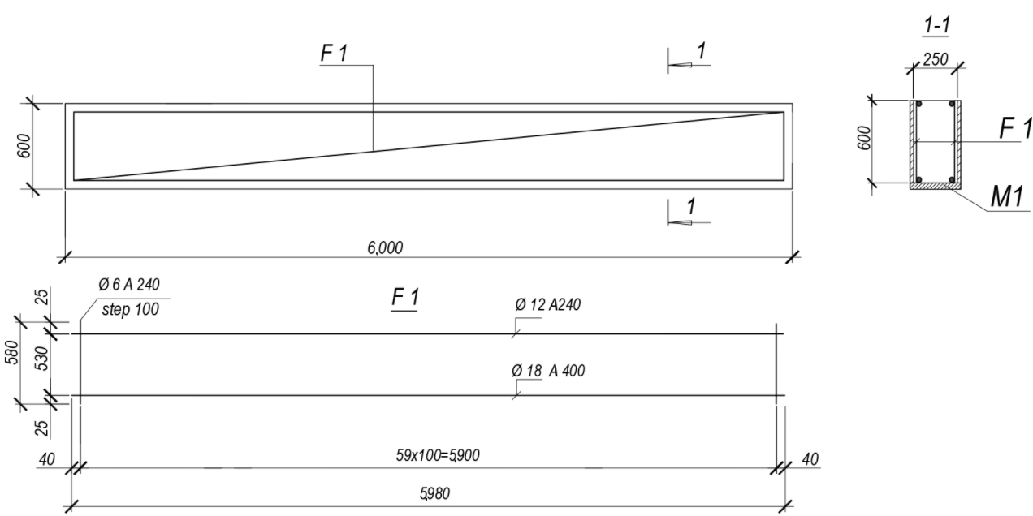
(a)
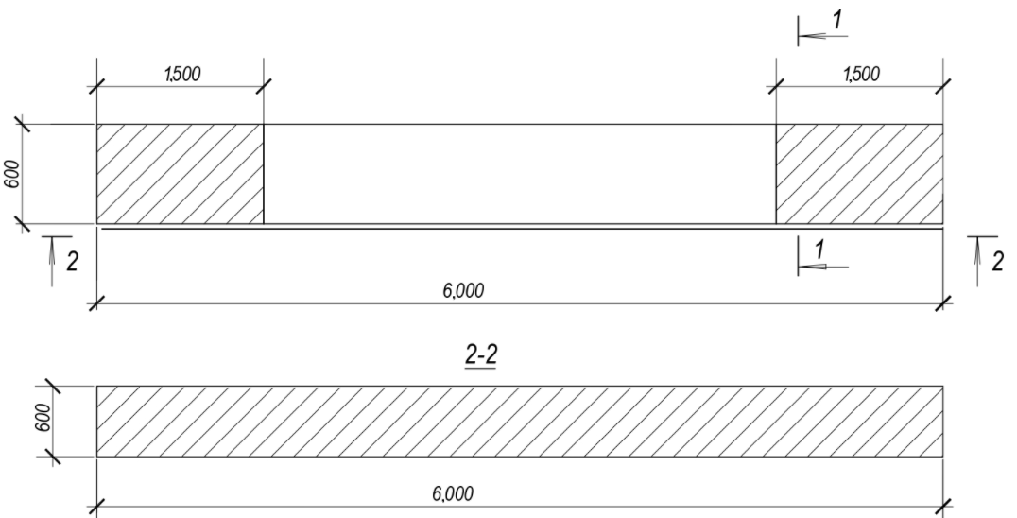
(b)
FIGURE 1. Formwork and reinforcement layout of the specimens: a) formwork layout, conventional reinforcement detailing; b) composite reinforcement detailing.

The stress-strain state of single-span, simply supported beams strengthened with externally bonded composite reinforcement was investigated according to the loading scheme shown in Figure 2. The design span of the beams was 600 cm, with a shear span of 200 cm. The load was applied incrementally from 10 to 21 tons, in 1-ton steps, up to the calculated values of the ultimate load prior to crack formation.

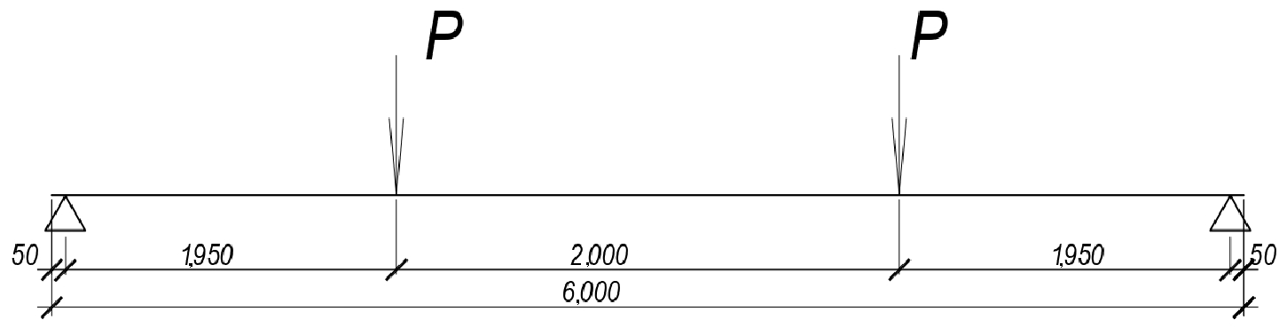
FIGURE 2. Design Scheme

The design of the beam strengthened with external GFRP reinforcement and the reinforcement layout are shown in Figure 1.
Three types of reinforced concrete beam models were considered: B-1, B-2, and B-3.
B-1: A reference beam without composite strengthening.
B-2: A beam strengthened with fiberglass fabric. The external reinforcement consisted of a single-ply composite strip, 250 mm wide, made of EWR400 fiberglass fabric, bonded to the bottom face. Additionally, U-wraps (end anchorage), 1500 mm wide, made of the same composite material were installed at the beam ends.
B-3: A beam strengthened with carbon fabric. The external reinforcement consisted of a single-ply composite strip, 250 mm wide, made of MBrace Fib CF carbon fabric, bonded to the bottom face. Additionally, U-wraps (end anchorage), 1500 mm wide, made of the same composite material were installed.
The stress-strain state (SSS) of model B-1 was analyzed, which was subjected to a short-term load up to a bending moment equal to 50% of the ultimate moment. Subsequently, the beam was strengthened with a composite material, and the load was increased until failure.
The following assumptions and hypotheses were adopted:
- within the depth of the composite flexural element, the strains in the concrete and reinforcement vary linearly, adhering to the Bernoulli hypothesis of plane sections;
- the hypothesis of small deformations and the superposition of relative and absolute deformations is valid;
- the hypothesis of mutual independence of partial deformations;
- a linear stress-strain relationship for the reinforcement;
- a nonlinear stress-strain relationship for the concrete;
- the shear forces and the stiffness of the interface layer influence the deformation of the strengthened flexural element;
- the use of a generalized physical model, which includes the equation of equilibrium of external and internal forces in a normal section, the deformation of the normal section, and the constitutive laws for concrete.
Mathematical expressions (1) for the principal moment were derived for various strengthening schemes under the condition of a perfectly rigid interface layer [17]. Analytical model of the cross-section in Fig. 3.

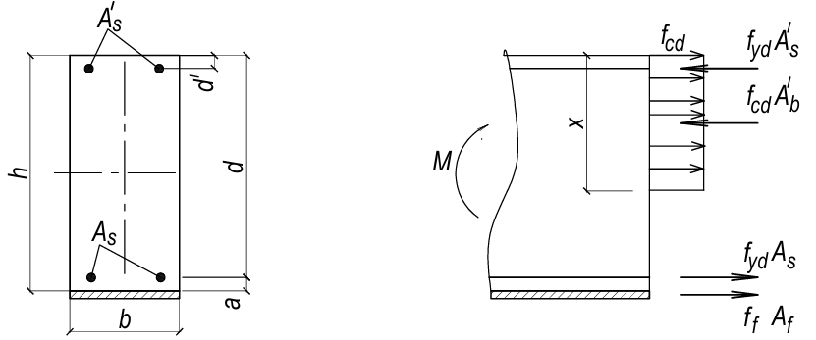
FIGURE 3. Analytical model of the cross-section

(1)

To simulate the behavior of flexural reinforced concrete elements, a numerical experiment was conducted using the finite element modeling and analysis software Autodesk Inventor (Licensed Software, Version 2023) [18]. The design schema is shown in Fig. 4.
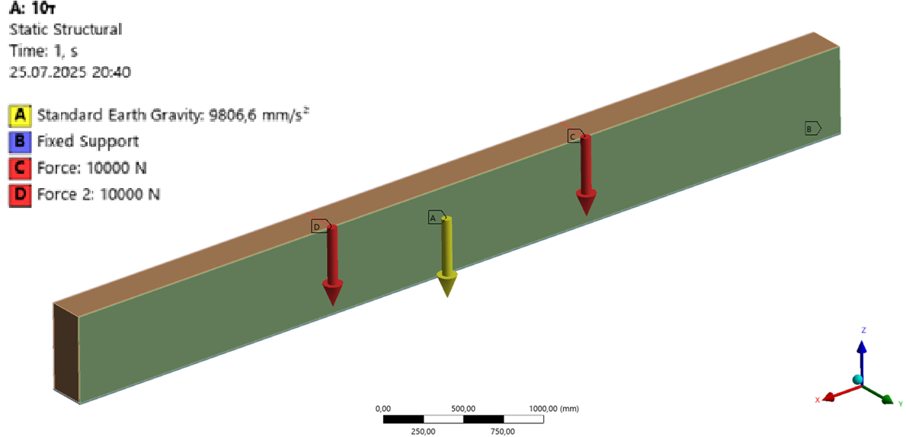
FIGURE 4. Loading Design Schema

The obtained theoretical conclusions were compared with the results of numerical studies on flexural reinforced concrete elements strengthened with externally bonded reinforcement.
Table 1 presents the results of the investigation into the stress-strain state of the beam strengthened with externally bonded composite reinforcement.

TABLE 1. Stress-Strain State of the Beam Strengthened with Externally Bonded Composite Reinforcement
Deformation | Stresses
Load 10 t
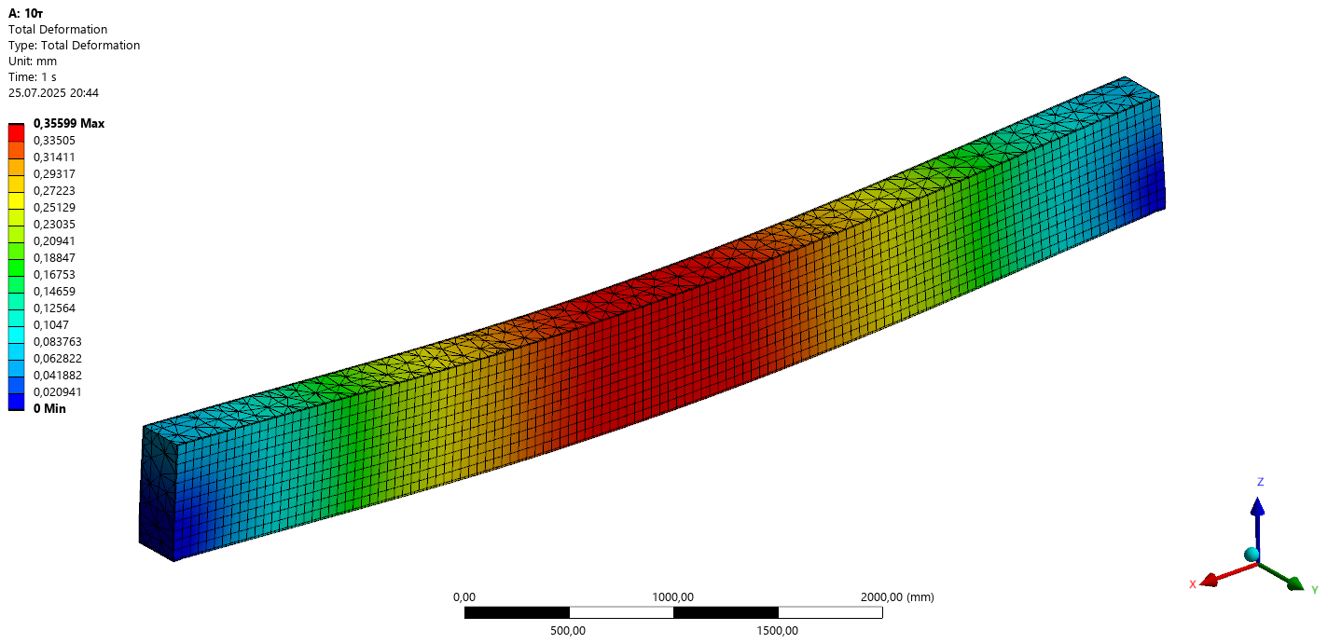 | 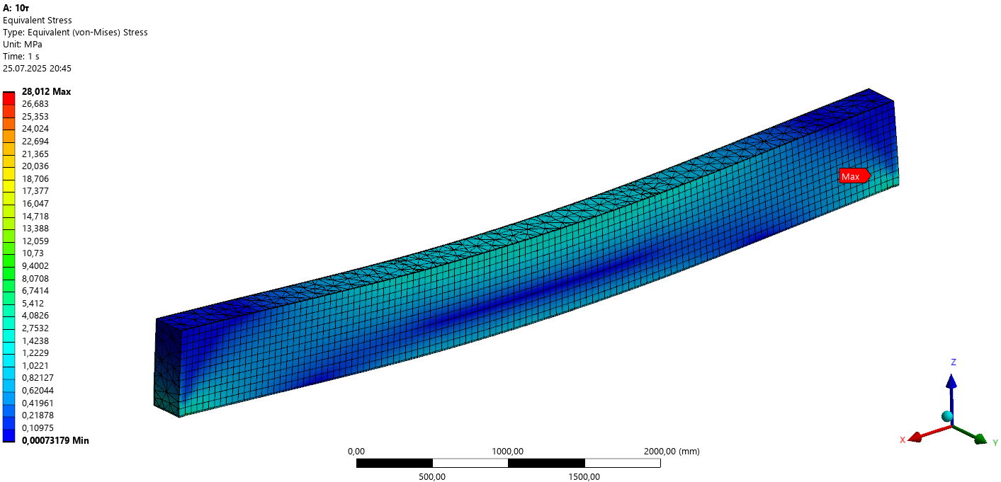
Load 19 t
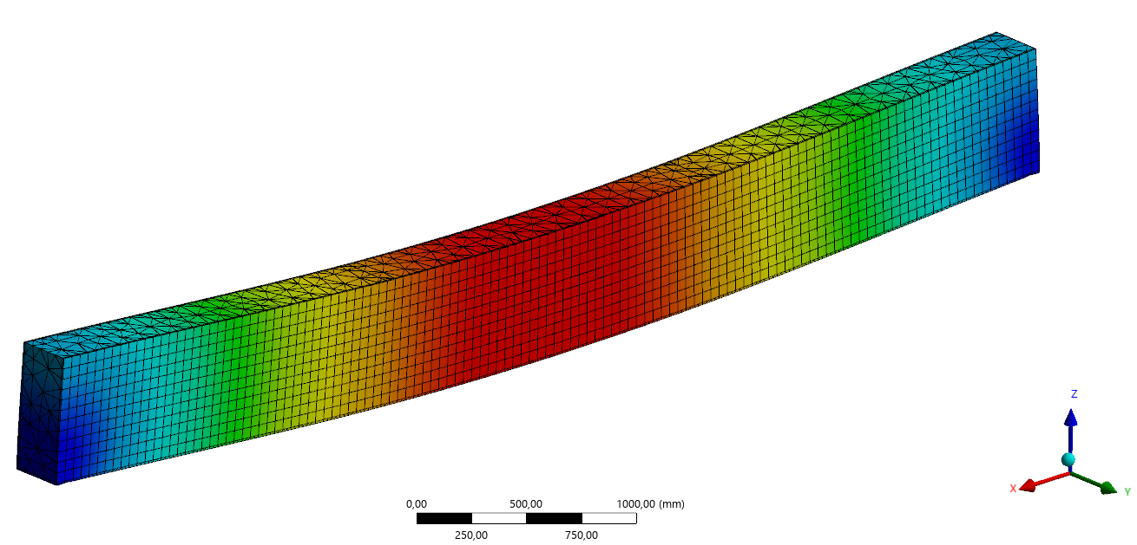 | 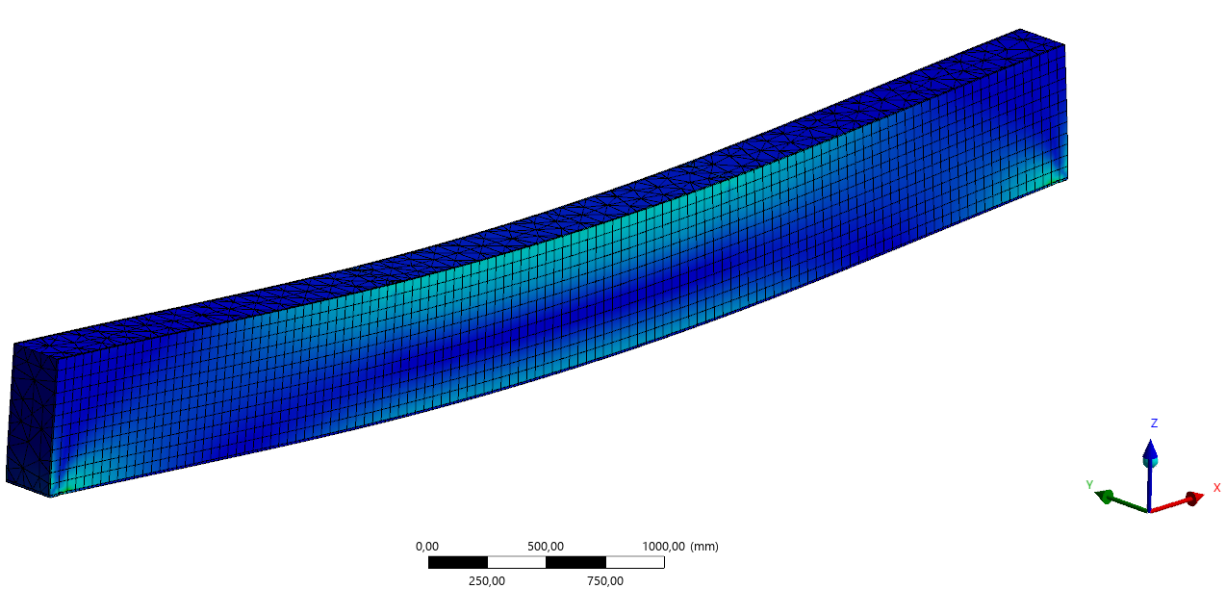
Load 20 t
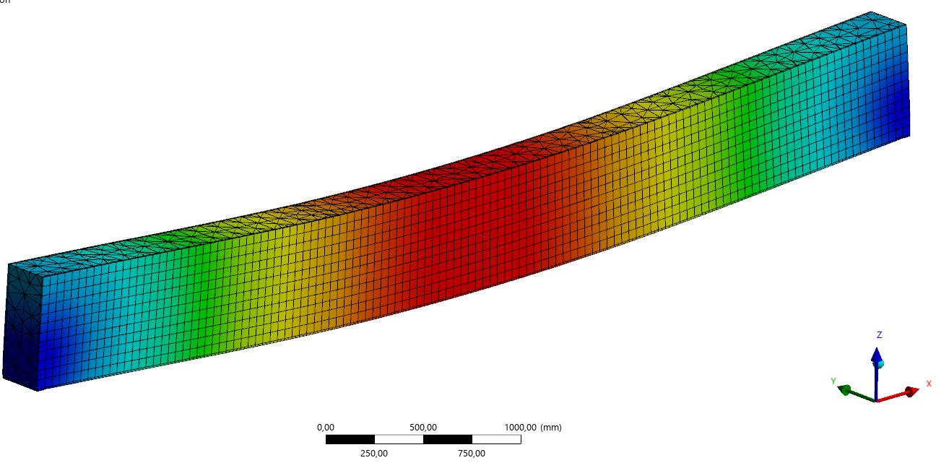 | 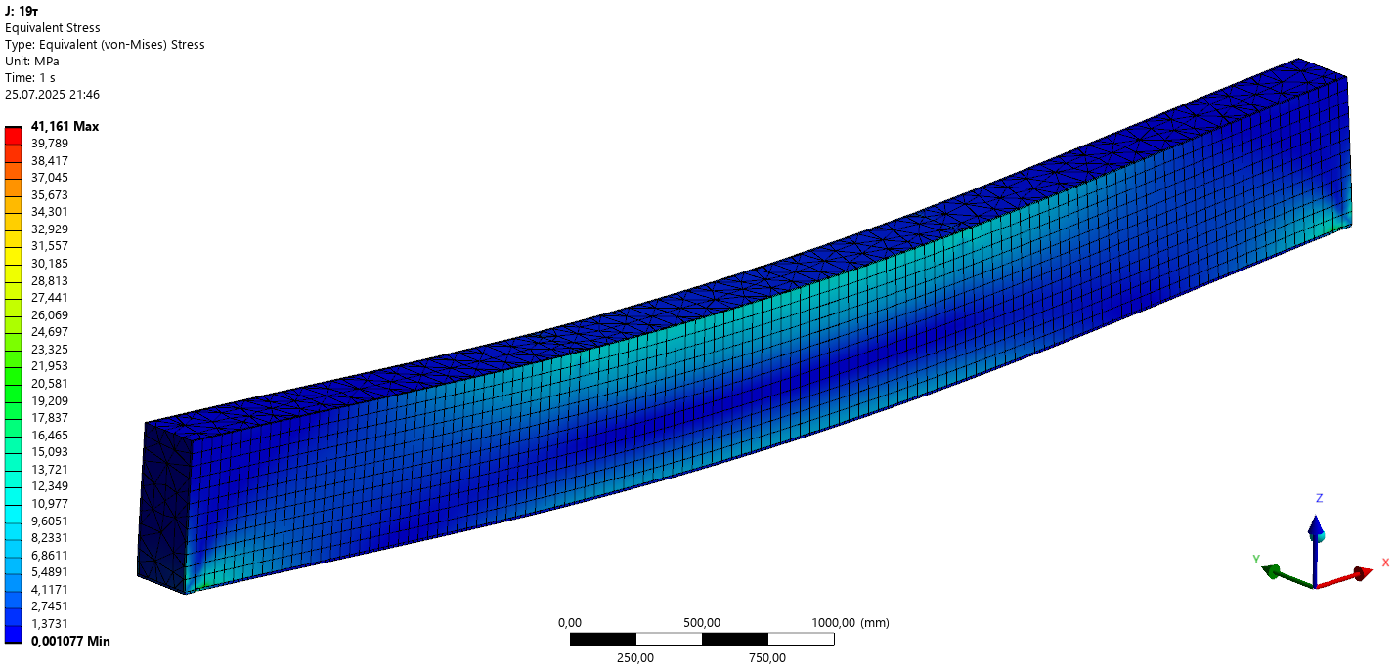
Load 21 t
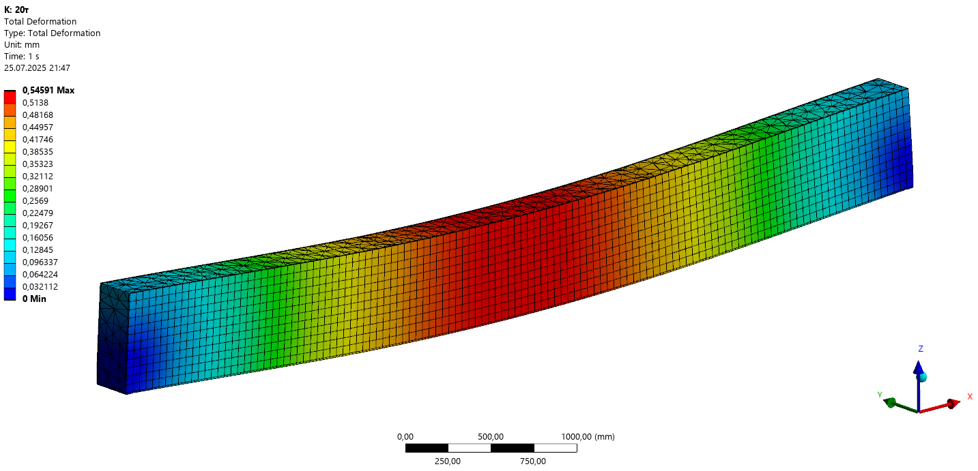 | 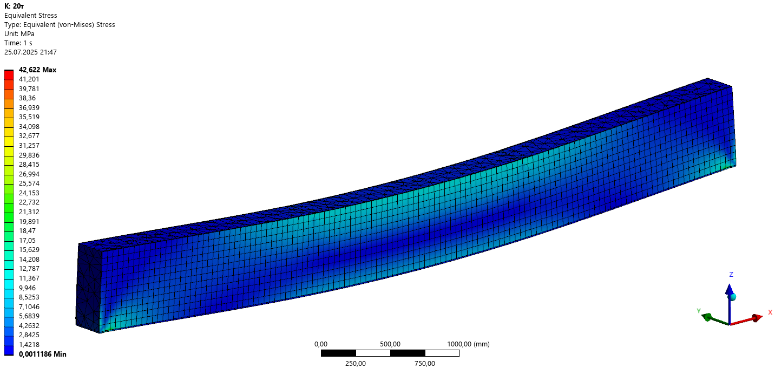

Based on the results of the numerical investigation into the stress-strain state of beams strengthened with GFRP and CFRP, compiled in Table 1, a σ-ε (stress-strain) diagram was plotted (Fig. 5).
The results of the study on the influence of the composite material type on the load-bearing capacity of the investigated beams are presented in Table 2.

TABLE 2. Results of the Stress-Strain State Analysis for Beams Strengthened with Externally Bonded Composite Reinforcement
Model by type of composite reinforcement | B-1 Control | B-2 Fiberglass fabric | B-3 Carbon fabric
Elastic modulus of the composite, GPa | - | 40 | 200
Tensile strength, MPa | - | 80 | 150
M (B-1), M_{f} (B-2, B-3) | 436 | 508 | 580
M_{f}/M, % | - | 116 | 133
Load-bearing capacity  P (B-1), P_{f} (B-2, B-3), кН | 218 | 254 | 240
Load P_{ult} at the maximum allowable deflection кН | 450 | 522 | 598

For the comparison of the results, an M-f (bending moment-deflection) relationship graph was plotted. (Fig. 5). Analysis of the moment-deflection curves for the three-specimen series (1 – control, 2 – strengthened with GFRP, 3 – strengthened with CFRP) allows for comprehensive conclusions regarding the behavior of reinforced concrete flexural beams with external composite reinforcement.
Firstly, the introduced reinforcement significantly alters the stress-strain state: the strengthened specimens exhibit delayed formation of the first crack and a more stable increase in the moment-deflection characteristic in the post-cracking phase. This indicates enhanced crack resistance and a more uniform stress redistribution in the concrete tensile zone due to the additional load-bearing contribution of the composite.
Secondly, a comparison of models B-2 and B-3 highlights the critical role of the elastic modulus of the external reinforcing material. The models strengthened with CFRP achieved the highest ultimate load-carrying capacity (peak moment values of ~580 kN·m) and greater stiffness in the initial stages of the curve. This is consistent with the fact that the elastic modulus of CFRP approaches that of steel; consequently, during crack formation, the external composite promptly engages in carrying tensile stresses and practically compensates for the loss of load-bearing capacity in the tensioned concrete. In the case of GFRP (model B-2), the modulus is significantly lower, resulting in a smaller increase in stiffness and load-bearing capacity, as evidenced by a more gradual slope of the curve and a lower peak moment.
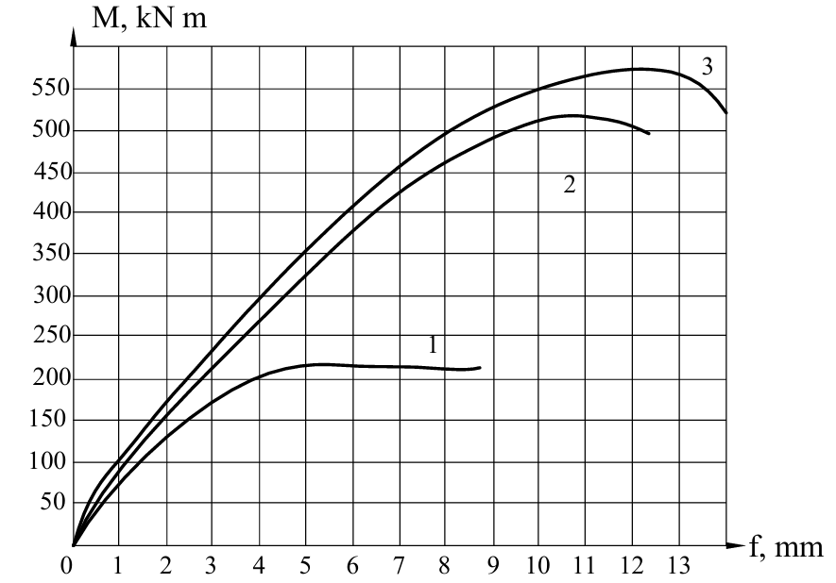
FIGURE 5. M-f (Bending Moment-Deflection) diagrams for beams strengthened with fiberglass fabric and carbon fabric.

Considering the nature of the post-peak curve descent, differences in failure modes should be noted. For the model with CFRP strengthening, the post-peak process is characterized by a relatively gradual decrease in load-bearing capacity, indicating a more "damped" behavior—the combined contribution of the internal steel reinforcement and the composite ensures a progressive redistribution of internal forces. In contrast, the control specimens (model B-1) exhibit a sharp transition to a plateau and an early decline, typical of rapid local failure after the loss of load-bearing capacity in the tensioned concrete. This behavior suggests lower ductility and lower energy absorption capacity at failure in the control specimens.
Mechanistically, external composite strengthening influences the following factors: reduction in the intensity and width of cracks in the tensile zone; decrease in stress concentration in the internal steel reinforcement due to the redistribution of a portion of tensile forces to the composite; increase in the moment of formation and development of the plastic zone in the cross-section; and a change in the failure mode—from steel yielding/concrete crushing to more complex modes where the primary role is played by composite debonding/delamination or failure of the internal reinforcement combined with local concrete brittleness. In this context, ensuring reliable composite adhesion/anchorage is an important technical consideration: without sufficient mechanical anchorage, the effectiveness of CFRP strengthening is markedly reduced due to premature local debonding.
From a design perspective, the results recommend CFRP strengthening for cases where the priority is increasing load-bearing capacity and reducing deflections with a limited increase in structural mass. GFRP strengthening may be advisable for applications where corrosion resistance and low cost are important, provided that smaller gains in stiffness are acceptable. For practical calculations, it is useful to account for the composite's contribution to the tensile force in the section by applying correction factors based on energy equivalence or via a reduced elastic modulus, which allows for an accurate assessment of the effective load-bearing cross-section in the post-cracking stage.
Analysis of the research data indicates that the type of composite material does not have a substantial influence on the ultimate load-bearing capacity. However, the deformability of the specimens is directly dependent on the type and presence of composite strengthening. A comparison of deflections shows that the control beams exhibit approximately 20% greater deflection than the beams strengthened with external reinforcement.
The deformability of beams strengthened with EWR400 fiberglass fabric was 15% lower than that of the control specimens. Beams strengthened with carbon fabric demonstrated a sharp reduction in deformation compared to the control specimens. The reduction in deformation is more pronounced with an increase in the modulus of elasticity of the carbon-fiber-based composite materials.
The conducted analysis demonstrates that the effectiveness of composite strengthening depends more significantly on the material's modulus of elasticity than on its tensile strength. Therefore, preference for strengthening reinforced concrete structures should be given to carbon-fiber-based composites, whose modulus of elasticity is equal to or slightly exceeds that of steel.
Furthermore, a comparison of the following parameters-mid-span deflection, flexural load-bearing capacity, and relative strains in the concrete and composite material-revealed that the load-bearing capacity of strengthened flexural reinforced concrete elements is influenced by the following factors: type of external reinforcement; loading history of the element prior to strengthening; strength and deformation characteristics of the external reinforcement; stress and strain distribution across the cross-section of the strengthened element.

Conclusions
Based on the findings, the following conclusions can be drawn:
- Strengthening with externally bonded composite reinforcement reduces the deformability of the model, regardless of the composite material type. The magnitude of deflections decreases when using composites with a higher modulus of elasticity.
- Numerical studies were conducted to determine the strength and deformation properties of elements strengthened with externally bonded composite reinforcement using the Autodesk Inventor software suite.
- Computer modeling of the load response of strengthened flexural reinforced concrete elements enabled the construction of deformation graphs and the derivation of stress and strain contours for the concrete and external reinforcement at various loading stages.

Acknowledgments
The authors would like to express their gratitude to Kharkiv National Automobile and Highway University and the organizing committee of the Modern Automotive Industry, Transport and Road Infrastructure (MAITRI) conference.

Conflict of interests
The authors declare that there is no conflict of interests regarding the publication of this paper.

References
[1] M. K. Askar, A. F. Hassan, and Y. S. S. Al-Kamaki, “Flexural and shear strengthening of reinforced concrete beams using FRP composites: A state of the art,” Case Studies in Construction Materials 16, e01189 (2022). https://doi.org/10.1016/j.cscm.2022.e01189
[2] A. Jahami, Y. Timsah, J. M. Khatib, and O. Baalbaki, “The behavior of CFRP strengthened RC beams subjected to blast loading,” Magazine of Civil Engineering 103 (3), 10309 (2021). https://www.researchgate.net/publication/351102636_The_behavior_of_CFRP_strengthened_RC_beams_subjected_to_blast_loading
[3] M. Zhong, M. Zhang, and X. Li, “Carbon nanomaterials and their composites for supercapacitors,” Carbon Energy 4, 950–985 (2022). https://doi.org/10.1002/cey2.219
[4] B. Hu, Y. Zhou, F. Xing, L. Sui, and M. Luo, “Experimental and theoretical investigation on the hybrid CFRP–ECC flexural strengthening of RC beams with corroded longitudinal reinforcement,” Engineering Structures 200, 109717 (2019). https://doi.org/10.1016/j.engstruct.2019.109717
[5] C. L. Nguyen, A. D. Mai, N. N. H. Hoang, and D. N. Nguyen, “Numerical simulation study on flexural behaviour of RC beams strengthened with ECC layer and CFRP sheets,” Journal of Science and Technology – Issue on Information and Communications Technology 23(6A), 209E (2025). https://doi.org/10.31130/ud-jst.2025.23(6A).209E
[6] M. Haris, E. Xiong, and W. Gao, “Strengthening reinforced concrete members using FRP—Evaluating fire performance, challenges, and future research directions: A state-of-the-art review,” Composite Structures 318, 118471 (2025). https://doi.org/10.3390/polym17010013
[7] M. A. Basit, M. T. E. Amin, “Experimental and numerical comparative study on RC beam flexurally strengthened with CFRP laminate,” IUBAT Review 6(1), 13–24 (2023). https://doi.org/10.3329/iubatr.v6i1.67228.
[8] A. Siddika, M. A. Al Mamun, R. Alyousef, and M. Amran, “Strengthening of reinforced concrete beams by using fiber-reinforced polymer composites: A review,” Journal of Building Engineering 25, 100798 (2019). https://doi.org/10.1016/j.jobe.2019.100798.
[9] European Committee for Standardization, Eurocode 2: Design of concrete structures – Part 1-1: General rules – Structural fire design (FprEN 1992-1-1:2023) (CEN, Brussels, 2023). https://concrete.fsv.cvut.cz/~drahomic/Pomucky/FprEN_1992-1-1-BD.pdf
[10] DBN B.1.2-2:2006, Reliability and safety system for building objects, Design standards, Amendment No. 1, effective since 01/01/2007. file:///C:/Users/Duchovny/Downloads/_load_0-0-1-753-20.pdf
[11] DSTU B V.2.6-156:2010, Concrete and reinforced concrete structures made of heavy concrete. Design rules (Minregionalbud of Ukraine, Kyiv, 2011). https://dbn.co.ua/load/normativy/dbn/1-1-0-792
[12] DBN V.2.6-98:2009, Concrete and reinforced concrete structures. Basic provisions (Minregionalbud of Ukraine, Kyiv, 2009). https://online.budstandart.com/ua/catalog/doc-page.html?id_doc=26677
[13] EN 1992-1-1:2004+AC:2008, Eurocode 2: Design of reinforced concrete structures. Part 1-1: General rules and regulations for buildings (CEN, Brussels, 2008).
[14] EN 1168:2005+A2:2009(E), Annex J (CEN, Brussels, 2009).
[15] TK P EN 1991-2-2009, Eurocode 1 (CEN, Brussels, 2009).
[16] DSTU B V.2.6-7-95, Prefabricated reinforced concrete and concrete construction products. Load test methods. Rules for assessing strength, stiffness and crack resistance (State Committee for Urban Development of Ukraine, Kyiv, 1997). https://www.ksv.biz.ua/GOST/DSTY_ALL/DSTY4/dstu_b_v.2.6-7-95.PDF
[17] V. M. Babaev, O. M. Bambura, O. M. Pustovoitova, P. A. Reznik, G. Stoyanov, and V. S. Shmukler, Practical design of elements of reinforced concrete structures according to DBN V.2.6-98:2009 in accordance with the design requirements for SNiP 2.03.01-84 and EN 1992-1-1 (Eurocode 2) (Zoloti Stories, Kharkiv, 2015). https://koha.kname.edu.ua/cgi-bin/koha/opac-detail.pl?biblionumber=87764
[18] Autodesk Inventor, licensed software, Version 2023. Available at: https://manage.autodesk.com/login?t=/products

