Theoretical Analysis of the Impact of the Product on the Vibrating Belt
Ruzimurad Rosulov^{1,a}, Bahrom Pardaev¹, Abdurakhmon Erdonov², Khusan Diyorov², Umid Berdimuratov², Olim Abdurakhmanov²
¹Tashkent Institute of Textile and Light Industry, Tashkent, Uzbekistan,
²Termez State University of Engineering and Agrotechnology, Termez, Uzbekistan
^{a)}Corresponding author: rasulov.ruzimurad@mail.ru
Abstract: The article provides detailed information about the elevator designed for transporting raw cotton, seeds and waste at cotton ginning plants. At the same time, in order to reduce damage to cottonseeds, an improved elevator design was developed. The movement of grains ejected from the elevator buckets moving vertically during the delivery of grains from sawn gins to linters in cotton ginning enterprises was theoretically studied, and it was determined that mechanical damage to the grains occurred as a result of the ejected grains hitting a metal surface (roof). Based on the analysis conducted on the basis of theoretical research, the values of the grain flow velocity in the OX and OY axes at different speeds of the bucket conveyor were determined.
Keywords: damage, waste, belt, elevator, inclined, vertical, bucket.
INTRODUCTION
Elevators are used in cotton ginning plants for vertical transportation of cotton, seeds and production waste.
Currently, EXS elevators are designed for vertical transportation of cotton, seeds and waste, and are equipped with a combed belt (for cotton transportation) or a scoop belt (for seed or waste transportation). The elevator consists of a head, a shoe, a drive unit, a set of pipes, a combed belt (for cotton transportation) or a scoop belt for seed and waste transportation [1].
Elevators are also used in other production conditions of industrial enterprises, where they are used for vertical, horizontal and mixed (vertical and horizontal) transportation of products [2].
In the design proposed by the author [3], in order to prevent damage to cotton during its transfer to the technological process, a TP-type transporter-supplier was proposed and an additional PLA-type receiving-transmitting device was prepared.
The authors [4] determined the parameters of the receiving-discharging bunker and proposed to reduce it to 0.4 m above the receiving bunker.
Currently, vertical elevators are used in cotton ginning enterprises to transport raw cotton, seeds and waste.
For transporting seeds and other waste to a height of 3640–25160 mm, ES-14M seed elevators and ES-14S waste elevators are used. The designs of these elevators are similar to those of the EX-15M1 elevator, with the following differences: the belt width is 350 mm, rubberized, four-layer, with two rubber coatings and 7 buckets with a capacity of 1.5 L are installed on it, per 1 meter. The ES-14S waste elevator belt is equipped with comb-shaped buckets [5-9].
The EX-15M1 cotton elevator is designed to transport cotton vertically to a height of 4130-18130 mm.
A theoretical analysis of the effect of the belt on seeds in different elastic elements in reducing the damage caused by the impact of the seed flow from the bucket elevator on the oscillating belt is presented (Fig. 1).
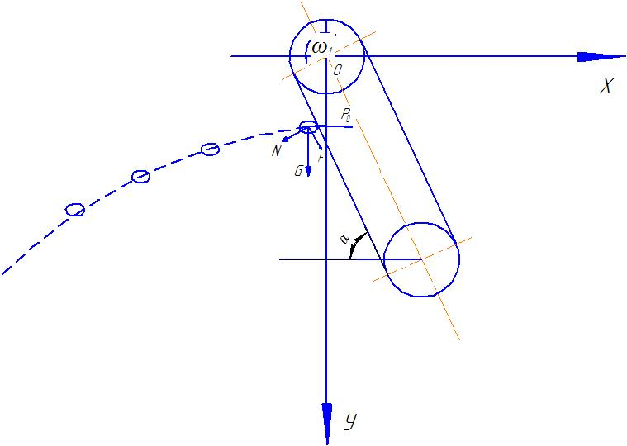

FIGURE 1. Scheme of movement under the influence of seeds on a vibrating belt

The external forces resulting from the action of the seeds on the vibrating belt are as follows $P_{0}=m⋅\ddot{l}$ - the vibrating force of the tape, $l=l_{0}⋅\sin{k}t$ бу ерда $k=\sqrt{\frac{c}{m}}$ is equal to, $c$ - the coefficient of friction, m - is the grain mass, N - is the pressure force, F - is the drag force of the grains on the belt surface, G=mg is the weight of the grains, N - is equal to m⋅g⋅sinα, G - is the weight of the grains
$$F=m⋅g⋅\cos{α}$$
In studying the damage caused by the impact of the grain flow transmitted from the belt conveyor on the vibrating belt, we determine the differential equation of motion on the vibrating belt.
The belt conveyor is installed at an angle α, and as a result of the impact of the grain on the Ox and Oy axes at a distance l_0, the projections are determined as follows (Fig. 2).

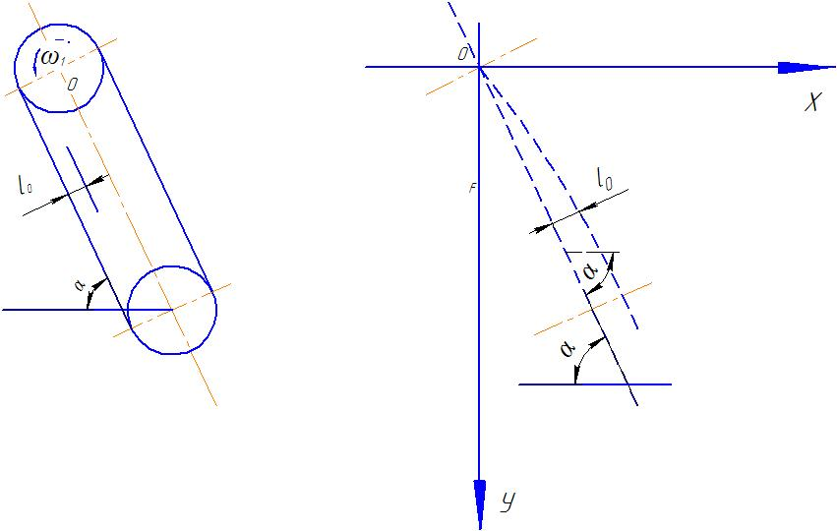
FIGURE 2. Scheme of movement of seeds on a vibrating belt
$$x=l_{0}⋅\sin{α}$$
$y=l_{0}⋅\cos{α}$ (1)
Now we construct the differential equation of motion resulting from the impact of the seed on the oscillating belt.
$m⋅\ddot{x}=P_{0}-N⋅\sin{α}$ (2)
(2) we calculate by substituting the forces acting on the above input into the differential equation
$$m⋅\ddot{x}=m⋅{\ddot{l}}_{0}⋅\sin{k}t-m⋅g⋅\sin{α}⋅\sin{α}$$
$\ddot{x}=-l_{0}⋅\frac{c}{m}⋅\sin{k}t-g⋅\sin^{2}{α}$ (3)
We integrate equation (3) twice.
$\dot{х}=\frac{l_{0}⋅c}{m}⋅\frac{1}{k}⋅\cos{k}t-g⋅\sin{α}⋅t+С_{1}$ (4)
We use the initial condition to determine the integral constantc c₁ from equation (4).
$(\dot{x})_{t=0}=ϑ_{0} ⇒c_{1}=υ_{0}-\frac{l_{0}⋅c}{m⋅k}$
we put the determined integral constant in equation (4).
$\dot{х}=\frac{l_{0}⋅c}{m⋅k}⋅\cos{k}t-g⋅\sin^{2}{α}⋅t+υ_{0}-\frac{l_{0}⋅c}{m⋅k}$ (5)
Let's integrate equation (5) again over time.
$x=\frac{l_{0}⋅c}{m⋅k^{2}}⋅\sin{k}t-g⋅\sin^{2}{α}⋅\frac{t^{2}}{2}+(υ_{0}-\frac{l_{0}⋅c}{m⋅k})⋅t$ (6)
Equation (6) was derived from the equation of motion of the impact of the grains on the vibrating belt. Here $l_{0}$ - is the displacement of the belt by how many mm, m - is the mass of the grain, g - is the acceleration of free fall, $υ_{0}$ - is the initial velocity of the grain, c - is the coefficient of elasticity of the belt, c - is chosen for rubber.
The notation equal to $k=\sqrt{\frac{c}{m}}$ is introduced. The following values ​​of the parameters were introduced in the calculations: m = 2.5 g, g =9.81 m/s, $υ_{0}$= 1.6 m/s.
The graphs were analyzed using the Maple program (Fig. 3, 4).

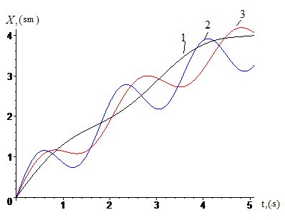
FIGURE 3. The units of impact of seeds on the belt conveyor are different 1-c₁= 200 kg/mm,
2- c₂=500 kg/mm, 3-c₃=800 kg/mm time-dependent graph.
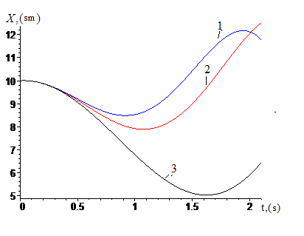
FIGURE 4. Time-dependent graph of the movement of grains on a belt conveyor at various inclination angles
$1-α_{1}=35^{0}$, $2-α_{2}={40}^{0}$,${3-α}_{3}={45}^{0}$
From the above graphs, it can be seen that the reduction of the belt conveyor's stiffness coefficients due to the impact of grains at a value of с₁=500 kg/mm and the inclination angle at which the vibrating belt is installed at a value of α₂=35⁰ resulted in a reduction in the impact force of grains on the belt.
In the next step, we determine the differential equation of motion along the axis of the Moon as a result of the impact of the grain.
$m⋅\ddot{y}=m⋅g+F⋅\sin{α}+N⋅\cos{α}$ (7)
$\ddot{y}=g+g⋅\cos{α}⋅\sin{α}+g⋅\sin{α}⋅\cos{α}$ $\ddot{y}=g⋅(\sin{2}α+1)$ (8)
We integrate equation (8) twice with respect to time. As a result, we determine the equation of motion along the Moon's axis as a result of the impact of the grains on the vibrating ribbon. If y=0 in the initial conditions,

$y=g⋅\frac{t^{2}}{2}(\sin{2}α+1)$ (9)
We analyze equation (9) graphically using the Maple program (Fig. 5).

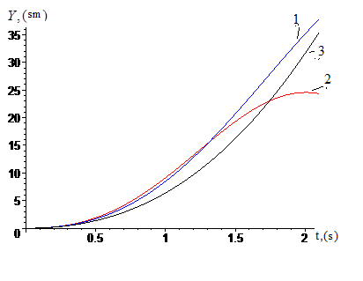
FIGURE 5. Time-dependent graph of the slope angle at different values ​​of the seed impact on the vibrating belt:
${1-α}_{1}=35^{0}$, $2-α_{2}=40^{0}$,${3-α}_{3}=45^{0}$-

The dynamics of the analysis of the failure state of the vibrating belt under the influence of a grain flow at different values ​​of the modulus of elasticity is presented. The differential equation of state of the vibrating belt under the influence of a grain flow is presented.
$m⋅\ddot{x}+c⋅x=F⋅\sin{ω}t$ (10)
The dynamics of the analysis of the failure state of the vibrating belt under the influence of a grain flow at different values ​​of the modulus of elasticity is presented. The differential equation of state of the vibrating belt under the influence of a grain flow is presented.
$\ddot{x}+\frac{c}{m}⋅x=\frac{F⋅\sin{ω}t}{m}$ (11)
We calculate the homogeneous part of the equation (11).
$\ddot{x}+\frac{c}{m}⋅x=0$ (12)
We calculate the solution of the homogeneous equation (12) in the following form
$k^{2}+\frac{c}{m}=0$ from this $k^{2}=-\frac{c}{m}$ identify solutions $k_{1}=\sqrt{\frac{c}{m}}i$ ; $k_{2}=-\sqrt{\frac{c}{m}}i$
$x_{1}=a⋅\sin{\sqrt{\frac{c}{m}}}t+b⋅\cos{\sqrt{\frac{c}{m}}}t$ (13)
(13) represents the general solution of the homogeneous part of the equation.
We look for the particular solution of the differential equation (10) in the following form.
$x_{2}=A⋅\sin{ω}t+B⋅\cos{ω}t$ (14)
We take the first and second derivatives from equation (14), substitute them into equation (10), and equating the corresponding coefficients, calculate
$${\dot{x}}_{2}=A⋅ω⋅\cos{ω}t-B⋅ω⋅\sin{ω}t$$${\ddot{x}}_{2}=-A⋅ω^{2}\sin{ω}t-B⋅ω^{2}⋅\cos{ω}t$ (15)
We put equation (15) into equation (10).
$-A⋅ω^{2}\sin{ω}t-B⋅ω^{2}⋅\cos{ω}t+c⋅A⋅\sin{ω}t+c⋅B⋅\cos{ω}t=F⋅\sin{ω}t$ (16)
We determine the values ​​of constants by equating the corresponding coefficients of equation (16).
$$-A⋅ω^{2}+c⋅A=F$$$-B⋅ω^{2}+c⋅B=0$ from this $A=\frac{F}{c-w^{2}}$
$$B=0$$
We look for a specific solution as follows
$x_{2}=\frac{F}{c-ω^{2}}⋅\sin{ω}t$ (17)
We present the general solution of the equation of motion in the action of seeds on a vibrating belt
$x_{ум}=x_{1}+x_{2}=a⋅\sin{\sqrt{\frac{c}{m}}}t+b⋅\cos{\sqrt{\frac{c}{m}}}t+\frac{F}{c-ω^{2}}⋅\sin{ω}t$ (18)

The following values of the parameters were included in the calculations: m = 2.5g, g =9.81 m/s, υ_0=1.6 m/s.
The graphs were analyzed using the Maple program (Figure 6).
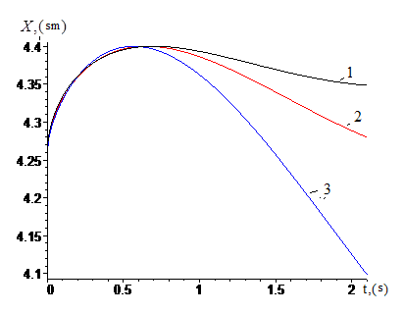
FIGURE 6. Time-dependent graph of the effects of the elastic force of seeds on the vibrating belt at different values:
1-с₁= 200 kg/mm, 2- с₂=500 kg/mm, 3- с₃=800 kg/mm
CONCLUSIONS
1. The movement of grains ejected from the elevator buckets was theoretically studied. According to it, mechanical damage to the grain is observed as a result of the ejected grains hitting the metal surface (roof).
2. The movement of grains in a bucket elevator was theoretically analyzed. In the theoretical studies, the values of the grain flow velocity in the OH and OU axes at different speeds of the bucket conveyor were determined. According to it, the grain flow velocity along the OH axis decreases over time, i.e. at a speed of ϑ_01="12m/s" after 0.6 s, the grain velocity reaches 4 m/s, at a speed of ϑ_02="16m/s" up to 7 m/s, and at a speed of ϑ_03=20"m/s" up to 9 m/s, and then the grain velocity increases.
3. In reducing the damage caused by the impact of the seeds on the different uniformity coefficients of the belt conveyor belt, the impact force of the seeds on the belt was reduced at the value of s1=200 kg/mm ​​and the slope angle of the belt conveyor at the value of α₂=35⁰.
REFERENCES
- Rosulov, R. K. H. (2022). Investigation of the interaction of volts with cleaner grates. Izvestiya Vysshikh Uchebnykh Zavedenii, Seriya Teknologiya Tekstil'noi Promyshlennosti, (4), 166–171. https://doi.org/10.47367/0021-3497_2022_4_166
- Rosulov, R., Urakov, N., Diyorov, K., & Turdiyev, A. (2025). The impact of the tilt angle of the upgraded drum on the time the seeds spend in the drum. In Lecture notes in networks and systems (pp. 200–208). https://doi.org/10.1007/978-3-031-95649-2_17
- Gaziev, S. A., Nurov, M. E., Ibroghimov, Kh. I., & Rudovsky, P. N. (2016). Motion analysis of the feather of the raw cotton over the blades of the drum of the dryer. Izvestiya Vysshikh Uchebnykh Zavedenii, Seriya Teknologiya Tekstil'noi Promyshlennosti, 362(2), 75–78.
- Yu, Y., Su, Z., Zhang, J., Li, J., & Qin, W. (2025). Analysis of vibration characteristics of the grading belt in Wolfberry sorting machines. Applied Sciences, 15(11), 6022. https://doi.org/10.3390/app15116022
- Heinemann, P. H., Pathare, N. P., & Morrow, C. T. (1996). An automated inspection station for machine-vision grading of potatoes. Machine Vision and Applications, 9(1), 14–19. https://doi.org/10.1007/bf01246635
- Murodov, O. J., Adilova, A. S., Saidova, N. A., & Agzamov, M. M. (2023). Improvement of the design of the unit for cleaning the air stream from dust at a cotton ginnery. E3S Web of Conferences, 390, 01023. https://doi.org/10.1051/e3sconf/202339001023
- Yuldashev, A., et al. K. (2023). Theoretical study of yarn tension in the spindle work of two-for-one twisting. AIP Conference Proceedings, 2789, 040117. https://doi.org/10.1063/5.0145422
- Jumaniyazov, K., Tojimirzaev, S., & Muminov. (2022). Research and evaluation of cotton fiber properties in technological processes. Proceedings of Higher Education Institutions Textile Industry Technology, 1, 162–170. https://doi.org/10.47367/0021-3497_2022_1_162
- Gou, H., Yan, H., Zhao, T., Ban, X., Meng, X., & Bao, Y. (2023). Dynamic response of high-speed train-track-bridge coupled system under combined wind and snow. Structure and Infrastructure Engineering, 21(4), 695–709. https://doi.org/10.1080/15732479.2023.2230576

