Analysis of the Motion of an Oscillating Mesh Surface
Ruzimurad Rosulov^{1,a}, Bahrom Pardaev¹, Abdurakhmon Erdonov², Khusan Diyorov², Umid Berdimuratov², Olim Abdurakhmanov²
¹Tashkent Institute of Textile and Light Industry, Tashkent, Uzbekistan,
²Termez State University of Engineering and Agrotechnology, Termez, Uzbekistan
^{a)}Corresponding author: rasulov.ruzimurad@mail.ru
Abstract. The article describes the increase in the cleaning efficiency of the equipment by vibrating the mesh surface of a machine for cleaning cotton from fine impurities used in cotton ginning plants with a certain frequency and amplitude. Equations describing the movement of cotton on the vibrating mesh surface were obtained. The equations were reworked using programs, and the dependence of the extraction efficiency of cotton particles on the surface of the vibrating mesh surface in cleaning from fine impurities and the time-varying graph of angular velocities $ω_{1}=15 s^{-1}; ω_{2}=20 s^{-1}; ω_{3}=25 s^{-1}; ω_{4}=30 s^{-1};$; were obtained at various values. According to it, it was found that the speed of the cotton flow and its cleaning from fine impurities depend on the amplitude and frequency of the mesh surface along the horizontal plane. In effective cleaning of small impurities from the cotton stream, the frequency of vibration is 60 Hz and the amplitude of vibration is 6 mm.
Keywords: cotton raw material, vibration, frequency, amplitude, drum, cleaning effect.
INTRODUCTION
The development of a vibrating mesh surface under the pile drums of cotton ginning machines and the use of new methods for processing cotton raw materials is one of the promising directions of the industry. A number of scientific works have been carried out on the possibilities of using such methods in cotton ginning machines.
Almost all currently operating cotton ginning equipment has these elements. The design and solutions are mainly focused on the number and technological structure of these working bodies. At the present stage of development of technologies for cleaning cotton raw materials from fine impurities, the most important thing is to improve the structural elements of the working bodies of cleaning machines, including pile drums, mesh surfaces, which will allow cleaning the maximum amount of cotton. Ensuring the interaction of cleaning elements with cotton raw materials, the maximum separation of impurities from them.
Some physical and mechanical properties of cotton have been studied, including the bulk density of loose cotton, the effect of compression of cotton bulk density on relative pressure, cotton friction, the strength of the fiber to bind to the grain, and many other indicators.
In order to clean the cotton raw material from small impurities - cotton flowers, cobs and leaves smaller than 10 mm - in the process of processing cotton raw material, cleaning equipment is used, the main working part of which is a drum with a peg and a grid or a grate [1, 2].
In order to separate the small impurities in the cotton, it requires strong shaking during the cleaning process. Therefore, when cleaning cotton from small impurities, tapping in peg drums is adopted. The main cleaning process takes place between the drum and the grid.
Drums can be of various types, including peg, slat, toothed, and combined [3, 4, 5, 6].
Four of these units were assembled to produce eight peg-slat drum cleaning machines of the 1ХК type (Fig. 1). The convenience of EN.178 units allows you to create a cleaning machine for small dirty mixtures with the required number of peg-slat drums. These units are also used in the UHC unit [1, 2].

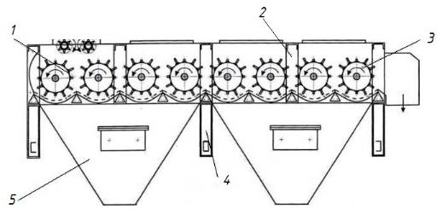
FIGURE 1. Scheme of the 1ХК type cleaning equipment
1-initial standardized pile section EN. 178.01 (with supply rollers); 2, 4- column,
3- standardized pile-slatted section EN. 178.02, 5- dirt bunker.

As is known, in the cleaning of cotton from small impurities, the cotton raw material, which is fed by feeders, is transported on a mesh surface using peg drums. We consider the movement of cotton pieces on the proposed vibrating mesh surface and the effect of the movement of cotton pieces along the MN-section on the vibrating motion of the mesh (Figs. 2, 3, 4).

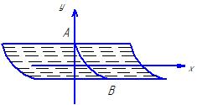
FIGURE 2. The movement of a piece of cotton on an oscillating mesh surface
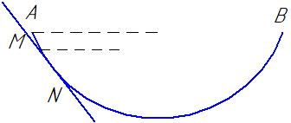
FIGURE 3. The effect of the grid in the oscillatory motion of the cotton pieces along the MN-section
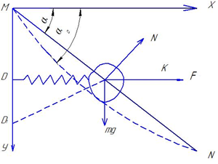
FIGURE 4. The movement of a piece of cotton on a vibrating mesh surface

MN = L – the deflection length of the mesh surface, MD – the distance, the vibration value is determined as follows.
$MD=MKcosα_{0}$ (1)
$MD_{1}$-the largest vibration value in the distance
$MD_{1}=\frac{MK}{cosα_{0}}$ (2)
We determine the moment of the piece of cotton relative to the point M:
$MKmgcosα_{0}-F_{el}MK sinα_{0}=0$ (3)
MK=l $l mgcosα_{0}={l F}_{el} sinα_{0}$ (4)
$F=m∙e∙ ∆l$
k - coefficient of unity.
We use Lagrange's second-order equations to describe the oscillatory motion of cotton particles on a grid surface, which depend on the direction of the grid surface S=S(t) and the angle α=α(t).
$\frac{d}{dt}\left(\frac{∂T}{∂\dot{S}}\right)-\left(\frac{∂T}{∂S}\right)=Q_{s}$ (5)
$\frac{d}{dt}\left(\frac{∂T}{∂\dot{α}}\right)-\left(\frac{∂T}{∂α}\right)=Q_{α}$ (6)
where T=T(S,α,S ̇,α ̇) is the kinetic energy. Q_s and Q_α are the total forces.
The kinetic energy of cotton particles along the surface of the grid is determined as follows:
$T_{1}=\frac{mL^{2}{\dot{α}}^{2}}{2}$ $T_{2}=\frac{m}{2}({\dot{S}}^{2}+S^{2}{\dot{α}}^{2})$ (7)
When determining the generalized forces Qs and Qα, the sum of the projections of the forces acting on the cotton pieces along the surface of the mesh is as follows:$Q_{s}=mg\left(sinα-fcosα\right)+2mf{\dot{S}}^{2}{\dot{α}}^{2}$
$Q_{α}=g\left(\frac{L}{2}m_{0}+mS\right)cosα-2mf{\dot{S}}^{2}{\dot{α}}^{2}-k∆L$ (8)
where f - is the coefficient of friction.
$f=f_{0}(1-\frac{S_{n}}{S_{0}})$
$S_{n}$, $S_{0}$ – the surface of the mesh surface and the surface between the peg and the mesh surface;
$f_{0}$ - is the coefficient of friction between the peg and the cotton ball;
(5) and (6) Using the Lagrange equations of the second type, we derive the following equations from equation (7), i.e. the kinetic energy of the cotton ball along the mesh surface, and equations (8), i.e. the generalized force equations:
$\frac{∂T}{∂\dot{S}}={(\frac{m}{2}\left({\dot{S}}^{2}+S^{2}{\dot{α}}^{2}\right))}^{2}=m\ddot{S}$ , $\frac{∂T}{∂S}=mS{\dot{α}}^{2}$
$$m\ddot{S}-mS{\dot{α}}^{2}=mg\left(sinα-fcosα\right)+2mf\dot{S}\dot{α}$$
$m\ddot{S}=mS{\dot{α}}^{2}+mg\left(sinα-fcosα\right)+2mf\dot{S}\dot{α}$ (9)
Equation (9) represents the movement of cotton particles along a vibrating mesh surface.
Equations (7) and (8) are derived by taking specific time derivatives, and we create the equations of motion of cotton pieces depending on the angle of coverage of piled drums:
$\frac{∂T}{∂\dot{α}}-mL^{2}\ddot{α }+mS \ddot{α}$, $\frac{∂T}{∂α}=0$
$\left(mL^{2}+mS^{2}\right)\ddot{α}=g\left(\frac{L}{2}m_{0}+mS\right)cosα-2mωRα-k∆L$ (10)

Equation (10) is the motion of the cotton particles along the surface of the oscillating mesh surface with respect to the coverage angle.
We integrate equations (9) and (10), determine variable values using initial and boundary conditions:
$α=α_{0}$ $S=S_{0}$ $\dot{α}=0$ $\dot{S}=V_{0}$
where $∆L=e_{1}(sin⁡(ωt+α)$ harmonic oscillatory motion of a meshed surface.
$m\ddot{S}-2mfω\dot{S}=mSω^{2}+mg(sinα+fcosα)$ (11)
$\left(mL^{2}+mS^{2}\right)\ddot{α}\ddot{+2mωR\dot{α}=g\left(\frac{L}{2}m_{0}+mS\right)cosα-ke_{1}sin⁡(ωt+α)}$ (12)
In determining the numerical solutions of equations (11) and (12), using the Maple program, it is important to choose rational values of the angular velocities of the peg drums, the eccentricity of the vibrating mesh surface, and the effective cleaning of fine impurities from the moving cotton stream on the surface of the peg drum and the vibrating mesh surface (Fig. 5).
Parameters affecting the cotton pieces in the effective cleaning of fine impurities from cotton pieces:
$m=2,5*{10}^{-4}kg$; $m_{0}=2,3*{10}^{-4}$; $R=0,2m$; $ω={15 s}^{-1}; f=0,3$;
$S=Rα$; $α-$coverage angle; $S-$ the length of the mesh surface.

$e_{1}=0,002 m$ $e_{1}=0,004 m$
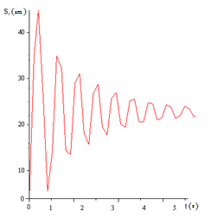
$e_{1}=0,006 m$ $e_{1}=0,008 m$
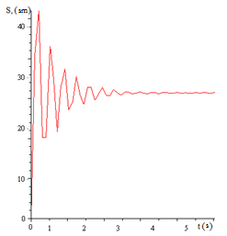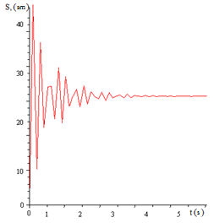
FIGURE 5. The dependence of cotton particles on the surface of the oscillating mesh surface in the cleaning of small impurities and the graph of changes in time at different values of angular velocities
$$ω_{1}=15 s^{-1}; ω_{2}=20 s^{-1}; ω_{3}=25 s^{-1}; ω_{4}=30 s^{-1};$$

From the analysis of the graphs, we can say that for effective cleaning of cotton pieces from small impurities, the vibration exponent of the vibrating screen is set at a value of ${ни e}_{3}=0,006 m$ and the angular velocity of the pin drum is $ω_{1}=15 s^{-1};$; which indicates effective separation of impurities from the screen surface.
The differential equation of motion of the cotton flow along the surface of the screen surface due to vibration on the plane of the ORF is as follows [7, 8];
$\left.\begin{aligned}m\ddot{x}=mAω^{2}sinωt+F \\ m\ddot{y}=mAω^{2}sinωt+N \end{aligned}\right\}$ (13)
where m - is the mass of a piece of cotton; ω - vibration frequency; A – vibration amplitude; g - acceleration of free fall; N- normal compressive strength; F - resistance force (Fig. 6).
$F=\left\{\begin{aligned}-fN if \dot{x}>0 \\ fN if \dot{x}<0\end{aligned}\right.$ (14)
where f - is the coefficient of sliding friction.
From equation (13), we determine the normal pressure of the cotton stream on the surface of the vibrating mesh:
$N=m\ddot{y}-mAω^{2}sinωt$ (15)

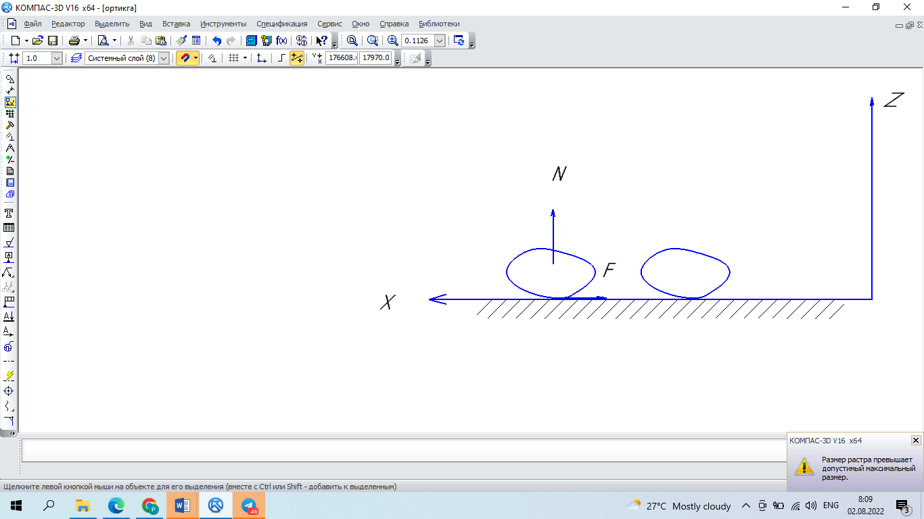
FIGURE 6. Pattern of movement of cotton particles on the surface of a vibrating mesh surface

If the movement of cotton particles is only along the OX axis, then it is equal $\ddot{у}=0$, then the equation (15) will look like this:
$N=-mAω^{2}sinωt$ (16)
Equation (16) gives the law of the normal pressure force N=N(t) over time. The dependence of the normal pressure force on the frequency and amplitude of oscillations over time in cleaning a cotton stream moving along a vibrating mesh surface from fine impurities is given.
We determine the equation of motion of a cotton stream along a mesh surface for Y=0 using equation (13):
$$m\ddot{x}=mAω^{2}sinωt+F$$
We replace F in equation (14) with F=fN:
$$m\ddot{x}- mAω^{2}sinωt±fN$$
$$m\ddot{x}-mAω^{2}sinωt±fN(-mAω^{2}sinωt)$$
$$\ddot{x}=Aω^{2}sinωt (1±f)$$
we integrate over time
$\dot{x}=Aω^{2}cosωt \left(1±f\right)+ C_{1}$ (17)
$x =Aω^{2} sinωt \left(1+f\right)+ C_{1} t + C_{2}$ (18)
Equation (17) is the speed of cotton flow along the surface of the oscillating mesh surface, and we use the following condition to determine the constants C₁ and C₂:

$$х\left(0\right)=0, \dot{х}\left(0\right)=0$$
from this
$$0=Aω \left(1±f\right)+ C_{1} ⇒ C_{1}= Aω \left(1±f\right)$$
$$C_{2}= - C_{1}t= Aω t\left(1±f\right)$$
Putting the constants in equation (18), the equation of the cotton flow along the surface of the oscillating mesh surface is determined.
$x=Asinω t \left(1±f\right)+ Aω t \left(1∓f\right)+ A ω t \left(1±f\right)$ (19)
Thus, equation (19) is a model of the process of cleaning oscillating fine impurities, in which the differential equation of the stationary motion of the cotton stream is constructed. From this equation, graphs are presented, which analyze the motion of cotton particles along the surface of the vibrating mesh, constructed using the Maple program (Figs. 7, 8).

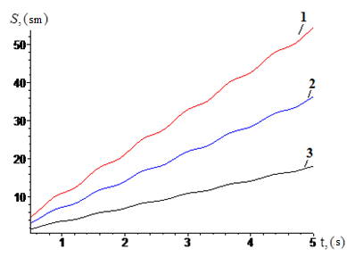
FIGURE 7. The graph of changes in time at different values of angular velocity during cleaning of
cotton particles from small impurities on the surface of a vibrating screen
$$ω_{1}=15 s^{-1}; ω_{2}=20 s^{-1}; ω_{3}=25 s^{-1};$$
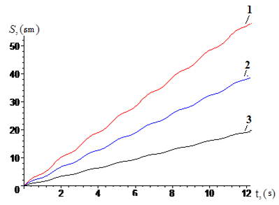
FIGURE 8. The graph of changes in time at different values of the vibration amplitude during the
cleaning of cotton particles from small impurities on the surface of the vibrating mesh
$А_{1}=4 mm; А_{2}=6 mm; А=8 mm;$
CONCLUSION
The differential equation of the movement of the cotton stream along the surface of the mesh is solved analytically and numerically, the results of which show that the speed of the cotton stream and its cleaning from fine impurities depend on the amplitude and frequency of the mesh along the horizontal plane.
The results show that the cleaning of the cotton stream from fine impurities and the vibrating mesh surface obey the parabolic law and the law of harmonic oscillation.
When the vibration frequency is 60 Hz and the vibration amplitude is 6 mm, it provides an effective cleaning of fine impurities from the cotton stream, while ensuring a cotton consumption of 7000 kg/h.
REFERENCES
- Rosulov, R. K. H. (2022). Investigation of the interaction of volts with cleaner grates. Izvestiya Vysshikh Uchebnykh Zavedenii, Seriya Teknologiya Tekstil'noi Promyshlennosti, (4), 166–171. https://doi.org/10.47367/0021-3497_2022_4_166
- Rosulov, R., Urakov, N., Diyorov, K., & Turdiyev, A. (2025). The impact of the tilt angle of the upgraded drum on the time the seeds spend in the drum. In Lecture notes in networks and systems (pp. 200–208). https://doi.org/10.1007/978-3-031-95649-2_17
- Gomaa, H., & Taweel, A. A. (2004). Dynamic analysis of mass transfer at vertically oscillating surfaces. Chemical Engineering Journal, 102(1), 71–82. https://doi.org/10.1016/j.cej.2004.02.004
- Blanpain-Avet, P., Doubrovine, N., Lafforgue, C., & Lalande, M. (1999). The effect of oscillatory flow on crossflow microfiltration of beer in a tubular mineral membrane system – Membrane fouling resistance decrease and energetic considerations. Journal of Membrane Science, 152(2), 151–174. https://doi.org/10.1016/s0376-7388(98)00214-2
- Rosulov, R., Pardaev, B., Erdonov, A., Berdimurodov, U., Diyorov, H., & Karshiev, O. (2025). Impact of peg drum shell diameter on cotton cleaning efficiency and productivity. AIP Conference Proceedings, 3304, 030032. https://doi.org/10.1063/5.0269589
- Djumaniyazov, K., Djumabaev, G., Juraeva, N., & Xurramov, A. (2021). Analysis of vibrations of the rings of the internal spinning machine. AIP Conference Proceedings, 2402, 070046. https://doi.org/10.1063/5.0072022
- Yuldashev, A., et al. K. (2023). Theoretical study of yarn tension in the spindle work of two-for-one twisting. AIP Conference Proceedings, 2789, 040117. https://doi.org/10.1063/5.0145422
- Qi, Z., Zhai, J., Li, G., & Peng, J. (2019). Effects of non-sinusoidal pitching motion on the propulsion performance of an oscillating foil. PLoS ONE, 14(7), e0218832. https://doi.org/10.1371/journal.pone.0218832

