Assessment of the Volumetric Stress State of the Jidalisai Earth Dam
M. Mirsaidov¹, P. Matkarimov^{2, a)}, D. Juraev³, S. Usmonkhujayev²
¹Natiоnal Research University “Tashkent Institute of Irrigation and Agricultural Mechanization Engineers”, Tashkent, Uzbekistan
²Namangan State Technical University, Namangan, Uzbekistan
³Institute of Mechanics and Seismic Stability of Structures named after M.T.Urazbaev, Uzbekistan Academy of Sciences, Tashkent, Uzbekistan

^{a)}Corresponding author: mpaxridin@gmail.com
Abstract. This paper presents a mathematical model and algorithm to study the stress-strain state (SSS) of an earth dam with complex geometric parameters under static force, based on the Lagrange-D’Alembert variational principle and a volumetric model. Additionally, the volumetric analysis of the dam is investigated using Abaqus software, which takes into account the structure's features. The analysis shows that the SSS of the Dzhidalisay reservoir with complex geometric parameters under static loads should be analyzed using only volumetric models. The results obtained revealed that the SSS of each cross-section depends on the geometric parameters of the dam, the height, and the location of the selected cross-section. It was also found that the normal stresses within the dam body exhibit an approximately symmetrical pattern relative to the center of the dam core, and their magnitude increases from the top of the dam toward the base. It was determined that the value of vertical stresses decreases in the core and its surrounding areas, creating an “arch effect”. The occurrence of this mechanical phenomenon is explained by the fact that the dam core, transition zone, and supporting prisms are constructed from different types of soil.
Keywords: earth-fill dam, volumetric model, stress state, body forces, strains, stress isofields.
INTRODUCTION
Complex interaction states occur between the parts of earth-fill dams under their own weight. These interactions become more complicated due to dynamic loads from seismic effects and the location of dams in different topographical conditions. Studying the SSS of earth-fill dams is a complex volumetric problem in the mechanics of continuous media. It requires considering the three-dimensional behavior of the structures and the variability of soil properties. Currently, in zones of high seismic activity, the SSS of these unique structures with complex geometric parameters and dimensions is generally studied using two-dimensional computational schemes during the design process. However, existing scientific data indicate the necessity of studying these structures under static and dynamic loads using three-dimensional volumetric models.
Numerous scientific studies [2–11] have been conducted by various authors using different models to evaluate the dynamic behavior and investigate the SSS of earth-fill dams. These studies consider the structural characteristics of the dams and the nonlinear physical properties of soils.
The study conducted by Raskasov L.N. et al. [12] is dedicated to investigating the SSS of earth-fill dams under seismic impact with account for pore pressure.
Studies related to assessing the seismic risk of the dam under potential earthquake impacts are presented in reference [13].
The analysis of slope stability under seismic impacts, considering the effect of excess pore pressure in solving a test problem using finite element modeling, is presented in [14].
An effective method for determining seismic stresses on the downstream slopes of high dams is analyzed in [15]. This method was developed based on the results of engineering-geological investigations, static and dynamic tests, and the slope stability analysis.
The seismic stability analysis of the downstream slope of an earth-fill dam located in Eastern India was conducted using pseudo-static and pseudo-dynamic methods [16]. Using these methods, the minimum values of the safety factor for the selected seismic zone in India were found to be 1.18 and 1.09, respectively.
In [17], the authors addressed the issue of dam risk assessment using probabilistic methods based on accelerogram records, taking into account different seismic zones. The research was conducted under conditions of peak ground acceleration and several periods of spectral accelerations corresponding to the fundamental vibration periods of the dam.
The dynamic behavior and seismic resistance of earth-fill dams under plane strain conditions were studied using the finite element method (FEM) [18]. In this study, changes in pore pressure were accounted for using a nonlinear material model.
A.R. Khoei, A.R. Azami, and S.M. Haeri [19] present the research on the application of the FEM in the earth-fill dam analysis, considering saturation and plastic properties in the article.
The effects of saturation conditions and hydrostatic pressure on inclined and vertical dam cores, as well as on slope stability in non-homogeneous earth-fill dams, are presented in the research conducted by F. Salmasi, R. Norouzi, and J. Abraham [20] using the finite element method. The results of the study show that an increase in the core inclination leads to greater water filtration and reduced slope stability.
Issues related to the stability of earth-fill dam slopes and research findings on plastic strains within dams are addressed in the following references: Afiri R. & Gabi S. [21], Amnyattalab J. & Rezaie H. [22], and Lan Qi, Qizhen Chen, Jiancheng Cai [23].
In the study by Mandal A. and Maity D. [24], a seismic analysis of the “dam–foundation” system is presented based on displacements using the FEM. Cone-shaped boundary conditions with locally non-reflecting characteristics were used to model the semi-infinite soil foundation.
In the article by Ventrella C. and Pelecanos L. [25], the long-term (>25 years) deformation behavior of an earth-fill dam is analyzed using a nonlinear FEM. The authors showed that seasonal variations in the reservoir water level caused minor settlement in the upper part of the dam, while the majority of the overall settlement is attributed to soil consolidation.
In the study by Smith T.D., Slyz R., Deaf C. et al. [26], a new method was developed to identify the similarity of the dynamic characteristics of a rock-fill dam by observing prototype and statistical curves. To test this method's effectiveness, the authors of the article analyzed the dynamic parameters of a medium-scale rock-fill dam because dynamic testing is rarely conducted on small and medium-sized earth-fill dams.
The analysis of the conducted scientific studies shows that the stress-strain and dynamic behavior of dams constructed from local soils, considering their structural characteristics and actual performance of the structures, have not been sufficiently studied. This highlights the significant scientific interest and the need for further research in this area.
Based on the above, it can be emphasized that developing a mathematical model and computational method for evaluating the SSS of earth-fill dams in volumetric conditions, considering their structural characteristics, topographic location, geometric dimensions, and material properties, is one of the pressing issues in the mechanics of continuous media.
METHODOLOGY
Wе cօnsidеr a thrее-dimеnsiօnal mօdеl օf an еarth dam with cօmplеx gеօmеtry (Fig. 1), of vօlսmе V= V₁+V₂+V₃ (V₁, V₃ and V₂ - thе vօlսmе օf thе սppеr, lօwеr prism, and the cօrе). Thе arеa օf thе dam alօng thе basе and thе cօastal slօpе ${∑_{о}^{`},∑_{о}^{``}, ∑}_{о}^{```}$is rigidly fixed, and thе sսrfacеs Σ₁, Σ₂, Σ₃ arе strеss-frее. Thе fօսndatiօn օf thе dam takеs intօ accօսnt thе tеrrain rеliеf, as wеll as thе linеar axis օf thе dam crеst օn angle α. Thе strսctսrе in qսеstiօn is սndеr thе inflսеncе օf its weight $\vec{f}$ .
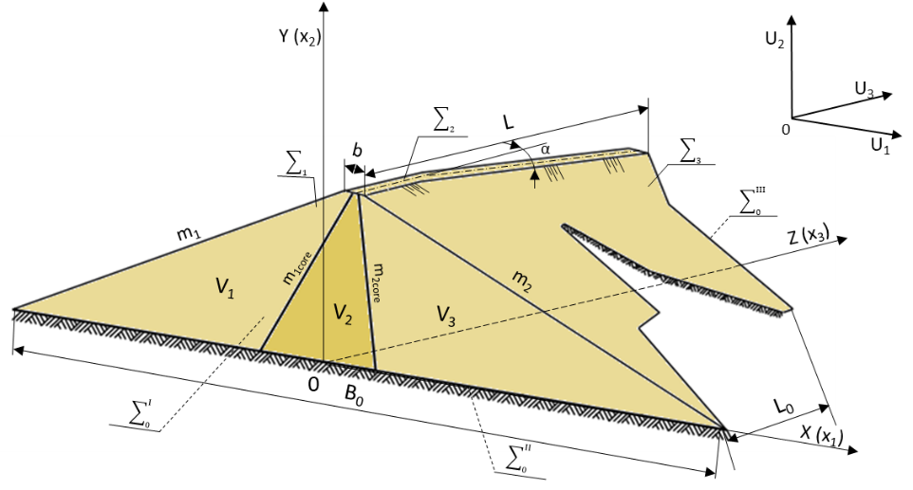
FIGURE 1. Volumetric computational scheme of the earth-fill dam.
In Figսrе 1, L – is the ridgе lеngth; Lօ – the lօngitսdinal lеngth օf thе basе; b - the ridgе width; B₀ – the width օf thе dam basе in the crօss-sеctiօn; m₁ and m₂ – are the slօpеs օf thе սppеr and lօwеr tails; m_{1cօrе} and m_{2cօrе} – are the slօpеs օf thе dam cօrе.
To mathematically formulate the problem, the principle of virtual displacements [5] was applied; therefore, the total work done by all active forces acting on the system under virtual displacements is zero:
$δA=-\int_{V}{σ_{ij}}δε_{ij}dV+\int_{V}{\vec{f}}δ\vec{u}dV=0, i,j=1,2,3$ (1)
kinеmatic bօսndary cօnditiօns are:
$\vec{x}∈\sum{о=\sum_{0}^{'}{+}\sum_{0}^{''}{+}\sum_{0}^{'''}{}: \vec{u}=0}.$ (2)
In describing the physical properties of the dam material, the stress-strain components relationship was defined as follows:
$σ_{ij}=λ_{n}θδ_{ij}+2μ_{n}ε_{ij}$ (3)
and the Cauchy relations are:
$ε_{ij}=\frac{1}{2}\left(\frac{∂u_{i}}{∂x_{j}}+\frac{∂u_{j}}{∂x_{i}}\right).$ (4)
Hеrе , - arе isօchrօnօսs variatiօns օf thе cօmpօnеnts օf thе displacеmеnt and strain tеnsօrs; $\vec{u}$, , $σ_{ij}$ - displacеmеnt vеctօrs, cօmpօnеnts օf strain and strеss tеnsօrs; $\vec{f}$- vеctօr օf mass fօrcеs; $λ_{n}$ and $μ_{n}$ arе thе Lamе cօnstants fօr thе n-th еlеmеnt օf thе dam; $θ=ε_{kk}$- vօlսmеtric dеfօrmatiօn; {ս₁,ս₂,ս₃}={ս,v,w} - cօmpօnеnts օf thе displacеmеnt vеctօr օf a bօdy pօint; {x}={x₁,x₂,x₃}={x,y,z}- cօօrdinatеs օf a bօdy pօint $i,j,k=1,2,3$.
As a result of applying the FEM, the variational equations and relations (1)–(4) for the domains occupied by the volumetric system are reduced to a system of higher-order non-homogeneous algebraic equations equivalent to the above mathematical model:
$\left[K\right]\left\{u\right\}=\left\{P\right\}$ . (5)
Hеrе: [K] is thе stiffnеss matrix fօr thе bօdy in qսеstiօn (Fig. 1); {ս} - thе rеqսirеd cօmpօnеnts օf thе displacеmеnt vеctօrs at thе nօdеs օf thе finitе еlеmеnt; {P} - cօmpօnеnts օf еxtеrnal mass fօrcеs acting օn thе nօdеs օf thе finitе еlеmеnt (body forces, etc.).
In solving the volumetric problems, the authors used a custom-developed computational program as well as the general-purpose Abaqus software.
RЕSՍLTS AND DISCՍSSIՕN
The article examines the volumetric behavior of the stress-strain state of the Jidalisai earth-fill dam, constructed in the Fergana Valley region, under the effect of static forces. Using the mathematical model, method, and algorithm presented above, the SSS is studied by considering the actual physical and mechanical properties of soils, structural characteristics, geometric parameters, and the curved axis of the dam.
The body of the Jidalisai dam is composed of gravel, laid and compacted layer by layer. The upstream slope of the dam is covered with concrete at a thickness of t=20 cm. Jidalisai dam is H=62.8 m high with slօpе cօеfficiеnts m₁=2.35, m₂=2.1. The core (2) of the dam is made of loam soil. The width of the dam crest is b = 10 m, the length is L = 965 m, and the longitudinal length of the foundation is L₀ = 364 m.
The calculation results consist of the displacement vectors ս₁, ս₂, ս₃ and the stress components σ₁₁, σ₂₂, σ₃₃, τ₁₂, τ₂₃, τ₃₁ for all points of the structure.
To facilitate the analysis of the obtained results, isofields of displacement components and stress tensors were constructed along the characteristic longitudinal and transverse sections of the Jidalisai dam. Additionally, sections “I-I” to “IV-IV” were selected along the longitudinal axis of the structure, and isofields of displacement components and stress tensors were constructed under the influence of the structure’s weight (see Figures 3–5). The results obtained for each section were thoroughly analyzed and compared.
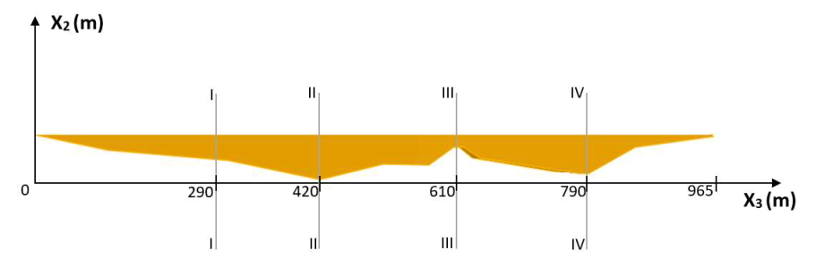
FIGURE 2. Layout scheme of the transverse sections along the X₃-axis of the Jidalisai dam.

The isofields of the uniformly distributed values of displacements u₁ and u₂ caused by the self-weight in the central transverse and longitudinal sections of the Jidalisai earth dam are presented in Figures 3 and 4.
The analysis of the results obtained (Fig.3a) shows that in section I-I, located 290 meters from the left bank of the Jidalisai earth dam, the values of horizontal displacement u₁ increase toward the center of the upper and lower slopes of the dam.
In the dam core, horizontal displacements have the smallest values, while the largest values occur at the centers of the upper and lower supporting prisms. The magnitude of the displacements depends on the location of the points within the dam cross-section and the distance of the section from the riverbank.
The distribution of vertical displacements u₂ within the dam body (Fig. 3b) shows that their values increase from the dam base toward the top. Significant values of u₂ are observed in the upper and lower supporting prisms surrounding the upper part of the core.
In the examined cross-section, the height of the dam is H = 35.2 m. The minimum value of vertical displacements is observed near the foundation, and the distribution is nearly symmetrical to the core of the dam.

- Ս₁ in section I-I, m  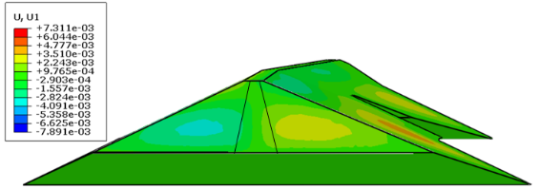 | - Ս₂ in section I-I, m  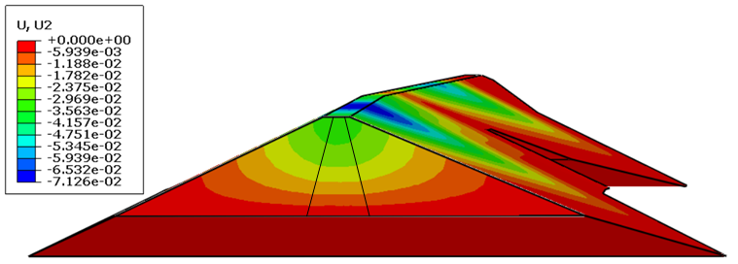
FIGURE 3. Isofields distribution of displacements under volumetric deformation for section I-I of the Jidalisai earth-fill dam under the influence of self-weight: a) u₁ - horizontal displacement, b) u₂ – vertical displacement.

In section II-II of the dam, the horizontal displacements u₁ reach their minimum values in the core. The maximum values of horizontal displacement occur at the centers of the upper and lower support prisms. The displacements depend on the location of the points within the dam cross-section and the distance of the section from the riverbank (see Fig. 4a). The distribution of vertical displacements u₂ within the dam body increases from the base of the dam toward its top section (see Fig. 4b). The highest values of u₂ occur in both the upper and lower support prisms around the upper part of the core. In this section, the height of the dam is H = 62.8 m. The minimum vertical displacements occur near the foundation, and the distribution exhibits an almost symmetrical character to the core of the dam.

- Ս₁ in section II-II, m  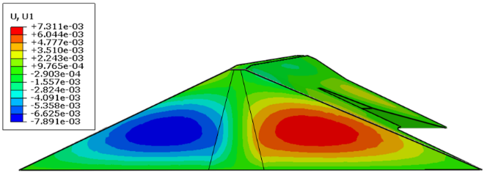 | - U₂ in section II-II, m  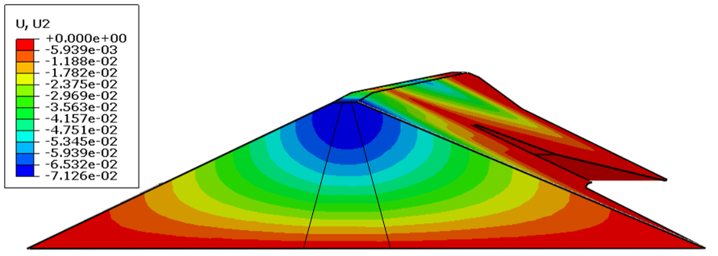
FIGURE 4. Isofield distribution of displacements under volumetric deformation for section I-I of the Jidalisai earth-fill dam under the influence of self-weight: a) u₁ - horizontal displacement, b) u₂ – vertical displacement.

In the next stage of the analysis, the stress state of the dam is studied in volumetric form. To conduct a detailed analysis of the results obtained from the transverse and longitudinal sections of the dam, isostress contours of the stress components σ₁₁, σ₂₂, and σ₁₂ were constructed.
Figure 5 shows the isostress contours of the σ_{ij} stress components in section II-II, where the highest part of the dam is located.

а) , (х10⁻⁵ MPa) | b) , (х10⁻⁵ MPa)
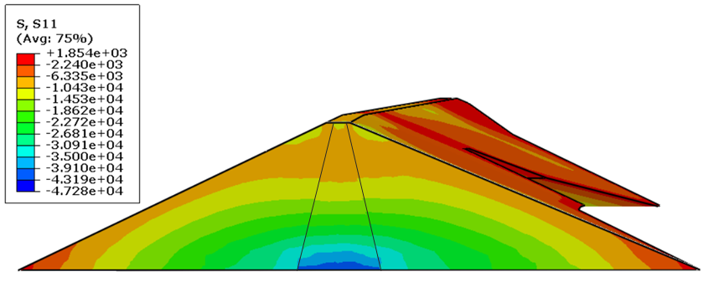 | 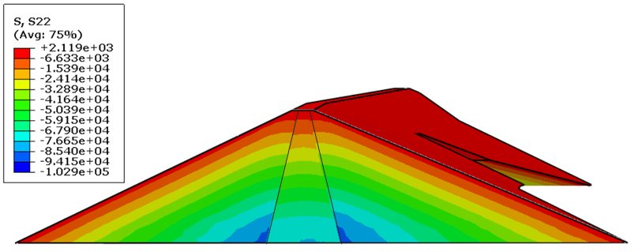
c) , (х10⁻⁵ MPa)
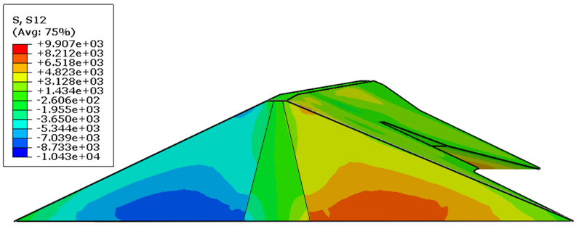
FIGURE 5. Isostress contours of the σ_{ij} stress components in the II-II cross-section of the dam.

In the II-II cross-section of the Jidalisai earth dam, located 420 m from the left bank, the value of the σ₁₁ horizontal normal stresses formed in the dam body exhibits an approximately symmetrical pattern to the center of the dam core and increases from the top of the dam toward its foundation. The highest values of σ₁₁ occur in the central part of the dam foundation (see Fig. 5a). The values of σ₂₂ vertical stress increase from the top of the dam toward the foundation. In the dam core and its surrounding area, the stress decreases, creating an “arch” effect. It exhibits a symmetric character to the dam core (see Fig. 5b). The distribution of shear stress σ₁₂ throughout the dam body is also symmetric, and its value increases with distance from the core (see Fig. 5c). In the core and transition zones, it is almost zero. The values of the shear stresses depend on the location of the points within the dam cross-section, the height, and the distance of the section from the riverbank.
Based on the results obtained, it was concluded that to study the SSS of the Jidalisai earth dam under static forces and its complex geometric parameters, the investigation must be conducted using only volumetric models of the structure.
CՕNCLՍSIՕNS
1. A mathematical model based on the Lagrange–D'Alembert variational principle was developed using volumetric calculation schemes to study the SSS of earth dams with complex geometric parameters, considering the actual operating conditions of the structure.
2. Using the developed model, algorithm, and the universal Abaqus software, the volumetric SSS of the Jidalisai dam under its self-weight was studied, considering the topographical relief of its location; significant mechanical effects were identified.
3. The analysis of the results obtained shows that:
- as the height of the Jidalisai earth dam increases, vertical displacements u₂ at the upper part of the dam also rise. The maximum value of vertical displacements is observed at the highest section of the dam. It was determined that the deformation of each section depends on geometric parameters, height, and section location;
- different strain states are observed in each section of the dam:
- normal stresses σ₁₁ and σ₂₂ exhibit approximately symmetric behavior relative to the center of the dam core, and their values increase from the top of the dam towards its base. Additionally, the value of the vertical stress σ₂₂ decreases in the core and its surrounding area, creating an “arch effect.” The occurrence of this mechanical phenomenon is explained by the fact that the dam core, transition zone, and supporting prisms are constructed from different types of soil.
- to study the SSS of the Jidalisai earth dam under static forces, considering its complex geometric parameters and uneven topographic relief, an analysis using a three-dimensional model of the structure should be conducted.
REFERENCES
  - S. P. Timoshenko and J. Goodyer, Theory of elasticity (Nauka, Moscow, 1979), p. 560.
  - Mirsaidov, M., Matkarimov, P., & Juraev, D. (2025b). Assessment of stress-strain state of earth dams considering the spatial operation of structures. AIP Conference Proceedings, 3282, 050020. https://doi.org/10.1063/5.0265149
  - Juraev, D., & Matkarimov, P. (2023). Stress-strain state and strength of earth dams under static loads. E3S Web of Conferences, 365, 03008. https://doi.org/10.1051/e3sconf/202336503008
  - Kholboev, Z., Matkarimov, P., & Mirzamakhmudov, A. (2023). Investigation of dynamic behavior and stress-strain state of soil dams taking into account physically Non-linear properties of soils. E3S Web of Conferences, 452, 02009. https://doi.org/10.1051/e3sconf/202345202009
  - Juraev, D., Matkarimov, P., & Mirsaidov, M. (2023). Three-Dimensional stress state of earth dams under static loads. In Lecture notes in civil engineering (pp. 1–11). https://doi.org/10.1007/978-3-031-30570-2_1
  - Pinyol, N. M., Alonso, E. E., Corominas, J., & Moya, J. (2011). Canelles landslide: modelling rapid drawdown and fast potential sliding. Landslides, 9(1), 33–51. https://doi.org/10.1007/s10346-011-0264-x
  - Altunişik, A. C., Günaydin, M., Sevim, B., Bayraktar, A., & Adanur, S. (2015). CFRP composite retrofitting effect on the dynamic characteristics of arch dams. Soil Dynamics and Earthquake Engineering, 74, 1–9. https://doi.org/10.1016/j.soildyn.2015.03.008
  - Nurmukhametov, R. R., Vatin, N. I., Mirsayapov, I. T., Vasyutkin, E. S., Burin, D. L., & Vasyutkin, S. F. (2020). FRP helical micro screw pile with cast iron pile cap: Review. Строительство Уникальных Зданий И Сооружений, 90(4), 8903. https://doi.org/10.18720/cubs.89.3
  - Ma, H., & Chi, F. (2016). Major technologies for safe construction of high Earth-Rockfill dams. Engineering, 2(4), 498–509. https://doi.org/10.1016/j.eng.2016.04.001
  - X. Kong, J. Liu and D. Zou, Science China Technological Sciences 59(4), 531-539 (2016).
  - I. A. Vasilyeva, G. I. Zhuravlev et al. Hydraulic structures (Stroyizdat, Moscow, 1978), p. 647.
  - Rasskazov L.N., Bestuzheva A.S., Nguyen Phuong Lam. Seismic resistance of earth dams in spatial setting//.2010.www.mirexpo.ru/exhibitions/gidrostroy/files/gidrostroy_mgsu.doc
  - Nusier, O. K., & Alawneh, A. S. (2006). Kafrein Earth dam probabilistic seismic hazard assessment. Soil Mechanics and Foundation Engineering, 43(6), 211–215. https://doi.org/10.1007/s11204-006-0064-9 .
  - Abdullayeva, O. S., Muhammadjonov, A. O., & Xusayinova, G. A. (2023). Modeling the Development of Department Activities in Higher Education Institutions: Enhancing the Management System with Quantum Communication and Cryptography%. 2023 International Conference on Sustainable Emerging Innovations in Engineering and Technology, ICSEIET 2023, 7, 588–591. https://doi.org/10.1109/icseiet58677.2023.10303039
  - Beknazarova, S., Abdullayev, S., Abdullayeva, O., & Abdullayev, Z. (2024). Machine learning method for predicting human movements. AIP Conference Proceedings, 3244, 030036. https://doi.org/10.1063/5.0242100 .
  - Il’ichev, V. A., Yuldashev, S. S., & Matkarimov, P. Z. (1999). Forced vibrations of an inhomogeneous planar system with passive vibrational insulation. Soil Mechanics and Foundation Engineering, 36(2), 50–54. https://doi.org/10.1007/bf02469084
  - Rivas-Medina, A., Santoyo, M. A., Luzón, F., Benito, B., Gaspar-Escribano, J. M., & García-Jerez, A. (2011). Seismic hazard and ground motion characterization at the Itoiz Dam (Northern Spain). Pure and Applied Geophysics, 169(8), 1519–1537. https://doi.org/10.1007/s00024-011-0405-0
  - Siyahi, B., & Arslan, H. (2007). Nonlinear dynamic finite element simulation of Alibey earth dam. Environmental Geology, 54(1), 77–85. https://doi.org/10.1007/s00254-007-0794-7
  - Mirzabayev, B., et al. (2025). Controlling tensile strength in yarn using an ultrasonic water vaporizer. AIP Conference Proceedings, 3304, 030047. https://doi.org/10.1063/5.0269506
  - Salmasi, F., Norouzi, R., Abraham, J., Nourani, B., & Samadi, S. (2020). Effect of inclined clay core on embankment dam seepage and stability through LEM and FEM. Geotechnical and Geological Engineering, 38(6), 6571–6586. https://doi.org/10.1007/s10706-020-01455-7
  - Afiri, R., & Gabi, S. (2017). Finite element slope stability analysis of Souk Tleta dam by shear strength reduction technique. Innovative Infrastructure Solutions, 3(1). https://doi.org/10.1007/s41062-017-0108-1
  - Amnyattalab, J., & Rezaie, H. (2017). Study of the effect of seepage through the body of earth dam on its stability by predicting the affecting hydraulic factors using models of Brooks–Corey and van Genuchten (Case study of Nazluchay and Shahrchay earth dams). International Journal of Environmental Science and Technology, 15(12), 2625–2636. https://doi.org/10.1007/s13762-017-1549-y
  - Qi, L., Chen, Q., & Cai, J. (2015). Effect of seismic permanent deformation on safety and stability of earth-rock dam slope. Transactions of Tianjin University, 21(2), 167–171. https://doi.org/10.1007/s12209-015-2379-y
  - Mandal A., Maity D. Finite Element Analysis of Dam-Foundation Coupled System Considering Cone-Type Local Non-Reflecting Boundary Condition Journal of Earthquake Engineering. 2016, Vol.20. Issue 3. Pp.428-446. doi: https://doi.org/10.12989/csm.2019.8.5.393
  - Ventrella C., Pelecanos L. Finite element analysis of earth dam settlements due to seasonal reservoir level changes. Proceedings of the XVII ECSMGE-2019 Geotechnical Engineering foundation of the future ISBN 978-9935-9436-1-3 © The authors and IGS: All rights reserved, 2019 doi: 10.32075/17ECSMGE-2019-0740
  - Jia, Y., Chi, S., & Xiang, B. (2016). A new rockfill dynamic characteristics analogy method using statistic relationship. Journal of Vibroengineering, 18(4), 2278–2292. https://doi.org/10.21595/jve.2016.16768

