Extrinsic Photoconductivity and Photo-Electrodistributive Force in pCdTe/nCdS and pCdTe/nCdSe Heterostructures with Deep Impurity Levels
Salim Otajonov^{1, a)}, Ravshanbek Ergashev^{1, b)}, Kadir Botirov¹, Umida Marufova¹, Oygul Mamasoliyeva¹, Syrga Berdibekova², Muxlisa Solijonova¹
¹Fergana State University, Fergana, Uzbekistan
²Osh Technological University, Osh, Kyrgyzstan

^{a)}Corresponding author: otajonov_s@mail.ru
^{b)}rova08@pf.fdu.uz
Abstract: In this paper, we consider the impurity photoconductivity and photovoltage in pCdTe/nCdS and pCdTe/nCdSe heterostructures with the addition of Group I elements as a dopant. It was found that the addition of the dopant significantly increases the photosensitivity in the absorption region of 0.4-3.0 eV and creates a long tail in the impurity absorption region, which is associated with silver or copper. The activation energies of deep levels were determined to be E₁=1.15 eV; E₂=1.33 eV; E₃=0.95 eV; which are responsible for the impurity photoelectromotive force.
Keywords: photosensitivity, activation energy, ligand, voltage, homojunction, effective mass.
INTRODUCTION
With the rapid growth of interest in renewable energy sources worldwide, there is a growing need for affordable, naturally occurring, and highly efficient semiconductor materials. Therefore, in modern semiconductor materials science, the A2B6 compound is receiving considerable attention in research to create new semiconductor compounds with unique properties suitable for the fabrication of low-cost and efficient solar cells. A potential avenue for research in this field involves developing photovoltaics using thin films composed of a combination of CdTe, CdS, and CdSe. [1].
The analysis of heterojunction properties is only possible when the band diagram is known and its key parameters are determined quantitatively [2]. Most studies of energy band diagrams in heterojunctions are closely linked to research on metal–semiconductor diodes and p–n homojunctions. The equilibrium energy diagram of a laser with an abrupt double heterojunction and minimal interface states involves n–n, n–p, and p+–p junctions [3]. The offset at the conduction energy band boundary ECE_CEC​ is determined by The variation in electron affinities between the two materials, whereas the built-in voltage VDV_DVD​ equals to the total of the built-in voltages on each part: VD=VD1+VD2V_D = V_{D1} + V_{D2}VD​=VD1​+VD2​. Importantly, because the forbidden energy gaps differ, effective resistant height—or quasi-built-in voltage—for electrons is not the same as that for holes.
The abrupt junction model serves as a reasonable approximation for many heterojunctions, especially when interface states are negligible [4]. However, attempts have been made to account for interface states by considering their influence on semiconductor band bending [5]. When present, these states produce charge accumulation—both monopolar and dipolar distributions at the interface, thereby modifying band bending [6]. As a result, some researchers argue that the conduction band offset (CBO) does not simply equal the electron affinity difference but is shifted by the dipole charge contribution [7].
Theoretical models of current transport in heterojunctions are generally adapted from homojunction theories, with adjustments for parameter changes at the interface. These modifications tend to reduce the contribution of various current components, since parameter discontinuities at the interface increase the likelihood of carrier reflection. Overall, the fine details of interface structure, such as abruptness, remain insufficiently characterized for precise calculations.
To explain the observed reduction in forward current, an American researcher introduced the concept of the transfer coefficient XXX. This parameter is characterized by the quotient between charge carrier density that successfully pass through the barrier to conduction and the total number of carriers that possess enough energy to overcome it.
In this regard, we conducted a study in pCdTe/nCdS and pCdTe/nCdSe heterostructures doped with a first-group element, which showed themselves in deep impurity levels of CdTe.
RESEARCH METHODOLOGY
A modern working chamber was used to produce controlled and activated photosensitive films. The vacuum in the working chamber reached approximately 10-5 mmHg. The vacuum chamber was made of glass, quartz, or metal with a glass porthole in the form of a cylindrical dome 15 cm in diameter and 35 cm high, where the initial semiconductor material and impurity were deposited. A frame-like holder was located 15-20 cm from the bottom of the working vacuum chamber, onto which the substrates were attached.
Measurements of the spectral dependences of photoconductivity (PC) and short-circuit current (Isc) were performed using constant photoconductivity methods on a setup equipped with a Globar illuminator and an IKS-14 monochromator..
EXPERIMENTAL RESULTS AND DISCUSSION
We propose a band diagram for the same p-CdTe/n-CdS heterostructure (see Fig. 1), but with a graded transition region, as illustrated in Fig. 2. This approach extends the earlier model [8] originally developed by other researchers for the n–n homojunction [9]. In this case, the effect resulting from dipole distributions on the electronic state range chart is treated as insignificant. A key characteristic of the graded band-gap model is that the force acting on electrons in the conduction band is not the same as that on holes within the valence band, as the force is directly related as a function of the gradient of the corresponding energy spectrum. To date, however, relatively minimal theoretical study has been devoted to describing the energy spectrum diagram within the interfacial region of a compositionally varied heterostructure.

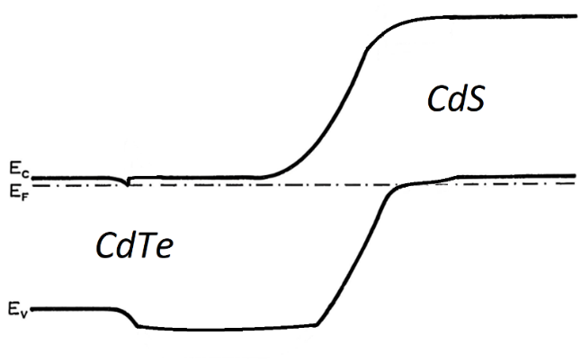
FIGURE 1. Equilibrium band structure of a graded double heterojunction with near-zero interfacial states.

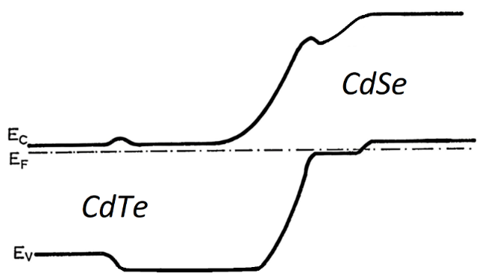
FIGURE 2. Equilibrium band structure of a graded double heterojunction with near-zero interfacial states.

The forward conduction in heterostructure interface may generally be classified to dual mechanisms: thermodynamic and athermal induced. The thermodynamic current mechanism is well established, arises from electrons and/or holes that must surmount a potential barrier to traverse the junction; it exhibits an exponential dependence on the applied voltage [10]. Non-thermal currents, often described as excess currents, encompass several processes. These include diffusion currents, which are limited by the carriers’ ability to diffuse away from the depletion region [11, 12], as well as tunneling, recombination, or multistep reactions. Recombination–tunneling currents, in particular, resemble the excess current processes observed in tunnel diodes, where interband tunneling is accompanied by recombination events that may proceed through multiple stages [13].
Experimental studies on n-ZnSe/p-Ge heterojunctions revealed that their current–voltage behavior is dominated by the highly resistive bulk ZnSe layer, which is effectively in series with the junction and produces a space-charge-limited current [14]. Comparable observations were reported for n-CdSe/n-CdS heterojunctions [15].
A consistent feature across these models is that reverse saturation currents, unlike in p–n homojunctions, are not constant but instead increase gradually with voltage until a soft breakdown occurs—an effect commonly seen in heterojunctions. When interface states are included in the models, n–n or p–p heterodevices may display rectifying behavior in either polarity, or saturation in both, much like two metal–semiconductor diodes connected back-to-back [16]. Under conditions of strongly asymmetric doping, this concept allows for the formation of a specialized device. In such cases, the heavily doped side develops a very thin depletion region, enabling electron tunneling, so that only one active depletion region functions as a single metal–semiconductor barrier. This configuration is expected to yield true rectification, the polarity of which can be reversed by altering the doping asymmetry.
The fundamental physical properties of semiconductor crystals are determined by four key factors:
1 Crystal Framework
2 Electronic Band Structure
3 Charge Transport Properties
4 Defects and Material Imperfections
For CdTe and CdSe, the crystal structure plays an important role. CdTe, with a zinc blende structure, exhibits piezoelectric behavior, while CdSe in its wurtzite phase is both pyroelectric and piezoelectric.
The energy band structure governs transport properties by determining electron–hole concentrations. Compounds of the A2B6 family are characterized by a direct band gap with both the conduction band minimum and valence band maximum located at k=(0,0,0)k = (0,0,0)k=(0,0,0). For CdTe, optical absorption measurements confirmed this direct-gap nature [17]. In the case of CdSe, analysis of exciton spectra using the Zeeman effect showed that the band extrema are either located at k=(0,0,0)k = (0,0,0)k=(0,0,0) or very close to it, also indicating a direct minimum gap [18].
Transport properties depend primarily on carriers within a few hundredths of an electronvolt near the conduction and valence band edges. Within this narrow range, the essential parameters are:
a) The nature of the band gap (direct or indirect) and the location of extrema in k-space;
b) The effective mass of carriers;
c) Possible curvature effects caused by degeneracy or nonparabolicity.
For CdTe, and likely for CdSe in the zinc blende structure, the conduction band minimum at k=(0,0,0)k = (0,0,0)k=(0,0,0) is non-degenerate, resulting in isotropic electron effective mass and mobility. Similarly, the valence band maximum at k=(0,0,0)k = (0,0,0)k=(0,0,0) implies isotropic effective mass, mobility, and scattering for holes.
In contrast, the wurtzite structure introduces anisotropy. Both the conduction and valence bands are anisotropic, though the conduction band remains nearly isotropic in terms of effective mass and mobility. The valence band, however, is distinctly anisotropic at k=(0,0,0)k = (0,0,0)k=(0,0,0), leading to anisotropic hole masses. For CdSe in the wurtzite structure, dielectric permittivity is also anisotropic, with different values parallel and perpendicular to the c-axis. These anisotropic properties, together with other transport parameters, define the electronic behavior of CdTe and CdSe at room temperature [19].
Based on the above, it can be concluded that, in the literature reviews cited above, many scientists have investigated the optical, electrical, and photoelectric properties of polycrystalline heterostructures based on CdTe/CdS and CdTe/CdSe. Analysis and summary of their results show that the behavior of various impurities in CdTe under irradiation and the role of impurities in the occurrence of extrinsic photoconductivity remain unclear.
Cadmium telluride films were specially doped with silver, which rapidly diffuses into CdTe [20] and can create deep levels with an activation energy of Ev +0.30 - 0.35 eV [21]. Due to the migration of silver atoms along the intercrystallite boundaries (this is energetically preferable), surface centers of the acceptor type Eс-1.15 eV are formed along the crystallite boundaries into the film depth. A change in the charge states of such levels leads to an additional change in the barrier height in the band bending region and the formation of similar potential barriers in the film depth. Since deep levels of the Eс-1.15 eV type are localized only in the intercrystallite region, as can be seen from Fig. 3, the contribution of these levels to the PT is negligible compared to the contribution of the other levels. Copper could also have been present in the films under study as an uncontrolled impurity, creating centers with almost the same activation energy [22]. During implantation, the concentration of tellurium inclusions increased, and copper and silver atoms could heterogeneously interact with these inclusions. Heat treatment facilitated the reverse diffusion of these atoms into the potential barrier regions (Figure 3). E₅ levels were created by complexes of silver or copper atoms, so their localization on the crystallite surface was preferable. During ion implantation, these complexes could be disrupted and reformed during heat treatment. Defects created during heat treatment become mobile. They migrate to traps (surfaces, grain boundaries), recombine with each other (for example, an interstitial atom recombines with a vacancy), or form new defects by combining with each other or with defects of other types (or impurities). Deep levels with optical activation energies of Ev +0.35, Ec –0.70 and Ev +0.95 eV were found in CdTe single crystals doped with chlorine during growth and heat treatment in Te vapor.

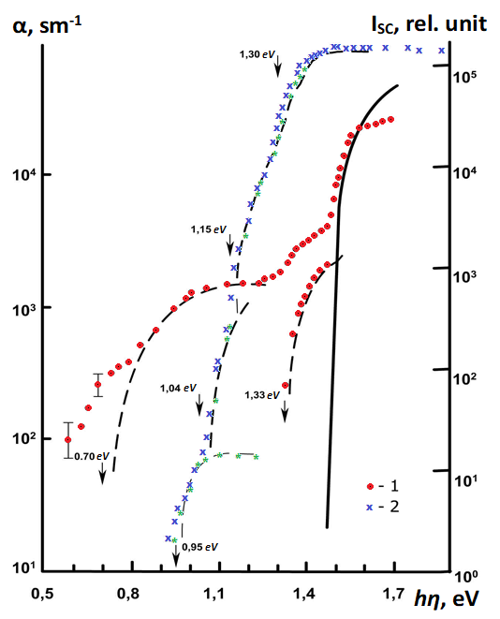
FIGURE 3. Absorption spectrum (1) and Isc (2) of CdTe:Ag films under frontal illumination. The solid line is the absorption edge of a CdTe single crystal.

In the case of impurity absorption =σ_{fi}‧n_{i}, where σfi is the cross section of photon capture, ni is the concentration of filled i-centers, which has spatial inhomogeneity.
A certain fraction of α, associated with the absorption of photons only in barrier regions with electron transitions of types 1 and 2 (see Fig. 3), participates in the generation of photo-EMF. Incomplete coincidence of the experimental absorption spectra αv and short-circuit current Isc(v) in the impurity absorption region (Fig. 3) is due to the obviously significant frequency dependence of the quantum yield ηv of photon absorption by impurity centers with subsequent spatial separation of the photocarrier of the same sign and the ion. From a comparison of the spectral curves αv and Isc(v) in Fig. 3 it follows that the quantum yield for the impurity photo-EMF in the frequency range hη<0.95 eV is negligible, however, with an increase in frequency in the range of (0.95÷1.3) eV, η increases more than several times, while α increases by less than 1 order of magnitude. In the frequency range hη≥Eg=1.50 eV (T÷300 K), the absorption coefficient α, as well as the quantum yield η, and therefore Isc, also experiences saturation.
CONCLUSION
In conclusion, doping CdTe/CdS and CdTe/CdSe heterostructures with Group I elements creates deep impurity levels in the CdTe band gap, which contribute to the impurity photo-EMF of CdTe. These levels significantly contribute to the impurity photo-EMF. The following deep impurity levels have been determined that contribute to the impurity photo-EMF: E₁ = 1.15 eV; E₂ = 1.33 eV; E₃ = 0.95 eV.
These studies will contribute to the impurity and intrinsic regions of semiconductors, which makes it possible to fabricate photodetectors over a wide range of received electromagnetic radiation.
REFERENCES
- M. Guseynaliyev. Study of the transformation process of thin CdS films to CdTe. Natural and Mathematical Sciences in the Modern World. SibAK No. 9 (33), 2015, pp. 44–49. https://sibac.info
- Zakharov, A. Y., Zakharov, M., & Kazakov, A. (2023). Theory of the electronic structure of semiconductor solid solutions of isovalent substitution. Vestnik NovSU, 1, 47–57. https://doi.org/10.34680/2076-8052.2023.1(130).47-57
- Fernández-Domínguez, E., Torres-Delgado, G., Castanedo-Pérez, R., Márquez-Marín, J., & Zelaya-Ángel, O. (2021). Effects of rapid thermal annealing as back contacts activation treatment on CdS/CdTe multi-contacted solar cells. Superlattices and Microstructures, 151, 106832. https://doi.org/10.1016/j.spmi.2021.106832
- Sürücü, G., Güllü, H. H., Bayraklı, Ö., & Parlak, M. (2017). Enhancement in photovoltaic characteristics of CDS/CDTE heterojunction. Journal of Polytechnic, 801–805. https://doi.org/10.2339/politeknik.368993
- Rami, M., Benamar, E., Fahoume, M., Chraibi, F., & Ennaoui, A. (2011). Effect of heat treatment with CdCl2 on the electrodeposited CdTe/CdS heterojunction. PRSM, 3. https://doi.org/10.34874/prsm.mjcm-vol3iss0.65
- Il’chuk, G. A., Kusnezh, V. V., Rud, V. Y., Rud, Y. V., Shapowal, P. Y., & Petrus, R. Y. (2010). Photosensitivity of n-CdS/p-CdTe heterojunctions obtained by chemical surface deposition of CdS. Semiconductors, 44(3), 318–320. https://doi.org/10.1134/s1063782610030085 .
- Kuciauskas, D., Moseley, J., & Lee, C. (2021). Identification of Recombination Losses in CdSe/CdTe Solar Cells from Spectroscopic and Microscopic Time‐Resolved Photoluminescence. Solar RRL, 5(4). https://doi.org/10.1002/solr.202000775
- Muzafarova, S. A., Mirsagatov, S. A., & Dzhamalov, F. N. (2009). Effect of irradiation with gamma-ray photons on the charge-transport mechanism in n-CdS/p-CdTe heterostructures. Semiconductors, 43(2), 175–180. https://doi.org/10.1134/s1063782609020109
- Muzafarova, S. A., Mirsagatov, S. A., & Janabergenov, J. (2007). Mechanism of charge transfer in n-CdS/p-CdTe heterojunctions. Physics of the Solid State, 49(6), 1168–1174. https://doi.org/10.1134/s1063783407060248
- Razykov, T., Contreras-Puente, G., Chornokur, G., Dybjec, M., Emirov, Y., Ergashev, B., Ferekides, C., Hubbimov, A., Ikramov, B., Kouchkarov, K., Mathew, X., Morel, D., Ostapenko, S., Sanchez-Meza, E., Stefanakos, E., Upadhyaya, H., Vigil-Galan, O., & Vorobiev, Y. (2008). Structural, photoluminescent and electrical properties of CdTe films with different compositions fabricated by CMBD. Solar Energy, 83(1), 90–93. https://doi.org/10.1016/j.solener.2008.07.003
- Gaubas E., Ceponis T., Sakalauskas S., Uleckas A., Velicka A., Fluence dependent variations of barrier charging and generation currents in neutron and proton irradiated Si particle detectors, Lith. J. Phys. 51 (2011) pp. 230–236. https://doi.org/10.3952/physics.v51i3.2034
- Mirzabayev, B., et al. (2025). Controlling tensile strength in yarn using an ultrasonic water vaporizer. AIP Conference Proceedings, 3304, 030047. https://doi.org/10.1063/5.0269506
- Gaubas, E., Simoen, E., & Vanhellemont, J. (2016). Review—Carrier Lifetime spectroscopy for defect characterization in semiconductor materials and devices. ECS Journal of Solid State Science and Technology, 5(4), P3108–P3137. https://doi.org/10.1149/2.0201604jss
- Burlakov, I. D., Dirochka, A. I., Korneeva, M. D., Ponomarenko, V. P., & Filachev, A. M. (2016). Solid state photoelectronics: the current state and new prospects. Journal of Communications Technology and Electronics, 61(10), 1166–1174. https://doi.org/10.1134/s1064226916100053
- Kuddus, A., Ismail, A. B. M., & Hossain, J. (2021). Design of a highly efficient CdTe-based dual-heterojunction solar cell with 44% predicted efficiency. Solar Energy, 221, 488–501. https://doi.org/10.1016/j.solener.2021.04.062
- Ren, B., Zhang, J., Liao, M., Huang, J., Sang, L., Koide, Y., & Wang, L. (2019). High-performance visible to near-infrared photodetectors by using (Cd,Zn)Te single crystal. Optics Express, 27(6), 8935. https://doi.org/10.1364/oe.27.008935
- Dirin, D. N., Vasiliev, R. B., Sokolikova, M. S., & Gaskov, A. M. (2010). Synthesis, morphology, and optical properties of colloidal CdTe/CdSe and CdTe/CdS nanoheterostructures based on CdTe tetrapods. Inorganic Materials, 47(1), 23–28. https://doi.org/10.1134/s0020168511010031
- Klyuev, V. G., Pham Thi Hai, M., & Bezdetko, Y. S. (2014). NATURE OF THE LUMINESCENCE CENTERS OF CdS NANOCRYSTALS. Kondensirovannye Sredy I Mezhfaznye Granitsy = Condensed Matter and Interphases, 16(1), 27-31. Retrieved from https://journals.vsu.ru/kcmf/article/view/800
- Saikia, D., & Phukan, P. (2014). Fabrication and evaluation of CdS/PbS thin film solar cell by chemical bath deposition technique. Thin Solid Films, 562, 239–243. https://doi.org/10.1016/j.tsf.2014.04.065
- Yang, J., Yin, W., Park, J., Ma, J., & Wei, S. (2016). Review on first-principles study of defect properties of CdTe as a solar cell absorber. Semiconductor Science and Technology, 31(8), 083002. https://doi.org/10.1088/0268-1242/31/8/083002
- Otazhonov, S., Akhmedov, T., Karimov, I., Ibragimova, B., Botirov, K., Ergashev, R., Alimov, N., Yokubzhonova, M., & Abdusattorova, M. (2023). Study of defects in photosensitive CdTe thin films under deformation. Scientific Collection «InterConf», (150), pp. 481–491. Retrieved from. https://archive.interconf.center/index.php/conference-proceeding/article/view/3018
- Alhammadi, S., Jung, H., Kwon, S., Park, H., Shim, J., Cho, M. H., Lee, M., Kim, J. S., & Kim, W. K. (2018). Effect of Gallium doping on CdS thin film properties and corresponding Cu(InGa)Se2/CdS:Ga solar cell performance. Thin Solid Films, 660, 207–212. https://doi.org/10.1016/j.tsf.2018.06.014

