Changes in the Volume Width and Capacitance of P-N-Junction Diodes under the Influence of a Magnetic Field and Temperature
Gafur Gulyamov, Gulnoza Majidova, Feruza Muxitdinova,
Saodat Madumarova^{a)}
Namangan State Technical University, Namangan, Uzbekistan

^{a)}Corresponding author: saodatmadumarova0609@gmail.com
Abstract: This article examines changes in the current-voltage characteristic (I-V) of p-n junction diodes under the influence of the Nehrs-Ettinghausen effect and a magnetic field. These effects cause variations in the width of the sample's bulk field, as well as the causes of changes in the charge carrier distribution when controlling the diffusion and bulk capacitances. The Nernst-Ettinghausen effect, temperature gradient, and magnetic field create an electromotive force (EMF). The temperature gradient speeds up the movement of charge carriers. The magnetic field changes their direction due to the Lorentz force.This disrupts the carrier distribution, influences diffusion, and results in changes in bulk capacitance. These processes are compared for homogeneous and inhomogeneous semiconductor samples.
Keywords: current-voltage characteristic (I-V), Nernst-Ettinghausen effect, bulk capacitance, diffusion capacitance, thermal gradient, electromotive force(EMF), recombination, Hall effect.
INTRODUCTION
The scientific research is now developing quickly all over the world, and practical experiments are especially active in the field of semiconductors. This is explained by a fast pace of development of modern technologies. Various physical processes occur when a diode is exposed to external voltage, temperature, light, magnetic fields, mechanical forces, and waves. This article examines the Nernst–Ettingshausen effect and the influence of a magnetic field on the p–n junction of a diode, both theoretically and experimentally. Let us consider these effects first for homogeneous semiconductors. If a semiconductor in which there is a temperature gradient along one of its sides is placed in a magnetic field perpendicular to this gradient, then secondary phenomena arise known as thermomagnetic effects. Among them are the longitudinal Nernst–Ettingshausen effect. In the presence of a temperature gradient, some thermoelectric force inevitably arises in a semiconductor. If such a semiconductor is placed in a magnetic field perpendicular to the temperature gradient, the magnitude of the thermoelectric force changes. This phenomenon is called the longitudinal Nernst–Ettingshausen effect [1-3]. In the absence of a magnetic field, the number of charge carriers moving from the hot side of the semiconductor to the cold side at equilibrium is equal to that moving from the cold side to the hot side. Consequently, a steady-state thermoelectric force is established in the semiconductor.
METHODS
When a semiconductor is placed in a magnetic field, these phenomena disrupt the equilibrium within the material, leading to a change in the thermoelectromotive force (TEF). The change in TEF in a semiconductor placed in a magnetic field can be expressed as follows [4-9].
$U_{NE}=AB^{2}(T-T_{0})$ (1)
In p-n junction semiconductors, assuming that the majority charge carriers in the n-region are electrons and in the p-region are holes, the carrier current at the boundary of the space-charge region of the p-n junction can be written as follows. The electron recombination current in the n-region are as follows:
$j_{n}=\frac{qn_{n}(e^{\frac{qφ_{0}}{kT}-\frac{q\left(φ_{0}-U\right)}{kT_{n}}}-1)}{τ_{n}L_{n}}$ (2)
The recombination current of holes in the p-region can be written as follows.
$j_{p}=\frac{qp_{p}(e^{\frac{qφ_{0}}{kT}-\frac{q\left(φ_{0}-U\right)}{kT_{p}}}-1)}{τ_{p}L_{p}}$ (3)
Using expressions (2) and (3), when calculating the I-V characteristic of a homogeneous semiconductor under the influence of a magnetic field, we obtain the following graph.
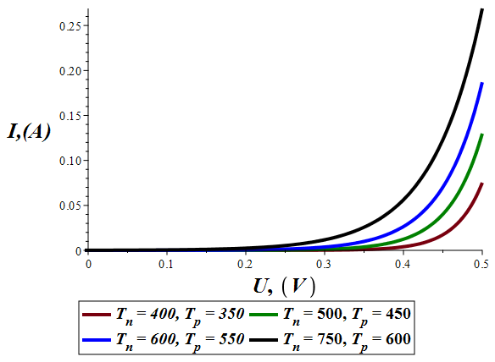
FIGURE 1. Change in I-V under the influence of a magnetic field
From Figure 1 it can be seen that, if we assume that in a constant magnetic field, the temperature does not change, then if $T=T_{n}=T_{p}$, the total current decreases due to an increase in resistance. Conversely, when the temperature changes, that is, when $T≠T_{n}≠T_{p}$, the current increases due to a decrease in resistance.
RESULTS AND DISCUSSION
Let's now apply the same effect to inhomogeneous semiconductors-diodes with p-n junctions. In this case, we'll consider the total current at the boundary of the diode's bulk region.
The total current is $j=j_{n}+j_{p}$. When a field is applied to a p-n junction semiconductor, the total current changes due to the Nernst-Ettingshausen effect. If a constant field is applied to a diode and the charge-carrier mobility is assumed to be uniform, then the Hall effect can be fully observed.[10] However, if the charge carrier mobility and temperatures are also different, then, in addition to the Hall effect, the Nernst-Ettingshausen effect will also influences the diode. In this case, the current can be expressed as:
$j=\frac{qn_{n}(e^{\frac{qφ_{0}}{kT}-\frac{q\left(φ_{0}-U-U_{1}+A_{n}B^{2}(T_{n}-T_{0}\right)}{kT_{n}}}-1)}{τ_{n}L_{n}}+\frac{qp_{p}(e^{\frac{qφ_{0}}{kT}-\frac{q\left(φ_{0}-U-U_{1}+A_{p}B^{2}(T_{p}-T_{0}\right)}{kT_{p}}}-1)}{τ_{p}L_{p}}$ (4)
If we calculate the current generated by the diode only due to the Nernst-Ettingshausen effect and plot the current-voltage characteristic, it will look like Figure 2.

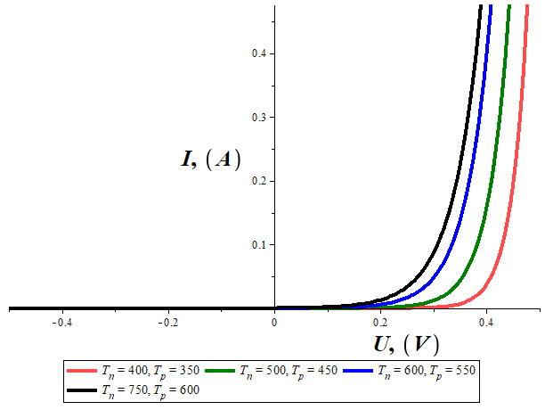
FIGURE 2. Changes in I-V under the influence of the Nernst-Ettingshausen effect
We assumed that the temperature of the majority charge carriers in the diode was increased to $T_{n}$=750. When generating this graph, the numerical values used were taken in accordance with the experimental results. From the graph, it can be concluded that when a magnetic field is applied to the diode, an increase in current can be observed even at a constant voltage due to the heating of charge carriers as a result of the Nernst-Ettingshausen effect. From Figure 2, it can be concluded that when a magnetic field is applied to the diode, an increase in current can be occurs even at a constant voltage, caused by the heating of charge carriers due to of the Nernst-Ettingshausen effect.
Let us now analyze the change in the width of the space-charge region of the p-n junction under the influence of a magnetic field.
It is known that p-n junction diodes are not directly affected by magnetic fields. To monitor magnetic field variations, high-frequency or highly sensitive sensors utilize the Hall effect.[10-19]
The total current generated when there is no effect on the diode is
$J=J_{s}(e^{\frac{qU}{kT}}-1)$ (5)
This is explained by Shockley's expression. The width of the space charge region formed upon contact is given by:
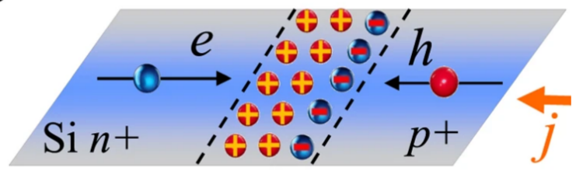
FIGURE 3. The width of the space charge volume formed at the p-n junction [20]
The process of diffusion in the p- and n-regions proceed further until the number of charge carriers, moving under the action of the electric field, becomes equal to the number of those diffusing, all depending on the state of equilibrium (Fig. 3). That is, upon contact, holes begin to diffuse from the heavily doped p-region into the lowly doped n-region, while electrons do just the opposite.
Consequently, electrons and holes which meet in the boundary region annihilate each other through recombination. As a result, there are less free charge carriers in this region, but the ionized atoms remain. The region where charge carriers are depleted has become a depletion layer, and thus, it has not become possible to have free flow of current because of the high resistance. From here, it can be said that the ionized layer between p- and n-regions creates an internal electric field, building up a contact potential barrier. When an external voltage is applied to the p–n junction, it changes its basic property to forward or reverse bias.

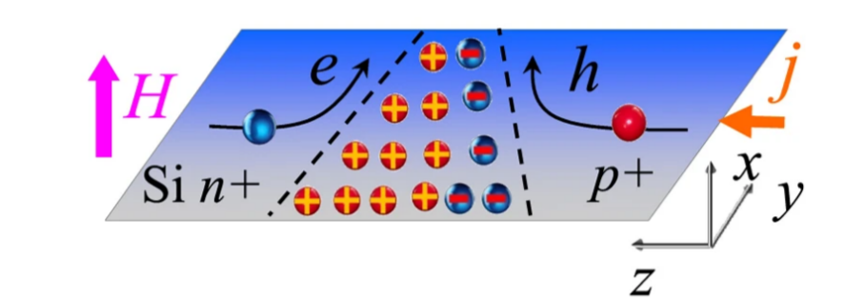
FIGURE 4. Change in the width of the space charge field of a p-n junction under the influence of a magnetic field. [20]
Current flows through a p-n junction diode, which, when placed in a magnetic field, experiences a change in the direction of charge carrier movement. Consequently, the electrons and holes take curved trajectories instead of moving along straight paths, as shown in Figure 4. This alteration in charge-carrier movement direction alters the recombination processes across the nand p-regions, thus modifying the flow of current through the diode. This, in turn, causes another Hall voltage that is perpendicular to the current-flow direction, which eventually changes the bulk and diffusion capacitances of the p–n junction diodes.
It is known that semiconductor devices possess capacitance, which arises from the diffusion of electric charges due to the accumulation of alternating charges. When forward-biased, the diffusion capacitance in a diode is large and increases with increasing voltage. Conversely, when reverse-biased, diffusion capacitance in diodes is almost absent, and bulk capacitance predominates.
If the p-n junction is in a magnetic field, the charge carriers are affected by the Lorentz force.
$J=J_{s}e^{(\frac{qφ_{0}}{kT}-\frac{q(φ_{0}-U+J(R_{b}+\frac{αR_{x}B}{l})}{kT_{e}})}$ (6)
As a result, the charges change their direction of motion, altering the diffusion and recombination processes. The variation of time taken by the charge carriers to reach the p–n junction boundary also alters the rate of diffusion. The process of diffusion becomes sluggish, and charge carriers recombine more prior to reaching the boundary. This reduces the quantity of injected charges. Additionally, the change in the direction of charge-carrier motion shifts the recombination site, thereby changing the capacitance.
The magnetic field always reduces the value of diffusion capacitance formed under its influence compared to the one not subjected to the magnetic field.
$$C_{d}(B)<C_{d}(B=0)$$
$C_{d}=\frac{qτ}{kT}J$ (7)
Our expression (7) changes under the influence of a magnetic field as follows.

$C_{d}=\frac{qτ}{kT}J_{s}(e^{\frac{qφ_{0}}{kT}-\frac{q(φ_{0}-U+JR_{b}+\frac{αJR_{x}B}{l}}{kT_{e}}}-1)$ (8)

By substituting the numerical values obtained in the experiments into expression (8), one can obtain a graph of the dependence of capacitance on voltage.

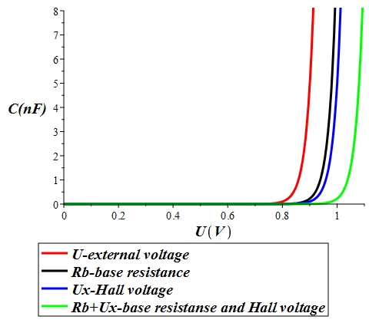
FIGURE 5. Graph of the dependence of diffusion capacitance on the magnetic field and base resistance
The graph shows that as the voltage increases, the diffusion capacity decreases under the influence of a magnetic field.
Bulk capacitance in p-n junctions is one of the fundamental electrical properties of a diode when reverse-biased. It represents the change in charge stored in the bulk region formed between the p- and n-regions, depending on the applied voltage. There are no free charge carriers in this bulk region; it is filled with ions that create a constant charge. Therefore, this region behaves like an electrical capacitor. Bulk capacitance becomes important when a reverse voltage is applied. This is because, under reverse bias, the barrier zone expands, and the capacitance decreases. When a forward voltage is applied, the opposite occurs, leading to an increase in diffusion capacitance.
The effect of a magnetic field on p-n junctions influences the movement of charge carriers and the properties of the barrier zone. Since the magnetic field changes the direction of charge-carrier motion, the geometric distribution of charges in the barrier zone also changes, leading to a variations in capacitance. A magnetic field causes a sharp reorientation and uneven distribution of charge carriers, which alters the degree of recombination. Consequently, the bulk capacitance can decrease under the influence of a magnetic field. Due to the uneven distribution of charges in strong magnetic fields, the barrier zone expands and the rate of charge-carrier diffusion decreases.
As a result, the bulk capacitance decreases. This occurs because charge carriers recombine before reaching the boundary region. With an increased magnetic field, the depletion width decreases and capacitance consequently decreases further due to the bulk field. A reduction in capacitance is also observed at higher applied voltages.
$C=\sqrt{\frac{εε_{0}qn_{n}p_{p}}{2(φ-U)(n_{n}+p_{p})}}$ (9)
The expression (9) is changed into the expression (10) because of adding the Hall’s potential created by the magnetic field.
$C=\sqrt{\frac{εε_{0}qn_{n}p_{p}}{2(φ-U+U_{x})(n_{n}+p_{p})}}$ (10)
Now, let us plot a graph showing dependence of volumetric capacitance on voltage, using the numerical values obtained from the experiments.

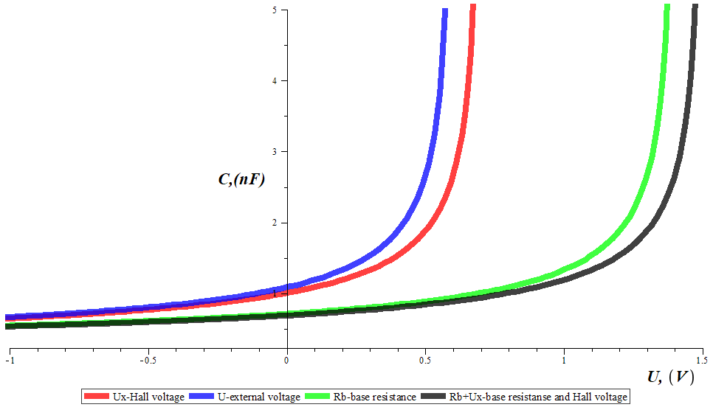
FIGURE 6. Graph of change in volumetric capacity depending on magnetic field and base resistance
The volumetric capacitance decreases under the influence of a magnetic field and base resistance, leading to an increase in voltage. The blue line corresponds to the case without any external influence, the red line to the case under the influence of a magnetic field, the green line to the case of a change only the sample's base resistance, and the black line to the case of simultaneous influence of both the magnetic field and base resistance. These effects lead to a decrease in capacitance and an increase in voltage.
CONCLUSION
From the above results, the essence of the basic process of the Nernst-Ettinghausen effect is that, under the influence of a temperature gradient and a magnetic field, electrons in semiconductors can fast along the direction of the temperature gradient, thus producing an electromotive force. Heat is transferred from the side with higher temperature to the side with lower temperature. Under the influence of a magnetic field, the Lorentz force changes the direction of electron motion, and thus the charge is distributed unevenly. The diffusion capacitance is formed as a result of uneven distribution of charges in the p-n junction. Since these effects alter the distribution of charge carriers, they also cause changes in the diffusion current and diffusion capacitance. The expansion and contraction of the space-charge region, due to changes in the Debye length and the charge-carrier distribution within semiconductors, directly determines the electron diffusion rate and accordingly the bulk capacitance.
REFERENCES
- V.L. Bonch-Bruevich, S.K. Kalashnikov, Fiss of Semiconductors. M.: Science. 1977.P.209
- S. Zi, Physics of Semiconductor Devices. Moscow: Mir. 1984. Pp. 58-65
- I.M. Vikulin, V.I. Stafeev, Physics of semiconductor devices. M:Sov.radio. 1980. pp. 30-31
- Peng Li , Pengfei Qiu , Jie Xiao, Tingting Deng , Lidong Chen , Xun Shi(2023). A giant Nernst power factor and figure-of-merit in polycrystalline NbSb₂ for Ettingshausen refrigeration. This journal is © The Royal Society of Chemistry. 16, 3753-3759. https://doi.org/10.1039/D3EE01450A.
- HERBERT METTE, WOLFGANG W. GARTNER, AND CLAIRE LOSCOE (1959). Nernst and Ettingshausen Effects in Germanium between 300 and 750°K. Physical Review Journals Archive. Phys. Rev. 115, 537. https://doi.org/10.1103/PhysRev.115.537.
- Kamran Behnia, Marie-Aude Me´asson, Yakov Kopelevich(2007). Oscillating Nernst-Ettingshausen Effect in Bismuth across the Quantum Limit. Physical Review Journals Archive. Phys. Rev. Lett. 98, 166602. https://doi.org/10.1103/PhysRevLett.98.166602.
- Sharma, G. Tunable topological Nernst effect in two-dimensional transition-metal dichalcogenides. Phys. Rev. B 98, 075416 (2018). https://doi.org/10.1103/PhysRevB.98.075416
- Asaba, T. et al. Colossal anomalous Nernst effect in a correlated noncentrosymmetric kagome ferromagnet. Sci. Adv. 7, eabf1467 (2021). https://doi.org/ 10.1126/sciadv.abf1467
- Zhu, Z., Yang, H., Fauqué, B., Kopelevich, Y. & Behnia, K. Nernst effect and dimensionality in the quantum limit. Nat. Phys. 6, 26–29 (2010). https://doi.org/10.1038/NPHYS1437
- Gulyamov, G., Majidova, G. N., Mukhitdinova, F. R., & Suvanov, A. X. Effect Of Magnetic Field On Photoelectric Characteristics Of PN Junction Diode. Journal of Optoelectronics Laser, 41, 451-459. https://www.researchgate.net/publication/363947545
- D. Z. Yang1, T. Wang1, W. B. Sui1, M. S. Si1, D. W. Guo1, Z. Shi2, F. C. Wang & D. S. Xue1Temperature-Dependent Asymmetry of Anisotropic Magnetoresistance in Silicon p-n Junctions. https://doi.org/ 10.1038/srep11096
- Tao Wang, Mingsu Si, Dezheng Yang, Zhong Shi, Fangcong Wang, Zhaolong Yang, Shiming Zhoub and Desheng Xue*Angular dependence of the magnetoresistance effect in a silicon based p–n junction device. https://doi.org/ 10.1039/c3nr04077a
- Yawen Zhang, Jiewen Fan, Qianqian Huang, Jiadi Zhu, Yang Zhao, VoltageControlled Magnetoresistance in Silicon Nanowire Transistors. https://doi.org/10.1038/s41598-018-33673-8
- Yang Cao, Wenbo Sui, Tao Wang, Mingsu Si, Huigang Shi, Light-InducedMagnetoresistance in p-n Junction Device. https://doi.org/10.1109/LED.2020.2969998.
- Yawen Zhang, Jiewen Fan, Qianqian Huang, Jiadi Zhu, Voltage-Controlled Magnetoresistance in Silicon Nanowire Transistors. https://doi.org/10.1038/s41598-018-33673.
- CaihuaWan, Xiaozhong Zhang, Xili Gao, Geometrical enhancement of low-field magnetoresistance in silicon. https://doi.org/10.1038/nature10375.
- D. Yang, F. Wang, Y. Ren, Y. Zuo et al, “A Large Magnetoresistance Effect in p–n Junction Devices by the Space-Charge Effect,” Adv. Funct. Mater, 2013. V.23. P. 2918–2923. https://doi.org/10.1002/adfm.201202695.
- T. Wang, M. Si, D. Yang “Angular dependence of the magnetoresistance effect in a silicon based p–n junction device,” Nanoscale, 2014. V.6. P. 3978–3983. https://doi.org/10.1038/srep00565.
- Gulyamov, G., Majidova, G., Muxitdinova, F., & Madumarova, S. (2023). Changes in diodes with a p-n-transition under the influence of microwave radiation. AIP Conference Proceedings, 2701, 050008. https://doi.org/10.1063/5.0126385
- Yang, D. Z., Wang, T., Sui, W. B., Si, M. S., Guo, D. W., Shi, Z., Wang, F. C., & Xue, D. S. (2015). Temperature-Dependent Asymmetry of Anisotropic Magnetoresistance in Silicon p-n Junctions. Scientific Reports, 5(1), 11096. https://doi.org/10.1038/srep11096

