Light-Induced Variation in the I–V Characteristics of Graphene/MoS₂ Heterostructures

Mukhammadjon Dadamirzaev, Mamura Kosimova ^{a)}, Azamat Makhmudov, Bakhromjon Xusanboyev
Namangan State Technical University, Namangan, Uzbekistan

^{a)}Corresponding author: omamuraqosimova@gmail.com

Abstract. This study examines how the current–voltage (I–V) characteristics of a graphene/MoS₂ heterostructure change when the structure is illuminated. The graphene/MoS₂ system is a van der Waals heterostructure in which graphene is combined with molybdenum disulfide (MoS₂). Each layer has its own distinctive electrical, optical, and quantum features. In this configuration, graphene provides high electrical conductivity, while the MoS₂ layer is responsible for absorbing light and generating charge carriers efficiently. Owing to these properties, the heterostructure exhibits photovoltaic behavior as well as quantum tunneling and other quantum-mechanical effects. In this work, the I–V characteristics of the graphene/MoS₂ heterostructure are analyzed under several illumination levels to show how they vary with light intensity.

Keywords: Graphene/MoS₂ heterostructure, I–V characteristics, light, photoabsorption, van der Waals junction.

INTRODUCTION

In the past few years, graphene, a two-dimensional (2D) material, which is made of carbon atoms, received considerable attention regarding nanoelectronics applications [1−3]. The 2D material is defined as those that are comprised of only one layer or few layers of atoms. The physicochemical properties and applications of 2D materials are vast and significant in various branches of science and engineering. The popular 2D material, graphene, is comprised of a single layer of atoms of carbon, which are usually arranged in the shape of a hexagonal lattice. The distinct properties of electrical and thermal conductivity, mechanical strength, and high-temperature stability of graphene distinguish it from other 2D materials. The high mobility and Fermi velocity of charges in graphene enable the creation of fast electronic devices [4,5].

In [6], vertical MoS2/Gr heterostructures with monolayer and bilayer graphene (Gr) and MoS2, named (1−2L) MoS2/(1−2L) Gr, were studied, focusing on the presence of additional layers at interfaces, based on structural and physical properties. In this research, correlative scanning probe microscopy and microspectroscopy are used to study the excitonic properties of the (MoS2)L/(MoS2)L/(1−2L)/Au devices. The various effects on the surface-related electronic properties, namely, neutral excitations, concentration of charged excitons (trions), long-lived trions, and decreased work functions, were obtained. The effects experimentally confirm rectification and an increased photocarrier concentration due to electronic interactions between layers, suppressing the Fermi level at the MoS2/Au interface.

In [7], it is demonstrated that the effect of interlayer interactions in graphene/MoS₂ heterostructures affects their optical properties. The interaction enhances the efficiency of vertically combined optoelectronic devices and, importantly, provides insights into the design of optoelectronic systems based on graphene and MoS₂.

Generally, the value of ZT in 2D materials, for example, graphene and MoS2, is very low (ZT ≤ 1). In this case, graphene shows no thermoelectric properties at all (ZT ≈ 0), considering the high thermal conductivity of this material. In [8], the researchers suggested a novel strategy to overcome this issue and used layered heterostructures rather than monolayers and crossed-plane currents, focusing on both heat and current transportation. The research took into consideration crucial factors, which are phonon scattering barriers, Debye frequency mismatch (the maximum phonon frequencies within crystal lattices), and phonon scattering between layers. From this study, it is clear that structural modification of 2D materials provides novel opportunities, especially within high-quality thermoelectric applications, for example, sensors, cooling devices, and thermoelectric harvesting components, which are mainly based on vertical graphene/MoS2 heterostructures.

In [9], electron exchange between layers and PL properties in graphene/MoS₂ heterostructures were explored. The authors obtained evidence that the PL signal intensified by 5 times in F-G/MoS₂ and by 1.8 times in MoS₂/F-G composites (with F-G on top). The above findings clearly show that the order of layer assembly influences the PL properties, and modification of graphene by functionalization increases the optoelectrical properties of MoS₂ significantly. This paves the way for novel applications in photonics, quantum detectors, and optoelectronics, leveraging the properties of 2D materials.

Due to its semi-metallic nature, high carrier mobility, broadband light absorption, and fast response time, graphene is considered a highly promising material for optoelectronic applications. Molybdenum disulfide (MoS₂), a 2D semiconductor, is also well-known for its sensitivity to light. In [10], it was demonstrated that large-area, continuous monolayer MoS₂ can be synthesized using the chemical vapor deposition (CVD) method, and that graphene can be transferred onto MoS₂ layers. The resulting graphene/MoS₂ heterostructure-based photodetectors are capable of achieving exceptionally high photogain. Experimental results show that after light absorption, electron–hole pairs are generated in the MoS₂ layer and then separated across the layers. Unlike traditional metal–semiconductor junctions, photo-generated electrons do not remain trapped in MoS₂ but are transferred to the graphene layer. This transfer is facilitated by an effective out-of-plane electric field formed by a combination of internal electric fields, external electrostatic fields, and charged impurities or adsorbates (adsorbed molecules on the surfaces of MoS₂ and graphene, which induce additional electric fields). As a result, the photoresponsivity of the device can be tuned.

These findings demonstrate both experimentally and theoretically, the potential of the graphene/MoS₂ heterostructure as a thin, flexible, and highly sensitive photodetector. Such 2D heterostructures mark a significant step forward in the development of next-generation optoelectronic devices.

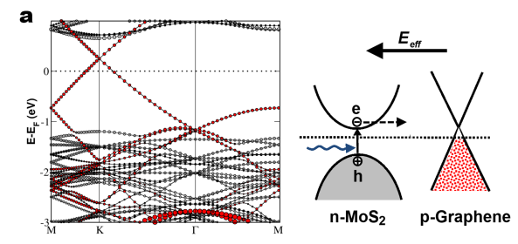

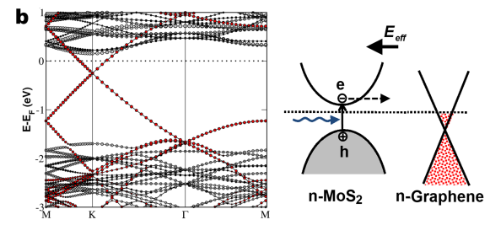

FIGURE 1. Energy band diagram illustrating the separation of charge carriers under illumination in the graphene/MoS₂ heterostructure [10]

Fig.1. energy band diagram showing that p-type graphene in a graphene/MoS₂ heterostructure creates a stronger effective electric field, enabling more efficient separation of photo-generated electron–hole pairs in the MoS₂ layer. Conversely, increasing the n-type doping level in graphene results in a reduced effective electric field, resulting in reduced photogain.

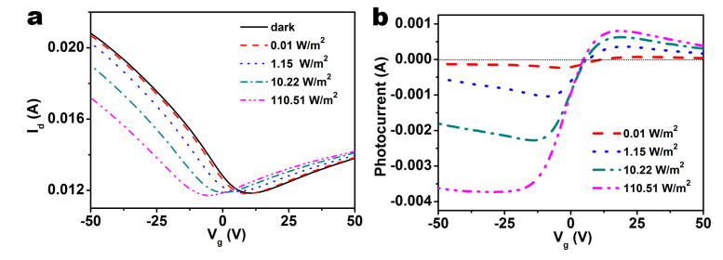

FIGURE 2. (a) Current–voltage (I–V) characteristics of the graphene/MoS₂ heterostructure under illumination; (b) Photocurrent as a function of applied voltage [10]

In Fig. 2, the transfer curves of a graphene/MoS₂ transistor illuminated with light of 650 nm wavelength at various power levels are presented [10]. It is observed that the charge neutrality point measured in the dark is located at approximately +10 V, indicating that the graphene is p-type. The shape of the transfer curve closely resembles that of pristine graphene on SiO₂, suggesting that charge transport in the device primarily occurs through the graphene channel.

When the graphene/MoS₂ heterostructure is illuminated, the current (I) in the p-channel is decreased, while the current in the n-channel is increased (Figure 2a), confirming that the photoexcited electrons are transferred into the graphene layer. Even under very low illumination, there is significant translation of the charge neutrality point into more negative voltages. The photoexcited holes are trapped inside the MoS₂ layer and act as an auxiliary positive gate voltage on the graphene channel. In [11], the electronic and optical properties of the graphene/MoS₂ heterostructure were explored through density functional theory (DFT) calculations. The graphene/MoS₂ system shows the redshift of the absorption coefficient, refractive index, and reflectance spectra, whereas the blueshift is shown by the loss spectrum. Monolayer graphene and MoS₂, combined together, show changed electronic and optical properties, proving the applicability of 2D material systems for advanced research and development. In [12], the effects of radiation on MoS₂-graphene FET devices caused by exposure to swift heavy ions were studied. From the experiment, it was found that after ion irradiation, there occurred the generation of a novel Raman spectrum, represented by the 'D’ peak Dirac point, confirming damage to the graphene layer by the ion beam. From the photoluminescence spectrum analysis of MoS₂, it was found that there occurred the transformation of trion-A⁻ into neutral exciton-A⁰ by the ion irradiations.

In [13], it was demonstrated that the electronic and structural properties of MoS₂/SLG heterostructures can be controlled by the chemical and morphological properties of the substrates. There are vast opportunities in the optoelectronic applications of MoS₂, including the creation of photodetectors, optical modulators, and transistors.As demonstrated in [14–17], the change in the electrophysical properties of 2D p–n junctions under external stimuli (light, high-frequency electromagnetic fields, mechanical strain) plays a crucial role in the design of optoelectronic devices.

For two-dimensional (2D) materials, the enhancement of the Raman spectrum is primarily governed by electronic transitions between probe molecules and the substrate materials. According to Fermi’s golden rule, the transition rate of such electronic transitions is given by [18]:

$$ω_{lk}=\frac{2π}{ћ}g(E_{k}){\left|H_{kl}^{'}\right|}^{2}$$

Here, $ω_{lk}​ -$denotes the transition probability rate, g(E_{k})— represents the density of states, and $H_{kl}^{'}-$ is the matrix element corresponding to transitions between the HOMO (highest occupied molecular orbital) and LUMO (lowest unoccupied molecular orbital) energy levels. Since graphene possesses a high electronic density of states [19], the transition rate $ω_{lk}​$ increases significantly when a graphene-based SERS (Surface-Enhanced Raman Spectroscopy) platform is employed. Additionally, the Fermi level of graphene lies close to the HOMO and LUMO levels of most probe molecules [20], which further enhances the probability of electron transitions between graphene and the analyte molecules. In [21], a non-metallic, reusable, and plasma-treated graphene–MoS₂ heterostructure-based SERS platform was proposed, which demonstrated high sensitivity in the detection of molecular analytes. This heterostructure showed excellent SERS performance, enabling the detection of analyte concentrations as low as 10⁻⁹ g. A comprehensive study [22] presented theoretical and numerical modeling, material characterization, and device physics involved in the design and analysis of photodetectors based on graphene/MoS₂ and graphene/h-BN/MoS₂ heterostructures incorporating plasmonic effects. However, in the aforementioned studies, the theoretical investigation of the I–V characteristics of the graphene/MoS₂ heterostructure under illumination remains insufficiently addressed. The objective of this work is to theoretically investigate the I–V characteristics of the graphene/MoS₂ heterostructure, identify changes arising under illumination, and analyze how photocurrents generated under various light intensities influence the overall current-voltage response of the system.
METHODS
In this work, the I-V curve of the graphene/MoS2 heterostructure is studied by theoretical modeling. The model is centered on the simulation of carrier processes in the system, including carrier transport, generation, thermionic emission, and quantum tunneling, as well as photocurrent in the presence of illumination. The graphene/MoS2 heterostructure is assumed to be a quasi-two-dimensional system, in which graphene is used as the electrode and MoS2 as the photoactive semiconductor layer. The model takes into consideration the van der Waals interaction between graphene and MoS2, which is important in the electron injection into graphene and exciton recombination in MoS2.
RESULTS AND DISCUSSION

In the graphene/MoS₂ heterostructure, graphene is a two-dimensional (2D) material with a zero band gap and high carrier mobility, thus playing a key role in electrical conduction. MoS₂, on the other hand, is a 2D semiconductor with a direct bandgap E_{g} >1.8 eV in its monolayer form. The layers of graphene and MoS₂ are not chemically bonded but interact via van der Waals forces. This interaction allows the layers to retain their individual properties and leads to the emergence of new physical phenomena at the heterointerface. When light is incident on the graphene/MoS₂ heterostructure, photons are primarily absorbed in the MoS₂ layer. If the photon energy satisfies $hν>E_{g}$, i.e., the photon energy exceeds the MoS₂ bandgap, electron-hole pairs (excitons) are generated. To dissociate the excitons into free electrons and holes, energy greater than the exciton binding energy must be delivered via an external electric field, satisfying the condition:

$$eFr≥E_{b}$$

The condition must be satisfied. Here,$e-$is the elementary charge, $F$ $-$is the external electric field strength, $r-$is the average radius of the exciton (the distance between the electron and the hole, typically about 1–2 nm), $E_{b}=\frac{m^{*}e^{4}}{2{(4πε)}^{2}ћ^{2}}$ $-$ is the exciton binding energy, m* $-$is the reduced effective mass of the electron and hole, ε$-$is the dielectric permittivity of the material, ℏ$-$is the reduced Planck constant.

In 2D materials, the exciton binding energy is relatively large. Therefore, a strong external electric field is required to dissociate the exciton. One of the main advantages of the graphene/MoS₂ heterostructure is that the excitons are generated within the MoS₂ layer. Since MoS₂ is a semiconductor, it acts as the absorbing layer. Graphene, being metallic in nature, facilitates rapid charge extraction. A difference in energy levels between graphene and MoS₂ creates a favorable band alignment, which enhances charge separation. The external electric field (or built-in potential barrier) drives electrons and holes in opposite directions, thereby contributing to the generation of photocurrent.

The total current in the graphene/MoS₂ heterostructure consists of two main components:
$J\left(U\right)=J_{q}\left(U\right)+J_{f}(U)$ (1)
Here, $J_{q}\left(U\right)-$is the dark current, $J_{f}\left(U\right)-$is the photocurrent.

The dark current can be expressed as the sum of the following components:
$J_{q}=J_{g}+J_{i}+J_{t}$ (2)

$J_{g}$– the generation current is associated with the formation of electron–hole pairs due to thermal energy.

The generation current is defined as follows:
$J_{g}=qGSW$ (3)

where,$G=\frac{n_{i}}{2τ}$ – is the generation rate, S – the surface area of the heterostructure,
W – the thickness of the region where the electric field exists, n_{i} ​ – the intrinsic carrier concentration, $τ-$ the generation (carrier lifetime) time.
$J_{i}=A_{R}ST^{2}exp⁡(-\frac{qφ_{B}}{kT})(\exp\left(\frac{eU}{nkT}\right)-1)$ (4)

Here, $A_{R}$– Richardson constant, which in the case of 2D materials obeys quantum confinement, density of states, and 2D Fermi statistics [24]. $φ_{B}$– potential barrier height,$T$– temperature, $k$– Boltzmann constant.

J_{t} – tunnel current. This current is related to the quantum tunneling effect, in which charge carriers pass through a narrow barrier by quantum mechanical means. Both graphene and MoS₂ are two-dimensional (2D) materials, and they are not chemically bonded (i.e., not through covalent or Schottky contact), but rather, they form an interface through van der Waals forces. Therefore, it is necessary to account for the tunneling current in the graphene/MoS₂ heterostructure [25]. In this paper, the tunneling current is calculated using the following expression:

$I_{t}\left(U\right)=I_{0}\int_{-∞}^{+∞}{D_{s}\left({E,U}_{b}\right)D_{d}\left({E,U}_{b}\right)T\left(E\right)[f_{s}\left(E,U_{b}, U_{g}\right)-}f_{d}\left(E,U_{b}, U_{g}\right)]dE$ (5)

Here, $I_{0}=\frac{qϑ_{F}}{2πL_{0}^{2}}$ – current density, T(E) – energy-dependent tunneling probability, D_{s},D_{d} – density of states, f_{s}, f_{d}​ – Fermi–Dirac distribution functions. The integral in this expression can be evaluated for the graphene/MoS₂ heterostructure using the following simplified assumptions:

The tunneling probability is taken as $T(E)≈T_{0}θ(E-φ_{B})$, meaning that tunneling occurs only at energies higher than the potential barrier. Here, $θ-$ is the Heaviside step function, which mathematically expresses that the tunneling probability is zero below the energy threshold, and only electrons with $E>φ_{B}$ are allowed to tunnel. In other words, only energies above the potential barrier are permitted, while lower energies are forbidden.

For the graphene/MoS₂ heterostructure, the density of states is assumed to be constant, i.e.,$D_{s}\left(E\right)≈D_{d}\left(E\right)≈D_{0}$. Here, $D_{0}$is the constant approximation of the D(E) real density of states , D₀=const taken for the analytical calculation of the tunnel current.

The density of states of the graphene/MoS₂ heterostructure is linearly dependent on energy and is given by $(E)=\frac{2\left|E\right|}{π{({ћϑ}_{F})}^{2}}$ . However, near $E≈E_{F}$​ (i.e., for small energy variations), this value can be approximated as constant D₀​, where $D_{0}=\frac{2\left|μ\right|}{π{({ћϑ}_{F})}^{2}}.$μ is the Fermi energy, and $ϑ_{F}={10}^{6} m/s$ is the Fermi velocity in graphene.

If the temperature is sufficiently high, the Fermi–Dirac distribution takes the following form:

$$f_{s}\left(E\right)-f_{d}\left(E\right)≈-\frac{∂f(E)}{∂E}qU$$

After these simplifications, the tunneling current is given by the following expression:

$I_{t}\left(U\right)=i_{0}D^{2}T_{0 }U\frac{1}{1+exp⁡(\frac{φ_{B}-μ}{kT})}$ (6)

Here, $i_{0}=\frac{q}{h}$ is the quantum transition rate for current.

Expression (6) shows how the tunneling current depends on the external voltage and the potential barrier height. In the tunneling current determined by this expression, electrons tunnel perpendicularly from MoS₂ to graphene. The effective tunneling probability increases with the applied voltage, and due to the difference in the Fermi-Dirac distributions, the current depends on the Fermi level and temperature.Considering these components, the total expression for the dark current is given by the following equation:

$J_{q}=qGSW+A_{R}ST^{2}\exp\left(-\frac{qφ_{B}}{kT}\right)(\exp\left(\frac{eU}{nkT}\right)-1)+$ $i_{0}D^{2}T_{0 }U\frac{1}{1+exp⁡(\frac{φ_{B}-μ}{kT})}$ (7)

When photons (light quanta) strike the MoS₂ layer, excitons are generated. If an external electric field is present, these excitons dissociate into electrons and holes, resulting in the formation of a photocurrent J_{f}(U):

$J\left(U\right)=qɳФS$ (8)

η – quantum efficiency, $Ф$– the number of photons incident per unit area.

When light is incident, excitons are generated in the MoS₂ layer. To separate these excitons and drive them as charge carriers through the circuit, an external electric field (i.e., voltage) is required. As the applied voltage increases, the electric field becomes stronger, excitons dissociate into electrons and holes more rapidly, the probability of recombination decreases, and both the photocurrent and quantum efficiency increase as functions of the voltage.

The quantum efficiency can be expressed as a function of voltage as follows:

$ɳ\left(U\right)=ɳ_{0}(1-exp⁡(-\frac{qU}{kT}))$ (9)

Substituting equation (9) into equation (8), we obtain the expression for the photocurrent as a function of voltage.

$J_{f}\left(U\right)=q{ФSɳ}_{0}(1-exp⁡(-\frac{qU}{kT}))$ (10)

Using equation (10), the graph of the photocurrent as a function of external voltage can be obtained.

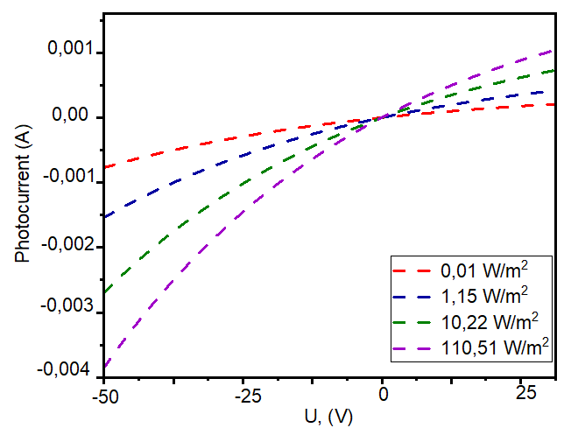

FIGURE 3. Variation of Photocurrent with External Voltage

This graph shows that in the graphene/MoS₂ heterostructure, the photocurrent varies sensitively with both light intensity and applied external voltage. The graph plotted using the derived equation (10) (Fig. 3) qualitatively agrees with the experimental results presented in Figure 2b from reference [10]. By using equations (7) and (10), a general expression for the current-voltage characteristics (I–V characteristics) of the graphene/MoS₂ heterostructure under illumination can be obtained.

$$J\left(U\right)=qGSW+A_{R}ST^{2}\exp\left(-\frac{qφ_{B}}{kT}\right)\left(\exp\left(\frac{eU}{nkT}\right)-1\right)+{ i}_{0}D^{2}T_{0 }U\frac{1}{1+\exp\left(\frac{φ_{B}-μ}{kT}\right)}-$$

$-q{ФSɳ}_{0}\left(1-\exp\left(-\frac{qU}{kT}\right)\right)$ (11)

Using equation (11), the current-voltage characteristic (I–V characteristic) of the graphene/MoS₂ heterostructure under illumination can be obtained.

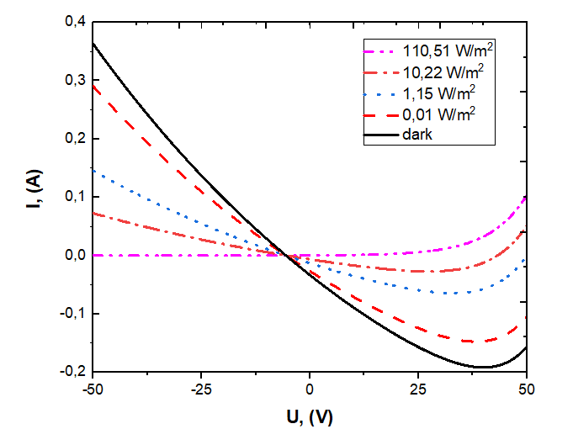

FIGURE 4. Current-voltage characteristics of the graphene/MoS₂ heterostructure at different illumination power levels.

Equation (11), by incorporating various current components and accounting for their dependence on both voltage and light intensity, qualitatively matches the experimental results presented in Figure 2a of reference [10], as shown in Figure 4. In particular, the combined use of tunneling and photocurrent models clearly explains the increase in current under illumination. Therefore, this equation is consistent with the experimental data and is considered suitable for describing the graphene/MoS₂ heterostructure.
CONCLUSION

In this research, the optoelectronic properties of the graphene/MoS₂ heterostructure were studied, and on the basis of the experimentally obtained current-voltage (I-V) characteristics under various light intensities, a theoretical model was developed. The experimental [10] and modeling studies revealed that under illumination, electron-hole pairs are mainly generated in the MoS₂ layer at the graphene/MoS₂ interface. On account of the effect of the electric field, the electrons migrate to the graphene layer, and the holes are captured by MoS₂, giving rise to the creation of a p-n junction and, hence, a non-metal semiconductor contact. This prompted the high photocurrent and high photo-responsivity.

There were four significant components in the current being modeled, namely the generation current, thermionic emission current, tunneling current, and photocurrent, and the model agreed well with the experimental data. Notably, the substantial rise in currents with the rise in light intensity within the range of -50V and 50V validated the consistency of the components and appropriately matched the experimental data. The consideration of the linear relationship between the tunneling current and voltage also contributed significantly to the graphene/MoS₂ heterostructure, as it helped interpret the mechanism of carrier transport. The results indicate that the graphene/MoS₂ heterostructure is a promising material for ultrathin, flexible, and highly sensitive photoelectronic devices. Moreover, modeling the photocurrent components generated within the structure has enabled a deeper understanding of the operation principles of such systems. Especially in the development of high-sensitivity photodetectors: lightweight and flexible detectors operating in the infrared, visible, and ultraviolet ranges, optoelectronic sensors: devices sensitive to light or radiation for environmental monitoring, biological analysis, and security systems, energy harvesting systems (PV): nanostructured solar panels that absorb sunlight and convert it into photoelectric energy, artificial vision systems and imaging: low-power, high-resolution image capturing technologies, 2D electronics and photonics: as key components for next-generation lightweight and flexible electronic devices — the application potential is considerable. In the future, the efficiency, controllability, and application scope of such structures can be enhanced by combining them with graphene nanoribbons, gapped graphene (graphene modified to exhibit semiconducting properties by creating a bandgap), or other 2D materials. The use of graphene nanoribbons or branched structures may allow for controlled photocurrent generation and improved on/off ratios.
ACKNOWLEDGMENTS
This research was financially supported by the fundamental research grant FZ-20200929243 – “The effect of hot electrons and phonons under strong electromagnetic fields on the characteristics of semiconductor solar cells and nanostructures.
REFERENCES
- Geim, A., Novoselov, K. The rise of graphene. Nature Mater 6, 183–191 (2007). https://doi.org/10.1038/nmat1849
- Novoselov, K., Geim, A., Morozov, S. et al. Two-dimensional gas of massless Dirac fermions in graphene. Nature 438, 197–200 (2005). https://doi.org/10.1038/nature04233
- Han, M. Y., Özyilmaz, B., Zhang, Y., & Kim, P. (2007). Energy Band-Gap Engineering of Graphene Nanoribbons. Physical Review Letters, 98(20). https://doi.org/10.1103/PhysRevLett.98.206805
- Obradovic, B., Kotlyar, R., Heinz, F., Matagne, P., Rakshit, T., Giles, M. D., … Nikonov, D. E. (2006). Analysis of graphene nanoribbons as a channel material for field-effect transistors. Applied Physics Letters, 88(14), 142102. https://doi.org/10.1063/1.2191420
- Lemme, M.C., Echtermeyer, T. J., Baus, M., & Kurz, H. (2007). A Graphene Field-Effect Device. IEEE Electron Device Letters, 28(4), 282–284. https://doi.org/10.1109/LED.2007.891668
- Gupta, S., Johnston, A. & Khondaker, S. Optoelectronic Properties of MoS₂/Graphene Heterostructures Prepared by Dry Transfer for Light-Induced Energy Applications. J. Electron. Mater. 51, 4257–4269 (2022). https://doi.org/10.1007/s11664-022-09672-x
- Yang, M., Wang, L., Hu, G. et al. Optical identification of interlayer coupling of graphene/MoS₂ van der Waals heterostructures. Nano Res. 14, 2241–2246 (2021). https://doi.org/10.1007/s12274-020-3215-9
- Sadeghi, H., Sangtarash, S., & Lambert, C. J. (2016). Cross-plane enhanced thermoelectricity and phonon suppression in graphene/MoS₂ van der Waals heterostructures. 2D Materials, 4(1), 015012. https://doi.org/10.1088/2053-1583/4/1/015012
- Cao, Q., Kreßler, M., Hußmann, M., Hu, Y., Kusch, P., & Eigler, S. (2024). Photoluminescence modulation of Graphene/MOS2 heterostructures separated by Laser-Induced functionalization. Chemistry of Materials, 36(7), 3267–3276. https://doi.org/10.1021/acs.chemmater.3c03166
- Zhang, W., Chuu, C., Huang, J., Chen, C., Tsai, M., Chang, Y., Liang, C., Chen, Y., Chueh, Y., He, J., Chou, M., & Li, L. (2014). Ultrahigh-Gain photodetectors based on atomically thin Graphene-MOS2 heterostructures. Scientific Reports, 4(1), 3826. https://doi.org/10.1038/srep03826
- Qiu, B.; Zhao, X.; Hu, G.; Yue, W.; Ren, J.; Yuan, X. Optical Properties of Graphene/MoS₂ Heterostructure: First Principles Calculations. Nanomaterials 2018, 8, 962. https://doi.org/10.3390/nano8110962
- J. Zeng,CB Nie,HD Chjan,PP Hu,K. Maaz,LJ Xu,PF Zhai,XR Yang,SX Chjan,J. Liu Optimized photoelectric performance of MoS₂/graphene heterostructure device induced by swift heavy ion irradiation. Applied Surface Science. Volume 642, 1 January 2024, 158629, https://doi.org/10.1016/j.apsusc.2023.158629
- Wördenweber, H., Grundmann, A., Wang, Z., Hoffmann-Eifert, S., Kalisch, H., Vescan, A., Heuken, M., Waser, R., & Karthäuser, S. (2023). The MOS2-Graphene-Sapphire heterostructure: influence of substrate properties on the MOS2 band structure. The Journal of Physical Chemistry C, 127(22), 10878–10887. https://doi.org/10.1021/acs.jpcc.3c02503
- Gulyamov, G., M.G. Dadamirzaev, M.O. Kosimova, Comparison of parameters of two-dimensional (2D) and threedimensional (3D) p-n-junction diodes. Romanian Journal of Physics, 2023. 68, 603.
- Dadamirzaev, M. G., Kosimova, M. O., Boydedayev, S., & Makhmudov, A. S. (2024). Comparison of 2D and 3D p-n Junction Differential Conductance and Diffusion Capacitance. East European Journal of Physics, 2, 372–379. https://doi.org/10.26565/2312-4334-2024-2-46
- Gulyamov, G., Majidova, G., Muxitdinova, F., & Madumarova, S. (2023b). Changes in diodes with a p-n-transition under the influence of microwave radiation. AIP Conference Proceedings, 2701, 050008. https://doi.org/10.1063/5.0126385
- Dadamirzaev, M. G., Kosimova, M. O., & Makhmudov, A. S. (2024). Effect of Variation of Non-ideal Ratio on Electrical Properties of PN-Junction in Strong Microwave Field, Theoretical Study. Iranian Journal of Materials Science & Engineering, 21(4). DOI: 10.22068/ijmse.3243
- Ling, X., Fang, W., Lee, Y., Araujo, P. T., Zhang, X., Rodriguez-Nieva, J. F., Lin, Y., Zhang, J., Kong, J., & Dresselhaus, M. S. (2014). Raman Enhancement effect on Two-Dimensional Layered materials: Graphene, H-BN and MOS2. Nano Letters, 14(6), 3033–3040. https://doi.org/10.1021/nl404610c
- Seo, J., Lee, J., Kim, Y., Koo, D., Lee, G., & Park, H. (2020). Ultrasensitive Plasmon-Free Surface-Enhanced Raman Spectroscopy with Femtomolar Detection Limit from 2D van der Waals Heterostructure. Nano Letters, 20(3), 1620–1630. https://doi.org/10.1021/acs.nanolett.9b04645
- Ling, X., Xie, L., Fang, Y., Xu, H., Zhang, H., Kong, J., Dresselhaus, M. S., Zhang, J., & Liu, Z. (2009). Can Graphene be used as a Substrate for Raman Enhancement? Nano Letters, 10(2), 553–561. https://doi.org/10.1021/nl903414x
- Pei J, Yang F, Zhao H. Plasma-induced enhancement of light–matter interaction on graphene–MoS₂ heterostructure for sensitive SERS sensing. Nano Research, 2025, 18(5): 94907376. https://doi.org/10.26599/NR.2025.94907376
- Sundararaju, U., Haniff, M. a. S. M., Ker, P. J., & Menon, P. S. (2021). MOS2/H-BN/Graphene Heterostructure and Plasmonic Effect for Self-Powering Photodetector: A Review. Materials, 14(7), 1672. https://doi.org/10.3390/ma14071672 .
- Anwar, A., Nabet, B., Culp, J., & Castro, F. (1999). Effects of electron confinement on thermionic emission current in a modulation doped heterostructure. Journal of Applied Physics, 85(5), 2663–2666. https://doi.org/10.1063/1.369627
- Wang, W., Liu, Y., Tang, L., Jin, Y., Zhao, T., & Xiu, F. (2014). Controllable Schottky Barriers between MoS2 and Permalloy. Scientific Reports, 4(1), 6928. https://doi.org/10.1038/srep06928
- Myoung, N., Seo, K., Lee, S. J., & Ihm, G. (2013). Large current modulation and Spin-Dependent tunneling of vertical Graphene/MOS$_{2}$ heterostructures. arXiv (Cornell University). https://doi.org/10.48550/arxiv.1302.0945

