Quantum Oscillation Effects in Semiconductor Structures under a Static Magnetic Field
Ulugbek Erkaboev¹, Rustamjon Rakhimov^{1, a)}, Gulora Yuldasheva², Dilfuza Buranova³, Yakhshilik Gulbaev⁴, Usmonali Isomaddinov¹
¹Namangan State Technical University, Namangan, Uzbekistan
²Urgench State University, Urgench, Uzbekistan
³Fergana State Technical University, Fergana, Uzbekistan
⁴Jizzakh Polytechnic Institute, Jizzakh, Uzbekistan

^{a)}Corresponding author: rgrakhimov @gmail.com
Abstract: In this paper, the problems related to studying the dependence of quantum oscillation effects in bulk and low-dimensional semiconductors on external factors under dynamic and static magnetic fields, as well as recommendations for addressing these issues, are presented. Based on the theoretical and experimental analysis of the available data, the formulation of the research objectives has been developed. In bulk and quantum-structured semiconductors, charged particles exhibit various dynamic processes under the influence of external factors. In particular, the quantization of oscillations in the density of energetic states and quantum magnetic effects under a static magnetic field are considered one of the fundamental and applied research directions in semiconductor physics. While the motion of charged particles splits into discrete Landau levels under a static magnetic field, the application of a weak alternating (dynamic) magnetic field gives rise to resonance properties in the electron system. As a result, the cyclotron frequency of the dynamic magnetic field interacts with the cyclotron frequency of the charged particle, leading to the manifestation of magnetoplasmon oscillations. The literature review indicates that, in order to fully study the dependence of quantum magnetic effects in quantum-sized semiconductor structures on dynamic magnetic fields, it is necessary to analyze their phase portraits.
Keywords: semiconductor, quantum well, magnetic field, temperature, forbidden zone, energy.
INTRODUCTION
In recent years, leading scientists around the world have shown a growing interest in studying the dependence of quantum oscillation effects in nanostructured semiconductors on external factors. Under the influence of a static magnetic field, the quantization of charge carrier motion and the emergence of discrete energy levels give rise to oscillatory processes in the electrical and transport properties of semiconductor structures. These phenomena make it possible to determine the Fermi level, the effective masses of charge carriers, and their relaxation times. Such quantum oscillation effects serve as a fundamental basis for promising research directions, including the development of new types of nanoelectronic devices, quantum sensors, and spintronic laser diodes.
In particular, studies reported in [1-8] investigate the dynamics of a Pt (8 nm)/Py (5 nm) bilayer spin-Hall nano-oscillator using micromagnetic simulations, where the current is injected through a triangular gold contact (d ≈ 100–200 nm). The magnetization field is applied either in the plane (along the y-direction) or with an out-of-plane component (in the YZ-plane at an angle of ~15° to the Z-axis). The Landau–Lifshitz–Gilbert equation is solved numerically by accounting for spin–orbit torques (SOT). It is shown that, in this geometry, the spin-Hall torque proportional to the current in the Pt layer is dominant, whereas spin-transfer torque (STT) in the ferromagnet and the Rashba torque are comparatively small.

METHODS
The spatial distribution of the current density in the bilayer is obtained using the finite-element method; approximately 90% of the current flows through the Pt layer, which determines the excitation (pumping) efficiency. For the in-plane magnetic field, the dependence of the auto-oscillation frequency on the current and the localization of the excited mode are reproduced in quantitative agreement with the experiment: a strongly localized stationary spin-wave mode of approximately 10 GHz (for instance, 9.98 GHz at H ≈ 100 mT, d = 100 nm, I = 14 mA) is observed within the current-injection region. At room temperature, the calculated minimum linewidth is ~142 MHz (I ≈ 16.3 mA).
The critical currents for switching on/off depend on the separation between the contacts: for d = 200 nm, the current profile is broader, increasing the effective damping and resulting in higher thresholds. In the out-of-plane configuration (H ≳ 0.7–0.8 T), a transition to a propagating regime is predicted, characterized by a pronounced front asymmetry due to current nonuniformity and the Oersted field, with a typical wavelength on the order of several hundred nanometers (~325 nm). In this regime, an upward (blue) shift in frequency (~120 MHz/mA) and a significantly narrower spectral linewidth compared to the localized mode are observed, as a larger magnetic volume participates in the process.
In Fig.1, two current values are compared: I = 14 mA (square markers with a dashed line) and I = 16.5 mA (circular markers with a solid line). The horizontal axis represents H (mT), while the vertical axis represents f (GHz). The graph shows that, overall, f(H) increases almost linearly as H increases; however, at a fixed value of H, increasing the current leads to a decrease in frequency. When the current is increased from I = 14 mA to I = 16.5 mA, the entire curve shifts downward, exhibiting a “red shift.” This behavior corresponds to the expected nonlinear regime for self-oscillations with an in-plane precession axis.
For example, at H ≈ 100 mT, the frequency for I = 14 mA is f ≈ 9.98 GHz, whereas at higher current the frequency becomes lower in the vicinity of the same magnetic field. Physically, such a shift is associated with enhanced effective damping and nonlinearity caused by the strengthening of the spin-Hall torque in the Pt layer: at higher I, the effective stiffness of the localized mode decreases, resulting in a lower oscillation frequency.
The absence of jumps in the curves indicates the dominance of a single localized mode (P1) and the stability of the regime. At the same time, the frequency tunability by current is qualitatively consistent with trends in STT nanocomposite oscillators.

FIGURE 1. Dependence of the auto-oscillation frequency f on the external magnetic field H in a Pt/Py (Pt|Py) spin-Hall nano-oscillator with a contact separation of d = 100 nm [1].

Additionally, in the studies [9-15], the spin-torque nano-oscillator (STNO) model was investigated. It was shown that, for a trilayer ferromagnetic structure (free layer of the Co|RuFe|Co type plus a pinned layer), the bilinear interlayer exchange interaction (J) alone is sufficient to induce ultra-high-frequency auto-oscillations in the tens-to-hundreds of gigahertz range. The calculations were performed based on the Landau–Lifshitz–Gilbert–Slonczewski (LLGS) equation, with the effective field including contributions from anisotropy, demagnetization, and exchange interaction associated with J.
The authors determined the current window [I_{min}, I_{max}] for which a stable limit cycle exists using both analytical and numerical methods. For J > 0, a closed-form expression was obtained for I_{min}, and analogous boundary conditions were established for J < 0. As the current increases, the precession trajectory transitions between in-plane and out-of-plane regimes; near J < 0, multistability is observed around I_{max}. The critical value of J (J_{c}) was determined, typically on the order of a few mJ/m²; above J_{c}, precession becomes more in-plane, and the threshold current decreases. Although the calculations were performed in the cold limit (T = 0 K), it was noted that perpendicular anisotropy in the free layer enhances thermal stability.
While previous studies of STNO/STO were typically limited to the GHz frequency range, this work demonstrates that, solely due to the bilinear exchange J, frequencies exceeding 300 GHz are achievable, with the frequency range varying from ~30 GHz up to hundreds of GHz depending on the sign and magnitude of J.
Fig. 2 illustrates four regimes of STNO dynamics. In panel (a), for small bilinear exchange (J = 0.4 mJ/m²), the phase trajectories of the magnetization vector m over the interval t = 299–300 ns are shown: the closed orbits gradually change for I = -0.5, -1, -1.5, -2.5, -3.25 mA; at I = -4 mA, the trajectory collapses to a single black point, indicating the loss of auto-oscillation and the system reaching a stationary equilibrium state (S₂). In panel (b), the case of strong exchange (J = 7 mJ/m²) is shown: for I = -2, -2.1, -2.2, -2.3, -2.35 mA, the trajectory shapes and sizes differ in a manner characteristic of the system’s increased stiffness due to J; at I = -3 mA, the trajectory again collapses to a black point, marking the transition from oscillation to the stationary state (|I| > I_{max}). This transition can be expressed analytically via the equilibrium angle: $sinθ^{*}=J/\left(dM_{s}(4πM_{s}-H_{k})\right)$, i.e., an increase in J leads to a larger deflection of m.
Panels (c) and (d) show the time evolution of m_x(t): for J = 0.4 mJ/m² and I = -1.5 mA (panel c), a stable quasi-harmonic limit cycle with nearly constant amplitude is observed; for J = 7 mJ/m² and I = -2.3 mA (panel d), the mean value shift and amplitude variations are consistent with the enhanced exchange interaction.

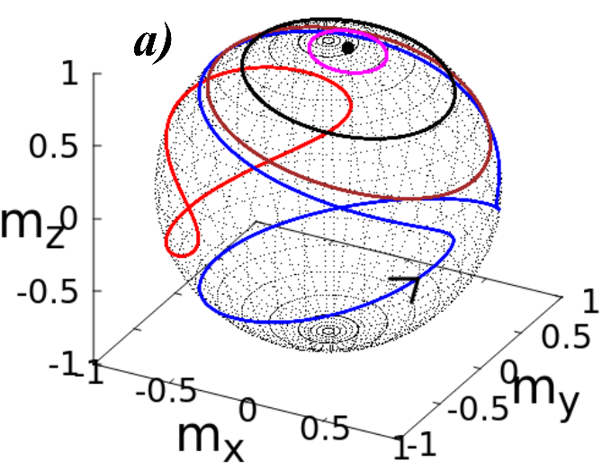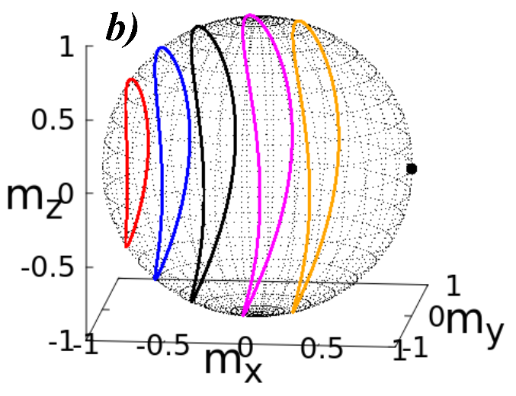

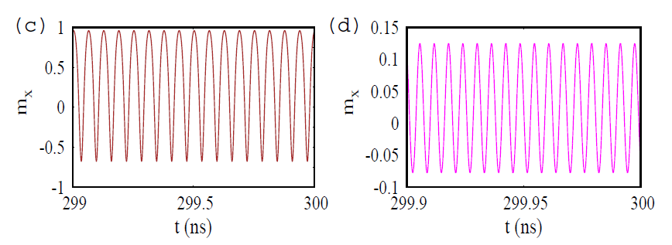
FIGURE 2. (a) Trajectories of the magnetization vector m over the interval t = 299–300 ns for I = −0.5 mA (red), −1 mA (blue), −1.5 mA (brown), −2.5 mA (black), −3.25 mA (magenta), and −4 mA (black point); J = 0.4 mJ/m². (b) Trajectories of m over the interval t = 299–300 ns for I = −2 mA (red), −2.1 mA (blue), −2.2 mA (black), −2.3 mA (magenta), −2.35 mA (dark orange), and −3 mA (black point); J = 7 mJ/m². (c) Time evolution of mₓ for J = 0.4 mJ/m² and I = −1.5 mA. (d) Time evolution of mₓ for J = 7 mJ/m² and I = −2.3 mA [9].
In our work, the phase portraits (appearance/disappearance of closed cycles, trajectory thickness, and symmetry) fully correspond to the regime transitions in LLGS dynamics: the current I and interlayer exchange J can be regarded as “control parameters.” This provides a clear visualization of the phase transition between a closed cycle and a stationary point.
In the works [16-24], measurements on nanostructures made of high-temperature superconductors were reported, aimed at determining the origin of conductivity in these materials. Until now, the rings fabricated from these compounds typically had sizes on the order of hundreds of nanometers. In the present work, the authors report measurement results on rings made of La₁.₈₄Sr₀.₁₆CuO₄ - a high-temperature superconductor that exhibits zero electrical resistance below ~38 K, with ring sizes reduced to tens of nanometers.
The authors observed the variation of resistance in the rings as a function of magnetic flux. These oscillations exhibit a period of h/2eh/2e, and their amplitudes are significantly higher than those expected for resistance oscillations due to the Little–Parks effect. Furthermore, unlike Little–Parks oscillations, which arise from the periodic modulation of the superconducting transition temperature, the oscillations observed in the study are attributed to the periodic variation of the interaction between thermally activated moving vortices and the induced oscillatory persistent currents in the rings.
Nevertheless, despite the enhanced amplitude of these oscillations, the authors note that, until recently, the previously predicted h/eh/e -periodic oscillations for nanostructures made of d-wave symmetric superconductors, or the expected h/4eh/4e -periodic oscillations for strip-shaped superconductors, have not been observed.
Fig.1 illustrates the resistance of the La₁.₈₄Sr₀.₁₆CuO₄ network as a function of the external magnetic field at a temperature of 28.4 K. The oscillations are superimposed on a parabolic background. The amplitude ΔR is clearly visible at low magnetic fields. The inset shows the temperature dependence of ΔR: the solid line represents the measured data, while the dashed line indicates the upper limit of the expected resistance oscillation amplitude based on the Little–Parks effect (note that the scale along this axis is magnified by a factor of 10).
Fig.3 shows the magnetoresistance of a network with dimensions of 150/500 nm. The measurements were performed at T = 28.4 K under a magnetic field oriented perpendicular to the film surface (i.e., along the a–b crystallographic plane). The measured magnetoresistance exhibits large oscillations superimposed on a parabolic background. The period of these oscillations, H₀ ≈ 950 Oe, corresponds to a magnetic flux quantum Φ₀=h/2e=AH₀, where h is Planck’s constant, e is the electron charge, and A is the area of the small ring. Additional oscillations with a period of ~80 Oe were also observed.

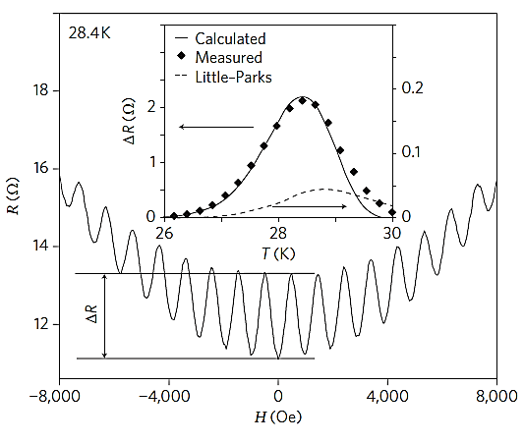
FIGURE 3. Magnetoresistance oscillations [16].
In the works [25-31], the role of field-like torque and the orientation of the external magnetic field in achieving complete synchronization in arrays of serially coupled spin-torque nano-oscillators (STNOs) was investigated. The authors modeled these systems using the Landau–Lifshitz–Gilbert–Slonczewski equation and analyzed mathematically and numerically the synchronization behavior for arrays containing 2, 10, and 100 STNOs.
The results indicate that for small N, a field-like torque is sufficient, whereas for larger N, fine-tuning of the external magnetic field orientation is necessary. The degree of synchronization was quantified using the Kuramoto order parameter, and the stability of the synchronized state was confirmed via the transverse Lyapunov exponent. In the synchronized regime, both the signal frequency and amplitude increase, which is of practical importance for high-power nanosensors and microwave generators based on STNOs.
In Fig.4, panels (a) and (b) show the time evolution of the m_{x1} and m_{x2} components for β = 0 and β = 0.2. In panel (a), the two signals exhibit a phase difference, i.e., they are not synchronized. In panel (b), the signals overlap completely, indicating full synchronization. Panels (c)–(f) depict the phase portraits (m_{x1}, m_{x2}) for different β values (0, 0.05, 0.1, 0.2). For β = 0, a large disparity exists between the two signals. As β increases, the trajectories converge, and at β = 0.2, they align along a single straight line — a 45° diagonal — indicating complete synchronization of the STNO pair. Consequently, this figure clearly demonstrates how synchronization can be achieved through the field-like torque.
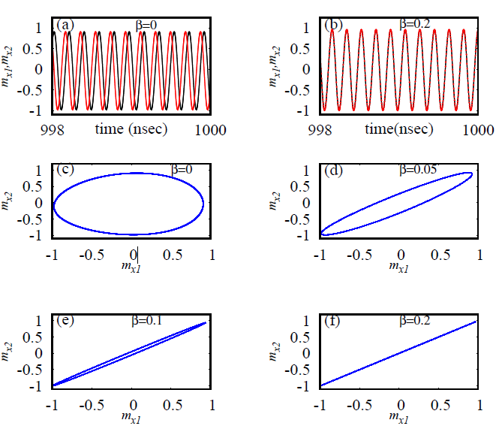
FIGURE 4. Influence of the field-like torque (β) on the synchronization of two
spin-torque nano-oscillators (STNOs) [25].
Fig.5(a) shows the dependence of the frequency of synchronized oscillations on the current I₀ in a system composed of 100 spin-torque nano-oscillators (STNOs). The graph presents three different values of the field-like torque, β = 0.2, 0.3, and 0.6. The frequency increases both with increasing I₀ and with increasing β. These results indicate that the frequency in STNO-based devices can be controlled over a wide range. Fig.5(b) illustrates the phase portrait between the m_{x} and m_{y} components. Here, (i) the black curve corresponds to clustered motion (i.e., partially synchronized but not fully) for β = 0 and θ_{h} = 0°, while (ii) the blue curve represents fully synchronized motion for β = 0.2 and θ_h = 6°. The large-amplitude circular shape in the blue curve indicates that all oscillators are moving along the same trajectory. These figures thus confirm that perfect synchronization can be achieved by adjusting the field-like torque and the angle of the external magnetic field.
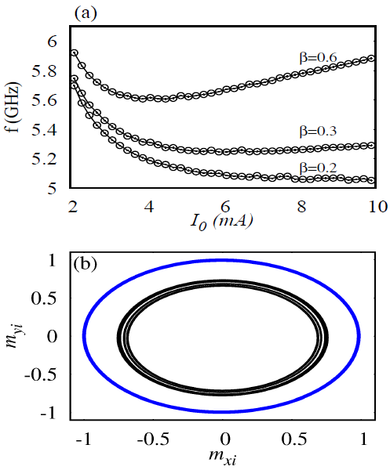
FIGURE 5. Frequency of synchronized oscillations and the phase portrait between components in a system of 100 spin-torque nano-oscillators (STNOs) [25].
CONCLUSION
In bulk and quantum-structured semiconductors, charge carriers exhibit various dynamic processes under the influence of external factors. In particular, the quantization of density-of-states oscillations and quantum magnetic effects under a static magnetic field represent one of the fundamental and applied directions in semiconductor physics. While the motion of charge carriers under a static magnetic field separates into discrete Landau levels, in a dynamic (time-varying) weak magnetic field, the electron system exhibits resonance properties. As a result, the cyclotron frequency of the dynamic magnetic field interacts with the cyclotron frequency of the charge carriers, giving rise to magnetoplasmon oscillations. These considerations indicate that, to fully study the quantum magnetic effects in quantum-sized semiconductor structures under dynamic magnetic fields, it is essential to analyze their phase portraits.
REFERENCES
- Giordano, M. Carpentieri, A. Laudani, G. Gubbiotti, B. Azzerboni, G. Finocchio. (2014). Spin-Hall Nano-oscillator: a micromagnetic study, Applied Physics Letters, 105(4), 042412. https://doi.org/10.1063/1.4892168
- Haazen, P.P.J., Murè, E., Franken, J.H., Lavrijsen, R., Swagten, H.J.M., Koopmans, B. (2013). Domain wall depinning governed by the spin Hall effect. Nature Materials, 12(4), 299-303. https://doi.org/10.1038/nmat3553
- Ryu, K.-S., Thomas, L., Yang, S.-H., Parkin, S. (2013). Chiral spin torque at magnetic domain walls. Nature Nanotechnology, 8, 527–533. https://doi.org/10.1038/nnano.2013.102
- Erkaboev, U.I., Rakhimov, R.G. (2023). Determination of the dependence of the oscillation of transverse electrical conductivity and magnetoresistance on temperature in heterostructures based on quantum wells. East European Journal of Physics, 2023(3), 133-145. https://doi.org/10.26565/2312-4334-2023-3-10
- Bhowmik, D., You, L., Salahuddin, S. (2013). Spin Hall effect clocking of nanomagnetic logic without a magnetic field. Nature Nanotechnology, 9, 59-63. https://doi.org/10.1038/nnano.2013.241
- Demidov, V.E., Urazhdin, S., Ulrichs, H., Tiberkevich, V., Slavin, A., Baither, D., Schmitz, G., Demokritov, S.O. (2012). Magnetic nano-oscillator driven by pure spin current. Nature Materials, 11(12), 1028-1031. https://doi.org/10.1038/nmat3459
- Fan, X., Wu, J., Chen, Y., Jerry, M.J., Zhang, H., Xiao, J.Q. (2013). Observation of the nonlocal spin-orbital effective field. Nature Communications, 4, 1799. https://doi.org/10.1038/ncomms2709
- Gulyamov, G., Erkaboev, U.I., Rakhimov, R.G., Mirzaev, J.I., Sayidov N.A. (2023). Determination of the dependence of the two-dimensional combined density of states on external factors in quantum-dimensional heterostructures. Modern Physics Letters B, 37(10), 2350015. https://doi.org/10.1142/S021798492350015X
- Arun, R., Gopal, R., Chandrasekar, V.K., Lakshmanan, M. (2023). High-frequency oscillations in a spin-torque nano-oscillator due to bilinear coupling. Physical Review B, 107, 224434. https://doi.org/10.1103/PhysRevB.107.224434
- Erkaboev, U.I., Rakhimov, R.G., Sayidov, N.A. & Mirzaev, J. I. (2022). Modeling the temperature dependence of the density oscillation of energy states in two-dimensional electronic gases under the impact of a longitudinal and transversal quantum magnetic fields. Indian Journal of Physics, 97, 1061-1070. https://doi.org/10.1007/s12648-022-02435-8
- Deng, K., Li, X., Flebus, B. (2023). Exceptional points as signatures of dynamical magnetic phase transitions. Physical Review B, 107, L100402. https://doi.org/10.1103/PhysRevB.107.L100402
- Yamaguchi, T., Tsunegi, S., Nakajima, K., Taniguchi, T. (2023). Computational capability for physical reservoir computing using a spin-torque oscillator with two free layers. Physical Review B, 107, 054406. https://doi.org/10.1103/PhysRevB.107.054406
- Beknazarova, S., Abdullayev, S., Abdullayeva, O., & Abdullayev, Z. (2024). Machine learning method for predicting human movements. AIP Conference Proceedings, 3244, 030036. https://doi.org/10.1063/5.0242100
- Liu, C., Kurokawa, Y., Hashimoto, N., Tanaka, T., Yuasa, H. (2023). High-frequency spin torque oscillation in orthogonal magnetization disks with strong biquadratic magnetic coupling. Scientific Reports, 13, 3631. https://doi.org/10.1038/s41598-023-30838-y
- Mirsaidov, M., Matkarimov, P., & Juraev, D. (2025). Assessment of stress-strain state of earth dams considering the spatial operation of structures. AIP Conference Proceedings, 3282, 050020. https://doi.org/10.1063/5.0265149
- Sochnikov, I., Shaulov, A., Yeshurun, Y., Logvenov G., Bozˇovic’, I. (2010). Large oscillations of the magnetoresistance in nanopatterned hightemperature superconducting films. Nature Nanotechnology, 5, 516-519. https://doi.org/10.1038/nnano.2010.111
- Ismanova, K., Isomaddinov, U., & Dedakhanov, A. (2023). Decision-making models for in-situ leaching process control. AIP Conference Proceedings, 2789, 020006. https://doi.org/10.1063/5.0145404
- Erkaboev, U.I., Sayidov, N.A., Negmatov, U.M., Mirzaev J.I., Rakhimov, R.G. (2023). Influence temperature and strong magnetic field on oscillations of density of energy states in heterostructures with quantum wells HgCdTe/CdHgTe. E3S Web of Conferences, 401, 01090. https://doi.org/10.1051/e3sconf/202340101090
- Juricic, V., Herbut, I. F. & Tesanovic, Z. (2008). Restoration of the magnetic hc/e-periodicity in unconventional superconductors. Physical Review Letters, 100, 187006. https://doi.org/10.1103/PhysRevLett.100.187006
- Vakaryuk, V. (2008). Universal mechanism for breaking the hc/2e periodicity of fluxinduced oscillations in small superconducting rings. Physical Review Letters, 101, 167002. https://doi.org/10.1103/PhysRevLett.101.167002
- Beknazarova, S., Joldasov, S., Abdullayeva, O., & Mamasoatov, D. (2023). Control mechanism of eliminate noise and improve visual perception of the image. AIP Conference Proceedings. https://doi.org/10.1063/5.0145732
- Wei, T.-C., Goldbart, P.M. (2008). Emergence of h/e-period oscillations in the critical temperature of small superconducting rings threaded by magnetic flux. Physical Review B, 77, 224512. https://doi.org/10.1103/PhysRevB.77.224512
- Zhu, J.-X. & Quan, H.T. (2010). Magnetic flux periodicity in a hollow d-wave superconducting cylinder. Physical Review B, 81, 054521. https://doi.org/10.1103/PhysRevB.81.054521
- Erkaboev U., Rakhimov, R., Mirzaev, J., Sayidov, N., Negmatov U., Abduxalimov M. (2023). Calculation of oscillations in the density of energy states in heterostructural materials with quantum wells. AIP Conference Proceedings, 2789(1), 040055. https://doi.org/10.1063/5.0145554
- Arun, R., Gopal, R., Chandrasekar, V.K., Lakshmanan, M. (2024). Exploration of field-like torque and field-angle tunability in coupled spin-torque nano oscillators for synchronization. Chaos, 34(1), 013114. https://doi.org/10.1063/5.0173943
- Kendzioczyk, T., Demokritov, S.O., Kunn, T. (2014). Spin-wave-mediated mutual synchronization of spin-torque nano-oscillators: A micromagnetic study of multistable phase locking. Physical Review B, 90, 054414. https://doi.org/10.1103/PhysRevB.90.054414
- Sharibaev, N., Jabborov, A., Rakhimov, R., Korabayev, S., Sapayev, R. (2024). A new method for digital processing cardio signals using the wavelet function. BIO Web of Conferences, 130, 04008. https://doi.org/10.1051/bioconf/202413004008
- Turtle, J., Buono, P.-L., Palacios, A., Dabrowski, C., In, V., Longhini, P. (2017). Synchronization of spin torque nano-oscillators. Physical Review B, 95, 144412. https://doi.org/10.1103/PhysRevB.95.144412
- Grollier, J., Querlioz, D., Stiles, M.D. (2016). Spintronic Nanodevices for Bioinspired Computing. Proceedings of the IEEE, 104(10), 2024-2039. https://doi.org/10.1109/JPROC.2016.2597152
- Korabayev, S., Ergashov, M., Akhmedov, K. I., Matismailov, S., Axmedov, M., Latipova, M., & Isomaddinov, U. (2025). Theoretical analysis of the effect of saw teeth on fibers during fiber discretization. AIP Conference Proceedings, 3304, 030085. https://doi.org/10.1063/5.0269092
- Mirzabayev, B., et al. (2025). Controlling tensile strength in yarn using an ultrasonic water vaporizer. AIP Conference Proceedings, 3304, 030047. https://doi.org/10.1063/5.0269506

