Ultrafast Magnetization Dynamics Studied by Optical Pump–THz Emission (OPTE) Spectroscopy

Guloyim Olimjonova^{1, a)}, Makhliyo Makhmudova^{1, b)}, Ikboljon Tulkinov², Roziya Nazirtashova³, Mаrhаbо Xоlmаtоvа⁴
¹Andijan State University, Andijan, Uzbekistan.
²Andijan State Technical Institute, Andijan,Uzbekistan,
³Fergana Medical Institute of Public Health, Fergana, Uzbekistan.
⁴Fergana State University, Andijan, Uzbekistan

^{a)}olimjonovaguloyim710@gmail.com
^{b)}Corresponding author: mahliyoanvarova939@gmail.com

Abstract: Studying the magnetization dynamics at ultrafast timescales is key to elucidating electron–phonon–spin interactions and to promoting advanced spintronic technologies. Yet accurate measurement is technically difficult at device-level in terms of these processes. In this work, we develop a fully contact-free optical pump–THz emission (OPTE) spectroscopic approach for directly probing ultrafast spin dynamics that is unbounded by the temporal width of the emitted THz pulse. For this, we analyze the excitation and relaxation of a laser-driven Fe monolayer. The OPTE measurements provide definitive resolution of distinct dynamical features, with an ultrafast demagnetization occurring at less than <0.5 ps, and rapid (~1 ps) and slow (10–50 ps) remagnetization processes driven by spin–lattice coupling and thermal diffusion, respectively. This finding is indicative of OPTE's remarkable ability as a powerful platform for characterization and optimization of magneto-optical recording media and spintronic THz emitters.

Keywords: Ultrafast magnetization dynamics, Spintronics, Optical pump–THz emission (OPTE), Terahertz spectroscopy, Fe monolayer, Demagnetization, Spin–lattice relaxation, Thermal diffusion, Ultrafast spectroscopy, Magneto-optical materials
INTRODUCTION
To fully understand spin dynamics on ultrafast timescales, and subsequently to elucidate electron–phonon–spin interactions, further high-performance spintronic devices should be realized. However, the quantification of these processes under realistic device conditions for the monitoring of these processes at high frequencies and levels is still problematic [1-3]. Here, we adopt an original contact-free, OPTE spectroscopic technique that directly investigates ultrafast magnetization dynamics independent of the length of the emitted THz pulses. We then apply this technique to test spin dynamics for a laser-activated Fe monolayer experimentally. The measurements exhibit two basic elements of the magnetization response:
1. In less than 0.5 ps an ultrafast demagnetization is observed.
2. Fast (≈1 ps) and slow (10–50 ps) recovery of magnetization that are explained based on spin–lattice interactions and thermal diffusion into the substrate.
OPTE was found to become a robust platform for the optimized magneto-optical recording materials and THz emission devices. Ultrafast spintronics, developed from the discovery of ultrafast demagnetization in ferromagnets in 1996, has rapidly spread due to the rapid growth in the area. Single or multiple femtosecond laser pulses are demonstrated experimentally to modulate the spins even without the help of an external magnetic field. However, the processes involved in ultrafast demagnetization are still lacking, due to contributions from the following sources:
• Local angular momentum transfer: electron–magnon and electron–phonon spin-flip scattering.
• Nonlocal spin transport: superdiffusive spin currents.
• Light–spin interactions: coherent spin excitation, inverse Faraday effect, OISTR.
Although multiple ultrafast methods have been developed for characterization (TR-XMCD, TR-MOKE, time-resolved photoemission), each has limitations pertaining to penetration depth, vacuum conditions, or complex interpretation. THz emissions of ferromagnetic films are a reliable method for observing ultrafast spin–charge interactions. Mechanisms for THz emissions, such as anomalous Hall effect (AHE), ultrafast magnetic dipoles, and ISHE are present [4-6].

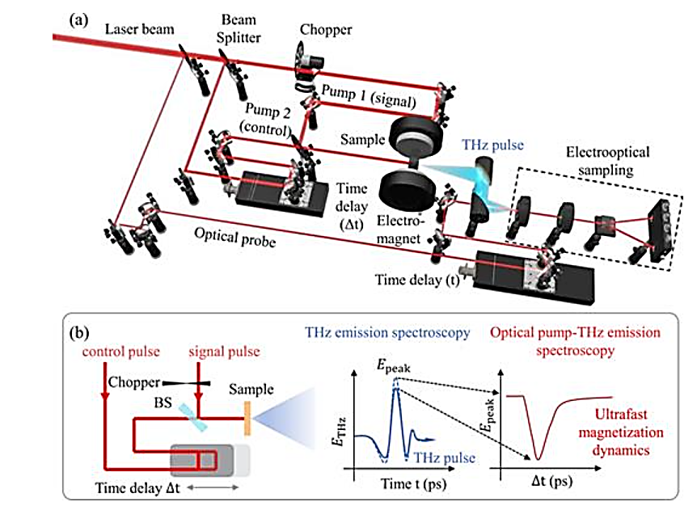
FIGURE 1. Schematic illustrating OPTE spectroscopy for ultrafast detection of magnetization dynamics. (a) Schematic illustrating OPTE spectroscopy for ultrafast detection of magnetization dynamics. (b) Pump 1 (signal pump pulse) was chopped, and the modulation of peak amplitude of the THz pulse Epeak was measured as a function of the time delay Δt between pump 2 (control pump pulse) and pump 1.
As illustrated in Fig. 1(b), a mechanical chopper is set to modulate pump 1 (the signal pump pulse) and generate THz emission from the Fe monolayer. Next, the emitted THz transient is characterized by scanning the temporal delay t between the signal pump and the optical probe pulse. For the detection of the THz waveform in the far field, free-space electro-optic sampling (EOS) using a 1-mm-thick ⟨110⟩-oriented ZnTe crystal is performed. In the EOS detection, the THz electric field is gated via a 35-fs, 800-nm probe pulse and read out using a balanced photodetector setup to ensure high-fidelity measurement [7-9]. One of the benefits of THz emission spectroscopy (TES):
• deeper penetration into materials,
• applicability to relatively thick heterostructures.
Nonetheless, TES is insensitive to frequencies below 0.1 THz, and therefore is poorly suited for processes exceeding ~10 ps, such as slow remagnetization.
Proposed method: Optical Pump–THz Emission (OPTE). We developed a dual-pump OPTE where we:
• Pump 1 generates THz emission,
• Pump 2 modifies the magnetization state,
and the THz amplitude is measured as a function of the time delay between the two pulses.
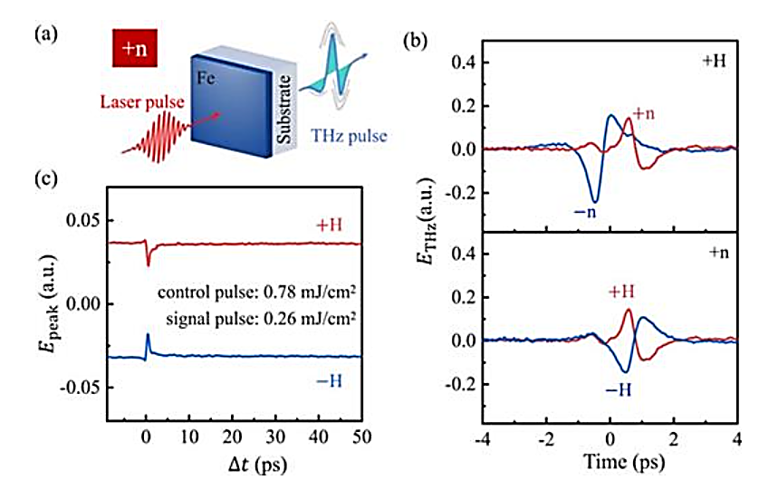
FIGURE 2. THz emission characteristics from a 12-nm Fe thin film under opposite static magnetization conditions. (a) Schematic of THz emissions from Fe thin film. (b) THz waveforms obtained from the photoexcited side of 12 nm thick Fe (+n) and substrate (−n) with ±H. (c) The OPTE measured an Epeak(Δt) of 12 nm thick Fe film for opposite static magnetization.
The typical OPTE spectroscopic curves Epeak(Δt) for a 12 nm thick Fe thin film, which were measured for opposite static magnetization, using pump fluences of 0.26 and 0.78 mJ/cm2 for signal and control pump pulses, respectively, are presented. It is seen that Epeak(Δt) is inverted after reversal of the static magnetization, demonstrating a strong connection between the OPTE signal and magnetic order. The Epeak(Δt) curves illustrate the typical response: a rapid quench of the magnetization on a time scale <500 fs, followed by a fast recovery on a time scale <1 ps, and finally a much slower recovery on tens of ps.

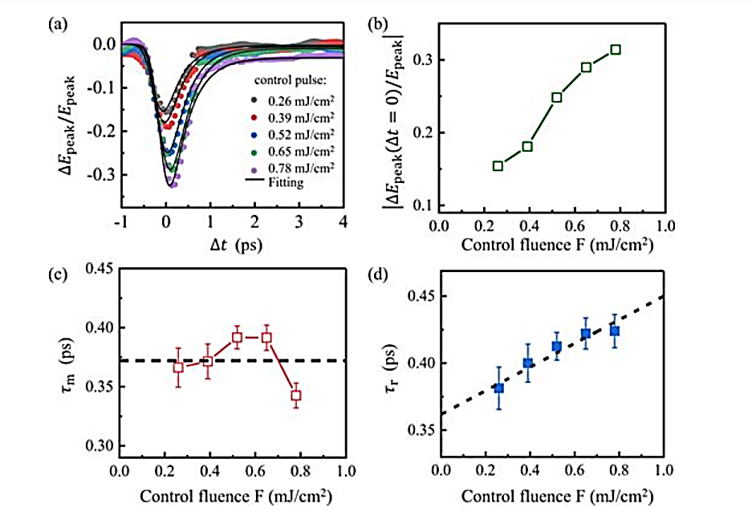
FIGURE 3. Control-pulse–dependent OPTE response and extracted spin-dynamic parameters for a 12-nm Fe thin film.
3fig. (a) ΔEpeak(Δt)/Epeak for a 12 nm thick Fe film with different control pump fluences of 0.26 and 0.78 mJ/cm2 and a fixed signal pump fluence of 0.78 mJ/cm2. The black lines represent the fits using Eq. (1). (b) Dependences of on control pump fluence. (c) τm and (d) τr as functions of control pump fluences, extracted from the Eq. (1) fits. The error bars are the standard deviation calculated from the fitting function. This method enables measurement of spin dynamics from sub-picosecond up to tens of picoseconds, beyond the limits of conventional TES.

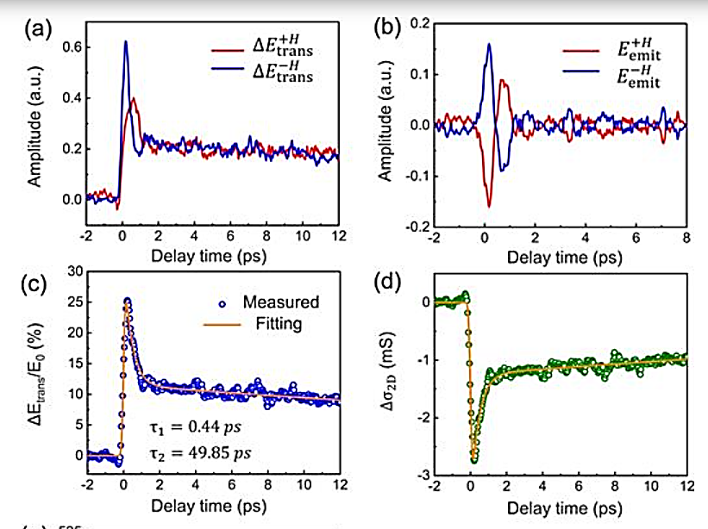
FIGURE 4. Transient THz response, conductivity dynamics, and two-temperature–model fitting for a 12-nm Fe thin film.
4fig. (a) Transient THz field peak changes of a 12 nm thick Fe thin film in the first 12 ps following photoexcitation at a pump fluence of 0.78 mJ/cm2 for two opposite polarities at H = ±110 mT. (b) The time-traces of the THz emission with ±H, obtained from (a). (c) The change in ΔEtrans/E0 as a function of the delay time between the optical pump and the THz probe pulse, extracted from (a). (d) The calculated transient sheet conductivity dynamics Δσ2D. (e) Temperature-calibrated measured data in (c). The fit is based on the two-temperature model with the electron (red) and the phonon temperature (green).
RESULTS
Origin of the THz Signal
A 12 nm Fe layer was chosen to ensure uniform pump absorption. The MgO substrate and SiO₂ capping layer suppress superdiffusive spin flow, indicating that ISHE is not the dominant source.
The dominant mechanism behind ultrafast demagnetization is:
• electron–magnon scattering, which rapidly reduces magnetization.
Demagnetization and Recovery Times
From OPTE data, the extracted characteristic times are:
TABLE 1. Extracted characteristic times of ultrafast demagnetization and recovery processes in a 12-nm Fe thin film.
Process | Time Constant
Demagnetization | 373 ± 20 fs
Fast recovery (spin–lattice) | ≈0.4 ps
Slow recovery (thermal diffusion) | ≈50 ps

The values conform to existing TR-MOKE and TES measurements. The fast recovery is attributed to the Elliott–Yafet spin-flip mechanism.
4.3. Electron–Phonon Coupling
Optical pump–THz probe (OPTP) measurements indicated that:
• laser excitation heats electrons rapidly,
• increasing electron scattering rate,
• generating negative photoconductivity.
Two relaxation factors have been found:
• τ₁ ≈ 0.44 ps — electron–phonon coupling
• τ₂ ≈ 49.85 ps — thermal diffusion
This gives the obtained electron–phonon coupling constant as:
G = 7 × 10¹⁷ W m⁻³ K⁻¹
This study shows that using OPTP spectroscopy, one can precisely quantify ultrafast magnetic processes in Fe monolayers. The method enables definite separation of:
• sub-picosecond demagnetization,
• spin–lattice relaxation,
• and thermal diffusion.
For magneto-optical and THz-emitting materials, OPTP offers a high-resolution, non-contact method for examining the performance. The strategy has strong potential to study light–spin interactions among varying ferromagnetic heterostructures with pump pulses of a range of wavelengths and polarizations.
CONCLUSION
In this study, ultrafast magnetization dynamics in a laser-excited Fe monolayer were investigated with high temporal resolution using optical pump–THz emission (OPTE) spectroscopy. The proposed OPTE approach removes the temporal limitations inherent to conventional THz emission techniques, enabling the clear separation of dynamic processes occurring on sub-picosecond (fs–ps) timescales.
The experimental results demonstrate that:
- The primary mechanism of demagnetization is electron–magnon scattering, leading to a rapid reduction of magnetization within 373 ± 20 fs.
- The fast recovery phase (≈0.4 ps) is governed by spin–lattice interactions and the Elliott–Yafet spin-flip mechanism.
- The slow recovery phase (≈50 ps) is driven by thermal diffusion into the substrate.
- OPTP (optical pump–THz probe) measurements reveal rapid electron heating, increased scattering rates, and negative photoconductivity. From the two-step relaxation dynamics, the electron–phonon coupling constant was quantified as G = 7 × 10¹⁷ W·m⁻³·K⁻¹.
These findings confirm that the OPTE method is highly effective for resolving ultrafast magnetic processes. The technique provides a robust, non-contact platform for studying light–spin interactions in ferromagnetic heterostructures and for optimizing magneto-optical recording materials and THz-emitting spintronic devices.
REFERENCES
- Chen Huang, Zhangshun Li, Bo Lu, Yifan Wang, Miao Cai, Lin Xi, Huiping Zhang, Zuanming Jin; Optical pump-terahertz emission probe of ultrafast magnetization dynamics. J. Chem. Phys. 14 December 2025; 163 (22): 224202. https://doi.org/10.1063/5.0309656
- Beaurepaire, E., Merle, J., Daunois, A., & Bigot, J. (1996). Ultrafast spin dynamics in ferromagnetic nickel. Physical Review Letters, 76(22), 4250–4253. https://doi.org/10.1103/physrevlett.76.4250
- Jin, Z., Tkach, A., Casper, F., Spetter, V., Grimm, H., Thomas, A., Kampfrath, T., Bonn, M., Kläui, M., & Turchinovich, D. (2015). Accessing the fundamentals of magnetotransport in metals with terahertz probes. Nature Physics, 11(9), 761–766. https://doi.org/10.1038/nphys3384
- Tengdin, P., You, W., Chen, C., Shi, X., Zusin, D., Zhang, Y., Gentry, C., Blonsky, A., Keller, M., Oppeneer, P. M., Kapteyn, H. C., Tao, Z., & Murnane, M. M. (2018). Critical behavior within 20 fs drives the out-of-equilibrium laser-induced magnetic phase transition in nickel. Science Advances, 4(3), eaap9744. https://doi.org/10.1126/sciadv.aap9744
- Zhang, W., Maldonado, P., Jin, Z., Seifert, T. S., Arabski, J., Schmerber, G., Beaurepaire, E., Bonn, M., Kampfrath, T., Oppeneer, P. M., & Turchinovich, D. (2020). Ultrafast terahertz magnetometry. Nature Communications, 11(1), 4247. https://doi.org/10.1038/s41467-020-17935-6
- Sharibaev, N., et al. (2024). A new method for digital processing cardio signals using the wavelet function. BIO Web of Conferences, 130, 04008. https://doi.org/10.1051/bioconf/202413004008
- Korabayev, S., Ergashev, O., Mahsudov, S. A., & Mamatova, S. (2024). Exploring common technical issues in modern technology. BIO Web of Conferences, 145, 03016. https://doi.org/10.1051/bioconf/202414503016
- Li, Z., Jiang, Y., Jin, Z., Li, Z., Lu, X., Ye, Z., Pang, J.-Y., Xu, Y., & Peng, Y. (2022). Terahertz Emission Spectroscopy of Ultrafast Coupled Spin and Charge Dynamics in Nanometer Ferromagnetic Heterostructures. Nanomaterials, 12(23), 4267. https://doi.org/10.3390/nano12234267
- Lin Huang, Ji-Wan Kim, Sang-Hyuk Lee, Seon-Dae Kim, Van Manh Tien, Kiran Prakash Shinde, Je-Ho Shim, Yooleemi Shin, Hee Jun Shin, Seongheun Kim, Jaehun Park, Seung-Young Park, Yeon Suk Choi, Hyun-Joong Kim, Jung-Il Hong, Dong Eon Kim, Dong-Hyun Kim; Direct observation of terahertz emission from ultrafast spin dynamics in thick ferromagnetic films. Appl. Phys. Lett. 30 September 2019; 115 (14): 142404. https://doi.org/10.1063/1.5087236

