Investigation the Effects of Temperature and Light on Nanoscale Semiconductor Materials
Rashid G. Rakhimov¹, Sherzod Korabayev^{1, a)}, Avazbek Obidov¹,
Dilnoza Kh. Makhmudova², Mansurjon Bustonov¹, Doniyor Sobirov³
¹Namangan State Technical University, Namangan, Uzbekistan
²Namangan State University, Namangan. Uzbekistan
³Urgench State University, Urgench, Uzbekistan

^{a)}Corresponding author: sherzod.korabayev@gmail.com
Abstract: This article studies the temperature dependence of magnetoresistance oscillations induced by a magnetic field in low-dimensional semiconductor structures. In low-dimensional systems, the quantized energy states of charge carriers lead to the emergence of oscillatory effects in the electrical transport properties. The temperature-dependent evolution of the amplitude and phase of magnetoresistance oscillations is systematically analyzed by considering charge carrier scattering mechanisms, Fermi–Dirac statistics, and the quantization of the electronic density of states. The regularities of the decrease in oscillatory effects with increasing temperature are considered, and the connection of these processes with the Shubnikov–de Haas effect is substantiated. The findings presented provide meaningful scientific and practical contributions by enhancing the understanding of quantum transport mechanisms in small-scale semiconductor systems and by informing the engineering of highly sensitive electronic and optoelectronic devices. More generally, this article investigates emerging trends in studies addressing the influence of thermal and optical factors on quantum oscillation effects in low-dimensional semiconductors.
Keywords: semiconductor, quantum well, magnetic field, temperature, magnetoresistance, quantum oscillations, temperature dependence.
INTRODUCTION
The investigation of semiconductor systems with reduced dimensionality has increasingly become a central focus in the advancement of nanoelectronic and quantum technological applications. As a result of the reduction of dimensions to the nanometer scale, the behavior of charge carriers deviates from classical laws, and quantum mechanical effects begin to take precedence. Such conditions promote the quantization of electronic energy levels, induce changes in the density of available states, and alter carrier scattering mechanisms, thereby significantly affecting charge transport characteristics.
Magnetoresistance oscillations observed in small-sized semiconductors under the influence of an external magnetic field are one of the most important manifestations of quantum transport phenomena. These oscillations are associated with the quantization of charge carriers into Landau levels, and their amplitude, periodicity, and phase directly depend on the fundamental parameters of the system, including such quantities as the effective mass, carrier concentration, and scattering time. In particular, Shubnikov–de Haas oscillations are clearly manifested at low temperatures and serve as an important experimental tool for determining the quantum properties of semiconductor structures.
Temperature is one of the decisive external factors in the formation of magnetoresistance oscillations. With increasing temperature, the broadening of the Fermi–Dirac distribution and the increase in the probability of inelastic scattering of charge carriers lead to a weakening of oscillatory effects. Therefore, by studying the temperature dependence of magnetoresistance oscillations, it becomes possible to better understand the stability of quantized energy states, the nature of scattering mechanisms, and the physical nature of quantum transport processes in low-dimensional systems [1-3].
This research is dedicated to examining the effects of temperature on magnetoresistance oscillations in low-dimensional semiconductor structures from both theoretical and physical perspectives. The aim of the research is to determine the laws of quantum oscillatory effects that occur under the combined influence of a magnetic field and temperature and to assess their practical significance in the design of nanoelectronic and optoelectronic devices.
METHODS
L.D. Landau [4] was the first to theoretically establish that not only does dimensional quantization occur in the energy of charge carriers in low-dimensional semiconductors under a transverse quantizing magnetic field, but an external magnetic field can also induce quantization. He showed that the continuous energy spectrum of free charge carriers is split into discrete Landau levels. Specifically, the quantization energy of free electrons in bulk semiconductors under a magnetic field can be obtained by solving the Schrödinger equation, where the momentum operator is expressed as [5]:
(1)
instead of, the following potential vector operator under the influence of a magnetic field is used:
(2)
Then, using (2), the Hamiltonian of a free electron is written as follows:
(3)
This relation is valid without taking into account the spin expansion (() term does not participate in the solution of equation (3)). Under the action of a transverse quantizing magnetic field, the field vector is aligned along the z-axis, normal to the XY plane. Then, the vector potential takes the form:
A_{y} = Hx; A_{x} = A_{z} = 0 (4)
According to equation (4), the Schrödinger equation () takes the following form:
(5)
Since equation (5) specifically involves only the X coordinate, the solution to this equation is found by looking for a function in the following form:
(6)
Substituting equation (6) into equation (5), we obtain the following expression:
or
(7)
It can be seen from equation (7) that it is very close to the equation of a one-dimensional quantum oscillator. The equation of a one-dimensional quantum oscillator has the following form:
(8)
The eigenvalues ​​of equations (7) and (8) are equal to:
(9)
where, . To apply expression (9) to quantum-enclosed semiconductors, it is also necessary to take into account the dimensional quantization condition:
(10)
In this context, 𝑑 corresponds to the quantum well width, 𝑁 specifies the Landau level, and 𝑚 defines the number of quantum dimensions.
RESULTS
While analyzing Landau’s theoretical framework, including the quantization conditions described above, two key fundamental effects—the Shubnikov–de Haas [6–7] and de Haas–van Alphen [7] phenomena—were discovered, and these findings were promptly validated experimentally. These quantum effects were, of course, observed at very low temperatures and in strong magnetic fields.
In recent decades, experimental observations of quantum oscillation effects at room temperature and in weak magnetic fields have been reported by various scientists [8–17]. These macroscopic quantum phenomena were achieved through electron-electron interactions under pressure, particularly in the presence of shells with low correlation energy that connect low-dimensional semiconductor systems. In addition to the effective interaction of free electrons under high pressure, the observation of quantum oscillation effects is further facilitated by the fact that electrons and holes in low-dimensional semiconductor systems—particularly at the interfaces of quantum wells—exhibit significantly reduced effective masses, nearly ten thousand times smaller than that of a free electron (Figures 1–4). However, all of these results are experimental facts and have not been studied theoretically.

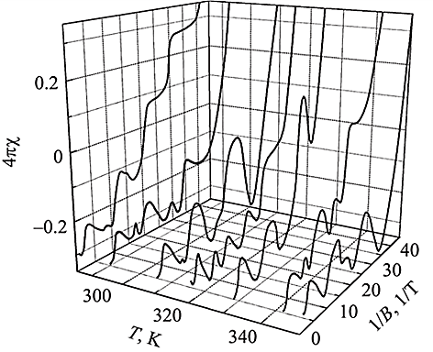
FIGURE 1. Dependence of the static magnetic susceptibility on the applied magnetic field, measured at various temperatures, in a CdB_{x}​F_{2−x}​/p-CdF₂​-QW/CdB_{x}​F_{2−x}​ nanosandwich structure fabricated on the surface of an n-CdF₂​ crystal [11]
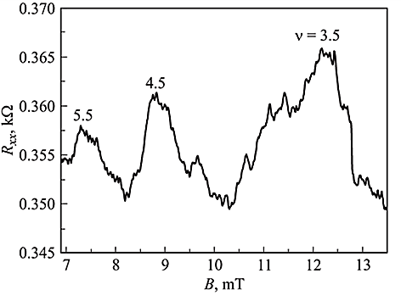
FIGURE 2. Shubnikov-de Haas oscillations in p-type ultra-narrow silicon quantum bands [10].
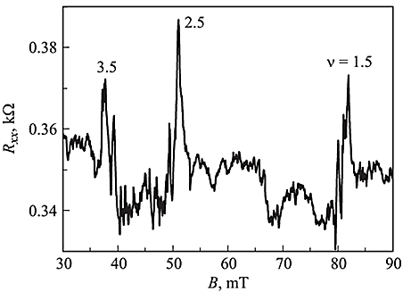
FIGURE 3. Magnetic field dependence of the longitudinal magnetoresistance measured in a p-type ultra-narrow silicon quantum well formed on an n-type Si(100) surface, confined by δ-barriers heavily doped with Boron [10].

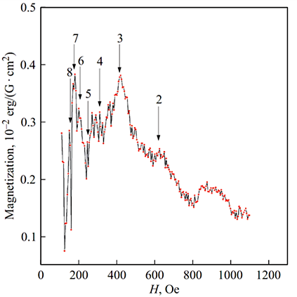
FIGURE 4. De Haas-van Alfen oscillations for a silicon nanosandwich at room temperature [12].

In these studies [18–22], experimental investigations of quantum oscillation phenomena in nanoscale thin-film semiconductor materials at various temperatures were reported. Specifically, reference [18] presents magnetotransport measurements conducted on a 156 nm thick Bi₂​Te₃​ epitaxial film within the temperature range of 1.9–300 K, with Shubnikov–de Haas oscillations experimentally observed at temperatures below 50 K. A detailed temperature-dependent analysis of these oscillations enabled the determination of key transport parameters, including the Landé g-factor and cyclotron masses (Fig. 5). As illustrated in Fig. 5, the longitudinal magnetoresistance (R_{xx}​) as a function of the magnetic field applied perpendicular to the sample surface is shown. Low-amplitude oscillations were detected for magnetic fields exceeding 6 T and temperatures below 50 K. Experimental results further demonstrate that quantum oscillations are more clearly resolved when analyzing the second-order derivative of R_{xx}​ with respect to the magnetic field (B). The inset of Fig. 5a displays the magnetic field dependence of at T = 4.2 K, highlighting the presence of the Shubnikov–de Haas effect. Figure 5b illustrates the variation of as a function of magnetic field across different temperatures.
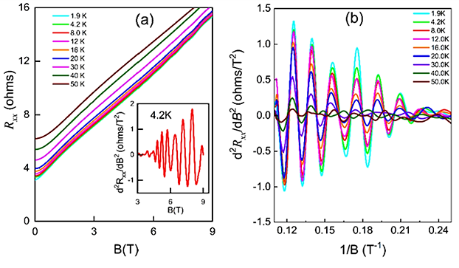
FIGURE 5. (a) Experimental measurements of the longitudinal magnetoresistance R_{xx} as a function of the magnetic field B in a nanoscale Bi₂​Te₃​ thin film [18]; (b) Magnetic field dependence of plotted as 1/B at various temperatures [18].

Consistent with expectations, the Shubnikov–de Haas oscillation amplitude decreases as temperature rises, with the oscillations almost completely vanishing at T = 50 K. From the graph, it is evident that the images of the Shubnikov-de Haas oscillations with different frequencies, i.e., having at least two components, were observed. However, in these works, the physical essence, i.e., the theoretical reasons for the results obtained in the experiments, were not studied. For example, quantum oscillations have not been observed not only in the 2nd-order derivative of the longitudinal magnetoresistance, but also in its 1st-order dependence of on B. In addition, the reason for the decrease in the oscillation amplitude with increasing temperature has not been proven.
DISCUSSION
Recent experimental studies have focused on the influence of external factors on longitudinal and transverse electrical conductivity and on magnetoresistance oscillations in quantum-well-based semiconductor heterostructures [23–24]. In related work [23], Shubnikov–de Haas oscillations were observed in Ga_{1-x}In_{x}N_{y}As_{y-1}​ quantum-wall heterostructures (x = 0.32, y = 0.009 and 0.012) doped with n- and p-type modulation under magnetic fields lower than 3 T and at temperatures up to 20 K. From these measurements, the effective mass, two-dimensional charge carrier density, and Fermi energy were extracted. Based on these experimental results, Fig. 6a presents magnetoresistance measurements of quantum wells with varying compositions (different x and y) at low temperatures.
Shubnikov–de Haas oscillations are known to appear in samples exhibiting low mobility when subjected to strong magnetic fields (µB > 1) and low temperatures (k_{B}T < ℏω_{C}). Since all samples possess the same dopant concentration, the mobility of charge carriers is a key factor determining the detectability of these oscillations. Fig.6b shows the dependence of the 2nd-order derivative $\frac{d^{2}R_{xx}}{dB^{2}}$ of GaInNAs/GaAs quantum well semiconductors on the magnetic field. The results of this experiment were obtained at temperatures of 6.1 K, 8 K, 12 K and 16 K. However, in these works, the dependence of the 1st-order derivative of the transverse magnetoresistance with respect to the magnetic field $\frac{dR_{xx}}{dB}$ on B was not studied.
Recent works [25–29] examined the magnetotransport behavior of two-dimensional electron gas (2DEG) in AlGaN/GaN heterostructures with elevated Al fractions, where an AlN/GaN superlattice served as the barrier, under conditions of low temperature and high magnetic field. Magnetoresistance oscillations were observed, which indicates the excellent quality of quasi-AlGaN/GaN heterostructures.

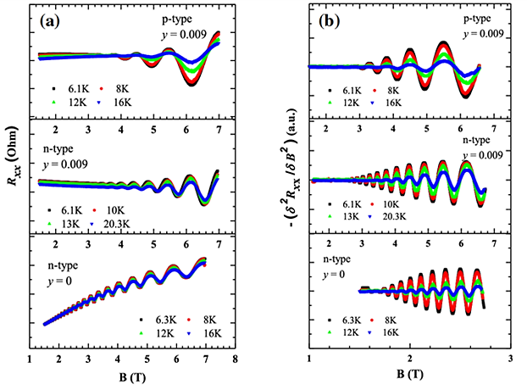
FIGURE 6. Shubnikov–de Haas oscillations: (a) raw magnetoresistance traces obtained experimentally; (b) second-order derivative of the Shubnikov–de Haas oscillations at multiple temperatures for samples without nitrogen (y = 0) and with nitrogen (y = 0.009) [23].

Room-temperature electrical properties were evaluated using Hall measurements, with indium dots serving as ohmic contacts in the van der Pauw configuration. Magnetotransport experiments were carried out at low temperatures under magnetic fields up to 14 T. As illustrated in Figures 7 and 8, well-defined Shubnikov–de Haas oscillations were observed in both samples, demonstrating the high quality of the quasi-AlGaN/GaN heterostructures.

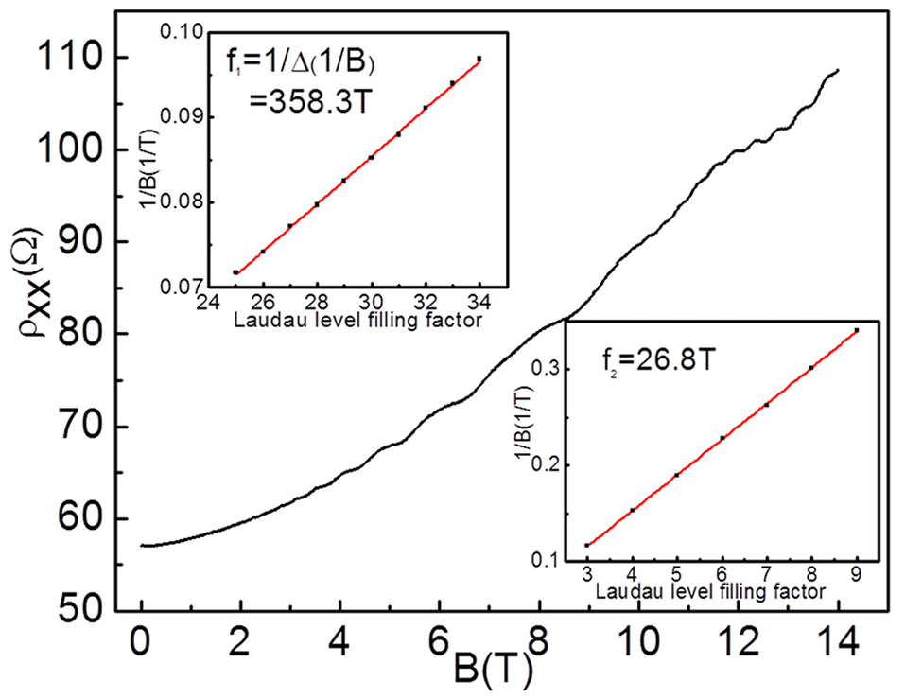
FIGURE 7. Longitudinal resistivity (ρ_{xx}​) versus magnetic field (B) along the normal interface of quasi-AlGaN/GaN heterostructures for sample A. Insets display the Shubnikov–de Haas frequency spectra obtained for the two sub-regions [25].
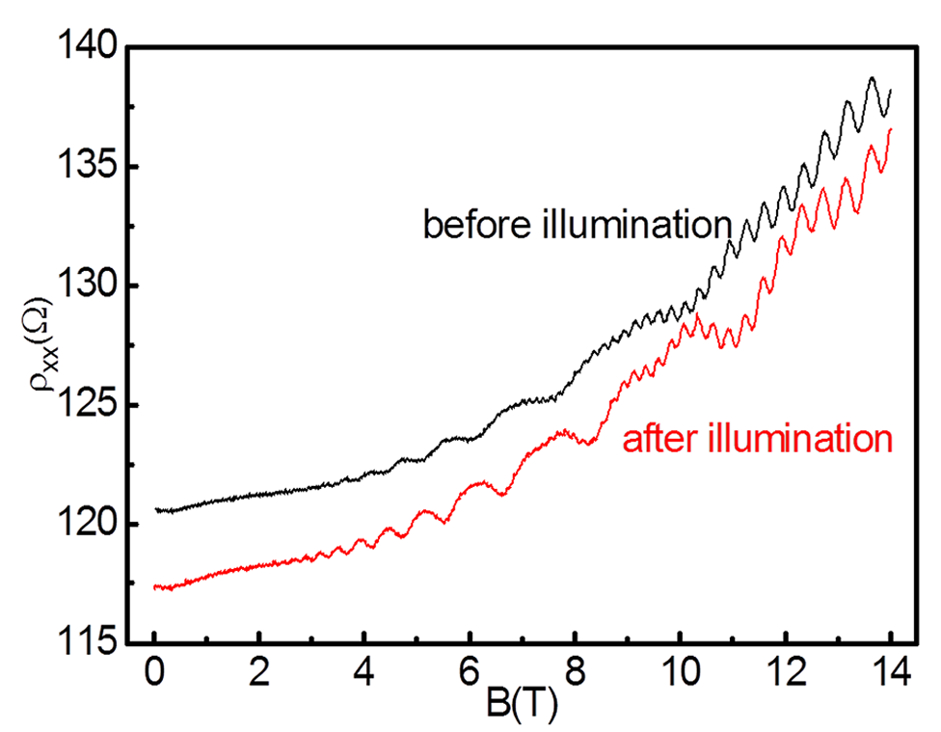
FIGURE 8. Longitudinal resistivity (ρ_{xx}​) versus magnetic field (B) along the normal interface of quasi-AlGaN/GaN heterostructures for sample B. The black and red curves correspond to measurements taken before and after illumination, respectively [25].
CONCLUSION
It has been extensively demonstrated that the response of electrical conductivity oscillations, transverse magnetoresistance oscillations, and first- and second-order magnetoresistance oscillations in nanoscale semiconductors to external influences has been the subject of investigation by prominent researchers for more than 100 years. Over this time, key discoveries in small-sized semiconductor structures—including Landau levels, Shubnikov–de Haas and de Haas–van Alphen effects, and the quantum Hall effect—have been made, some of which were recognized with Nobel Prizes. However, no exact solution has been found to the theoretical problems of the dependence of the above-mentioned quantum oscillation phenomena on temperature and light. The importance of studying this issue is that the results can clarify how electrical conductivity and transverse magnetoresistance oscillations depend on external factors.
REFERENCES
- Erkaboev, U.I., Rakhimov, R.G. (2023). Determination of the dependence of the oscillation of transverse electrical conductivity and magnetoresistance on temperature in heterostructures based on quantum wells. East European Journal of Physics, 2023(3), 133-145. https://doi.org/10.26565/2312-4334-2023-3-10
- Gulyamov, G., Erkaboev, U.I., Rakhimov, R.G., Mirzaev, J.I., Sayidov N.A. (2023). Determination of the dependence of the two-dimensional combined density of states on external factors in quantum-dimensional heterostructures. Modern Physics Letters B, 37(10), 2350015. https://doi.org/10.1142/S021798492350015X
- Sharibaev, N., Jabborov, A., Rakhimov, R., Korabayev, S., Sapayev, R. (2024). A new method for digital processing cardio signals using the wavelet function. BIO Web of Conferences, 130, 04008. https://doi.org/10.1051/bioconf/202413004008
- Landau, L. (1930). Diamagnetismus der Metalle. Zeitschrift für Physik. 64, 629-637. https://doi.org/10.1007/BF01397213
- Abrikosov, A.A. (1987). Fundamentals of the theory of metals. Moscow, “Science”, 520. https://www.rfbr.ru/rffi/ru/books/o_71898
- Schubnikov, L., de Haas, W.J. (1930) Magnetische Widerstandsvergrosserung in Einkristallen von Wismut bei tiefen Temperaturen. Leiden Communications. 207a, 130-133. https://dwc.knaw.nl/DL/publications/PU00015868.pdf
- Schubnikow, L., & De Haas, W. J. (1930). A new phenomenon in the change of resistance in a magnetic field of single crystals of bismuth. Nature, 126(3179), 500. https://doi.org/10.1038/126500a0
- Goodrich, R. G., Browne, D., Kurtz, R., Young, D. P., DiTusa, J. F., Adams, P. W., & Hall, D. (2004). de Haas–van Alphen measurements of the electronic structure ofLaSb2. Physical Review B, 69(12). https://doi.org/10.1103/physrevb.69.125114
- Shoenberg, D. (1949). Magnetic Properties of Metal Single Crystals at Low Temperatures. Nature, 164, 225-226. https://doi.org/10.1038/164225a0
- Bagraev, N.T., Brilinskaya, E.S., Gets, D.S., Klyachkin, L.E., Malyarenko, A.M., Romanov, V.V. (2011). Shubnikov-de-Haas and de-Haas-van-Alphen oscillations in silicon nanostructures. Semiconductors, 45(11), 1447–1452. https://doi.org/10.1134/S1063782611110030
- Bagraev, N.T., Brilinskaya, E.S., Danilovskii, E.Yu., Klyachkin, L.E., Malyarenko, A.M., Romanov, V.V. (2012). The de Haas-van Alphen effect in nanostructures of cadmium fluoride. Semiconductors, 46(1), 87–92. https://doi.org/10.1134/S1063782612010022
- Romanov, V.V., Kozhevnikov, V.A., Tracey, C.T., Bagraev, N.T. (2019). De Haas–van Alphen Oscillations of the Silicon Nanostructure in Weak Magnetic Fields at Room Temperature. Density of States. Semiconductors, 53(12), 1629–1632. https://doi.org/10.1134/S1063782619160231
- Bagraev, N.T., Grigoryev, V.Yu., Klyachkin, L.E., Malyarenko, A.M., Mashkov, V.A., Romanov, V.V. (2016). Room temperature de Haas–van Alphen effect in silicon nanosandwiches. Semiconductors, 50(8), 1025-1033. https://doi.org/10.1134/S1063782616080273
- Erkaboev U., Rakhimov, R., Mirzaev, J., Sayidov, N., Negmatov, U., Mashrapov, A. (2023). Determination of the band gap of heterostructural materials with quantum wells at strong magnetic field and high temperature. AIP Conference Proceedings, 2789(1), 040056. https://doi.org/10.1063/5.0145556
- Bagraev, N.T., Grigoryev, V.Yu., Klyachkin, L.E., Malyarenko, A.M., Mashkov, V.A., Romanov, V.V., Rul, N.I. (2017). High-temperature quantum kinetic effect in silicon nanosandwiches. Low Temperature Physics, 43, 110–119. https://doi.org/10.1063/1.4974190
- Erkaboev, U.I., Rakhimov, R.G., Sayidov, N.A. & Mirzaev, J. I. (2022). Modeling the temperature dependence of the density oscillation of energy states in two-dimensional electronic gases under the impact of a longitudinal and transversal quantum magnetic fields. Indian Journal of Physics, 97, 1061-1070. https://doi.org/10.1007/s12648-022-02435-8
- Erkaboev U., Rakhimov, R., Mirzaev, J., Sayidov, N., Negmatov U., Abduxalimov M. (2023). Calculation of oscillations in the density of energy states in heterostructural materials with quantum wells. AIP Conference Proceedings, 2789(1), 040055. https://doi.org/10.1063/5.0145554
- Holgado, D.P.A., Bolaños, K., de Castro, S., Monteiro, H.S.A., Pena, F.S., Okazaki, A.K., Fornari, C.I., Rappl, P.H.O., Abramof, E., Soares, D.A.W., Peres, M.L. (2020). Shubnikov–de Haas oscillations and Rashba splitting in Bi₂Te₃ epitaxial film. Applied Physics Letters, 117(10), 102108. https://doi.org/10.1063/5.0019081
- Herrero, C.P., Ramírez, R. (2022). Quantum effects in two-dimensional silicon carbide. Journal of Physics and Chemistry of Solids, 171, 110980. https://doi.org/10.1016/j.jpcs.2022.110980
- Dey, R., Pramanik, T., Roy, A., Rai, A., Guchhait, S., Sonde, S., Movva, H.C.P., Colombo, L., Register, L.F., Banerjee, S.K. (2014). Strong spin-orbit coupling and Zeeman spin splitting in angle dependent magnetoresistance of Bi₂Te₃. Applied Physics Letters, 104(22), 223111. https://doi.org/10.1063/1.4881721
- Nichele, F., Kjaergaad, M., Suominen, H.J., Skolasinski, R., Wimmer, M., Nguyen, B.-M., Kiselev, A.A., Yei, W., Sokolich, M., Manfra, M.J. (2017). Giant spinorbit splitting in inverted InAs/GaSb double quantum wells. Physical Review Letters, 118(1), 016801. https://doi.org/10.1103/PhysRevLett.118.016801
- Xiong, J., Luo, Y., Khoo, Y., Jia, S., Cava, R.J., Ong, N.P. (2012). High-field Shubnikov–de Haas oscillations in the topological insulator Bi₂Te₂Se. Physical Review B., 86(4), 045314. https://doi.org/10.1103/PhysRevB.86.045314
- Erkaboev, U.I., Sayidov, N.A., Negmatov, U.M., Mirzaev J.I., Rakhimov, R.G. (2023). Influence temperature and strong magnetic field on oscillations of density of energy states in heterostructures with quantum wells HgCdTe/CdHgTe. E3S Web of Conferences, 401, 01090. https://doi.org/10.1051/e3sconf/202340101090
- Sarcan, F., Donmez, O., Gunes, M., Erol, A., Arikan, M.C., Puustinen, J., Guina, M. (2012). An analysis of Hall mobility in as-grown and annealed n- and p-type modulation-doped GaInNAs/GaAs quantum wells. Nanoscale Research Letters, 7(1), 529. https://doi.org/10.1186/1556-276X-7-529
- Liu, S.D., Tang, N., Shen, X.Q., Duan, J.X., Lu, F.C., Yang, X.L., Xu, F.J., Wang, X.Q., Ide, T., Shimizu, M., Ge, W.K., Shen, B. (2013). Magnetotransport properties of high equivalent Al composition AlGaN/GaN heterostructures using AlN/GaN superlattice as a barrier. Journal of Applied Physics, 114(3), 033706. https://doi.org/10.1063/1.4813512
- Erkaboev U., Rakhimov, R., Mirzaev, J., Negmatov U., Sayidov, N. (2024). Influence of the two-dimensional density of states on the temperature dependence of the electrical conductivity oscillations in heterostructures with quantum wells. International Journal of Modern Physics B, 38(15), 2450185. https://doi.org/10.1142/S0217979224501856
- Yagi, S., Shen, X.Q., Kawakami, Y., Ide, T., Shimizu, M. (2010). Demonstration of quasi-AlGaN/GaN HFET using ultrathin GaN/AlN superlattices as a barrier layer. IEEE Electron Device Letters, 31(9), 945-947. https://doi.org/10.1109/LED.2010.2052778
- Abdullaev, A., Liu, F., Peng, K., You, Y., Qu, K., Islam, M. Z., Si, Y., & Fu, Y. (2025). Production of PI/PTFE@PI nanocomposite membranes as dielectric materials using electrospinning and dip-coating methods. Composites Communications, 56, 102367. https://doi.org/10.1016/j.coco.2025.102367
- Erkaboev, U.I., Sayidov, N.A., Negmatov, U.M., Rakhimov, R.G., Mirzaev J.I. (2023). Temperature dependence of width band gap in In_{x}Ga_{1-X}As quantum well in presence of transverse strong magnetic field. E3S Web of Conferences, 401, 04042. https://doi.org/10.1051/e3sconf/202340104042

