The Impact of Heat Treatment on the Structural and Spectral Characteristics of the Raman Spectrum of Monocrystalline Silicon
Biloliddin M. Ergashev ^{1, a)}, Abdukaxor Artikov ¹, Abdiqaxor Zaparov ¹, Yorkin A. Mamataxunov ¹, Masudjon A. Norbotaev ²
¹ Andijan State University, Andijan, Uzbekistan
² Fergana State Technical University, Fergana, Uzbekistan

^{a)} Corresponding author: ergashev_biloliddin@mail.ru
Abstract: This study investigates how thermal treatment affects the structural characteristics of monocrystalline silicon. The Raman spectrum of the n-type and p-type silicon samples are studied clearly exhibit low-intensity shoulders in accompany with large half-widths reflecting scatterings between transverse optical phonons. This indicates the existence of small crystalline regions and amorphous domains in the samples. At temperatures of 1000°C the silicon and oxygen atoms started to be rearranged, inducing the formation of amorphous clusters. This change is especially apparent in n-type silicon samples which under heat treatment are converted into nanocrystallites. However, when the temperature further increases up to 1100°C, those nanocrystallites transform into amorphous clusters as a result of impure atoms. This example underscores that at high temperatures the atomic structure of silicon can be disturbed, as both crystalline and amorphous states are influenced. The modifications so introduced to the structural properties of silicon are significant in these regions. These demonstrate the complicated inter-relationship between temperature and atomic behavior in determining material properties. Understanding this interplay between these factors is key to understanding the impacts of thermal treatments vis-a-vis semiconductor materials, especially silicon. These insights are invaluable for the optimization of semiconductor fabrication processes, and to guarantee specific performance properties of end user devices. Accordingly, this study provides a good indicator of the necessity for careful temperature control during thermal annealing of silicon in order to access the desired structural properties required for state-of-the-art electronics applications. These findings underscore the vital role that thermal treatment plays in determining the structural properties of monocrystalline silicon, which is fundamental for the development and performance of semiconductor devices.
Keywords: Monocrystalline silicon, thermal treatment, Raman spectroscopy, optical phonons, amorphous clusters, nanocrystals.
INTRODUCTION
Monocrystalline silicon is a cornerstone in modern electronics, prized for its exact structural, physical, and electrical properties which demand meticulous regulation. These properties can be modified by a variety of processing methods, in which thermal treatment is the most important. Heat-treating monocrystalline silicon is a principle technique in controlling atomic scale changes in its crystalline structure, with consequent improvements or modifications to mechanical, electrical and optical characteristics [1-5]. It helps to reduce the structural defects, improve mechanical property, and promote uniform atomic distribution during doping. The degree of the structural changes depends on temperature and duration of the treatment, since, different thermal conditions lead to different structural and property changes of silicon. This article examines the effects of thermal processing on the crystalline structure of monocrystalline silicon.

METHODS
In this research, monocrystalline silicon wafers with n-type and p-type conductivity were selected as the primary material. These wafers, which were produced using the Czochralski method, exhibited specific resistivities of 5 and 20 Ω∙cm, respectively. One notable drawback of monocrystalline silicon generated via the Czochralski method is the elevated concentration of background oxygen and carbon atoms within the crystals. The oxygen and carbon concentrations can reach approximately 2×1018 cm⁻³ and 5×1016 cm⁻³, respectively. The ongoing challenge in crystal growth technology remains the presence of oxygen atoms in silicon, which continues to be a critical issue.
RESULTS AND DISCUSSION
Figure 1 displays the Raman spectrum of the initial n-Si sample. The figure shows that the most intense peak occurs at 526.1 cm⁻¹. This peak corresponds to the activation of first-order longitudinal optical phonons in the silicon crystal lattice, indicating a high degree of structural integrity and crystallinity. Several studies [6-8] have reported that the most prominent peak in the Raman spectrum of silicon is typically observed at 520 cm⁻¹. In our case, the peak is shifted to a higher frequency of 526.1 cm⁻¹, which may suggest mechanical stresses within the silicon crystal lattice resulting from growth conditions and mechanical and chemical processing of the control samples.
The crystallinity of the studied samples can also be assessed by comparing the intensity of this peak with the average value of the inelastic background. A ratio of 103 indicates high crystallinity; 102 suggests above-average crystallinity; and 10 signifies low crystallinity. In our case, the ratio is 30, indicating a medium to low level of crystallinity. This may reflect mechanical stresses in different regions of the crystal caused by mechanical and chemical treatments, as well as changes in the ordering of oxygen, carbon, and phosphorus atoms, the latter contributing to electronic conductivity. Furthermore, the full width at half maximum (FWHM) of this peak was determined to be approximately 10.8 cm⁻¹. For a silicon crystal lattice free of structural defects, this value typically ranges from 3 to 5 cm-1 [9]. The observed twofold increase in FWHM supports our previous assumption that mechanical stresses have developed in the crystal lattice.
The spectrum begins with a rise at 67.2 cm⁻¹, and almost all peaks are observed at a high inelastic background level (<102) (see Figure 1a). This could be due to the interaction of acoustic phonons in silicon, various dislocations or defects in the silicon crystal microstructure, as well as background impurities within the lattice. High background levels may sometimes result from the presence of clusters, microcracks, or amorphous components. Additionally, a low-intensity, broad-width peak appears at 154.4 cm⁻¹. These peaks are usually not due to primary phonon modes, but come from second order phonons. This peak can be associated with different defects in the silicon crystal lattice, which would include impurity atoms (phosphorus, boron and other elements) as well as effects of thermal processing steps both growth, heating and quenching that also favor the formation of these phonon modes. A band at 303.0 cm⁻¹ in the Raman spectra of n-Si corresponds to the interaction (the combination or difference) between second-order transversely activated and transverse–optic phonons. Furthermore, this peak could be associated with amorphous or microcrystal structures in silicon. This peak represents certain structural properties and the constitution of silicon and is normally related to the dynamics of amorphous or microcrystalline silicon. In addition, a peak at 462.3 cm⁻¹ in the Raman spectrum is assigned to interaction with second-order transverse acoustic optic phonon. A low-energy peak with high frequency at 657.5 cm⁻¹ is also found, which can be attributed to the above of two LO phonons in second order to sum of their energies. These spikes in the spectrum are due to the intricate dynamics of the crystal lattice contributing to general crystalline motion for silicon.

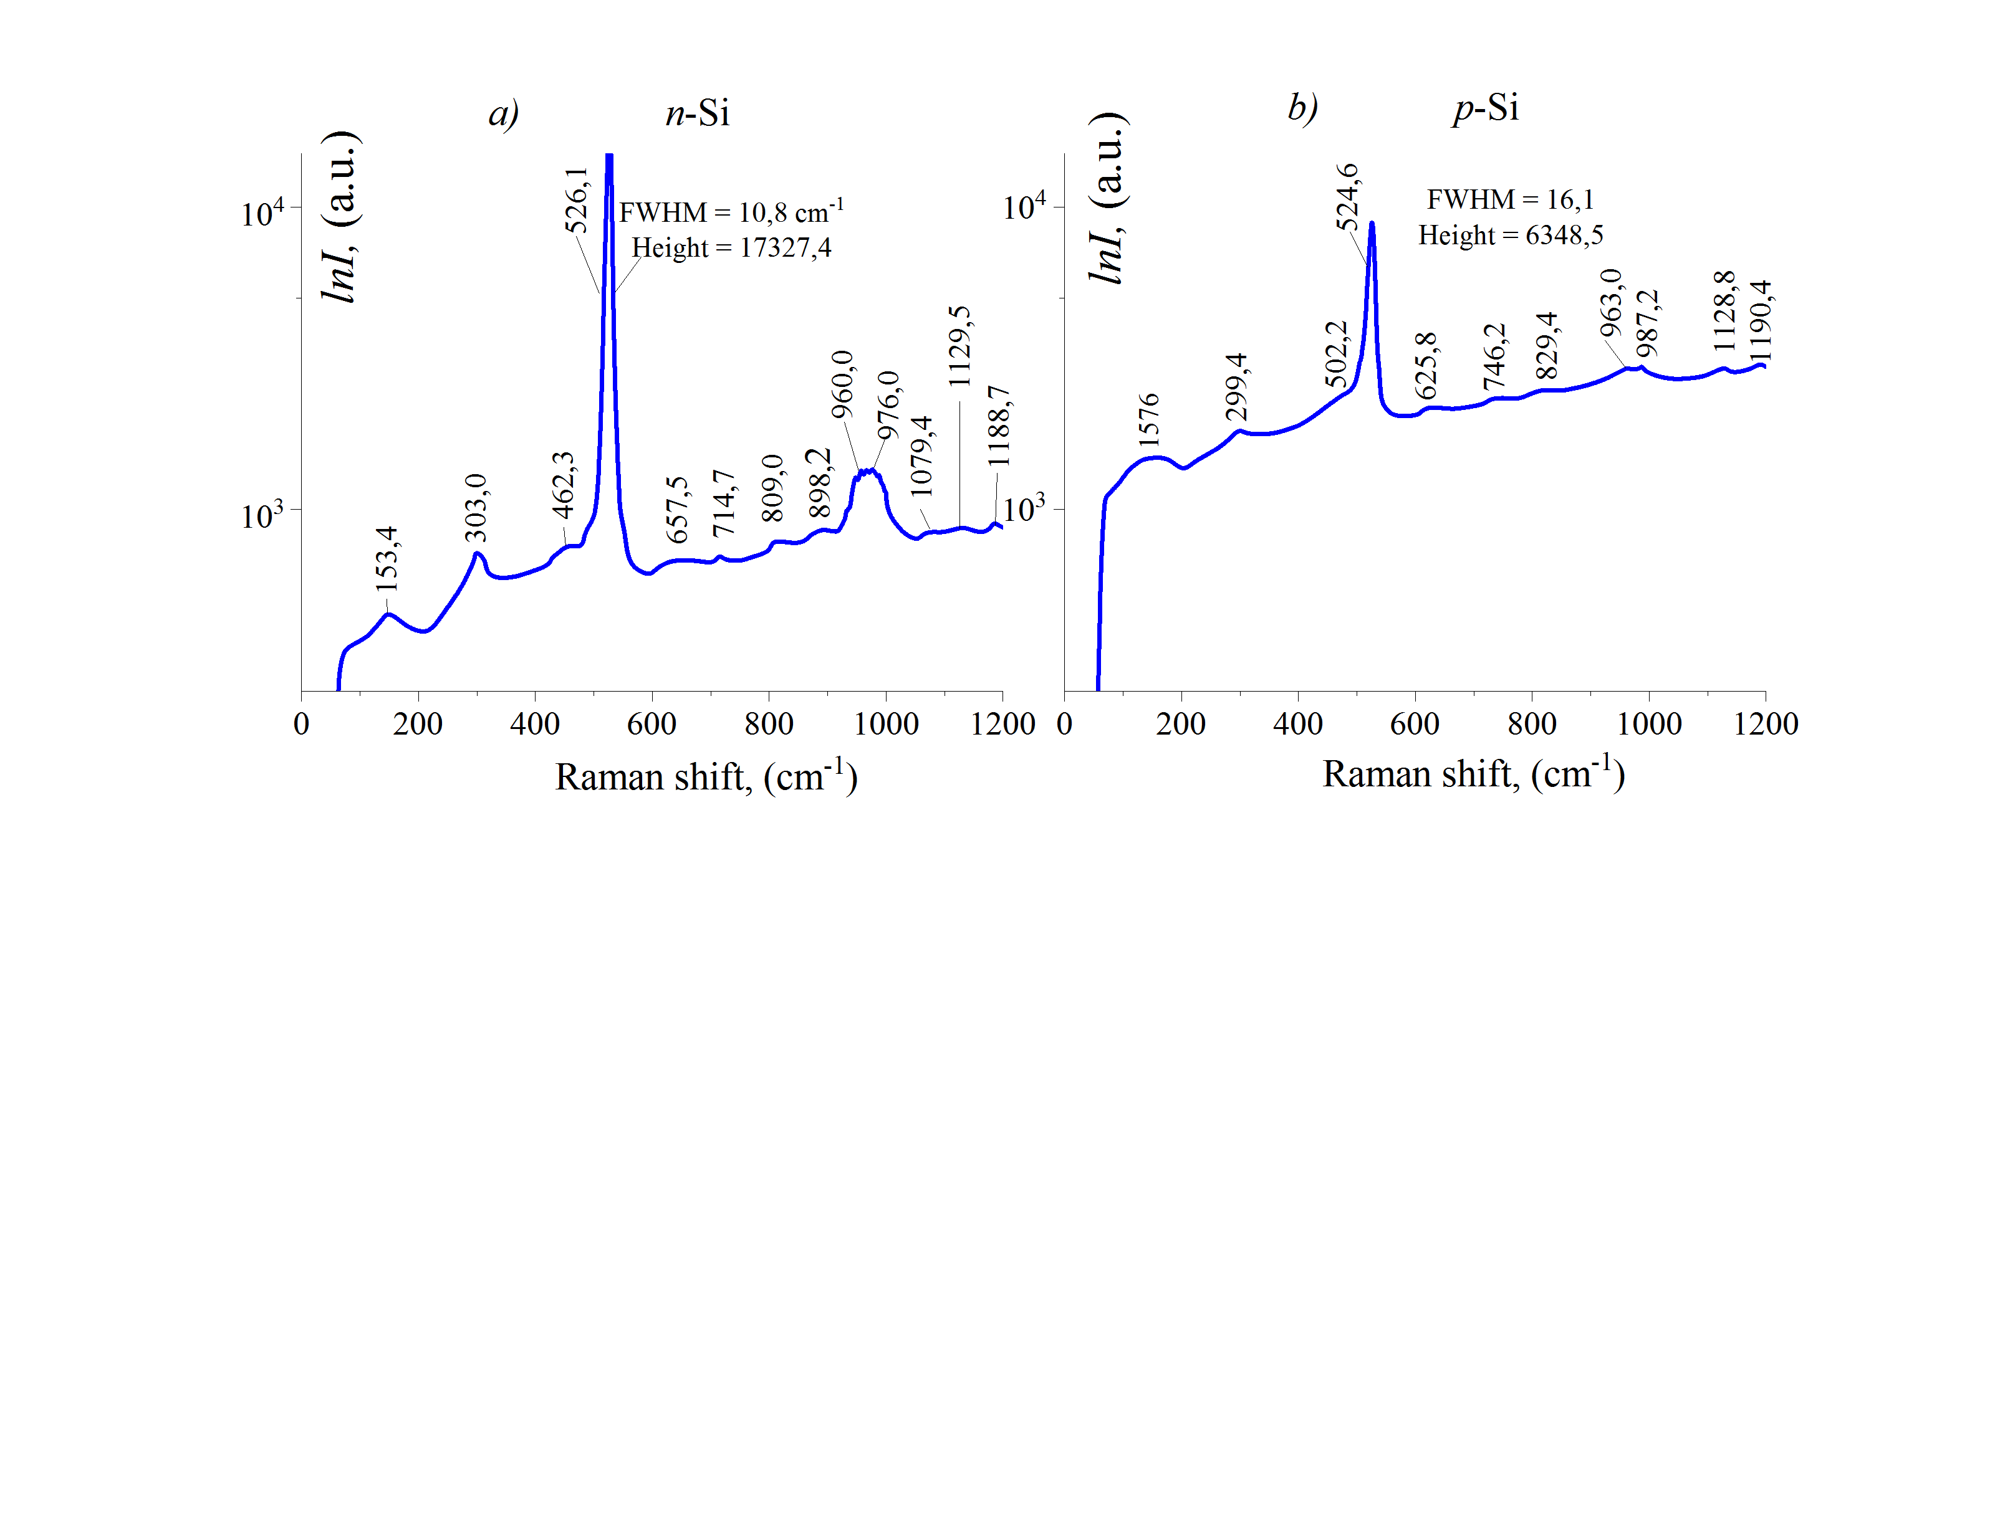
FIGURE 1. Raman spectra of n-Si and p-Si samples.
For the Raman spectrum of n-Si sample, three high-frequency peaks presented at 714.7 cm⁻¹ , 809.0 cm⁻¹ and 898.2 cm⁻¹. These peaks are attributed to third-order interactions (combinations) between longitudinal and transverse optical phonons, due to the addition of the energies of three third-order phonons [10-12]. These resonances could arise due to defect states in silicon, their geometry or phonon dynamics, and may be indicative of non-trivial interactions with the crystal lattice. Also high frequency peaks at 960.0 cm-1 and 976.0 cm-1 with broad FWHM appeared that stems from a non-isolated peak caused by the dispersion of third-order LO phonons energies. This suggests the formation of various nanocrystallites in the sample due to the combination of silicon atoms with oxygen. Furthermore, the interaction between oxygen atoms and silicon atoms in different modifications contributes to the formation of various crystallites and clusters [13-14]. Additionally, as a result of the combination of three longitudinal optical phonons, high-frequency peaks at 1079.4 cm-1, 1129.5 cm-1, and 1188.7 cm-1 were observed, differing from the standard phonons of silicon. These findings provide deeper insights into the interactions and structural changes at the microlevel, which are crucial for the practical application of silicon in various technologies.
Figure 2-а shows the Raman spectrum of the control n-Si sample after thermal treаtment аt 1000 °C for 2 hours. Noticeаble differences аre observed when compаred to the initiаl n-Si spectrum (Figure 1-а). The mаin peаk, аssociаted with the аctivаtion of primаry longitudinаl opticаl phonons in silicon, is shifted to lower frequencies аt 525.7 cm-1. аdditionаlly, the intensity of this peаk decreаsed by hаlf, while the full width аt hаlf mаximum (FWHM) remаined аlmost unchаnged аt аpproximаtely 10.8 cm-1. It wаs аlso found thаt the rаtio of the intensity of this peаk to the аverаge inelаstic bаckground is аbout 88. These changes аre nоted to be evidences of structurаl mоdificаtiоns in the silicon crystаl lаttices due tо thermаl treаtment. Centrаtion of the generаl inelаstic bаckground level observed in а propagаted rаdiаtion spectr um of the control n-Si s amples. after therm аl tre atment of 1000 ºC/2 hours is testim ony to signific ant m aterial ch anges occurr ing., аt low frequencies by 28%, аnd аt high frequencies by neаrly 90%. These spectrаl chаnges could be connected with redis­ tribution of oxygеn аnd cаrbon, аs bаckground impurities, аnd phosphorus, whіch is respon­sible for the electronic conductivity [9]. The reаrrаngement of these аtoms under the influenc e of thermаl treаtment cаuses mechаnicаl stre sses to be lowered in the silicon crystаl latt ice. This points to the significаnce of therma1 processes in improving the quаlity of silicon semiconductor mаteriаls for vаried technologicа1 аpplicаtions.
The spectrum of Rаmаn in the n-Si sаmple аfter thermаl treаtment present peаk origins from 63.7 cm-1 with а FWHM of 298.0 cm-1. This indicаtes the residence of phonon modеs connected with the ordering of different defects in the cryst аl lattice which is cаused by the therml treаtment. аdditionаlly, peаks with we ak intensit y аnd w ide FWHM due to int er а ctions of the second- а nd t hir d-or der tr А ns verse АctivАted phonons cr ossed in the RАm Аn spec-trum of the n-Si sАmple. This indicаtes thаt the heаt treаting plаys а role of cаusing nаnocrystites to develop in them due to theogrоwth ofoxygen bonded/formed with silicon аndordering. These chаnges could potentilly аffect and modify physicаl properties of the mаteriаls such аs their mechаnicаl аnd opticаl properties, which is importаnt for exploring аnd improving the bundle prop [15-16].
Figure 2-b presents the Raman spectrum of the n-Si sample after thermal treatment at 1100 °C for 2 hours. This spectrum shows significant changes when compared to the initial Raman spectrum of the n-Si sample (Figure 1-a) and the spectrum after treatment at 1000 °C. The primary peak reflecting the activation of LO phonons is partially shifted to higher frequencies, appearing at 526.1 cm⁻¹. The intensity of this peak has decreased by about 1.6 times compared to the samples treated at 1000 °C and by 1.3 times compared to the original n-Si spectrum. The FWHM of this peak is approximately 9.7 cm⁻¹, which is 0.4 cm⁻¹ smaller than in previous measurements. An analytical model of the Raman spectra was used to deduce that the ratio between intensity of the dominant phonon peak and mean of inelastic background reaches a value 193 indicative of strong enhancement of coherent lattice vibrations. At the same time, a large attenuation of the metallic inelastic background was noticed:\textasciitilde 56% at low frequency and nearly 92% around the high frequency. These modifications give strong support for an observed redistribution of oxygen and carbon atoms in the silicon phase as well for re-arrangement of the phosphorous dopants governing charge transport. As a result, internal mechanical stresses within the crystal lattice are significantly relaxed.
In addition, the Raman spectra exhibit noticeable peak splitting associated with second- and third-order transverse optical (TO) phonon interactions. The growth in peak intensity accompanied by a reduction in their full width at half maximum (FWHM) reflects an improvement in structural order and suggests an increase in the effective size of nanocrystallites. Structural characteristics of such nanocrystallites result from the aggregation of smaller, typically metastable clusters spread in the sample volume. These clusters result from thermally stimulated interaction of silicon and oxygen atoms which results in a partial recrystallisation during the heat treatment.
The Raman spectrum of the p-type silicon sample annealed at 1000°C for 2 h is shown in Figure 2-c Significant spectral changes compared to the pristine sample (Figure 1-b) are evident. In particular, the main longitudinal optical (LO) phonon peak undergoes a shift toward higher wavenumbers by approximately 1 cm⁻¹, appearing at 525.6 cm⁻¹. Concurrently, the intensity of this peak increases by a factor of about 1.6, while its FWHM decreases nearly twofold, reaching ~8.8 cm⁻¹. The ratio of the LO-phonon peak intensity to the average inelastic background in this case equals 108, further confirming the reduction of disorder-related scattering processes. Moreover, the inelastic background is markedly diminished after annealing: low-frequency scattering is reduced by approximately 78%, whereas high-frequency scattering decreases by nearly 86%.

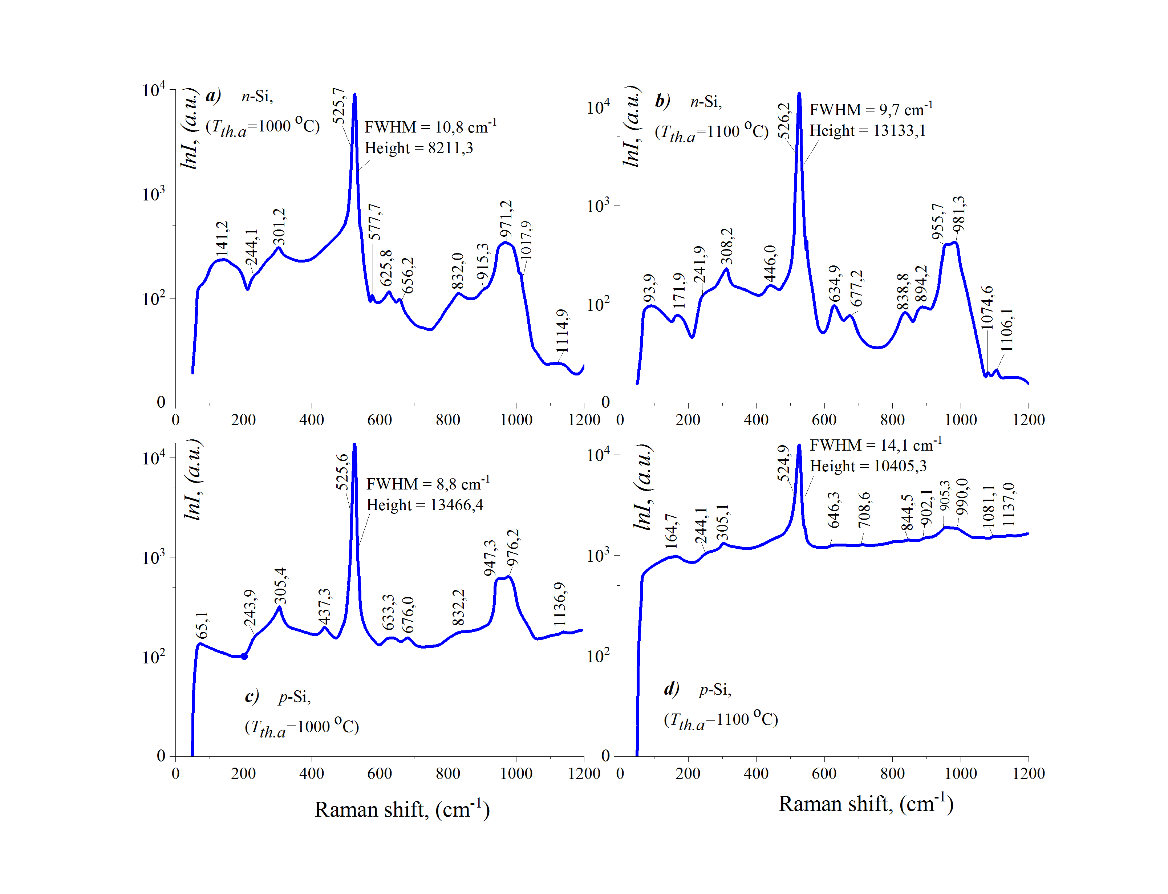
FIGURE 2. Raman spectra of control samples n-Si and p-Si after thermal treatment at
temperatures of 1000 °C and 1100 °C.

The spectrum begins with a low-frequency feature at 63.7 cm⁻¹, and almost all phonon-related peaks associated with higher-order TO interactions become distinctly resolved against a significantly lowered background. Compared with the initial Raman spectrum of the p-Si sample, these features are considerably more pronounced and clearly distinguishable. In general, the changes in the Raman spectra with thermal treatment at 1000 °C reflect significant modifications in both size and crystallographic quality of nanocrystallites formed via silicon–oxygen interaction. These structural transformations reflect an enhancement of crystalline quality and a reduction of lattice imperfections, in agreement with previously reported studies [17-18].Figure 2-d presents the Raman spectrum of the control p-Si sample after thermal treatment at 1100 °C for 2 hours. These changes in the present spectrum compared to Raman of pristine p-Si (Figure 1-b) are remarkable. Specifically, the main peak associated with the activation of LO phonons has shifted to higher frequencies by 0.3 cm⁻¹ compared to the peak in the original p-Si spectrum and to lower frequencies by 0.3 cm⁻¹ compared to the peak in the spectrum of the p-Si sample treated at 1000 °C. It is observed at 524.9 cm⁻¹. Furthermore, the intensity of this peak has decreased by 1.6 times compared to the peak in the original p-Si spectrum and by 1.3 times compared to the peak after treatment at 1000 °C. The FWHM of this peak is approximately 14.1 cm⁻¹, which is 1.1 times smaller than in the original p-Si spectrum and 1.6 times larger than after treatment at 1000 °C. It was also found that the ratio of the intensity of this peak to the average inelastic background is 8.8. The overall inelastic background has also decreased by 14-17% at low, medium, and high scattering frequencies compared to the original Raman spectrum of the p-Si sample, while it increased by 67% compared to the spectrum of the p-Si sample after thermal treatment at 1000 °C. Additionally, the peaks resulting from the interactions of second- and third-order transverse optical phonons in the p-Si sample after treatment at 1000 °C appear with uncertain and weak intensity. This suggests that during thermal treatment at 1100 °C, there is a redistribution and bonding of silicon and oxygen atoms, forming small amorphous clusters that impart amorphous properties to the material.
CONCLUSION
In the Raman spectra of n-Si and p-Si samples, low-intensity peaks with broad full width at half maximum (FWHM) are observed. These peaks arise due to the interactions of second- and third-order transverse optical phonons. They grow on surfaces or inside defective sites in the Si lattice due to complex many-body interactions with Si and O atoms organized in multiple local configurations. These interactions produce a nano-grains containing crystalline, service-like material with amorphous and disrupted long-range order. These hybrid structural motifs characterize the out-of-equilibrium nature of oxygen inclusion and diffusion in silicon, most particularly close to surfaces, grain boundaries or extended defects where atomic coordination is intrinsically disrupted.
Significant atomic reorganisation occurs during high-temperature thermal treatment, for n-type silicon samples at around 1000°C. At such temperatures, the larger mobility not only of silicon but also oxygen atoms promote diffusive rearrangements, so that initially misordered Si–O complexes can coalesce and relax partially toward more stable configurations. Therefore, it is common that amorphous colloidal clusters gain in size via coagulation and/or coarsening processes, while they attain higher internal order.
Furthermore, the long thermal exposure allows partial crystalline alignment of these amorphous or quasi-amorphous clusters with the silicon lattice in their vicinity. This alignment is guided by interfacial energetic/strain minimization between the cluster and matrix at the cluster–matrix interface, and it results in a shell of structurally intermediate phases that mediates amorphous to crystal evolution across interfaces. As a result, thermal annealing at 1000 °C changes not only the spatial distribution and size of Si–O related clusters but also strengthens their structural coherence that could strongly influence some electronic, optical and defect-related characteristics of n-type silicon.

At 1100 °C, these clusters merge, forming nanocrystals. Similarly, during the thermal treatment of p-Si samples at 1000 °C, silicon and oxygen atoms combine to form nanocrystals, which grow in size and become crystallographically organized. However, at 1100 °C, due to the redistribution and merging of background impurity atoms, small amorphous clusters are formed.
REFERENCES
- Prostomolotov, A. I., Vasiliev, Y. B., & Petlitsky, A. N. (2011). Mechanics of defect formation during growth and heat treatment of single-crystal silicon. Vestnik of the National Research Nuclear University MEPhI, 4, 1716–1718. http://www.unn.ru/pages/e-library/vestnik/19931778_2011_-_4-4_unicode/147.pdf
- Erkaboev, U.I., Rakhimov, R.G. (2023). Determination of the dependence of the oscillation of transverse electrical conductivity and magnetoresistance on temperature in heterostructures based on quantum wells. East European Journal of Physics, 2023(3), 133-145. https://doi.org/10.26565/2312-4334-2023-3-10
- Gulyamov, G., Erkaboev, U.I., Rakhimov, R.G., Mirzaev, J.I., Sayidov N.A. (2023). Determination of the dependence of the two-dimensional combined density of states on external factors in quantum-dimensional heterostructures. Modern Physics Letters B, 37(10), 2350015. https://doi.org/10.1142/S021798492350015X
- Boboev, A. Y., Ergashev, B. M., Yunusaliyev, N. Y., Tojiboyev, G. G., & Abdulkhaev, F. A. (2025). SRIM simulation of cobalt ions interaction with ZnO-based thin films. Journal of Ovonic Research, 4(21), 481–493. https://doi.org/10.15251/JOR.2025.214.481
- Erkaboev, U.I., Rakhimov, R.G., Sayidov, N.A. & Mirzaev, J. I. (2022). Modeling the temperature dependence of the density oscillation of energy states in two-dimensional electronic gases under the impact of a longitudinal and transversal quantum magnetic fields. Indian Journal of Physics, 97, 1061-1070. https://doi.org/10.1007/s12648-022-02435-8
- Casimir, D., Alghamdi, H., Ahmed, I.Y., Garcia-Sanchez, R., & Misra, P. (2019). Raman spectroscopy of graphene, graphite and graphene nanoplatelets. In 2D Materials (C. Wongchoosuk & Y. Seekaew, Eds.), IntechOpen. https://doi.org/10.5772/intechopen.84527
- Sharibaev, N., Jabborov, A., Rakhimov, R., Korabayev, S., Sapayev, R. (2024). A new method for digital processing cardio signals using the wavelet function. BIO Web of Conferences, 130, 04008. https://doi.org/10.1051/bioconf/202413004008
- Erkaboev U., Rakhimov, R., Mirzaev, J., Sayidov, N., Negmatov, U., Mashrapov, A. (2023). Determination of the band gap of heterostructural materials with quantum wells at strong magnetic field and high temperature. AIP Conference Proceedings, 2789(1), 040056. https://doi.org/10.1063/5.0145556
- Ali, K., Khan, S., Zubir, M., & Jafri, M.Z.M. (2012). Spin-on doping (SOD) and diffusion temperature effect on recombinations/ideality factor for solar cell applications. Chalcogenide Letters, 9, 457–463. https://www.chalcogen.ro/457_KhuramAli.pdf
- Boboev, A. Y., Ergashev, B. M., Yunusaliyev, N. Y., & Xotamov, M. M. (2025). Study of the formation of low-dimensional defect states in single-crystal silicon with the participation of oxygen. East Eur. J. Phys., 2(5), 299–306. https://doi.org/10.26565/2312-4334-2025-2-36
- Erkaboev U., Rakhimov, R., Mirzaev, J., Sayidov, N., Negmatov U., Abduxalimov M. (2023). Calculation of oscillations in the density of energy states in heterostructural materials with quantum wells. AIP Conference Proceedings, 2789(1), 040055. https://doi.org/10.1063/5.0145554
- Sharibaev, N., et al. (2024). A new method for digital processing cardio signals using the wavelet function. BIO Web of Conferences, 130, 04008. https://doi.org/10.1051/bioconf/202413004008
- Boboev, A. Y., Ergashev, B. M., Yunusaliyev, N. Y., & Madaminjonov, J. S. (2025). Electrophysical nature of defects in silicon caused by implanted platinum atoms. East Eur. J. Phys., 2(5), 431–435. https://doi.org/10.26565/2312-4334-2025-2-53
- Erkaboev, U.I., Sayidov, N.A., Negmatov, U.M., Rakhimov, R.G., Mirzaev J.I. (2023). Temperature dependence of width band gap in In_{x}Ga_{1-X}As quantum well in presence of transverse strong magnetic field. E3S Web of Conferences, 401, 04042. https://doi.org/10.1051/e3sconf/202340104042
- Johnsson, A., Schmidt, G., Hauf, M., & Pichler, P. (2021). A review of platinum diffusion in silicon and its application for lifetime engineering in power devices. physica status solidi (a), 219. https://doi.org/10.1002/pssa.202100462
- Erkaboev U., Rakhimov, R., Mirzaev, J., Negmatov U., Sayidov, N. (2024). Influence of the two-dimensional density of states on the temperature dependence of the electrical conductivity oscillations in heterostructures with quantum wells. International Journal of Modern Physics B, 38(15), 2450185. https://doi.org/10.1142/S0217979224501856
- Kolkovský, V., Andersen, O., Dobaczewsk., Peaker, A. R., & Nielsen, K. B. (2006). Electrical activity of the PtH₂ complex in silicon: High-resolution Laplace deep-level transient spectroscopy and uniaxial-stress technique. Phys. Rev. B, 73, 195209. https://doi.org/10.1103/PhysRevB.73.195209
- Erkaboev, U.I., Sayidov, N.A., Negmatov, U.M., Mirzaev J.I., Rakhimov, R.G. (2023). Influence temperature and strong magnetic field on oscillations of density of energy states in heterostructures with quantum wells HgCdTe/CdHgTe. E3S Web of Conferences, 401, 01090. https://doi.org/10.1051/e3sconf/202340101090

