Development and Evaluation of a Multivariate Econometric
Model of the Cotton Cleaning Process

Mukhammadziyo Ismanov^{1, a)}, Abdusamat Karimov², Nurjaxon Imomnazarova²

¹Namangan State Technical University, Namangan, Uzbekistan

²University of Business and Science, Namangan, Uzbekistan

^{a)}Corresponding author: ismanovm91@gmail.com

Abstract. This research work developed a mathematical model to determine the optimal parameters affecting the cleaning efficiency of cotton ginning machines in separating large impurities from cotton gin. New grid designs with different hole profiles - round, rectangular and elliptical - were analyzed to improve the efficiency of the cleaning process. Experimental data were statistically processed using correlation-regression methods, and the adequacy of the model was confirmed by Fisher's criterion. Three-dimensional surfaces were generated using MAPLE-17 software to visualize the relationship between cleaning efficiency and the key technological parameters: the hole surface area on the grate, the diameter of the grate rods, and the distance between the saw drum and the grate. The results showed that the maximum cleaning efficiency of 87.56% is achieved when the grate hole profile is elliptical, the rod diameter is 25 mm, and the distance between the saw drum and the grate is 14 mm. The proposed model provides an effective basis for optimizing cotton-cleaning machine design, enhancing productivity, and minimizing fiber loss.

Keywords: cotton, design, experiment, slope, regression, equation, yield, factors, coefficients, dimensions, surfaces.

INTRODUCTION

It is known that the diameter of the combs in cotton gins is important for cleaning efficiency, as well as reducing the amount of cotton lint that is included in the waste. Currently, cylindrical full-surface combs are used in cotton gins. During the cleaning process, along with small and large impurities, a certain amount of cotton lint also escapes from the working chamber [1-4].

However, the distance between the saw drum and the combs and the speed of rotation of the saw drum are one of the main factors in increasing the efficiency of cleaning cotton from impurities. Therefore, the authors proposed combs with oval and other perforated surfaces on their surfaces. As a result, during the operation of cleaning machines equipped with this comb, the passage of cotton particles into the dirt chamber is reduced [5-9]. When constructing a mathematical model of the cleaning process, the distance between the saw drum and the combs, as well as the speed of rotation of the saw drum and the additional open surface Determining the optimal parameters of the holes is of great importance. This issue is solved using the analysis of correlation-regression relationships between efficiency and several factors affecting it.to the shell thickness are taken as a criterion for dynamic buckling [10-11].

MATHEMATICAL MODEL OF THE PROBLEM
Based on the above, the following factors were taken as input parameters: Surfaces of the holes opened on the surface of the grate:
- for a circular hole
$d_{0}=6.7,s_{1}=\frac{π{(d_{0})}^{2}}{4}=35{mm}^{2}$ (1)
- for a rectangular hole
$a=7mm, b=7.85mm,s_{1}=ab=55{mm}^{2}$ (2)
- for elliptical hole
$a=5mm, b=19mm, s_{1}=\frac{πab}{4}=\frac{3.14*5*19}{4}=75{mm}^{2}$ (3)
So: x₁=35;55;75; Diameter of the rod: x₂=20÷30 mm,
The distance between the saw drum and the rails: x3=14÷16 mm,
Output parameter: Y1- Cleaning efficiency of the machine, %
So the area of the holes opened on the surface of the grid is the first factor: x1=20;35;50; The diameter of the rod is the second factor: x2=20÷30 mm. The distance between the sawn drum and the wheels is the third factor: x3=14÷16 mm, outgoing parameter: Y1- cleaning efficiency of the machine, %
Selection of levels and ranges of change of the factors under study

TABLE 1. To develop and evaluate a multivariate econometric model of the cotton cleaning process.

Name and designation of factors | Levels of change |  |  | Change interval
Name and designation of factors | -1 | 0 | 1 | Change interval
x₁ – Surfaces of holes opened on the surface of the grate (${mm}^{2}$) | 20 | 35 | 50 | 15
x₂ -Diameter of the column (mm) | 20 | 25 | 30 | 5
x₃- The distance between the saw drum and the rails (mm) | 14 | 15 | 16 | 1

As an output parameter, we obtain the efficiency of the cleaning flow. For this, we conduct experiments with 3 repetitions in each condition based on the planning matrix. In this case, the number of experiments $N=2^{3}=8$.
The experimental results and variances of the output parameter are presented in Table 2.

TABLE 2. The variances of the output parameter.

u | Factors |  |  | Cleaning efficiency
1 | - | - | - | 81.19 | 81.64 | 81.31 | 81.37 | 0.060
2 | + | - | - | 86.64 | 86.6 | 86.71 | 86.65 | 0.003
3 | - | + | - | 82.7 | 82.8 | 82.6 | 82.70 | 0.010
4 | + | + | - | 84.37 | 84.24 | 84.35 | 84.32 | 0.005
5 | - | - | + | 85.63 | 85.34 | 85.46 | 85.47 | 0.021
6 | + | - | + | 87.61 | 87.45 | 87.27 | 87.44 | 0.029
7 | - | + | + | 78.22 | 78.81 | 78.18 | 78.40 | 0.124
8 | + | + | + | 85.24 | 85.28 | 85.39 | 85.30 | 0.006

Here: $\overset{̿}{Y}=\frac{\sum_{1}^{3}{Y_{i}}}{m}$ Arithmetic mean; $S^{2}\left\{Y\right\}=\frac{\sum_{1}^{3}{{(Y_{i}-\overset{̿}{Y})}^{2}}}{m-1}$ standard deviation; m=3 number of factors.

Processing the experiment results
Based on the table above, the estimated value of the Cochrane criterion is calculated using the following formula:
$G_{x}=\frac{S^{2}{\{Y\}}_{max}}{\sum{S^{2}\{Y\}}}$ (4)
S²{Y}max - i- maximum variance of the test; S²{Y}- the sum of all serial variances. $G_{x}=\frac{S^{2}{\{Y\}}_{max}}{\sum{S^{2}\{Y\}}}$=87.44/672=0.13;
To determine the recovery of the experiment, we compare the calculated value of the Cochrane criterion with the table.
In our case FEE (full factorial experiment) 23 va R=0,95 for G_{tab.v} =(f1 va f2)R=0,95 when, here (f1=N=8; f2=m-1=3-1=2)=0,5137. (N - number of degrees of freedom) If Gx<G_{tab.v}- If so, the experiment is repeated and we can proceed to calculating the regression coefficients. $G_{tab.v}=0.5137;G_{x}=013;$ So the inequality is being fulfilled.
In this case, the regression equation in the multifactor model will look like this:
$y_{R}=b_{0}+b_{1}⋅x_{1}+b_{2}⋅x_{2}+b_{3}⋅x_{3}+b_{12}⋅x_{1}⋅x_{2}+b_{13}⋅x_{1}⋅x_{3}+b_{23}⋅x_{2}⋅x_{3}+b_{123}⋅x_{1}⋅x_{2}⋅x_{3}$ (5)
The coefficients in the equation were determined using the mean values. The resulting regression equation looks like this:
$$y_{R}=83.96+1.97⋅x_{1}-1.28⋅x_{2}+0.197⋅x_{3}+0.16⋅x_{1}⋅x_{2}+$$$+0.25⋅x_{1}⋅x_{3}-1.3⋅x_{2}⋅x_{3}+1.07⋅x_{1}⋅x_{2}⋅x_{3}$ (6)
To check the adequacy of the resulting model, we use the formulas of the Fisher criterion. The calculated value of the criterion is calculated using the following formula:
$$F_{R}=\frac{0.0676}{0.02708}=2.503$$
We can find the tabular value of Fisher's criterion from a special table:
$$F_{T}[P_{D}=0.95; f(S_{y}^{2})=16,f(S_{\text{хад}}^{2})=4]=5.85$$
So, The model is adequate because, That is, it adequately reflects the change in the thread's tensile strength during processing. The efficiency of the cleaning process can be improved by different $x_{1}, x_{2}, x_{3}$ The regression equation expressing the change in dependence on the factors is expressed as follows:
${a) x}_{1}$- profile of holes drilled in the surface of the columns;
${b) x}_{2}$ - to the diameters of the columns;
${c) x}_{3}$- distance between the saw drum and the rails (mm);
Cleaning efficiency $x_{1},x_{2}, x_{3}$, the laws of change depending on factors are presented in 3D, in the graph in Fig.1.

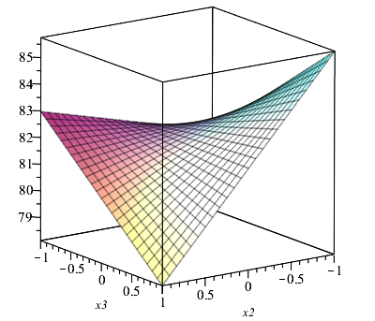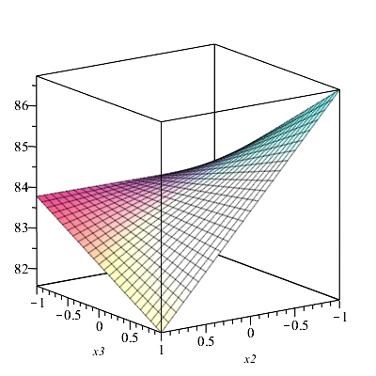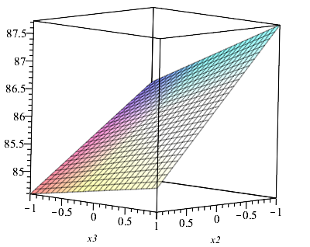
- b) c)
FIGURE 1. Cleaning efficiency $y_{R}$ changes depending on factors x₁, x₂, x₃. a) $x_{1}=-1,hole profile circle;$ b) $x_{1}=0,$ the hole profile is rectangular; c) $x_{1}=1$, the hole profile is elliptical.

From the graphical analysis, we can see that the optimal cleaning efficiency: $x_{1}=1; x_{2}=-1; x_{3}=1;y_{max}=87,56\%$.

CONCLUSION

The conducted experimental and mathematical studies made it possible to identify the optimal parameters that ensure high cleaning efficiency in removing large impurities from cotton bolls. Based on regression and correlation analysis, a reliable mathematical model was developed, and its adequacy was confirmed by the Fisher criterion. The results showed that the cleaning efficiency primarily depends on the shape of the holes on the grate surface, the diameter of the grate rods, and the distance between the saw drum and the grate. According to the obtained regression equation and 3D graphical analysis, the maximum cleaning efficiency of 87.56% is achieved when the grate rod diameter is d = 25 mm, the distance between the saw drum and the grate is h = 14 mm, and the hole profile is elliptical. This configuration provides the best balance between impurity removal and fiber preservation. The developed model can be used to optimize cotton-cleaning machine design, predict performance, and improve the overall technological process by reducing energy loss and enhancing product quality.

References
- Ilyasov, M. (2006). Dynamic stability of viscoelastic plates. International Journal of Engineering Science, 45(1), 111–122. https://doi.org/10.1016/j.ijengsci.2006.08.016
- Robinson, M. T. A., & Adali, S. (2016). Nonconservative stability of viscoelastic rectangular plates with free edges under uniformly distributed follower force. International Journal of Mechanical Sciences, 107, 150–159. https://doi.org/10.1016/j.ijmecsci.2015.12.029
- Ilyushin, A. A., & Pobedrya, B. E. (1970). Fundamentals of the mathematical theory of thermal viscoelasticity. Nauka.
- Volmir, A. S. (1972). Nonlinear dynamics of plates and shells. Nauka.
- Volmir, A. S. (1979). Shells in fluid and gas flow: Problems of hydroelasticity. Nauka.
- Grigolyuk, E. I., & Mamai, V. I. (1997). Nonlinear strain of thin-walled constructions. Nauka.
- Koltunov, M. A. (1964). On the calculation of flexible gently sloping orthotropic shells with linear heredity. Bulletin of Moscow State University, (5), 79–88.
- Ismanov, M., & Karimov, A. (2024). The action of shock waves on cylindrical panels. AIP Conference Proceedings, 3045, 030101. https://doi.org/10.1063/5.0197285
- Gulyamov, G., Dadamirzaev, M. G., & Boidedaev, S. R. (2000). Kinetics of attaining the steady state of hot carrier thermoelectric power in a p-n junction with consideration for lattice heating. Semiconductors, 34(3), 260–263. https://doi.org/10.1134/1.1187967
- Lemeshko, B. Y., & Mirkin, E. P. (2004). Bartlett and Cochran tests in measurements with probability laws different from normal. Measurement Techniques, 47(10), 960–968. https://doi.org/10.1007/s11018-005-0027-y
- Sharibaev, N., et al. (2024). A new method for digital processing cardio signals using the wavelet function. BIO Web of Conferences, 130, 04008. https://doi.org/10.1051/bioconf/202413004008

