Assessment of the Geko K–Ω Model Accuracy in Predicting the Flow Structure of an Axisymmetric Hot Supersonic Jet
Dilshod Navruzov^{1, a)}, Murodil Madaliev², Ganisher Yunusov³,
Madinabonu Sayidova⁴, Hamrokul Sayidov¹, Alouddin Umarov¹
¹Bukhara State Technical University Bukhara, Uzbekistan
²Fergana State Technical university, Fergana, Uzbekistan
³Bukhara University of Innovations, Bukhara, Uzbekistan
⁴Bukhara State Medical Institute, Bukhara, Uzbekistan

^{a)}Corresponding author: navruzov.d@mail.ru
Abstract. The article considers the problem of coupled axisymmetry of a hot supersonic jet. The k–ω GEKO turbulence model in the ANSYS Fluent environment is chosen to solve the problem. The purpose of this work is to evaluate the selected model for high-speed high-temperature jet streams. The numerical data obtained are compared with the experimental data available on the NAS turbulence modeling database, as the NAS turbulence model database is a benchmark for researchers around the world in terms of reliability and accuracy compared to other experimental data. The study took into account the change in the Mach number and static pressure with a change in temperature along the axial line of the jet. In addition, in order to obtain reliable results consistent with the experimental data from the NASA database, we had to include visualization of the contours of velocity, density, kinetic energy of turbulence and vortex viscosity. The results obtained allow us to provide a scientifically sound understanding of the internal structure of the jet and its interaction between shock waves and shear layers. In the initial region of the jet, the results obtained using the GEKO turbulence model show the effectiveness of predicting the potential core and sequence of impact cells. It is these factors that influence the attenuation of the main parameters. It is known that the main disadvantage of turbulent RANS models is to underestimate both pressure and temperature at large distances downstream, in Hydro-aerodynamic problems with unsteady mixing processes. To summarize, we can safely say that the results obtained using the k–ω GEKO turbulence model indicate that our chosen turbulence model is adequate for engineering modeling of supersonic jet streams and provides a reasonable balance between accuracy and computational costs.
Keywords: supersonic jet, turbulence, numerical simulation, k-ω GEKO, Ansys Fluent, shock waves, axisymmetric flow, Mach number, kinetic energy, eddy viscosity.
INTRODUCTION
It is known that many aerospace engines use supersonic jet engines for engineering work. The design and characteristics of rocket engines are greatly influenced by their behavior. In addition, the development of high technologies designed for supersonic and hypersonic flights is also influenced by supersonic jet engines, which makes their importance more significant for science. The thrust created during the launch of propulsion systems of a high-speed jet exiting the nozzle is necessary for the movement of modern aircraft and for research spacecraft [1-3]. The reliability of numerical results for such complex flows from the point of view of gas dynamics helps engineers around the world to increase the efficiency of the propulsion system, which reduces fuel consumption and noise levels in aerospace propulsion systems.
This is the main task of design engineers when creating modern and efficient next-generation aviation systems and hypersonic vehicles. For this reason, the choice of mathematical models of turbulence and numerical schemes is no less important, where the flow reaches up to five Mach numbers, which lead to complex physical processes. During the development of propulsion systems, the development of modern propulsion systems for thermal protection and cooling, suitable for extreme aerodynamic heating [4-6], during shock waves, the expansion region and near-surface jet streams is the main physical phenomenon. In addition, the aerospace industry is not the main area of application for jet engines. Such engines are also used in the energy industry, where cooling systems are essential. In gas turbine engines, detailed calculation of internal combustion is the main method that contributes to the optimization of aerodynamic blades, which increases the efficiency of the system and increases the shelf life of engine components [7-8].
In complex engineering tasks of gas dynamics, high-speed injectors are widely used to improve mixing and combustion to improve fuel combustion efficiency and flame stabilization, where reducing pollutant emissions significantly affects the environmental safety of the surrounding environment. Gorenje is a popular source of energy efficiency in the field of combustion and flame stabilization. Advances in computational fluid dynamics (CFD) and modern turbulence modeling do not provide us with a complete picture to improve numerical prediction. In this context, the present study focuses on the application of the k–ω GEKO turbulence model, which was developed to improve the modeling of complex aerodynamic processes, especially those that occur in high-speed jet streams.
The purpose of the study is numerical modeling of an axisymmetric hot supersonic jet (AHSSJ) in the Ansys Fluent software package, as well as verification of the obtained numerical results based on experimental data presented on the NASA Turbulence Modeling Resource platform. The work analyzes key flow characteristics, including the distribution of the Mach number, pressure and temperature along the jet axis, as well as visualization of the isolines of the Mach number, velocity, density, turbulence kinetic energy and eddy viscosity. Comparison of the simulation results with experimental data allows us to assess the adequacy of the k-ω GEKO model for problems related to predicting the characteristics of supersonic jets. In conclusion, the work analyzes errors and suggests possible directions for further improvement of the model.
PHYSICAL STATEMENT OF THE PROBLEM
The present study aims to test the ability of the k-ω GEKO turbulence model to reproduce the physical features of an axisymmetric hot supersonic jet (AHSSJ) flow. Unlike verification, the purpose of which is to confirm the correctness of the implementation of the numerical method, in this case, validation is carried out - a comparison of the obtained numerical simulation (CFD) results with experimental data to assess the adequacy of the model. In the experiment under study, an axisymmetric jet with a diameter of 𝐷_{𝑗}=9.144 cm, exiting into the environment, was studied. The jet was launched with a fully expanded Mach number 𝑀_{𝑗}=2.0. Under experimental conditions, the jet exits into still ambient air, however, for the convenience of numerical modeling, in this CFD study, a weak background flow with a low Mach number 𝑀_{𝑟𝑒𝑓}=0.01, directed from left to right, coinciding with the direction of the jet, is used. This small difference in boundary conditions may have a minor effect on the results, but previous studies of subsonic hot jets have shown that this effect is insignificant. The jet Reynolds number and reference static temperature are calculated based on available experimental data T/T_{𝑟𝑒𝑓}=4.017. The appropriate jet conditions are provided by specifying the total pressure and temperature at the jet inlet surface. It is important to note that this simulation is not a 2D calculation. Instead, a periodic (rotated) grid structure is used with appropriate boundary conditions on the periodic boundaries. Thus, the initial and boundary conditions used allow correct modeling of the hot supersonic jet dynamics in Ansys Fluent and also provide the possibility of accurate comparison with the experimental data provided by the NASA Turbulence Modeling Resource. The boundary conditions are shown in the corresponding Fig. 1.
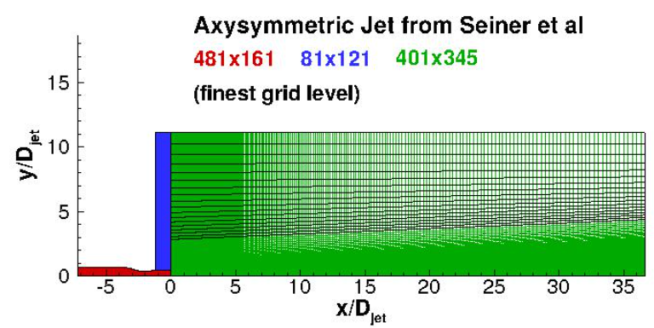 | 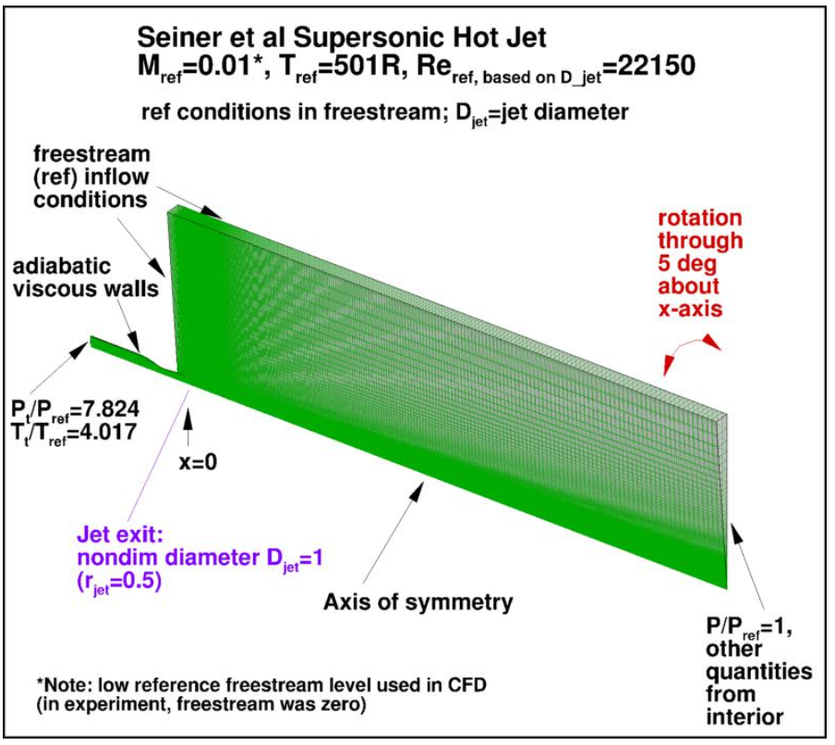
a) | b)
FIGURE 1. Axisymmetric Hot Supersonic Jet. a) computational mesh and b) boundary conditions
MATHEMATICAL STATEMENT OF THE PROBLEM
The Reynolds equations – averaged Navier-Stokes (RANS) equations are used to model turbulent flows at high Mach numbers, including supersonic and hypersonic flows. They are based on averaging the equations of motion, which allows modeling the effect of turbulence without explicitly taking into account all turbulent scales.
The continuity equation in averaged form is written as:
(1)
ρ is the average density, 𝑢_{𝑗} is the average velocity component, 𝑡 is the time, 𝑥_{𝑗} is the coordinate.
For high-speed flows, the Navier-Stokes equation, taking into account turbulent stress, is written as:
(2)
where: 𝑝 is the average pressure, 𝜏_{𝑖𝑗} are the viscous stresses (laminar), 𝜌𝑢_{𝑖}′𝑢_{𝑗}′ is the turbulent Reynolds stress. Viscous stresses are determined through the stress tensor:
(3)
where 𝜇 is the dynamic viscosity.
For compressible gases (high Mach numbers), the full energy balance is taken into account:
(4)
where: 𝐸 is the total specific energy, 𝜌𝑢_{𝑗}′ℎ′ is the turbulent enthalpy flow, 𝑞_{𝑗} is the heat transfer. The heat flow is taken into account by the Fourier law:
(5)
where: 𝑘 is the thermal conductivity coefficient, 𝑇 is the average temperature.
In the well-known turbulent models belonging to the RANS family, an additional term θ'θ' is introduced for the averaging procedure. This value is usually called the Reynolds stress tensor. It is this quantity that influences the turbulent fluctuations in the mean flow field. Since these stresses reflect during pulse transmission during, this stress causes turbulence, the presence of a Reynolds stress basically adds several new unknowns to the equation, which leads to an unclosed equation system. As a result, the system can no longer be solved directly and requires a turbulence model.
TURBULENCE MODELS
The GEKO (Generalized k-ω) SST model used is a modification of the standard K-ω SST model. The modification of the K-ω SST model makes it possible to provide a more accurate description under various turbulent flow modes, where the Mach number reaches up to five. The turbulent model is described by equation (6).
(6)
Turbulent eddy viscosity is calculated by: .
(7)
(8)
(9)
(10)
(11)
The coefficients and reaction functions used in the turbulent model are described in detail [9-11].
METHOD OF SOLUTION
In the mathematical modeling of an axisymmetric hot supersonic jet (AHSSJ), all calculations were performed in the ANSYS Fluent software package. The Roe Flux-Difference Splitting (Roe-FDS) method was used to accurately describe inviscid flows. This method is also known for its adequacy to capture shock waves for tasks related to supersonic modes. Spatial discretization was performed using a second-order precision headwind scheme, where numerical scattering constraints allow for increased accuracy in predicting turbulent flows.
CALCULATION RESULTS AND THEIR DISCUSSION
Figure 2 shows the distribution of the Mach number along the jet axis in coordinates 𝑥/𝐷_{𝑗𝑒𝑡}, where 𝑥 is the distance from the nozzle, normalized to the jet diameter 𝐷_{𝑗𝑒𝑡}.

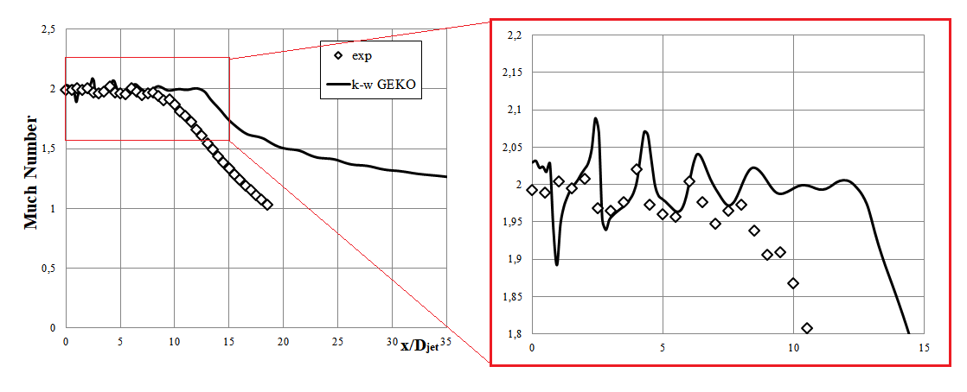
FIGURE 2. Distribution of the Mach number along the jet axis in coordinates

Figure 2 shows that as the flow moves down the current, the Mach number gradually decreases. This is especially noticeable in the area close to the nozzle, where the numerical results of the potential core reflect the deceleration very well. But we can also observe noticeable discrepancies in the output.
The main graph illustrates how the Mach number of the jet gradually decreases as the flow moves downstream. In the region close to the nozzle, where the potential core is still preserved, the numerical results reproduce the deceleration trend quite well. Further away from the exit, however, noticeable discrepancies appear: in the mixing and decay zones the GEKO model tends to predict slightly lower Mach numbers than those observed experimentally. The enlarged view shown on the right (red-framed inset) provides additional detail for the near-field region of the jet, specifically for (0 < x/D_{jet} < 15), and helps to visualize the initial evolution of the flow more clearly. In this region, the simulation captures the shock cell structure and oscillatory behavior in the Mach number profile, although some discrepancies in the amplitude and phase of the oscillations are observed. These shock cells are characteristic of under-expanded supersonic jets and are influenced by complex shock–shear layer interactions, which are challenging to capture accurately in RANS-based turbulence models.
Figure 3 shows the distribution of the normalized pressure 𝑃/𝑃_{𝑡,𝑗𝑒𝑡} along the jet axis in coordinates 𝑥/𝐷_{𝑗𝑒𝑡}.

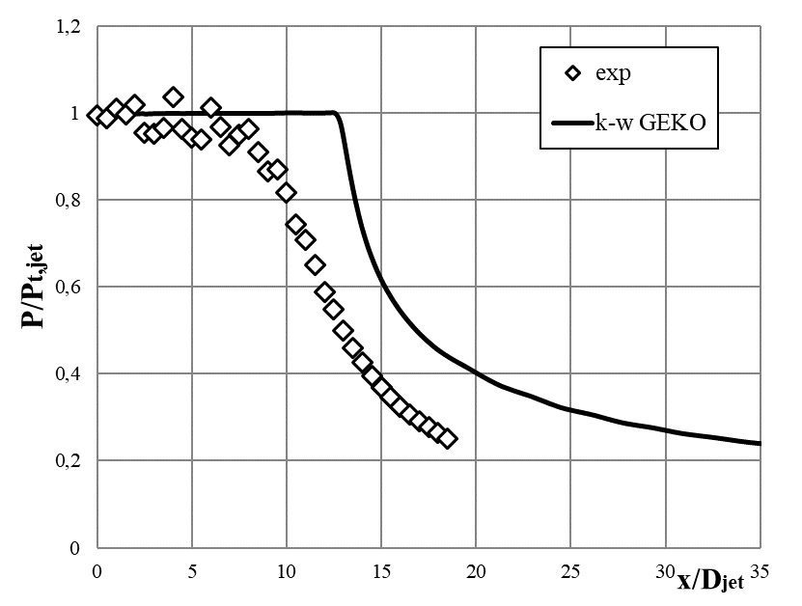
FIGURE 3. Distribution of normalized pressure 𝑃/𝑃_{𝑡,𝑗𝑒𝑡} along the jet axis

In this figure, we observe a sudden drop in pressure compared to the experimental data.
Figure 4 shows the distribution of the normalized temperature 𝑇/𝑇_{𝑡,𝑗𝑒𝑡} along the jet axis in coordinates 𝑥/𝐷_{𝑗𝑒𝑡}.

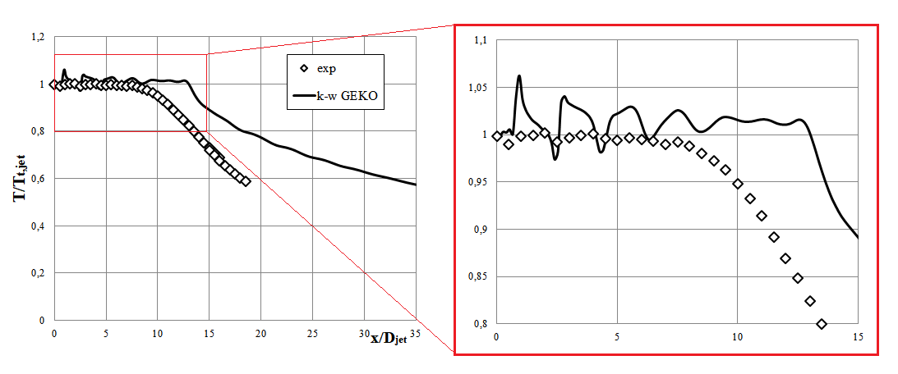
FIGURE 4. Distribution of normalized temperature 𝑇/𝑇_{𝑡,𝑗𝑒𝑡} along the jet axis

In the near-field part of the jet (𝑥/𝐷𝑗𝑒𝑡<10), the normalized temperature stays close to 1.0, indicating that the thermal structure of the potential core remains largely intact. The results of the numerical study show that, with the underexpansion of supersonic jets, small fluctuations are observed on the temperature curve characteristic of the turbulence model related to the RANS family. Farther downstream, in the transition and decay region (𝑥/𝐷𝑗𝑒𝑡>10), the computed temperatures begin to fall below the experimental values.
The predicted thermal decay is more pronounced than in the experiment. This discrepancy may be due to increased mixing rates predicted by the RANS turbulence model, which tends to over-diffuse thermal gradients in the jet shear layer. The zoomed-in inset provides a clearer view of the temperature fluctuations in the potential core region, highlighting that the GEKO model captures the oscillation pattern but overestimates its magnitude. In general, the k-ω GEKO model demonstrates a good ability to reproduce the thermal structure of the hot supersonic jet in the near field, though some deviation exists in the far field due to turbulence modeling limitations.
Figure 5 shows the contour plots of various flow parameters obtained from numerical simulations of a supersonic hot jet using the k-ω GEKO model in Ansys Fluent.
The Mach number distribution shows a stable supersonic flow in the initial zone (𝑀≈2) with subsequent formation of shock cells and velocity decrease due to turbulent mixing. Velocity isolines demonstrate maximum values in the central part of the jet, where the supersonic flow regime is maintained, while the peripheral zones are characterized by a significant velocity gradient. The density distribution indicates rarefaction zones appearing during the jet expansion. Eddy viscosity isolines confirm that turbulent mixing is most intense at the jet boundaries, where interaction with the environment occurs. The turbulent kinetic energy (TKE) distribution demonstrates the highest values in the mixing zones, where maximum velocity and density gradients arise. Turbulent activity remains low in the central part of the jet. The presented numerical data confirm the adequacy of the k-ω GEKO model in predicting the supersonic jet structure, including key effects such as shock waves, turbulent mixing zones and viscosity distribution, however, small discrepancies are possible in the far field of the jet, which requires further refinement of the model.

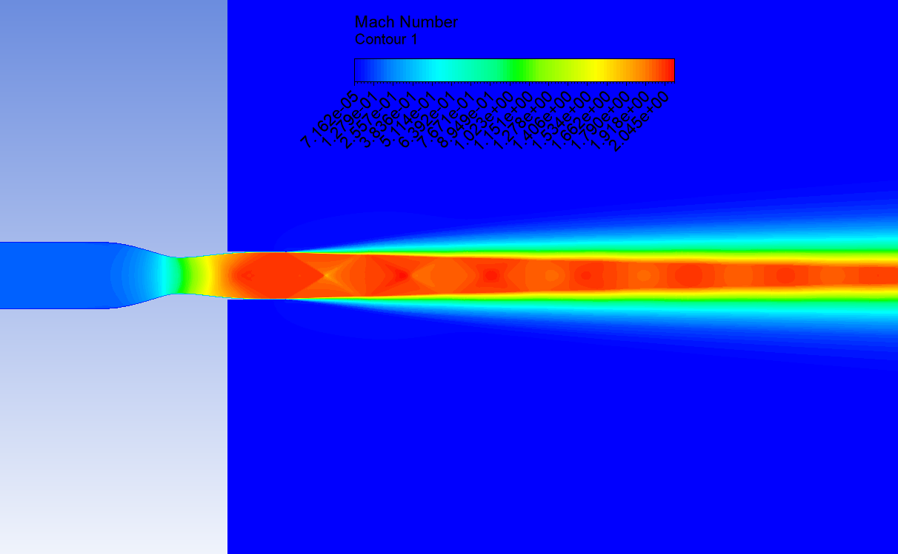 | 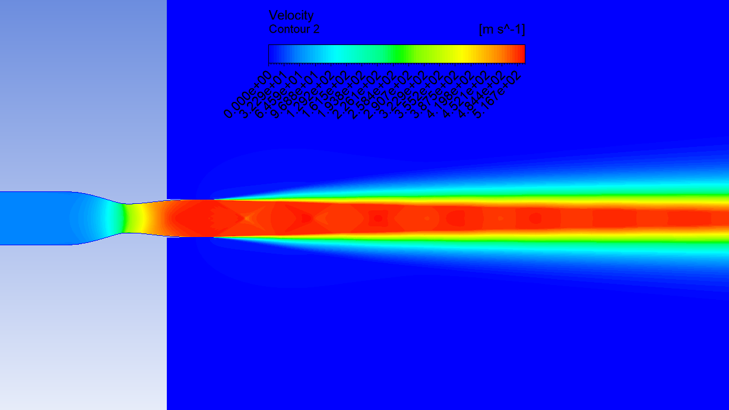
a) | b)
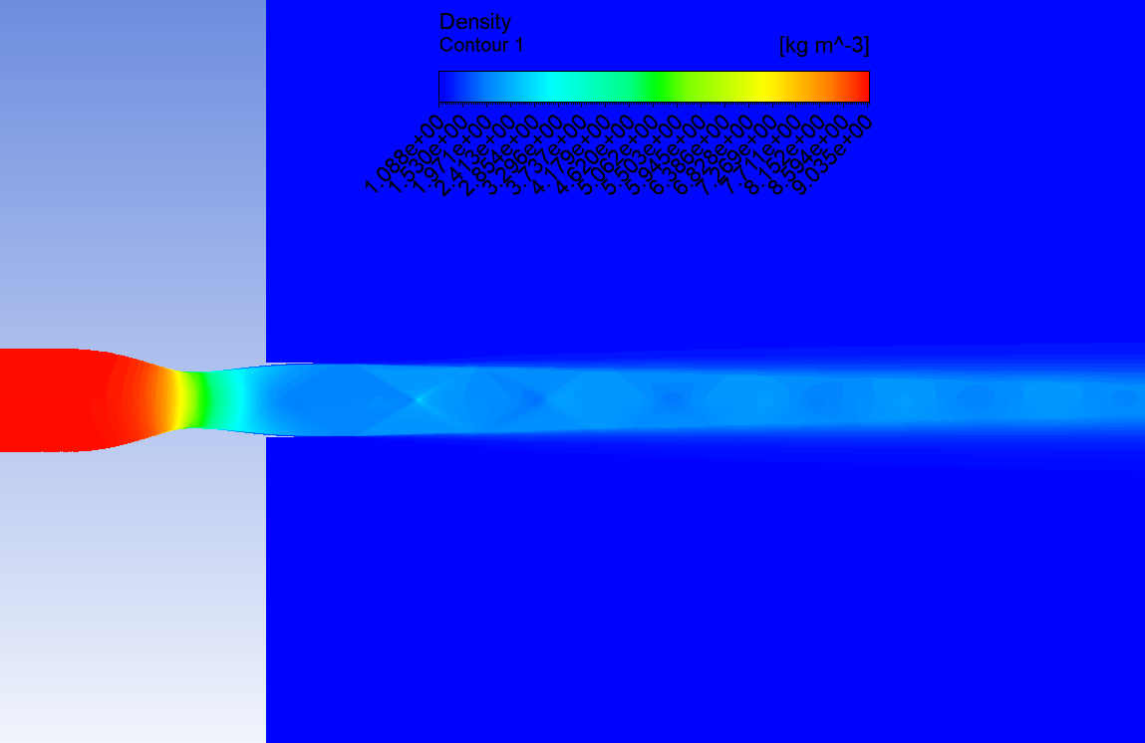 | 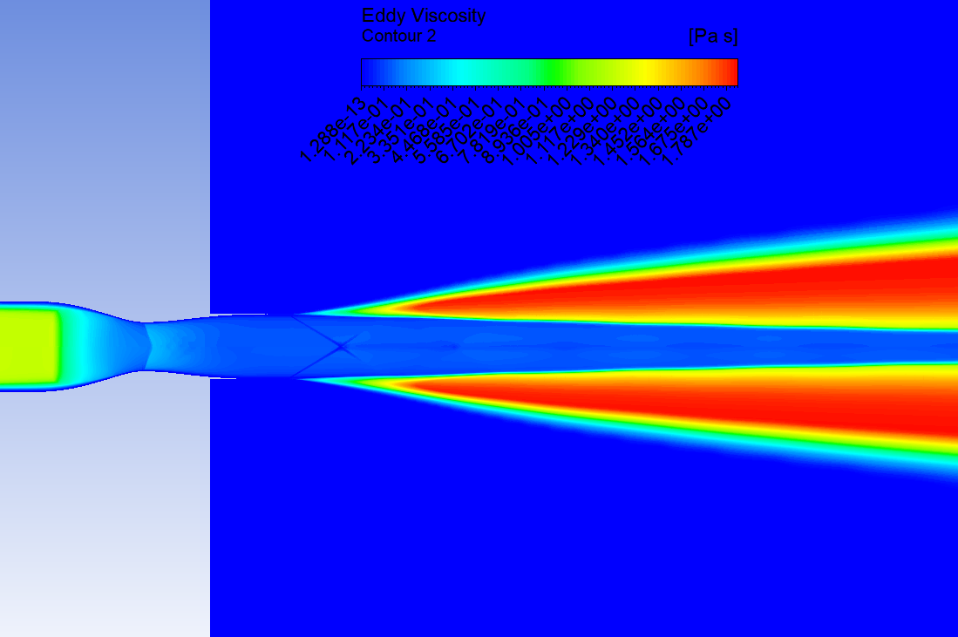
c) | d)
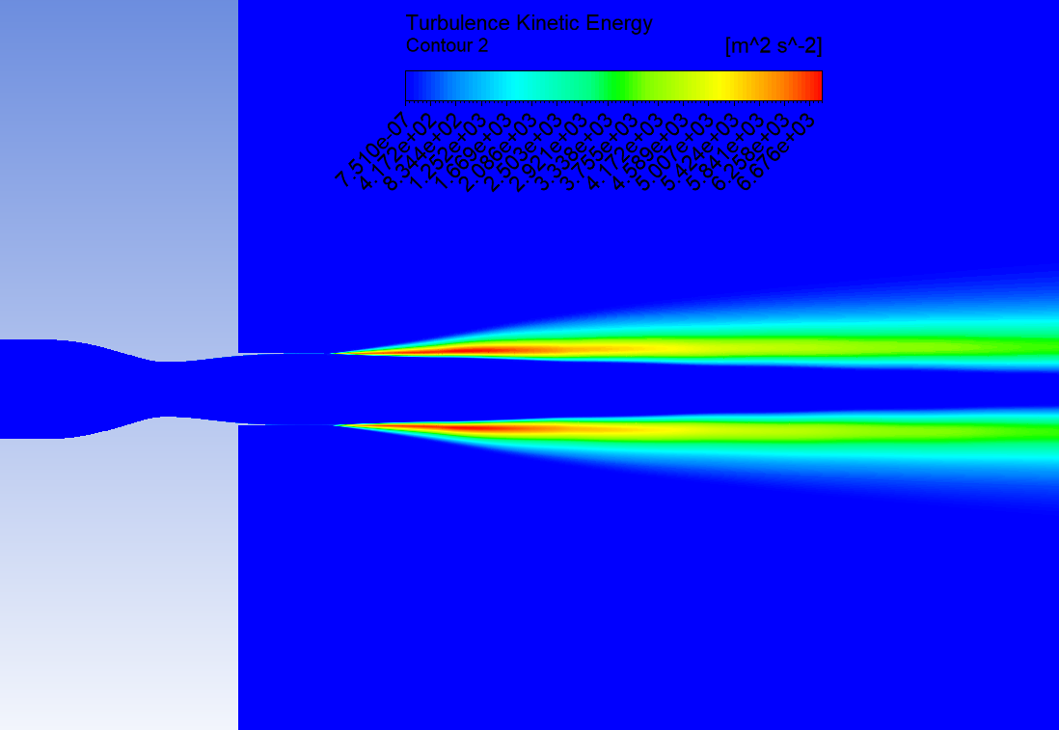
e)
FIGURE 5. Isolines of various flow parameters obtained as a result of numerical modeling of a supersonic hot jet: a) Much number Contour 1; b) Velocity Contour 2; c) Density Contour 1; d) Eddy Viscosity Contour 2; e) Turbulence Kinetic Energy Contour 2

CONCLUSION
In this study, the centerline behavior of an axisymmetric hot supersonic jet was investigated using the k–ω GEKO turbulence model available in ANSYS Fluent, and the numerical results were compared with experimental data from NASA’s Turbulence Modeling Resource for validation. The simulations reproduced the principal flow features in the near-field region quite well, capturing both the extent of the potential core and the sequence of shock cells that typically appear in under-expanded supersonic jets. Further downstream, a modest underestimation of static pressure and temperature was observed, which is consistent with the known constraints of steady RANS approaches when dealing with unsteady turbulent mixing and thermal transport. Even with these downstream deviations, the k–ω GEKO model showed a strong overall ability to predict the main characteristics of compressible, high-speed jet flows and succeeded in representing the dominant physical mechanisms. As a result, it may be considered a practical and computationally efficient option for applications involving high-Mach-number or thermally stratified jets, including many problems encountered in aerospace and energy-related simulations.
REFERENCES
- Boscheri, W., & Pareschi, L. (2021). High order pressure-based semi-implicit IMEX schemes for the 3D Navier-Stokes equations at all Mach numbers. Journal of Computational Physics, 434, 110206. https://doi.org/10.1016/j.jcp.2021.110206
- Frolov, R. (2018). An efficient algorithm for the multicomponent compressible Navier–Stokes equations in low- and high-Mach number regimes. Computers & Fluids, 178, 15–40. https://doi.org/10.1016/j.compfluid.2018.10.001
- Prasad, C., & Gaitonde, D. V. (2023). Turbulence modeling of 3D high-speed flows with upstream-informed corrections. Shock Waves, 33(2), 99–115. https://doi.org/10.1007/s00193-023-01123-8
- Wang, J., Huang, J., Duan, L., & Xiao, H. (2018). Prediction of Reynolds stresses in high-Mach-number turbulent boundary layers using physics-informed machine learning. Theoretical and Computational Fluid Dynamics, 33(1), 1–19. https://doi.org/10.1007/s00162-018-0480-2
- Huang, J., Wang, H., & Yang, H. (2020). Int-Deep: A deep learning initialized iterative method for nonlinear problems. Journal of Computational Physics, 419, 109675. https://doi.org/10.1016/j.jcp.2020.109675
- Sharibaev, N., et al. (2024). A new method for digital processing cardio signals using the wavelet function. BIO Web of Conferences, 130, 04008. https://doi.org/10.1051/bioconf/202413004008
- Musharbash, E., & Nobile, F. (2017). Dual Dynamically Orthogonal approximation of incompressible Navier Stokes equations with random boundary conditions. Journal of Computational Physics, 354, 135–162. https://doi.org/10.1016/j.jcp.2017.09.061
- Malikov, Z. M., Fayziev, R. A., Navruzov, D. P., & Malikov, B. Z. U. (2022). SIMULATION OF SWIRLING FLOWS BASED ON MODIFIED TWO-FLUID TURBULENCE MODEL. ACM International Conference Proceeding Series, 27–32. https://doi.org/10.1145/3584202.3584207
- Gulyamov, G., Dadamirzaev, M.G., Uktamova K.M., Misliddinov B.Z. (2023). The effect of a heated electron on the VAX of a tunnel diode. AIP Conference Proceedings, 2700(1),050007. https://doi.org/10.1063/5.0126516
- Gulyamov, G., Dadamirzaev, M.G., Boydedayev, S.R. (2000). Hot carrier electromotive force caused by surface potential modulation in a strong microwave field. Semiconductors, 34(5), 555-557. https://doi.org/10.1134/1.1188027
- Madaliev, M. E., Navruzov, D. P., Nazarov, F. K., Hamrayev, Y. Y., Boltayev, S. A., & Abdukhamidov, S. K. (2023). Development of new efficient technology for extraction of fine dust impurities from cotton. E3S Web of Conferences, 401, 05009. https://doi.org/10.1051/e3sconf/202340105009

