Assessment of the Degree of Well Productivity Decline Caused by Reservoir Deformation: a Case Study of Gas Condensate Fields in the Beshkent Trough
Avaz Agzamov^{1,}, Saidaxon Abbasova², Khamidullo Mukhammadiyev^{1 a)},
Zafar Mavlanov¹
¹Karshi State Technical University, Kashkadaryo region, Republic of Uzbekistan
²Tashkent State Technical University, Tashkent city, Republic of Uzbekistan

^{a)}Corresponding author: hammuh@mail.ru
Abstract. The results of studies on the impact of reservoir deformation on well productivity during the development of gas and gas condensate fields are summarized. The methods of investigation and the mechanism of the process are presented. By analyzing hydrodynamic study data from gas condensate field wells characterized by abnormally high reservoir pressures and composed of carbonate rocks, correlations between the productivity index and reservoir drawdown have been established. The varying rates of well productivity decline are attributed to the wide variety of genetic types of limestones and their petrographic variations within the productive horizons of the analyzed gas condensate fields. A trend has been identified indicating an increase in the rate of productivity decline due to reservoir deformation during field development, depending on the initial productivity level. The obtained scientific and practical results are recommended for substantiating optimal well operation regimes and for planning geological and technological measures to enhance the gas recovery factor.
Keywords: field, reservoir, hydrocarbon, production, flow rate, well, depression, formation, pressure, productivity, deformation, project, fact, factor, geology, technology, development.

INTRODUCTION
To improve the efficiency of gas and gas condensate field development, the rate of gas extraction and recovery, various technologies are used to reduce the negative impact of geological and technological factors. At the same time, the efficiency of the applied technologies for intensifying the extraction, the gas recovery factor (GRF) and condensate (GRF) in various geological and physical conditions of the fields vary widely (40-80%). In this regard, one of the priority tasks of the oil and gas industry is to study the causes of low GRF and GRF values and find ways to increase them [1-3].
The results of numerous studies have shown that a decrease in reservoir pressure during the development of gas and gas condensate fields and the operation of wells with large depressions on the reservoir leads to a change in the initial stress state of reservoir rocks, expressed in a decrease in the porosity and permeability of productive horizons. As a result, the productivity factors of wells and gas extraction decrease [4].
The conducted research and generalization of the experience of developing gas and gas condensate fields have established that the decrease in the well productivity factor during development in depletion modes can be significant [5].
The purpose of this work is to establish the degree of influence of reservoir deformation during development on the productivity of wells in gas condensate fields of the Beshkent trough of the Bukhara-Khiva region (Republic of Uzbekistan, Kashkadarya Region, Nishan District) [6-7].

RESEARCH METHOD
To date, a large number of theoretical, experimental and field studies have been conducted to study the degree of influence of geological and technological factors on the final gas and condensate recovery factors in various geological and physical conditions of gas condensate deposits.
The results of these studies, the current state of development of gas and gas condensate fields, as well as the low gas recovery factors achieved for most objects show the need for further improvement of theoretical developments. One of the ways to solve this problem is to study the influence of reservoir deformation during field development on the well productivity factor and KIG [8-10].
In practice, methods of analyzing indicator diagrams, specific selection curves, and laboratory studies have been widely used to determine the magnitude of reservoir pressures at which deformation processes begin.
Information obtained during gas-hydrodynamic studies is used to determine the thermobaric parameters of wells, filtration-capacitive properties of collectors and filtration resistance coefficients, allowing to establish the operating mode of wells. To solve the task, we used materials from well studies using the steady-state selection method.
The paper presents the results of calculations of modeling the influence of depression on the productivity of oil wells in carbonate reservoirs on the hydrodynamic simulator ECLIPSchulumberger. As a result of numerical modeling, it is shown that in oil wells, depending on the operating mode (increase in the diameters of the nozzles), the productivity coefficient decreases.
The theoretical foundations developed to date and accumulated experience indicate that the initial stress-strain state of rocks changes during the development of hydrocarbon deposits. The extent of these changes depends on the mining and geological conditions of the deposits (depth of occurrence of productive strata, filtration-capacitive and mechanical properties of reservoir rocks and reservoir fluids, initial reservoir pressure and temperature, total and effective thickness of the reservoir, degree of heterogeneity of reservoirs, etc.) and the implemented development systems (rate of hydrocarbon extraction, maintenance of reservoir pressure, reservoir and well operating modes, etc.) [11].
The mechanism of these changes is presented by many researchers as follows.
When developing hydrocarbon deposits without using reservoir pressure maintenance methods, it decreases. Since the rock pressure of the overlying rocks remains unchanged, the effective pressure (the difference between the rock and reservoir pressure) increases. Naturally, with unchanged rock pressure of the overlying rocks, part of the load that the fluid contained in the pores of the rocks took on will be absorbed by the rock skeleton (its solid matrix). As a result, the porosity and permeability of the reservoir decrease, which leads to a decrease in the flow rate and productivity coefficient of the wells [12].
Y.A. Kashnikov and S.G. Ashikhmin present the decrease in the well productivity coefficient during the development of hydrocarbon deposits as follows. During the operation of production wells, as a result of the formation of a depression funnel in the near-wellbore zone of the formation, a significant decrease in formation pressure is observed. As the production wells operate, the depression funnel expands. As a result, the reservoir reservoirs, especially in the near-wellbore zone, begin to experience additional vertical loading, leading to deformation of the pore and fracture space. In this case, both elastic and irreversible (plastic) decrease in the capacity and filtration properties of rocks occurs.
Analysis of the results of studies of this problem show that reservoirs of fractured and fracture-porous types, which are represented by deep-lying productive objects with abnormally high reservoir pressures, are particularly sensitive to deformation. The development process of such objects is characterized by a comparatively rapid drop in reservoir pressure, unpredictable dynamics of water intrusion and uneven productivity of wells.
However, in hydrodynamic modeling and drafting of design documents for the development of hydrocarbon deposits, deformation processes are not given due attention. This is due to the fact that the theoretical and methodological foundations of rock deformation have not been fully developed to date and the complexity of the processes occurring in the subsurface. The generalization of the accumulated experience in the development of hydrocarbon deposits with deformable reservoirs also requires its solution [13].

MATERIALS
The carbonate deposits of the Upper Jurassic are industrially gas-bearing at the analyzed deposits of Northern Nishan, Beshkent, Kamashi (Republic of Uzbekistan, Kashkadarya Region, Nishan District). In commercial practice, they are divided into 3 productive horizons (XVI, XVa and XV).
All deep exploratory wells at the fields have opened reef-free sections.
Horizon XVa, which is the main productive horizon at the deposits, is composed predominantly of dense limestones of grey and dark grey colour, platy and coarsely platy, in places massive, with interlayers of porous and finely cavernous limestones. The rocks are characterised by intensive (in some areas) fracturing.
The most widespread in the section of this horizon are the clotted-algal varieties of limestones, consisting of clots and lumps of pelitomorphic calcite, algae balls, detritus and intermediate calcite mass, which is intensively recrystallized, dolomitized (sometimes up to 20%), and in places weakly (2-3%) anhydritized. There are interlayers of aphanitic limestones composed of polytomorphic calcite, which has an indistinctly expressed clotted structure. The rock is heavily dolomitized in places. At the same time, its confinement to the wing and periclinal parts of the fold is clearly visible.
The reservoir rocks are present in the form of layers with a thickness of 0.6 to 7.6 m. Their porosity varies within the range of 5.5 – 13.5%, and the total thickness is 23 – 41% of the total thickness of the horizon (84 – 102 m).
The North Nishan fold is a sublatitudinal brachyanticline, the axis of which is slightly curved in the northern direction, gradually deviating to the southwest. The dimensions of the fold along the closed isohypse minus -3300 m are: length 11 km, width (in the central part) 5.5 km, height 420 m. The fold has an asymmetric structure, the angles of incidence of the layers on the wings are 5 - 8 ° (see Fig. 1).

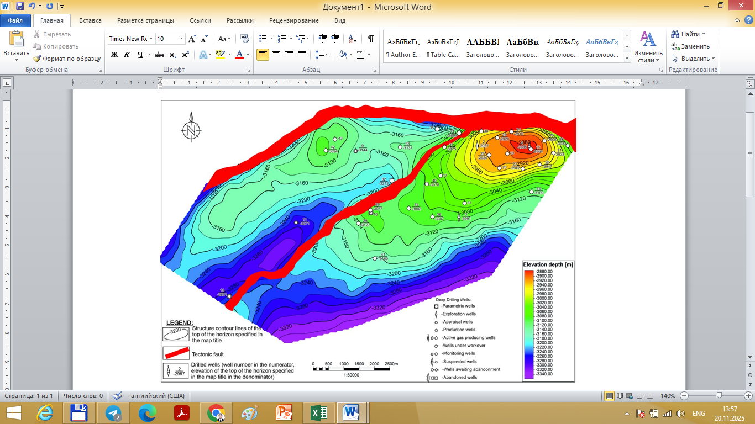
FIGURE 1. Structural map of the roof of the XV horizon of the Northern Nishan deposit
(Republic of Uzbekistan, Kashkadarya Region, Nishan District)

The Kamashinskaya fold on the roof of the XV horizon is a sublatitudinal brachyanticline, against the background of which two domes stand out: western and eastern. The axis of the fold is slightly curved in the northern direction. According to the minus 3100 m isohypse, the length of the fold is 13 km, the width is 1.75 - 2.5 km. The angles of dip of the layers on the wings are 9 - 11°, on the pericline the fold is more gentle (up to 5°) (see Fig. 2).
The western dome along the closed isohypse minus 3100 m has dimensions of 2.5-3.0 x 1.5-1.75 km with a height of 80 m. It is separated from the central dome by a depression with an amplitude of about 100 m.
The eastern dome is outlined by the minus 3050 m isohypse, within which the length is 7.5 km, the width is 1.5-2 km with a height of 150 m. They are separated from each other by a synclinal depression.

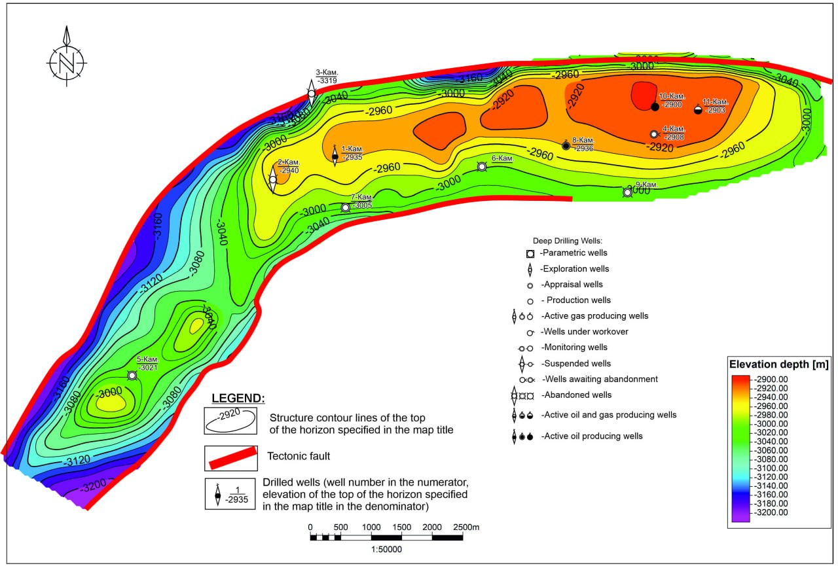
FIGURE 2. Structural map of the roof of the XV horizon of the Kamashi deposit
(Republic of Uzbekistan, Kashkadarya Region, Nishan District)

The northern limb of the fold is complicated by a fault with an amplitude of 250-300 m. In the southwestern direction, the fault amplitude gradually fades. According to the fault, the northern limb is subsided relative to the central part of the fold. In the east, the Kamashinskaya structure is adjoined by the Beshkentskaya structure, separated from the latter by a shallow synclinal trough, clearly visible in time sections and representing a two-dome brachyanticline fold. The dimensions of the fold along the closed isohypse minus -2947 m are: length 8.2 km, width 1.0-2.3 km. The northern limb of the fold is complicated by a tectonic fault with an amplitude of 200-250 m. In the northeastern direction, the fault gradually fades and in the area of the eastern dome its amplitude is reduced to 100-50 m (see Fig. 3). The angles of dip of the layers reach 12°. In the eastern direction the fold flattens out somewhat and in the area of the eastern dome the angles of incidence do not exceed 5°.

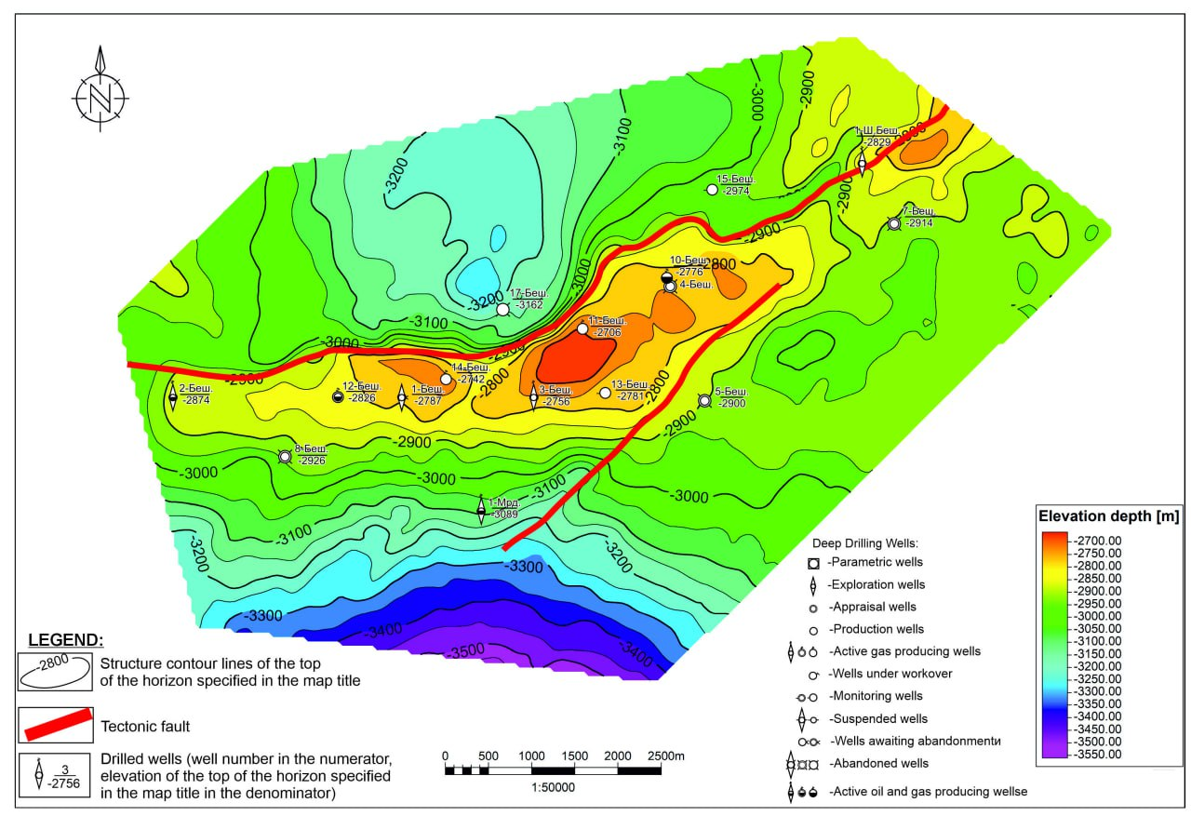
FIGURE 3. Structural map of the roof of the XV horizon of the Beshkent deposit
(Republic of Uzbekistan, Kashkadarya Region, Nishan District)
The main distinguishing geological factor of the Northern Nishan, Beshkent and Kamashi gas condensate fields is the abnormally high reservoir pressure of 54.96; 57.34 and 54.96 MPa. With an average depth of the productive horizon, the reservoir pressure anomaly coefficient is 1.57; 1.64 and 1.57, respectively.
It should be noted that oil and gas deposits with abnormally high reservoir pressures are currently found in almost all oil and gas regions of the world at various stratigraphic horizons and depths, with different types and reserves of hydrocarbons.
Experience in developing hydrocarbon deposits with abnormally high reservoir pressures shows that this factor, depending on the geological and physical conditions of the deposits, can affect the oil and gas recovery factor as both a positive (increasing) and a negative (decreasing) factor. In this case, positive factors include a higher concentration of reserves in the specific volume of the deposit, relatively high well flow rates, ensuring well flow for a long time, maintaining high reservoir properties of reservoir rocks, and negative factors include a decrease in stability and susceptibility of oil- and gas-saturated reservoirs to deformation processes.

RESULTS AND DISCUSSIONS
Analysis of the results of gas-dynamic studies and the behavior of the curves of the dependences of the productivity factor on the depression on the reservoir for wells of the Northern Nishan, Beshkent, Kamashi fields shows that for most of the studied intervals, starting from a certain value of the depression on the reservoir, there is a decrease in the growth rate of the productivity factor and flow rate. These decreases are explained by a change in the stress state and a change in the filtration-capacitive properties of reservoir rocks.
However, it is possible that it can be caused by the precipitation of water and hydrocarbon condensate in the bottomhole zone, as well as an increase in the velocity of gas movement and, as a result, an increase in pressure losses caused by inertial forces arising due to the tortuosity of pore channels, a sharp heterogeneity of reservoirs by area, causing a limited drainage area.
In this regard, we have carried out calculations to determine the minimum flow rate ensuring steady-state fluid removal from wells and the maximum flow rate at which inertial forces may occur, the value of which for the geological and physical conditions of the Northern Nishan, Beshkent and Kamashi fields amounted to 150-1500 thousand m³ per day, respectively. In order to increase the reliability of the obtained results of gas-hydrodynamic studies, well flow rates of less than 150 and more than 1500 thousand m³ per day were excluded from further analysis. This will eliminate the effect of water and hydrocarbon condensate precipitation in the bottomhole zone and pressure loss due to inertial forces and take into account the decrease in the productivity coefficient only due to collector deformation.
Gas-hydrodynamic studies of wells using the method of steady-state selections that meet these requirements at the analyzed fields turned out to be 16. During the study of wells, the depression on the formation (from 1.46 to 46.75 MPa) and well productivity factors (from 0.044 to 2.251 thousand m³/day/MPa²) changed within very wide limits.
Figures 4 and 5 show the dependence of the well productivity coefficient (Q/(P²_{lay}- P²_{bott})) on the reservoir depression (P²_{lay}- P²_{bott}). From the given dependencies it is evident that with the exception of gas-dynamic studies in 4 intervals (Beshkent field, well No. 3, interval 3252-3243 m; Beshkent field, well No. 1, interval 3132-3128 m; Kamashi field, well No. 1, interval 3265-3223 m; Northern Nishan field, well №. 8, interval 3624-3616 m) in the remaining 12 intervals (Northern Nishan field, well No. 2, interval 3482-3322 m; Northern Nishan field, well No. 2, interval 3320-32308 m; Northern Nishan field, well No. 2, interval 3302-3298 m; Northern Nishan, well №8, interval 3652-3642 m; Beshkent field, well №3, interval 3234-3225 m; Beshkent field, well №2, interval 3256-3253 m; Beshkent field, well №2, interval 3245-3238 m; Beshkent field, well №1, interval 3173-3167 m; Beshkent field, well №1, interval 3140-3136 m; Kamashi field, well №4, interval 3303-3295 m; Kamashi field, well №4, interval 3282-3274 m) a decrease in the productivity factor of wells is observed at large depressions in the formation. In some wells, the productivity factor increases in the initial 2-3 study modes, and then decreases. In other wells, the productivity factor decreases without increasing its value in the initial study modes. The increase in the productivity factor of some wells in the initial study modes can be explained by the cleaning of the bottomhole formation zone from solid particles and filtrate of the washing liquid that penetrated during the formation opening process.
The absence of reservoir deformation (in 25% of the studied intervals) and the decrease in the productivity coefficient at different rates (in 75% of the studied intervals) can be explained by the large diversity of genetic types of limestones and their petrovarieties in the productive horizons: biogenic + biochemogenic (lumpy-clotty, microlumpy, algal, detritus-algal); clastic (clastic, algal-clastic, lumpy-detritus); chemogenic (aphanite, fine-grained, detritus-aphanite, lumpy-afnite).

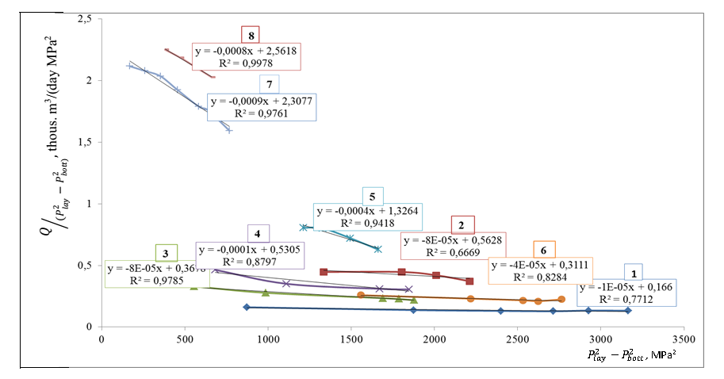
FIGURE 4. Well productivity coefficient as a function of reservoir depression: 1 – Beshkent field, well №3, interval 3234-3225 m; 2 – Beshkent field, well №2, interval 3277-3265 m; 3 – Beshkent field, well №2, interval 3256-3253 m; 4 – Beshkent field, well №2, interval 3245-3238 m; 5 – Beshkent field, well №1, interval 3173-3167 m; 6 – Beshkent field, well No. 1, interval 3140-3136 m; 7 – Kamashi field, well No. 4, interval 3303-3295 m; 8 – Kamashi field, well No. 4, interval 3282-3274 m.

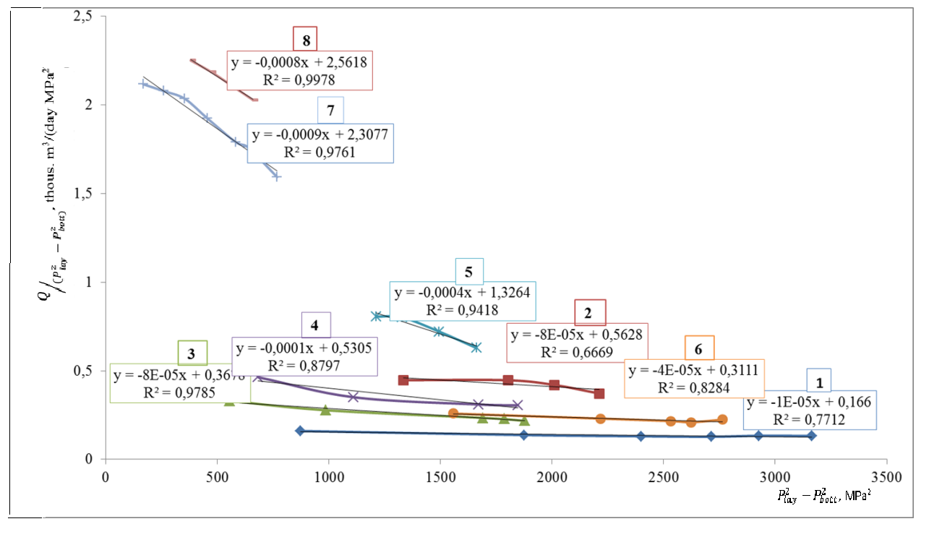
FIGURE 5. Well productivity coefficient dependence on reservoir depression: 1 – Beshkent field, well №3, interval 3252-3243 m; 2 – Beshkent field, well №1, interval 3132-3128 m; 3 – Kamashi field, well №1, interval 3265-3223 m; 4 – Severnaya Nishan field, well №2, interval 3482-3322 m; 5 – Severnaya Nishan field, well №2, interval 3320-3308 m; 6 – Sev.Nishan field, well No. 2, interval 3302-3298 m; 7 – Sev.Nishan field, well No. 8, interval 3652-3642 m; 8 – Sev.Nishan field, well No. 8, interval 3624-3616 m.

The authors of the work, who conducted experimental studies of the effect of reservoir pressure on the filtration-capacity properties of reservoir rocks, came to similar results. The analysis of the reaction of the pore reservoirs of the Bashkirian stage of the Siberian field to a change in their stress-strain state with a decrease in the initial reservoir pressure showed the individuality of changes in the studied capacity and filtration parameters over the entire range of porosity and permeability studied in the experiments. The reason for the scatter of experimental points is the great diversity of the studied lithological varieties of limestones. They also came to the conclusion that a wide range of structural and lithological features of rocks predetermines the diversity in the change in filtration-capacity properties with a decrease in the pressure of reservoir fluids in them. In addition, each field has its own specific features - a different degree of secondary transformations, deformations, fracturing, leaching and calcitization processes.
The paper studies the features of changes in porosity and permeability of oil and gas reservoir rocks depending on the effective pressure, which is understood as the difference between rock and pore pressure. They found that the common feature of porosity and permeability is the intensity of change of these parameters from their initial properties - with the improvement of reservoir properties, the relative decrease increases. At the same time, the individuality of the change in permeability depending on its initial value and lithological features of rocks is more pronounced than for porosity. The established experimental dependences of permeability change on effective pressure once again confirmed that changes in the filtration-capacitive properties of reservoirs in reservoir conditions for rocks of different lithological compositions differ significantly.
However, from Figures 4 and 5, it is clear that the tendency is for the rate of decrease of the productivity coefficient to increase depending on its initial value, i.e. the higher the initial productivity, the higher the rate of its decline with large depressions in the formation.

CONCLUSION
Summarizing the results of theoretical studies and experience in developing gas and gas condensate fields with abnormally high pressures, it is shown that a decrease in reservoir pressure during development leads to reservoir deformation, which leads to a decrease in their filtration and capacity properties. As a result, well productivity, production rates and gas recovery factor decrease.
The results of processing the materials of hydrodynamic studies of wells of the Northern Nishan, Beshkent, Kamashi gas condensate fields of steady-state selections confirm the conclusions of theoretical studies of this process. It is concluded that the reason for the decrease in well productivity due to reservoir deformation at different rates is due to the diversity of limestone types in productive horizons.
A tendency of increasing the rate of decrease of the well productivity coefficient depending on its initial value is noted, i.e. the higher the initial productivity, the higher the rate of its decline due to the deformation of the collector during the development of gas condensate fields under depletion conditions. This conclusion has greater scientific and practical significance for substantiating the optimal mode of well operation and planning geological and technological measures to increase the KIG.

REFERENCES
- Strizhkov, I. N., Kochkin, S. E., & Mikhailov, A. I. (2004). Influence of deformation of productive formations on their development indicators under dissolved gas regime. Oil Industry, (4), 52–53.
- Strizhkov, I. N., & Zamakhaev, V. S. (2004). Flexible-cargo mode of hydrocarbon deposit development (for discussion). Oil Industry, (8), 82–83.
- Popov, S. G., Belokon, A. V., Ekhlakov, Yu. A., & Ugryumov, A. N. (2005). Features of manifestation of fluid-dynamic processes at great depths. Geology, Geophysics and Development of Oil and Gas Fields, (3–4), 55–59.
- Agzamov, A. Kh., Mukhammadiev, H. M., & Turdiev, Sh. Sh. (2018). Estimation of the magnitude of productivity loss of wells of the Northern Nishan gas condensate field. In Proceedings of the XIII International Symposium “Fundamental and Applied Problems of Science” (pp. 180–184). Russian Academy of Sciences.
- Afanaskin, I., Korneeva, D., Steinberg, Yu., et al. (2016). The influence of depression on the productivity of oil wells during the development of subgas zones in carbonate reservoirs. Nefteservis, (3), 36–39.
- Gringarten, A. C. (1984). Interpretation of tests in fissured and multilayered reservoirs with double-porosity behavior: Theory and practice. Journal of Petroleum Technology, 36(4), 549–564. https://doi.org/10.2118/10044-PA
- Rakhimov, G. B., & Murtazayev, F. I. (2023). Increasing the efficiency of heat exchange by changing the construction of a shell-and-tube heat exchanger. In E3S Web of Conferences (Vol. 443, Article 03008). EDP Sciences. https://doi.org/10.1051/e3sconf/202344303008
- Khurmamatov, A. M., Abdugaffor, M., Rakhimov, G. B., Ismailov, O. Y., Auesbaev, A. U., & Khametov, Z. M. (2025). Increasing the efficiency of heat exchange by improving the design of heat exchangers. Nafta-Gaz, (1), 73–83. https://doi.org/10.18668/NG.2025.01.07
- Entov, V. M. (1974). On the change in the stress-strain state of rocks with a change in pressure in a fluid-saturated formation. Bulletin of the USSR Academy of Sciences: Mechanics of Solids, (6), 53–56.
- Zhukov, V. S., Kuzmin, Yu. O., & Poloudin, G. A. (2002). Assessment of the processes of subsidence of the earth's surface during the development of gas fields (case study of the Severo-Stavropolskoye field). Geology, Geophysics and Development of Oil and Gas Fields, (7), 54–60.
- Mishchenko, I. T., & Kodratyuk, A. T. (1996). Features of development of deposits with hard-to-recover reserves. Moscow Oil and Gas.
- Shevtsov, V. M., Zhuravlev, Ya. E., Zakirova, A. O., et al. (2011). Adjustments to the project for the development of the Northern Nishan gas condensate field. JSC UzLITIneftegaz.
- Ortikov, N., Fayzullaev, N., Hamidov, D., & Buronov, F. (2023). Study of methane carbonate conversion process in fixed catalyst layer in different membrane reactors. In E3S Web of Conferences (Vol. 402, Article 14013). EDP Sciences. https://doi.org/10.1051/e3sconf/202340214013

