Mathematical Models of the Rectification Column
Process in the Oil Processing Industry
Maksadkhon Yakubov¹, Barxayot Uzakov^{1, a)}, Baxodir Xoshimov¹,
Bakhrom Soliyev², Rahmatillo Zaynabidinov²
¹Tashkent University of Information Technologies named after Muhammad al-Khorazmi, Tashkent, Uzbekistan
²Fergana State Technical University, Fergana, Uzbekistan

^{a)}Corresponding author: barhayotuzoqov@gmail.com
Abstract. The paper addresses the mathematical modeling of rectification processes in oil refining with the aim of enhancing operational efficiency and product quality. A model of swirling flow in a vortex tube was developed to determine the distribution of axial and azimuthal velocities, revealing mechanisms of kinetic-to-thermal energy conversion within nozzle rectification columns. Furthermore, mathematical formulations of diffusion and rectification processes in the temperature field of a mini-refining unit were proposed, enabling identification of optimal operating regimes where rectification effectively prevails over diffusion. Numerical implementation in the validity of the models, demonstrating their capability to predict concentration dynamics and light fraction yields under varying thermal conditions. The research outcomes substantiate the possibility of process optimization without additional energy costs through precise synchronization of competing mass-transfer phenomena. In addition, design recommendations for vortex-based hydrodynamic heat generators and nozzle rectification columns were provided, ensuring improved heat exchange, intensified mass transfer, and higher efficiency of separation. The proposed modeling approach contributes to the development of situational control strategies in oil refining and establishes a theoretical and practical basis for modernizing mini-refining technologies. The results highlight the significance of mathematical modeling as a tool for optimization, energy saving, and innovation in petroleum processing.
Keywords: diffusion and rectification process, azimuthal velocity, fraction of petroleum products, rectification columns, heat generator, centrifugal field.
INTRODUCTION
Distillation and mass transfer processes constitute the backbone of modern chemical engineering, underpinning a wide range of industrial operations such as petroleum refining, petrochemicals production, and fine chemical synthesis. They are indispensable not only for achieving the required purity of target products but also for ensuring energy efficiency and sustainability in large-scale process industries. Over the last decades, significant advances have been made in conventional distillation and rectification technologies; nevertheless, the intensification of heat and mass transfer remains an open research problem due to the inherent limitations of traditional apparatuses [1-3].
Vortex devices have emerged as a promising alternative for separation processes, offering potential advantages such as intensified turbulence, enhanced mixing, and enlarged interfacial contact area. These unique hydrodynamic characteristics create favorable conditions for accelerating phase exchange processes, thereby reducing the equipment footprint, lowering energy consumption, and improving overall separation efficiency. Consequently, the exploration of vortex-assisted separation has become an increasingly relevant topic in the development of next-generation mass transfer technologies [4].
Despite these advantages, several scientific and engineering challenges hinder the broad implementation of vortex-based systems. In particular, the complex interplay between convective transport, molecular diffusion, and thermodynamic phase equilibrium within swirling flows creates substantial mathematical difficulties in establishing predictive models. Moreover, there is still a lack of robust and effective methods to regulate the competition between diffusion and convective mass transfer, which significantly constrains process optimization and scale-up. Addressing these challenges requires a deeper theoretical and computational understanding of the fundamental mechanisms governing vortex-driven mass transfer [5-8].
The present study aims to fill this research gap by developing an integrated mathematical framework that combines vortex flow dynamics with diffusion–rectification equations. By coupling hydrodynamic and thermodynamic descriptions, the proposed model seeks to capture the synergistic effects of swirling convection and molecular diffusion in multiphase mass transfer processes. Such a unified approach not only contributes to advancing the fundamental understanding of vortex-assisted separation but also provides practical insights for the design and optimization of highly efficient equipment in petroleum refining and related industries [1, 2].

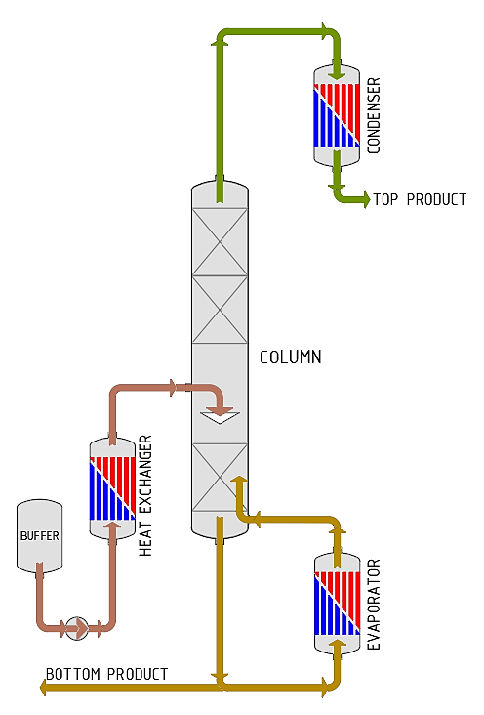
FIGURE 1. Scheme of the main distillation column.

This type of mass exchange technology allows to implement the hydrodynamic principle of interaction of gas and liquid on inclined grids and to increase the time of passage of the vapor-liquid flow through a stable temperature zone. At the moment of contact (braking) of the flow with ceramic packings, a part of the kinetic energy of rotational motion is converted into thermal energy. At the same time, the temperature effect on the rectification process occurs. The process of separation of the solution (oil) is considered along the axis o_{x} S- the cross-sectional area of the tube, (x₁, x₂) - elementary section. Oil is separated into components by different temperature regimes, and multiple evaporation and condensation occur, which causes two competing processes, namely diffusion and rectification. But for the rectification process to proceed "successfully", it is necessary to observe conditions under which the rectification process would dominate the diffusion process. For this purpose, we will consider the diffusion and rectification processes sequentially. If the medium is unevenly filled with gas, then diffusion occurs from places with higher concentration to places with lower concentration [9-15].

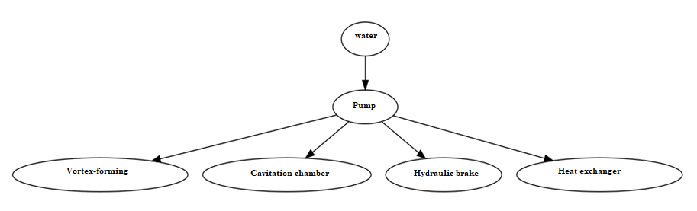
Figure 2. Structure of a Vortex Heat Generator.

Reaching the optimal parameters of the technological process is possible due to the study of the patterns of change in the mass transfer process in the temperature field occurring during the processing of oil or gas condensate in the rectification column of a mini-oil refinery. The selected approach allows modeling various technical conditions in devices and apparatuses, which is a prerequisite for their further improvement and the preparation of new design solutions for industry. Fig. 2 shows a block diagram of a vortex heat generator consisting of a pump, a swirler , a cavitation chamber, a hydraulic brake and a storage heat exchanger. The heat generator has no moving and rubbing parts and due to the swirling of the liquid from one section to another, an increasing intensity of heat release is provided with the transformation of translational motion into rotary-translational, with the formation of a vortex flow entering the cavitation chamber, and with constant operation of the received internal and kinetic energy into heat on the braking devices of various designs. The device can be used for autonomous water heating instead of centralized. This will eliminate the costs of transporting heat carriers, get rid of low-efficiency small boiler houses, reduce the costs of maintaining the service personnel and improve the ecology of the environment.
METHODS
We have analyzed the rotational motion of a mixture of oil and gas condensate and presented a mathematical modeling of a steady-state axisymmetric flow with swirling in a vortex tube. A mathematical model of the process occurring in a nozzle rectification column has been developed using a mini-oil refining unit as an example. A necessary condition for the operation of a vortex tube is the presence of a rotating flow in it. The rotation of the flow inside a smooth-walled tube is ensured by introducing gas (liquid) through a nozzle located tangentially to its inner surface. At the outlet of the nozzle, a flow is formed that enters the vortex tube tangentially at a high speed. Flowing around the inner surface of the pipe, the flow acquires a rotational motion characterized by a tangential velocity . The highest tangential velocities will be in the nozzle section of the pipe (the cross-section of the pipe passing through the center of the nozzle). Tangential velocities change along the radius of the pipe - they decrease towards the center. The swirling of the flow in the vortex causes part of the heat, which is part of the internal energy of the system, to be converted into kinetic energy of the translational motion of the flow along the vortex axis.
The velocity vector of the acquired translational motion turns out to be perpendicular to the vector of the instantaneous tangential velocity of the rotational motion of particles in the flow and does not change the value of the latter. We have analyzed the conversion of the kinetic energy of rotation into thermal energy. It is shown that the possibility of controlling the processes of initiating the discharge of excess internal energy of a nonequilibrium system during the acceleration of rotation of bodies of technical dimensions allows us to significantly expand the capabilities of vortex energy. The basics of a vortex heat generator for heating a liquid without using electric, flame and other heaters are presented. The essence of the operation of a hydrodynamic heat generator is to accelerate the flow of water in the volute along the guide blades, converting the translational motion into rotational-translational motion, forming a vortex flow entering the cavitation chamber, and constantly converting the resulting internal and kinetic energy into heat on braking devices of various designs [1, 2].
Next, we study the mathematical modeling of a steady-state axisymmetric flow with swirl in a vortex tube or an inlet device in a nozzle rectification column [3, 4]. The general vector equation of fluid motion with a velocity and vorticity has the form
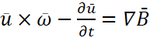 (1)
Let us consider an axisymmetric flow in cylindrical coordinates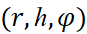 with the corresponding velocity components and given 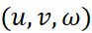 vorticity components
: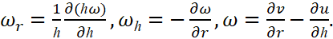 (2)
The equation of conservation of mass will be satisfied if the components of the velocity And will be expressed through the current function 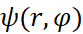 as follows:
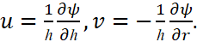 (3)
Hence, the azimuthal component of vorticity will be equal to
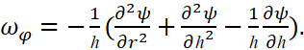 (4)
From (1) we obtain three scalar equations
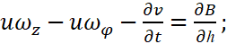 (5)
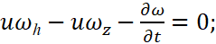 (6)
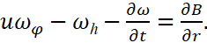 (7)
Equation (6) can be rewritten as follows:
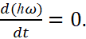 (8)
In this form (8) expresses the constancy of circulation along a liquid circuit in the form of a circle, having its center on the axis of symmetry and lying in a plane normal to it. For a steady flow, each particle of liquid moves along the streamline along the surface formed by the rotation of the curve lying in the axial plane, relative to the axis of symmetry of the flow. In this case, from (8) and Bernoulli's theorem we have
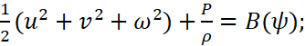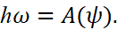 (9)
From (4) we obtain an equation for the current function:
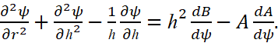 (10)
Equation (10), applicable throughout the entire flow field, is reduced to the Bessel equation in the cylindrical region by simple transformations
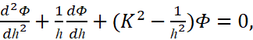 (11)
having a general solution
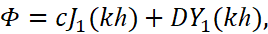 (12)
where and are Bessel functions of the 1st and 2nd kind; Ф is determined from the expression
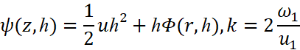
Finally, for the axial velocity in the cylindrical region we have
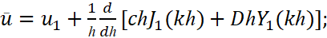 (13)
for azimuthal velocity
(14)
where and — constant axial velocity and angular velocity of rotation of the liquid as a whole. This, as a result of the conducted research, we obtain an expression for the distribution of axial and azimuthal velocity and thus opens up the possibility of technological control of the process due to the transformation of part of the kinetic energy of rotational motion into heat. The processes of separation of mixtures and obtaining individual substances of varying purity play a key role in the modern petrochemical industry.

RESULTS AND DISCUSSION
As can be seen from this, based on mathematical modeling and precise equations, it is possible to achieve a result and isolate the necessary substances in a short time. Among the separation processes, the rectification column plays a key role, and its useful share for achieving the result is about 90%. This is explained by the sufficient versatility of rectification processes and the ability to process massive material flows [5, 6]. Rectification is based on the possibility of separating substances from liquids by vaporization and condensation. This is due to the fact that each substance has its own, different saturated vapor pressure. The saturated vapor pressure of a substance determines its boiling point and the amount of vapor in its mixture with other substances. It has been demonstrated that heat and mass transfer processes can be carried out using rectification columns with minimal spatial and time expenditure.
The same phenomenon occurs in solutions if the concentration of the dissolved substance in the volume is not constant. Let us consider the diffusion process in a hollow tube or a tube filled with a porous medium, assuming that at any given time the concentration of gas (solution) is the same across the tube cross-section. Porosity is due to the presence of space between the conical "herringbone" type sheets, filled with ceramic material. Then the diffusion process can be described by a function u (x, t) representing in combination x; at the moment of time t. According to Nernst's law, the mass of gas flowing through the cross section over a period of time (t, t+∆t) equal
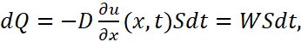 (15)
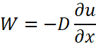
where is the diffusion coefficient, is the cross-sectional area of the tube, 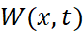 - the density of the diffusion flow, equal to the mass of gas flowing per unit time through a unit area. By definition of concentration, the amount of gas in a volume V is equal to hence 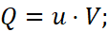 we obtain that the change in the mass of gas in the section of the tube 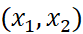 when the concentration changes equals
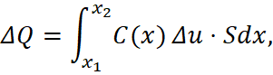
Where 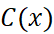 - porosity coefficient. Let's make an equation for the gas mass balance in the area over a period of time 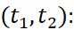
From here we obtain the equation:
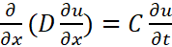 (16)
which is the diffusion equation. If the diffusion coefficient is constant, then the diffusion equation takes the form
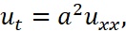 Where 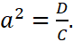
If the porosity coefficient and the diffusion coefficient are constant, then the diffusion equation has the form
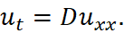
Let's find the solution to equation (16)
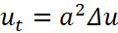 inside the region at 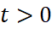 with initial condition 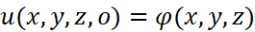 and the boundary condition 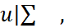 where is the boundary of the region T. Let us consider an auxiliary problem: find a non-trivial solution to the equation
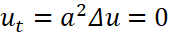 in T at (17)
satisfying a homogeneous boundary condition 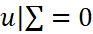 and representable as a product 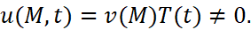 Separating the variables in the usual way, we arrive at the following conditions defining the functions 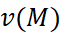 and 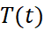.
For the function V we obtain the problem of finding the eigenvalues. Let be the eigenvalues, and 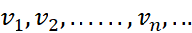 be the eigenfunctions of problem (18). The functions 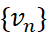 form an orthogonal system. The corresponding functions 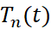 have the form 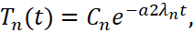 and the auxiliary problem has a non-trivial solution
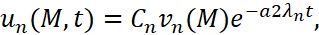 (18)
The general solution to the original problem can be represented as
(19)
Satisfying the initial condition
(20)
we find the coefficients
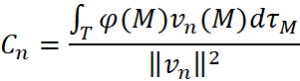
where 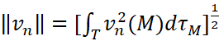 is the norm of the function V. Thus, expression (21) represents the solution to the problem. The rectification process is based on the separation of substances by converting them from liquid to vapor (evaporation) and back (condensation). This is due to the fact that each substance has its own, different from the others, saturated vapor pressure. According to the model discussed above, the mass of gas flowing through section X in a period of time 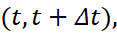 is equal to
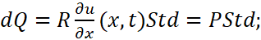 (21)
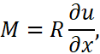
where R is the rectification coefficient, S is the cross-sectional area of the tube, P(x, t) is the density of the rectification flow, equal to the mass of gas flowing per unit time through a unit area. By definition of concentration, the amount of gas in volume V is equal to
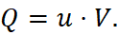
It follows that the change in the mass of gas in the section of the tube (x₁, x₂) when the concentration changes by ∆u equal
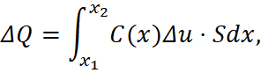
Where - porosity coefficient.
Gas mass balance equation in the area (x₁, x₂) over a period of time (t₁, t₂) will look like this:
from here we get the equation
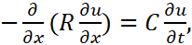 (22)
which describes the rectification process.
The solution to equation (24) is similar to the solution to equation (16):
(23)
As a result of the constructed mathematical equations and their numerical implementation, we obtain graphs of the processes of diffusion and rectification during oil refining. By synchronizing these two points A and B competing processes over time, we can consider a combined graph of the concentration-time dependence at constant temperature (T = 250 °C) in real time (see Fig. 3). Point A graphically represents the diffusion mode and point B represents the rectification mode. It is evident from the figure that the values u_{n} correspond to the optimal concentration of oil in the rectification column, its maximum excess can lead to the process of "flooding" the column, and the values above u_{n} correspond to an effective rectification process at the values of the parameter t less, t_{n} . Under such conditions, the rectification process dominates over the diffusion process. Thus, the mathematical model makes it possible to simulate various technical situations and obtain recommendations for practical use.

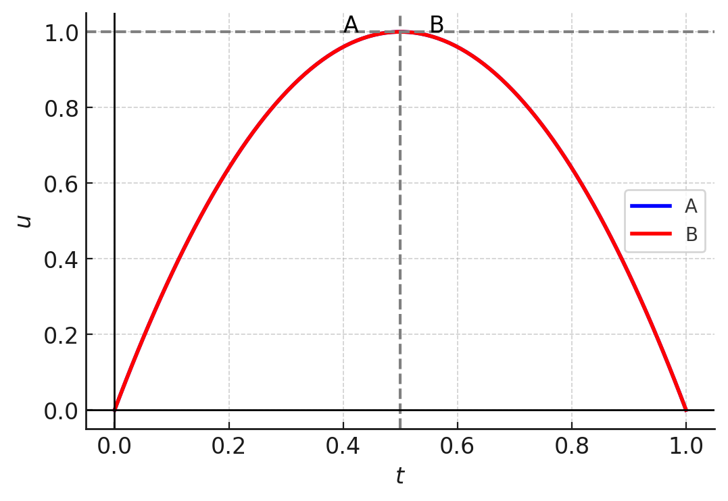
FIGURE 3. Models of diffusion and rectification processes: A is the diffusion mode, B is rectification mode.

Based on process optimization, it is possible to predict technical solutions, including increasing the efficiency of the column and increasing the yield of light fractions without additional costs.
To improve the technical and economic indicators of oil refining processes and thereby increase the degree of light petroleum product extraction, it is proposed to equip the lower part of the main rectification column with an additional heat jacket in the form of casings. This optimization aims to enhance the column's operation and intensify mass and heat exchange. Calculations for the fuel oil heating coil in the column's cube have been performed, and the obtained results are presented in detail [5, 6]. Table 1 presents the technical specifications of the mini oil refining unit (MORU).
It has been shown that the use of the device makes it possible to improve the technical and economic indicators of the rectification column process, increase the degree of extraction of light petroleum products, and reduce energy consumption.

TABLE 1. The technical specifications of the mini oil refining unit (MORU)
Indicators | Value
Raw material capacity (oil), thousand tons/year | 15-50
Display %:
- Gasoline | 20-40
- Diesel fuel | 30-50
Gas condensate capacity, thousand tons/year | 15-50
Display , %:
- Gasoline | 25-65
- Diesel fuel | 20-35
Furnace fuel consumption, kg/h | 25-35
Circulating (cooled) water consumption, m3/hour | 25
Installed power , kW | 36
Power consumption , kW | 17
Dimensions , m | 6x6x15
Device mass , t | 15
Column Type | Installation
Heat exchangers | Pressurized cap tube
Hydrocarbon heater | WBO-40H, two-wire, bruller
CONCLUSION
In this study, a comprehensive mathematical modeling framework for the rectification column processes of oil refining was developed and analyzed. The proposed models captured the fundamental dynamics of swirling flows, diffusion, and rectification, enabling accurate prediction of mass and heat transfer phenomena in mini-refining units. These findings demonstrate that mathematical modeling can serve as a powerful tool for optimizing operational modes in distillation columns and for improving the efficiency of petroleum product separation.
The results demonstrated that the conversion of rotational kinetic energy into thermal energy plays a crucial role in enhancing the rectification process. Determining the distribution of axial and azimuthal velocities in packed rectification columns allows models to provide a scientific basis for controlling separation efficiency and achieving results with minimal time investment. This opens up new possibilities for developing energy-saving technologies in oil refining and ensuring sustainable production.
Beyond theoretical contributions, the study also proposed practical recommendations for the design of vortex-based heat generators and mini-refinery configurations. These innovations demonstrate that cost-effective improvements in mass and heat exchange can be achieved without additional energy consumption, thereby reducing the environmental and economic burden of oil refining operations.
Overall, the research emphasizes the relevance of integrating mathematical models into the operational management of oil refining processes. The models not only support process optimization but also provide a foundation for further technological modernization, particularly in small-scale refining units. Future research can extend these models with advanced computational methods and experimental validation to further enhance reliability, adaptability, and industrial applicability.
REFERENCES
- Redkozubov, S. A., & Vartanov, K. S. (2007). Mathematical modeling of the process in a distillation column. Natural and Technical Sciences, (5), 242–247.
- Sixth All-Russian Symposium on Strategic Planning and Development of Enterprises. (2005, April 12–13). Innovative development of oil and gas enterprises: Experience of foreign countries (Section 3: Experience of strategic planning at Russian and foreign enterprises, pp. 234–239). Moscow, Russia.
- Yakubov, M. S., Uzakov, B. M., & Khoshimov, B. M. (2024). On mathematical modeling and automation of the oil refining process. Miasto Przyszłości, 48, 213–216.
- Luyben, W. L. (2019). Control of distillation columns and processes: Recent trends and challenges. Computers & Chemical Engineering, 127, 230–245. https://doi.org/10.1016/j.compchemeng.2019.03.023
- Kiss, A. A. (2019). Advanced distillation technologies: Design, control and applications. Springer Nature.
- Olujić, Ž., & de Rijke, A. (2020). Energy-efficient distillation column design and operation. Chemical Engineering and Processing: Process Intensification, 157, 108125. https://doi.org/10.1016/j.cep.2020.108125
- Chen, J., & Li, H. (2020). Application of CFD modeling in distillation column design. Computers & Fluids, 197, 104366. https://doi.org/10.1016/j.compfluid.2019.104366
- Vu, T. M., & Abdul Rani, A. M. (2009). Modeling and control of distillation column in a petroleum process. Journal of Applied Mathematics, 2009, 1–12. https://doi.org/10.1155/2009/404702
- Tan, H., & Cong, L. (2023). Modeling and control design for distillation columns based on the equilibrium theory. Processes, 11(2), 607. https://doi.org/10.3390/pr11020607
- Yusof, K. M., Karray, F., & Douglas, P. L. (2012). Development of neural network models for a crude oil distillation column. Jurnal Teknologi, 38(1), 51–64. https://doi.org/10.11113/jt.v38.509
- Kong, L., & Maravelias, C. T. (2019). From graphical to model-based distillation column design: A McCabe-Thiele-inspired mathematical programming approach. AIChE Journal, 65(10), e16731. https://doi.org/10.1002/aic.16731
- Abdul-Wahab, M. I., Al-Dawery, S., & El-Shariefy, M. H. (2003). Mathematical model for multicomponent distillation column. Iraqi Journal of Chemical and Petroleum Engineering, 4(1), 9–16. https://doi.org/10.31699/IJCPE.2003.1.2
- Abdullah, Z., Aziz, N., & Ahmad, Z. (2007). Nonlinear Modelling Application in Distillation column. Chemical Product and Process Modeling, 2(3). https://doi.org/10.2202/1934-2659.1082
- Mendez-B, J., Gonzalez-Avalos, G., Gallegos, N. B., Ayala-Jaimes, G., & Rubio-Maya, C. (2022). Modeling and Simulation of an Energy Integrated Distillation Column in a Bond Graph Approach. Entropy, 24(9), 1191. https://doi.org/10.3390/e24091191
- Paludetto, R., Paret, G., & Donati, G. (1992). Multicomponent distillation with chemical reaction: Mathematical model analysis. Chemical Engineering Science, 47(11), 2891–2904. https://doi.org/10.1016/0009-2509(92)87147-I

