Improving Vacuum Generation Systems in Vacuum Columns for Primary Oil Distillation
Maksadkhon Yakubov¹, Baxodir Xoshimov^{1, a)}, Barxayot Uzakov¹,
Jamoldin Nazirkulov², Azizjon Xayitov²
¹Tashkent University of Information Technologies named after Muhammad al-Khorazmi, Tashkent, Uzbekistan
²Fergana State Technical University, Fergana, Uzbekistan

^{a)}Corresponding author: bxoshimov89@gmail.com
Abstract. The article develops a comprehensive methodology for the interdependent calculation of the main elements of technological units operating under vacuum. This methodology allows you to take into account the interaction of the main technological object and the properties of the vacuum-generating system. Also, a procedure for interdependent modeling of complex chemical-technological systems is developed, and a method is proposed that allows you to simultaneously calculate the technological object being evacuated and the vacuum-generating system in systems operating under vacuum. Basic criteria based on operating costs have been developed to compare the efficiency of different types of vacuum-generating systems. Mathematical models of complex chemical-technological systems operating under vacuum have been created, taking into account the interdependencies between the main elements of their operation. A mathematical model of a liquid-ring vacuum pump has been developed, the correctness of which has been confirmed by experimental studies.
Keywords: Vacuum generating systems, vacuum condenser, vapor/gas ejector, vapor phase, fore vacuum pump, specific heat capacity, vapor-liquid equilibrium, liquid-ring vacuum pump.
INTRODUCTION
The development of chemical technology is unimaginable without the production of substances with a complex structure, the separation and purification of which are carried out at low residual pressures in order to reduce the boiling point and reduce the intensity of thermal destruction processes. In addition, such substances are often subject to strict quality requirements, which imposes serious restrictions on the hardware and technological implementation of the processes.
In chemical-technological production, methods of conducting processes under vacuum are widely used on an industrial scale. Such processes include, in particular, such technologies as vacuum distillation, vacuum sublimation, vacuum drying, and vacuum rectification. Many sources note the possibility of reducing process temperatures, separating substances that decompose under the influence of heat, reducing energy consumption, and improving product quality by working under vacuum [1-3].
One of the main problems of vacuum technology is ensuring the tightness of devices, reducing heat losses, and increasing corrosion resistance. Therefore, based on the standards of the American Society of Mechanical Engineers (ASME), research is being conducted on the use of new materials (corrosion-resistant steel, polymer coatings), the development of integrated vacuum systems (for example, a combination of ejector and pump systems) (ASME Boiler and Pressure Vessel Code).
There are also significant achievements in the literature in the direction of automation and optimization of processes. With the help of modern process control systems (Aspen HYSYS, ChemCAD, Unisim Design), mathematical models of vacuum-operated devices are created, and their operating modes are monitored in real time. This, along with increasing the efficiency of the equipment, makes it possible to prevent emergencies [4-5].
Research centers in European and Asian countries (Fraunhofer Institute for Chemical Technology, RIKEN, Korean Institute of Industrial Technology) are also conducting research on increasing the energy efficiency of vacuum equipment, waste gas recovery, and ensuring environmental safety. These studies are an important step towards the implementation of sustainable production principles in global industry [6-7].
In most typical processes carried out under vacuum, the required residual pressure range belongs to low ("technical") vacuum. Since the density of the vapor (gas) phase decreases with decreasing pressure, the volumetric consumption of steam along the cross-section of the apparatus increases, therefore, the equipment for such processes is characterized by large volumes and dimensions. This requires designers to take a thoughtful approach and take into account the operating characteristics of vacuum units and vacuum generating systems that work together and interact with each other. Therefore, the task of improving the hardware and technological design of vacuum units and vacuum generating systems is urgent, the solution of which will allow increasing the energy efficiency of enterprises of the Republic of Uzbekistan.
MATERIALS AND METHODS
A technological device operating under vacuum is a complex system, since it is a set of elements (devices) interconnected by technological flows and interacting with each other (see Fig.1). A schematic representation of such complex chemical-technological systems (CCTS) is presented in Figure 1.

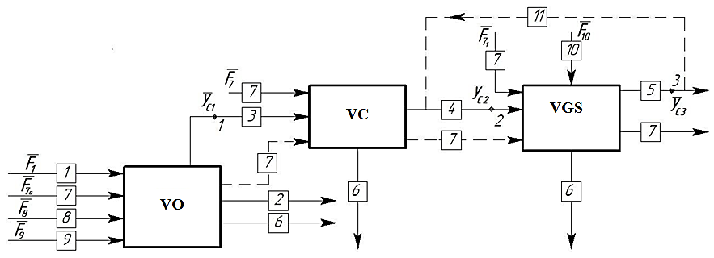
FIGURE 1. Vacuum under working CCTS energy resources to enter into account received without decomposition: 1 - initial raw material flow; 2 - product; 3 - non-condensable gases; 4 - flow in the vacuum generating system (VGS); 5 - waste; 6 - condensate; 7 - heat carrier; 8 - decomposition gases; 9 - exhaust gases; 10 - energy resource; 11 - bypass flow for adjusting the properties of the VGS. 1, 2, 3 - points: points of contact.

The vector function 𝜑, which refleCCTS the sequence of solving a system of equations in a mathematical description defined by a functional operator:
$${\overline{y}}_{c1}={\overline{φ}}_{1}({\overline{F}}_{1},{\overline{F}}_{7_{0}},{\overline{F}}_{8},{\overline{F}}_{9},{\overline{a}}_{1})$$ | (1)
$${\overline{y}}_{c2}={\overline{φ}}_{2}({\overline{y}}_{c1},{\overline{F}}_{7},{\overline{a}}_{2})$$ | (2)
$${\overline{y}}_{c3}={\overline{φ}}_{3}({\overline{y}}_{c2},{\overline{F}}_{7_{1}},{\overline{F}}_{10},{\overline{a}}_{3})$$ | (3)
For industrial technological facilities, the VGS consists of a set of various types of machines and equipment, which allows dividing the block into a number of subsystems at the same hierarchical level. The decomposition of the VGS consisting of three blocks is shown in Figure 2.
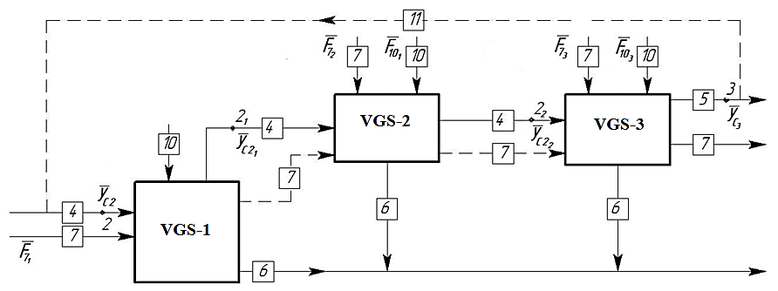
FIGURE 2. Decomposition of the three-block VGS

At the same time, the vector functions of a complex chemical-technological system operating under vacuum, in which the VGS consists of 3 blocks, are filled in as follows:
$${\overline{y}}_{c2_{1}}={\overline{φ}}_{2_{1}}({\overline{y}}_{c2},{\overline{F}}_{7_{1}},{\overline{F}}_{{10}_{1}},{\overline{a}}_{2_{1}})$$ | (4)
$${\overline{y}}_{c2_{2}}={\overline{φ}}_{2_{2}}({\overline{y}}_{c2_{1}},{\overline{F}}_{7_{2}},{\overline{F}}_{{10}_{2}},{\overline{a}}_{2_{2}})$$ | (5)
If VGS n ( n = 1,..., N ) pieces from the block consists of if it is , it without system decomposition in Figure 3 cited to look takes.
The vector functions of the structural elements of a vacuum-generating system consisting of n elements are written as follows:
$${\overline{y}}_{c2_{(n-1)}}={\overline{φ}}_{2_{(n-1)}}({\overline{y}}_{c2_{(n-2)}},{\overline{F}}_{7_{(n-1)}},{\overline{F}}_{{10}_{(n-1)}},{\overline{a}}_{2_{(n-1)}})$$ | (6)
$${\overline{y}}_{c3}={\overline{φ}}_{3}({\overline{y}}_{c2_{(n-1)}},{\overline{F}}_{7_{n}},{\overline{F}}_{{10}_{n}},{\overline{a}}_{3})$$ | (7)

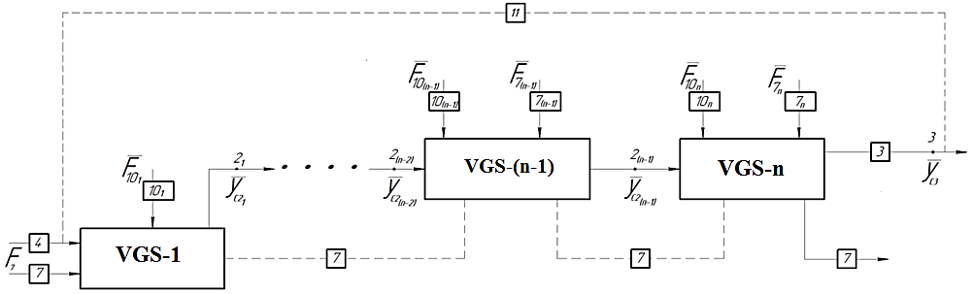
FIGURE 3. Decomposition of a VGS consisting of n blocks

Combining the characteristics of a technological facility and a vacuum generation system means coordinating their main characteristics, which means the main parameters that characterize the operating conditions of these units as a whole.
The main goal in modeling and calculating vacuum blocks is to determine the required load on the VGS, as well as to determine the location of the VGS, which is capable of maintaining the required level of residual pressure of the object within a specified range of production conditions while maintaining the required quality of product flows. The calculation of the vacuum block in relation to the problem considered in the article can be represented in the form of a block diagram presented in Figure 4.
According to the presented block diagram, the characteristics of the object and connecting pipes are entered and its calculation is performed based on the given pressure in the block. Then the condenser parameters are entered, the cooling temperature of the absorbed mixture is given and the calculation is performed. If the surface reserve and pressure drop are outside the permissible range, then a new cooling temperature is entered.
After the initial condenser has been successfully calculated, the VSS parameters are entered, in which the suction pressure is taken into account taking into account the calculated pressure drop. If the calculated VSS efficiency is less than the consumption of the uncondensed gas phase in the initial condenser, then a new value for the residual pressure in the block is entered and the calculation starts anew. If at any stage the temperature or pressure is outside the permissible range, then the calculation is terminated and the VGS for the selected object is considered invalid.
Calculation and modeling of the structural elements of the VGS is carried out according to a similar principle (see Fig. 5). The parameters of the equipment are entered, the efficiency of the vacuum pumps and the temperature of the outlet streams are calculated. At the beginning of the calculation, the pressure at the inlet to the VGS, the pressure at the inlet to the forevacuum pump and its efficiency are given. Then the efficiency of all elements of the system is calculated sequentially.
If VGS next stepmother productivity previous from the mother outgoing of the stream volumetric at the expense relatively small if it is, it without at the entrance pressure new value is entered or to the VGS at the entrance mixture expense is reduced. At the same time, if the calculated (or entered) intermediate pressures are outside the permissible limits , then the calculation is terminated. As a result of the calculation, the calculated efficiency of the VGS, the pressure at the inlet and the parameters of the intermediate flows are obtained.
The development of mathematical models of technological processes operating under vacuum was carried out according to the following algorithm:

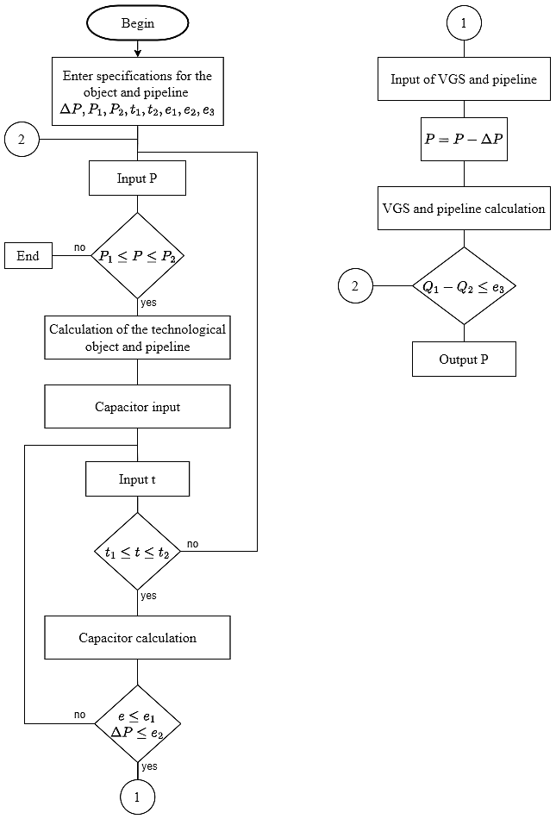
FIGURE 4. Structural diagram of the methodology for the interconnected modeling of vacuum blocks of industrial devices

1. An analysis of the studied CCTS was conducted, in which the entire process was divided into a number of sub-processes, respectively interconnected by material and energy flows, according to the decomposition principle. If necessary, an operator scheme of the process was developed based on the technological scheme, in which sub-processes were replaced by model technological operators.
2. Modules designed to describe specific subprocesses of the chemical-technological system (CTS) were selected from the Unisim Design R451 (Aspen HYSYS V12) universal modeling platform database. These modules were "linked" to each other and specified in such a way as to increase the "flexibility" of the scheme and ensure convergence of the solution.
3. A computational experiment was conducted, resulting in the calculation of the material and energy balance of the investigated chemical-technological system (CTS).
4. The calculation scheme synthesized in the RUM was checked for adequacy, which consisted in comparing the obtained calculation data with the results of industrial testing, technological testing, or experimental research of the apparatus (module).
If the data of the industrial test (experimental study) do not differ from each other by more than 15%, the calculation scheme is considered sufficient. The peculiarity of the operation of the vacuum condenser is that the device has two heat exchange zones: the first zone (I) - the vapors are cooled from the initial temperature to the saturation temperature; the second zone (II) - the saturated vapors are condensed at the saturation temperature and supercooled to a specified temperature, at which part of the vapors is additionally condensed. It should be noted that the saturation temperature is determined by the pressure of the mixture at the inlet and the total pressure drop in the intertube space.

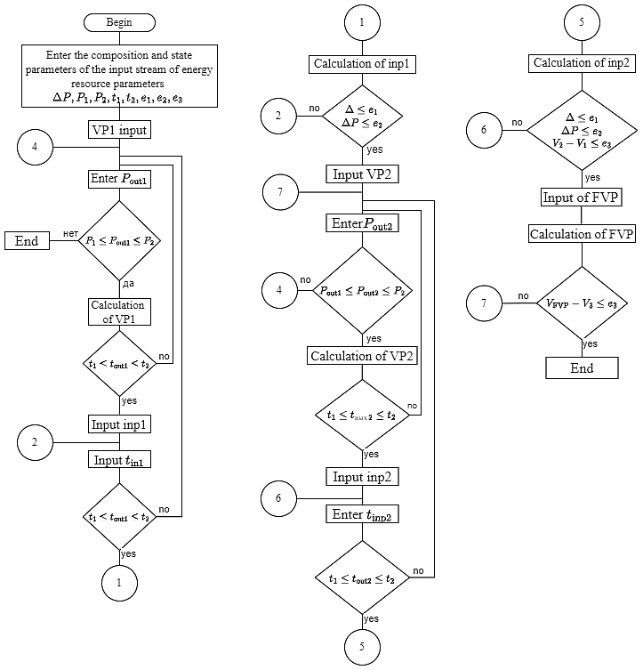
FIGURE 5. VGS of calculation block diagram

In turn, it is the consumption of inert components of the mixture that determines the pressure drop in the intertube space. The scheme of a standard shell-and-tube condenser operating under vacuum is shown in Figure 6. The implementation of the mathematical model of the vacuum condenser in the form of a set of modules of the Unisim Design R451 (Aspen HYSYS V12) software complex is shown in Figure 6.
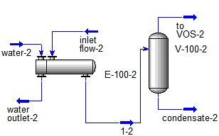
FIGURE 6. Vacuum of the capacitor computer model

For a successful calculation of the condenser, it is necessary to calculate the VF (VE) process, taking into account the peculiarities of technological processes carried out under vacuum. The VF (VE) equations are recorded in the Unisim Design R451 (HYSYS V12) program database and implemented as a Separator module. The principle of operation of the module is that the pressure of the inlet stream is taken as the pressure, and in the presence of several inlets - the lowest pressure of the inlet streams. Then, the temperature is determined at which the composition of the vapor and liquid phases is calculated according to the heat balance. This approach cannot be applied to the considered VGS, since the temperature and pressure in the condensing units depend on the structure of the condenser, the parameters of the technological process and the temperature of the heat carrier used. The capabilities of the Unisim Design R415 program allow the user to specify a specific temperature and pressure, for which the “Heat Exchanger” module, designed to model heat exchange processes, can be added before the “Separator” module.
In this module, the temperature and pressure difference are given, at which the thermophysical parameters of the mixture are automatically calculated by the program. In the calculation according to the proposed block diagram, it is assumed that the design of the condenser is known, therefore, the cooling temperature of the mixture is given in the range of surface reserve $ε_{1}$= 0-5%.
RESULTS AND DISCUSSION
The block diagram of the calculation of a vacuum capacitor is shown in Figure 7.

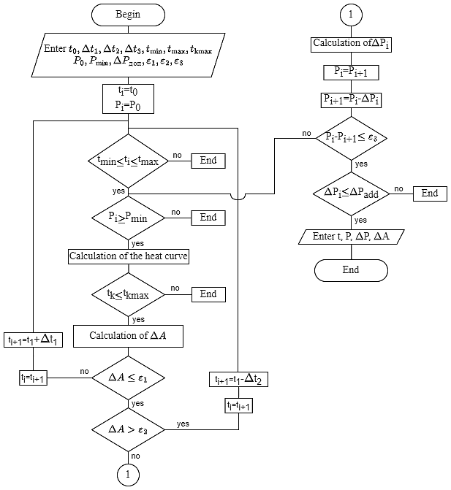
FIGURE 7. Block diagram of the calculation of a vacuum condenser

It is proposed that the calculation of a vacuum shell-and-tube condenser be carried out according to the following method:
1. Enter the mixture temperature at the outlet of the intertube space and calculate the heat curve;
2. Calculate the condenser, determining the surface reserve and hydraulic resistance. If the surface reserve is less than 0 (temperature increases) or greater than the permissible value (temperature decreases), a temperature correction is made;
3. If the corrected temperature value is not within the permissible limits, then the calculation is terminated and the heat exchanger is considered unsuitable for these conditions;
4. The hydraulic resistance of the intertube space is calculated separately for each zone at the average temperature of the mixture in each zone. The pressure drop for each zone is summed and the resulting value is calculated as a total for the condenser;
5. If the newly calculated pressure value differs significantly from the given value, then the heat curve is corrected taking into account the hydraulic resistances and points 2-4 are repeated;
6. If the total pressure drop exceeds the permissible value (for example, more than 50% of the inlet pressure), then the calculation is stopped and the heat exchanger is considered unsuitable for these conditions.
The parameters required for the capacitor calculation (thermal curves, thermophysical parameters of flows, etc.) are determined using the Unisim Design R451 (HYSYS V12) program, and the result of the calculation is the cooling temperature of the mixture, the surface reserve, and the pressure drop. Calculation according to the specified methodology largely depends on the initial approximations of temperature and pressure, as well as on the values of Δt and ε₃. It is most appropriate to set the initial temperature t₀ at 2-4°C above the maximum allowable temperature of the circulating water (t_{kmax}) at the condenser outlet. Typically, the maximum temperature of the circulating water at the condenser outlet is 38°C, therefore, as an initial approximation, the temperature can be set at 40-42°C. It is recommended to adopt a value of ε₃ = 0.5-1 mm Hg, and a permissible pressure drop ΔP_{add} = 4-10 mm Hg.
The overall efficiency of the VGS determines the characteristics of the forevacuum stage, which determines the achievable pressure difference. As noted above, the exhaust gases leaving the technological facility contain substances that condense at temperatures and pressures that can be achieved in the final stages. Therefore, it is advisable to choose forevacuum pumps whose performance does not depend on the condensation of part of the mixture. Such a pump is a liquid ring vacuum pump (LRVP).
The principle scheme of the operation of the LRVP can be presented in the form of figures 8, 9. Cell I corresponds to the suction zone, where the sucked gas enters. This cell corresponds to the lowest pressure in the pump, at which the sucked gas is saturated with vapors of the evaporated working fluid. Then the gas passes into cell II, where the gas is compressed to the driving pressure and passes into cell III, which corresponds to the driving cell, from which the sucked gas is discharged from the pump. In this case, part of the gas from cell III is returned for suction (to cell I). As mentioned above, cell IV corresponds to the separator of the working fluid and sucked gas.

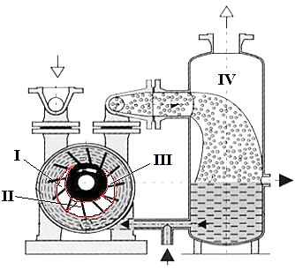
FIGURE 8. LRVP scheme with cells shown

In the LRVP the vapor -gas medium to be absorbed takes the following form:
$$V_{0}\left(ε\right)+∆V_{0}\left(ε\right)=V_{1}∙F\left(μ\right)∙F\left(ρ\right)+[V_{rez}\left(ε\right)+∆V_{rez}(ε)]$$ | (8)
The passport characteristics of the LRVP are characterized by pronounced nonlinearity, therefore, it is advisable to switch from volumetric efficiency to molar efficiency in equation (8).

$$\frac{G_{o}(ε)}{G_{I}∙F\left(μ\right)*F(ρ)}∙\left[\left(1+\frac{∆G_{o}\left(ε\right)}{G_{o}\left(ε\right)}\right)+ψ_{rez}\left(ε\right)\right]=1$$ | (9)
$$ψ_{rez}={G_{rez}}/{G_{o}(ε)}$$ | (10)
The heat balance is written as:
$$G_{o}H_{o}+L_{o}h_{o}+Q_{N}+L_{u}∙h_{u}=G_{K}H_{K}+L_{K}h_{K}+Q_{мо}$$ | (11)
For the "water-air" system, it can be written as follows:
$$G_{K}=G_{o}+∆G_{o}$$ | (12)
$$L_{K}=L_{o}-∆G_{o}$$ | (13)
$$∆G_{o}=G_{o}∙\frac{Y_{I}^{*}-Y_{o}}{1-Y_{I}^{*}}$$ | (14)
If we assume that the mass transfer process occurs at the saturation line and assume that the fraction of the driving energy dissipated as heat is 90%, then the heat balance is written as the following equation:
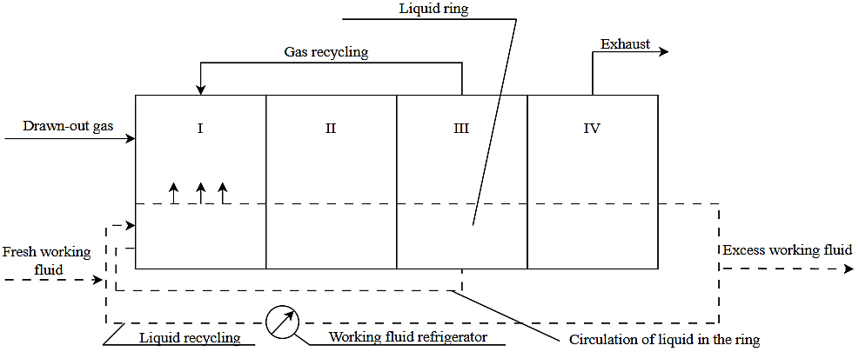
FIGURE 9. Schematic diagram of the workflow.

$$G_{o}c_{pv}t_{vo}+L_{o}c_{pL}t_{Lo}+0.9N∙3600+L_{u}∙c_{pL}∙t_{Lk}==\left(G_{o}+∆G\right)c_{pv}t_{nk}+\left(L_{o}-∆G\right)c_{pL}t_{Lk}+∆G∙r$$ | (15)
The S H VN can be represented in the form of a sequence of exemplary processes and a computer model of the LRVP can be constructed (see Figure 10).

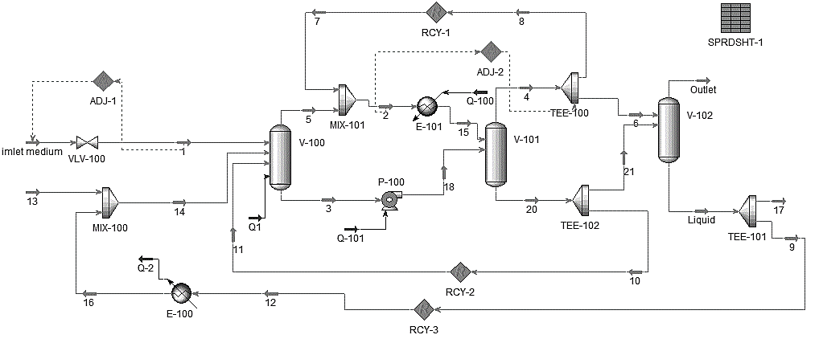
FIGURE 10. Calculation scheme of LRVP in identification mode

The absorbed gas and working fluid (streams 1 and 14) enter the suction cell I (V-100 module), where the same heat flow Q1 is transferred, which is determined by the condition that 90% of the driving power is dissipated as heat. The composition of the vapor and liquid phases is calculated from the condition that the vapor -liquid equilibrium (VLE) is reached, the vapor mixes with the recirculating gas and enters the V-101 separator (corresponds to cell III), the pressure of which corresponds to the outlet pressure. The liquid phase of the V-101 separator is supplied to the same module. The vapor phase of the V-101 separator is divided into recirculating gas streams (returned to cell I), and the liquid phase is divided into a circulating liquid stream and a working liquid stream discharged from the LRVP. The P-100 module is used to compress the mixture (corresponds to cell II). The V-102 module fits into cell IV, which corresponds to the LRVP separator.
According to this model, it is necessary to determine the circulating gas consumption, for this a specific type of LRVP is determined. The inlet flow consumption is recorded at the inlet (this corresponds to the LRVP passport efficiency), and the circulating flow consumption is determined in such a way that the combined flow consumption of the circulating gas and the vapor phase of chamber I (flow 2 in the scheme in Fig. 11) corresponds to the maximum possible efficiency of the LRVP (this is determined based on the passport specification). Therefore, as an example, it was proposed to identify computer models of two types of liquid ring vacuum pumps (LRVP): a single-stage Mex-25 LRVP installed in the laboratory device of the FerSTU IT department and a two-stage LPH 85340 LRVP recommended for the reconstruction of the secondary steam condenser in the vacuum block of a small oil refinery.
The suction pressure and the approximation equations expressing this relationship are shown in Figures 11 and 12.
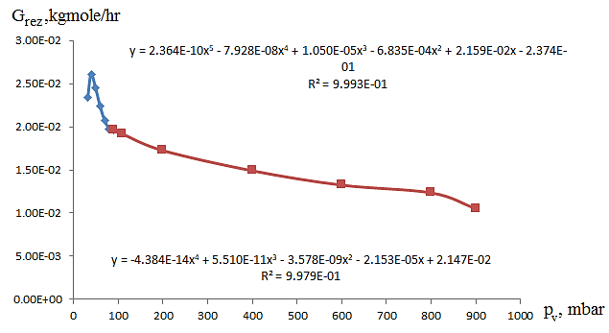
FIGURE 11. Flow rate of G_{rez} as a function of p_{v} (MEX-25)

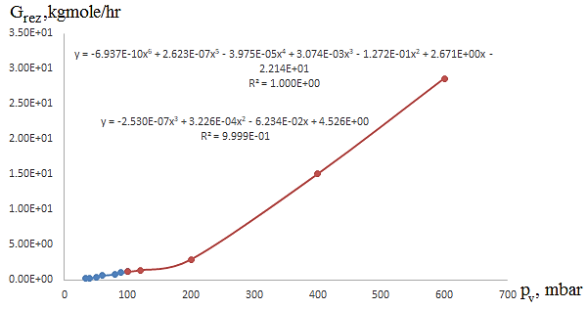
FIGURE 12. Flow rate of G_{rez} as a function of p_{v} (LPH 85340)

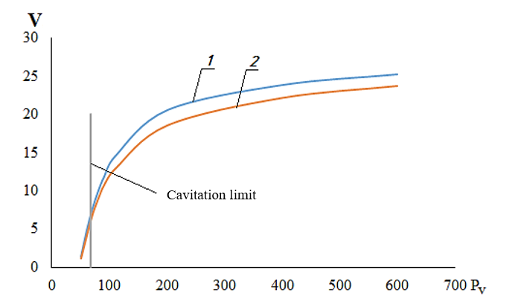
FIGURE 13. Characteristics of MEX-25 LRVP at t_{sl} = 30°C

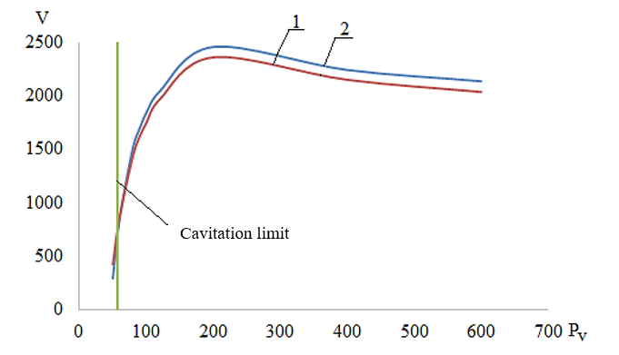
FIGURE 14. Characteristics of LPH 85340 LRVP at T_{sl} = 30°C

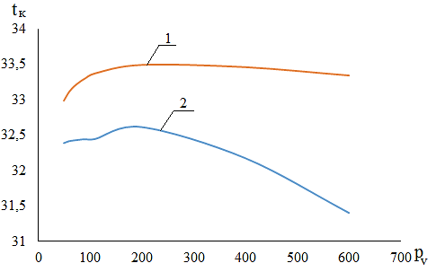
FIGURE 15. Characteristics of MEX-25 LRVP at t_{sl} = 30°C

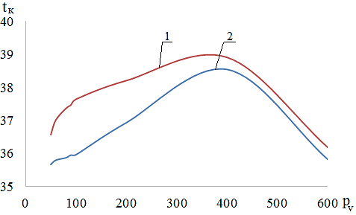
FIGURE 16. Variation of outlet temperature at t_{sl} = 30 °C

The accuracy of the developed computer model, the results of calculating the efficiency and temperature change of the service fluid at the outlet were compared with the results obtained according to the method given in the manual "Ring Vacuum Pumps and Ring Compressors". The analysis was carried out on the basis of the "Technical Details and Areas of Application" of the Sterling SIHI group (hereinafter referred to as the methodology). The efficiency change curve calculated according to the methodology (curve 1) and the curve calculated according to the model developed in the Unisim R451 (HYSYS) program (curve 2) are shown in Figures 13 and 14.
By the methodology (curve 1) and the model (curve 2) is presented in Figures 15 and 16.
Efficiency calculation error at a pressure of 33-40 mbar ranges from 18% to 33%, while the developed mathematical model shows lower efficiency values. The differences in outlet temperature do not exceed 10% (the model also gives lower values in this case).
A laboratory device was designed to experimentally validate the model, the schematic diagram of which is shown in Figure 17.

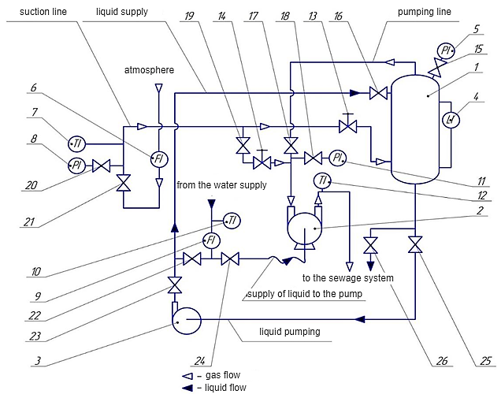
FIGURE 17. Scheme of the device for studying VGS: 1 - saturator; 2 - liquid-ring vacuum pump MEX-25; 3 - pump; 4 - level gauge; 5, 8, 11 - pressure sensors; 6, 9 - flow sensors; 7, 10, 12 - temperature sensors; 13-26 - shut-off valves

During the experiment, the suction gas consumption was determined by the readings of the flow meter 6 (according to the conditions corresponding to the readings of the thermometer 7 and the manometer 8), which was then recalculated to the suction conditions. Also, the temperature rise of the working fluid, which is the difference between the readings of the thermometers 10 and 12, was determined. During the experiment, the pressure maintained by the valve 13 was recorded, at which the suction gas consumption was determined every 10 minutes. For a total pressure, the consumption and temperature of the service fluid at the outlet were measured 4 times, then the next pressure was set using the valve 13 (see Fig. 17).
Figures 18 and 19 show the temperature change of the service fluid at the outlet of the SHVK, calculated using the methodology (curve 1), model (curve 2), and experimentally measured (curve 3).
As shown in Figures 18 and 19, the calculations based on the model and methodology are in good agreement with the experimental data. This is observed both in terms of efficiency (the maximum difference from the experimental data does not exceed 15 percent) and in terms of the service fluid temperature at the outlet of the liquid ring vacuum pump (the maximum difference from the experimental data does not exceed 7 percent).
A user module was used to create a computer model of a Roots-type pump, which included equations for recalculating efficiency and inlet pressure. The calculation scheme of a Roots pump circuit with intercooler is shown in Figure 20.

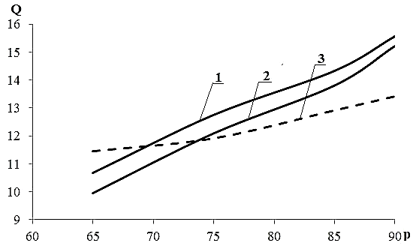
FIGURE 18. Variation of productivity according to suction pressure

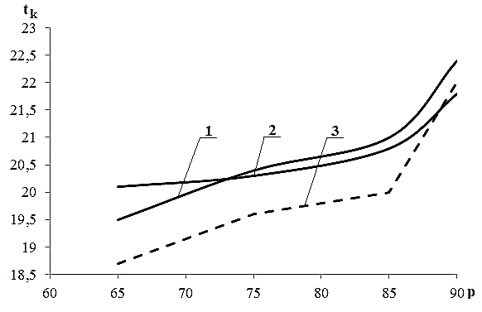
FIGURE 19. Dependence of liquid temperature change on suction pressure

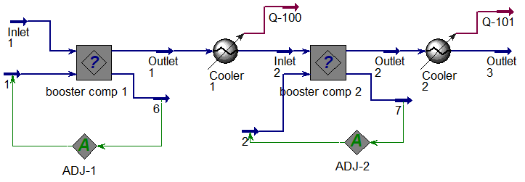
FIGURE 20. Calculation diagram of a chain of Roots pumps with intercooler

The calculation block diagram is shown in Figure 21.
The calculation according to the block diagram was carried out in several stages:
1. The flow was given to the module input (pressure, temperature, flow rate and composition were entered);
2. The pressure at the pump outlet was given;
3. The initial 𝑘_{th} approximation was given;
4. The temperature at the pump outlet was calculated.

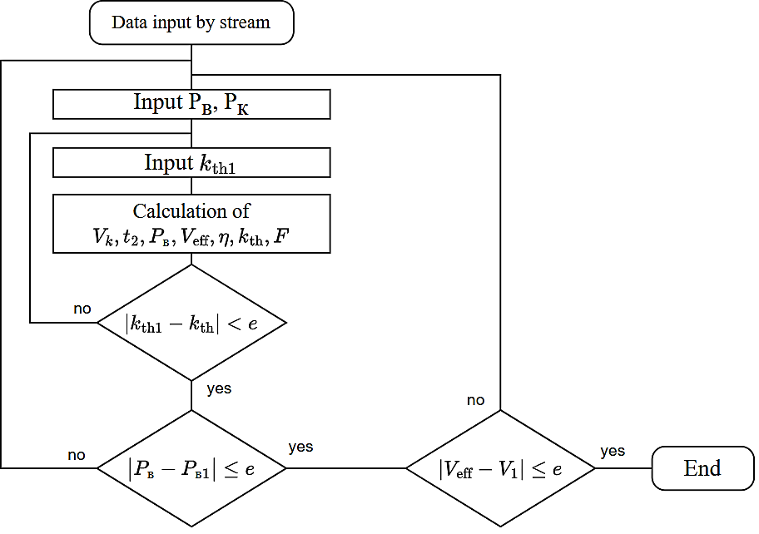
FIGURE 21. Block diagram of the calculation of a Roots-type pump

5. Then the following condition was checked: the ratio of the volumetric flow rate at the pump inlet to the volumetric flow rate at the outlet should not differ by more than 10% from the calculated one. If the condition is not met, a new k_{th} value is entered and steps 3 and 4 are repeated.
6. If the condition specified in step 5 is met, the inlet pressure and the volumetric efficiency of the pump are calculated.
7. If the pressure received at the inlet does not match the calculated pressure, a new pressure value is accepted and steps 1-6 are repeated.
For the group of vacuum columns for the separation of ethanolamine mixtures, the composition of the VGS based on the Roots and LRVP pumps was determined, and the economic efficiency amounted to 458527300 soums with a payback period of 3.88 years. As a result of replacing the steam-ejector vacuum pump (SEVP) for the vacuum column of the small oil refinery plant(ORP) with LRVP, operating costs decreased by 78%, while the system retained its ability to operate in all operating modes. The use of a single vacuum-generating system based on LRVP with a pre-connected ejector in one of the columns of the unit for the processing of phenol and acetone production waste by the cumulon method made it possible to reduce the pressure in the columns by 1,5 times. As a result of determining the optimal distribution of pressures in stages when calculating the SEVP for the drying column of the hydrocracking unit, more accurately calculating the pressure drop in vacuum condensers, and developing a circulating water transfer scheme, it was possible to reduce the steam consumption by 494 kilograms per hour while maintaining the required performance of the VGS. The methodology used in developing the SEVP project for the fuel oil rectification column made it possible to determine the optimal geometry of the steam ejectors, the circulating water transfer scheme, and reduce operating costs by 20% compared to the existing option.
Notation: y - fraction in the vapor phase; x - fraction in the liquid phase; ${\overline{y}}_{c}$- vector of output variables; $\overline{F}$- vector of input variable flows; P - pressure, kPa (mbar); t - temperature, ⁰ C; e - driving fraction; e₁ , e₂ , e₃ - error; VP - vacuum pump; FVP - forevacuum pump; V - volumetric flow, m³ /h; VVO - pipe; L - liquid flow, kg/h; G - gas flow, kg/h; SE (EC) - single evaporation (condensation); PCCTS - complex chemical technological system operating under vacuum; VGS - vacuum generating system; с_{p} - specific heat capacity, kJ/ (kg ºC); r - heat of vapor formation, kJ/kg; G_{rez} - circulating gas flow, kg-mol/h; η - efficiency coefficient (EC); LRVP - liquid-ring vacuum pump; SEVP - vapor-ejector vacuum pump; VLE - vapor-liquid equilibrium.
Indexes: o - initial; k - final; eff - effective; sl - working fluid; L - liquid, v - vapor; u - circulation.
CONCLUSION
Interrelated modeling of vacuum technological units and vacuum generation systems has been developed. In this methodology, the vacuum unit and the vacuum generation system are considered as a single complex chemical-technological system. The calculation of the vacuum generation system is carried out taking into account the changes in the properties of the vacuumed object under various parameters of the technological mode of the device under study. Conclusion. The general strategy of a systematic approach to the analysis of existing industrial installations operating under vacuum is clarified and presented in the form of a methodology for modeling technological objects and vacuum generation systems. A calculation model of the LRVP, which takes into account the heat and mass exchange processes occurring in the pump in the Unisim Design R451 environment, was synthesized. Passport specifications (dependence of productivity and power consumption on pressure) provided by manufacturing plants are used to adjust the model. The adequacy of the model was checked by comparing the calculation results with the standard method of recalculating the characteristics and the results of experimental research. This model can be used in any type of universal modeling software. Mathematical models of the main types of vacuum generating systems used in industrial installations of chemical, petrochemical and oil refining complexes have been developed and integrated into the Unisim Design R451 universal modeling complex (vacuum condenser, steam/gas ejector, LRVP, Roots-type vacuum pump).
Due to the uncertainties that arise when choosing different solutions at the design stage. At the same time, this allows optimizing existing vacuum generating systems, and this opportunity is achieved by using a systematic approach strategy.
REFERENCES
- Perry, R. H., & Green, D. W. (2019). Perry’s chemical engineers’ handbook (9th ed.). McGraw-Hill Education.
- Mass-Transfer Operatiopns 3 Edition : Robert E. Treybal : Free download, borrow, and streaming : Internet Archive. (1981). Internet Archive. https://archive.org/details/cftri.19584masstransferoper0000robe_s5e2
- McCabe, W. L., Smith, J. C., & Harriott, P. (2005). Unit operations of chemical engineering (7th ed.). McGraw-Hill.
- Khafaji, H., Shahsavand, A., & Shooshtari, S. H. R. (2024). Simultaneous optimization of crude oil refinery vacuum distillation column and corresponding ejector system. Energy, 294, 130702. https://doi.org/10.1016/j.energy.2024.130702
- Zatonskiy, A. V., Tugashova, L. G., Alaeva, N. N., & Gorshkova, K. L. (2017). Controlling the oil rectification process in a primary oil refining unit using a dynamic model. Petroleum Chemistry, 57(12), 1121–1131. https://doi.org/10.1134/s0965544117100206
- Safarova, A. (2025). Development of algorithms for adaptation of mathematical models of the atmospheric block of the technological complex of primary oil refining. Herald of the Azerbaijan Engineering Academy, 17(2), 66–72. https://doi.org/10.52171/herald269
- Gu, W., Huang, Y., Wang, K., Zhang, B., Chen, Q., & Hui, C. (2014). Comparative analysis and evaluation of three crude oil vacuum distillation processes for process selection. Energy, 76, 559–571. https://doi.org/10.1016/j.energy.2014.08.053

