Implementation of Rapid Scientifically-Based Methods for Reducing Harmonic Distortions and Predictive Assessment in 6–10 kV Industrial Power Supply Systems
Akram Tovbaev^{a)}, Islom Togaev, Sardor Norbayev
Navoi State University of Mining and Technologies, Navoi, Uzbekistan

^{a)}Corresponding author: tovboyev70@mail.ru
Abstract. Nonlinear loads are a necessarily component of present day mechanical control supply frameworks and speak to the most sources of higher sounds, which lead to non-compliance with control quality necessities and infringement of worldwide and national measures. This marvel is watched in nearly all mechanical segments, counting mining, oil, and gas businesses where controlled frameworks are in operation. Tall current and voltage sounds lead to a number of negative results for the components of control supply frameworks, counting extra misfortunes in overhead and cable lines, decreased benefit life of control transformers and electrical hardware, breaking down of transfer assurance, and extra motions in electromechanical frameworks.
Keywords: Power quality, power supply, higher harmonics, switching overvoltage, assessment and prediction, rapid methods.

INTRODUCTION

A number of specialized implies are effectively connected to progress control quality, counting dynamic, inactive, and crossover channels, anti-resonance reactors, as well as electronic gadgets outlined to alter the setup of control supply frameworks and the control components of nonlinear loads. In any case, the hypothesis and hone of utilizing these gadgets and arrangements don't fully take into consideration the event of reverberation wonders caused by reactive control emolument capacitors and supply transformers within the nearness of nonlinear loads. Commonplace control supply frameworks of mechanical undertakings, in specific beneficiation plants, incorporate capacitor banks associated to 6(10) kV transport bars and different sorts of filter-compensation gadgets, dynamic channels, and other gear introduced on the side of wide-scale conveyance units coordinated towards 0.4 kV, where nonlinear loads of frequency-controlled electric drives are show [1, 2]. When reverberation marvels emerge, capacitor establishments can be subjected to unsatisfactory over-burdens, and dynamic channels may glitch, as has been appeared and substantiated in a number of household and remote logical thinks about [3, 4]. These gadgets work at the same time, performing their capacities and commonly affecting each other. Their behavior must be considered when improving control quality in mechanical control supply frameworks, as well as within the choice of the structure and key parameters of capacitor establishments for receptive control emolument.

LITERATURE SURVEY
Investigation of the most sources of higher sounds beneath mechanical control supply framework conditions, their effect on control quality levels, and misfortunes in electrical hardware and arrange components, as well as guaranteeing control quality compliance with the benchmarks indicated in neighborhood and worldwide administrative reports. Modeling and investigation of non-sinusoidal working modes in mechanical control supply frameworks with different setups of capacitor establishments beneath nonlinear loads, counting the event of reverberation wonders, voltage waveform twists, amplitudes of higher current sounds, as well as modeling capacitor over-burdens to evaluate their effect on control quality pointers in terms of voltage twisting and current levels. Investigation of the parameters, characteristics, control strategies, application regions, focal points, and drawbacks of different sorts and arrangements of filter-compensation gadgets, as well as specialized gadgets based on dynamic components. Advancement of a recreation show of working modes to consider straight and nonlinear loads beneath reverberation conditions, move forward power quality, and select the foremost levelheaded specialized arrangement, as well as to assess the execution of capacitor establishments in mechanical control supply frameworks and the application of distinctive sorts of filter-compensation gadgets [5-8]. The actual voltage value is expressed through its instantaneous values and is determined by the expression U (t) according to equation 1:
${ U}_{d}^{2}=\frac{1}{T}\int_{0}^{T}{u^{2}\left(t\right)dt}$ (1)
$T=2π$-voltage signal period
If U (t) is substituted into expression for the voltage, then, omitting the intermediate transformations, we obtain to equation 2:
$U_{d}=\sqrt{U_{1}^{2}}+U_{2}^{2}+…+U_{n}^{2}$=$\sqrt{U_{1}^{2}}+\sum_{k=1}^{n}{U_{k}^{2}}$ (2)
U₁–the instantaneous values of the first (fundamental) component:
U₂…U_{n,} – the higher harmonics of the voltage to equation 3.
i(t)=$I_{1max}\sin\left(ωt+φ_{1}\right)+I_{2max}\sin\left(2ωt+φ_{2}\right)+……+I_{n max}sin⁡(nωt+φ_{n})$ (3)
and the true value of the non-sinusoidal current to equation 4.
$I_{d}=\sqrt{I_{1}^{2}}+I_{2}^{2}+…+I_{n}^{2}$=$\sqrt{I_{1}^{2}}+\sum_{k=1}^{n}{I_{k}^{2}}$ (4)
The active power of a non-sinusoidal current is equal to the average value of the instantaneous power over the period T of the first harmonic to equation 5.
$P=\frac{1}{T}\int_{0}^{T}{u\left(t\right)i\left(t\right)dt}$ (5)
Time-domain diagrams of the current and voltage phases in Figure 1.

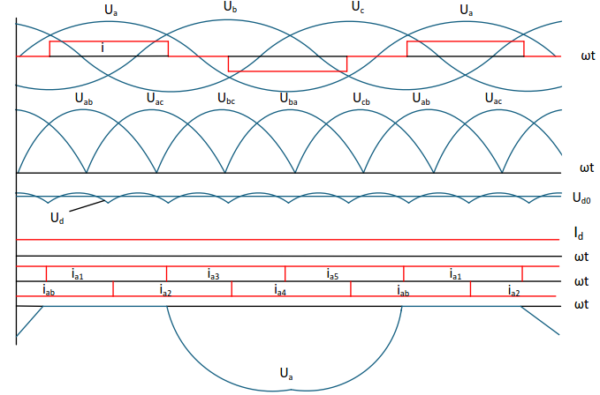
FIGURE 1. The rectifier phase current contains higher harmonics

The conduction interval of one half-wave is equal to 120°. The subsequent current is determined by the following to equation 6.
$i=\frac{2\sqrt{3i_{d}}}{π}(cosωt-\frac{1}{5}cos5ωt+\frac{1}{7}cos7ωt-\frac{1}{11}cos11ωt+…)$ (6)
In actual rectifiers, the natural commutation of the current occurs within the time interval of the commutation angle γ, as a result of which the phase current waveform differs from the ideal rectangular shape, as shown in Figure 2. In this case, canonical harmonics also dominate in the actual phase current curve.
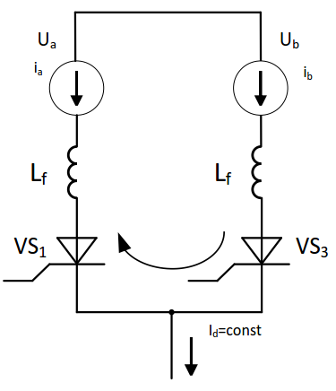
FIGURE 2. Short-circuited commutation circuit

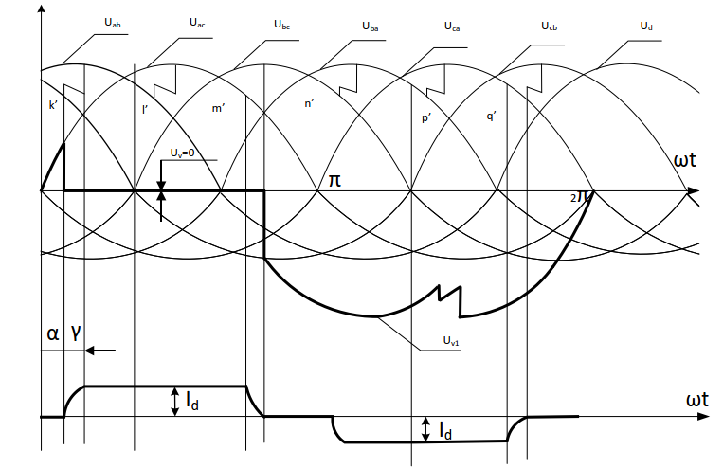
FIGURE 3. In the explanatory process, the voltage versus time dependence diagram.

The harmonic composition of the current consumed from the network by the rectifier in to equation 7.
$i_{1(n)}=\frac{6\sqrt{3}}{π^{2}k_{tr}}∙(sinωt-\frac{1}{5^{2}}sin5ωt+\frac{1}{7^{2}}sin7ωt-\frac{1}{{11}^{2}}sin11ωt+….)$ (7)
The logical and specialized issue of guaranteeing the quality of electrical vitality and the electromagnetic compatibility of electrical gear, as well as the significance of receptive control remuneration and the alteration of nonlinear loads with capacitor gadgets in mechanical control supply frameworks, is substantiated. Various nearby and remote logical works in this field have been analyzed, and based on their comes about, the level of advancement of the chosen investigate course has been decided. The most sources of current waveform twisting in mechanical control supply frameworks are considered, and an investigation of the consonant spectra created by voltages, counting movable electric drive frameworks, uninterruptible control supplies, and electrical innovation gadgets, has been carried out.
Table 1 provides the values of the coefficients of the odd harmonic components of the voltage.

TABLE 1. Coefficients of the harmonic components of the voltage
n-th order harmonic components | THD_{U} (n),% $U_{1}$ The value of the harmonic voltage component coefficient
n-th order harmonic components | Voltage in electrical networks, kV
n-th order harmonic components | 0.38 | 6-25 | 35 | 110-220
5 | 6 | 4 | 3 | 1.5
7 | 5 | 3 | 2.5 | 1
11 | 3.5 | 2 | 2 | 1
13 | 3 | 2 | 1.5 | 0.7
17 | 2 | 1.5 | 1 | 0.5
19 | 1.5 | 1 | 1 | 0.4
23 | 1.5 | 1 | 1 | 0.4
25 | 1.5 | 1 | 1 | 0.4
$$>25$$ | 1.5 | 1 | 1 | 0.4

Table 2 provides the coefficient values of odd harmonic components are given multiplied by three times the voltage.

TABLE 2. The values of the coefficients of odd harmonic components multiplied by three times the voltage
n-th order of harmonic components | THD_{U} (n),% $U_{1}$ Value of the coefficient of harmonic voltage components
n-th order of harmonic components | Voltage in electrical networks, kV
n-th order of harmonic components | 0.38 | 6-25 | 35 | 110-220
3 | 5 | 3 | 3 | 1.5
9 | 1.5 | 1 | 1 | 0.4
15 | 0.3 | 0.3 | 0.3 | 0.2
21 | 0.2 | 0.2 | 0.2 | 0.2
$$>21$$ | 0.2 | 0.2 | 0.2 | 0.2

Table 3 provides the values of the even harmonic voltage coefficients are presented.

TABLE 3. The presented values correspond to the coefficients of even harmonic voltage components
n-th order harmonic components | THD_{U} (n),% $U_{1}$ Value of the harmonic voltage component coefficient
n-th order harmonic components | Voltage in electrical networks, kV
n-th order harmonic components | 0.38 | 6-25 | 35 | 110-220
2 | 2 | 1.5 | 1 | 0.5
4 | 1 | 0.7 | 0.5 | 0.3
6 | 0.5 | 0.3 | 0.3 | 0.2
8 | 0.5 | 0.3 | 0.3 | 0.2
10 | 0.5 | 0.3 | 0.3 | 0.2
12 | 0.2 | 0.2 | 0.2 | 0.2
$$>12$$ | 0.2 | 0.2 | 0.2 | 0.2

Such a decrease in higher harmonic values can be described by a general linear expression in Figure 4.

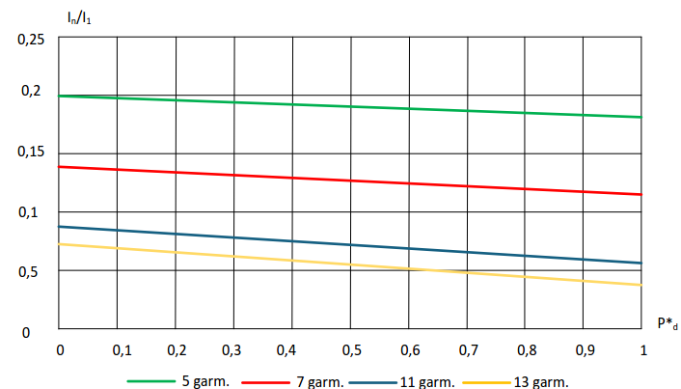
FIGURE 4. Variation of harmonic amplitudes depending on the transformer loading.

RESULTS AND DISCUSSION
The working modes of standard electrical supply plans in different mechanical control supply frameworks were modeled through arrangements, voltages, and powers, counting the control of variable straight and nonlinear loads and their alteration utilizing capacitor gadgets. For all considered plans, the relative values of the appraised powers of the capacitor gadgets were decided. Reverberation conditions emerge at characteristic consonant frequencies due to the operation of nonlinear loads, which can lead to unsatisfactory over-burdens of the capacitors (over-burden coefficient surpassing). Off base stacking units influence the quality level of voltage as well as the variety of consonant amplitudes within the nonlinear stack current. In scientific and recreation models of control supply frameworks, the nonlinear stack ought to be spoken to not as an unbounded control source, but as a constrained control source, as emphasized in various neighborhoods and outside logical considers. Besides, the capacity of such sources ought to be chosen based on the nonlinear stack and the providing control transformer. By recreating conditions and limitations in physical, numerical, and computer recreation models, the hypothetical premise for modeling and analyzing non-sinusoidal working modes with reverberation marvels in mechanical control supply frameworks can be set up. Detached and dynamic filter-compensation gadgets give remuneration for higher harmonics and responsive control within the arrange. In Figure 5 presents the classification of filter-compensation gadgets. It has been decided that, when resonance-suppression reactors are associated to capacitor gadgets, they moderate the enhancement of voltage consonant amplitudes; be that as it may, they are incapable to guarantee normalized control quality markers. When current and voltage mutilations are related with the upper parcel of the nonlinear stack relative to the evaluated control, not one or the other neither the providing transformer nor the thunderous organize mode is show.

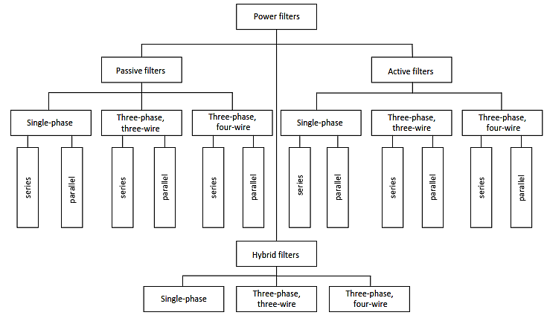
FIGURE 5. Classification of filter-compensation devices.

When passive filters are switched on, the operating modes of the network can be represented by the power supply system expressed as a G-shaped quadruple, as shown in Figure 6.

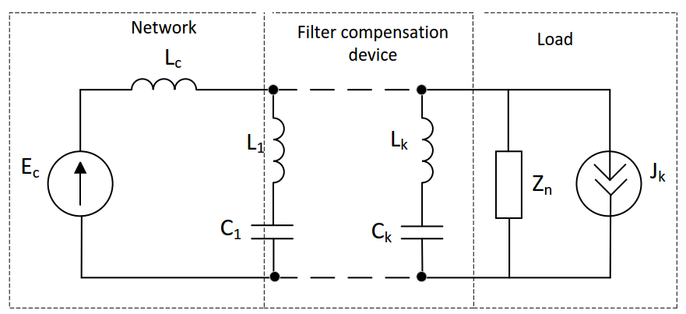
FIGURE 6. Equivalent circuit of a G-shaped network with passive filters connected.

The most common configurations of hybrid filters are presented in Figure 7. Passive filters are installed at harmonic frequencies with the highest amplitude values.

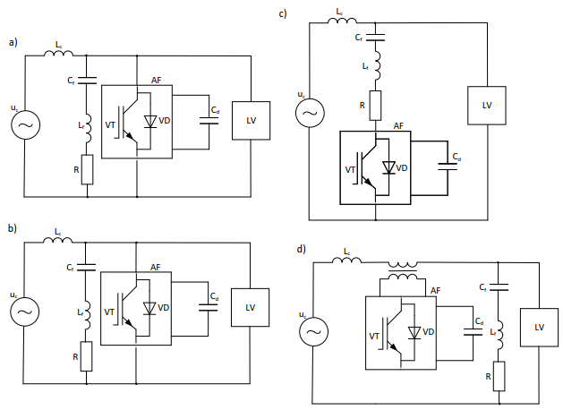
FIGURE 7. Schemes of hybrid filters: a) Parallel connection of an active filter and a passive filter-compensation device; b) Parallel connection of the passive filter-compensation device’s active-inductive part with the active filter; c) Series connection of a passive filter-compensation device with a parallel active filter; d) Parallel connection of the passive filter-compensation device and series connection of the active filter device.

APPLICATIONS
The most specialized implies and arrangements for compensating higher current and voltage sounds were analyzed; schematic arrangements for the sound development of dispersion systems with nonlinear loads were examined, and resonance-suppression reactors were connected in circuits of capacitor gadgets, as well as inactive, dynamic, and cross breed filter-compensation gadgets. The classification of filter-compensation gadgets was inspected, and their structures, control strategies, and modes of association to the compensated network were analyzed. The most strategies of controlling dynamic filter-compensation gadgets were considered, counting Parka Clarke changes and Acacia™s momentary control hypothesis, with their characteristics, points of interest, and impediments displayed. Specialized frameworks for progressing control quality based on dynamic converters were analyzed, counting inactive receptive control recompense (STATCOM) and energetic voltage twisting recompense (DVR/DKIN) gadgets, with their characteristics, focal points, and impediments demonstrated. Suggestions were given on the utilize of different strategies and apparatuses for making strides power quality in mechanical control supply frameworks, taking into consideration the nonlinear stack control relative to the transformer capacity. A generalized calculation for analyzing and modeling non-sinusoidal modes was created to back the levelheaded determination of specialized implies, or arrangements were proposed for making strides control quality in mechanical control supply frameworks with nonlinear loads and capacitor gadgets.
Table 4 provides the distortion factors of current and voltage on load buses with voltages of 0.4 kV and 10 kV

TABLE 4. It ensures the maximum distortion of current and voltage.
The considered operating modes in an electric power supply system refer to various conditions of load and network element operation | THD_{U}  (0,4 кV) % |  | THD_{U}  (0,4 кV) % |  | THD_{U}  (10 кV) % |  | THD_{U}  (10 кV) %
Nonsinusoidal mode (when capacitors are switched off) |  | 10.9 |  | 23.6 |  | 3.1 |  | 6.2
Nonsinusoidal mode, when capacitors are switched on (in case of resonance at the 7th harmonic) |  | 16.3 |  | 21.4 |  | 11.8 |  | 27.7

Table 5 provides during the operation of the passive filter block at network resonance in the harmonics, the current and voltage distortion factors are presented.

TABLE 5. Current and voltage distortions.
n | Q_{ku}, kvar | THD_{U} (0.4 kV) % | THD₁ (0.4 kV) % | THD_{U} (10 kV) % | THD₁ (10 kV) %
17 | 450 | 4.6 | 19.1 | 21.4 | 19
19 | 350 | 5.3 | 14.8 | 19.9 | 15.7
23 | 250 | 6.2 | 13.4 | 22.5 | 14.6
25 | 200 | 5.8 | 11.7 | 20.9 | 12.5

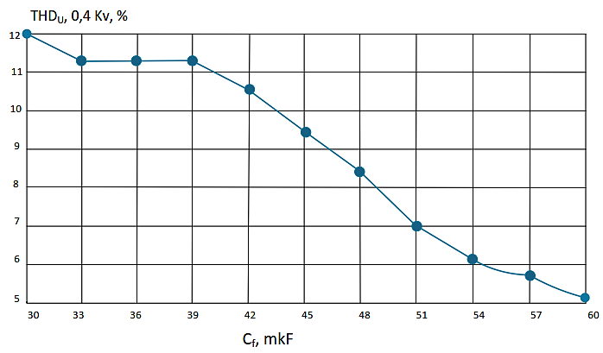
a)
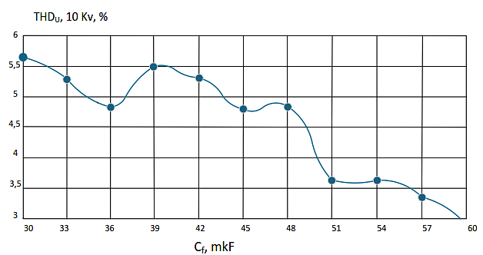
b)
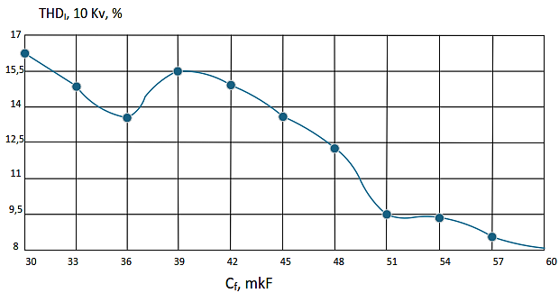
c)
FIGURE 8. Dependence of the coefficients: a) THDU at 0.4 kV; b) THDU at 10 kV; c) THDI at 10 kV when the filter capacitance C_{f} is used with R_{f}=1.5 Ω

CONCLUSION
Based on the comes about of the conducted inquire about, the taking after conclusions were drawn. The operation modes of standard plans of mechanical control supply frameworks were recreated on the illustration of different arrangements of beneficiation plants. For responsive control recompense, the alteration of straightly and non-linearly shifting loads all through the day was considered, which depends on voltage and control and incorporates capacitor banks. For all considered plans, the relative values of the flexible capacities of the capacitor units were decided. In this case, resounding modes emerge at characteristic higher consonant frequencies due to the operation of nonlinear loads. This leads to unsatisfactory over-burdens of the capacitor units and weakening within the quality of the voltage per unit of stack, as well as to changes within the amplitudes of higher sounds of nonlinear stack streams (with an over-burden figure surpassing). It was appeared that in numerical and recreation modeling of control supply frameworks, the existing nonlinear stack ought to be spoken to as sources of restricted capacity, since, as emphasized in many domestic and remote logical works, boundless capacity isn't reasonable. Additionally, the control of such sources ought to be chosen depending on the nonlinear stack and supply capacity by choosing suitable control transformers. The thunderous wonders gotten as a result of modeling the conditions and limitations of physical, numerical, and computer recreations can be considered as a hypothetical premise for the modeling and examination of non-sinusoidal modes in mechanical control supply frameworks. The distinguished values related to the relative capacities of the capacitor establishment, beneath thunderous conditions, are related with varieties within the amplitudes of canonical higher current sounds and disintegration of voltage quality. This limits the modeling of consonant sources of nonlinear stack streams beneath restricted capacity, and is associated with the require for sensible choice of change conspire parameters. In this setting, the modeling and examination of complex non-sinusoidal modes in normal mechanical control supply plans serve as a hypothetical premise for levelheaded determination of specialized implies or arrangements to make strides control quality.

REFERENCES
- Soedel, W. (1993). Vibrations of shells and plates (2nd ed.). Marcel Dekker.
- Morgantini, M., & Betti, R. (2020). The inner product vector as an output-only cross-correlation-based feature to structural damage assessment. Journal of Vibroengineering, 22(6), 1373–1398. https://doi.org/10.21595/jve.2020.21373
- Zhou, Z., Fu, H. L., & Li, L. (2002). Theoretical solution of bearing capacity of shallow circular foundation (in Chinese). Journal of Changsha Railway University, 20(3), 12–16.
- De Luca, A., Oriolo, G., & Robuffo Giordano, P. (2010). Kinematic control of nonholonomic mobile manipulators in the presence of steering wheels. In Proceedings of the 2010 IEEE International Conference on Robotics and Automation (pp. 1792–1798). IEEE. https://doi.org/10.1109/ROBOT.2010.5509570
- Tovbaev, A., Ibadullayev, M., & Davronova, M. (2024). Study of subharmonic oscillation processes in ferroresonance circuits. E3S Web of Conferences, 525, 03008. https://doi.org/10.1051/e3sconf/202452503008
- Tovboyev, A. N., Togayev, I. B., Uzoqov, I. Q., & Nodirov, G. Y. (2023). Use of reactive power sources in improving the quality of electricity. E3S Web of Conferences, 414, 03001. https://doi.org/10.1051/e3sconf/202341403001
- Eckoldt, H., Ponci, F., & Monti, A. (2025). Assessment of power quality in an industrial facility: a case study at DESY Hamburg. IEEE Open Journal of Instrumentation and Measurement, 4, 1–11. https://doi.org/10.1109/ojim.2025.3629874
- Vlahinić, S., Brnobić, D., & Vučetić, D. (2009). Measurement and analysis of harmonic distortion in power distribution systems. Electric Power Systems Research, 79(7), 1121–1126. https://doi.org/10.1016/j.epsr.2009.02.004

