Computer Aided Design (CAD)/ Computer Aided Manufacturing (CAM) Application for Manufacturing Processes Improvement
Ikrom Kambarov^{1, 2, a)}, Khusanboy Makhammadjanov¹,
Zukhriddin Juraboyev³
¹Central Asian University (CAU), Tashkent, Uzbekistan
²Tashkent Turin Polytechnic University (TTPU), Tashkent, Uzbekistan
³Central Asian Univeristy (CAU), Tashkent, Uzbekistan

^{a)}Corresponding author: i.kambarov@centralasian.uz
Abstract. Computer-aided design and computer-aided manufacture (CAD/CAM) has lately gained popularity in the production of universal machines due to the rapid growth of digitalization technology. The technical use of the CAD/CAM tool in the manufacturing sector has caused companies to gradually change their traditional approaches to product design and manufacturing. With the CAD module, product makers can gather information about a product and use feature-based design to make models of that product. The product model is shown on a screen in the CAD setting and then sent to the CAM module at the next step. This paper talks about how to use CAD/CAM for solid models, designing fixtures and machining processes, and making virtual parts. The part was designed and manufactured using Siemens NX, which created a three-dimensional (3D) model of the component from a two-dimensional (2D) blank drawing. The technical timetable for the gear was determined based on the completed gear drawing, which included selecting and calculating machining parameters, selecting machine tools and cutting tools, and determining machining procedures. The gear was then virtually produced using NX CAM software, following which a unique fixture was designed to retain it in the machine. In conclusion, the CAD/CAM tool is critical to manufacturing technology because it automates the manufacturing process, reducing costs, time, and energy while boosting production flexibility.
Keywords: CAD/CAM. Machining, CNC, manufacturing.

INTRODUCTION
The product development lifecycle is divided into three major stages based on functionality, modeling, planning and manufacturing. For each of these three stages, the automation systems are represented by Computer Aided Design (CAD), Computer Aided Process Planning (CAPP), and Computer Aided Manufacturing (CAM). As shown in Figure 1, the system that transforms the design concept into a geometric draft form is called CAD. CAPP interpolates the design information as the steps of manufacturing operations by transferring the designed geometry into the operational phases with general level machine instructions. As a final phase, the CAM system uses programmable automation to target particular operation processes and manage the flow of materials and machine tools. Using precise machining instructions, the so-called Computerized Numerically Controlled (CNC) program performs each of these tasks [1-4].
The integration of CAD and CAM is increasingly vital in modern production systems. This technology has rapidly improved and expanded throughout the manufacturing sector. Sasany et al [5] made a component utilizing a CAD/CAM tool. The component was predominantly fabricated with Unigraphics following the creation of a 3D model in Pro/E. They concluded that these methods are effective for producing components in a virtual environment with real materials. Liao et al [6] used a CAD/CAE tool to increase the efficiency of riser design approach. After modeling the heat conducting process, the CAD/CAE tool was able to separate the steel's liquid phases without the need for risers. Unigraphics was used to depict the different liquid phases and automatically generate the risers. A easy casting test was used to evaluate the CAD/CAE system. According to the findings, the riser design was adequate, and the CAD/CAE system reduced the time required for riser design throughout the casting process, ensuring casting quality while cutting costs [7-8].

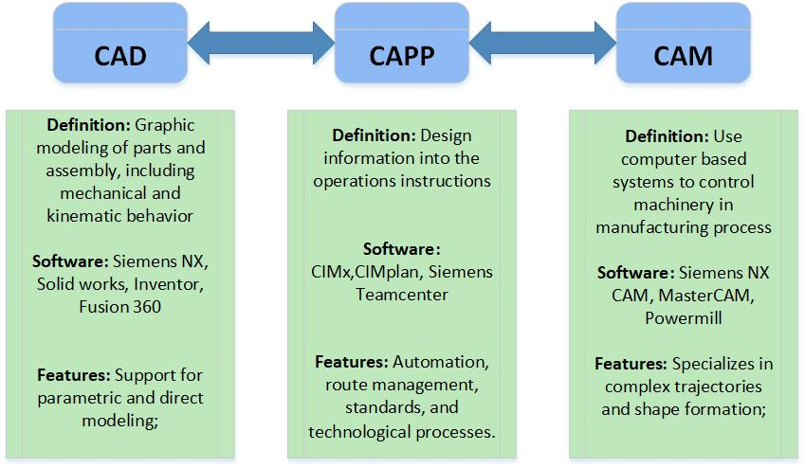
FIGURE 1. Three phases of Computer Integrated Manufacturing.

The purpose of this study is to look at how CAD/CAM technology is employed in the manufacturing business and how these digital tools will affect production time, reduce manufacturing costs, and change the operational flexibility of the gear manufacturing industry.
To achieve this purpose, the papers are ordered in the following order: Section 2 discusses the process of selecting materials, constructing fixtures for 4 axis machinery operation, calculating cutting parameters, and utilizing CAD/CAM technology in gear manufacturing. Section 3 follows with a case study demonstrating the application of this methodology in actual manufacturing. Finally, Sections 4 and 5 address the paper's findings and conclusions.

METHODS
Figure 2 depicts the five steps that comprise the approach. Each phase is described in detail in the subchapters that follow.

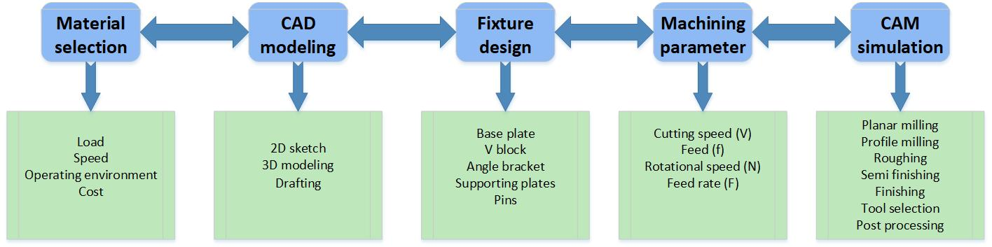
FIGURE 2. Methodology of CAD CAM application

A lot of criteria determine the material choice of a gear, including load, speed, operating circumstances, and cost. The most common substances include cast iron, brass, bronze, polymers, and steel alloys (carbon, alloy, and stainless). Steel is the most commonly employed material due to its strength, durability, and heat-treating capabilities. Brass and bronze are used when little friction is required, although cast iron is better suited for lower-speed applications. Plastics are often used due to their light weight and ability to minimize noise.
CAD modeling can be used to generate real or virtual objects, or a combination of both, in a larger context. Computer simulation, on the other hand, is the act of utilizing computer software to create and code an operational, quantitative model that represents a real-world system or process. The parameters used in this model can be adjusted, and the results are immediately accessible. The integrated system's consequences are investigated utilizing the simulation model. Following the creation of a model, the impact of modifying variables over time is analyzed. To obtain reliable results, it is critical to ensure that a model is accurate when compared to the real world. When CAD modeling tools are used to model production systems, they give flexibility, simplify production processes, allow for the development of prototypes, reduce time to market, improve communication, and make structured data monitoring easier. Simulation tools are increasingly being used to dynamically mix heterogeneous system components in digital spaces at many stages of the product lifecycle, in addition to their traditional role in assembly design. This allows you to swiftly assess the implications of both internal and external manufacturing variables.
A fixture is a specialized instrument that holds, locates, clamps, and supports a workpiece during assembly, machining, or inspection. The fixture reduces non-uniform quality in the manufacturing process and the need for individual labeling, placement, and frequent monitoring. This reduces operating time and increases productivity. Fixtures are widely used in the industrial industry because to their advantages and features.
In terms of the amount of fixtures that must be created, the arrival of CNC machining technology and the ability of multi-axis machines to do many operations while reducing the number of setups have simplified the fixture design process.
The machining process includes roughing, finishing, and profile milling. The formula below can be used to determine the spindle speed for milling (1):
$N=100*V/D*3.14$ (1)
where D is the cutter diameter, V is the cutting speed in m/min, and N is the spindle speed in rpm. V was chosen from the reference table. This decision is based on the material's properties and the cutting tool of choice (uncoated carbide).
The basic time of milling process (2) can be calculated as:
$T=L/F$ (2
where T = basic time in minute, L = length in mm, and F = feed rate in mm/rev and it is expressed as shown in (3)
$F=f*n$ (3)
where n is the cutter's tooth count and f is feed/tooth. F was chosen from the table of references. The material's properties and the chosen cutting tool (uncoated carbide) served as the basis for this choice.
Using computer-aided manufacturing (CAM) simulation, a part's machining process can be realistically represented and examined, allowing the discovery of potential problems before the commencement of actual manufacturing [5]. To provide a visual representation of the machining process, simulate toolpaths, material removal, and potential collisions. This reduces the likelihood of production errors, improves efficiency, and optimizes the process.

RESULTS AND DISCUSSION
The material used is stainless steel grade 174, the most commonly used precipitation-hardening steel. hardening grade. It is extremely strong, durable, and resistant to corrosion. Table 1 shows the chemical composition of the drug.

TABLE 1. The chemical composition of stainless steel.
Element | Composition (%)
Fe | 73
Cr | 15-17
Ni | 3-5
Cu | 3-5
Mn | 1
Si | 1
Ta | 0.45
Nb | 0.45
Nb+Ta | 0.15-0.45
C | 0.070
P | 0.040
S | 0.030

The gear was regularly modeled with Siemens NX 2024 features. The crucial geometrical structure of the part was designed using Siemens NX software. The part's design variables include a depth of 19 mm and circle radii of 50, 40, and 20 mm. Figure 3 displays the gear's top and isometric 3D models.

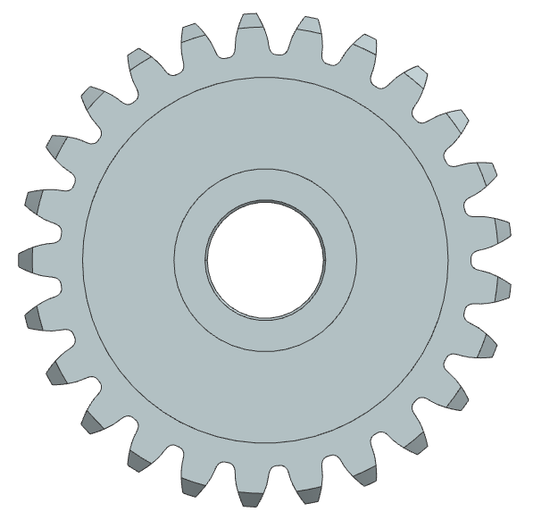 | 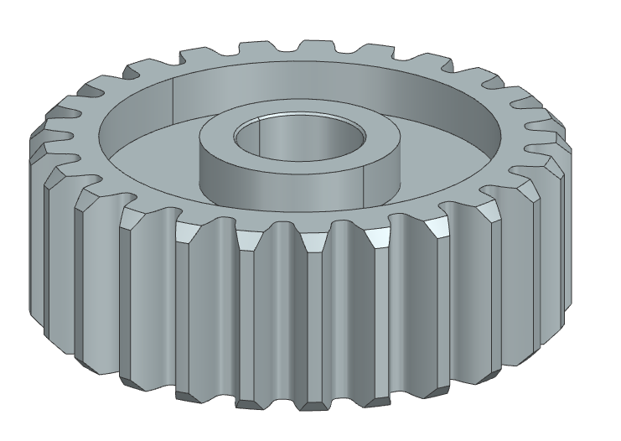
FIGURE 3. 3D top and isometric view of the gear

A 600 mm by 400 mm base block and pillow beneath the base plate were created to design the fixture for milling, profiling, and reaming the hole while maintaining the spatial link between the fixture's components, as shown in Figure 4.

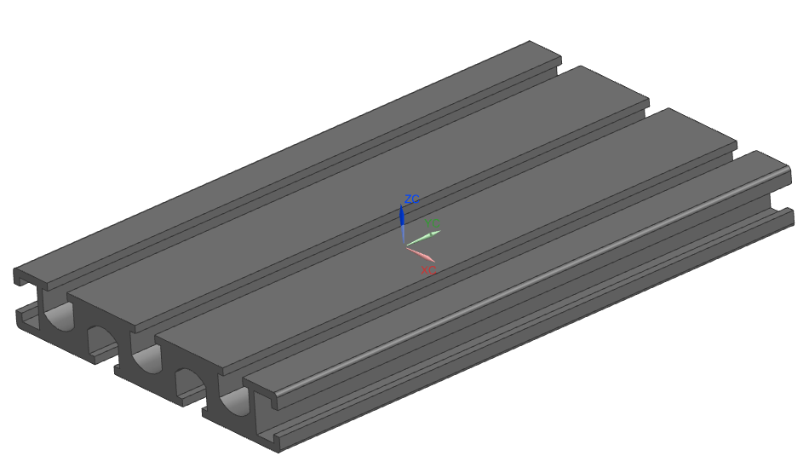 | 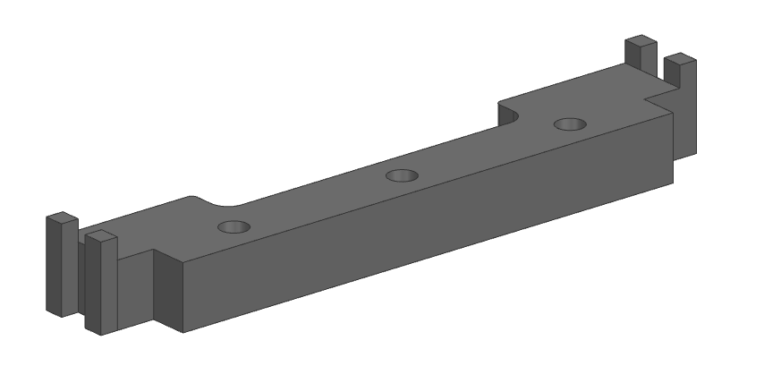
FIGURE 4. The base plate and pillow to fixture components

The base plate and pillows were then built with four blocks measuring 100 mm long, 70 mm high, and 85 mm broad, as shown in Figure 5.

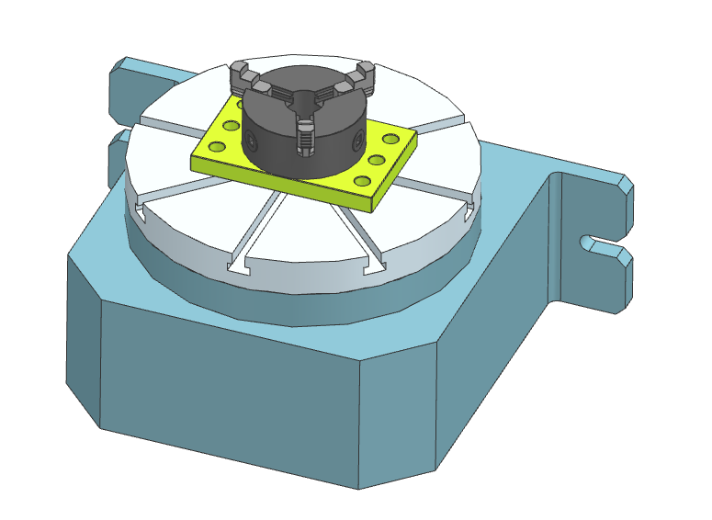
FIGURE 5. The fixture of 4 axis milling machine

The gear is machined with hole, profile, and milling operations. The machining process sequence is shown in Table 2. The machining time is calculated using Equation (2).

TABLE 2. Process sequence for gear machining
Order | Description | Tool diamater | Machning time (min)
1 | Hole milling | D10 | 10.5
2 | Rough milling | D8 | 3.51
3 | Semi finish milling | D6 | 3.09
4 | Profile milling | D4 | 1.56

The spindle speed for the milling operation can be estimated using equation (1), and Table 3 shows the values for four tools. The cutting speeds V in this formula are 40 mm/min for roughing operations and 60 mm/min for finishing operations in stainless steel.

TABLE 3. Spindle speed and cutting speed parameters
Tool | Process | Cutting speed (mm/min) |  | Spindle speed (RPM)
D10 | Hole milling | 40 | 1273
D8 | Rough milling | 40 | 1592
D6 | Semi finish milling | 60 | 3184
D4 | Profile milling | 60 | 4777

The gear was machined using Siemens NX CAM 2024. To ensure that the gear was within the machining boundary, the machine boundary was defined and a circle was drawn. Next, the machining settings were entered, such as the retract angle, feed rate, and spindle speed. The tool path and final portion were then generated by the CAM software. Figure 6 depicts the resulting toolpath, whereas Figure 7 shows the completed operation after roughing. Following the entry of final parameters, the flange tube simulation was seen using Siemens NX CAM.

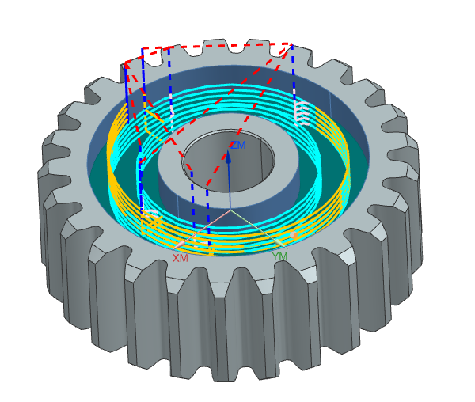
FIGURE 6. Toolpath in CAM

The toolpath displays the tool's trajectory while it is being machined. The red line represents the tool path during rapid movement using G00 codes. The tool retracts from the workpiece at the point marked by the blue dash line. The orange line indicates the tool's initial contact with the workpiece. Finally, the machining process is represented by the Tiffany color.

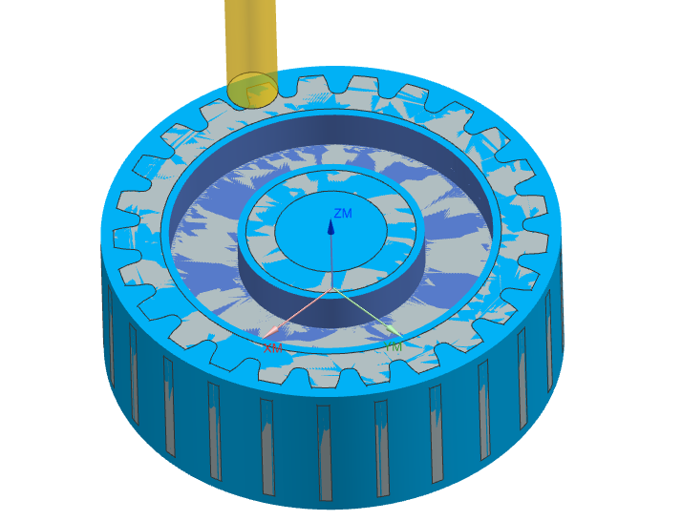
FIGURE 7. Machined part after roughing operation

Figure 7 shows the machine part after the roughing procedure. A 4 mm diameter profile milling tool is utilized to finish the remaining 1 mm thick material in the walls.
CAD/CAM is a useful tool in the industrial sector. Time, money, and energy can be saved by manufacturing components that would be difficult to make without changing the raw materials. The gear and associated production fixture were modeled using CAD. This enables us to change the features of the equipment by giving us a real-time preview of how it will seem. Thousands of gears can be manufactured utilizing the two specifically designed and made fittings. Every factor that affects the fixture's longevity has been considered. These components comprise the fixture's body, positioning, clamping, and support. The fittings were designed to withstand repeated use by the machinist. The machining operation times for various machining processes are shown in Table 2. It is obvious that in milling operations, the larger the workpiece diameter, the longer the operation time; in gear manufacturing, the contrary is true. The G and M code sections must be written in order to validate the simulation. Both the programming and the portion program need to be written. This would give the simulation model a realistic or real appearance.
Once the simulation stage is over and the designer is pleased with the machining settings, cutter size, and so on, the NC program may be generated easily in CAMworks. By selecting the post-process option, CAMworks will generate an NC program. Details are provided in Appendix B. The NC programs generated by CAMworks for machining the insert part are as follows:
Postprocessor: Fanuc 4-axis mill
Output file: gear_output.nc
Units: Metric (mm)
Key Codes: G17, G21, G90, G0/G1, M03/M05, G81 (for drilling)
G-code Snippet
G21 ; Metric units
G17 ; XY plane selection
G90 ; Absolute positioning
T1 M06 ; Select tool 1
M03 S1500 ; Spindle on CW
G00 X0 Y0 Z5
G81 X20 Y30 Z-10 R2 F75 ; Drilling cycle
G80
M05
M30.
According to the features of the components and the simulation results from CAM, the preparation to machine the component on the CNC machine tool is an important stage, which includes the preparation of the NC program, the cutting tools, clamping devices, the operation sheet etc. For an inexperienced person, to carry out this work without mistakes will be a difficult task. In order to help an inexperienced person such as students to go through this stage smoothly, the main steps are outlined below and a machining process using the NC program generated by CAMworks is shown in Figure 8.
The brief of a machining process:
• Download the NC program form a PC to the CNC milling machine.
• Setup the mate1ial and the cutting tools for machining.
• Set the machining datum.
• Off set the machining datum.
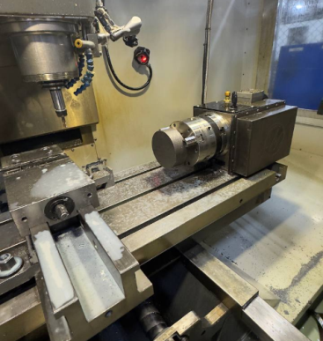 | 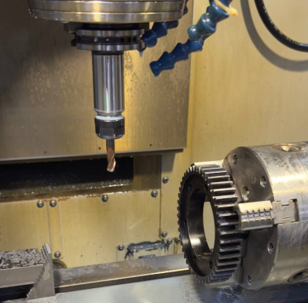
FIGURE 8. One of the machining processes using NC program

• Dry run the NC program
• Offset the machining datum back.
• Machine the material to produce the component

CONCLUSION
The following conclusions were reached after using the CAD/CAM tool in this article to create a gear's machining process and tooling devices: The gear's three-dimensional (3D) model was created with Siemens NX CAD, a CAD application. The fixture's gear was designed, created, supported, and located in the same program. The manufacturing environment for the gear was simulated using the Siemens NX CAM tool. G and M codes may be used in the simulation to check the part. It was demonstrated that manufacturing methods can be optimized using a CAD/CAM tool such as Siemens NX. As a result, they allow for flexible manufacturing in response to customer needs and desires, which improves product quality while lowering production costs.

REFERENCES
- Suh, S., Noh, S., & Choi, Y. (1995). A PC-based retrofitting toward CAD/CAM/CNC integration. Computers & Industrial Engineering, 28(1), 133–146. https://doi.org/10.1016/0360-8352(94)00033-j
- Moseng, B., & Nes, B. H. (1984). Integration of CAD/CAm as seen from the production planners point of view. Computers in Industry, 5(4), 341–350. https://doi.org/10.1016/0166-3615(84)90057-5
- Singh, I., Singh, K., & Sethi, N. (2022). CAD/CAM – Historical aspects, Processing and Various systems: a literature review. IAR Journal of Medical Sciences, 3(01), 1–6. https://doi.org/10.47310/iarjms.2022.v03i01.001
- Alam, J., Panda, S., & Dash, P. (2022). A comprehensive review on design and analysisof spur gears. International Journal on Interactive Design and Manufacturing (IJIDeM), 17(3), 993–1019. https://doi.org/10.1007/s12008-022-01148-w
- Sasany, R., & Yilmaz, B. (2022). Marginal discrepancy and fracture load of thermomechanically fatigued crowns fabricated with different CAD‐CAM techniques. Journal of Prosthodontics, 32(7), 602–607. https://doi.org/10.1111/jopr.13612
- Liao, D., Zhou, J., Chen, L., Shen, X., & Gong, X. (2011). Casting CAD/CAE automatic optimal riser design technology. International Journal of Cast Metals Research, 24(3–4), 247–252. https://doi.org/10.1179/136404611x13001922708830
- Shivegowda, M. D., Boonyasopon, P., Rangappa, S. M., & Siengchin, S. (2022). A review on Computer-Aided design and manufacturing Processes in Design and architecture. Archives of Computational Methods in Engineering, 29(6), 3973–3980. https://doi.org/10.1007/s11831-022-09723-w
- Fayzimatov, S., & Tojiyev, B. (2023b). Determination of device construction design and parameters for copper wire extending methods. E3S Web of Conferences, 460, 10009. https://doi.org/10.1051/e3sconf/202346010009

