Methods and Research on Screening of Construction Inert Materials Using Small-Sized Circular Vibration Screens
Muslima Ravshanovа, Nuriya Toirova, Murtoza Toirov^{a)}
Navoi State University of Mining and Technologies, Navoi, 210100 Uzbekistan

^{а)} Corresponding author:murtoza.toirov@mail.ru
Abstract. This article examines the assembly design of rotary vibrating screens, which operate using the principle of a screening surface vibrating vertically and oscillating on inert building materials. These screens provide the required separation efficiency and high productivity, making them indispensable in various industries, including mining, road construction, building materials, and many others. An experimental approach to improving the rotary vertical vibrating screen is discussed. The advantages of the proposed vibrating screen relative to various existing screen designs and their disadvantages are demonstrated, highlighting the need to find solutions that improve the quality of the product produced by rotary vertical vibrating screens. A description is provided of the composite design of the experimental rotary vertical vibrating screen we developed, along with its design features highlighting the advantages of separating material into fractions based on size.
Keywords: Circular oscillating vertical vibration, advantages of effective sifting of inert materials.
INTRODUCTION
Screening is widely used in the construction and road construction industries and involves the qualitative reduction of the linear dimensions of solid inorganic substances through mechanical vibration. The purpose of screening is to improve the quality of mortar for the construction and road construction industries. Therefore, screening is divided into the following subgroups:
a) improving the concrete mortar used by adding inert materials to strengthen the load-bearing structure of building materials, etc.;
b) accelerating the drying of building products after pouring. In this case, screened inert materials are considered the main auxiliary inorganic substances in mortar production technology;
c) improving mixing with cement and accelerating moisture absorption in mortars.
Therefore, screening inert materials is considered a key element in the basic technological process for producing concrete mortars. The main characteristic of sifting inert materials for the production of concrete solutions shows that the ratio of the particle size before and after crushing is of great importance and is determined by the following formulas [1-2]:
$i=\frac{d_{n}}{d_{k}}$ (1)
$i-$degree of sifting;
$d_{n}-$particle size before sifting;
$d_{k}-$particle size after sifting.
The degree of sifting of inert materials is determined by the mesh size of the sieve. Therefore, inert material sieves come in different sizes relative to the mesh size. After crushing, inert materials are sifted, and the particle size ranges from 3 mm to 20 mm. In road and railway construction, the accuracy of inert materials can reach up to 40 mm.
In the construction industry in the world, two types of sifted inert materials are particularly used: a) type - fine (particle size 1-10 mm); b) type - medium (particle size 40-10 mm).
Mechanical (sieve) sifting through screening is always carried out by mechanical vibration during sorting of crushed materials using sieves [3-5].Vibrating screens are available with a cover (for dry screening) or without a cover (for wet screening). Vibrating screens are characterized by a dynamic coefficient, which is calculated using the following formula:
$K_{g}=\frac{39,44∙{an}^{2}∙sinα_{v.k.}}{{3600}_{g}{cosα}_{ppp}}$ (2)
$a-$oscillation amplitude, m;
$α_{v.k.}-$vibrator tilt angle, degrees;
$α_{ррр}-$angle of inclination of the movable screening surface of the screen to the horizon, degrees;
$g-$acceleration of gravity (9.81 m/s²).
MATERIALS AND METHODS
Vibratory sorting equipment and technology are expanding their scope and application every year, gaining a stronger foothold in various sectors, including urban construction and high-rise construction. Vibrations are seen as harmful, but there are also benefits, which is why they are widely used in all sectors of the national economy (see Fig. 1).

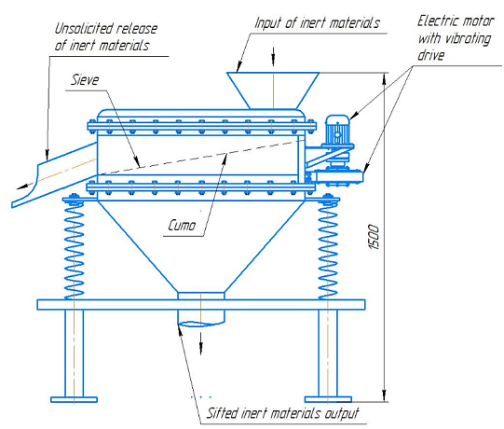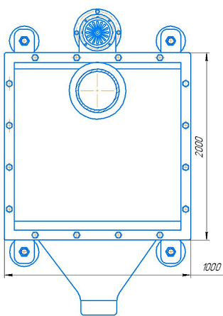
FIGURE 1. Vibrating screen with sharp oscillations

Small-sized circular vibrating screens are less common in the higher industries mentioned above, particularly for screening crushed stone, soil, sand, and bulk materials. They are especially used in the paint and varnish industry for screening dry granules. Vibrating screens are also used in mining and metallurgy. The quality of sorted ore depends on the amplitude fluctuations. These fluctuations cause the vibrating screen box to sift through inert materials, as the volume of sorted inert materials depends on the screen openings fixed in the screen box. Currently, small-sized circular vibrating screens are stationary and difficult to relocate, thus, they are not widely used in production. The small-sized vibrating screens we offer for screening inert materials oscillate in a circular motion and at the same time vibrate vertically, and mainly operate due to shear deformation.

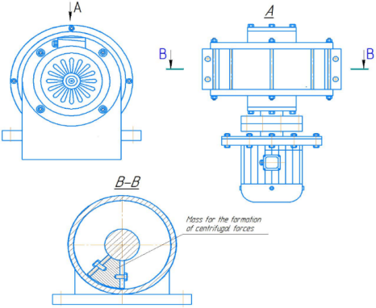
FIGURE 2. Drive for circular oscillation
To ensure the vibrating screen body acts on two forces, the vibrating screen must be set at an angle of${10}^{0}$. Then the vibrating screen body will vibrate perpendicularly and also oscillate parallel to the screen surface with circular rotations. This allows the crushed inert material to pass through the screen openings and be classified into fractions [6-7]: The time it takes for a point to complete one complete oscillation is called the period of oscillation (T). The number of complete oscillations per unit of time is called the frequency of oscillation (f). The unit of frequency—hertz (Hz)—is one oscillation per second. The period and frequency of oscillations are related by the equation:
$T=\frac{1}{f}$ (3)
The maximum deviation of an oscillating point from a stable equilibrium position is called the amplitude (A), which is measured in meters (m) or centimeters (cm). To ensure oscillatory rotation, rolling bearings are installed on the vibrating device, the bearing strength of which must correspond to this oscillation. Therefore, when designing the structure of vibrating screens, designers must take into account that the bearings must be suitable for this vibration. Bearings for vibrating screens, as a rule, are calculated for a nominal service life in hours from 10,000 to 20,000 hours. Rolling bearings for vibrating screens are selected based on the severity of the imbalance. The weight of the imbalance is selected from the mass of inert materials sifted on the surface of the screen. To ensure the durability of the vibrating screen and vibration exciter, designers must take into account the weight of the imbalance when designing the vibrating screen [8]:. The strength of the bearings must withstand a certain load, which creates an imbalance during circular rotation. Bearing calculations are carried out using the following equation:
$L_{h}=\left(\frac{C}{P}\right)P·\frac{106}{\left(n∙60\right)} \left[H\right]$ (4)
C- dynamic lifting capacity, [kN], cm;
P- equivalent dynamic load, [kN];
p= 3.33 - exponent for calculating the service life of roller bearings;
n- rotation speed rpm.
When calculating the equivalent dynamic load of a bearing, P is not sufficiently affected, the precise bearing parameters are taken into account by multiplying the radial load Fr with a safety factor of $f_{z}=$1.2. Experience shows that using this method, a sufficient bearing service life is achieved.
The vibrator's rotation speed is limited to a certain value, as at higher speeds, the resulting centrifugal force presses the inert materials against the screen's working surface. At this point, the inert materials adhere to the screen's working surface, making screening impossible. The rotation speed at which the layer of inert materials adjacent to the screen's surface begins to vibrate along with the vibrating screen box under the action of centrifugal force is called the critical speed (Fig. 1, Fig. 2). The critical speed is calculated using the following formula:
$n_{critikal}=30∙ {\left(\sqrt{R}\right)}^{-1}rpm$ (5)
$R-$drum radius, m.
Positive rotation speedvibration exciteris assigned less than the critical speed within the limits:
$n=(\frac{8}{14})∙{\left(R\right)}^{-1})$ (6)
Peripheral speedvibration excitermaintained from 0.6 to 1.25 m/s.
The operating principle of a vibrator with circular vibrations and unbalanced motion. The bearing load is determined by the centrifugal force of the vibrating screen box, the vibration radius, and the rotation speed, according to the formula:
$F_{r}=\frac{1}{z}∙\frac{m}{{10}^{3}}∙r∙ω^{2}=\frac{1}{z}∙\frac{G}{g}∙r{\left(\frac{π∙n}{30}\right)}^{2}\left[kN\right]$ (7)
$F_{r}$- radial load [kN];
m- weight of the box [kg];
r- vibration radius [m];
m- angular velocity [1/s];
G- weight of the box [kN];
g- acceleration of gravity [9.81 m/$s^{2}$];
n- rotation frequency [min-1];
z- number of bearings.
The vibration radius of a vibration exciter with circular oscillations can be determined from the ratio of the weight of the box and the weight of the load, which is intended to cause centrifugal force [9]. Since vibration exciters generally operate in a supercritical mode and the static vibration amplitude is almost reached, the common axis of the center of gravity of both masses (the vibrating screen box and the vibration exciter) can be considered unchanged (see Fig. 3).

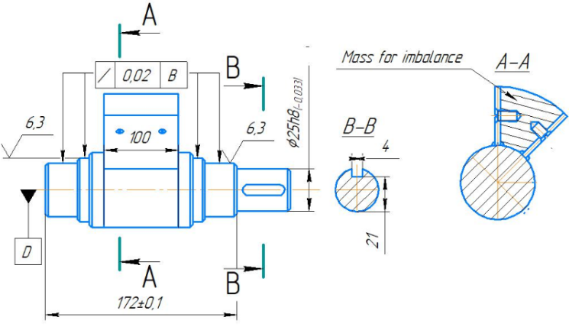
FIGURE 3. Assembly drawing of the vibrator shaft with unbalance.

Based on this premise, the following equality holds:
$G_{a}∙r=G_{1}∙\left(R-r\right)$ (8)
Forming the vibration radius:
$r=\frac{G_{1}+R}{G+G_{1}}$ (9)
G- weight of the vibrating screen box[kN];
$G_{1}$- weight of vibration exciter [kN];
R- distance between the center of gravity of the vibration exciter and the bearing axis [m];
r- vibration radius of the vibrating screen box [m];
$G_{a}$• R – moment of vibration exciter imbalance [kNm];$∙$
G+$G_{a}$ - total weight supported by springs [kN].
Substituting equation (3) into (4), we obtain the radial load on the bearing by means of transformations:
$F_{r}=\frac{1}{z}∙\frac{G_{1}}{g}∙\frac{R}{1+\frac{G_{1}}{G}}∙{\left(\frac{π∙n}{30}\right)}^{2}∙\left[kN\right]$ (10)
Weight of the vibrating screen box G = 0.035 kN;
Vibration radius r = 0.020 m;
Rotation speed n = 1895 rpm;
Number of bearings z = 2;
The bearing load is determined according to equation (9).
$F_{r}=\frac{1}{2}∙\frac{1}{9,81}∙0,002∙ {\left(\frac{π∙1895}{30}\right)}^{2}=0,004 kN$ (11)
The equivalent dynamic load required to determine the dynamic load rating of a bearing is calculated using the formula:
$P=f_{z}∙F_{r}=f_{z}∙0,004=0,0024 kN$ (12)
For an unbalanced vibration exciter, internal losses are mainly friction losses in the bearing assemblies of the unbalanced shaft. To determine the forces, the rotating centrifugal force vectors are projected onto the axis in the direction of the line connecting both directions, as well as in the horizontal and perpendicular directions. Clearly, the inert materials projected onto the line connecting both shafts cancel each other out, while the components in the perpendicular direction add up and generate a harmonically varying inertial force, imparting linear oscillations to the vibrating screen box. Since the so-called static amplitude is established due to supercritical modes in the direction of vibration, and the common axis of the center of gravity of the vibrating screen box and vibration exciters remains unchanged during oscillation, the loads acting on the bearing are calculated as follows. In the direction of vibration:
$F_{min}=\frac{1}{z}∙\frac{m}{{10}^{3}}∙r∙ω^{2}=\frac{1}{z}∙\frac{G}{g}∙r∙{\left(\frac{π∙n}{30}\right)}^{2}=\frac{1}{z}∙\frac{G_{1}}{g}∙(R-r)∙{\left(\frac{π∙n}{30}\right)}^{2}\left[kN\right]$ (13)
RESULTS AND DISCUSSION
To study the screening process of a perforated sieve screen, a mathematical design of experiments was used. The screening efficiency, expressed as a percentage, was adopted as the function under study.
$Е=\frac{α-ϑ}{α∙(100-ϑ)}∙{10}^{4}$ (14)
where is the mass content of the lower class: α – in the original material, %; ϑ – product above the sieve surface in %.
The speed of movement of inert materials during sifting over the surfaces of a sieve can be determined by the formula:
$v_{inert}=0,105∙R∙n∙tg2α, m/s$ (15)
α– angle of inclination of the screen drum, degrees.
The theoretical productivity of a flat vibrating screen for the initial material, calculated based on its transport capacity, at the feed rate of inert materials determined by the formula, is equal to %
$Q=720μ∙γ∙n∙tg2α∙\sqrt{R^{3}∙h^{3}}, Ton/hour$ (16)
μ– material loosening coefficient equal to 0.6–0.8;
γ – material density, t/m3;
h – thickness of the material layer on the drum (no more than double the size of the maximum pieces), m.
According to practical data, the average productivity of a round vibrating screen is 0.25-0.3 t/h per 1 m2 of screen area and per 1 mm of hole size during dry screening. Based on these data, we carry out virtual experiments were conducted using Altair EDEM software. A regression equation was developed during the virtual experiments to adequately describe the screening efficiency depending on the factors. Maple 11 software was used to conduct the study and obtain graphical dependencies that characterize the function change (see Fig. 4). The function is continuous in the given domain. The function extrema were determined, with the minimum value Emin=19.7% attained at a=6 mm, l=1.5 mm, and m=48∙10-3 kg. The maximum value Emax=97.7% attained at a=2.85 mm, l=1.85 mm, and m=59.7∙10-3 kg. The difference between${ E}_{max}$ and $E_{min}$ is 77.9%.
Varying the values of the sieve oscillation amplitude a in the studied range leads to a pronounced nonlinear nature of the function change. Moreover, this factor has a significantly greater effect, in comparison with m and l, on the values of E. At the initial stage, an increase in the values of a leads to an increase in the values of E with their subsequent decrease with an increase in the values of the factor under consideration. Thus, at l = 1.5 mm, m = 48∙10-3 kg and a1 = 2 mm, a2 = 3 mm, a3 = 6 mm, the screening efficiency, respectively, takes the values E11 = 84.9%, E12 = 88.8% and E13 = 19.7%. With an increase in l and m to l = 1.8 mm, m = 61.5∙10-3 kg, the screening efficiency, respectively, takes the values E21 = 92.4%, E22 = 97.1% and E23 = 31.3%. With a further increase in l and m to l=2.1 mm, m=75∙10-3 kg, the screening efficiency accordingly takes on the values E31=83.6%, E32=89.6% and E33=26.5% [10-11].
Changing the l values also results in a nonlinear change in the E values with its maximum values located near the central region of this factor's values. At the initial stage, an increase in its values leads to an increase in the E values, followed by a decrease with an increase in the factor's values. Thus, for a=2 mm, m=48∙10-3 kg and l1=1.5 mm, l2=1.8 mm, l3=2.1 mm, the screening efficiency takes the following values, respectively: Е41=84.9%, Е42=89.9% and Е43=87.7%. With an increase in a and m to a=4 mm, m=61.5∙10-3 kg, the screening efficiency takes the following values, respectively: Е51=83.8%, Е52=88.8% and Е53=86.6%. When a and m increase to a=6 mm, m=75∙10-3 kg, the screening efficiency takes on the values E61=23.80%, E62=28.84% and E63=26.58%, respectively. At the initial stage, an increase in the values of l leads to an increase in the values of E, followed by a decrease with an increase in the values of this factor. Thus, for a=2 mm, l=1.5 mm and m1=48∙10-3 kg, m2= 61.5∙10-3 kg, m3=75∙10-3 kg, the screening efficiency takes the values Е71=84.7%, Е72=87.4% and Е73=80.8%, respectively. For a=4 mm, l=1.8 mm and the specified values of m1, m2, m3, the function takes the values Е81=84.3%, Е82= 88.8% and Е83=84.3%, respectively. For a=6 mm, l=2.1 mm and the specified values of m1, m2, m3, the function takes the values Е91=22.5%, Е92=29.1% and Е93=26.5%, respectively. Rational ranges of values include: for the relative amplitude of sieve oscillations a=2-3 mm; for the width of the sieve sifting surface l=1.8-1.9 mm; for the mass of the fed material: m=(55-65) ∙${10}^{3}$kg.

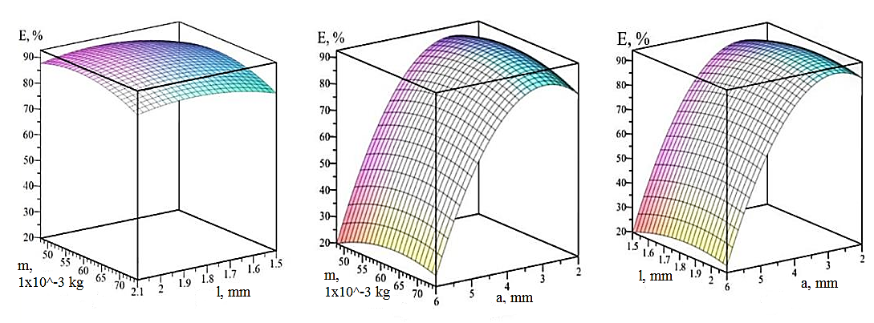
a) b) c)
FIGURE 4. Graphic efficiency of the vibrating screen depends on the oscillatory rotation, for screening E and also depends on the amplitude of oscillations a, the diameter of the holes and the width of the sifting surface of the sieve, the mass of the fed inert material m-mass: a) - a = 2 mm; b) - l = 1.5 mm; c) - m = 48 ∙ 10-3 kg

In the illustrations (see Fig. 5) Longitudinal sections of vibrating screen housing models with a composite mesh sieve design are shown. In this experiment, the factors under consideration provided the maximum value of $E_{max}$=97.7% and had the following values: a = 2.85 mm, l = 1.85 mm, m = 59.7∙10-3 kg. The number of lower-class particles was n1 = 56,027 pcs. Tables 1 and 2 present the values of the parameters characterizing the screening processes [11-12].

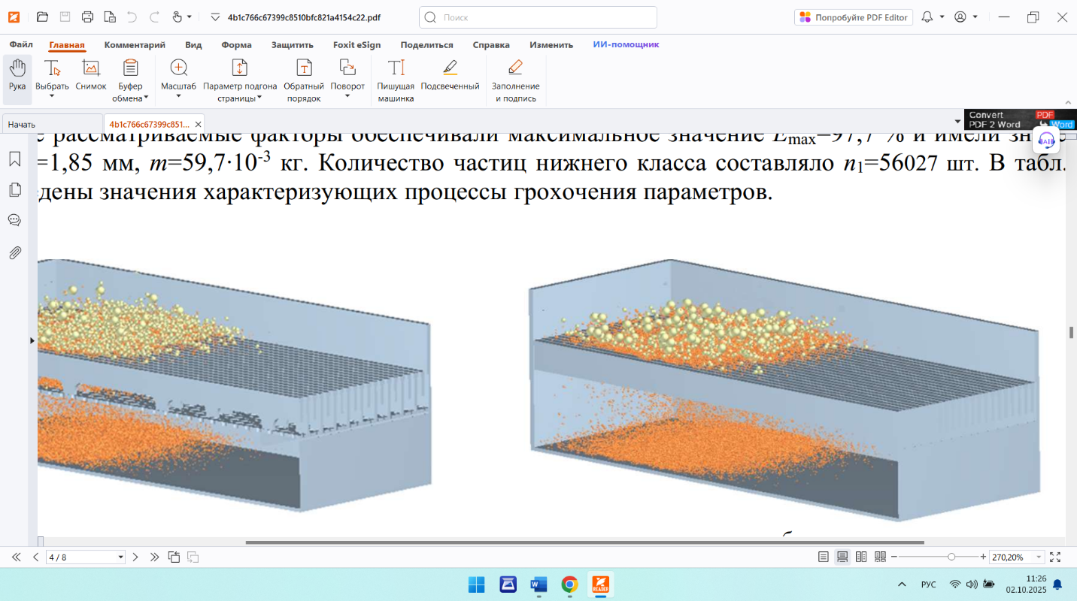
FIGURE 5. Longitudinal sections of the vibrating screen after the start of the classification process.

From the data in Table 1, it follows that at the initial stage, in the interval from $t_{0}$=0 s to$t_{2}$=0.4 s, the classification process by the composite sieve design is less efficient, which is confirmed by the values of $E_{12}$=52.67% and the corresponding prototype sieve design of $E_{22}$=56.70% (the second digit of the parameter index corresponds to the ordinal number of the experiment in Tables 3 and 4). The reason lies in the two-stage classification process on the composite sieve design – first by its first sifting surface, and then, with some delay, by the second sifting surface.
TABLE 1. The values of the parameters characterizing the screening processes
No. | Particle sieving time t, s | Passed through a sieve particles, $n_{1}$, pcs. | Efficiency of the clasification process, %$E_{l}$ | The difference in the efficiency of the qualification process with its previous value, %${ ∆}_{1}$
1 | 0.2 | 10558 | 18.84 | 18.84
2 | 0.4 | 29513 | 52.67 | 33.83
3 | 0.8 | 50953 | 90.94 | 38.26
4 | 1 | 52500 | 93.70 | 2.76
5 | 1.6 | 53818 | 96.05 | 2.35
6 | 2 | 54121 | 96.59 | 0.54
7 | 3 | 54711 | 97.65 | 1.05
8 | 3.9 | 54738 | 97.70 | 0.05
9 | 4 | 54738 | 97.70 | 0

With further continuation of the classification process, the previously described advantageous features of this sieve ensure an increase in the efficiency of this process starting from $t_{3}$=0.8 s ($E_{13}$=90.94%, $E_{23}$=81.69%). The classification processes on the housing models with a composite sieve design and its prototype are completed with the characteristic values of $E_{18}$=97.70% and $E_{27}$=89.99%, respectively. Thus, the difference of 7.7% between these values characterizes the developed composite sieve design with holes as more efficient, ensuring an increase in the quality of the inert materials classification process [12].

TABLE 2. The values of the parameters characterizing the screening processes
No. | Process time,  t, With | Passed through a sieve particles,  $n_{1}$, pcs. | Process efficiency  classifications, $Е_{1}$, % | Difference in efficiency  classification process with its  previous value, Δ2, %
1 | 0.2 | 11712 | 20.90 | 20.90
2 | 0.4 | 31772 | 56.70 | 35.80
3 | 0.8 | 45769 | 81.69 | 24.98
4 | 1 | 46292 | 82.62 | 0.93
5 | 1.6 | 48708 | 86.93 | 4.31
6 | 2 | 49734 | 88.76 | 1.83
7 | 3 | 50424 | 89.99 | 1.23
8 | 3.9 | 50424 | 89.99 | 0
9 | 4 | 50424 | 89.99 | 0

Analyzing the change in the difference between the previous and subsequent values of the classification process efficiency at${ ∆}_{1}and ∆_{2}$, it is necessary to note their significant increase in the initial stages. At $t_{11}$= 0.2, $t_{12}$= 0.4 s for the composite sieve design, this parameter increases to $∆_{11}$= 18.84% and $∆_{12}$= 33.83%, respectively, for the design of its prototype - to $∆_{21}$= 20.90% and $∆_{22}$= 35.80%. Then, $t_{08}$=0.8s, there is a slight increase for the composite screen design ($∆_{13}$=38.26%) and a fairly significant decrease for the prototype screen design ($∆_{23}$=24.98%). Continuing the modeling of the processes leads to significant decreases in the parameter under consideration (up to several units) for both screen housing models. This trend continues until the completion of the modeling processes, which end for the screen models: with the composite screen design at $t_{18}$=3.9 s; with the prototype screen design - at $t_{27}$=3 s [13].
CONCLUSIONS
The main areas of improvement for vibrating screens are examined. The advantages of screens with holes and smooth surfaces are demonstrated, as well as the assembly designs and their shortcomings, highlighting the need to find solutions to improve the quality of inert products produced through screening.
A description is given of the developed composite design of a flat sieve with holes and the advantageous features of the implemented single-stage process of separating material particles by size due to its design.
Using the Altair EDEM computer program, simulation modeling of screening processes was conducted using models of a composite perforated screen design based on its prototype. For the composite perforated screen design, a regression relationship was obtained between the efficiency E of the vibratory screening process and the screen oscillation amplitude, the screening surface hole diameter, and the mass of inert material fed. The influence of these factors on E values was determined, and their rational values were determined.
Comparison of the efficiency values E of the vibratory screening process obtained on the prototype models and the composite design of the screen with holes showed that a corresponding increase in this indicator is achieved from 89.99% to 97.71%.
REFERENCES
- Gerasimov, M. D. (2015). Theoretical and technical foundations for improving vibrating screens. Belgorod: Publishing House of BSTU named after V. G. Shukhov.
- Weisberg, L. A., Kartavyy, A. N., & Korovnikov, A. N. (2005). Screening surfaces of screens: Designs, materials, application experience. St. Petersburg: VSEGEI Publishing House.
- Naduty, V. P., & Lapshin, E. S. (2009). Effect of clogging of screening surface holes on the kinetics of vibratory screening. Vibrations in Engineering and Technologies, 4(56), 107–110.
- Weisberg, L. A. (1986). Design and calculation of vibrating screens. Moscow: Nedra.
- Pelevin, A. E. (2011). Probability of particles passing through a sieve and the segregation process on a vibrating screen. News of Universities. Mining Journal, 1, 119–129.
- Ogurtsov, V. A., Aleshina, A. P., Ogurtsov, A. V., & Brik, E. R. (2016). Kinetics of fractionation of finely dispersed bulk materials using woven screen fabrics. News of Universities. Technology of the Textile Industry, 1, 201–204.
- Khanin, S. I., Malakhov, M. A., & Mordovskaya, O. S. (2024). Vibrating screen (Russian Federation Patent No. 225593). Federal State Educational Institution of Higher Education “BSTU named after V. G. Shukhov”.
- Ogurtsov, V. A., Aleshina, A. P., Fedosov, S. V., & Mizonov, V. E. (2008). Modeling the kinetics of vibratory screening based on Markov chains. Construction Materials, 5, 33–35.
- Iudin, A. (2018). Probability simulation of the process of fractions extraction at bar screening surface with an open slot. Izvestiya Vysshikh Uchebnykh Zavedenii Gornyi Zhurnal, 91–96. https://doi.org/10.21440/0536-1028-2018-2-91-96
- Bembenek, M., Buczak, M., & Baiul, K. (2022). Modelling of the Fine-Grained Materials Briquetting Process in a Roller Press with the Discrete Element Method. Materials, 15(14), 4901. https://doi.org/10.3390/ma15144901
- Hou, S., Wang, S., Ji, Z., & Zhu, X. (2022). Design and test of the clearing and covering of a Minimum-Tillage Planter for corn stubble. Agriculture, 12(8), 1209. https://doi.org/10.3390/agriculture12081209
- Amadi, A. H., Mohyaldinn, M., Abduljabbar, A., Ridha, S., Avilala, P., & Owolabi, G. T. (2024). Wear analysis of NITI sand screens using Altair Discrete Element Method. Materials, 17(2), 281. https://doi.org/10.3390/ma17020281
- Karimov, K., Mardonov, B., Akhmedov, A., & Toirov, M. (2024). Prospects for mathematical modeling in mining system development: accounting for global oscillations and seismic waves. E3S Web of Conferences, 525, 05017. https://doi.org/10.1051/e3sconf/202452505017

