Theoretical Analysis of Thermal Efficiency of a Conical Spiral Tube Solar Air Collector
Javohir Qayumov^{1, a)}, Muzaffar Murodov²,
Elmurod Berkinov²
¹ Fergana State Technical University, Fergana, Uzbekistan
²Namangan State Technical University, Namangan, Uzbekistan

^{a)}Corresponding author: javohirqayumov29@gmail.com
Abstract. This paper theoretically analyzes the heat transfer characteristics of a conical spiral tube solar-air collector. The main objective of the study is to maximize the thermal efficiency of the collector by determining the optimal geometric shape and its operating conditions. A theoretical model based on the Hottel-Whillier-Bliss method was used to simulate the collector performance under various conditions, such as different materials (copper, aluminum, iron), air flow velocity (0.5-4.0 m/s), and ambient temperature (0-40 °C).The models used to calculate the total heat loss coefficient (UL) showed that the collector made of copper (Cu) showed the highest heat collection efficiency due to its high thermal conductivity. The analysis of the performance parameters showed that an increase in the air mass flow rate (m) is also associated with an increase in the useful thermal power (Qu) and the overall efficiency (η) of the collector, while simultaneously leading to a decrease in the outlet air temperature (Tout).Furthermore, it was found that increasing the ambient temperature (Ta) significantly increases the efficiency by reducing the heat losses. The optimization analysis carried out revealed the critical importance of choosing precise geometric parameters to maximize the collector performance. The optimal parameters identified by the model are: core diameter 0.2 m, height 0.5 m, tube diameter 0.1 m and 15 spiral turns. This specific configuration allows achieving a maximum efficiency of 86.81% and a useful thermal power of 111.25 W. This research provides a deep scientific understanding of the working mechanisms of solar-air collectors and serves as an important foundation for future scientific work.
Keywords: Solar air collector, geometric parameters, spiral tube, cone height, efficiency, air temperature, maximum efficiency.
INTRODUCTION
The pneumomechanical spinning technique is widely used in the textile industry due to its excellent economic prospects. The rotor is the most important component of the pneumomechanical spinning machine, and its speed has a significant effect on the yarn quality. In the study of Chen and Slater, the flow behavior in the rotor changes significantly with increasing speed. Koc¸ and Lawrence conducted studies on twisting mechanics and rotor spinning under different operating conditions. Effects of rotor speed and geometrical parameters on airflow Xiao et al. analyzed by and they found that angular velocity and slip angle, good axisymmetry of the spiral structure in the meridional plane of the rotor is achieved. An analysis of existing literature indicates that comprehensive studies on the combination of conical and spiral geometries are limited. Therefore, this work focuses on a theoretical investigation of the thermal performance of this novel collector design. The main objective of the research is to conduct a deep analysis of the impact of material type, air velocity, and ambient temperature on collector efficiency, and to determine the optimal geometric parameters that maximize the systemʻs performance. The results of this study will serve as an important scientific basis for the future design and effective practical application of solar air collectors [1-6].

THEORETICAL MODEL AND METHODOLOGY
The performance of the solar air collector examined in this study was analyzed based on the Hottel-Whillier-Bliss model. The following key parameters were used to evaluate the collectorʻs performance:
Geometric and Material Parameters are following: Cone base diameter (D_{base}): 0.5 m; Cone height (H): 1.0 m; Spiral tube diameter (D_{tube}): 0.05 m; Number of spiral turns (N_{turns}): 15; Collector absorber area (S_{cone}): = 0.39 m²; three different materials copper, aluminum, and iron were considered. The effective transmittance-absorptance coefficient (τα) eff was assumed to be 0.90, 0.85, and 0.80, respectively.

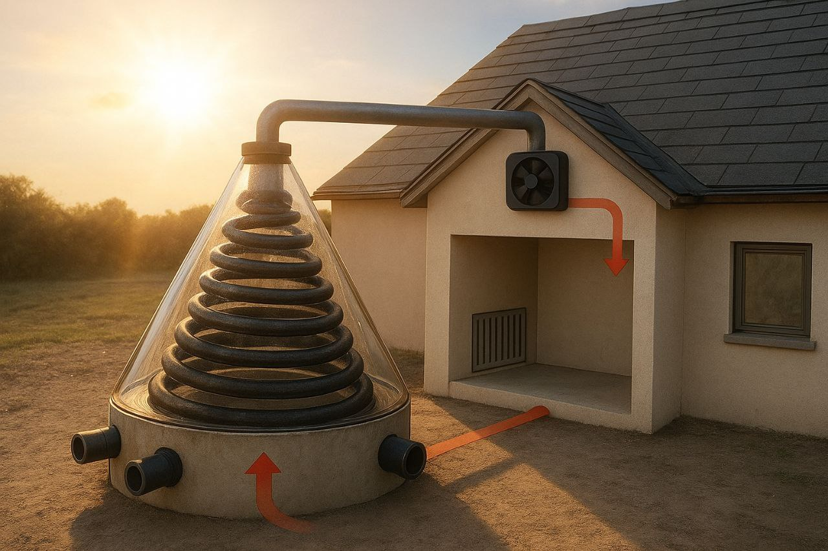
FIGURE 1. Schematic Diagram of the Conical Solar Air Collector.

Energy Balance and Efficiency:
The useful heat gain $Q_{u}$ and the thermal efficiency (η) of the collector were calculated using the following formulas:
$Q_{u}=m∙C_{p}∙(T_{out}-T_{in})$ (1)
Here, $m$ is the mass flow rate of air, $C_{p}$ is the specific heat capacity of air, and $T_{out}$ and $T_{in}$ are the outlet and inlet air temperatures.
The overall thermal efficiency (η) of the collector is calculated as :
$ƞ=\frac{Q_{U}}{A_{collector}∙G}∙100\%$ (2)
Here, $A_{collector}$ is the collectorʻs absorber area, and G is the incident solar radiation on the collector surface.
Calculation of the Heat Loss Coefficient (UL):
The overall heat loss coefficient of the collector, UL, is taken as an approximate value of 4.0 W/(m²K) based on a simplified model. This value is variable, depending on the collectorʻs operating temperature, ambient temperature, and wind speed, and consists of the sum of convective and radiative heat losses. A more detailed approach requires more complex iterative calculations.
RESULTS AND DISCUSSION
In this section, the results from the theoretical calculations and optimization analysis are presented in a concise format. Effect of Air Velocity (Ambient temperature T _{amb}=20 °C).
According to Table 1, the effect of air velocity on collector performance was examined for solar air collectors made of three different materials. The data show that when the air velocity was increased from 0.5 m/s to 4.0 m/s, both the efficiency (%) and the useful heat output (Qu) increased significantly for all materials. However, concurrently, the outlet temperature (Tout) decreases. This is explained by the fact that as the air flow rate increases, the contact time between the heat-carrying fluid (air) and the collector surface decreases, even as the mass of air flowing per unit of time increases. [6-7] Among the materials, the collector made of copper demonstrated the best performance due to its superior thermal conductivity.

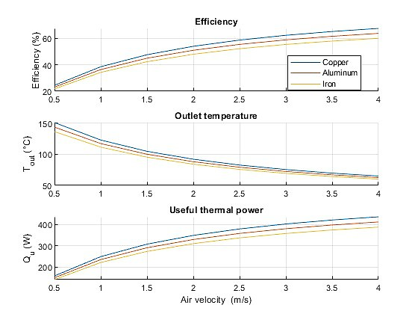
FIGURE 2. Effect of Air Velocity on Collector Performance.

TABLE 1. Effect of Air Velocity on Collector Performance.
Material | Air Velocity (m/s) | Efficiency (%) | Outlet Temperature (T_{out}, °C) | Useful Heat Output (Q _{u}, W)
Copper | 0.5 | 24.50 | 151.01 | 158.66
 | 2.0 | 53.94 | 92.12 | 349.35
 | 4.0 | 67.45 | 65.09 | 436.87
Aluminum | 0.5 | 23.14 | 143.73 | 149.84
 | 2.0 | 50.95 | 88.11 | 329.95
 | 4.0 | 63.71 | 62.59 | 412.60
Iron | 0.5 | 21.78 | 136.45 | 141.03
 | 2.0 | 47.95 | 84.10 | 310.54
 | 4.0 | 59.96 | 60.08 | 388.33

Effect of Ambient Temperature (Air velocity V_{air}=1.5 m/s)
Table 2 provides a summary of the changes in collector performance as the ambient temperature increases from 0 °C to 40 °CAs the outdoor temperature increases, the output parameters of all materials; efficiency, output temperature, and useful heat increase. This is because the temperature difference between the solar-air collector and the outdoor environment decreases, which in turn reduces heat losses and allows a greater portion of the absorbed heat to be converted into useful energy.

TABLE 2. Effect of Ambient Temperature on Collector Performance
Material | Ambient Temperature (T_{a}, °) | Efficiency (%) | Outlet Temperature (T _{out,} °C) | Useful Heat Output (Q_{u,} W)
Copper | 0 | 42.30 | 95.40 | 273.95
 | 20 | 47.59 | 104.83 | 308.1
 | 40 | 52.87 | 114.25 | 342.4
Alumium | 0 | 39.66 | 90.69 | 256.8
 | 20 | 44.94 | 100.12 | 291.0
 | 40 | 50.23 | 109.54 | 325.3
Iron | 0 | 37.01 | 85.98 | 239.7
 | 20 | 42.30 | 95.40 | 273.9
 | 40 | 47.59 | 104.83 | 308.1
OPTIMIZATION RESULTS OF SOLAR-AIR COLLECTOR
Table 3 presents the results of the optimization analysis of the solar-air collector using the Fmincon algorithm. This table shows the combination of optimal parameters and the maximum performance indicators achieved with them. The identified optimal parameters enable a significant increase in efficiency compared to the initial design. A collector with a smaller base diameter and height (Dbase=0.2 m, H=0.5 m) can achieve high efficiency even with a minimal surface area, although in this case, the outlet air temperature will be relatively lower.

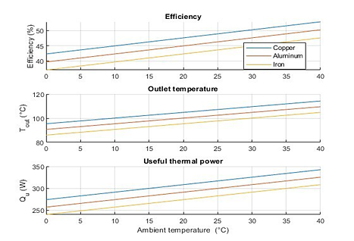
FIGURE 2. Effect of Ambient Temperature on Collector Performance.

TABLE 3. Results of Optimization Analysis
Optimal Base Diametr (m) | Optimal Height (m) | Optimal Tube Diameter (m) | Optimal Number of Turns | Maximum Efficiency (%) | Optimal Outlet Temperature (T) | Optimal Base Diameter (m)
0.20 | 0.50 | 0.10 | 15 | 86.8 | 26.38 | 111.2
CONCLUSION
This study provided important insights into the thermal performance of a conical solar air collector with a spiral tube. Based on the theoretical analysis and optimization results, the following conclusions were reached: The material used in the solar-air collector had a significant impact on its heat production. The highest efficiency and useful heat output were found in the copper collector. It was found that increasing the air velocity improves the overall efficiency and useful heat output of the collector, but it can also reduce the outlet air temperature. Increasing the ambient temperature had a positive effect on the collector efficiency. It was observed that optimizing the geometric parameters can significantly increase the collector efficiency (up to approximately 86.81%). These results can serve as an important practical guide for the design and optimization of solar-air collectors, especially for improving efficiency in specific climatic conditions. Future studies will include different flow regimes, turbulence inducers, and economic analyses.

REFERENCES
- Mao, Q., Zhao, Y., & Zhang, Y. (2024). Study on thermal storage performance of a novel conical spiral tube heat storage system. Applied Thermal Engineering, 245, 122910. https://doi.org/10.1016/j.applthermaleng.2024.122910
- Vengadesan, E., Gurusamy, P., & Senthil, R. (2023). Thermal performance analysis of flat surface solar receiver with square tubular fins for a parabolic dish collector. Renewable Energy, 216, 119048. https://doi.org/10.1016/j.renene.2023.119048
- Paraschiv, S., Paraschiv, L. S., & Ion, I. V. (2014). EXPERIMENTAL AND THEORETICAL ANALYSES ON THERMAL PERFORMANCE OF a SOLAR AIR COLLECTOR. Environmental Engineering and Management Journal, 13(8), 1965–1970. https://doi.org/10.30638/eemj.2014.217
- Alsalame, H. A. M., Sik, K. K., & Lee, G. H. (2024). Comparative Numerical and Experimental Analyses of Conical Solar Collector and Spot Fresnel Concentrator. Energies, 17(21), 5437. https://doi.org/10.3390/en17215437
- Lewandowski, A., & Simms, D. (1987). An assessment of linear Fresnel lens concentrators for thermal applications. Energy, 12(3–4), 333–338. https://doi.org/10.1016/0360-5442(87)90092-2
- Xie, W., Dai, Y., & Wang, R. (2011). Numerical and experimental analysis of a point focus solar collector using high concentration imaging PMMA Fresnel lens. Energy Conversion and Management, 52(6), 2417–2426. https://doi.org/10.1016/j.enconman.2010.12.048
- Alsalame, H. A. M., Hussain, M. I., Amjad, W., Ali, A., & Lee, G. H. (2022). Thermo-Economic Performance Evaluation of a Conical Solar Concentrating System Using Coil-Based Absorber. Energies, 15(9), 3369. https://doi.org/10.3390/en15093369

