Fundamentals of Designing Livestock Buildings and Structures in Agro-Industrial Complexes in General Plans
Zokirjon Kimsanov^{1, a)}, Arifjan Salimov², Oktamjon Juraev¹,
Natalya Goncharova¹
¹Fergana State Technical University, Fergana, Uzbekistan
²Tashkent University of Architecture and Construction, Tashkent, Uzbekistan

^{a)} Corresponding author: zokirjon.kimsanov@mail.ru
Abstract. The master layout of buildings and structures plays an important role in the effective organization of livestock complexes. Approaches based on technological, sanitary-hygienic, and economic design requirements are analyzed. In particular, the issues of functional interconnection of production buildings and auxiliary territories, the organization of transport and communication networks, and reducing the negative impact on the environment will be studied. On the example of the Fergana region, the problems of planning and solutions of buildings and structures are considered. The article is intended to cover the design stages, taking into account the main climatic indicators of sun, wind, and air temperature. Climate analyses are expected to be obtained through websites that conduct electronic continuous analysis.
Keywords: agro-industrial complex, azimuth angle, solar elevation, Holstein cows, Simmental cattle breed, open veranda, graphic material.
INTRODUCTION
Considering that the architectural solution is the most important aspect in the development of master plans, the correct solution to the design problem is presented. When organizing agro-industrial complexes, livestock buildings and structures are mainly planned based on the placement of wind direction or at a certain degree. There are also cases of requiring the design of vacant plots on existing livestock farms. In practice, the lack of strictly defined norms for the placement of livestock buildings and structures in accordance with the direction of the sun and wind is an important factor negatively affecting efficiency. The placement of residential, public buildings, and hospitals relative to solar and wind directions is carried out according to norms and rules. The solution of the basic rules for the placement of livestock at the design stage is one of the problems in the field of architecture. Developing well-founded planning principles and providing scientific solutions based on graphic materials is one of the pressing issues in contemporary architecture [1-3].
The energy efficiency of buildings and structures was also considered important. In this regard, it is necessary to increase energy efficiency in the industrial sector by at least 20%, as defined in Presidential Decree No. PP-436 of the Republic of Uzbekistan. Specific plans have been identified for the transition to a green economy, stimulating the efficient use of resources, including reducing energy consumption by enterprises.
The master plan provides scientific solutions through graphic materials that determine the exact location of farms. Next to sprinklers and air mixers various forms of shadows are increasingly cited, such as woodlots, extension of roof eaves, installation of nets reducing insolation [4]. The goal is to design buildings and structures according to specific cords across seasons in terms of climate and solar orientation.
Uzbekistan's GHI (Global Horizontal Irradiance) is estimated at 4.52 kWh per square meter (m²) per day in the median value (with a range of 4.0-5.0 kWh/m2/day), which is higher than several European countries with good solar conditions, such as Spain (4.64 kWh/m2/day) or Italy (4.07 kWh/m2/day). The DNI in Uzbekistan is 4.44 kWh/m2/day in the median value (ranging from 3.03 kWh/m2/day to 5.27 kWh/m2/day). In comparison, Spain and the United States, the major markets for CSP globally, show slightly higher median DNI (5.34 kWh/m2/day and 4.76 kWh/m2/day, respectively), but these are on par with the values observed in the southern regions of Uzbekistan [5].
MATERIALS AND METHODS
Scientific results are obtained through graphical materials, and solutions based on precise calculations are provided using the analytical method. Statistical data are analyzed, and the results are organized by highlighting the article based on tables. The main material and methods are as follows:
Graphic materials;
Analytical calculations;
Statistical analysis;
Creating tables;
The use of comparison methods is provided.
The Uchkuprik district of Fergana region was selected as the site for developing the research master plan and for the placement of shelters for livestock. Uchkuryk District Coordinates: 40°32′32′′N 71°3′39′′E. Landforms predominantly flat. The southern part consists of the foothills of the northern foothills of the Turkestan Range, and the central part of the plains, where agriculture has been practiced since ancient times. The northern and northeastern parts are adjacent to Central Fergana. The hills stretch for several kilometers within the district. They consist of ancient conglomerates of the Sokh River outflow. The climate is continental. The Kurama, Chatkal, and Fergana mountain ranges block cold winds from the north. Therefore, winter is warm here. The average annual temperature is 13.5°. In July 27-28°, the highest - 42°, in January - 2.2°, the lowest - 23°. The vegetation period is 235 - 240 days. Average annual precipitation is 100 - N5 mm.
RESULTS AND DISCUSSION
If we look at the principles of introducing best practices in urban planning and rural development, one of the main principles is the constant consideration of climate factors. This approach is considered a well-founded approach. In particular, it allows the United States' National Oceanic and Atmospheric Administration, a center specializing in the scientific analysis and observation of all natural phenomena on Earth, to determine the sunrise and sunset throughout the year according to Earth's coordinates. The sun's altitude angle and azimuth angle to the Earth's surface precisely determine how it falls on the coordinates. In the Fergana region, at latitude 40.419769, longitude 71.2326049, the lowest elevation in winter is observed on December 21, and two equinoxes in spring and autumn are observed on March 20-22, and in summer, the highest point is observed on June 21. Based on this constant movement in nature, it increases the possibility of accurate placement of buildings and structures of livestock farms in the master plan of agro-industrial complexes. Below, using graphic materials, a scientific solution is given based on the placement of verandas on the master plan for livestock farms and the architectural solutions of verandas, images, coefficients, and biological dimensions (see Fig. 1).
Simmental cattle are considered large-bodied and have developed musculature. Cows have a shoulder height of 155 cm and a body length of 160-165. The head is large and broad in the forehead, the neck is of medium length. Holstein breed The average height of cows is 144 cm, and bulls - 158-160 cm. The live weight of Holstein cows ranges from 670 to 700 kg, and bulls - from 960 to 1250 kg.
In intensive livestock systems, the raised animals usually live lifelong in a confined environment; therefore, it is of fundamental importance that the barn is built adequately to respond to their needs [6]. In a properly selected agro-industrial complex with respect to solar orientation, buildings or structures have a serious impact on the rapid quality and healthy growth of the animals being raised. Mainly in the summer months, due to the increase in the angle of the sun's elevation relative to the ground, it simultaneously achieves a sharp reduction in shading solutions organized through the structures of buildings and structures. Therefore, it is advisable to place terraces with a clear solution in the master plan to ensure that the sun falls on the inner surface of the veranda for 3 hours a day, taking into account the height angle. It is taken into account that 3 hours of sunshine do not coincide with the peak air temperature. In the remaining months, for example, in autumn and spring, considering the relatively moderate air temperature, it is beneficial for the sun to penetrate deep into the verandas of livestock farms. Due to the cold winter season, livestock in agro-industrial complexes are kept in enclosed spaces.
Open terrace (for livestock) - architectural solution and calculation rules. Basic concepts and rules of measurement are given below.
L - size of livestock (cow, cattle body length).
L_{a} - service corridor and feeding area (person walking corridor).
L_{total} -total projection to the last protruding part of the roof structure (total "length" of the veranda).
h - a small height of the roof on the lower edge (so that the animal's head and horns do not touch it).
h_{i} - minimum height near the central support to the interior structure (for the safety of people and animals).
The formulas for a one-sided veranda (Fig. 1) are determined as follows.
Service lane L_{a} = 0.5xL, total length L_{total} = L+L_{a}, lowest extreme height h=0.9xL, inner minimum height h_{i} ≥ 1.70 m.
Note: Denoting h with a coefficient of 0.9xL ensures the optimal height for preventing the animal from hitting its head, ventilation, and creating a dry zone. Placement by solar orientation The most effective solution is the placement of single-sided verandas in the direction of south, southeast (135°-150°) or southwest (195°-210°) on the master plan (see Fig. 2). The slope of roof structures is selected at 10º-15º.
The formulas for the double-sided veranda (see Fig. 2) are determined on the basis of the following.
The length of the semi-sloping roof structure is assumed to be equal to L for each side, and the total length L_{total} = 2xL, the minimum extreme height h=1.1xL, the height in the center up to the minimum structure h_{i} ≥ 1.70 m is assumed.
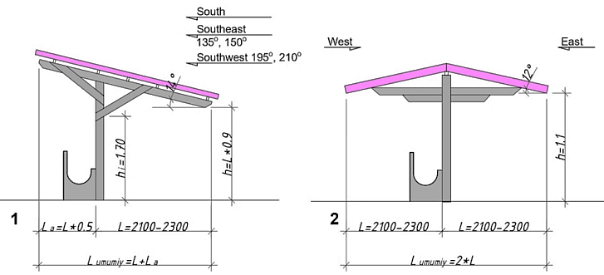
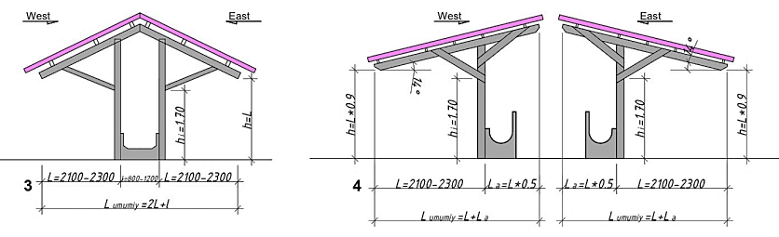
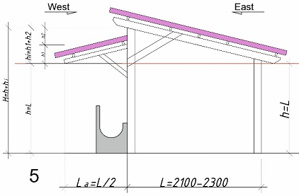
FIGURE 1. Alternative solutions for the orientation of open terraces: 1. Single-slope veranda. Double-sloped veranda. 3. Double-sloped veranda (feeding from both sides). 4. Two-sloped divided veranda. 5. Double-slope terrace (single-sided feeding).

a two-sided roof base veranda (see Fig. 1, drawing 5) is an effective architectural solution for sun protection. this veranda consists of two roofs: a small roof and a large roof. the slopes of the roofs are assumed to be the same. L, La, h are taken as the charts of the above drawings. H - the dimension up to the highest point of the veranda, this value is found through h+hi.
hi-height of the small roof.
The formulas for finding the architectural solution of drawing 5 by analytical and graphical methods are presented (see Fig. 2):
Formula for finding the service corridor and feeding part:
$La=\frac{L}{2}$ (1)
Formula for total length:
$L_{total}=L+L_{a}$ (2)
Low height:
$h=L$ (3)
Formula for finding the height of a small roof:
$hi=h1+h2$ (4)
h1 is equal to 9.55% of the total height;
h2- is taken equal to 12.1% of the total height.
In the process of drawing graphically, the height of the column 1 is determined by dividing the total height into 3 parts in percentages: h - the biological size of cattle is taken as the existing size.
Total height: H_{total}=h (L) +hi

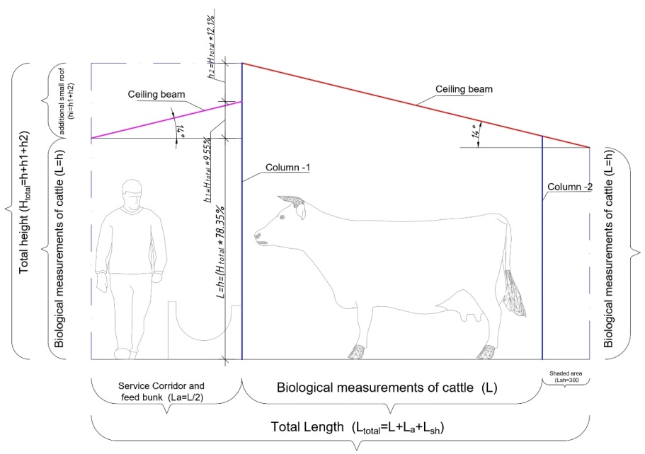
FIGURE 2. Graphical representation of the design of a two-slope veranda.

Placement according to the sun's orientation: the most effective is the arrangement of double-sided verandas in the east and west directions. The main difference between this type of terrace and others is that it is easier to place it correctly in the sun's orientation. When developing an architectural solution, it is possible to find the height of the first small column of the veranda and the total height of the large column, using the size of the cattle, cow. As a result of graphical analysis, it was established that the length of biological cows is equal to the height of the small column, and the height of the small column is 78.35% of the large column. When designing this terrace, the heights of the small and large columns are determined using the proportional method.
Determined by the following proportion: H_{total}
$\frac{h}{Htotal}=\frac{78.35\%}{100\%}Htotal=\frac{h*100\%}{78.35\%}$ (5)
By determining the H_{total} height, the distances to the small roof are also determined. According to the result determined by the graphical material, a result equal to h1=9.55% and h2=12.1 was obtained. H_{total} heights h1, h2 are determined by the proportion method. The roof slope is assumed to be 14º.
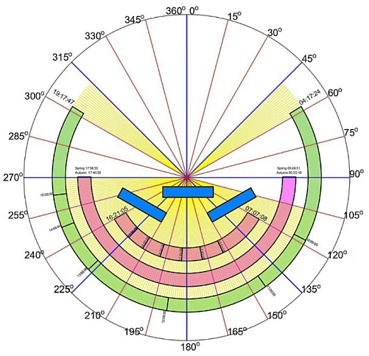
FIGURE 3. Taking into account the orientation of the Sun, placing the terraces between 105º-255º degrees relative to the azimuth angle of the Sun. (Fig. 1, location of the terraces depicted in Fig. 1)

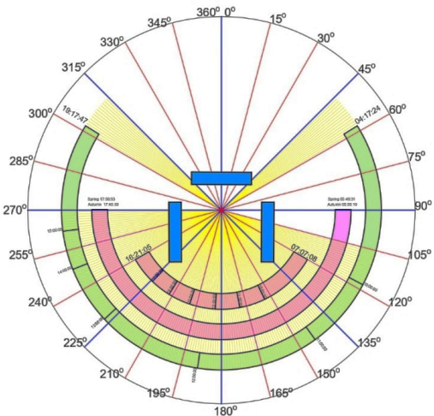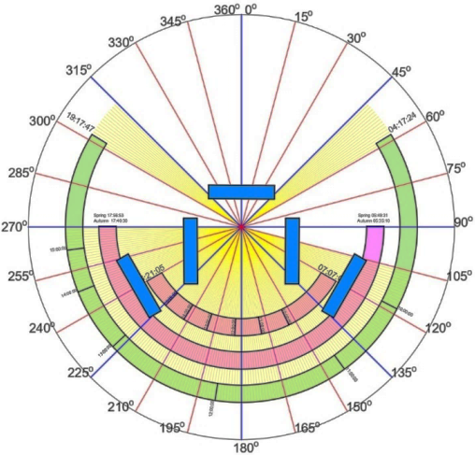
FIGURE 4. Placement of terraces opposite to the West-East direction relative to the North (The arrangement of drawings 2, 3, 4, 5 shown in Figure 1 corresponds to this figure)

In relation to the north, the results of the placement of agro-industrial complexes correspond to the required results. In the summer months, the correct design of shaded verandas in livestock farming has a positive effect on the growth of fast and high-quality animals. The placement of the open summer veranda, depicted in Figure 1, in accordance with the graphic material in Figure 3, in the intervals of 105º-225º degrees to the azimuth angle of the sun was justified graphically and analytically. By designing open summer verandas, shown in Figure 1 above, with an azimuth angle of the sun 105º-225º , it is possible to reduce direct sunlight by approximately 75-85% at 12:00 when the elevation angle reaches its maximum point. In drawings 2, 3, 4, 5 of Figure 1, the same result is achieved by placing them along the North-South and East-West directions. Thanks to this result, livestock positively affects the maintenance of cattle and cows in a favorable environment.
At the basis of all methods of shaping rational stationary solar shielding devices lies the geometry of the visible movement of the Sun in the sky, namely the geometric model of the process of sunbathing of a point on the Earth's surface during a day. This model represents a one-parameter set of solar rays arriving at one point on the Earth's surface within a day - the diurnal cone of solar rays. The angle of incidence of the Sun on the Earth is called the altitude angle, as shown above. Thanks to this result, it is possible to achieve architectural solutions that include various types of research. Analysis of the results using various graphical and proportional formulas is sufficient to obtain a scientific result. Agro-industrial complexes are one of the leading industries in the world for the production of food products. Despite the many beneficial aspects of sunlight, excessive exposure to it harms livestock. To protect open porches from sunlight, an architectural solution should be provided, taking into account the summer months. Previous work found that beef cattle show short-term preferences for shade that provided more protection from solar radiation.
CONCLUSION
It is concluded that when designing livestock farms in agro-industrial complexes, it is necessary to take into account one small aspect by creating a favorable environment for achieving a large-scale result. Necessary shortcomings in the agro-industrial complex: small adverse effects lead to negative consequences for living organisms. In particular, during extremely hot summer months, the lack of shade or incorrect orientation leads to diseases and sharply reduces the development process of cows and cattle. In obtaining the results of climate research, a result was achieved by using statistical materials for the summer months observed in the territory of the Fergana International Airport as data for analysis in the agro-industrial complex. The organization of shaded areas with trees and the use of building materials that do not remove heat from sunlight play a key role in the design of livestock shelters.
REFERENCES
- Orsini, F., & Marrone, P. (2019). Approaches for a low-carbon production of building materials: A review. Journal of Cleaner Production, 241, 118380. https://doi.org/10.1016/j.jclepro.2019.118380
- Isola, D., Bigiotti, S., & Marucci, A. (2025). Livestock Buildings in a Changing World: Building Sustainability Challenges and Landscape Integration Management. Sustainability, 17(12), 5644. https://doi.org/10.3390/su17125644
- Rojas-Downing, M. M., Nejadhashemi, A. P., Harrigan, T., & Woznicki, S. A. (2017). Climate change and livestock: Impacts, adaptation, and mitigation. Climate Risk Management, 16, 145–163. https://doi.org/10.1016/j.crm.2017.02.001
- Sarkodie, S. A., & Strezov, V. (2018). Economic, social and governance adaptation readiness for mitigation of climate change vulnerability: Evidence from 192 countries. The Science of the Total Environment, 656, 150–164. https://doi.org/10.1016/j.scitotenv.2018.11.349
- Castillo, L., Rebagliatti, C., Esenarro, D., Mendez, R., & Cobeñas, P. (2024). Agroindustrial Complex to Promote the Economic and Social Development of Agricultural Producers of the Callejon de Huaylas, Ancash, Peru 2023. Sustainability, 16(13), 5744. https://doi.org/10.3390/su16135744
- Parlato, M. C. M., Valenti, F., & Porto, S. M. C. (2022). Sustainable Promotion of Traditional Rural Buildings as Built Heritage Attractions: A Heritage Interpretation Methodology Applied in South Italy. Sustainability, 14(23), 16206. https://doi.org/10.3390/su142316206

