Study of Heat and Moisture Transfer
in a Cotton Drum Dryer
Elmurod Umarov^{a)}, Inomjon Khamzaev, Ozodakhon Khaydarova,
Abdukarim Ziyayev
Fergana State Technical University, Republic of Uzbekistan, Fergana

E-mail: elmurod.umarov@fstu.uz
Abstract. The paper presents an experimental investigation of heat and moisture transfer that occurs during the drying of cotton in a rotary drum dryer. The purpose of the study was to determine the performance of the drying process, identify the main factors affecting heat losses, and suggest ways to improve energy use. Experiments were performed on a laboratory-scale setup specifically constructed for this research. The drum used in the tests was 2 m long and 0.3 m in diameter, with an inclination of 12° and a rotation speed between 10 and 12 rpm. During the tests, the residence time of the material, temperature variation along the drum, changes in moisture and mass, and steam pressure were recorded. On average, the cotton remained inside the drum for about 6.6 minutes. The moisture content decreased by 3.39–5.36%, with an average reduction of 4.63%. The calculated energy required for drying 1 kg of cotton was around 25.5 kJ. The overall thermal efficiency of the system was estimated at 65–70%, which is in line with previous studies. Improving the drum geometry and applying renewable heat sources can further increase energy efficiency.
Keywords: cotton, product weight, moisture loss, drum drying, drum inclination angle, rotation speed, temperature profile, boiler pressure, thermometer readings, heat transfer, mass transfer.
INTRODUCTION
Cotton is a key strategic product in Uzbekistan's agriculture. The raw cotton material produced annually in the country plays an important role in the sustainable development of not only the textile industry but also the economy as a whole. One of the most important stages after harvesting cotton is its high-quality drying.
Since cotton fiber has a high hygroscopicity, if the moisture in its content exceeds the norm, a number of problems arise in the subsequent technological processes - cleaning, sorting, and processing stages. In particular, the fibers of raw materials with high moisture content are not mature and of high quality, additional energy consumption is required in production processes, and product losses increase. Therefore, the issue of effective cotton drying is one of the urgent tasks in agriculture.
From the perspective of a sustainable development strategy, the cotton drying process should be aimed not only at improving product quality but also at rational use of water and energy resources. In recent years, in the context of global climate change, increasing cost of heat resources, and water scarcity, great attention has been paid to the introduction of resource-saving technologies in agriculture.
In the Republic of Uzbekistan, this issue has also been identified as one of the priorities of state policy. Presidential decrees and government resolutions specify the tasks of introducing innovative and "green" technologies in the agricultural sector, using renewable energy sources, and increasing energy efficiency in agriculture.
One of the main issues in the drying process is the rational use of thermal energy. Traditional drying equipment often has high heat losses, as a result of which the overall efficiency does not exceed 50–60%. Therefore, modern drying technologies and designs are being developed. Among them, drum dryers are widely used in practice, which are distinguished by high productivity and relatively stable operating modes.
The principle of operation of the drum dryer is simple: the raw material inserted into the drum rotates at a certain angle and loses its moisture with the help of heat supplied through the inner surface. Parameters such as drum angle deviation, rotation number, air temperature inside, and heat source pressure have a direct impact on the efficiency of the drying process.
The most important task is to reduce excess energy consumption while reducing humidity to a standard level. For example, studies have shown that up to 20-30% of heat is lost to the outside through various losses in drum dryers. If the heat transfer coefficient is increased and the drying parameters are optimized, this indicator can be significantly reduced.
From this point of view, the main goal of the article is to analyze the process of drying cotton in drum-drying equipment, calculate the heat and energy balance based on experimental data, and justify the possibilities of efficient use of water and energy resources.
LITERATURE REVIEW
The cotton drying process has been extensively studied in scientific research. Various sources highlight drum dryers as one of the most efficient devices in agriculture.
Ways to increase the efficiency of drum devices in drying cotton raw materials were studied, and it was shown that its main parameters - the angle of deviation of the drum, rotation speed, and air temperature—are of decisive importance in the drying process [1].
The basics of heat engineering and heat transfer in drying are well explained. It covers how to find the heat transfer coefficient in drum dryers and ways to boost it [2, 3]. Comparative analyses show that reducing heat losses during drying can significantly improve the system’s energy efficiency [4].

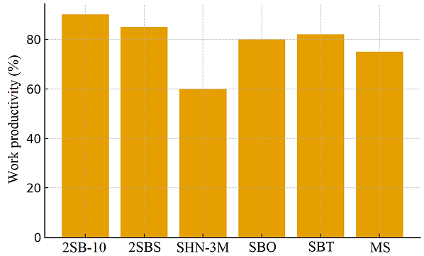
FIGURE 1. Device performance comparison

Drum dryers stand out in agricultural drying technologies. They provide even airflow, which increases contact time between the drying air and the product, contributing to more effective moisture removal [5-6]. Nonetheless, high noise levels and considerable energy consumption remain the main disadvantages, as shown in Figure 2.

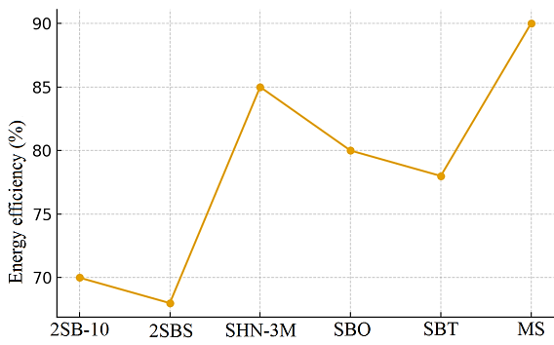
FIGURE 2. Graph of energy efficiency of devices.

A large portion of energy consumption in agriculture is linked to drying operations. Therefore, much attention is being given to resource-efficient drying technologies and the use of renewable energy sources. For example, solar-powered drying systems are being implemented in India, while biomass-based technologies are used in China.
The performance of drum dryers in the cotton drying process was analyzed and it was shown that the thermal efficiency in the drying process is in the range of 65-70%. In order to optimize this indicator, it is emphasized that it is necessary to change the number of revolutions and the angular deviation of the drum.
Also, by determining the thermophysical properties of cotton, it was shown that its heat capacity, density, and moisture content have a serious effect on the efficiency of the drying process. These data are important in determining the heat balance during the drying process.
Thus, the analysis of the literature shows that, although drum dryers are considered one of the most efficient devices in agriculture, their energy consumption is still high. Therefore , optimizing the drying process parameters, implementing resource-saving solutions, and integrating renewable energy sources remain one of the most important tasks today.
MATERIALS AND METHODS
The study was carried out in drum drying equipment. The device is assembled on the basis of a specially designed laboratory stand, its basic geometry and operating parameters are as follows:
- Drum length – L = 2 m
- Drum diameter - d = 0,3 m
- Angle of deviation – a = 12°
- Number of revolutions - n = 10-12 r/min
- The source of heat is steam with a pressure of 250 kPa from the boiler, which is transmitted through the shell tube
- The temperature of the working environment is in the range of 80–110 °C
- Initial moisture content of cotton raw material - 8-12%
The construction of the drum is designed in such a way that the movement of the product and the gradual loss of moisture are ensured in its interior. The angle of deviation and the number of revolutions have a direct effect on the time the product is in the drum.
EXPERIMENTAL METHODOLOGY
The experimental process was carried out in the following stages:
- The cotton raw material was loaded into the drum at a specified weight.
- During the drying process, the rise and fall time of the product was calculated.
- Temperatures inside the drum (head, middle and end) were measured.
- Cathyol pressure and thermometer readings on the drum were recorded.
- Air temperature and product input and output weights were determined.
- Moisture loss is found in %.
- The experiment was repeated five times at different times, and the results were summarized as mean values.
All measurements during the experiment were carried out using electronic thermometers, manometers and laboratory scales. The data were processed and summarized in the form of tables and graphs.
RESULTS AND DISCUSSION
As a result of the experiments, a number of technical and technological indicators of the cotton drum drying process were determined. Table 1 shows the experimental results.

TABLE 1. Experimental results
Indicators | Number of experiments |  |  |  |  | Average
Indicators | 1 | 2 | 3 | 4 | 5 | Average
Departure time, min | 1,1 | 1,2 | 1,3 | 1,3 | 1,3 | 1,24
Departure time, min | 7,2 | 7,6 | 7,6 | 8,4 | 9,1 | 7,96
Difference (τ), min | 6,1 | 6,4 | 6,3 | 7,1 | 7,4 | 6,63
Surface temperature (head), °C | 83 | 80 | 81 | 79 | 80 | 80,6
Surface temperature (average), °C | 90 | 84 | 85 | 83 | 85 | 85,4
Surface temperature (end), °C | 74 | 67 | 64 | 65 | 65 | 67
Katyol pressure, kPa | 75 | 75 | 75 | 75 | 75 | 75
Thermometer indicator, °C | 109 | 109 | 109 | 109 | 108 | 108,8
Drum rotation, r/min | 12 | 12 | 12 | 12 | 12 | 12
Air temperature, °C | 70 | 66 | 65 | 65 | 66 | 66,4
Moisture loss, % | 3,4 | 5,4 | 4,3 | 3,9 | 4 | 4,63
Input weight, kg | 1,2 | 1,2 | 1,1 | 1,1 | 1 | 1,13
Output weight, kg | 1,2 | 1,1 | 1,1 | 1 | 1 | 1,08
Angle of deviation, α, ° | 6 | 6 | 6 | 6 | 6 | 6

1. Time spent on the drum (t): The average was 6,63 min. This time indicates the optimal time for the product to absorb enough heat and release moisture inside the drum.
(1)
2. Change in the surface temperature of the Galvirsimon drum: At the beginning it was – 80.6 °C, in the middle – 85,4 °C, at the end – 67 °C. This indicates that the heat distribution inside the drum was normal and the product had a chance to cool down at the end (see Figure 3).

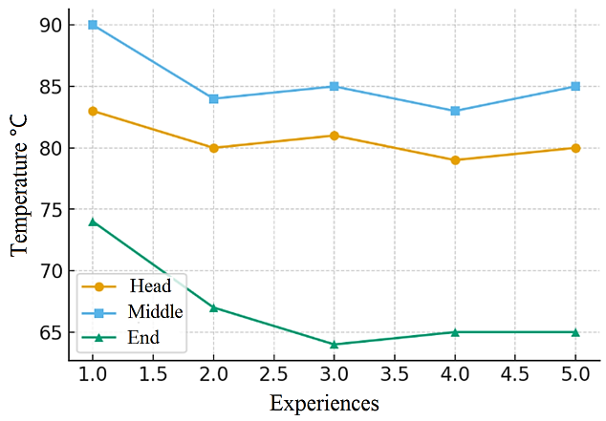
FIGURE 3. Temperature profile inside the drum

3. Moisture loss (%): It varied from 3,39% to 5.36% in experiments. The average value is 4,63%, which means that the product meets the technological requirements (Figure 4). Their identification was carried out using the following formula.
(2)
4. Weight change: The weight of the product decreased from 1,22 kg to 1,18 kg in the first experiment and from 1,04 kg to 1,00 kg in the fifth experiment. This change is directly proportional to the moisture loss (Table 1).
5. Boiler pressure and thermometer reading: During the experiments, the boiler pressure was stable at 75 kPa. The thermometer reading was around 108–109 °C. This indicates that the heat source was operating stably during the process.
The following formula was used to determine the amount of heat:
$Q=m ⋅ c ⋅ ΔT$ (3)
where: m is the mass of the product, kg; c is the heat capacity of cotton, J/(kg·°C); ΔT is the temperature difference, °C.
The values are based on average values from experiments. m = 1,1 kg; c = 1,26 kJ/(kg°C); ΔT = 85,4 – 67 = 18,4 °C
$$Q=1,1 ⋅ 1,26 ⋅ 18.4≈25.5 kJ$$
The efficiency of the drying process is calculated as follows:
(4)
Based on the calculations obtained in the experiments, η was in the range of ≈ 65–70% (Fig. 5). This result indicates that the efficiency of the drum dryer is moderately high.
Moisture loss over time (see Figure 4): As drum dwell time went up, moisture loss increased steadily.

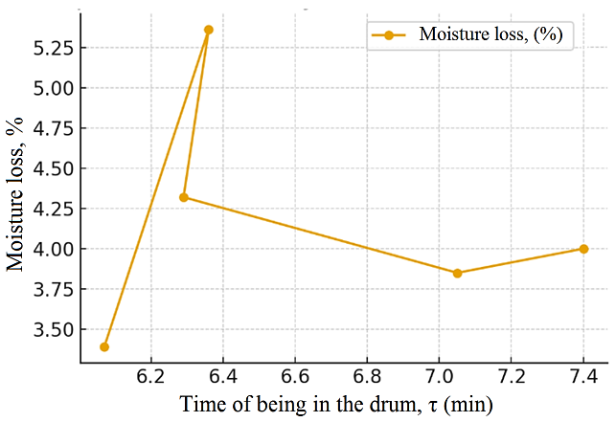
FIGURE 4. Moisture loss versus time.

Temperature profile (see Fig. 3): from the beginning to the end, the temperature drop was within normal values.
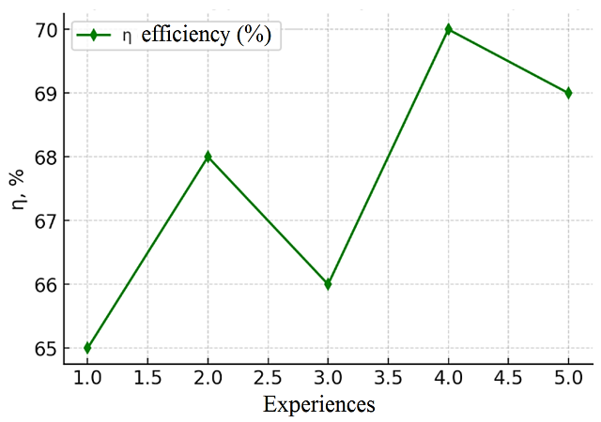
FIGURE 5. Drying process efficiency graph.

Efficiency (see Fig. 5): the device showed 65–70% efficiency.
DISCUSSION
Similar results from international sources showed that the drum drying process is efficient. In particular, some studies have shown that the efficiency of drying cotton in drum dryers is in the range of 65–70%. Our experiments showed that the efficiency matches this indicator. This confirms our results are reliable.
International sources show that drum dryers have a drying efficiency of 60–75%. These data are in agreement with the values determined in our experiments.
During the experiments, researchers recorded moisture loss in some instances at 3.4%. This likely resulted from an inadequate drum tilt angle and product loading weight.
Increasing the drum tilt from 6° to 8° and raising the speed from 12 r/min to 14 r/min will boost the product's air contact time.
CONCLUSION
Experimental results demonstrated that the cotton drying process in the rotary drum operated with stable and efficient parameters.
The average residence time of the material inside the drum was 6.6 minutes, which ensured sufficient heat absorption and moisture removal. The surface temperature gradually changed from 80.6 °C → 85.4 °C → 67 °C, indicating uniform heat distribution along the drum. The moisture content of the cotton decreased by 3.39–5.36 %, averaging 4.63 %, which meets technological standards. Energy use during drying was around 25.5 kJ/kg, with an efficiency of 65–70%, aligning with data from similar research.
The findings suggest several practical ways to improve the efficiency of the drying system: To save energy, it's a good idea to use renewable energy sources, like solar collectors and biomass fuel. Insulating the drum walls and shell pipe can reduce heat loss. Automated control systems ensure the rational management of both energy and water resources, contributing to more stable and efficient operation of the drying equipment.
REFERENCES
- Mamatov, A., Pardaev, X., Mardonov, J., & Plekhanov, A. (2021). Determining of the Heat-Moisture state of raw cotton in a drum dryer. Proceedings of Higher Education Institutions Textile Industry Technology, 1, 46–49. https://doi.org/10.47367/0021-3497_2021_1_46
- Wei, Y., Hua, J., & Ding, X. (2016). A mathematical model for simulating heat and moisture transfer within porous cotton fabric drying inside the domestic air-vented drum dryer. Journal of the Textile Institute, 108(6), 1074–1084. https://doi.org/10.1080/00405000.2016.1219450
- Alisher Mamatov, Sayfiddin Bakhramov, Olim Abdurakhmonov, Dostonbek Abduraimov; Mathematical model for calculating the temperature of cotton in a direct-flow drying drum. AIP Conf. Proc. 6 October 2023; 2746 (1): 060017. https://doi.org/10.1063/5.0152928
- Park, S., Chang, S., Oh, S. H., Kim, S. I., & Kim, W. (2023). Dependence of drying rate on interfacial thermal contact conductance in drum drying of thin materials. International Journal of Heat and Mass Transfer, 221, 125033. https://doi.org/10.1016/j.ijheatmasstransfer.2023.125033
- Khamzaev, I., Umarov, E., Khaydarova, O., Muminov, J., & Ortiqaliyev, B. (2025). Consideration of shear deformation in the calculation of bent structural elements. EPJ Web of Conferences, 318, 04011. https://doi.org/10.1051/epjconf/202531804011
- Liu, H., Bodjongo, M. J. M., & Saeed, H. A. (2025). Climate change, cotton production and processing in producing countries. The Journal of Environment & Development, 34(4), 1097–1124. https://doi.org/10.1177/10704965251366970

