Studying the Geometric Structure of a Copper
Cluster by Computer Simulation
Akbarali Rasulov, Nodirbek Ibrokhimov, Jakhongir Khodjimatov^{a)},
Azamat Tukhtasinov, Nilufar Abdulhamidova
Fergana State Technical University, Fergana, Uzbekistan

^{a)}Corresponding author: johnhojimatov@gmail.com
Abstract: The paper contains the results of modeling the geometric structure of low-energy small neutral metallic copper clusters using the Molecular Dynamics method. For the calculation of interatomic interactions, EAM potential was used. Main structural characteristics, such as geometric configurations and Cu–Cu bond lengths, were detected for a series of copper cluster models denoted as Cu_{n} (n = 2–60). After this, the results of molecular dynamics simulations were compared with available experimental data to evaluate the accuracy of the modeled results.
Keywords: Copper, cluster, molecular, dynamics, simulation, geometry, bonding.
INTRODUCTION
Clusters are nanoscale assemblies of atoms whose geometric, thermodynamic, and electronic properties are sharply different from those of bulk crystalline materials [1]. Due to these unique features, the geometric behavior of clusters has remained one of the focus areas in theoretical and experimental materials research alike [2-3].
In recent years, much theoretical and experimental effort has been given to studying the geometric properties of copper clusters. For example, the structural parameters, stability, and so-called “magic numbers” of copper clusters up to 45 atoms have been investigated by means of molecular dynamics simulations based on empirical potentials. These investigations have revealed a strong correlation between atomic structure and cluster stability; among these, the most stable configurations were found to be Cu₁₃ and Cu₂₆ [1, 2]. Other studies have focused on low-energy copper clusters with up to 26 atoms, using molecular dynamics to investigate their binding energy, relative stability, and HOMO–LUMO gap. Researchers' findings indicate that copper clusters' stability is determined mainly by electronic factors, such as shell filling and electron pairing within the HOMO, rather than by geometrical factors. Furthermore, strongly correlated molecular dynamics models have been successful in simulating metallic interactions [3]. Other research has used Density Functional Theory (DFT) with the Perdew–Wang exchange–correlation functional to investigate structural, energetic, and electronic properties for copper clusters up to ten atoms [4]. DFT calculations for smaller systems, such as those with up to five atoms, were able to gain detailed insight into bond lengths, binding energies, and the Jahn–Teller effect in Cu₃ and Cu₄ clusters; results were in very good agreement with experimental and theoretical benchmarks [5]. Other studies using the Douglas–Kroll–Hess (DKH) relativistic approximation have probed stability, bond lengths, binding energies, ionization potentials, and electrophilicity indices for copper clusters up to eight atoms, with results in good accord with experimentally derived values [6]. Frequency and bond-length analyses of the Cu₅ cluster, carried out via DFT, similarly yielded results that compared fairly with experimentally measured values [7]. The reason for selecting copper clusters in this work is the large amount of experimental data available for comparison, which enables meaningful comparisons of computational models with real-world observations to be made. In this paper, the geometric properties of small metallic copper clusters are investigated by computer simulation using the molecular dynamics method (MD).

METHODS AND MATERIALS
Many methods have been developed to study the modelling behavior of nanoclusters. Typically, MD is applied depending on the adiabatic and isothermal states of the system. The adiabatic state aligns more closely with classical mechanics and assumes that the total energy of the modeled system does not change. However, this version is rarely used as it does not account for energy consumption, which is usually incompatible with real systems' formation. The isothermal state is maintained in MD using mechanical algorithms or special thermostats that ensure a constant temperature. These algorithms must perform their core function without significantly disturbing the system’s phase trajectory, thereby maintaining the natural evolution prescribed by Newton’s second law.
$$a_{xi}=\frac{dv_{xi}}{dt}=m^{-1}\left(Σ_{i≠j}F_{xij}+Σ_{i}f_{xi}\right)$$
$a_{yi}=\frac{dv_{yi}}{dt}=m^{-1}\left(Σ_{i≠j}F_{yij}+Σ_{i}f_{yi}\right)$ (1)
$$a_{zi}=\frac{dv_{zi}}{dt}=m^{-1}\left(Σ_{i≠j}F_{zij}+Σ_{i}f_{zi}\right)$$
$a_{xi}$, $a_{yi}$, $a_{zi}$ — components of the acceleration vector of atom i, $v_{xi}$, $v_{yi}$ and $v_{zi}$, — velocity vector components, $t$ — time, $m$ — atomic mass, $F_{xij}$, $F_{yij}$ and $F_{zij}$ — components, internal forces acting on an atom $f_{xi}$, $f_{yi}$ and $f_{zi}$ — components of external forces equal to zero for a free nanoparticle [3].
The algorithms used in this work provide results of remarkably high accuracy. However, the corresponding software implementations are often complex and demand substantial memory resources to handle large data sets. Considering these factors, the Verlet algorithm was selected for our simulations [4].
$\begin{matrix}\vec{r}\left(t+∆t\right)=2\vec{r}\left(t\right)-\vec{r}\left(t-∆t\right)+\vec{a}\left(t\right){\left(∆t\right)}^{2} \\ \vec{v}\left(t\right)=\frac{\vec{r}\left(t+∆t\right)-\vec{r}(t-∆t)}{2∆t}\end{matrix}$ (2)
The Embedded Atom Method (EAM) potential was used in the simulation of metallic systems [8]. Molecular dynamics calculations of the copper cluster geometries were performed with the LAMMPS software package, developed at Sandia National Laboratories [9, 10]. The Jmol program was used to visualize the obtained cluster structures.
During the course of the simulations, atomic bond lengths within the clusters were optimized every 10,000 steps. All modeling was performed under isothermal–isobaric (NPT) ensemble conditions, with periodic boundary conditions applied in every spatial direction of the simulation box. The molecular dynamics runs were executed with a time step of 0.0001 ps, and the equations of motion were integrated by means of the Verlet algorithm. The total simulation time was 1,000 ps. System pressure was maintained at 1 bar by using a Berendsen barostat, while temperature control was achieved by the Berendsen thermostat, which kept the temperature at 300 K for 1 ps. The melting and solvent regions were thermostatted independently to ensure thermal stability.
RESULTS AND DISCUSSION
Figure 1 presents the geometrical configurations for small neutral copper clusters. Spheres indicate individual copper atoms, and the lines connecting them correspond to interatomic bonds. It gives a three-dimensional view of the atoms and their bonding nature in each cluster and, therefore, provides a better insight into the structure and stability sequence of the clusters.
The Cu₂ cluster takes the form of a simple linear arrangement of two atoms connected by a single bond. The geometry of the Cu₃ cluster is equilateral triangular, while Cu₄ assumes the shape of a regular tetrahedron. The five atoms in Cu₅ are arranged in such a way that three atoms in one plane form an equilateral triangle and the other two are symmetrically positioned above and below the center of the triangle. The geometry taken by Cu₆ is octahedral, with four atoms forming a square base and the other two positioned symmetrically above and below the center. In Cu₇, five atoms form a regular pentagonal plane, and the other two are symmetrically arranged above and below that plane. The Cu₈ cluster displays a slightly distorted parallelogram structure: four atoms lie in one plane, one atom is situated above the center, and three atoms are positioned beneath it. Larger clusters, such as Cu₁₃ and Cu₅₅, tend to adopt nearly spherical geometries, reflecting their high degree of structural symmetry.
The molecular dynamics (MD) method is one of the widely used methods for the theoretical study of all processes in materials science. Its main idea is to describe the formation (evolution) of a system of particles over time. At the same time, the molecular dynamics (MD) method is widely used in modeling physical processes. The main reason for this is that, as we mentioned above, this method is completely responsive to real-time simulations. Therefore, we believe that the MD method provides adequate results for atomistic simulations [10-14].
The bond length (Cu-Cu bond distance) of the Cu₂ cluster is 2.61 Å. The bond lengths of the Cu₃ cluster are 2.6 Å. 2.6 Å in the Cu₄ cluster. 2.6 Å and 2.61 Å in the Cu₅ cluster. 2.6 Å and 2.61 Å in the Cu₆ cluster.

 |  |  | 
Co₂ | Co₃ | Co₄ | Co₅
 |  |  | 
Cu₆ | Cu₇ | Cu₈ | Cu₉
 |  | 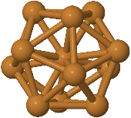 | 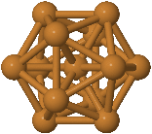
Cu₁₀ | Cu ₁₁ | Cu₁₂ | Cu₁₃
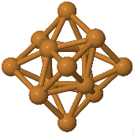 | 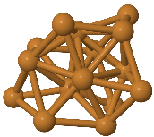 |  | 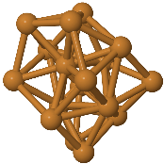
Cu₁₄ | Cu₁₅ | Cu₁₆ | Cu₁₇
 | 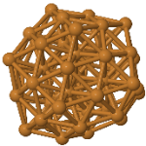 | 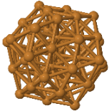 | 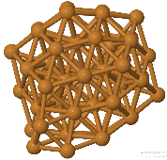
Cu₅₂ | Cu₅₄ | Cu₅₅ | Cu₆₀
FIGURE 1. Typical geometric configurations of neutral copper clusters with up to 60 atoms, as obtained from molecular dynamics modeling.

In the Cu₇ cluster these distances are 2.59 Å, 2.62 Å and 2.64 Å. 2.43 ÷ 2.96 Å in the Cu₈ cluster. 2.29 ÷ 3.04 Å in the Cu₉ cluster. 2.56 ÷ 2.65 Å in the Cu₁₀ cluster. In the Cu₁₁ cluster these distances are 2.53 ÷ 2.67 Å. 2.5 ÷ 2.63 Å in the Cu₁₂ cluster, 2.51 ÷ 2.64 Å in the Cu₁₃ cluster, 2.54 ÷ 2.67 Å in the Cu₁₄ cluster, 2.52 ÷ 2.68 Å in the Cu₁₅ cluster, 2.26 ÷ 3.18 Å in a cluster Cu₁₆, 2.47 ÷ 2.7 Å in the Cu₁₇ cluster, 2.39 ÷ 2.59 Å in the Cu₅₂ cluster, 2.4 ÷ 2.59 Å in the Cu₅₄ cluster, 2.41 ÷ 2.58 Å in the Cu₅₅ cluster and 2.12 ÷ 2.70 Å in a cluster Cu₆₀.
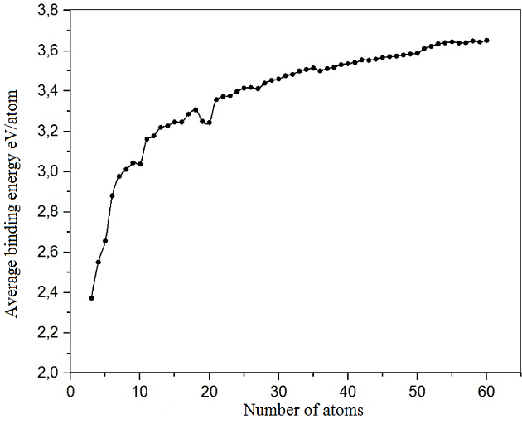
FIGURE 2. Dependence of the average binding energy of a cluster on the number of atoms in the cluster.
TABLE 1. Comparison of structural parameters — Cu–Cu bond lengths (in Å) — for neutral
copper clusters containing up to ten atoms.
Cluster | Structural parameters
Cluster | [12]-ref |  | [13]- ref | Our results
Cu₂ | 2.21 |  |  | 2.16
Cu₃ | 2.30 |  | 2,25 | 2.28
Cu₃ |  |  | 2.24 | 2.28
Cu₃ |  |  | 2.24 | 2.28
Cu₄ | 2.35 |  | 2.23 | 2.35
Cu₄ | 2.32 |  | 2.22 | 2.35
Cu₄ |  |  | 2.24 | 2.35
Cu₅ | 2.30 |  | 2.23 | 2.36
Cu₅ | 2.42 |  | 2.38 | 2.42
Cu₆ | 2.36 |  | 2.4 | 2.36
Cu₆ | 2,47 |  | 2.39 | 2.38
Cu₆ | 2.42 |  | 2.41 | 2.41
Cu₆ | 2.28 |  |  | 2,57
Cu₇ | 2.39 |  | 2.41 | 2.39
Cu₇ | 2.39 |  | 2,63 | 2.42
Cu₇ |  |  | 2,45 | 2.39
Cu₈ | 2.35 | 2,47 | 2.41 | 2.41 | 2.42
Cu₈ | 2.38 | 3.07 | 2,61 | 2.41 | 3.12
Cu₈ | 2.39 | 2.38 | 2,59 | 2.42 | 2.39
Cu₈ | 2.35 | 2,47 | 2.39 | 2.39 | 2.42
Cu₉ | 2.44 | 2.40 | 2.44 | 2.42 | 2.41
Cu₉ | 2.41 | 2.37 | 2,59 | 2.42 | 2.41
Cu₉ | 2.44 | 2.37 | 2.41 | 2.42 | 2.41
Cu₉ | 2.43 | 2.38 |  | 2.42 | 2.41
Cu₁₀ | 2.33 |  |  | 2.39
Cu₁₀ | 2.42 |  |  | 2.44
Cu₁₀ | 2,45 |  |  | 2,46
In figure 2 shows graphs of the dependence of the average binding energy (per one cluster atom) on the number of atoms depending on the size of the clusters (the number of atoms in them).
The graphs show that the larger the clusters, the greater the average binding energy of the atoms in them. In this case, the growth of clusters was observed with a decrease in the “contribution” of surface atoms to the average binding energy.
CONCLUSION
The geometric properties of neutral small copper clusters were studied using the EAM potential using molecular dynamics (MD) methods. Using computer modeling, stable structures and configurations of low-atomic copper clusters were established, and the dependence of the binding energy in copper clusters on the number of atoms was determined. The lengths of bonds between cluster atoms were determined. Some low-atomic copper clusters (Cu_{n}, n=2, 3, 4, 5, 6, 7, 8, 9, 10, 11, 12, 13, 14, 15, 16, 17, 52, 54, 55, 60) were visual images were obtained. According to our calculations, it is shown that the shape of copper clusters (Cu₁₃ and Cu₅₅) with 13 and 55 atoms is very close to spherical. For metals, there are stable clusters with a magic number. This “magic number” is also associated with the closeness to the spherical shape of the Cu₁₃ and Cu₅₅ clusters. It was found that copper clusters with an even number of atoms are more stable than copper clusters with an odd number of atoms. The results obtained from the computer experiment were compared with experimental and theoretical results obtained by other researchers, and the results were found to be consistent with each other. This research work was carried out in the research laboratory “Modeling of complex processes” of the Fergana branch of the Tashkent University of Information Technologies.

REFERENCES
- Böyükata, M., & Belchior, J. C. (2008). Structural and energetic analysis of copper clusters: MD study of Cu n (n = 2-45). Journal of the Brazilian Chemical Society, 19(5), 884–893. https://doi.org/10.1590/s0103-50532008000500012
- Rasulov, A., Ibrokhimov, N., Khodjimatov, J., & Tukhtasinov, A. (2024). Simulating the Dynamics of Bimetallic Clusters Deposited onto a Surface Using Molecular Dynamics. Journal of Applied Mathematics and Physics, 12(08), 2820–2828. https://doi.org/10.4236/jamp.2024.128167
- Kabir, M., Mookerjee, A., & Bhattacharya, A. K. (2004). Copper clusters: electronic effect dominates over geometric effect. The European Physical Journal D, 31(3), 477–485. https://doi.org/10.1140/epjd/e2004-00142-y
- Jug, K., Zimmermann, B., Calaminici, P., & Köster, A. M. (2002). Structure and stability of small copper clusters. The Journal of Chemical Physics, 116(11), 4497–4507. https://doi.org/10.1063/1.1436465
- Calaminici, P., Köster, A. M., Russo, N., & Salahub, D. R. (1996). A density functional study of small copper clusters: Cun (n⩽5). The Journal of Chemical Physics, 105(21), 9546–9556. https://doi.org/10.1063/1.472939
- Jorge, F. E., Ferreira, I. B., Soprani, D. D., & Gomes, T. (2015). Estimating the impact of an All-Electron basis set and scalar relativistic effects on the structure, stability, and reactivity of small Copper clusters. Journal of the Brazilian Chemical Society. https://doi.org/10.5935/0103-5053.20150261
- Gong, H., Li, G., & Jia, Y. (2011). Isomers of the Cu 5 cluster: a density function theory study. Chinese Physics B, 20(3), 033105. https://doi.org/10.1088/1674-1056/20/3/033105
- Daw, M. S., & Baskes, M. I. (1984). Embedded-atom method: Derivation and application to impurities, surfaces, and other defects in metals. Physical Review. B, Condensed Matter, 29(12), 6443–6453. https://doi.org/10.1103/physrevb.29.6443
- Bogatikov, E. V., Bityutskaya, L. A., & Shebanov, A. N. (2013). Simulation of nanoclusters using the molecular dynamics method (pp. 10–24). Voronezh, Russia: Publishing and Printing Center of Voronezh State University.
- Allen, M. P. (2004). Introduction to molecular dynamics simulation. In Computational Soft Matter (John von Neumann Computer Institute, NIC Series, Vol. 23, pp. 1–28).
- Kuzmin, V. I., Tytik, D. L., Belashchenko, D. K., & Sirenko, A. N. (2008). Structure of silver clusters with magic numbers of atoms by data of molecular dynamics. Colloid Journal, 70(3), 284–296. https://doi.org/10.1134/s1061933x08030058
- Jug, K., Zimmermann, B., Calaminici, P., & Köster, A. M. (2002b). Structure and stability of small copper clusters. The Journal of Chemical Physics, 116(11), 4497–4507. https://doi.org/10.1063/1.1436465
- Rasulov, A. M., & Dzhurakhalov, A. A. (2003). Low‑energy Ne⁺ ion channeling and implantation into Cu(100) and Cu₃Au(100). MRS Online Proceedings Library, 792, 604–608.
- Ibrokhimov, N. I. (2021). Study of the geometric structure of low‑atomic copper clusters using computer simulation. Scientific‑Technical Journal, 4(4), 57–62.

