Magnetic, Electromagnetic, and Strain Effects on Tunnel Diode Properties
Muhammadjon Dadamirzayev, Mamura Kosimova, Adolatkhon Ganieva^{a)}
Namangan State Technical University, 160103, Namangan, Uzbekistan

^{a)}Corresponding author: adolatkhonganieva@gmail.com
Abstract. This paper theoretically investigates the tunneling probability in a semiconductor tunnel diode under additional actions from magnetic, deformation, and UHF electromagnetic fields. Each factor has been considered separately to define its particular influence on the process of tunneling. The magnetic field introduces the Landau quantization of the electron energy spectrum; oscillatory behavior of the tunneling probability in this case should be present. The effect of the UHF field on the tunneling consists in the appearance of photon-assisted tunneling: electrons absorb or emit energy quanta of the electromagnetic field. Mechanical strains shift the value of the effective mass of charge carriers and the height of the potential barrier, shifting the transmission coefficient of the tunneling system. For each case, the analytic expressions of the tunnel probability and I-V characteristics have been derived. The results obtained demonstrate the different dependences of the external influence: suppression or enhancement of tunneling depends on their value and orientation. These results give a theoretical understanding of quantum transport mechanisms in tunnel structures and are useful in the development of new design ideas for strain- and field-sensitive semiconductor devices.
Keywords: resonant tunneling diode (RTD); magnetic field; ultra-high-frequency (UHF) field; WKB method; deformation; tunneling probability; Esaki model; Tien–Gordon model; current–voltage characteristic (I–V).
INTRODUCTION
The electron and hole motion in a semiconductor is described by the rules of quantum mechanics [1-2]. Among various quantum phenomena in a semiconductor, quantum tunneling is of highest significance because it explains how an electron tunnels through a barrier, which is essentially utilized in a number of nanoelectronic devices such as tunnel diodes, resonant tunneling diodes (RTDs), quantum dots, and superlattices [3-5]. Modulation and maximization of this phenomenon remain one of the biggest challenges in this field because of its extreme sensitivity to perturbations of the exterior environment, which may drastically influence its probability as well as its barrier height and the carrier spectra [6]. Various exterior perturbations in a semiconductor include magnetic fields, ultra-high-frequency (UHF) electromagnetic waves, and mechanical stress [7-8].
In a magnetic field, electrons experience quantized Landau orbits and thus a quantized Landau-level spectrum that influence their tunneling current in a unique manner [9-10]. Studies have been carried out to reveal that when a magnetic field of increasing strength is applied, it is possible to control tunnelling current through such magnetic fields [11-12]. In addition, when a high-frequency or a microwave field is applied, electrons experience a periodic motion in terms of quantum absorption or emission of photons, thus creating a multichannel current that is known as photon-assisted current tunnelling [13-14]. This phenomenon is explained by Tien & Gordon according to an I-V curve that oscillates when an electromagnetic field is applied [15-16].
Mechanical deformation changes the crystal lattice geometry, affecting both the band gap and the effective masses of charge carriers. Experimental studies have reported that uniaxial strain can increase excess current and shift the I–V curve of tunnel diodes [17].
Despite extensive studies on tunneling under magnetic and electromagnetic fields, the combined influence of mechanical strain and external fields on the tunneling probability, particularly in p–n junction tunnel diodes has not been fully addressed from a theoretical standpoint. Therefore, the main objective of this study is to develop a theoretical framework describing how magnetic fields, UHF fields, and deformation collectively influence tunneling probability and current–voltage characteristics in semiconductor tunnel diodes.
THEORY AND METHODOLOGY
In this research work, a methodology is developed to examine theoretically and numerically how magnetic field influence, UHF field influence, and mechanical deformation act together in influencing a semiconductor structure's electron tunneling phenomenon. This study is performed by employing a semiclassical WKB approximation and Tien-Gordon model. By employing such methods, it is possible to describe quantitatively how electrons pass through a barrier in a semiconductor material possessing a certain probability under the influence of an applied magnetic field and a UHF field. In this research work, magnetic field influence was treated in a manner that considered Landau quantization of electron motion. In such a manner, the electron's motion is quantized in a manner proportional to a magnetic field's strength value, as electron energies depend directly upon a magnetic field's strength value. In this context, a formula related to a semiconductor material's magnetic field influence in terms of electron tunneling is developed.
Similarly, the influence of a UHF field is described by photons that cause modulation of electron energies in a manner that enables a multichannel electron tunneling phenomenon in a semiconductor material. By employing a Tien-Gordon model, it is possible to describe a formula related to an electron tunneling phenomenon in a semiconductor material influenced by a magnetic field and a UHF field. In that manner, a formula related to a semiconductor material's electron tunneling phenomenon influenced by a magnetic field is developed. On the other hand, Bessel functions related to a Tien-Gordon model are described in order to calculate an electron tunneling phenomenon in a semiconductor material influenced by a magnetic field and a UHF field. By employing such a Tien-Gordon formula, it is possible to calculate quantitatively an electron's motion influenced by an applied magnetic field.
In all analytical solutions, calculations are done through Maple software, while numerical simulations are conducted in order to analyze the graphic output.
RESULTS AND DISCUSSION
The tunneling probability can be expressed within the framework of the semi-classical WKB approximation [2]:
$T≈e^{-2\int_{x_{1}}^{x_{2}}{k\left(x\right)d}x} k=\frac{\sqrt{2m^{*}(U_{0}-E)}}{ℏ}$ (1)
Here, $m^{*}$ is the effective mass of the electron, $U_{0}$ is the potential barrier height, E is the electron energy, $ℏ$ is the Planck constant. In the presence of an external electric field, the potential barrier assumes a triangular profile:
${E=V}_{0}-eFx$ (2)
The width of the potential barrier, x, is determined as follows:
$x=\frac{V_{0}-E}{eF}$ (3)
Under the influence of a magnetic field, the energy levels of electrons become quantized, forming Landau levels [2]:
$E_{n}={ℏν}_{c}(n+\frac{1}{2})$ (4)
Here, $ν_{c}=\frac{eB}{m^{*}}$is the cyclotron frequency and n=0, 1, 2, … denotes the energy levels.For the lowest energy level (n = 0):
$E_{0}=\frac{ℏeB}{2m^{*}}$ (5)
This increase in the particle’s total energy consequently reduces the effective potential barrier height, as expressed by the following relation:
$V=V_{0}-\frac{ℏeB}{2m^{*}}$ (6)
Substituting Eqs. (3) and (6) into Eq. (1) yields the tunneling probability as a function of the magnetic field B.
$T\left(B\right)≈exp(\frac{-4\sqrt{2m^{*}}}{3ℏ eF}({V_{0}-\frac{ℏeB}{2m^{*}} )}^{\frac{3}{2}}$ (7)
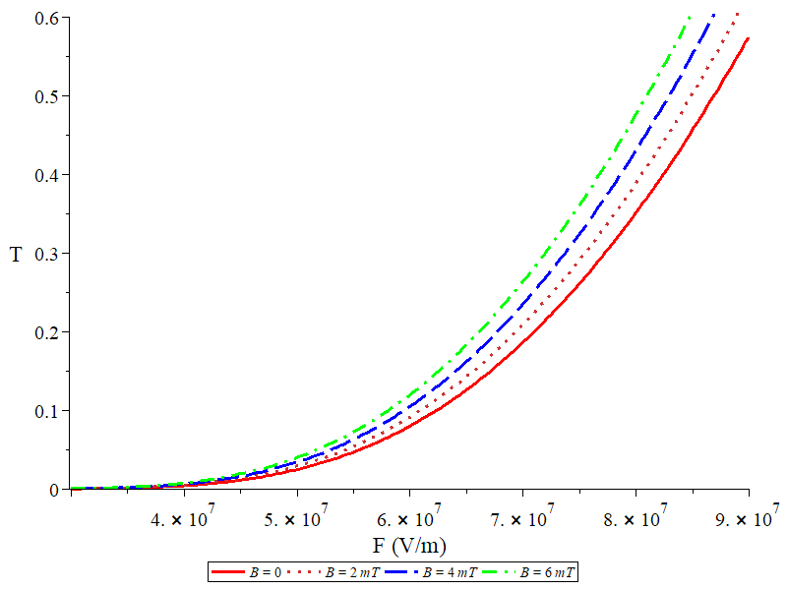 | 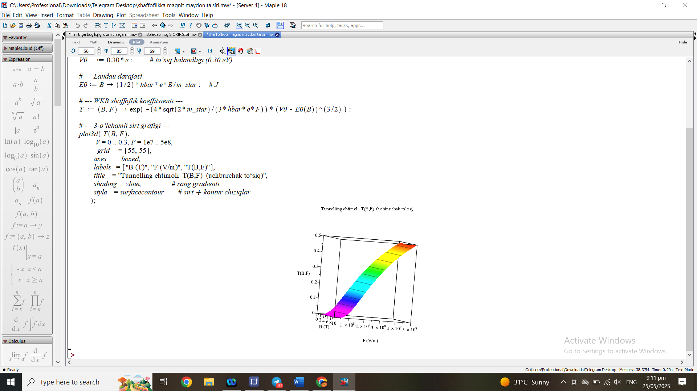
FIGURE 2. Variation of tunneling probability as a function of the electric field for different values of magnetic field induction. | FIGURE 3. Three-dimensional representation of the tunneling probability as a function of the magnetic field (B) and electric field (F).

The relationship of the tunneling probability T to the electric field and the magnetic field at different levels is depicted in Figure 2. The graph reveals that the probability of tunneling becomes more likely with the electric field's strength being higher. In addition, when there is a magnetic field present, the probability of tunneling is still greater than it was with no magnetic field (B=0). One can conclude this as stated in Eq. (7), the lowering of the potential barrier height, which results from the integration of Landau levels, has outweighed the negative influence of the magnetic field. Therefore, the magnetic field becomes an aiding factor in the tunneling process. Figure 3 presents the relationship between the tunneling probability T (B, F) and the electric and magnetic fields. It can be seen that the tunneling probability is not only influenced by the electric field but also by the magnetic field—so, the stronger both fields are, the higher the probability of tunneling. It is a matter of fact that, according to Eq. (7), the above-mentioned behavior can be interpreted in terms of the potential barrier height decrease due to the magnetic fields and the lightening of the particle's transmission energy through the barrier by the electric fields. Such an approach thereby gives rise to a thoroughgoing examination of quantum tunneling events. The findings are especially valuable for quantum devices that rely on concurrent application of electric and magnetic fields, such as resonant tunneling diodes, quantum dots, magnetic field sensors, and superlattice structures. The graph results signify that the tunneling process is mainly under the influence of the electric and magnetic fields to some extent, which turns out to be a theoretical foundation for the generation and designing of next-generation quantum electronic systems. Therefore, it is the quantization of the electron energy level by the magnetic field that controls the tunneling probability.
The following will describe the behavior after the addition of an external UHF field to the analyzed magnetic field. Quantum tunneling in the presence of a UHF field may be described using the Tien–Gordon model, where electrons interact with photons while tunneling. The applied microwave voltage is expressed as: [8]:
$V\left(T\right)=V_{dc}+V_{ac}\cos\left(wt\right)$ (8)
$E\left(T\right)=E+eV_{ac}\cos\left(wt\right)$ (9)
The wave function of the electron takes the following form:
$φ(t)≈exp⁡(-\frac{i}{ℏ}\int{E\left(t\right)dt)=e^{\frac{-iEt}{ℏ}}}{*e}^{iα\sin\left(wt\right)}$ (10)
Here, $V_{ac}$ is the amplitude of the microwave field, $w$ is the angular frequency of the field, $α=\frac{eV_{ac} }{ℏω}$ is the modulation parameter.
The exponential phase factor in the electron wave function can be expanded in terms of Bessel functions as follows:
$e^{iα\sin\left(wt\right)}=\sum_{n=-∞}^{+∞}{J_{n}\left(α\right)*e^{-inwt}}$ (11)
This implies that the electron can absorb or emit nnn photons, thereby increasing or decreasing its total energy to $E+nℏω$. The electron then tunnels through the potential barrier with this modified energy.
Thus, the total tunneling probability can be expressed as follows:
$T_{eff}(a)=\sum_{n=-∞}^{+∞}{{J_{n}\left(α\right)}^{2}*T_{0}(E+nℏω) }$ (12)
Here, $T_{eff}\left(a\right)$ denotes the total tunneling probability under the influence of the UHF, , $J_{n}\left(α\right)$-is the Bessel function of order n, and $T_{0}\left(E+nℏω\right)$ represents the tunneling probability at each energy level.
In this formula, each n-photon channel has its own tunneling probability, weighted by the square of the corresponding Bessel function. Consequently, the total transmission coefficient is obtained by summing over these probabilities. The angularly averaged tunneling probability can be expressed as follows:
$T_{eff}(a)=\frac{1}{2π}\int_{0}^{2π}{T_{0}(E+}ℏωαcosφ)dφ$ (13)

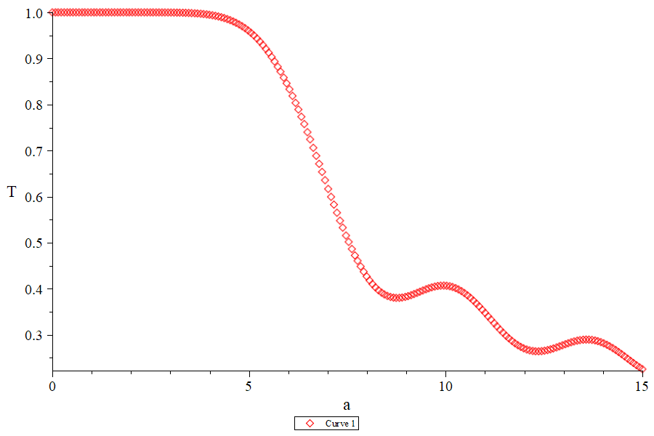 | 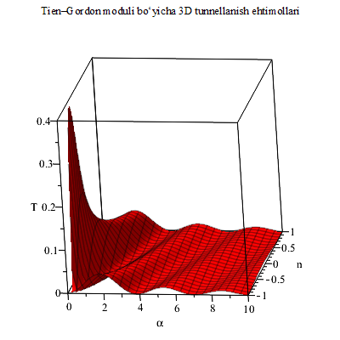
FIGURE 4. Dependence of the tunneling coefficient on the modulation parameter. | FIGURE 5. Dependence of the tunneling coefficient on α (modulation parameter) and n (photon number).

From Figure 4, it is evident that the tunneling coefficient changes periodically with an increase in the modulation parameter α of the microwave electromagnetic field. This behavior is connected to the characteristics of Bessel functions, wherein the input of photon-assisted tunneling channels gets stronger with the increase of the modulation parameter. With small values of α, the tunneling is predominantly through the fundamental channel (n=0), implying that the microwave field has no influence at all. On the contrary, at moderate and high values of α, the participation of the higher-order channels (n≠0) becomes quite significant, therefore stating that tunneling is indeed assisted by photons. The peaks and troughs seen in the chart are linked to the alterations in the input of each channel, which is in turn altered by the squares of the Bessel functions. Thus, it can be concluded that the application of a microwave field causes the quantum states of electrons to oscillate, which in turn results in the oscillation of the tunneling probability through the interaction with photons. The Tien–Gordon model posits that when a particle gets entangled with an external electromagnetic field, it may absorb or emit n photons during the tunneling process. Therefore, the tunneling probability for each channel is given as a function of the square of the respective Bessel function. The theoretical investigation of the alteration of the transmission coefficient caused by a microwave field during the quantum tunneling process was the objective of this study. It turns out that for specific values of the modulation parameter α and the number of photons n, the tunneling probability is maximized, which is in line with the notion of resonant quantum-mechanical tunneling states. Theoretically, this work shows that the strong electromagnetic field can be modulation-controlled quantum tunneling process. The obtained results open up the possibility of controlling tunnel diodes, quantum dots, and resonant tunneling devices at the high-frequency level, thus providing a basis for future nanoelectronics applications. Thus, both the microwave field and quantum mechanics affect the tunneling process and create resonant tunneling states. After that, we will study how the mechanical deformation affects the tunneling process.
Finally, the effect of mechanical deformation on the tunneling and current–voltage (I–V) characteristics is analyzed. In classical experiments, strain modifies both the tunneling current and I–V curve. The total current can be written as [3]:
$I_{um}=I_{tun}+I_{diff}+I_{ex}$ (14)
$I_{ tun}—$tunneling current, $I_{diff}—$diffusion current, $I_{ex}—$excess current.
The pure tunneling current was written based on Esaki diode theory [16], and the effect of deformation was introduced through the reduced effective masses of electrons and holes [13]. Since the reduced mass appears in the expression for the tunneling probability, the tunneling coefficient also changes under the influence of deformation.
$$T=e^{\frac{-2d\sqrt{2μ(U_{0}-E)}}{ℏ}}$$
$I_{tun}=\frac{1}{2}Ae^{\frac{-2d\sqrt{2μqV}}{ℏ}}(ϰ_{n}+ϰ_{p}-qV)(\frac{(e^{\frac{ϰ_{n}}{kT}}+1)(e^{\frac{ϰ_{p}}{kT}}+1)}{(e^{\frac{ϰ_{n}-qV}{kT}}+1)(e^{\frac{-qV-ϰ_{p}}{kT}}+1)}$ (15)
$ϰ_{n}, ϰ_{p}$- Fermi energies on the n- and p-sides. $μ$-reduced effective mass.
$μ=\frac{m_{e}^{*}m_{h}^{*}}{m_{e}^{*}+m_{h}^{*}}$ (16)
$m_{e}^{*}$ and $m_{h}^{*}$ — the effective masses of electrons and holes, respectively.
$I_{diff}=I_{0}\left(e^{\frac{qV}{kT}}-1\right)$ (17)
$I_{0}-$saturation current.
In the absence of external influences, the excess current in tunnel diodes is expressed as follows.
$I_{ex}=G_{0}V$ (18)
In this work, the external influence is considered only as uniaxial strain, i.e., stretching or compression of the crystal along the direction. In this case, the directional component of the strain is determined as follows:
$ε=ε_{zz}-\frac{1}{2}(ε_{xx}+ε_{yy})$ (19)
Here, $ε_{zz}$ denotes the strain along the elongation direction, while ​ $ε_{xx}$ and $ε_{yy}$ represent the lateral strains (determined by the Poisson’s ratio). For small deformations, other strain components were neglected. Thus, in the model, strain was introduced only through $ε$.
Uniaxial deformation alters the dispersion relations of electrons and holes. The effective masses of electrons and holes then take the following linear form:
$m_{e}^{*}(ε)=m_{e0}^{*}$(1+$β_{e}ε$) $m_{h}^{*}(ε)=m_{h0}^{*}$(1+$β_{h}ε$) (20)
As a result, the reduced mass varies with the relative deformation as follows:
$μ(ε)=\frac{m_{e}^{*}(ε)m_{h}^{*}(ε)}{m_{e}^{*}(ε)+m_{h}^{*}(ε)}$ (21)
Based on this, the tunneling probability under the influence of uniaxial deformation can be expressed as follows:
$T=e^{\frac{-2d\sqrt{2\frac{m_{e}^{*}(ε)m_{h}^{*}(ε)}{m_{e}^{*}(ε)+m_{h}^{*}(ε)}(U_{0}-E)}}{ℏ}}$ (22)
An increase in μ under the influence of deformation leads to a decrease in the tunneling probability. Substituting this variation into the current–voltage characteristic (I–V curve) yields the following expression:
$I_{tun}=\frac{1}{2}Ae^{\frac{-2d\sqrt{2qV\frac{m_{e}^{*}(ε)m_{h}^{*}(ε)}{m_{e}^{*}(ε)+m_{h}^{*}(ε)}}}{ℏ}}(ϰ_{n}+ϰ_{p}-qV)(\frac{(e^{\frac{ϰ_{n}}{kT}}+1)(e^{\frac{ϰ_{p}}{kT}}+1)}{(e^{\frac{ϰ_{n}-qV}{kT}}+1)(e^{\frac{-qV-ϰ_{p}}{kT}}+1)}$ (23)

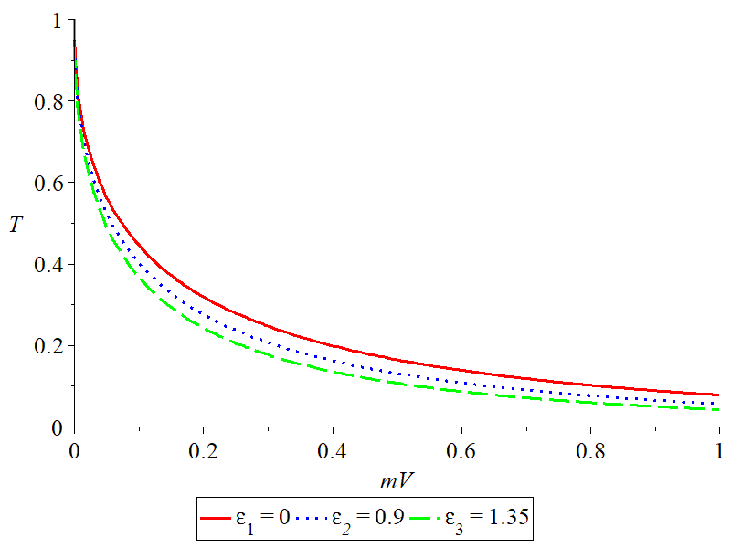 | 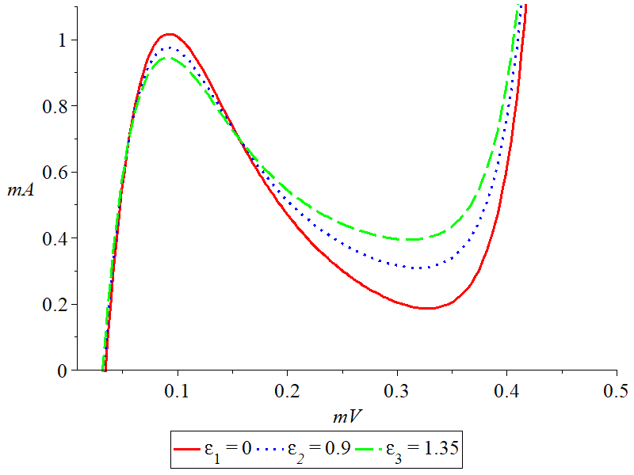
FIGURE 6. Variation of the tunneling coefficient under the influence of deformation. | FIGURE 7. I–V characteristics of a GaSb tunnel diode under the influence of deformation, obtained from equation (22).

As the deformation increases, the number of defect channels rises, leading to an increase in the excess current. This phenomenon can be described by the following expression:
$I_{ex}(ε)=G_{0}(1+α_{1}ε+α_{2}ε^{2})V$ (24)
Here, $α_{1}$ and $α_{2}$ are the deformation sensitivity coefficients. This expression explains the increase in excess current under deformation.
$I_{um}(ε)=I_{tun}(ε)+{+I_{ex}(ε)+I}_{diff}$ (25)
$I_{um}(ε)= \frac{1}{2}Ae^{\frac{-2d\sqrt{2qV\frac{m_{e}^{*}(ε)m_{h}^{*}(ε)}{m_{e}^{*}(ε)+m_{h}^{*}(ε)}}}{ℏ}}(ϰ_{n}+ϰ_{p}-qV)(\frac{(e^{\frac{ϰ_{n}}{kT}}+1)(e^{\frac{ϰ_{p}}{kT}}+1)}{(e^{\frac{ϰ_{n}-qV}{kT}}+1)(e^{\frac{-qV-ϰ_{p}}{kT}}+1)}+G_{0}(1++α_{1}ε+α_{2}ε^{2})V+I_{0}\left(e^{\frac{qV}{kT}}-1\right)$ (26)
The performed calculations show that the I–V characteristics of the tunnel diode perfectly correspond to the classical Esaki model in the absence of deformation. The tunneling current, the negative differential resistance region, and the tail section were clearly observed. These results qualitatively agree with the experimental data reported in reference [10]. When a uniaxial compressive deformation is applied to the crystal, the energy spectra of electrons and holes are redistributed. As a result, the resonant tunneling region becomes narrower, and the tunneling current decreases compared to the undeformed state.
CONCLUSION
From this agreement of theoretical calculations with experimental data, several important conclusions can be drawn. In the present work, the effects of magnetic, UHF, and mechanical deformation fields on the tunnel process in semiconductor tunnel diodes have been theoretically analyzed. Analytical expressions for tunnel probability and I-V characteristics have been obtained within the framework of the semiclassical WKB approximation and the Tien-Gordon model. The given analysis has shown that the magnetic field increases the probability of tunneling due to Landau quantization, while the UHF field results in photon-assisted multichannel tunneling. On the other hand, the mechanical deformation changes the effective masses of charge carriers and parameters of the potential barrier and shifts the I-V characteristics. Theoretical results obtained show good qualitative correspondence with experimental data reported earlier, which confirms the validity of the model developed to describe tunnel processes in semiconductor structures under external actions.
REFERENCES
- Esaki, L. (1958). New phenomenon in narrow Germaniump−nJunctions. Physical Review, 109(2), 603–604. https://doi.org/10.1103/physrev.109.603
- Sze, S. M. (1981). Physics of semiconductor devices (2nd ed.). John Wiley & Sons.
- Tsu, R., & Esaki, L. (1973). Tunneling in a finite superlattice. Applied Physics Letters, 22(11), 562–564. https://doi.org/10.1063/1.1654509
- G Vieira, G., Guimarães, P., Alves, E., Allen, S., Campman, K., & Gossard, A. (1998). Resonant magnetic field induced enhancement of the tunneling current in multi-quantum wells. Physica B Condensed Matter, 256–258, 527–530. https://doi.org/10.1016/s0921-4526(98)00541-9
- Berger, P., Gulyamov, G., Dadamirzaev, M., Uktamova, M., & Boidedaev, S. (2024). Influence of microwave and magnetic fields on the electrophysical parameters of a tunnel diode. Romanian Journal of Physics, 69(3–4), 609. https://doi.org/10.59277/romjphys.2024.69.609
- Gulyamov, G., Majidova, G., Muxitdinova, F., & Madumarova, S. (2023). [Title of the conference paper]. In AIP Conference Proceedings (Vol. 2700, p. 050008). AIP Publishing. https://doi.org/10.1063/5.0126385
- Tien, P. K., & Gordon, J. P. (1963). Multiphoton process observed in the interaction of microwave fields with the tunneling between superconductor films. Physical Review, 129(2), 647–651. https://doi.org/10.1103/PhysRev.129.647
- Uktamova, M. K., & Nazarov, S. (2022). [Title of the article]. Web of Scientist: International Scientific Research Journal, 3(10), 800–806. https://wos.academiascience.org/index.php/wos/article/view/2601/2475
- Pittel, J., & Rindner, W. (1967). Degeneracy effects in tunnel diodes. *Solid-State Electronics, 10*(8), 767–770. https://doi.org/10.1016/0038-1101(67)90005-6
- Bernard, W., Rindner, W., & Roth, H. (1964). Photon-assisted tunneling in metal-semiconductor junctions. Journal of Applied Physics, 35(6), 1860–1864. http://dx.doi.org/10.1063/1.1713755
- Zhao, W. (2009). Characterization and modeling of tunneling field-effect transistors (TFETs) for low power applications [Doctoral dissertation, University of Notre Dame].
- Murphy-Armando, F., Chang Liu, Yi Zuhao, & Duffy, R. (2025). Non-equilibrium Green’s function simulation of tunneling field-effect transistors: A tutorial. Physica Status Solidi RRL–Rapid Research Letters, 19(6), 2400221. https://doi.org/10.1002/pssr.202400221
- Vieira, G. S., Guimarães, P. S. S., Oliveira, C. R., Sombra, A. S. B., & Neto, O. P. V. (1998). Tunneling current fluctuations in resonant tunneling diodes: A Monte Carlo approach. Physica B: Condensed Matter, 256–258, 635–638. https://doi.org/10.1016/S0921-4526(98)00541-9
- Esaki, L., & Haering, R. R. (1962). Tunneling from an accumulation layer in silicon. Journal of Applied Physics, 33(6), 2106–2109. https://doi.org/10.1063/1.1728904
- Jensen, K. L., Shabaev, A., Riga, J. M., & Lambrakos, S. G. (2021). Reevaluating the Hartman effect for field emission. Physical Review A, 104(6), 062203. https://doi.org/10.1103/PhysRevA.104.062203
- Landau, L. D., & Lifshitz, E. M. (1977). Quantum mechanics: Non-relativistic theory (3rd ed.). Pergamon Press.
- Dadamirzaev, M., Kosimova, M., Boydedayev, S., & Makhmudov, A. (2024). The influence of barrier thickness on the characteristics of a resonant tunnel diode. East European Journal of Physics, (2), 372–379. https://doi.org/10.26565/2312-4334-2024-2-46

