Investigation of Printed Circuit Board Enrichment Using Magnetic and Pneumatic Separation Methods
Umidjon Khujamov^{a)}, Shakhnoza Khalilova
Navoi State University of Mining and Technologies, Navoi, Uzbekistan

^{a)}Corresponding author: xujamovumid@gmail.com
Abstract. This article presents research results on the processing and enrichment of electronic scrap, particularly printed circuit boards. The initially crushed printed circuit board is enriched using magnetic separation. However, the negative result was the main reason for conducting further experiments using the gravitational enrichment method. As the main method of gravitational enrichment, pneumatic separation was chosen, the purpose of which is to separate metallic compounds from non-metallic ones in the air flow. A laboratory pneumatic separator was used in the laboratory research. The main factor influencing the process of obtaining pneumatic concentrate is the size of the incoming fractions.The experiments were conducted using a crushed product of varying sizes: -63 μm, -125 μm, -250 μm, -500 μm. During the conducted experiments, the optimal enrichment method for printed circuit boards was determined, and the main technical and economic indicators of enrichment were obtained.
Keywords: magnetic separator, printed circuit board, pneumatic separator, magnetic fraction, concentrate.
INTRODUCTION
Globally, the annual accumulation of electronic waste exceeds 60 tons, resulting in the use of electronic and electrical equipment, of which 10 million tons of raw materials are processed in the mining and metallurgical industry and over 70% accumulate in dumps as technogenic waste. Large areas of land suitable for economic needs are occupied by dumps. Here, the landscape is disrupted, the ecological situation of the region is deteriorating. Therefore, the requirement for environmental protection is increasing, the mandatory environmental condition indicates the need to utilize technogenic production waste, to pay special attention to increasing the complexity of raw material utilization, and to apply resource-saving technology[1, 2].
Currently, the intensification of work on the development of effective methods for processing electronic scrap and extracting all useful components from them is accelerating worldwide. Work is also underway to transition to low-waste and waste-free technologies, involving all types of electronic waste in their recycling. At the same time, the basis for creating new highly efficient technologies in the metallurgical industry is the development of integrated technologies for processing electronic scrap in the production process, the introduction into practice of methods for extracting valuable metals and valuable components from electronic waste[3, 4].
When choosing the enrichment method, the physical and chemical properties of the crushed printed circuit boards were taken into account. For magnetic enrichment of printed circuit boards, the main element is the iron content. Scientific research conducted on magnetic enrichment allows for the separate processing of the magnetic fraction. The non-magnetic fraction is processed using another enrichment method or subjected to metallurgical processing.
METHODS
Crushing and grinding printed circuit boards is one of the urgent tasks before enrichment, as conventional crushers used in ore crushing cannot perform these functions. Here, it is necessary to consider the following factors, such as the properties of printed circuit boards and production methods. In many printed circuit boards, epoxy resin is used as a binding agent, which leads to the appearance of elasticity in the boards. Experiments conducted in jaw, conical, and roller crushers proved the above-mentioned opinion. For the research, a mass of 1 kg of printed circuit boards was taken. 840 grams of product were received for the crushing process of a heat-treated printed circuit board using a single-rotor crusher. The crushing process was carried out for 5 minutes and a fraction of 5 mm was obtained (see Fig. 1).

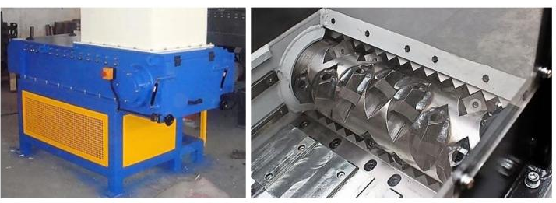
FIGURE 1. Single-rotor shredder.

The advantages of a single-rotor crusher crusher are that the product is obtained homogeneously in terms of size, as well as in terms of equipment design, used knives can be rearranged and reused in the process. Crushing is the next stage in reducing size, and this process is considered important for further enrichment and hydrometallurgical stages. The IVS-4 (75T-DRM) brand vibration sampler was used as the grinding equipment (see Fig. 2).

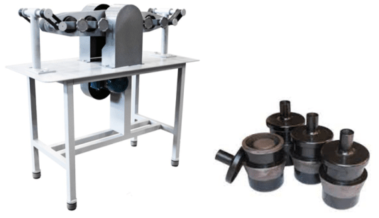
FIGURE 2. Vibrating IVS-4 (75T-DRM) Sample Eraser.

The grinding time was determined experimentally. The resulting product was analyzed after grinding using the Retsch AS 450 control vibration screen, resulting in a granulometric composition.
Magnetic enrichment experiments were conducted on a ROLLER DRY MAGNITIK XSG magnetic separator, which operates by the dry method (see Fig. 3).

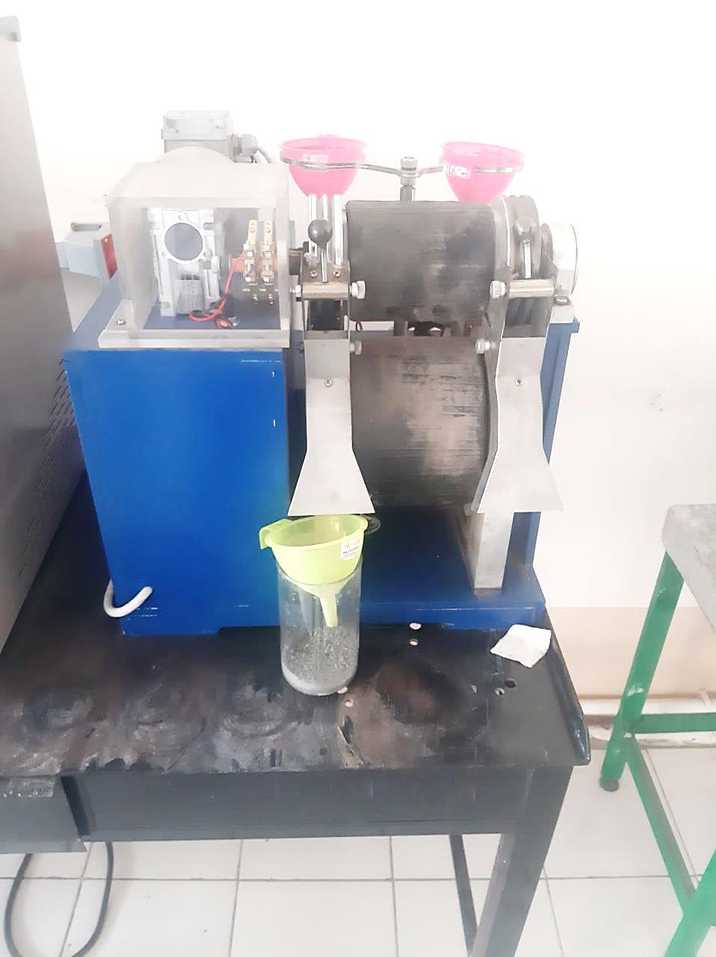
FIGURE 3. ROLLER DRY MAGNITIK XSG Magnetic Separator.

Gravitational enrichment of the ground product was carried out on a laboratory pneumatic separator (see Fig. 4).

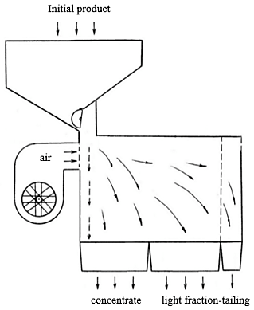
FIGURE 4. Laboratory pneumatic separator.
RESULTS AND DISCUSSION
Figure 5 shows the results of crushing printed circuit boards to a size of 5 mm.

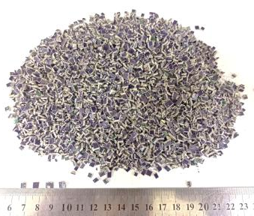
FIGURE 5. Product appearance after crushing the printed circuit board with a single-rotor crusher crusher.

Based on the results of the conducted research on the grinding of printed circuit boards, a graph of time dependence on the degree of grinding was compiled, shown in Figure 6.

FIGURE 6. Dependence of crushing degree on time.
As a result of sieving using a selective screen, the granulometric composition of the ground product was obtained (see Table 1).

TABLE 1. Granulometric analysis result of the ground product

Size class output
-0.5+0.250 mm |  | -0.250+0.125 mm |  | -0.125+0.63 mm |  | -0.63 mm |  | Total weight
gr. | % | gr. | % | gr. | % | gr. | % | gr. | %
- | - | 10.08 | 1.2 | 504.84 | 60.1 | 325.08 | 38.7 | 840 | 100

When grinding the suprasettle product, the optimal grinding time was 1 minute for each sample, and the resulting grated product has a size of -125 μm (see Fig. 7).

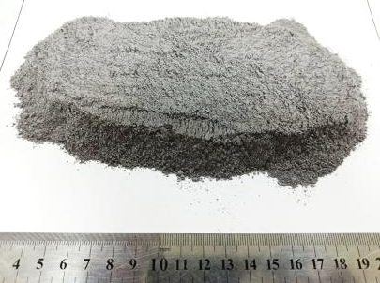
FIGURE 7. A crushed product with a size of -125 μm.

This particle size is sufficient for enrichment operations and therefore no further grinding experiments have been conducted.
The analysis results showed the economic inexpediency of using this method for enriching crushed printed circuit boards, as the resulting concentrate contains, in addition to iron, other non-ferrous metals, which led to additional processing of the magnetic fraction to separate other metals (see Table 2., Figure 8 and 9), and in the mixture of the non-metallic product, other metals occurred as alloys with iron.

FIGURE 8. Extraction of metals into magnetic enrichment products.
TABLE 2. Content of basic metals in magnetic product

№ | Metal | %
1 | Cu | 46,36
2 | Fe | 25,7
3 | Ni | 10,4
4 | Pb | 10,99
5 | Ti | 0,021
6 | Zn | 2
7 | Sn | 0,072
8 | Al | 0,0012

Further research was conducted on a pneumatic separator with various sizes of crushed printed circuit boards. The experiments were conducted using a crushed product of varying sizes: -63 μm, -125 μm, -250 μm, -500 μm (see Fig. 9).

FIGURE 9. Metal content in concentrate depending on grinding size.

Using this analysis method, the metal content in the obtained beneficiation products was studied depending on the size (see Fig. 10).

FIGURE 10. Yield of enrichment products at different sizes.

According to the analysis results, it can be seen that during grinding to a particle size of -63 μm, the copper and other metals content in the concentrate was lower than at a particle size of -125 μm. At fineness of -250 μm and -500 μm, the metal content in the concentrate was even lower than at fineness of -125 μm. The metal content in the tail of the enrichment showed a copper content of 2.033% with a fineness of the crushed product of -125 μm.
CONCLUSION
As a result of experiments conducted on jaw, conical, and roller crushers, it was proven that crushers used for ore crushing are unsuitable for processing printed circuit boards, and a single-rotor crusher crusher was selected as the optimal equipment for crushing printed circuit boards. The grinding time was determined experimentally, and the optimal time for grinding the crushed product in the IVS-4 (75T-DRM) vibration abrasive sample was 1 minute for each sample. Granulometric analysis was carried out using the Retsch AS 450 control vibration screen, where sample sizes were determined from -0.125 to +0.63 mm fractions and up to -60.1%, as well as -0.63 mm fraction together with the fraction - 38.7%.
Magnetic enrichment experiments were conducted on a ROLLER DRY MAGNITIK XSG magnetic separator operating on a dry method. The analysis results showed the economic feasibility of using this method for enriching crushed printed circuit boards, as the resulting concentrate contains, in addition to iron, other non-ferrous metals, which led to additional processing of the magnetic enrichment products.
Scientific research on gravitational enrichment was conducted on a laboratory pneumatic separator. The experiments were conducted at different sizes of the grinding product: -63 μm, -125 μm, -250 μm, -500 μm. As a result of the analysis of the beneficiation products for metal content, it was determined that the optimal particle size for pneumatic separation is -125 μm. At this size, the concentrate yield was 62.56% and the waste yield was 21.44%, respectively. The copper content in the concentrate was 22.25%, and in the tail of the pneumatic enrichment was 2.033%. These indicators prove the feasibility of using the pneumatic enrichment method as an enrichment process in the processing of printed circuit boards.
REFERENCES
- P. Hadi, M. Xu, C.SK. Lin,. (2015). Waste printed circuit board recycling techniques and product utilization. Journal of Hazardous Material, 283, 234–243. https://doi.org/10.1016/j.jhazmat.2014.09.032
- Khamidov, R., Narzullayev, Zh., Kuznetsov E. (2021). Prerequisites for Processing a Foam Product in the Process of Bacterial Oxidation of Gold-Bearing Concentrates in a Separate Cycle. The Second Interregional Conference “Sustainable Development of Eurasian Mining Regions (SDEMR-2021)” E3S Web of Conferences 278, 01012 , 483–492. https://doi.org/10.1051/e3sconf/202127801012
- Vokhidov, B., Mamaraimov, G., Khurramova, D., Dauletov, K., Babayev, M., Khujamov, U. (2025). Investigation of the technology for extracting vanadium semi-products from Sijjak ore fields. VI International Conference on Geotechnology, Mining and Rational Use of Natural Resources (GEOTECH-2025), E3S Web of Conferences 627, 03007. https://doi.org/10.1051/e3sconf/202562703007
- Normurodov, A., Badalov, F., Asabayev, D., Botirov, M., Jabborov, E., Khujamov, U. (2025). Cleaning talc samples from iron-containing minerals. VI International Conference on Geotechnology, Mining and Rational Use of Natural Resources (GEOTECH-2025), E3S Web of Conferences 627, 01007. https://doi.org/10.1051/e3sconf/202562701007

