Analysis of Energy-Saving Properties of Motor Oils Under Operating Conditions
Shovkat Magdiyev¹, Murodjon Rakhmatov^{1, a)}, Nurlan Quatbekov²
¹Tashkent State Transport University, Tashkent, Uzbekistan
²Peoples' Friendship University named after Academician A.Kuatbekov,
Shymkent, Kazakhstan

^{a)}Corresponding author: murodjonraxmatov9@gmail.com
Abstract. In an internal combustion engine, the primary function of motor oils is to reduce friction and wear on engine parts by creating a durable oil film on their surfaces. To reduce oil consumption, it's important to choose a rational oil change interval. This requires establishing a schedule for motor oil changes by determining the content of wear products in the oil.
Keywords: effective heat dissipation, reliable protection, high stability, long oil life, reasonable oil life.
INTRODUCTION
The operating conditions of oils in internal combustion engines are constantly becoming more stringent. Increasing engine load and speed modes and reducing the specific capacity of the lubrication system lead to an increase in the temperature of the main parts and, as a consequence, to an intensification of oil oxidation processes.
The main function performed by motor oils is to reduce friction and wear of engine parts by creating a strong oil film on their surfaces [1].
METHODS
At the same time, motor oils must provide:
- sealing gaps in the mating surfaces of a running engine, primarily in the cylinder-piston assembly;
- efficient heat dissipation from rubbing parts, removing wear debris and other foreign substances from friction zones;
- reliable protection of engine component working surfaces from the corrosive effects of oil oxidation and fuel combustion products;
- prevents the formation of all types of deposits (carbon, varnish, ash, sludge) on engine parts during operation under various conditions;
- high stability against oxidation, mechanical stress, and water contamination, i.e., preservation of the original properties both under a variety of operating conditions and during long-term storage;
- low oil consumption during engine operation;
- long oil life before replacement without compromising engine reliability.
The performance of the specified functions by motor oils is possible only if their quality satisfies a number of operational requirements [2]:
- possess optimal viscosity properties, ensuring reliable and economical operation of units under all operating conditions;
- have good lubricating properties to prevent intensive wear of rubbing parts;
- possess sufficient chemical resistance, ensuring minimal changes in the lubricant's properties during use, as well as low formation of corrosive products and harmful deposits, which ultimately allows for extended lubricant life with minimal corrosive and mechanical wear of mechanisms;
- be resistant to evaporation, foaming, and emulsion formation, as well as additive loss;
- reliably protect friction surfaces and other metal parts from atmospheric corrosion.
RESULTS AND DISCUSSION
To perform the above functions, during daily maintenance and the first maintenance, the oil level is checked (topped up if necessary), and during the second maintenance, the oil in the engine crankcase is changed (according to the schedule) and the filter elements (coarse and fine) are washed [4].
According to GOST 21624, the recommended intervals for the first and second maintenance of trucks for Category I operating conditions are 3,500 and 14,000 km, respectively. Recommended intervals (in kilometers or engine hours) for crankcase oil changes are also established by many manufacturers. However, these guidelines provide virtually no guidance on the possible operating modes of the lubrication system, taking into account operating conditions, or on engine oil rejection criteria [3].
The reliable and trouble-free operation of vehicles largely depends on the quality and timely replacement of engine oils. Given that domestically produced vehicles are currently widely used on the roads of the Republic of Uzbekistan, this task is highly relevant.
The main objective of this research work is to determine and justify the choice of rational timing for replacing motor oils in domestically produced vehicles.
Taking into account the peculiarities of vehicle operation in urban conditions, the composition and properties of local fuel, as well as the manufacturer's recommendations for the use of fuel and lubricants, we were faced with the task of being able to use imported and domestically produced motor oils.
The study of changes in the quality of motor oils during operation will be carried out by taking samples after 3000-4000 km of vehicle travel and determining the kinematic viscosity at 100ºC, alkalinity, flash point, as well as the content of wear products by spectral analysis [4-5]. Based on the results of the analysis of literary sources, maximum permissible values of physical and chemical indicators characterizing the quality of motor oils were established (see Table 1).

TABLE 1. Maximum permissible values of physicochemical parameters characterizing the quality of motor oils

Physicochemical properties | Meaning
Change in viscosity at 100ºС from the nominal value:
- decrease | 15-20 %
- increase | 20-25 %
Flash point in open crucible, not less than | 180 ºС
Total alkaline number, not less than | 3 mg KON/g
Fuel content in oil, not more than | 0,8 %

To determine the timing of oil changes, it is of interest to study not only such quality indicators as kinematic viscosity, base number and flash point, but it is also very important to determine the wear products in the oil, which are limited to certain values in the standards.
Due to the constant improvement of modern engines (increasing the power per liter while decreasing the mass indicators), the temperature and load conditions of the engine parts are increasing sharply, which leads to stricter requirements for the properties of the oils used, which in turn leads to an increase in cost and production.
Thus, the above-mentioned features of the lubrication system operation also make it possible to solve the issues of reducing fuel consumption and harmful exhaust emissions and thereby take into account the energy-saving properties of crankcase oil [6].
Such oils have a lower viscosity or controlled viscosity, i.e. they contain thickening additives that, depending on the speed of movement of engine parts and their temperature, maintain a rational level of viscosity from the point of view of reducing friction costs.
Furthermore, given that certain engine operating modes have a marginal lubrication regime, the oil must contain friction-modifying additives. By meeting these requirements, fuel savings of up to 5.5% can be achieved under real-world operating conditions.
In conclusion, it should be noted that the rational frequency of replacing crankcase oil, taking into account its energy-saving properties, should take into account the brand of oil; type and design features of the engine (gasoline, diesel, turbocharged, etc.); technical condition of the engine and its units (topping up oil); conditions (intensity) of operation; professional level of the driver; road and climatic conditions; the level and rationality of the technology of technical maintenance and lubrication and air preparation systems; depletion of base additives and loss of light fractions; type and brand of motor fuel used; presence of an exhaust gas toxicity reduction system [7-8].
To determine the timing of oil changes, it is of interest to study not only such quality indicators as kinematic viscosity, base number and flash point, but it is also very important to determine the wear products in the oil, which are limited to certain values in the standards.
In this regard, we will conduct research on the content of wear products (Fe, Al, Pb, Cu, Sn, Si, and Cr) using spectral analysis [9].
It is known that the method for determining the energy-saving properties of oils includes bench tests of the engine with the oils under study, where mechanical friction costs are determined.
This process is labor-intensive and requires a lot of material and labor costs. The proposed method for assessing the energy-saving properties of oils is quite simple. It is based on experimental studies and is implemented as follows:
1. The viscosity-temperature characteristic is constructed experimentally using a step of ∆t = 20°C in the range from 20°C to 100°C. The adopted temperature limit covers the temperature limit (20°C to 100°C) specified in regulatory documents (see Fig. 1).
2. The kinematic viscosity of oil samples was determined using a glass capillary viscometer ASTM D445, using the SAE J300 method. The results are presented in Table 2.

TABLE 2. Change in oil viscosity depending on heating temperature

Types of oil | Heating temperature, °С
Types of oil | 20 | 40 | 60 | 80 | 100
Reference | 192 | 81 | 44 | 25 | 15
M10DM | 150 | 55 | 27 | 21 | 12
М14DМ | 200 | 100 | 62 | 27 | 15
Texaco | 162 | 75 | 18 | 29 | 15

3. The resulting graphical data is subjected to statistical processing using Microsoft Excel applications. Regression equations are found for the oils under study (M10DM, M14DM, and Texaco) and for the reference oil (recommended by the manufacturer). In this case, the following functions are obtained:
$$Y^{etal}=C_{1}t^{3}+C_{2}t^{2}+C_{3}t+C_{4}=-0,0004t^{3}+0,109t^{2}-10,516t+358,6$$ | (1)
$$Y^{im(M10DM)}=C_{1}t^{3}+C_{2}t^{2}+C_{3}t+C_{4}=-0,0004t^{3}+0,1091t^{2}-9,8173t+304,13$$ | (2)
$$Y^{im(M14DM)}=C_{1}t^{3}+C_{2}t^{2}+C_{3}t+C_{4}=-0,0002t^{3}+0,0779t^{2}-8,6381t+341,8$$ | (3)
$$Y^{im(Texaco)}=C_{1}t^{3}+C_{2}t^{2}+C_{3}t+C_{4}=-0,0005t^{3}+0,1271t^{2}-11,522t+362,13$$ | (4)
We integrate these dependencies from $t_{20}$ to $t_{100}$ and obtain the following formulas:
- for reference oil:
$$У^{etal} = \int_{20}^{100}{(}-0,0004t^{3}+0,109t^{2}-10,516t+358,6)dt$$ | (5)
- for oil M10DM:
$$У^{im(М10DМ)} =\int_{20}^{100}{(}-0,0004t^{3}+0,1091t^{2}-9,8173t+304,13)dt$$ | (6)
- for oil M14DM:
$${У }^{im(М14DМ)}=\int_{20}^{100}{(}-0,0002t^{3}+0,0779t^{2}-8,6381t+341,8)dt$$ | (7)
- for Texaco oil:
$$У^{im(Texaco)} =\int_{20}^{100}{(}-0,0005t^{3}+0,1271t^{2}-11,522t+362,13)dt$$ | (8)
4. On the interval $t_{20}≤t≤t_{100}$, the areas under the curves $Y = f(t).$ The program displays them as a function
$$У(S_{i}) = X$$ | (9)
Here:
$X-$ is the area under the desired graph, found by integrating the corresponding dependencies $Y=f(t)$.

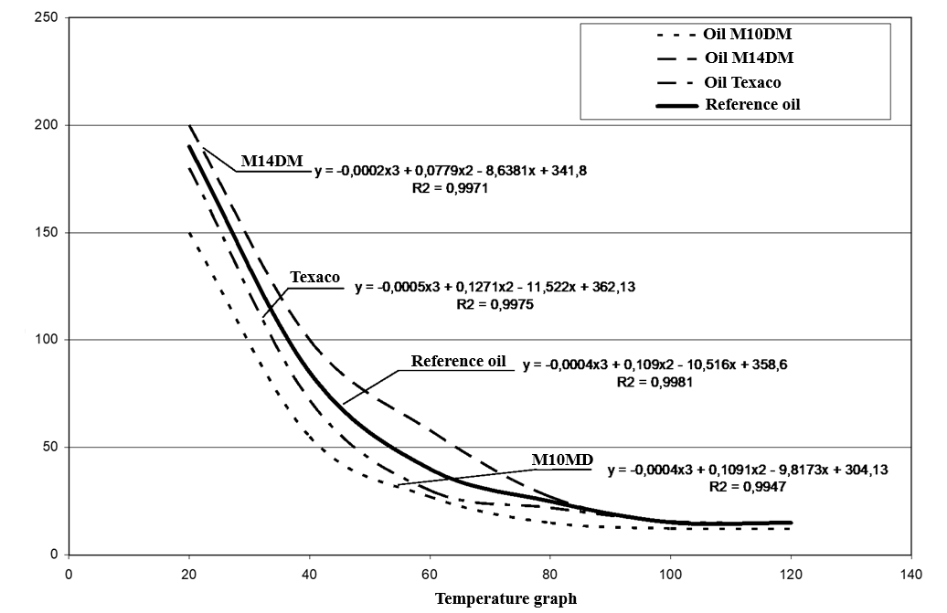
FIGURE 1. Viscosity-temperature characteristics of the oils studied

5. We determine the energy-saving properties of the oils under study using the formula
$$К_{es}=\frac{S_{u}^{im}}{S_{u}^{em}}-1$$ | (10)
If the ratio ${S_{u}^{im}}/{S_{u}^{em}}=1$, then $К_{es}=0,$ i.e., the oil being tested has the same energy-saving properties as the reference oil. That is, the viscosity of the oil being studied is equal to the specified standard.
If ${S_{u}^{im}}/{S_{u}^{em}}>1$, then $К_{es}>0,$ i.e., the oil being tested has the same energy-saving properties as the reference oil.
During the conducted assessment of the energy-saving properties of the studied oils in the range from 20°С to 100°С, it was obtained:
$$S^{etal} = 4269;$$ | $S^{im(М10DМ)}=3299$;
$$S^{im\left(M14DM\right)}=6659$$ | $S^{im(Texaco)}=3212$.
Then
$$К_{es}^{M10DM}=\frac{3299}{4269}-1=0,78-1=-0,22$$
$$К_{es}^{M14DM}=\frac{6659}{4269}-1=1,56-1=0,56$$
$$К_{es}^{Texaco}=\frac{3212}{4269}-1=0,75-1=-0,25$$
CONCLUSION
The following conclusions can be drawn from the results obtained:
- the tested M10DM oil has 22% lower energy-saving properties than the reference oil;
- the tested M14DM oil has 56% higher energy-saving properties than the reference oil;
- the tested Texaco oil has 25% lower energy-saving properties than the reference oil.
To obtain specific results, it is necessary to conduct research before replacing the engine oil, and then draw final conclusions.
Based on the analysis results, the following conclusions can be drawn:
1. Determine the key quality indicators of the tested motor oils over the vehicle's mileage before replacement.
2. To establish a schedule for motor oil replacement, it is necessary to determine the content of wear products in the oil.
REFERENCES
- Magdiyev, Sh. P. (2021). Technical operation and service of automobiles.
- Alimov, M., Riskulov, A., Nurmetov, K. (2023). Choosing of rational periodicity of engine crankcase oil changing taking into account energy-saving properties of oils. In E3S Web of Conferences (Vol. 401). EDP Sciences. https://doi.org/10.1051/e3sconf/202340105021.
- Kadirshaev, T., Tadjibaev, A., Ibrahimov, K. (2023). Improving the technological accounting of maintenance stations located in cities. AIP Conference Proceedings. https://doi.org/10.1063/5.0145667.
- Magdiyev Sh.P. and Rakhmatov M.I. (2024). Standardization of the Motor Oil Change Frequency in Automobiles in the Mountainous Conditions. International Conference on Thermal Engineering: Theory and Applications, ICTEA 2024.
- Nuritdinovich, B.M. and Uktamjonovich, O.M. (2025). AI-driven VIN verification and RFID integration for error-proofing in automotive manufacturing. Vibroengineering Procedia. https://doi.org/10.21595/vp.2025.24957.
- Riskulov A., Antonov A., Avliyokulov J. and Alimov M. (2025). Engineering materials based on modified industrial thermoplastics. AIP Conference Proceedings. https://doi.org/10.1063/5.0273703.
- Ibrahimov K.I., Alimova Z.Kh., Turakulov B.H. and Khalmurzaev N.B. (2025).Investigation of performance indicators of filtration materials used for air purification. AIP Conference Proceedings. https://doi.org/10.1063/5.0269660.
- Turakulov, Bakhtiyor (2025). Design and Diagnostics Features of Automatic Transmissions of the GM 6T Family. SAE Technical Papers. https://doi.org/10.4271/2025-01-8506.
- Abdinabi A. Tadjibayev., Vasik U. Jovliyev (2024). Evaluation of operational reliability indicators. International Scientific Conference on Green Energy (Green Energy 2024). https://doi.org/10.1051/e3sconf/202458703014.

