Development of a Solar Air Heater Based on Theoretical Analysis of Solar Air Heater Operating Method
Bekzod Abdukarimov^{a)}, Jaxongir Orzimatov, Jamshidbek Obidov, Doston Xoshimov, Azizbek Rakhmonov
Fergana State Technical University, Uzbekistan, 150107, Fergana, 86 Fergana str.

^{a)}Corresponding author: bekzodbek45484@mail.ru
Abstract. In this article analyzes the significance of utilizing renewable energy sources, with a particular focus on the environmental impact of solar energy. The increasing energy demand and ecological challenges necessitate the transition to renewable energy sources. Among these, solar energy stands out as the most sustainable and environmentally friendly source. Additionally, the article provides a theoretical examination of the widely used types of solar air heaters (SAHs), their operating principles, advantages, and disadvantages. Based on the conducted analysis, a new type of solar air heater is proposed to enhance the efficiency of existing systems. In addition, the article explores the numerical mathematical modeling of heat exchange processes occurring in solar air heaters. There is also the primary factor influencing the heat transfer capability of the solar air heater with a triangular absorber is the turbulence of the airflow. The averaged values of turbulence were obtained by solving the Navier-Stokes equations based on the principles of energy and mass conservation.
Keywords: energy, solar air heater, air flow, heat exchange, air duct, absorber, insulation, transparent surface, casing.
INTRODUCTION
In recent times, many researchers and scientists are conducting studies on the implementation of advanced technologies and equipment that enable the efficient and economical use of energy, fuel, and energy resources in heat supply systems. As is well known, the natural fuels and energy resources currently used on an industrial scale are rapidly depleting. Therefore, the use of renewable energy sources provides an opportunity to preserve natural resources and maintain the current ecological balance. [1-3]. In the 21st century, the world faces two serious challenges in the energy sector: ensuring a reliable energy supply and combating climate change. On one hand, emerging environmental problems, and on the other, an extremely unstable market for energy resources, along with the risks of an energy supply system based solely on fuel use—given the finite nature of all resources—could lead to serious energy-related issues in the future [4].
The use of various energy sources plays a crucial role in global economic development and industrialization. Today, solar energy is increasingly used as a vital source to meet the growing energy demand in the process of sustainable development. This is because it is an infinite and environmentally clean energy source.
Currently, one of the most expensive types of energy is thermal energy. This is due to the specific challenges involved in generating thermal energy. Additionally, the constant rise in fuel costs and the low efficiency of thermal power plants result in an efficiency of only about 40-70% in supplying heat to consumers
Depending on the intensity of surface cleaning, there are several methods to increase the efficiency of modern solar air heaters. The structure of the heater can be categorized into several types[5].
Air flow unidirectional moving collectors. One-flow single-pass – this is the most common and simple type of solar air heater. This type of solar air heater mainly consists of an air flow channel, a transparent glass surface, an absorber, and an insulating material at the bottom of the absorber. The absorber is located at the bottom of the air flow channel. The upper part of the channel may have one or more layers of transparent glass. The absorber is made of a material with a high solar absorption rate. Typically, a black plate is used as a selective absorber, as it is known for its high sunlight absorption. To prevent heat loss from the solar air heater's barrier structure, the bottom of the absorber is insulated. Solar radiation passes through the transparent surface and is absorbed by the absorber. The heat emitted by the heated absorber is transferred to the air flowing through the air duct. In a single-flow solar collector, the air inlet and outlet are direct. Therefore, this type of solar air heater is referred to as a single-flow single-pass heater based on its operating principle [6].

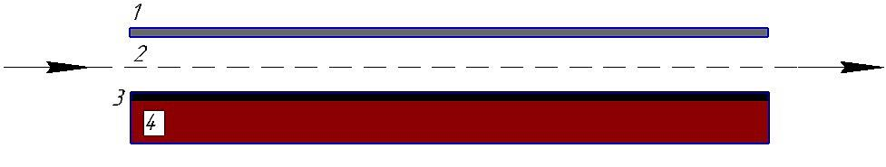
FIGURE 1. Principle diagram of a one-flow single-pass solar air collector: 1 – Transparent surface, 2 – air duct, 3 – absorber, 4 – insulation layer.

A one-flow single-pass solar air heater is very similar to a double-flow single-pass solar air heater. The main difference between them is the number of air flow channels. In a double-flow single-pass solar air heater, as shown in Figure 1, there are two air ducts. The upper air duct is located between the absorber, which absorbs solar radiation, and the transparent surface. The second duct, located at the lower part of the first channel, is positioned between the lower part of the absorber and the insulated surface. The incoming air is split into two flows: half of the air flows through the upper duct, while the other half passes through the lower duct. For both ducts, the airflow enters and exits directly. Therefore, such solar air heaters are referred to as "double-flow single-pass" heaters. Using a double-flow solar air heater increases the heat transfer surface area [7].

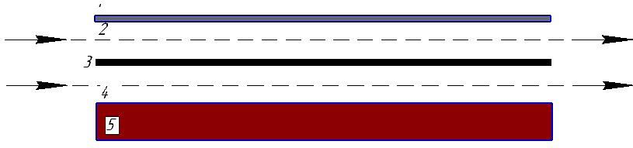
FIGURE 2. Principle diagram of a double-flow single-pass solar air collector: 1) Transparent surface, 2;4) air ducts, 3) absorber, 5) insulation layer (casing), 6) solar radiation.

Solar air heaters operating in the single-flow recirculation type (see Figure 2) are considered, where the air flow moves along the entire surface of the device. The relatively longer stay of air in the collector's working chamber positively affects the increase in air temperature. However, in general, the efficiency of collectors operating in this type is low [8].

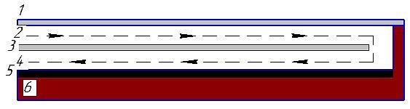
FIGURE 3. Principle diagram of a one-flow, double-pass solar air collector: 1) Transparent element, 2;4) air ducts, 3) transparent surface, 5) absorber, 6) insulation layer (casing).

Airflow collectors in double-flow. In the first type of collector, there are two air ducts: one between the transparent material and the absorber, and the other between the absorber and the thermal insulation (see Figure 3). The airflow passes over both the top and bottom surfaces of the absorber. In the second type of collector, the absorber is shorter than the length of the air duct. As a result, the airflow first moves between the bottom surface of the absorber and the insulation, and then it flows between the transparent material and the upper surface of the absorber, washing over the top surface of the collector absorber. Therefore, the friction surface between the absorber and the airflow increases, which increases the path length of the airflow passing through the collector [8]. In the research, the heat conductivity and heat transfer characteristics of a solar air heater filled with wire mesh matrices were studied. The experiments were conducted using geometric parameters of the wire mesh matrices, such as the height and number of layers of the air duct (see Figure 4). The dimensions of the solar air heater are 2390 x 500 mm. The height between the two glass covers installed as the transparent surface is 20 mm. The wire mesh grid is placed between the second glass layer and the lower absorber. The heat exchange and local resistance coefficients depend on the wire diameter, height, and the number of layers in the matrix.
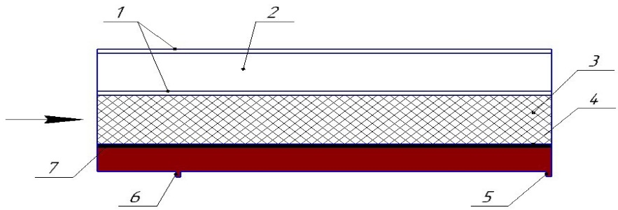
FIGURE 4. Diagram of a solar air heater with different absorbers.

To evaluate the application and feasibility of such a system, a solar air heater was developed. The absorber surface is made of black-painted carbon steel with dimensions of 1800 x 1000 x 4 mm. A single-layer glass cover with a thickness of 3 mm was used in the device. Two aluminum air ducts with fiberglass insulation 20 mm thick were employed for the air inlet and outlet chambers of the collector. The study determined that the optimal mass flow rate providing the highest efficiency is 0.0011 kg/s. The primary drawback of this type of collector is the complexity of determining the optimal operating point for air flow. The first category of solar air heater research is “Classification based on the configuration of airflow channels”. This category is classified into four different configurations. Since the air duct configuration is an important parameter that affects the efficiency of the solar air heater and the temperature of the air leaving the collector, researchers have investigated various types of air duct configurations [9].
METHODS
Many recommendations are being developed for the use of solar energy. The efficiency of solar collectors is calculated using the following formula.
$η=\frac{K_{k}}{E_{k}*A}$ (1)
Here:
Q_{k} is the thermal efficiency of the collector, measured in kWh.
The amount of solar energy incident on 1 m² of the solar air heater surface.
The surface area of the absorber in the solar air heater, measured in m².
The value of Q_{k} can be determined based on the mass flow rate of the heat transfer medium (mmm, kg/s), its specific heat capacity (C_{p}, W·h/(kg·°C)), and the temperature difference between the inlet and outlet of the heat transfer medium:
$Q_{k}=MC_{P}(T_{2}-T_{1})$ (2)
The efficiency of a solar collector can be expressed in terms of its optical efficiency and heat loss coefficient, K_{k}, as follows:
$η_{k}=η_{0}-Q_{k}(T_{1}-T_{Out})/I_{k}$ (3)
Here:
I_{k} is the intensity of the flow of solar energy falling on the surface of solar air heaters, measured in W/m².
K_{k} is the heat loss coefficient, measured in W/m²·°C.
Outdoor air temperature, measured in °C.
The above formulas provide the instantaneous value of the efficiency coefficient, which can be considered as the average for a given hour of the day. However, the intensity of the solar energy flux fluctuates from zero to its maximum throughout the day. As seen, the average daily value of the efficiency coefficient is lower than its maximum value.
From the research studies reviewed, it can be concluded that developing new concave air channel absorbers with high heat transfer capacity and low hydraulic resistance has been identified as an urgent task. As a result, a triangular concave air channel solar air heater was developed (see Figure 5).

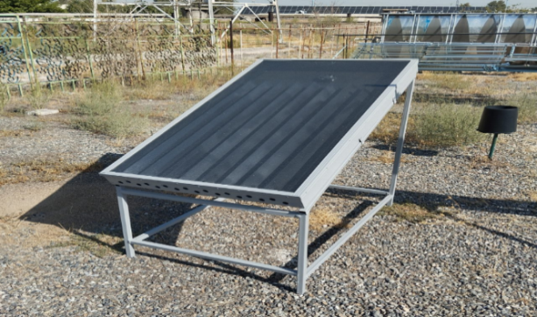
FIGURE 5. General view of the triangular duct solar air heater.

This type of solar air heater operates on the same principle as the previously mentioned device model. The dimensions of the triangular air duct solar air heater are as follows: length b=800 mm, width a=400 mm, height h=62h mm. The working chamber of this solar air heater is equipped with triangular-shaped metal air ducts (see Figure 5). This absorber enhances the heat exchange process by accelerating the rate of thermal energy transfer. Its structural design generates a vortex motion within the airflow, increasing turbulence intensity. The absorber, developed using a specialized engineering approach, facilitates an accelerated convective heat exchange process. The induced vortex motion ensures better mixing of air layers, reducing the formation of the thermal boundary layer and improving heat absorption efficiency. As a result, the convective heat transfer coefficient increases, enhancing the overall thermal efficiency of the system. Additionally, the increased turbulence contributes to a more uniform temperature distribution across the absorber surface, further optimizing heat transfer performance.

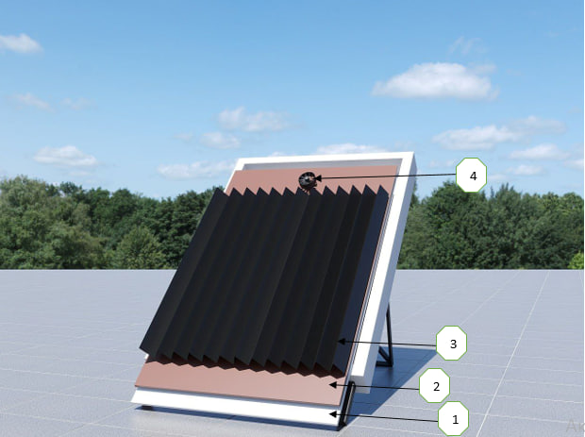
FIGURE 6. Schematic of the triangular channel solar air heater: 1,2- Insulating layers, 3- darkened surface, 4- suction fan

In this device, the heated air outlet pipe is located at the center of the solar air heater in terms of width and above the center in terms of height, as heated air moves upward.

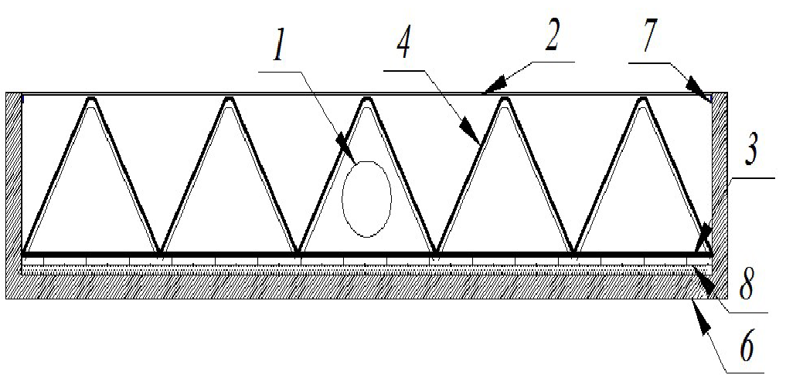
FIGURE 7. Longitudinal cross-section of a triangular air duct solar air heater: 1) Heated air outlet pipe, 2) glass, 3) darkened metal surface (absorber), 4) air duct, 6) casing, 7) bonding insulation layer (foam), 8) foil.

In this device, the length of each air channel is d=150 mm, the distance between the two bases of the air channel is l₂=60 mm, and the height of the channel's base is h₂=60 mm. Two rows of internal convex geometric shapes are provided on each side of the air channels, with a depth of h₃=2 mm and a width of b=15 mm (Figure 7). A connecting thermal insulation layer (7) is placed between the absorber and the casing of the solar air heater, which prevents heat loss from the heated absorber and aids in transferring the available heat to the air. [12].
Through simulation modeling of the heater's heat dissipation processes, the heat dissipation and airflow dynamics of the device were modeled and analyzed. The thermal technical parameters of the device and the heat exchange process in the absorber were also modeled.
RESULTS AND DISCUSSION
The equation of the Navier-Stokes and mass conservation law is given in terms of a tensor as follows:
(4)
Working with the Navier-Stokes equations directly in a numerical manner requires the Reynolds number to be at very low values. Therefore, Reynolds uses a time-centered version of the Navier-Stokes equation.
After applying the Businesk hypothesis of the Reynolds equation, the tensor representation is.
(5)
Since the field under consideration is cylindrical, the differential equations for the Reynolds, Spalart-Allmaras, and heat scattering will take the following form. The density of the airflow is assumed to be constant [10].
(6)
Where the axial, radial, and tangential velocity vectors of the airflow, T- temperature of the air, P-pressure, -density, - Splart-Allmares molecular viscosity coefficient, - molecular and turbulent viscosity, Pr,Pr_{t}- laminar and turbulent Prandtl numbers, usually this amount will be until to Pr-1, Pr_{t}-0.7$÷$0.9 [11].

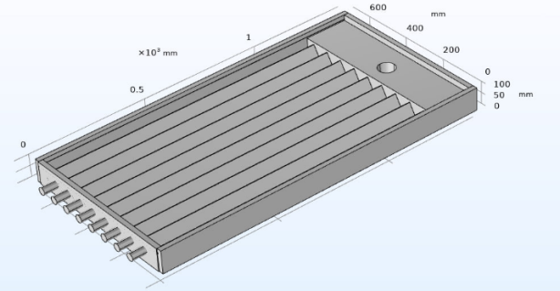 | 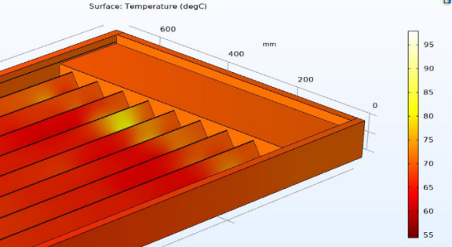
a) | b)
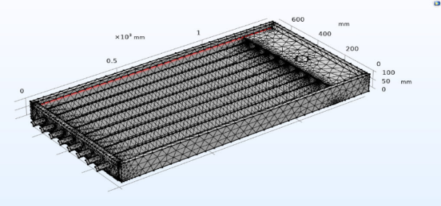 | 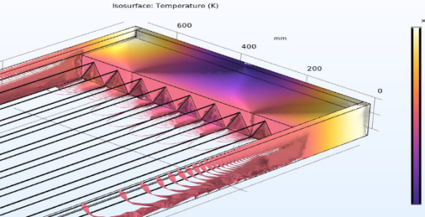
c) | d)
FIGURE 8. a) General view of the device; b) Heat distribution in the absorber; c) Mesh partitioning of the device (MESH) d) Temperature gradient.

The heat exchange process in the channels was analyzed when the solar radiation was 900 W/m² and the speed was 3-5 m/s. The heat distribution and the time required for the device to reach full operational status were determined.

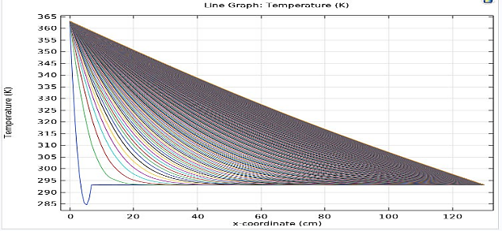 | 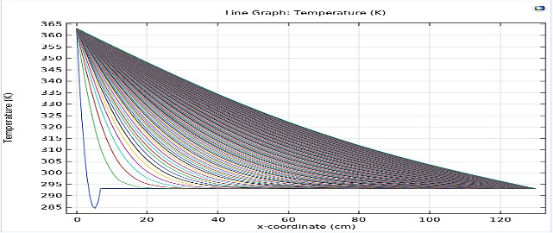
a) | b)
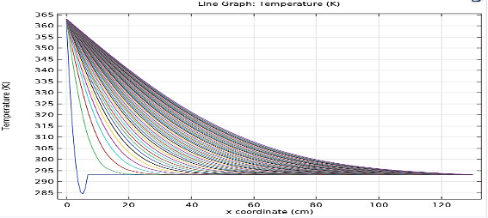 | 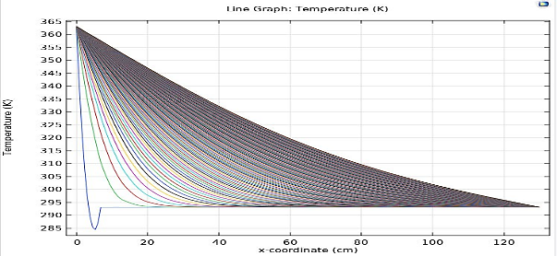
c) | d)
FIGURE 9. Heat distribution over time: a) Heat distribution in the triangular channel over 1 hour; b) Heat distribution in the triangular channel over 30 minutes; c) Heat distribution in the triangular channel over 20 minutes; d) Heat distribution in the triangular channel over 10 minutes.
CONCLUSION
The proposed new type of solar air heater demonstrates higher energy efficiency and enhanced heat exchange performance compared to conventional systems, with its optimized absorber design contributing to this improvement. Specifically, the incorporation of triangular-shaped air channels increases the heat exchange surface area and influences the turbulent motion of the airflow. This leads to an increase in the Nusselt number, significantly enhancing thermal conductivity. Additionally, the aerodynamically optimized triangular air channels reduce pressure losses, thereby improving the overall thermo hydraulic efficiency of the system. Furthermore, the integration of separate air intake pipes for each air channel ensures uniform airflow distribution across the absorber surface of the collector. As a result, the efficiency of the solar air heater is significantly improved, contributing to enhanced performance in solar energy utilization.
REFERENCES
- Moghadasi, H., & Saffari, H. (2021). Experimental study of nucleate pool boiling heat transfer improvement utilizing micro/nanoparticles porous coating on copper surfaces. International Journal of Mechanical Sciences, 196, 106270. https://doi.org/10.1016/j.ijmecsci.2021.106270
- Nakhchi, M., Hatami, M., & Rahmati, M. (2020). Experimental investigation of heat transfer enhancement of a heat exchanger tube equipped with double-cut twisted tapes. Applied Thermal Engineering, 180, 115863. https://doi.org/10.1016/j.applthermaleng.2020.115863
- Libby, P. A. (1975). On the prediction of intermittent turbulent flows. Journal of Fluid Mechanics, *68*(2), 273–295.
- Nakhchi, M., Hatami, M., & Rahmati, M. (2021). Experimental investigation of performance improvement of double-pipe heat exchangers with novel perforated elliptic turbulators. International Journal of Thermal Sciences, 168, 107057. https://doi.org/10.1016/j.ijthermalsci.2021.107057
- Malikov, Z. (2021). Mathematical model of turbulent heat transfer based on the dynamics of two fluids. Applied Mathematical Modelling, *91*, 186–213.
- Yan, S., Golzar, A., Sharifpur, M., Meyer, J. P., Liu, D., & Afrand, M. (2020). Effect of U-shaped absorber tube on thermal-hydraulic performance and efficiency of two-fluid parabolic solar collector containing two-phase hybrid non-Newtonian nanofluids. International Journal of Mechanical Sciences, 185, 105832. https://doi.org/10.1016/j.ijmecsci.2020.105832
- Abdukarimov, B. A., & Kuchkarov, A. A. (2022). Research of hydrodynamic processes occurring in solar air heater collectors with a concave air duct absorber. Applied Solar Energy, *58*(6), 847–853.
- Manjunath, Karanth, K. V., & Sharma, N. Y. (2018). Numerical investigation on heat transfer enhancement of solar air heater using sinusoidal corrugations on absorber plate. International Journal of Mechanical Sciences, 138–139, 219–228. https://doi.org/10.1016/j.ijmecsci.2018.01.037
- Nakhchi, M. E., & Rahmati, M. T. (2020). Turbulent flows inside pipes equipped with novel perforated V-Shaped rectangular winglet turbulators: numerical simulations. Journal of Energy Resources Technology, 142(11). https://doi.org/10.1115/1.4047319
- Abdukarimov, B. A., & Kuchkarov, A. A. (2022). Numerical solution of the mathematical model of air flow movement in a solar air heater with a concave tube. Applied Solar Energy, *58*(1), 109–115.
- Malikov, Z., & Madaliev, M. (2021). New Two-Fluid turbulence model based numerical simulation of flow in a flat suddenly expanding channel. Herald of the Bauman Moscow State Technical University Series Natural Sciences, 4 (97), 24–39. https://doi.org/10.18698/1812-3368-2021-4-24-39
- Bisht, V. S., Patil, A. K., & Gupta, A. (2017). Review and performance evaluation of roughened solar air heaters. Renewable and Sustainable Energy Reviews, 81, 954–977. https://doi.org/10.1016/j.rser.2017.08.036

