Constructing the Phase Portrait of the Kinetic and Dynamic Parameters of Materials Under the Influence of an Alternating Magnetic Field
Ulugbek Erkaboev, Rustamjon Rakhimov ^{a)}, Ulugbek Negmatov, Muzaffar Dadamirzaev, Mukhriddin Tursunov, Qudratali Temirov
Namangan State Technical University, Namangan, Uzbekistan

^{a)}Corresponding author: rgrakhimov@gmail.com
Abstract: In this paper, a literature review is conducted on the dependence of quantum oscillation effects in bulk and low-dimensional semiconductors on external factors in dynamic and static magnetic fields, and the formulation of the research problems is presented. Based on the theoretical and experimental analysis of the available data, the research tasks have been defined. In bulk and quantum-structured semiconductors, charged particles exhibit various dynamic processes under the influence of external factors. In particular, the quantization of oscillations in the density of energetic states and quantum magnetic effects under a static magnetic field are considered one of the fundamental and applied research directions in semiconductor physics. While the motion of charged particles splits into discrete Landau levels under a static magnetic field, the application of a weak alternating (dynamic) magnetic field gives rise to resonance properties in the electron system. As a result, the cyclotron frequency of the dynamic magnetic field interacts with the cyclotron frequency of the charged particle, leading to the manifestation of magnetoplasmon oscillations. The literature review indicates that, in order to fully study the dependence of quantum magnetic effects in quantum-sized semiconductor structures on dynamic magnetic fields, it is necessary to analyze their phase portraits.
Keywords: Semiconductors, quantum oscillations, phase portrait, magnetic field, kinetic and dynamic parameters, temperature, magnetoplasmon effects
INTRODUCTION
Analyzing the kinetic and dynamic parameters of semiconductor structures under a weak alternating magnetic field through phase portraits is one of the research directions of significant scientific and practical importance in modern micro- and nanoelectronics. According to the existing literature, various external factors—such as temperature, pressure, magnetic and electric fields, mechanical stresses, and electromagnetic radiation—profoundly alter the phase behavior of materials. Specifically, at very low temperatures, the kinetic energy of free electrons is minimal, and their phase portraits are represented as ordered closed-loop trajectories. However, as temperature increases, the concentration of lattice phonons rises, the electron–phonon scattering rate increases, and the trajectories deviate from standard circular paths, gradually forming spiral patterns. At very high temperatures, chaotic behavior is observed in the phase portraits. Therefore, temperature is one of the main factors determining the degree of order in the phase portrait.
The motion trajectories of free electrons in a quantizing magnetic field begin to thicken, and the state space of charged particles narrows. Therefore, phase portraits under the influence of a magnetic field are widely used as an effective tool for a deep understanding of the electronic structure and transport processes of semiconductor structures. For bulk semiconductors, phase portraits usually take the form of an ellipse, spiral, or limit cycle, while in quantum structured materials the distribution functions are different, in which a number of quasi-probability (Wigner function, Husimi Q-function, Glauber-Sudarshan P-function, Husimi–Kano function, Kirkwood–Rihaczek function) functions are used as the main mathematical tool, which allows describing the dynamic processes at the quantum levels of nanostructured semiconductors. In general, the experimental results of quantum effect oscillations in 3D and 2D semiconductor structures can be graphically interpreted using phase portraits. This serves as a solid theoretical foundation not only for fundamental scientific research, but also for the development of new technologies in the fields of applied electronics, spintronics, and nanophotonics.
METHODS
To date, phase portraits have been applied to a number of scientific fields. In particular, in the works [1-3], a study of the influence of recombination centers in nanoscale semiconductor films on phase portraits was considered. The study investigated how the concentration of recombination centers in semiconductor materials affects the shape of the phase portrait. According to the results of the study, a change in the concentration of charge carriers was observed as a result of an increase or decrease in the concentration of recombination centers.
In works [1-2] The main method used in the article is the analysis of phase portraits, which allows for an effective analysis of the generation-recombination processes occurring in semiconductor materials. The study considered the continuity equation of charge carrier concentration, taking into account all-directional variable deformation and light effects. This equation is expressed in the following form:
$$\frac{∂n}{∂t}=g-r$$ | (1)
here, 𝑔 is the generation rate, r is the recombination rate. In the study, the recombination process through recombination centers was expressed in the following formula using Shockley-Read statistics:
$$r=\frac{c_{n}c_{p}(pn-n_{i}^{2})}{c_{n}(n+n_{1})+c_{p}(p+p_{1})}N_{t}$$ | (2)
Here, 𝑁_{𝑡} is the concentration of recombination centers, 𝑐_{𝑛} and 𝑐_{𝑝} are the electron and hole capture coefficients, respectively.
Fig.1 shows a phase portrait of the charge carrier concentration versus the rate of change during a period of variable deformation. This portrait is in the form of a closed circle, and the charge carrier concentration in a semiconductor undergoes stable periodic oscillations. In Fig.2 ( n=$2⋅{10}^{13} sm^{-3}$ ; n=$8⋅{10}^{13} sm^{-3}$), the increase in the concentration of recombination centers leads to the phase portrait spiraling inward. This reflects a decrease in the maximum concentration of charge carriers as a result of the increase in recombination centers.
In these works [4-5], it is proven that the phase portrait method can clearly demonstrate the dynamic processes occurring in semiconductor structures. Specifically, in works[1], the effect of varying recombination center concentrations on the dynamics of charge carrier concentrations and the corresponding changes in the shape of phase portraits is presented.
Additionally, in other researchs [6-8] provide detailed analyses of n-dimensional phase portraits in high-order systems.
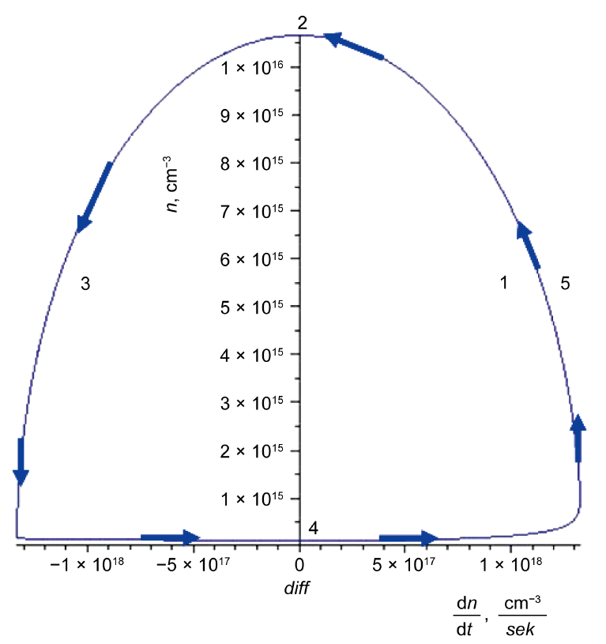
FIGURE 1. Phase portrait of the rate of change of charge carrier concentration (𝑛n) ($\frac{dn}{dt}$) [1].
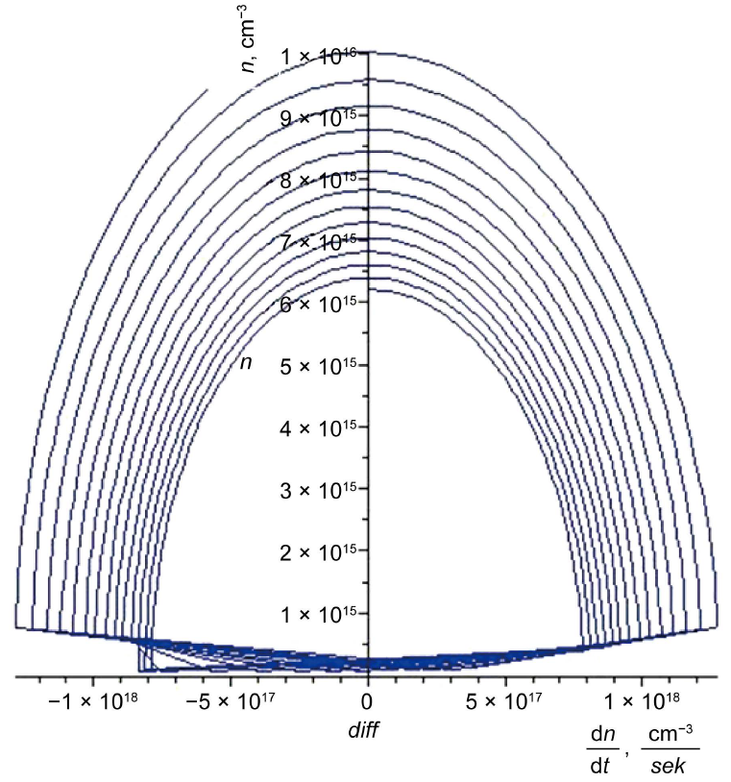
FIGURE 2. Phase portrait of the charge carrier concentration n with respect to its rate of increase ($\frac{dn}{dt}$). The concentration of recombination centers varies from $N_{t}=2⋅10^{13} cm^{-3}$to $N_{t}=8⋅10^{13} cm^{-3}$[1].

Researchers have conducted a detailed analysis of the capabilities and limitations of graphically representing dynamic systems using phase portraits. In this work, a phase portrait is considered a powerful analytical tool that allows the graphical depiction of the time-independent states of dynamic systems. Traditional phase portraits are typically applied to two- or three-dimensional systems. It has been noted that representing systems with more than three dimensions graphically poses the problem of data loss. The authors have proposed using various combinations of states to graphically analyze higher-order systems, thereby enabling a detailed examination of the dynamic properties of such systems. In this work [6], the authors considered the following chaotic system:
$$\begin{matrix}{\dot{x}}_{1}=35⋅\left(x_{2}-x_{1}\right)+x_{2}x_{3} \\ {\dot{x}}_{2}=25x_{1}-x_{2}-x_{1}x_{3} \\ {\dot{x}}_{3}=x_{1}x_{2}-7x_{3}\end{matrix}$$ | (3)
In Fig.3, the phase portraits obtained for a chaotic system described by equation (3) are shown using three state combinations ($x_{1}, x_{2}, x_{3}$). This figure shows the dynamic trajectories of chaotic systems in detail. The graphs clearly demonstrate the complexity and unpredictability of the trajectories, as well as their high sensitivity to the initial conditions of the system. The trajectories plotted for each combination change in a complex way, clearly demonstrating the difficulty of predicting the dynamics of the system. In Fig.4, a chaotic system is analyzed, and phase portraits are drawn using three different combinations of states ($x_{1}, x_{2}, x_{3}$) and different initial conditions. These graphs show the complex and unpredictable trajectories of chaotic systems. This clearly shows the sensitivity of the systems to the initial conditions and the rapid variability of their dynamic trajectories. The graphs depict trajectories using different colors, visually explaining the behavior of chaotic systems and their complexity depending on the initial conditions.
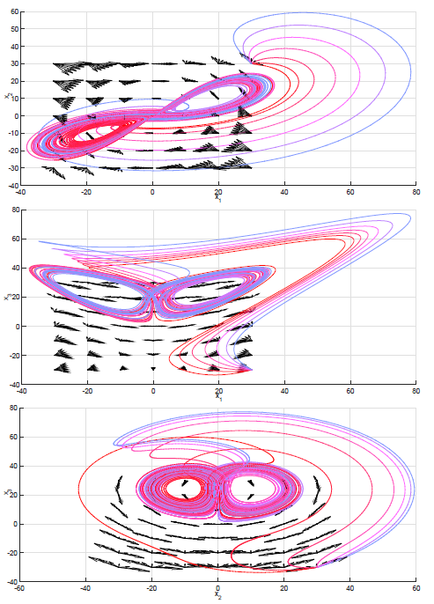
FIGURE 3. Phase portrait of a chaotic system constructed using formula (3)[6].

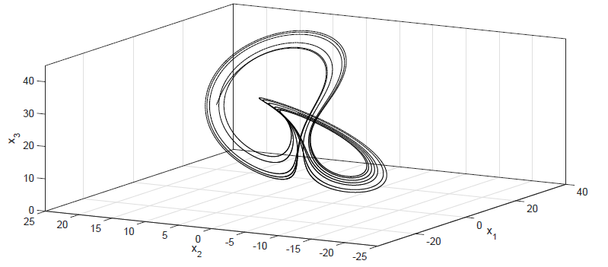
FIGURE 4. Phase portrait of the chaotic system described by formula (3) under $x_{1}(0) = x_{2}(0) = x_{3}(0) = 20$ conditions [6].

The results of the research work [6] allow for a more effective and in-depth analysis of complex behavior of systems by graphically constructing phase portraits in the study of dynamic processes of semiconductor structures and other higher-order systems. In our work, it opens up the possibility of better understanding complex dynamic phenomena occurring in semiconductors, especially under the influence of a dynamic magnetic field or other external factors, through various combinations of states.
In works [9-13], a detailed analysis of studies on the formation of phase portraits of second-order linear systems taking into account their dynamic properties is provided. In this study, the phase space method is presented as an effective tool for studying the dynamics of mathematical and physical systems. The researchers created an analog model of a second-order linear system and implemented its vectorized representation in the Simintech software environment. During the study, a system interface was developed that allows changing the model coefficients in real time, which showed the possibility of simulating external influences that disrupt the stability of the system. In particular, in work [9], three different equilibrium states were analyzed, and they were classified by the authors as follows: "Center", "Stable Focus" and "Unstable Focus". The results obtained during the research work Fig.5 shows the phase portrait of the system in the "Center" equilibrium state and the time-dependent transition process. In this case, according to the initial conditions chosen for the equilibrium state, trajectories are observed that form a closed circle (in the form of an ellipse). This helps to express that the system is a conservative system without energy consumption. Periodic oscillations occur at the equilibrium point of the system, and they are repeated in the form of a closed circle. Fig.6 depicts the phase portrait of the system in the "Stable Focus" state and the transition process. In this case, the trajectories gradually approach the center (equilibrium point) in the form of a spiral.

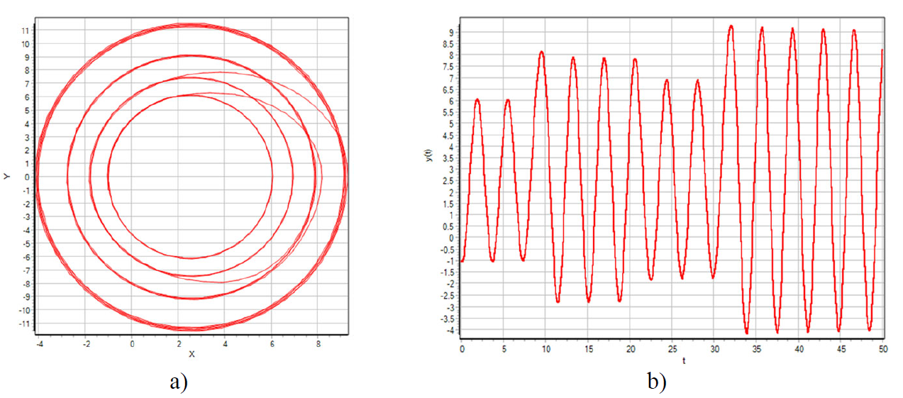
FIGURE 5. Features of studying the model in the “center” equilibrium state (a - phase portrait, b - ongoing process) [9].

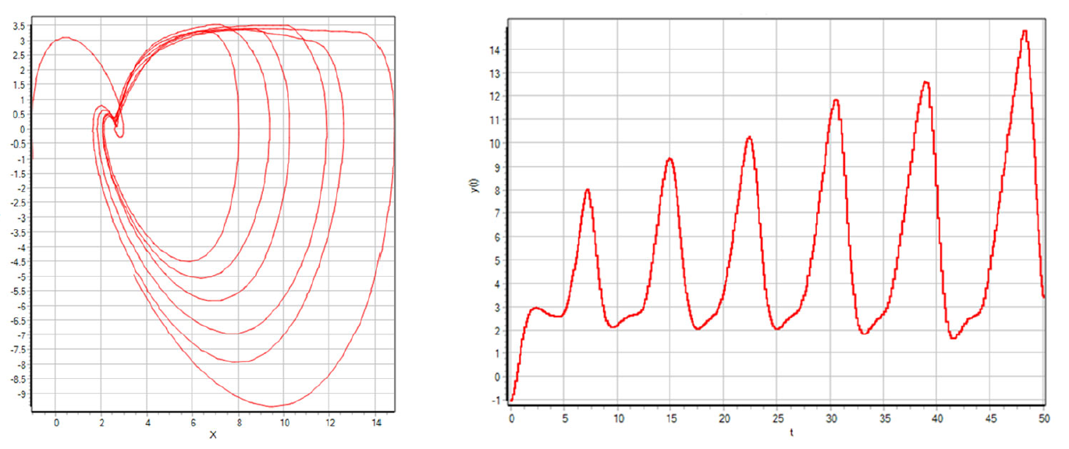
FIGURE 6. Graphical characteristics of the model in the “Stable Focus” equilibrium state (a – phase portrait, b – transition process) [9].

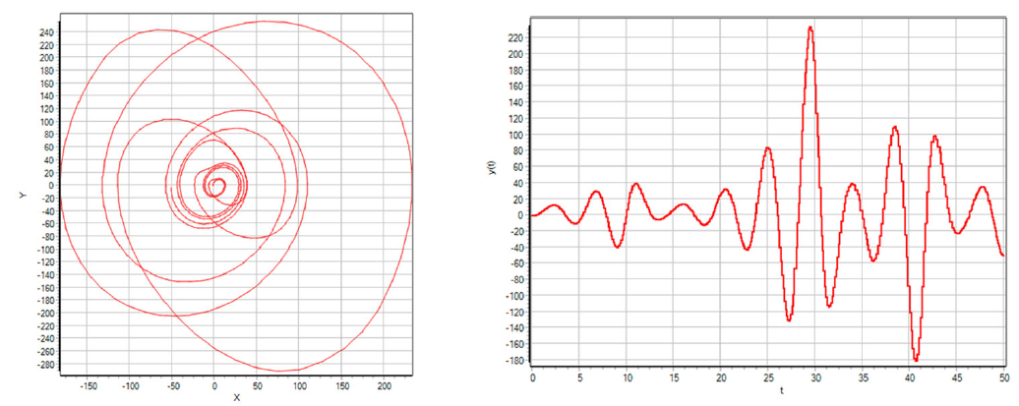
FIGURE 7. Graphical characteristics of the model in the “Stable Focus” equilibrium state (a – phase portrait, b – transition process) [9].
As a result, the asymptotic stability of the system is visually expressed, and by changing the model coefficients in real time, it is possible to observe the change in the speed of the trajectories approaching the center. Fig.7 shows the phase portrait of the system in the “Unstable Focus” state and the transition process. In this case, it is observed that the trajectories of the system are in the form of a spiral moving away from the center. In this case, the equilibrium point of the system is sensitive to external influences, and as a result of any small external influence, the system leaves the equilibrium state and generates oscillations of increasing amplitude. As a result of changing the coefficients in real time, the trajectories initially approach the center for a short time, and then quickly move away from the center are depicted. The results obtained in work [9] show that the use of phase portraits helps to understand more deeply the complex dynamic phenomena occurring in systems under the influence of external factors. By changing the model coefficients in real time, it serves as an important tool for graphically observing the formation and change processes of phase trajectories, identifying scientific innovations, and assessing the stability of systems. However, these studies did not investigate phase portraits for analyzing the effects of dynamic magnetic fields on oscillatory phenomena in quantum electronics.
The authors of the works [14-16] focused on monochromatic Alfvén waves and successfully represented their radial variations in the magnetosphere using phase portraits. In work[14], a new methodology was developed to analyze the phase structure of Alfvén waves propagating in the plasma environment of the Earth’s magnetosphere based on space observations, using phase portraits. The main goal of the research is to develop a method that allows us to determine the type of wave, its propagation direction, and its structural properties in space through the electric and magnetic field components that make up Alfvén waves. The phase portrait is interpreted in this article as consisting of two graphs: first, the spatial (radial) distribution of the transverse components of the electric or magnetic field of the wave; second, the change in the phase shift between these components in the radial direction. This approach allows us to determine whether the wave has a simple harmonic or complex modulated nature, as well as the direction of their propagation. The theoretical foundations are based on magnetohydrodynamic equations and are built on the assumption of a gradual change in the wave parameters in the direction of propagation.
The experimental part of the study is based on data obtained by the THEMIS-E satellite on March 8, 2016. The time-varying components of the electromagnetic field were analyzed using spectral filtering and phase portraits were generated. The analysis shows that in some cases, phase shifts are observed between the components in the phase portraits, which indicates that the wave has a directional (moving in the other direction) property. The phase relationships between the electric and magnetic fields provide important information about the behavior of the wave - for example, whether it is stationary or mobile. One of the main achievements of the scientific treatise is that this method, along with the wave structure, can indirectly obtain information about local plasma parameters (density, magnetic field gradient, electrical conductivity). This makes the phase portrait method a universal tool for analyzing the space plasma environment. Especially in cases where direct measurements in space cannot be made, this methodological approach allows us to understand complex processes based on the observed parameters. The results presented in the study also expand the possibilities of comparing theoretical models with experimental data. The approach presented in the study can also be effectively applied in other areas related to plasma physics. For example, this methodology is of great importance in laboratory experiments, thermonuclear fusion modeling, and the study of wave processes in the solar corona. In our scientific work, in the analysis of oscillatory processes in technical and physical systems using phase portraits, this method of Leonovich and co-authors can serve as a theoretically and experimentally solid basis. Thus, the analysis method based on phase portraits proposed in the article takes Alfvén waves to a new level in diagnostics and serves as an effective methodological basis for studying processes. Fig.8 serves as the main model for forming a phase portrait of Alfvén waves. It depicts the transverse components of the Alfvén wave and their mutual phase shift, obtained based on experimental data recorded by the THEMIS-E satellite. This figure shows two main parts of the phase portrait typical of an Alfvén wave: (a) the radial amplitude profile of the electric and magnetic field components, and (b) the radial distribution of the phase shift between these components. Fig.8a shows the variation of the transverse electric and magnetic components radially in the Earth’s magnetosphere. This graph primarily illustrates the structural complexity of an electromagnetic wave, in particular the influence of plasma density and magnetic field gradients on the waveform. The variation in amplitude indicates that the wave is modulated rather than purely harmonic, demonstrating the presence of radial dispersion. In Fig.8b, the phase difference ($∆φ$) between the electric and magnetic field components is presented graphically. This phase shift illustrates how the wave front propagates radially. A constant $∆φ$ would indicate a monochromatic wave, whereas the significant variations observed in this figure indicate dispersive properties of the wave. The phase shift also helps to determine the origin of the wave, whether from the inner or outer magnetosphere.
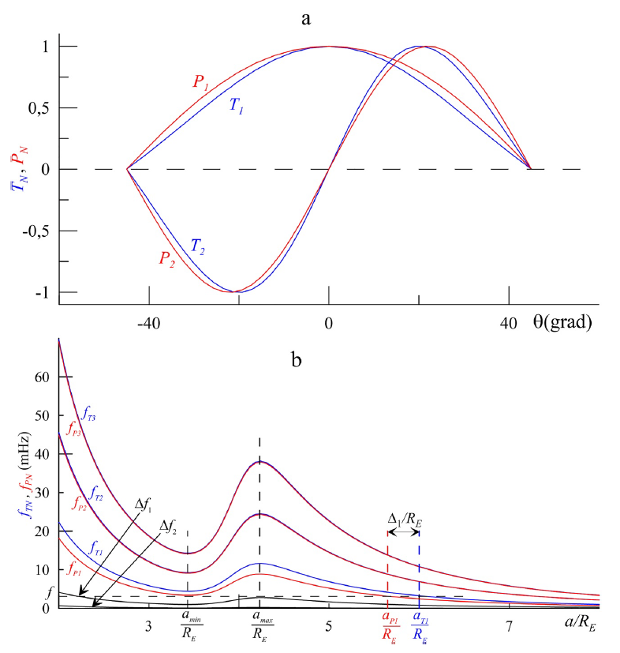

FIGURE 8. Standing Alfvén waves in a dipole magnetosphere model.
a) Longitudinal (along magnetic field lines) structures of the first two harmonics (N = 1, 2) with poloidal (P_{N}) and toroidal (T_{N}) polarizations.
b) Distribution of the characteristic frequencies of standing Alfvén waves along magnetic shells (a coordinate) for poloidal ($f_{PN}=Ω_{PN}/2π$, red lines) and toroidal ($f_{TN}=Ω_{TN}/2π$, blue lines) components, as well as the frequency differences ($Δf_{N}=f_{TN}-f_{PN}$, black lines) for the first three harmonics (N = 1, 2, 3) [10; pp. 51–57].

Fig.8 demonstrates that the structure of Alfvén waves varies not only in time but also in phase space, making it difficult to evaluate using classical methods. Therefore, the phase portrait approach serves as a convenient tool for understanding these complexities both graphically and analytically. This figure connects the theoretical model presented in the article with experimental data and practically validates the main thesis of Leonovich and co-authors: that the characteristics of Alfvén waves can be determined using phase portraits. In particular, this approach can also be applied to the study of dispersive oscillations in electromagnetic media, as well as in semiconductor physics and phase-resonance phenomena.
In the existing literature, de Haas–van Alphen oscillatory effects have been experimentally observed in weak static magnetic fields and at high temperatures. However, previous studies have not theoretically or practically explored the phase portraits of quantum oscillation effects under dynamic weak magnetic fields and their temperature dependence.
Studies [17-27] applied phase representations (delay maps) of dynamic systems to analyze pulse signals and develop diagnostic criteria using phase portraits. The authors proposed a quantitative indicator representing the intensity of blood flow during the rapid ejection phase of the cardiac cycle. Radial artery pulse signals were used as the experimental base, with a sampling frequency of 200 GHz and a delay time of Δt ≈ 50 ms, recorded using an automated pulse-diagnostic system. In the delay maps, each point corresponds to a pair f(k) and f(k–c), allowing the phase portraits to compactly represent the dynamic properties of the signals. The authors performed qualitative analyses of over 200 samples, examining the shape and topology of the portraits. In conclusion, delay maps are suitable for assessing pulse dynamics, process speed, and degree of stationarity, supporting clinical differentiation with quantitative criteria. In the context of our dissertation, this work demonstrates the universality of the phase portrait method: mapping oscillatory processes (contour topology, closed-cycle stability, bifurcation transitions) in parameter space aligns methodologically with the physical (magnetic-field) models we employ.
Furthermore, studies [28-38] developed polyhedral dynamic systems $x'=P(x)$ to construct symmetries in phase portraits systematically, introducing stratification of symmetry in sets of equilibrium points through the concept of “local phase portrait similarity.” Similarity was defined by the equality of eigenvalues of the Jacobian matrix, i.e., phase portraits around two equilibria were considered “similar” if their spectra were identical. The Null(P) set was interpreted as “highly symmetric” if it contained a minimal number of layers.
Relying on the Grobman–Hartman theorem, the authors also represented topological equivalence through the similarity of Jacobian matrices. A practical scheme for constructing symmetric systems was presented: for quadratic/polyhedral systems, matrix classes that can be simultaneously diagonalized were identified, particularly referring to circulant matrix theory. Circulant matrices were diagonalized via the Discrete Fourier Transform (DFT), and a general spectral form was obtained using the DFT–Vandermonde matrix. For ODEs written in circulant convolution form $x^{'}=Dx^{⊙k}-x$, it was proven that the Jacobian eigenvalues were identically distributed for all nonzero equilibria.
The studies provided two illustrative constructions: (I) quadratic systems in the form of a “linear pencil,” where characteristic polynomial multipliers at symmetric equilibria split linearly; (II) the planar system $\frac{d}{dt}z={\overline{z}}^{k}-z, \overline{z}=x-iy, k=2,3,…$, where the phase portrait exhibits dihedral group $D_{k+1}$ symmetry, and nonzero equilibria are evenly distributed along the unit circle as saddle points.
In the context of our dissertation, this work reinforces the “phase portrait diagnosis” approach, enabling systematic construction of regime changes and stability windows in parameter space (for us, magnetic field/temperature; in the cited works, algebraic constructors $D_{k}$​ and circulant structures). In particular, the criterion of spectral equality directly corresponds to our phase-portrait-topology analysis.

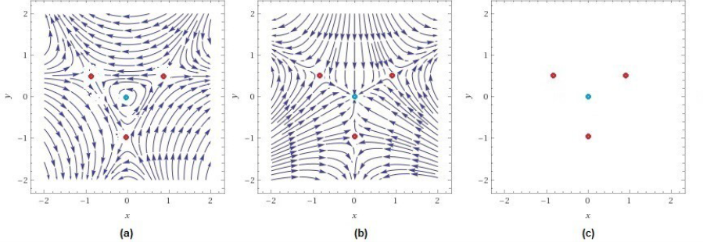
FIGURE 9. A constructive representation of the class of planar quadratic systems that possess a set of equilibria located at the vertices of an equilateral triangle and at its center.

In Fig.9, the authors consider a vector field of the form $P\left(x,y\right)=aP_{1}+bP_{2}$​, where $P=aP_{1}+bP_{2}, P_{1}=\left(x,y\right)=\left\{x^{2}-y^{2}-y, -2xy+x\right\}, { P}_{2}=\{2xy-x, x^{2}-y^{2}-y\}$, ($x^{2}-y^{2}-y$)} were chosen. The caption of Fig.2 states that panels (a) and (b) display the phase portraits of P₁ and P₂​, respectively, while panel (c) illustrates their common set of hyperbolic equilibrium points. The authors demonstrate that this configuration preserves the dihedral symmetry group D₃​; the generators S and R of D₃​ are written explicitly, and the invariance conditions $SP(x)=P(Sx), RP(x)=P\left(Rx\right)$ are verified. Furthermore, based on a step-by-step derivation, the Jacobian matrix at the origin has eigenvalues $[-b±ai]$, leading to center/focus–type local dynamics. At the remaining equilibria located at the vertices of the triangle, the eigenvalues take the form $\left[-b±\sqrt{3a^{2}+4b^{2}}\right]$, which correspond to hyperbolic (saddle-type) points. Thus, Fig.9 visually shows that the phase portraits of P₁ and P₂​ “adhere” to the same Null(P) set and that the local spectra agree due to symmetry. The construction method is also explained: in order to obtain identical local dynamics at the triangle’s vertices, the conditions $A=b$, $B=-a$ were imposed on the general quadratic coefficients, after which the form $P=aP_{1}+bP_{2}$ ​ emerged as the resulting solution.

CONCLUSION
In volumetric and quantum-structured semiconductors, charge carriers exhibit various dynamical processes under the influence of external factors. In particular, the quantization of oscillations in the density of energetic states under a static magnetic field and the resulting quantum magnetic effects constitute one of the fundamental and applied research directions in semiconductor physics. While the motion of charged particles in a static magnetic field is quantized into discrete Landau levels, in a dynamic (time-varying) weak magnetic field the electronic system develops resonance characteristics. As a result, the cyclotron frequency of the dynamic magnetic field interacts with the cyclotron frequency of the charge carriers, giving rise to magnetoplasmon oscillations. A review of the literature indicates that, in order to thoroughly investigate the dependence of quantum magnetic effects in quantum-confined semiconductor structures on a dynamic magnetic field, it is necessary to analyze their phase portraits.
Based on the discussion above, solving several issues requires addressing the following key problems:
- To derive analytical expressions for the energy of free electrons in a quantum well under a dynamic weak magnetic field, $E_{n}^{2d}(B(t))$, and its time derivative,$\frac{dE_{n}^{2d}\left(B\left(t\right)\right)}{dt}$;
- To develop a mathematical model that determines the phase portrait of Landau levels in a quantum-confined semiconductor under a time-varying weak magnetic field, expressed as
$PhasePortret\left[E_{n}^{2d}\left(B(t),ω_{c}\right);\frac{dE_{n}^{2d}\left(B(t),ω_{c}\right)}{dt} \right]$;
- Using the Schrödinger equation, to obtain a generalized analytical expression describing the dependence of the oscillations of the density of states of nanoscale semiconductor materials on time, the frequency of the dynamic magnetic field, and the quantum-well thickness,$N_{s}^{2d}\left(B\left(t\right),ω_{c},d\right)$;
- To develop a mathematical model that determines the phase portrait of the oscillations of the density of states in a quantum-confined semiconductor under a dynamic weak magnetic field,
$PhasePortret\left[N_{s}^{2d}\left(E,B(t),d\right);\frac{dN_{s}^{2d}\left(E, B(t),d\right)}{dt} \right]$;
- To determine the dependence of the phase portrait of the density-of-states oscillations on temperature and quantum-well thickness under a time-varying weak magnetic field.

REFERENCES
- Gulyamov G.G., Gulyamov A.G., Muhitdinova F.R. (2016). Influence of Recombination Centers on the Phase Portraits in Nanosized Semiconductor Films, Journal of Modern Physics, 7(13), 1661-1667. https://doi.org/10.4236/jmp.2016.713151
- Erkaboev, U.I., Rakhimov, R.G. (2023). Determination of the dependence of the oscillation of transverse electrical conductivity and magnetoresistance on temperature in heterostructures based on quantum wells. East European Journal of Physics, 2023(3), 133-145. https://doi.org/10.26565/2312-4334-2023-3-10
- Gulyamov, G., Erkaboev, U.I., Rakhimov, R.G., Mirzaev, J.I., Sayidov N.A. (2023). Determination of the dependence of the two-dimensional combined density of states on external factors in quantum-dimensional heterostructures. Modern Physics Letters B, 37(10), 2350015. https://doi.org/10.1142/S021798492350015X
- Erkaboev, U.I., Rakhimov, R.G., Sayidov, N.A. & Mirzaev, J. I. (2022). Modeling the temperature dependence of the density oscillation of energy states in two-dimensional electronic gases under the impact of a longitudinal and transversal quantum magnetic fields. Indian Journal of Physics, 97, 1061-1070. https://doi.org/10.1007/s12648-022-02435-8
- Erkaboev U., Rakhimov, R., Mirzaev, J., Sayidov, N., Negmatov, U., Mashrapov, A. (2023). Determination of the band gap of heterostructural materials with quantum wells at strong magnetic field and high temperature. AIP Conference Proceedings, 2789(1), 040056. https://doi.org/10.1063/5.0145556
- Rodríguez-Licea M.-A., Perez-Pinal F.-J., Nuñez-Pérez J.-C., Sandoval-Ibarra Y. (2019). On the n-Dimensional Phase Portraits. Applied Science, 9, 872. https://doi.org/10.3390/app9050872
- Volos, C., Maaita, J.O., Vaidyanathan, S., Pham, V.T., Stouboulos, I., Kyprianidis, I. (2016). A novel 4-D hyperchaotic four-wing system with a saddle-focus equilibrium. IEEE Trans. Circuits Syst. II Express Briefs, 64, 339–343. http://dx.doi.org/10.1109/TCSII.2016.2585680
- Xiong, L., Liu, Z., Zhang, X. (20174). Analysis, circuit implementation and applications of a novel chaotic system. Circuit World, 43, 118–130. http://dx.doi.org/10.1108/CW-02-2017-0007
- Kovalev I., Kulmurodova N., Saramud M., Kalinin A., Borovinsky D. (2025). The research of the formation of phase portraits of linear second-order systems taking into account the dynamic characteristics of the model. Applied Sciences. EPJ Web of Conferences, 318, 04007 https://doi.org/10.1051/epjconf/202531804007
- Rodríguez-Licea, M.A., Perez-Pinal, F.J., Perez, J.C.N., Sandoval-Ibarra, Y. (2019). On the n-Dimensional Phase Portraits. Applied Sciences, 9(5), 872. https://doi.org/10.3390/app9050872
- Alward, Y., Ansari, M. (2020). Industrial automation and control system development using different approaches, Journal of Information and Optimization Sciences, 41, 345-354 (2020). https://doi.org/10.1080/02522667.2020.1721631
- Erkaboev U., Rakhimov, R., Mirzaev, J., Negmatov U., Sayidov, N. (2024). Influence of the two-dimensional density of states on the temperature dependence of the electrical conductivity oscillations in heterostructures with quantum wells. International Journal of Modern Physics B, 38(15), 2450185. https://doi.org/10.1142/S0217979224501856
- Erkaboev, U.I., Sayidov, N.A., Negmatov, U.M., Mirzaev J.I., Rakhimov, R.G. (2023). Influence temperature and strong magnetic field on oscillations of density of energy states in heterostructures with quantum wells HgCdTe/CdHgTe. E3S Web of Conferences, 401, 01090. https://doi.org/10.1051/e3sconf/202340101090
- Chelpanov, M., Mager, P., Klimushkin, D., & Mager, O. (2019). Observing magnetospheric waves propagating in the direction of electron drift with Ekaterinburg Decameter Coherent Radar. Solar-Terrestrial Physics, 5(1), 51–57. https://doi.org/10.12737/stp-51201907
- Chen, L., Zonca, F., & Lin, Y. (2021). Physics of kinetic Alfvén waves: A gyrokinetic theory approach. Reviews of Modern Plasma Physics, 5(1), 1. https://doi.org/10.1007/s41614-020-00049-3
- Elsden, T., & Wright, A. (2020). Evolution of high-m poloidal Alfvén waves in a dipole magnetic field. Journal of Geophysical Research: Space Physics, 125, e2020JA028187. https://doi.org/10.1029/2020JA028187
- Boronoev, V.V., Ompokov, V.D. (2022), Study of the dynamics of phase portraits of pulse signals, Journal of radio electronics, 2022, 7. https://doi.org/10.30898/1684-1719.2022.7.11
- Kurakin, V.G., Kurakin, P.V. (2018). Phase portrait of a scattered bunch of charged particles. Journal of Technical Physics, 88(5). 795-798. https://doi.org/10.21883/JTF.2018.05.45910.2342
- Usmanova, K.R., Zhuravlev, Yu.I., Rudakov, K.V., Strizhov, V.V. (2020). Approximation of the phase trajectory of quasiperiodic signals by the spherical regression method. Bulletin of Moscow University, 4, 40-46.
- Chikhachev, A.S. (2017). Dynamics of the Phase Portrait of an Ellipsoidal Charged Bunch in a Nonuniform Magnetic Field. Journal of Communications Technology and Electronics, 62(12), 1408-1413. https://doi.org/10.1134/S1064226917110031
- Basarab, M.A., Konnova, N.S., Mitrokhin, V.N. et al. (2017). Diagnostics of cardiovascular system conditions using nonlinear digital processing of signals from Doppler blood flow velocity meters. Biomedical Radioelectronics, 5, 3-12.
- Grishutina, E.A., Balandin, V.A. (2020). Model and phase portrait of the ECG T-wave in ischemic heart disease. Innovative technologies in electronics and instrument making. Russian scientific and technical conference with international participation of the Physical-Technological Institute of the Russian Technical University MIREA. Moscow, 269-272.
- Ompokov, V.D., Boronoev, V.V. (2019). Time-frequency analysis of pulse signals based on the Hilbert-Huang transform. Journal of Radio Electronics, 8. https://doi.org/10.30898/1684-1719.2019.8.4
- Boronoev, V.V., Ompokov, V.D., Pupysheva, N.V., Naguslaeva, I.V. (2021)., Variability of the frequency spectrum of a pulse signal under exposure to optical radiation. Proceedings of SPIE. https://doi.org/10.1117/12.2603256
- Gulyamov, G., Erkaboev, U.I., Baimatov, P.Zh. (2016). Modeling the dependence of the absorbed photon energy on the magnetic field in semiconductors. Alternative Energy and Ecology, 19-20 (207-208), 130-138.
- Erkaboev U., Rakhimov, R., Mirzaev, J., Sayidov, N., Negmatov U., Abduxalimov M. (2023). Calculation of oscillations in the density of energy states in heterostructural materials with quantum wells. AIP Conference Proceedings, 2789(1), 040055. https://doi.org/10.1063/5.0145554
- Erkaboev, U.I., Sayidov, N.A., Negmatov, U.M., Rakhimov, R.G., Mirzaev J.I. (2023). Temperature dependence of width band gap in In_{x}Ga_{1-X}As quantum well in presence of transverse strong magnetic field. E3S Web of Conferences, 401, 04042. https://doi.org/10.1051/e3sconf/202340104042
- Krasnov, Y., Koylyshov U.K. (2020). Symmetries in Phase Portrait. Symmetry, 12(7), 1123. https://doi.org/10.3390/sym12071123
- Kra, I., Simanca, S.R. (2012). On circulant matrices. Notices of the American Mathematical Society, 59(3), 368–377. https://dx.doi.org/10.1090/noti804
- Hartman, P.A. (1960). Lemma in the Theory of Structural Stability of Differential Equations. Proceedings of the American Mathematical Society, 11, 610–620. http://dx.doi.org/10.1090/S0002-9939-1960-0121542-7
- Balanov, Z.; Kononovich, A.; Krasnov, Y. (2012). Projective dynamics of homogeneous systems: Local invariants, syzygies, and the global residue theorem. Proceedings of the Edinburgh Mathematical Society, 55(3), 577–589. http://dx.doi.org/10.1017/S0013091511000435
- Krasnov, Y.; Tkachev, V.G. (2018). Idempotent geometry in generic algebras. Advances in Applied Clifford Algebras, 28, 84–98. http://dx.doi.org/10.1007/s00006-018-0902-7
- Balanov, Z., Krasnov, Y. (2019). On good deformations of A_{m}-singularities. Discrete and Continuous Dynamical Systems - Series S, 12(7), 1851–1866. https://doi.org/10.3934/dcdss.2019122
- Krasnov, Y. (2019). Spectral Theory for Nonlinear Operators: Quadratic Case. In Modern Methods in Operator Theory and Harmonic Analysis, 291, 199–216. https://doi.org/10.1007/978-3-030-26748-3_12
- Sharibaev, N., Jabborov, A., Rakhimov, R., Korabayev, S., Sapayev, R. (2024). A new method for digital processing cardio signals using the wavelet function. BIO Web of Conferences, 130, 04008. https://doi.org/10.1051/bioconf/202413004008
- Abdullayeva, O., & Beknazarova, S. S. (2024). Algorithm for finding reference brightness correction coefficients. SPIE, 6, 67. https://doi.org/10.1117/12.3025212
- Mirzabayev, B., et al. (2025). Controlling tensile strength in yarn using an ultrasonic water vaporizer. AIP Conference Proceedings, 3304, 030047. https://doi.org/10.1063/5.0269506
- Mirsaidov, M., Matkarimov, P., & Juraev, D. (2025). Assessment of stress-strain state of earth dams considering the spatial operation of structures. AIP Conference Proceedings, 3282, 050020. https://doi.org/10.1063/5.0265149

