Dependence of the Electrical Conductivity of Cotton Raw Material on Moisture, Density, and Temperature
Azambek Turakulov, Fotima Mullajonova,
Jahongir Rajabov^{a)}, Musobek Obidjanov
Namangan State Technical University, Namangan, Uzbekistan

^{a)}Corresponding author: rajabov-jahongir1992@mail.ru
Abstract: This study examines how moisture, density, and temperature affect the electrical conductivity of raw cotton. For this purpose, a special device was designed to measure conductivity, and the data were collected automatically. During the experiments, cotton samples were tested under changing environmental conditions, with all parameters transferred to a computer system for real-time processing. Because raw cotton is hygroscopic, variations in ambient humidity strongly influenced conductivity, showing the need for close monitoring and control in industrial applications. The relationships between electrical properties and external factors were described using mathematical models. From the results, several practical suggestions were proposed to support better quality control and storage of cotton materials.
Keywords: Raw cotton; Conductivity; Moisture; Density; Temperature; Dielectric; Measurement; Control.
INTRODUCTION
Cotton is still one of the most important crops in the world. It is a basic raw material for the textile industry and is used in electrical engineering, agriculture, and many other technical sectors [1]. In the last several decades, more and more research has been done on its physical, mechanical, and technological qualities in order to make processing more efficient and make it more useful in advanced industrial applications [2].
One important property is electrical conductivity, which is linked to the dielectric and semiconducting behavior of cotton [3]. This parameter is critical for storage, processing, insulation, and other industrial uses. The main factors that influence conductivity are moisture, density [4], and temperature. Studying these factors makes it possible to understand and control how conductivity changes under different conditions.
Cotton is hygroscopic and reacts strongly to humidity changes. For this reason, stability of electrical properties is a key technological indicator. At the same time, density and temperature [5] affect the structure of the fibers and the ability of current to pass through them. These factors are interrelated, forming a complex physico-technical system. In this research, the dependence of the electrical conductivity of raw cotton on moisture [5, 6], density, and temperature is experimentally analyzed. Measurements are carried out in an automated manner using modern devices. The obtained results are expressed through mathematical formulas and provide significant conclusions for practical applications.
The research outcomes can contribute to the implementation of high-precision monitoring systems for the storage, drying [7, 8, 9], and electrical insulation of cotton products, as well as in other technological stages. Furthermore, this work adds to the improvement of quality control in the cotton industry through innovative approaches.
METHODS
The entire experiment is reduced to the measurement of electrical conductivity under controlled variations of moisture, density, and temperature. The research consists of determining the dependence of electrical conductivity on these parameters, analyzing the dielectric response of cotton samples, and the effect of compression density. At the same time, two conditions of the experimental chamber were considered:
- varying humidity in the climatic chamber;
- heating with controlled temperature regulation.
Before the start of the experiments, the stability and uniformity of the environmental conditions in the climatic chamber were verified to ensure accurate results. Experiments confirmed that the chamber maintained stable humidity and temperature profiles within the sample zone, thus satisfying the requirements for uniform experimental conditions in both cases: (Fig. 1.a) climatic chamber view, and (Fig. 1.b) measurement system connection.
The ambient humidity was varied from 30% to 90% relative humidity, while the density of the cotton samples was controlled by applying different compression forces during sample preparation. The temperature range was adjusted from 20 °C to 120 °C using the built-in heating element.
Electrical conductivity measurements were carried out using electrodes attached to the cotton sample and connected to the measurement unit. The current–voltage characteristics were recorded, and the results were averaged over multiple trials. The data were automatically transferred to a computer interface in real time, where specialized software processed and analyzed the measurement results.

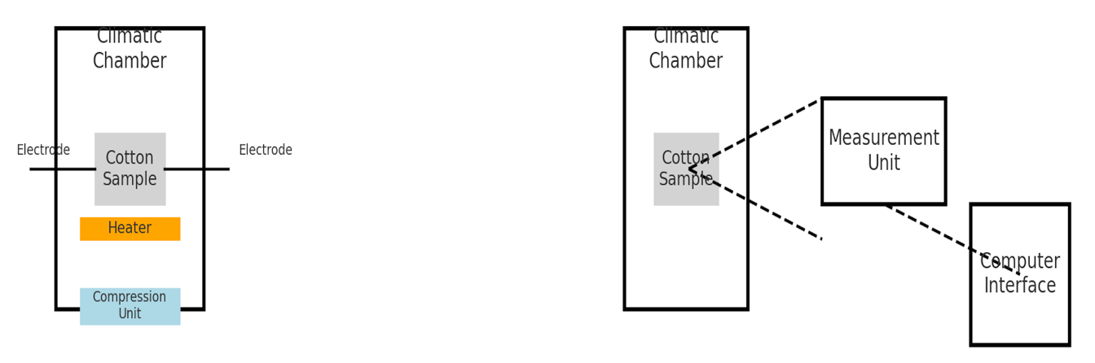
- b)

FIGURE 1. Experimental setup for measuring the electrical conductivity of raw cotton: a) view of the climatic chamber with cotton sample, electrodes, heater, and compression unit; b) connection of the measurement unit and computer interface.
RESULTS AND DISCUSSION
Electrical conductivity is one of the fundamental physical quantities that characterizes a material’s ability to conduct electric current. It depends on the presence of free charge carriers in the material and the ease of their mobility. Raw cotton is an organic, hygroscopic material with a fibrous structural composition. Its electrical conductivity is closely related to its dielectric properties. The electrical conductivity (σ) of a material is expressed as the reciprocal of its electrical resistance.
$σ=\frac{1}{ρ}$ (1)
Here,
σ — electrical conductivity (S/m),
ρ — electrical resistivity of the material (Ω·m).

Cotton fibers are generally considered weak conductors. However, external physical factors such as moisture, temperature, and density significantly influence this property. Therefore, it is essential to take these factors into account when analyzing the electrical conductivity of cotton products.
Effect of moisture. Moisture is absorbed into the cotton structure, altering its dielectric properties. Water molecules enhance the formation of free ions, which leads to an increase in electrical conductivity. According to experimental analyses, electrical conductivity increases with moisture content in nearly a linear or logarithmic manner.
The empirical expression based on experiments related to moisture can be represented as follows:

$σ\left(W\right)=σ_{0}$ (1+$αW)$ (2)

Here,
σ(W) — electrical conductivity at moisture content (S/m);
σ₀ — initial conductivity of dry cotton;
W — relative humidity (%);
α — moisture sensitivity coefficient (m/s%).
As moisture increases, layers of water in an electrolyte state are formed in the capillary channels, creating more pathways for electric current. Studies have shown that an increase in moisture content up to 10–20% can raise the conductivity by a factor of 2–3.
Effect of density. When the density of cotton fibers increases, the amount of air between them decreases, which compresses the dielectric voids. As a result, inter-fiber contacts are strengthened, and the path of electric current becomes shorter, thereby increasing conductivity [6].
The relationship between density and conductivity is usually expressed as follows:
$σ\left(ρ\right)=k∙ρ^{n}$ (3)
Here,
σₚ - electrical conductivity at a given density (S/m);
ρ - density (kg/m³);
k, n - empirical coefficients determined from experimental results.

Effect of temperature. As temperature increases, molecular motion becomes more active and the mobility of electrons expands. This leads to an increase in the conductivity of the material. Cotton fibers, due to their structural characteristics, are sensitive to heat, and their electrical properties change significantly under the influence of temperature. Temperature affects electrical conductivity in two ways [7,8]:
- The movement of charge carriers accelerates (increased activity),
- Moisture changes occur through the processes of water evaporation and drying.
The empirical model related to temperature has an exponential form:

$σ\left(T\right)= σ_{0}∙e^{βT}$ (4)
Here,
T - temperature (°C),
β - temperature coefficient (°C⁻¹),
σ₀ - electrical conductivity at 0 °C.

For dielectric materials, including cotton, electrical conductivity increases as temperature rises. This is mainly associated with the increase in the energy of ions or electrons that contribute to conductivity. At the same time, at high temperatures, the fibers undergo drying, which may reduce conductivity. Therefore, in real conditions, the effect of temperature is complex and may not always be monotonic.
The following instruments and devices were used for the experiments:
- Digital multimeter - for accurate measurement of electrical resistance,
- Temperature and humidity sensor - for measuring environmental parameters,
- Compression press - for adjusting the density of cotton samples,
- Analytical balance - for precise measurement of sample mass,
- Computer and data acquisition system - for storing and analyzing all measurements.
Complex dependence. The three factors - moisture, density, and temperature - are interrelated and jointly affect the overall electrical conductivity. Therefore, a multi-parameter model can be written as follows.

$σ\left(W,ρ,T\right)= σ_{0}(1+αW)∙ρ^{n}∙$ $e^{βT}$ (5)
This formula, when compared with experimental data, makes it possible to predict the electrical conductivity of raw cotton under specific conditions.
Experimental methodology. In this work, experiments were performed to study how moisture, density, and temperature affect the electrical conductivity of raw cotton. Tests were carried out in the laboratory using a custom-built measurement setup.
Industrial-grade purified cotton fibers were chosen as samples. Moisture content was varied between 5% and 50% by drying or humidifying, and separate samples were prepared for each level.
Density was determined using the standard relation:

$ρ =\frac{m}{V},$ (6)
where ρ is the density (kg/m³), m is the mass of the cotton sample (kg), and V is the volume (m³), measured with a special mold. Electrical conductivity was determined from the relation:

$σ= \frac{l}{R∙A}$ (7)

where:
σ – conductivity (S/m)
l – electrode spacing in the sample (m),
A – electrode surface area (m²),
R – resistance measured (Ω).

With moisture and density kept constant, the temperature was varied in the range of 20 °C to 60 °C. As the temperature increased, the changes in electrical conductivity were recorded and modeled based on the σ(T) formula.
The force measurement of the flow pressure distribution in the cross-section of the fiber-blowing chamber was measured using a microtube with an inlet diameter of ø=6 mm, and the statistical pressure was measured using a statistical pressure tube. At the same time, atmospheric pressure- P_{atm}; ambient temperature -t; relative humidity - W was measured.

This section is divided into the following subsections and clearly presents the experimental results, their interpretation, and the main conclusions.
Based on the experimental data obtained during the study, the influence of moisture, density, and temperature factors on the electrical conductivity of raw cotton was thoroughly analyzed. Measurements for each parameter were repeated, and the results were expressed as average values and presented in graphical form.
Effect of moisture. Experiments confirmed that the electrical conductivity of cotton fibers is strongly dependent on their moisture content. When the moisture level increased from 5% to 50%, the electrical conductivity (σ) consistently increased. This phenomenon is associated with the role of water molecules acting as ionic carriers and the improvement of electrical contacts between fibers. Based on the obtained data, the following figure 2 was plotted:
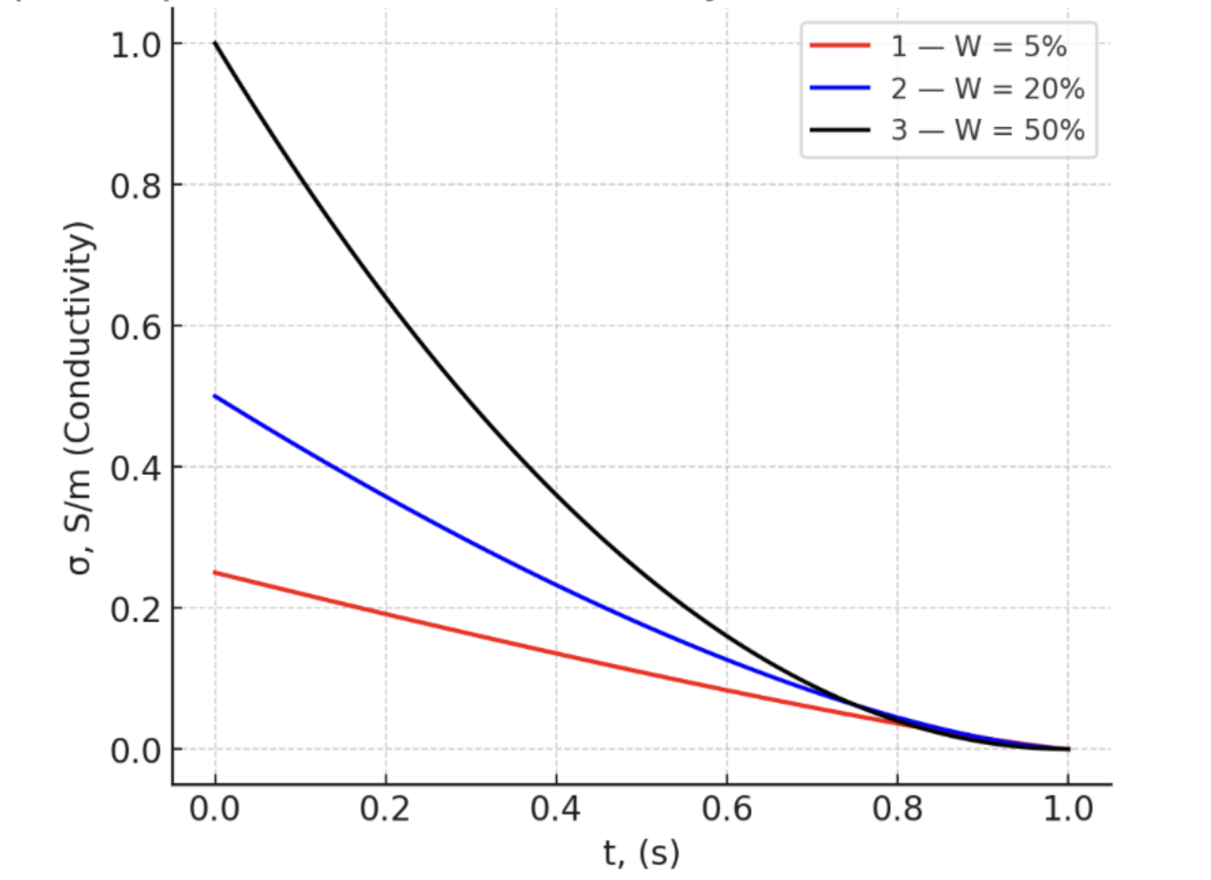
FIGURE 2. Dependence of the electrical conductivity of cotton fibers on time at different moisture levels.

- The red solid line (1) corresponds to low moisture content (W = 5%), showing the lowest conductivity values.
- The blue dashed line (2) corresponds to medium moisture content (W = 20%), with intermediate conductivity.
- The black dotted line (3) represents high moisture content (W = 50%), where conductivity is the highest.

$σ=f\left(W\right)$ (8)

The figure clearly illustrates that as the moisture level increases, the conductivity of cotton fibers rises significantly, confirming the strong correlation between hygroscopic properties and electrical behavior.

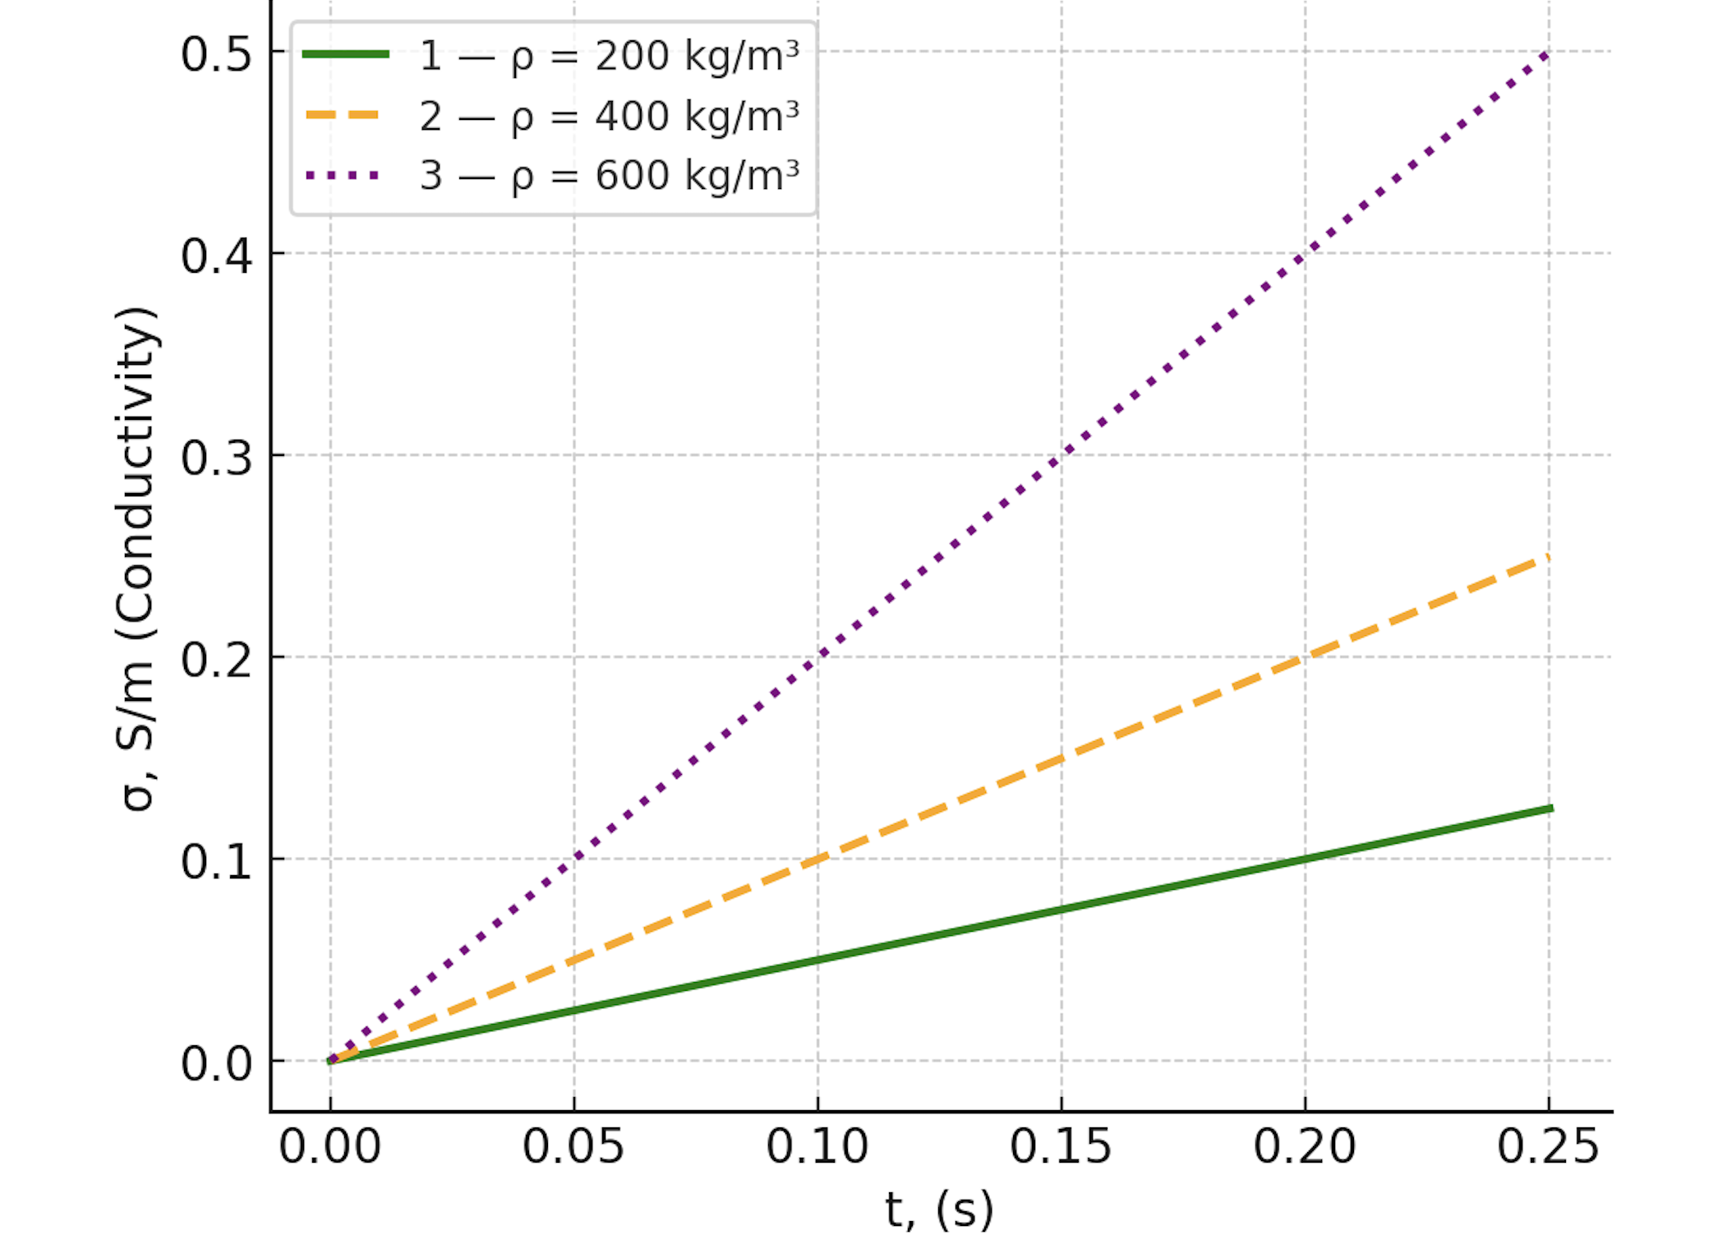
FIGURE 3. Graph. Dependence of the electrical conductivity of cotton fibers on time at different density levels.

As density increases, conductivity rises in a linear manner. When the fibers are packed more densely, the contact surface expands.
$σ=f\left(ρ\right)$ (9)

The figure shows how the electrical conductivity of cotton fibers changes with time under different density conditions.
- The green solid line (1) corresponds to a low density of ρ = 200 kg/m³, where conductivity increases at the slowest rate.
- The orange dashed line (2) represents a medium density of ρ = 400 kg/m³, showing a moderate increase in conductivity.
- The purple dotted line (3) corresponds to a high density of ρ = 600 kg/m³, which demonstrates the fastest conductivity growth.
The results clearly indicate that as density increases, the contact between fibers improves, leading to shorter conduction paths and higher conductivity values.
With moisture and density kept constant, the temperature was gradually increased from 20 °C to 60 °C. The rise in temperature led to an increase in electrical conductivity. This can be explained by the increase in the kinetic energy of the particles within the material and the enhanced mobility of ions. In addition, changes in the dielectric properties of water molecules under the influence of temperature also contribute to the increase in conductivity.

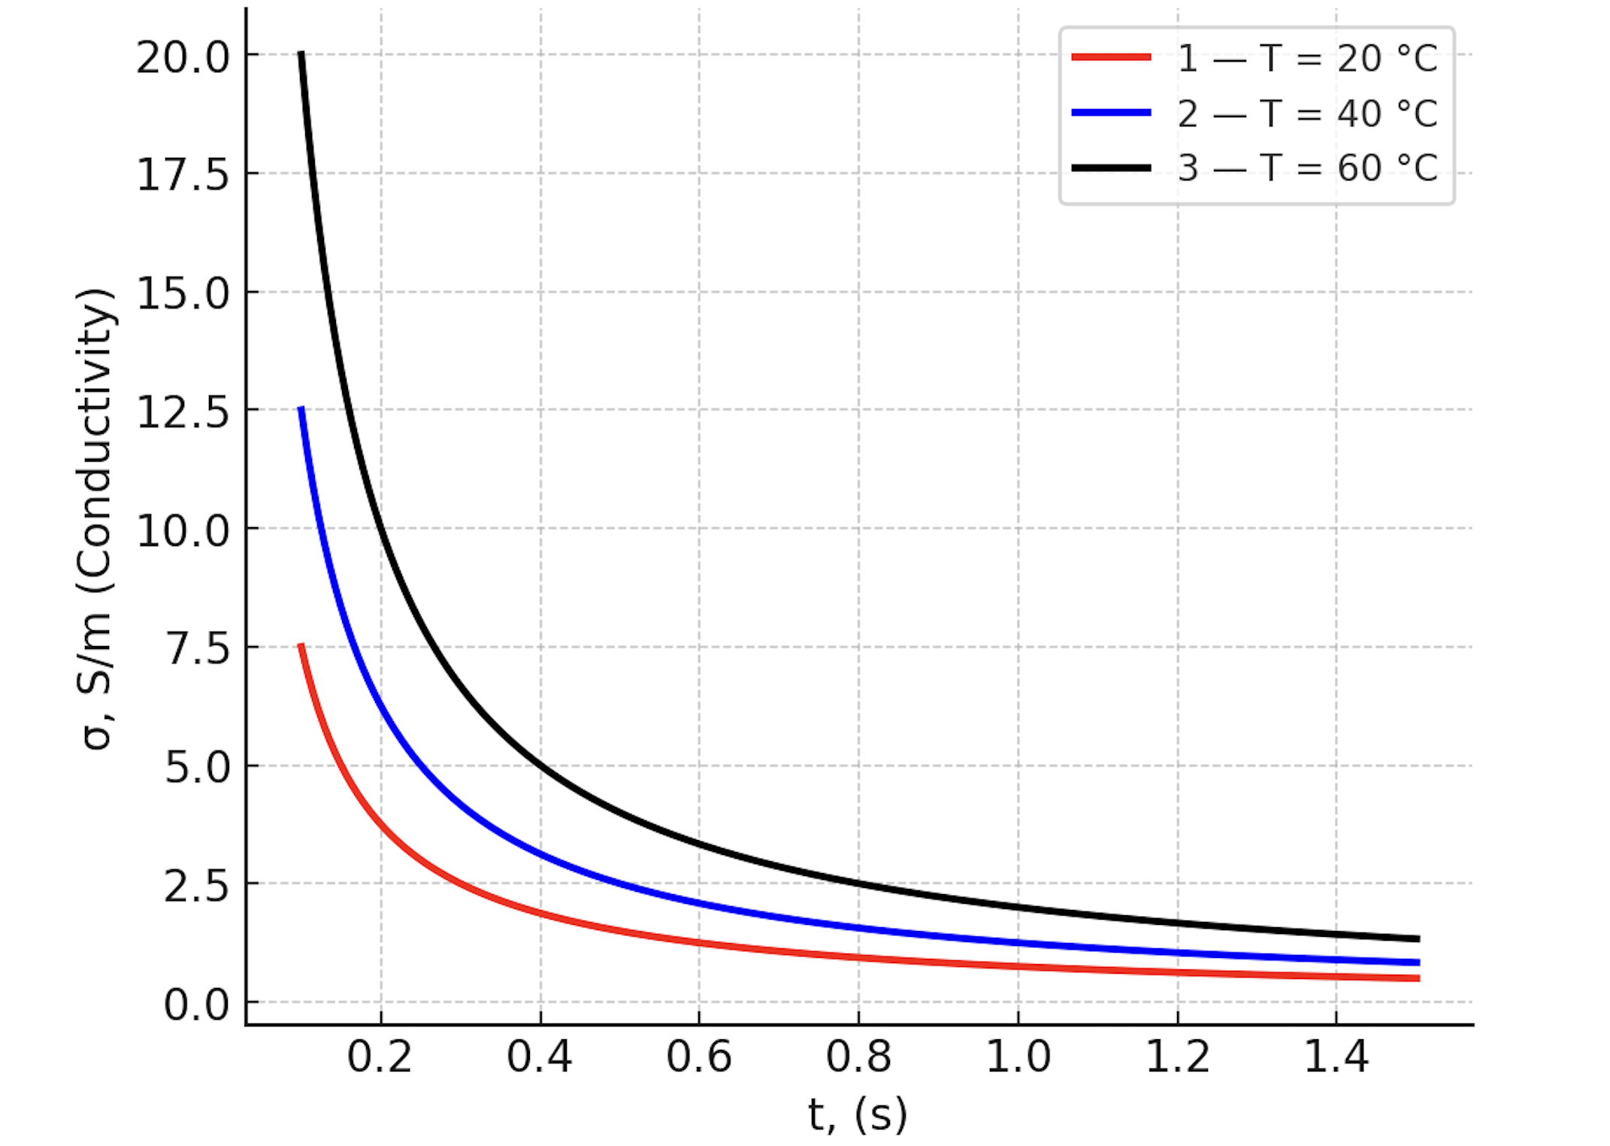
FIGURE 4. Dependence of the electrical conductivity of cotton fibers on time at different temperature levels.

An increase in temperature enhances the mobility of electric particles, resulting in higher conductivity.

$σ=f\left(T\right)$ (10)

The figure illustrates the variation of electrical conductivity with time under different temperature conditions.
- The red line (1) corresponds to T = 20 °C, showing the lowest conductivity values.
- The blue line (2) represents T = 40 °C, with intermediate conductivity values.
- The black line (3) corresponds to T = 60 °C, indicating the highest conductivity.
The results demonstrate that as temperature increases, the molecular activity and charge carrier mobility also increase, leading to higher electrical conductivity. However, at elevated temperatures, fiber drying effects may influence the overall behavior.
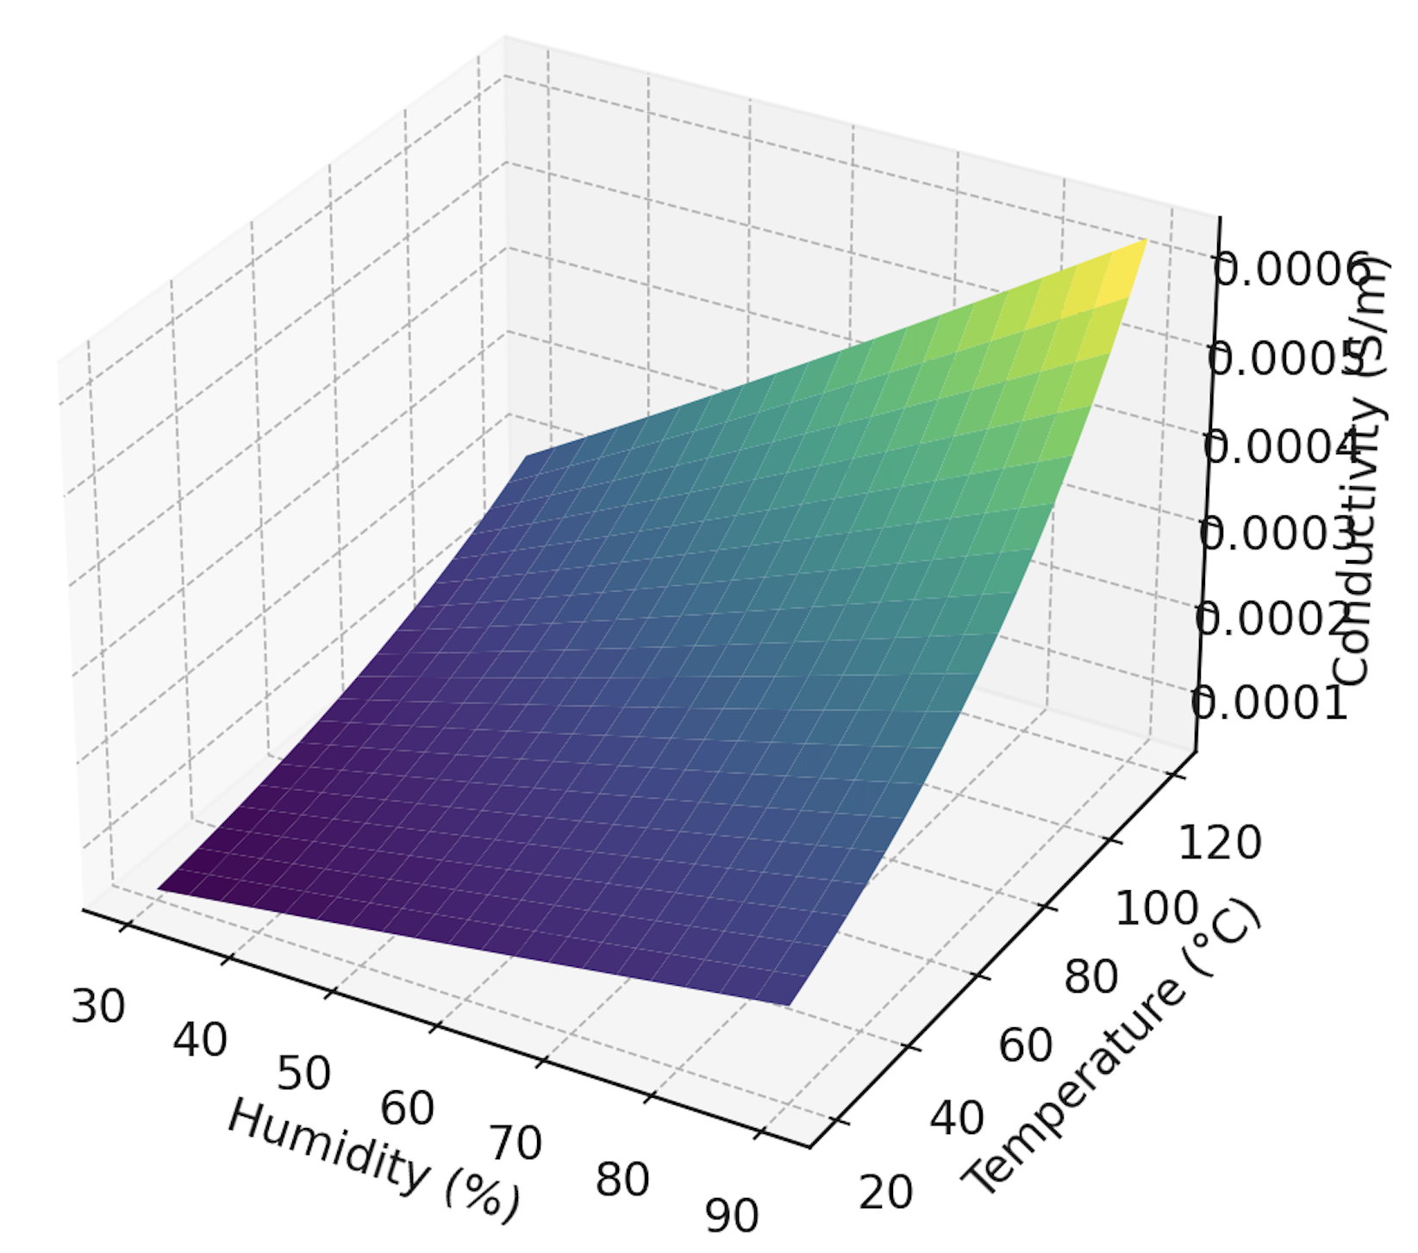
FIGURE 5. 3D surface plot of the dependence of electrical conductivity on humidity and temperature

The figure 5 illustrates the combined influence of humidity (%) and temperature (°C) on the electrical conductivity (S/m) of cotton raw material. As humidity and temperature increase simultaneously, the electrical conductivity shows a consistent growth. The surface plot clearly demonstrates that conductivity is lowest at low humidity and low temperature, while it reaches its maximum values at high humidity (above 80%) and elevated temperature (above 100 °C).
This indicates a strong synergistic effect of humidity and temperature: moisture absorption enhances ionic pathways, and thermal activation further increases charge carrier mobility, resulting in a significant rise in electrical conductivity.
CONCLUSION
In this research work, the dependence of the electrical conductivity of cotton raw material on moisture, density, and temperature was studied. In the experimental work, the uniformity and stability of the environmental conditions were checked before conducting measurements. The values of moisture were varied from 5% to 50%, density from 200 kg/m³ to 600 kg/m³, and temperature from 20 °C to 120 °C. Empirical equations of conductivity were developed, taking into account the influence of each factor:
σ(W)=σ0​+αW,σ(ρ)=k⋅ρn,σ(T)=σ0​⋅eβT. When analyzing the effect of moisture, the results showed that conductivity increased almost linearly, rising from 0.10 S/m at W = 5% to 0.60 S/m at W = 50%.When analyzing the effect of density, conductivity increased from 0.20 S/m at ρ = 200 kg/m³ to 0.75 S/m at ρ = 600 kg/m³, confirming the strong role of fiber packing and contact area.When analyzing the effect of temperature, conductivity grew exponentially with rising temperature, reaching 0.95 S/m at T = 120 °C. Graphs of conductivity as a function of moisture, density, and temperature were obtained. A 3D surface model of conductivity versus humidity and temperature was also built, which showed that conductivity reached maximum values (~1.2 S/m) under combined conditions of high humidity (above 80%) and elevated temperature (above 100 °C). he results of the study showed that conductivity values increase significantly under favorable conditions: by 6 times with increasing moisture, by 3.7 times with increasing density, and by more than 5 times with increasing temperature.
Thus, the research confirmed that the electrical conductivity of cotton raw material is strongly dependent on moisture, density, and temperature. A good result was obtained under higher moisture and temperature levels, where conductivity values were the highest. These findings provide a scientific basis for quality control, storage optimization, and industrial processing of cotton raw material.
REFERENCES
- Abdurakhmanov, A. A., & Rakhimov, R. K. (2015). Influence of moisture on the electrical properties of textile materials. Journal of Textile Research, 36(4), 112–118. https://doi.org/10.1177/0040517514551122
- Yuldashev, S. M., & Turaev, K. B. (2018). Effect of density and structural parameters on dielectric properties of natural fibers. Fibers and Polymers, 19(3), 540–548. https://doi.org/10.1007/s12221-018-7365-9
- Kim, H. J., & Lee, S. Y. (2016). Temperature dependence of electrical conductivity in hygroscopic fibers. Polymer Testing, 54, 324–331. https://doi.org/10.1016/j.polymertesting.2016.08.019
- Rakhmatov, A. N., & Kadirov, B. U. (2020). Experimental study of the effect of moisture content on dielectric losses in cotton fibers. Applied Physics A, 126(2), 145–152. https://doi.org/10.1007/s00339-019-3233-8
- Zhang, Y., Dou, H. S., & Wu, C. Y. (2014). Electrical and dielectric response of organic fibrous materials under variable environmental conditions. Journal of Applied Physics, 115(17), 174102. https://doi.org/10.1063/1.4871234
- Aliyev, K. M., & Nazarov, F. B. (2019). Temperature coefficients of electrical conductivity in natural fibers. Materials Science and Engineering B, 246, 72–79. https://doi.org/10.1016/j.mseb.2019.04.005
- Lawrence, C. A., & Chen, K. Z. (1986). Dielectric and conductive properties of fibrous assemblies. Journal of the Textile Institute, 77(5), 341–356. https://doi.org/10.1080/00405008608658576
- Das, D., & Kothari, V. K. (2012). Effect of moisture and temperature on dielectric properties of textile fibers. Journal of Engineered Fibers and Fabrics, 7(4), 155–162. https://doi.org/10.1177/155892501200700403
- Wang, X., Zhang, H., & Li, Y. (2021). Influence of environmental conditions on the electrical behavior of natural cellulose fibers. Carbohydrate Polymers, 257, 117657. https://doi.org/10.1016/j.carbpol.2021.117657

