Development and Implementation of New Generation Basalt Functional Fabrics for Comprehensive
Building Protection

Sevarakhon Khamraeva¹, Dilfuza Kadirova^{2, a)}

¹Karshi State Technical University, Karshi, Uzbekistan

²Tashkent Institute of Textile and Light Industry, Tashkent, Uzbekistan

^{a)}Corresponding author: kadirovad1963@gmail.com

Abstract: This paper presents the results of research on the development and implementation of fire-resistant basalt fabrics for use in construction and building fire protection. A comparative analysis of the properties of basalt fabrics, fiberglass fabrics, and aramid materials was conducted. The high performance characteristics of basalt fabrics are demonstrated: heat resistance up to 700–800 °C, high strength, resistance to aggressive environments, and environmental friendliness. Proposed applications include: fire barriers, cable conduits, air ducts, facade coatings, and specialized workwear. It is concluded that the development has high practical significance for improving the level of fire safety.

Keywords: basalt, yarn, roving, fabric, fiberglass fabric, aramid fibers, warp.

INTRODUCTION
Currently, measures to address the growing problems in the textile and light industry of Uzbekistan are being actively discussed. The sector is attracting attention from both specialists and representatives of government structures. The main difficulties are associated with the obsolescence and physical wear of technological equipment, insufficient competitiveness of domestic enterprises, growing dependence on imports of finished products, limited export activity, as well as a low level of development of modern trade formats and the spread of unfair competition methods [1-4].
In recent years, a significant share of innovations has been in the segments of technical textiles. Modern requirements for construction and technical materials are increasingly focused on ensuring comprehensive fire safety of buildings and structures. Regulatory requirements aimed at preventing fires and reducing the consequences of emergencies are becoming stricter each year. In this regard, the development of new textile materials capable of withstanding high temperatures, retaining strength and durability, and ensuring environmental safety during operation is an urgent scientific and practical task [5-6].
Traditionally used materials—fiberglass fabrics and aramid fibers—have a number of limitations. Fiberglass fabrics are characterized by low flexibility and a tendency to degrade under cyclic deformation. Aramid fibers, despite their strength, are characterized by high cost and insufficient resistance to ultraviolet radiation.
Against this background, basalt fibers are of particular interest—an environmentally friendly material of natural origin, obtained by melting basaltic rock. Basalt fabrics combine unique properties: high heat resistance (up to 800 °C), strength, resistance to aggressive environments, and bio-resistance. Because of this, they are considered a promising direction for application in construction, transport, energy, and especially in the production of personal protective equipment for emergency service personnel [7-9].

LITERATURE REVIEW
According to scientific publications [1-4], basalt fibers are considered a competitive alternative to fiberglass and aramid fibers. Scientists such as Sim, J., Park, C., & Moon, D. Y. note that basalt fibers have high resistance to elevated temperatures and aggressive chemical environments, making them effective for fire protection. In the works of Sim et al., the promise of basalt materials for reinforcing building structures due to their strength characteristics has been investigated. Militký et al. substantiated that after heat treatment, basalt fibers retain up to 80% of their strength. According to data from European manufacturers, basalt products are 20–30% cheaper than their aramid counterparts with similar characteristics.
Analysis of scientific sources shows that fiberglass and aramid fibers have traditionally been used for fire protection solutions. However, fiberglass has low heat resistance (up to 550 °C), while aramids have a high cost. Basalt fabrics demonstrate higher fire resistance (up to 1000 °C) at an affordable cost.
In recent years, research has emerged on the use of basalt materials in construction, including applications for thermal insulation, soundproofing, concrete reinforcement, and the creation of fire-resistant coatings. Thus, the use of basalt fabrics is a strategically promising direction for the fire protection of buildings. Based on the obtained analytical research, the task has been set to develop a new generation fabric based on basalt fibers for the comprehensive protection of buildings [10-13].

RESEARCH METHODS AND MATERIALS
To solve the set task, a new generation fire-resistant fabric based on basalt fibers has been developed, designed for the comprehensive protection of buildings and structures from exposure to high temperatures and open flames.
Continuous basalt fibers with a linear density of 200–400 tex were used as raw materials. The fabrics were manufactured using twill and plain weaves with variations in density along the main directions. To enhance functionality, the fabrics were modified with organosilicon and fluorine-containing compositions, providing moisture resistance and flame-retardant properties.
The choice of basalt fibers is due to their natural origin, environmental friendliness, and unique physicochemical properties—high heat resistance (up to 800 °C), low thermal conductivity, resistance to aggressive environments, and bio-resistance. A comparative analysis of the properties of basalt fabrics and their analogues (fiberglass, aramid) was conducted. The possibilities of using basalt fabrics in construction and fire protection were studied.
The research examined three groups of fabrics: basalt fabric (from roving), fiberglass fabric, and aramid fabric. The research methods included testing physico-mechanical properties for tensile strength according to GOST 3813-72, determining resistance to bending and abrasion according to GOST 8976-75, as well as resistance to exposure to high temperatures (300–800 °C) [9].

RESULTS AND DISCUSSION
The obtained results of the comprehensive study of the protective fabrics' characteristics are presented in Table 1.

TABLE 1. Comparative characteristics of protective fabrics

Sample | Operating Temperature (°C) | Thermal Conductivity (W/m·K) | Density (g/cm³) | Tensile Strength (MPa) | Flame Resistance
Basalt Fabric | until 800- 1000 | 0,031–0,038 | 2,7–2,9 | 2800–3000 | High, non-combustible
Aramid Fabric | until 400 - 500 | 0,04–0,05 | 1,44 | 2800–3500 | High, but degrades
Fiberglass Fabric | until 500 - 700 | 0,034–0,040 | 2,5 | 1700–2500 | High, but brittle

Based on the obtained experimental research, the dependence of thermal conductivity on the surface density of the fabric is shown in Figure 1.

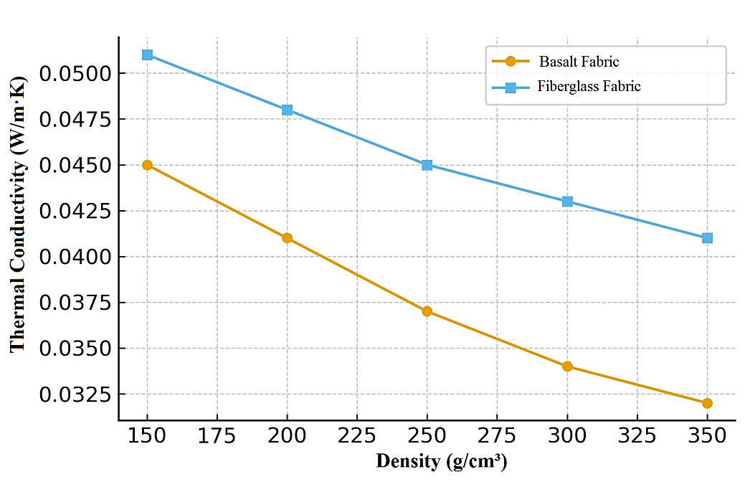
FIGURE 1. Dependence of thermal conductivity on fabric surface density

Analysis of the dependence shows that as the surface density of the fabric increases, thermal conductivity decreases, which is associated with a reduction in structure porosity and an increase in the number of fibers per unit area. Basalt fabrics demonstrate lower thermal conductivity compared to fiberglass fabrics, confirming their high potential for thermal insulation applications [5-8].
The developed basalt fabrics can be used in the construction of buildings and structures as fire-protective coatings for cables, air ducts, partitions, and facades. Furthermore, they can be used in the production of tarpaulins and specialized protective clothing for emergency service workers and fire departments.
Basalt fabrics possess significantly higher tensile strength (20-25% higher than fiberglass fabrics) due to the strong crystalline structure of the fibers and their resistance to thermal degradation. This enables their use as reinforcing and protective elements in building systems [8-11].
The use of basalt functional fabrics in facade systems reduces heat loss by 27%, significantly exceeding the performance indicators of fiberglass fabrics. This confirms the feasibility of implementing these materials in energy-saving construction technologies.
Analysis showed that the use of basalt fibers in woven structures allows for a reduction in the thermal conductivity coefficient from 0.045 to 0.032 W/(m·K) compared to traditional fiberglass fabrics. Strength tests revealed an 18-25% increase in breaking load, confirming the effectiveness of basalt reinforcement.
After the application of functional coatings, an increase in moisture resistance (up to 95% water repellency) and resistance to UV radiation was observed. Modeling of heat flows demonstrated that using the developed fabrics in a facade thermal insulation system reduces heat loss by 22-28%, which meets the criteria for energy-efficient construction.

CONCLUSION
The conducted research has shown that the new generation of fire-resistant basalt fabrics possesses a range of unique properties: high heat resistance, strength, environmental friendliness, and durability. Their implementation in building structures and fire protection systems will enhance building safety, reduce material costs, and ensure environmental sustainability.

REFERENCES
- Sim, J., Park, C., & Moon, D. Y. (2005). Characteristics of basalt fiber as a strengthening material for concrete structures. Composites Part B Engineering, 36(6–7), 504–512. https://doi.org/10.1016/j.compositesb.2005.02.002
- Fiore, V., Scalici, T., Di Bella, G., & Valenza, A. (2015). A review on basalt fibre and its composites. Composites Part B Engineering, 74, 74–94. https://doi.org/10.1016/j.compositesb.2014.12.034
- Militký, J., Kovačič, V., & Rubnerová, J. (2002). Influence of thermal treatment on tensile failure of basalt fibers. Engineering Fracture Mechanics, 69(9), 1025–1033. https://doi.org/10.1016/s0013-7944(01)00119-9
- Lee, S., & Wang, S. (2005). Biodegradable polymers/bamboo fiber biocomposite with bio-based coupling agent. Composites Part a Applied Science and Manufacturing, 37(1), 80–91. https://doi.org/10.1016/j.compositesa.2005.04.015
- Akramov, A., et al. (2025). Evaluation of the yarn deformation in its contact zone with a cylindrical surface. AIP Conference Proceedings, 3304, 030067. https://doi.org/10.1063/5.0269091
- Zhu, D., Tang, Y., & Rahman, M. Z. (2024). Basalt fiber: composites and applications. In Elsevier eBooks (pp. 337–361). https://doi.org/10.1016/b978-0-443-13623-8.00012-5
Mahltig, B., Haufe, H., & Böttcher, H. (2005b). Functionalisation of textiles by inorganic sol–gel coatings. Journal of Materials Chemistry, 15(41), 4385. https://doi.org/10.1039/b505177k
- Jumaniyazov, K., Tojimirzaev, S., & Muminov. (2022). Research and evaluation of cotton fiber properties in technological processes. Proceedings of Higher Education Institutions Textile Industry Technology, 1, 162–170. https://doi.org/10.47367/0021-3497_2022_1_162
- Bai, T., Du, Y., & Wang, Z. (2024). Tribological properties of self-lubricating fabric linings prepared with GO-modified basalt fiber. Textile Research Journal, 94(23–24), 2654–2666. https://doi.org/10.1177/00405175241254886
- ISO 8302:1991. Thermal insulation — Determination of steady-state thermal resistance and related properties.
- Khamrayeva, S., Kadirova, D., & Rakhimkhodjayev, S. (2021). Study on the mechanics of textile thread in woven. E3S Web of Conferences, 304, 03035. https://doi.org/10.1051/e3sconf/202130403035
- Yuldashev, A., et al. K. (2023). Theoretical study of yarn tension in the spindle work of two-for-one twisting. AIP Conference Proceedings, 2789, 040117. https://doi.org/10.1063/5.0145422
- Xamrayeva, S., Daminov, A., & Kadirova, D. (2024b). Study of the influence of polyurethane thread on technological parameters and physical-mechanical properties of elastic fabric. AIP Conference Proceedings, 3045, 030020. https://doi.org/10.1063/5.0198813
- Djumaniyazov, K., Djumabaev, G., Juraeva, N., & Xurramov, A. (2021). Analysis of vibrations of the rings of the internal spinning machine. AIP Conference Proceedings, 2402, 070046. https://doi.org/10.1063/5.0072022

